Supplementary Information for
Wood-based Superblack
Bin Zhao¹, Xuetong Shi², Sergei Khakalo^{3,4}, Yang Meng⁵, Arttu Miettinen⁶, Tuomas Turpeinen⁷, Shuyi Mi⁸, Zhipei Sun^{8,9}, Alexey Khakalo¹⁰, Orlando J. Rojas^{1,2,*}, Bruno D. Mattos^{1,*}

¹Department of Bioproducts and Biosystems, School of Chemical Engineering, Aalto University; Espoo, FI-02150, Finland
²Bioproduct Institute, Department of Chemical & Biological Engineering, Department of Chemistry and Department of Wood Science, The University of British Columbia; Vancouver, BC V6T 1Z3, Canada
³Department of Civil Engineering, School of Engineering, Aalto University; Espoo, FI-02150, Finland
⁴Integrated Computational Materials Engineering, VTT Technical Research Centre of Finland Ltd.; Espoo, FI-02044, Finland
⁵Faculty of Chemical Engineering, Kunming University of Science and Technology; Kunming, 650500, PR China
⁶Department of Physics, University of Jyvaskyla; Jyväskylä, FI-40014, Finland
⁷Fiber web processes, VTT Technical Research Centre of Finland Ltd.; Jyväskylä, FI-40400, Finland
⁸Department of Electronics and Nanoengineering, Aalto University; Espoo, FI-02150, Finland.
⁹QTF Centre of Excellence, Department of Applied Physics, Aalto University; Espoo,
FI-02150, Finland
¹⁰Functional Cellulose, VTT Technical Research Centre of Finland Ltd.; Espoo, FI-02044, Finland

*Authors for correspondence: Bruno D. Mattos, E-mail: bruno.mattos@aalto.fi
Orlando J. Rojas, E-mail: orlando.rojas@ubc.ca

This PDF includes:
Supplementary Sections 1 to 3
Supplementary Figures 1 to 27
Supplementary Tables 1 to 10
References

Supplementary Section 1. Finite element modeling of the optical properties of cellular structures.
Simulation setup
In the framework of continuum description of condensed matter, finite element (FE) software COMSOL Multiphysics® (Electromagnetic Waves, Frequency Domain in Wave Optics Module¹) is used for modeling the optical properties of cellular structures. In total, 13 cases are studied. The two-dimensional simulation setup for Case 1 is shown in Supplementary Figure 1a. In Case 1, taken as a reference case, we analyze the optical properties of a flat surface. It is modeled by considering a two-dimensional unit cell with a width of 1 μm. The model consists of three parts. The first part (highlighted in blue) represents a graphite material, the second part (grey color) is used for air, and the third part (marked as green) defines perfectly matched layers (PMLs). For air, the refractive index is real and takes the value 1, while graphite has wavelength-dependent real and imaginary parts of refractive index². Floquet periodic boundary conditions (PBCs) are applied on the left and right sides of the computational domain. The interior boundary with a Port BC with active domain-backed slit condition (yellow line in Supplementary Figure 1a) is placed 2 μm above the air-graphite interphase and used to launch a plane wave incident at 0 degrees with port input power of 1 W/m and wavelengths in a range from 350 nm to 800 nm. PMLs are used to absorb all reflected light (top layer) and transmitted light (bottom layer). Two additional interior boundaries (red lines in Supplementary Figure 1a) are introduced to monitor the total reflected and transmitted light by integrating the power flux normalized with respect to the incident power. The interior boundaries are placed in front of (0.1 μm away from) the PML domains. The absorbance within the graphite is computed by integrating the losses within the graphite domain. Quadratic discretization is used for electric field. Free triangular and mapped mesh options are selected with minimum and maximum element size, respectively, of 0.9 nm and 35 nm. To assure accurate integration, a boundary layer mesh option is used for the interior boundaries with the following properties: number of boundary layers is 4, boundary layer stretching factor is 2, and thickness of first layer is 1 nm. More details can be found in a COMSOL Blog on modelling the optical properties of rough surfaces³. Distribution of the electric field norm for a reference Case 1 is shown in Supplementary Figure 1b.
In Cases 2-3 and 6-15, we analyzed the optical properties of cellular structures. The structures are modelled as a regular 2D array of straight rectangular (or trapezoidal) pillars with a skew bottom part. Domain occupied by a graphite material is highlighted in blue, while grey color is used for domain occupied by air. Simulation setup is similar to Case 1 except of the unit cell size and composition.
To investigate the light interactions with wood anatomical elements, 2D vertical cylinder array of straight rectangular pillars was employed in the simulation (Supplementary Figure 2a). Light reflectance on 2D cylinder array with varied fiber length (spanning 20-200 μm), cell wall thickness (spanning 0.7-6 μm), lumen width (spanning 7.5-60 μm), and cell end tilt angle (spanning 0-60 °) are studied in Cases 2-3, 6-12 and 14. The dimension of the anatomical elements used in the simulation was extracted from the microCT scans (Supplementary Figure 7) and SEM images (Supplementary Figures 15-20) of balsa wood. Case 2 examines the total light reflectance of cylinder array as a function of cell end tilt angle. Cases 1, 2, 3, 8 and 9 show the effect of cell wall thickness on the light reflectance of cylinder array. Cases 2, 10, 11 and 12 examine the carbonized wood-light interactions in cylinder array with varied fiber length. Cases 2, 6, 7 and 14 study the effect of lumen width on the light reflectance. To verify the contribution of new subwavelength structures to light absorption, 2D cylinder array of trapezoidal pillars is employed in both Cases 13 and 15 (Supplementary Figures 5-6). The dimension of the short base and the long base of the trapezoidal pillars is 0.2 μm and 1.5 μm, respectively, which is used in both Cases 13 and 15. The altitude of trapezoidal pillars is set at 30 μm and 100 μm, which corresponds to the height of bandsaw-like microarrays in NW carbon (in Case 13) and carbon microfiber arrays in superblack wood (Case 15), respectively. To create the interfiber porosity of tens of microns, one blackbody-like cell unit is installed adjacent to the regular cylinder array (Supplementary Figure 6b).

Case studies and results
For Cases 2 and 3, the pillars have height 120 μm and are placed in space with a step of 15 μm. The pillars have width 1.5 μm (Case 2) and 6 μm (Case 3). The corresponding unit cells (shown in Supplementary Figure 2a and 2b) are selected such that they include halves of the neighbouring pillars. The bottom part (in its horizontal position) is placed 100 μm below the pillars top surface (H=100 μm). The bottom slope is introduced by rotating the bottom part around a middle point at the upper surface of the bottom part. The rotation angle is taken in a range from 0° to 60° with 5° increment. For fixed height and spacing between the pillars, Cases 2 and 3 study the influence of the pillar width (representing cell wall thickness in wood) and slope of a bottom part (representing cell end tilt angle in wood) on the reflective properties. For Case 2, with the selected bottom slopes 0°, 15°, 30°, 45°, and 60°, distribution of the electric field norm is presented in Supplementary Figure 2c for wavelength λ=350 nm and in Supplementary Figure 2d for wavelength λ=800 nm. Reflectance as a function of wavelength is plotted in Supplementary Figure 2e for Cases 2 (including Case 1 and Case 3, φ=30 °).
For Cases 6-9, the pillars have height 120 μm and are placed in space with a step of 7.5 μm (Case 6, H=100 μm, W=7.5 μm), 30 μm (Case 7, H=100 μm, W=30 μm), and 15 μm (Cases 8 and 9, H=100 μm, W=15 μm). The pillars have width 1.5 μm (Cases 6 and 7), 1 μm (Case 8), and 0.7 μm (Case 9). The corresponding unit cells are shown in Supplementary Figure 3a-3d. The bottom part (in its horizontal position) is placed 100 μm below the pillars top surface (H=100 μm) and then rotated by 30° around a middle point at the upper surface of the bottom part. For fixed height of the pillars and slope of the bottom part, Cases 6-9 study the influence of the pillar width (representing cell wall thickness in wood) and spacing between the pillars (representing lumen width in wood) on the reflective properties. Distribution of the electric field norm for wavelengths λ=350 nm and λ=800 nm is presented in Supplementary Figure 3e for Case 6, in Supplementary Figure 3f for Case 7, in Supplementary Figure 3g for Case 8, and in Supplementary Figure 3h for Case 9. Reflectance as a function of wavelength is plotted in Supplementary Figure 3i (including results for Case 2, φ=30° and Cases 10-12).

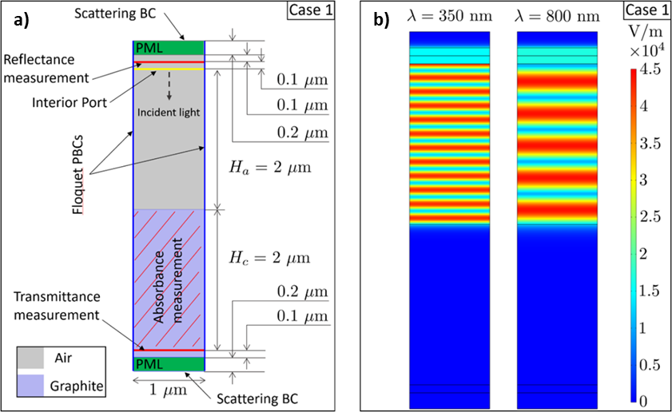

Supplementary Figure 1. FEM simulation setup for Case 1. a) Computational model. b) Distribution of the electric field norm for wavelengths λ=350 nm and λ=800 nm.

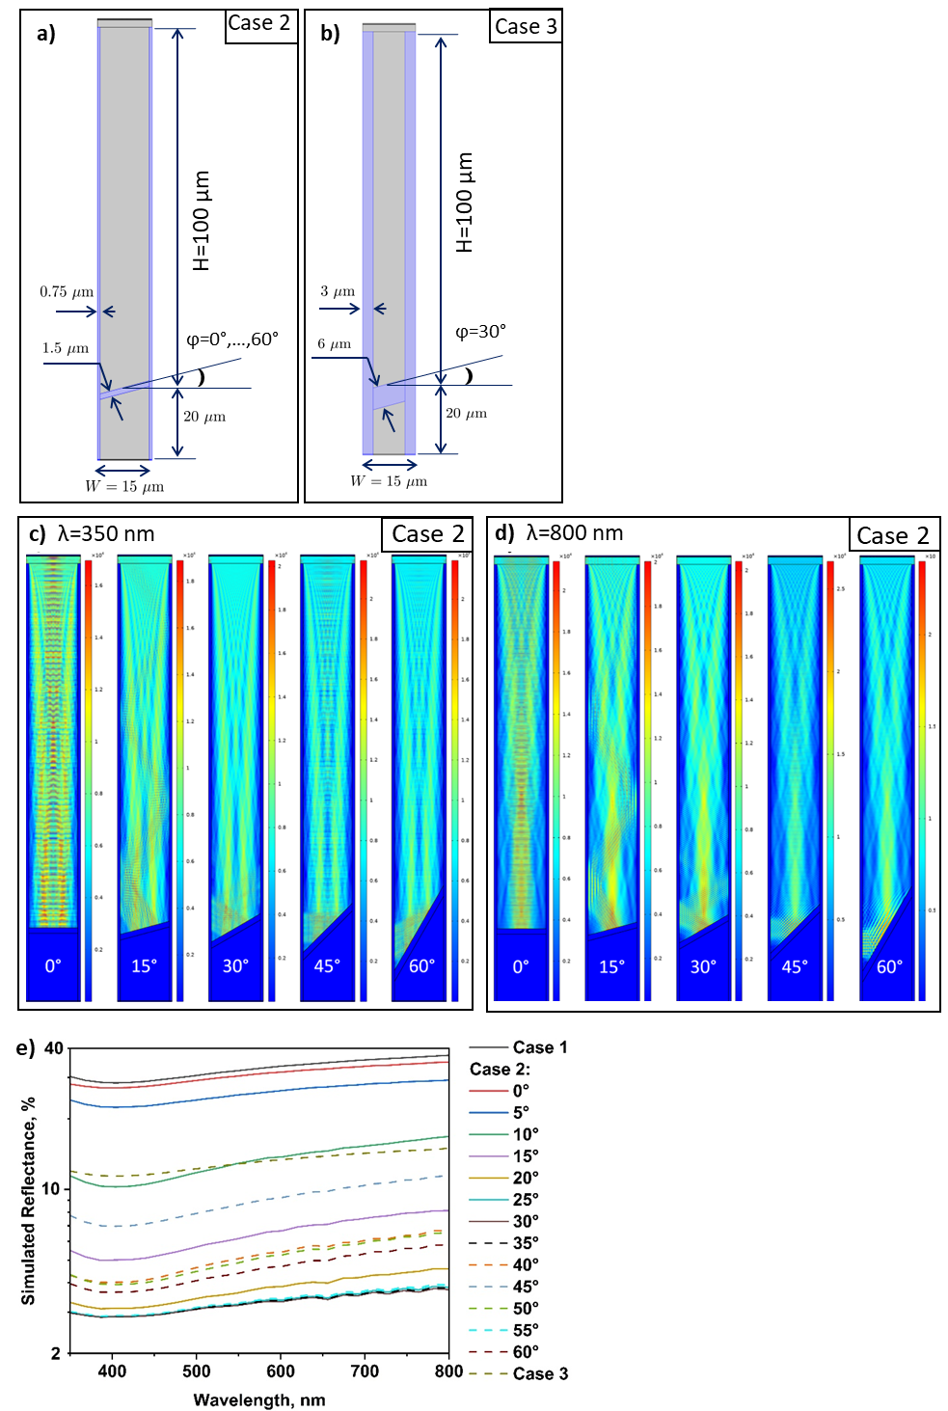
Supplementary Figure 2. FEM simulation setup for Cases 2 and 3. Computational model for a) Case 2 and for b) Case 3. Distribution of the electric field norm for Case 2 at wavelengths c) λ=350 nm and d) λ=800 nm. (e) Reflectance as a function of wavelength for Cases 1-2, and Case 3, φ=30 °.
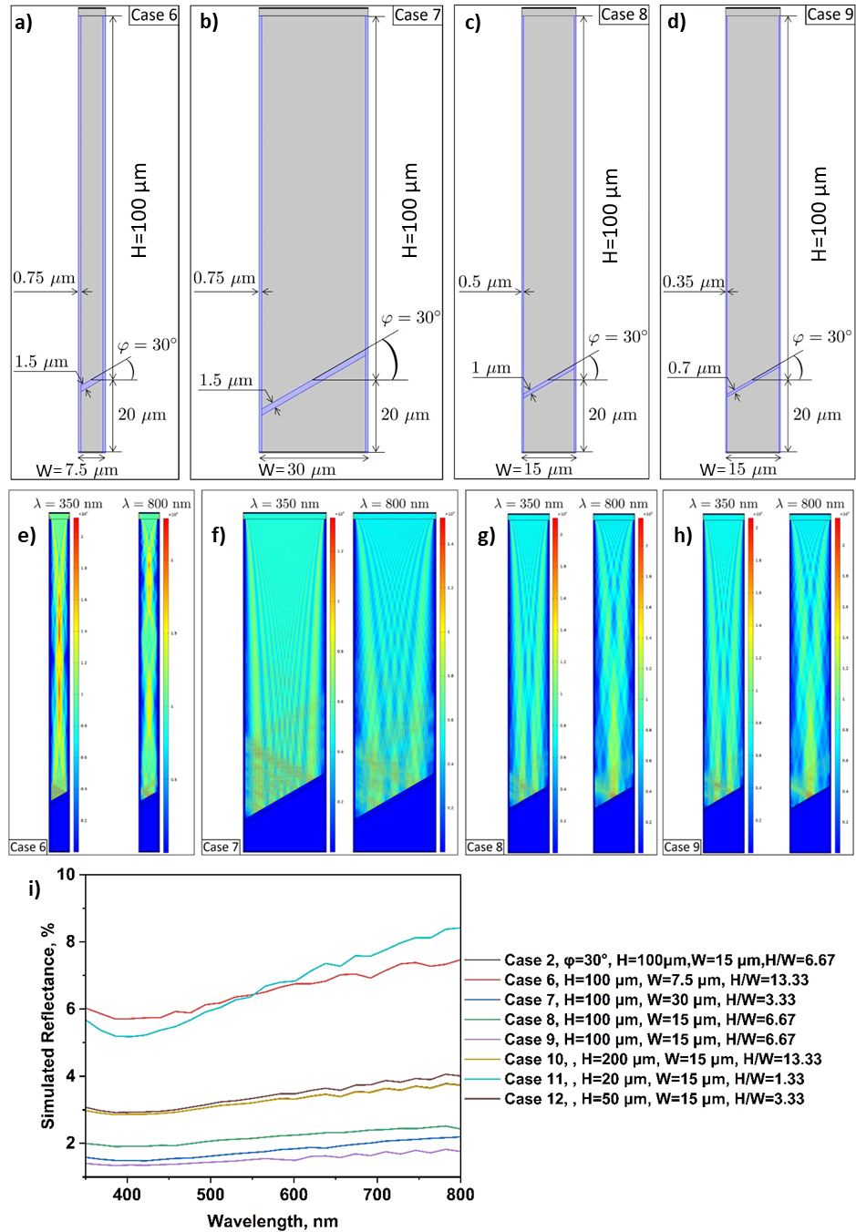
Supplementary Figure 3. FEM simulation setup for Cases 6, 7, 8, and 9. Computational model for a) Case 6, for b) Case 7, for c) Case 8, and for d) Case 9. Distribution of the electric field norm for wavelengths λ=350 nm and λ=800 nm for e) Case 6, for f) Case 7, for g) Case 8, and for h) Case 9. i) Reflectance as a function of wavelength for Cases 6-12 (including Case 2, φ=30°).
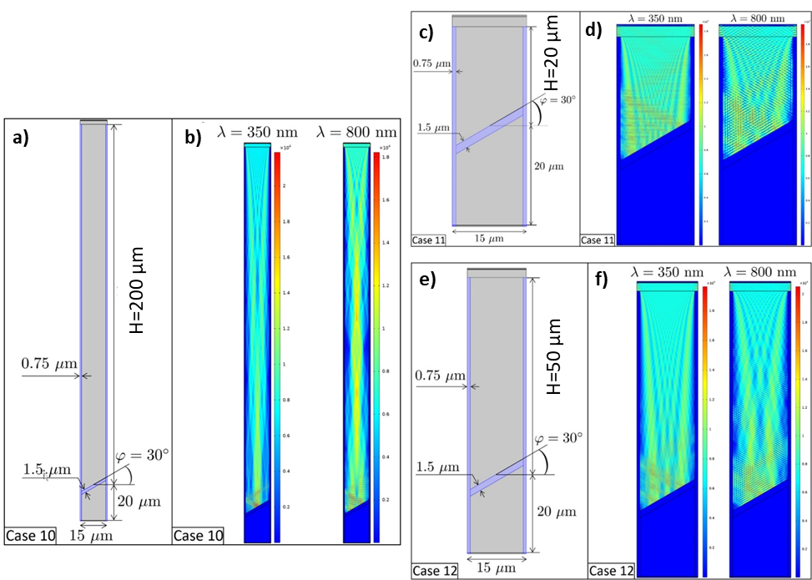
Supplementary Figure 4. FEM simulation setup for Cases 10, 11, and 12. Computational model for a) Case 10, for c) Case 11, and for e) Case 12. Distribution of the electric field norm for wavelengths λ=350 nm and λ=800 nm for b) Case 10, for d) Case 11, and for f) Case 12.

For Cases 10-12, the pillars have height 220 μm, 40 μm, and 70 μm, respectively, and are placed in space with a step of 15 μm. The pillars have width 1.5 μm. The corresponding unit cells are shown in Supplementary Figure 4a, 4c, and 4e. The bottom part (in its horizontal position) is placed 200 μm (for Case 10, H=200 μm, W=15 μm), 20 μm (for Case 11, H=20 μm, W=15 μm), and 50 μm (for Case 12, H=50 μm, W=15 μm) below the pillars top surface and then rotated by 30° around a middle point at the upper surface of the bottom part. For fixed slope of the bottom part, width and spacing between the pillars, Cases 10-12 study the influence of the pillar height (representing fiber length in wood) on the reflective properties. Distribution of the electric field norm for wavelengths λ=350 nm and λ=800 nm is presented in Supplementary Figure 4b for Case 10, in Supplementary Figure 4d for Case 11, and in Supplementary Figure 4f for Case 12. Reflectance as a function of wavelength is plotted in Supplementary Figure 3i (including results for Case 2, φ=30° and Cases 6-9).
For Case 13, the pillars have shape of right trapezoid with top and bottom sides of 0.2 μm and 1.5 μm, respectively. The corresponding unit cells are schematically shown in Supplementary Figure 5a. The height of the trapezoidal pillars is 30 μm between the pillars top surface and the straight rectangular pillars. The total pillars height takes values H=120 μm below the pillars top surface. Width between the pillars takes W=40 μm for Case 13. Distribution of the electric field norm for wavelengths λ=350 nm and λ=800 nm is presented in Supplementary Figure 5c for Case 13. For Case 14, the pillars are straight rectangles with width 1.5 μm. The pillars have height H+20 μm (representing fiber length in wood) and distance between the pillars (representing lumen width in wood) is W. The corresponding unit cells are schematically shown in Supplementary Figure 5b. The bottom part (in its horizontal position) is placed below the pillars top surface by distance H and then rotated by 30° around a middle point at the upper surface of the bottom part. Distance H takes values H=100 μm and H=200 μm for Case 14. Width between the pillars takes W=40 μm and W=60 μm. Distribution of the electric field norm for wavelengths λ=350 nm and λ=800 nm is presented in Supplementary Figure 5d for Case 14 (with H=200 μm and W=60 μm). Reflectance as a function of wavelength is plotted in Supplementary Figure 5e for Case 13 (including Case 14, H=100 μm and W=40 μm) and in Supplementary Figure 5f for Case 14 (including Case 2, φ=30°, Cases 6 and 7).
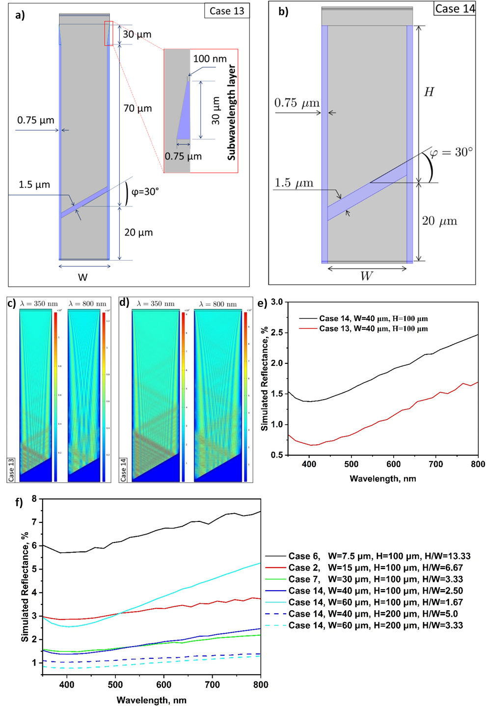
Supplementary Figure 5. FEM simulation setup for Cases 13 and 14. a) Computational model for Case 13. Total pillar height takes values H=120 μm while the height for the trapezoidal parts take value 30 μm. Distance between the pillars at bottom part takes values W=40 μm. b) Computational model for Case 14. Pillar height takes values H=100 μm and H=200 μm. Distance between the pillars takes values W=40 μm and W=60 μm. Distribution of the electric field norm for wavelengths λ=350 nm and λ=800 nm for c) Case 13, for d) Case 14 with H=200 μm and W=60 μm. Reflectance as a function of wavelength for e) Case 13 and for f) Case 14 (including results from Cases 2, 6 and 7, H=100 μm).

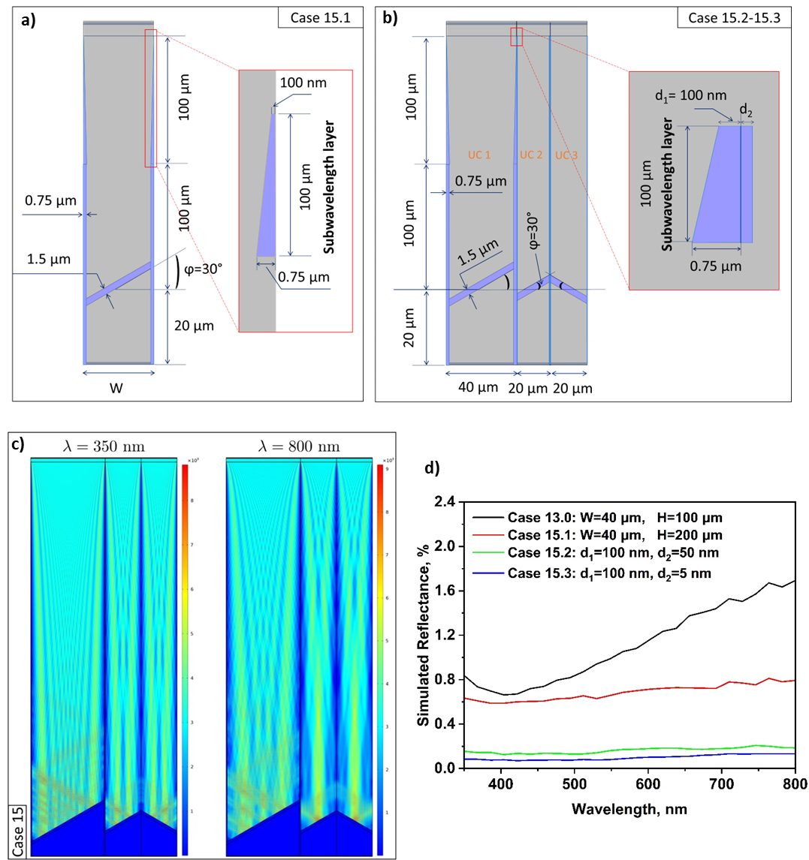

Supplementary Figure 6. FEM simulation setup for Case 15. a-b) Computational model details. c) Distribution of the electric field norm for wavelengths λ=350 nm and λ=800 nm for Case 15.3: d₁=100 nm and d₂=5 nm. d) Reflectance as a function of wavelength.
For Case 15.1, the cylinder array has trapezoidal pillars with top and bottom sides of 0.2 μm and 1.5 μm, respectively. The height of the trapezoidal pillars between the topmost surface and the straight rectangular pillars is 100 μm as schematically shown in Supplementary Figure 6a. The total pillar height takes values H=220 μm below the pillars top surface. The bottom part (in its horizontal position) is placed 200 μm below the pillars top surface and then rotated by 30° around a middle point at the upper surface of the bottom part. Width between the pillars takes W=40 μm. For Cases 15.2 and 15.3, the computational model combines three-unit cells as schematically shown in Supplementary Figure 6b. Unit cell UC 1 represents a cylinder array of the trapezoidal pillars with the bottom side of 1.5 μm. The top side has width 2 d₁ where d₁ takes value d₁=100 nm and the height of the trapezoidal pillars is 100 μm, which corresponds to unit cell in Case 15.1. Unit cells UC 2 and UC 3 represent a regular array of straight rectangular pillars with width 2 d₂ where d₂ takes values d₂=50 nm and d₂=5 nm for Cases 15.2 and 15.3, respectively. The pillars have height 220 μm and distance between the pillars is 40 μm for UC 1 and 20 μm for both UC 2 and UC 3. The bottom part (in its horizontal position) is placed 200 μm below the pillars top surface and then rotated by 30° (in UC 1 and UC 2) and by -30° (in UC 3) around a middle point at the upper surface of the bottom part. Distribution of the electric field norm for wavelengths λ=350 nm and λ=800 nm is presented in Supplementary Figure 6c for Case 15.3: d₁=100 nm and d₂=5 nm. Reflectance as a function of wavelength is plotted in Supplementary Figure 6d (including results for Case 13).
The studies demonstrate that the light reflectance decreases when the cell end tilts at larger angles (up to 30º) (Fig. 2f-2g and Case 2 shown in Supplementary Figure 2e). The studies conclude that light reflectance positively correlates with cell wall thickness (Fig. 2h and Cases 1, 2, 3, 8, and 9 shown in Supplementary Figure 2e and 3i). The studies demonstrate that larger lumen width also favors the overall light trapping and lowers the light reflectance (Fig. 2i and Cases 2, 6, and 7 shown in Supplementary Figure 5f). It is also noted that nanolevel sharp edges showing low backscattering^{4, 5} and large openings of tens microns^{5, 6, 7} are also desirable for reaching supreme-black level. The studies indicate that a fiber length of 50 µm is enough to inhibit light escaping from the cylindrical arrays with a lumen width of 15 μm (Cases 2, 10, 11, and 12 shown in Supplementary Figure 3i and 4). However, with a larger lumen, e.g., width of 40 μm, light confinement fails in cylindrical arrays with a fiber length of 100 µm (Case 14 shown in Supplementary Figure 5). With enlarged fiber length of 200 µm, cylindrical arrays with lumens width of 40 μm and 60 μm display efficient light trapping property. Therefore, the aspect ratio (H/W) of fiber length to lumen width is essential to induce effective multiple internal light reflections (MILR) for cylindrical arrays. It is concluded that the aspect ratio (H/W) should be > 5 to confine the incident light in cylindrical arrays and to induce effective MILR (Supplementary Figure 3i and Supplementary Figure 5f). In balsa wood, the aspect ratio (H/W) of fiber length to lumen width could be up to ~20 considering the maximum fiber length of 800 μm^{8, 9}, which favors effective MILR. Microcavity of high aspect ratios is essential to reach the blackness level for supreme-black^{4, 5, 7} and nickel-phosphorus (Ni-P) superblack¹⁰, which requires heavy etching steps in the fabrication process. As-grown VANTA with inter CNT distance of tens of nm do not favor MILR^{11, 12, 13}. Plasma treatment of as-grown CNT forest induces aggregate of CNT and creating microcavity between CNT clusters, which facilitates MILR and reduce the light reflectance from 450 to 94 ppm^{14, 15}. Effective MILR plays a crucial role but requires heavy etching steps^{5, 16} and plasma treatment¹⁵ in many superblack materials, which is enabled by the intrinsic cellular structure in superblack wood.
Combined with Case 14, the studies in Case 13 verify the contribution of 30 μm high trapezoidal pillars, corresponding to bandsaw-like microarrays in NW carbon, to light reflectance as shown in Fig. 3i and Supplementary Figure 5e. Combined with Case 13, the studies in Cases 15 verify the contribution of 100 μm high trapezoidal pillars, corresponding to microfiber arrays with interfiber porosity in superblack wood, to light reflectance as shown in Fig. 4j and Supplementary Figure 6d.
The simulation results have verified the contribution of wood anatomical elements to the light reflectance. In addition, simulation also demonstrates the contribution of the new subwavelength structures to the light absorption in both NW carbon and superblack wood. However, wood structure is heterogeneous in nature and their dimension and geometry vary with their ages and density. It is hard to find out of a set of geometric parameters that perfectly represents wood. For instance, fiber length is essential factor determining the light absorption property in cylinder arrays. However, it is hard to estimate the average fiber length for wood blocks which may vary from zero to the maximum length of 800 μm due to the heterogenous distribution of fibers along the grain. In addition, ray cells having fiber length of <30 µm, which usually shows failed MILR, is also not considered in the simulation setups. The idealized simulation setups are much simpler than the complex and heterogeneous subwavelength structures in superblack wood. Therefore, the minimum reflectance value of 0.08 % in the simulation is much lower than the minimum light reflectance of 0.4 % for superblack wood in the experiments.

Supplementary Section 2. Supplementary Figures and related supplementary discussions.

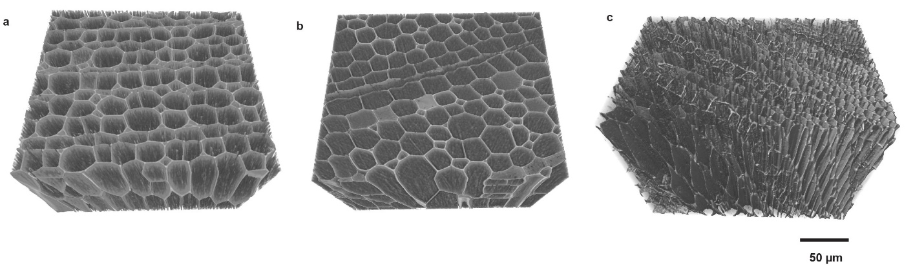
Supplementary Figure 7 Microtomography images of: (a) Wood (W), (b) Delignified wood (DW), (c) Delignified wood that are carbonized at 1500 ºC (cDW).

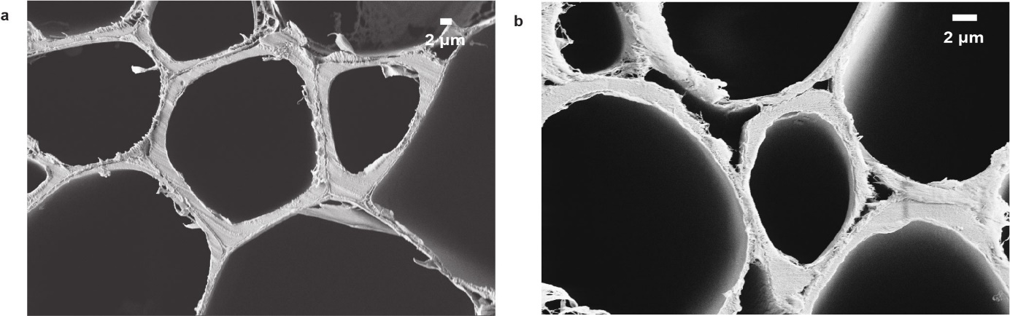
Supplementary Figure 8. SEM image showing the morphology of cell walls in (a) wood (W) and (b) delignified wood (DW).

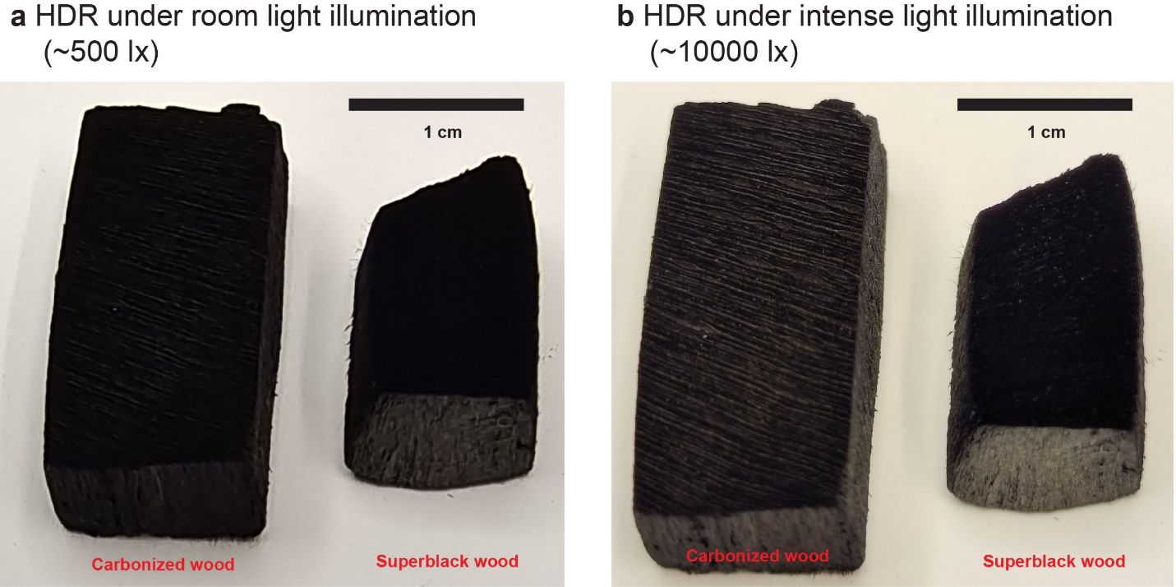
Supplementary Figure 9. Carbonized wood (cW), and Superblack wood photographed under (a) room light illumination (~500 lx) and (b) intense light illumination (~10000 lx) in high dynamic range (HDR).

Dynamic range is a measure of the light intensities from the highlights to the shadows. High dynamic range (HDR) whose synonyms are wide dynamic range is a dynamic range higher than standard dynamic range (SDR). In HDR mode, more surface features from low-reflectance samples (e.g., Superblack) can be captured, which otherwise appear pure black. Human eyes, image sensors, display devices and printed media have typical dynamic ranges of 5, 4, 3 and 2 orders of magnitude, respectively. The higher dynamic range the camera has, the closer the photos will compare to what human eyes can see. Although the light strips on cW can be observed by human eyes, the camera cannot capture them. The light stripes are hardly spotted when cW is photographed under room light illumination (~500 lx) (Supplementary Figure 9a). To capture more details, cW and Superblack wood are photographed under intense light illumination (~10000 lx) in HDR mode (Supplementary Figure 9b). The light stripes on cW become clearly visible under intense light illumination (~10000 lx). The light stripes on cW result from the carbonized ray cells in the form of flat structures with the order of tens of microns in width (Fig. 2b shown in green color and Fig. 3c). However, these light strips disappeared in Superblack wood, and cross section appear as pure black surface even under intense light illumination (~10000 lx) (Supplementary Figure 9b). In cDW, the ray cells shrunk significantly and were converted into ca. 1 µm-wide thin bands (Fig. 4d-4e, shown in green color), which explain well the disappearance of the light strips in superblack wood.

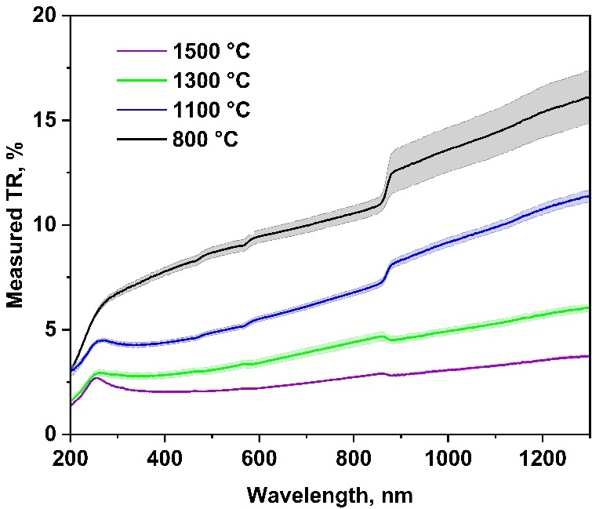
Supplementary Figure 10. Total light reflectance (TR) of radial section in wood carbon (cW) obtained at 800-1500 ºC.

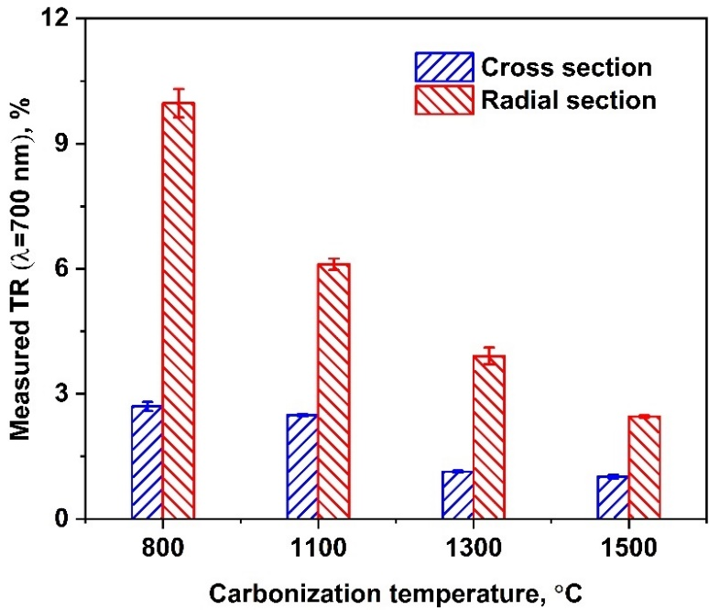
Supplementary Figure 11. Total light reflectance (TR) at 700 nm of cross section and radial section in wood carbon that were obtained at 800-1500 ºC (cW).

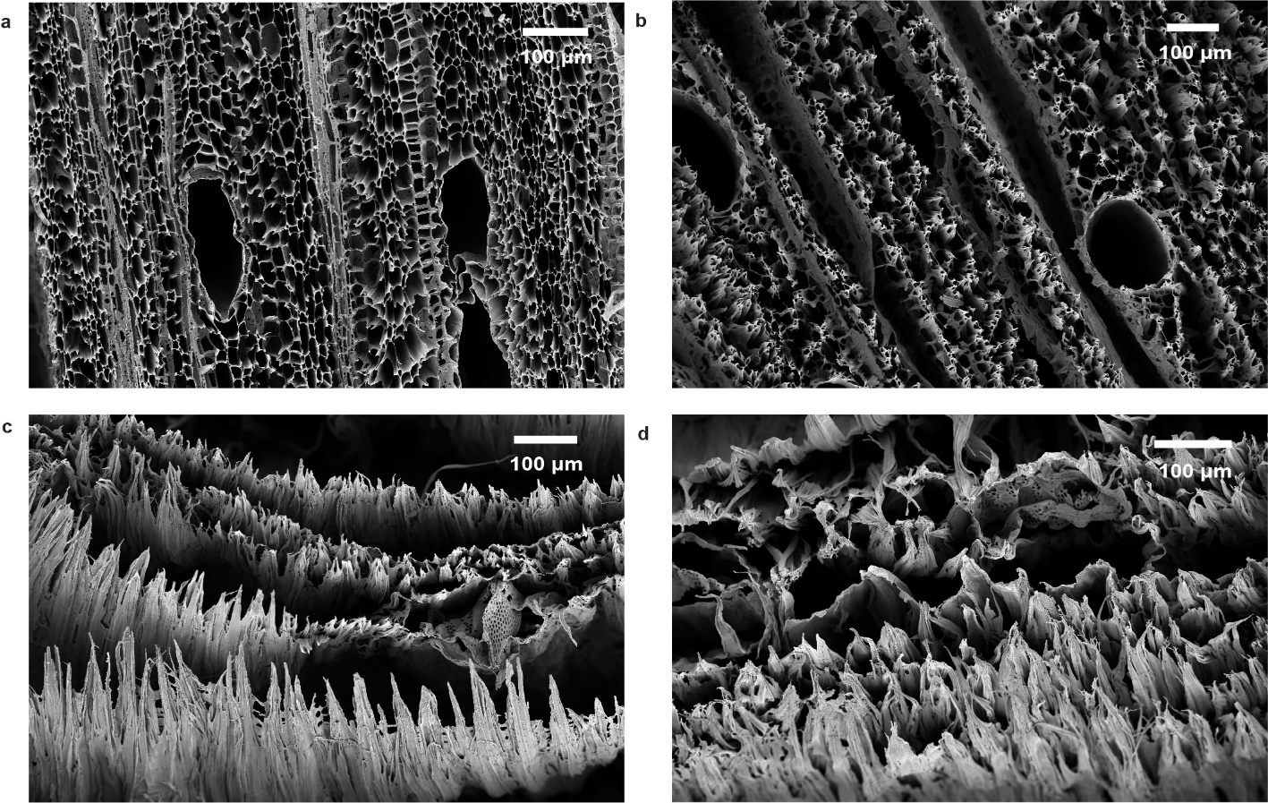
Supplementary Figure 12. SEM images showing the cross-section morphology of wood carbon (cW) that were obtained at 1500 ºC. The delignification time: (a) 0 h, (b) 1 h, (c) 2 h, (d) 3 h.

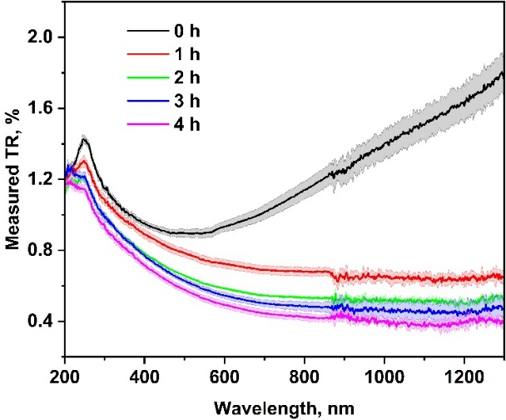
Supplementary Figure 13. Total light reflectance (TR) of cross section in cDW that were obtained at 1500 ºC. Wood was delignified with time varied from 0 to 4h.

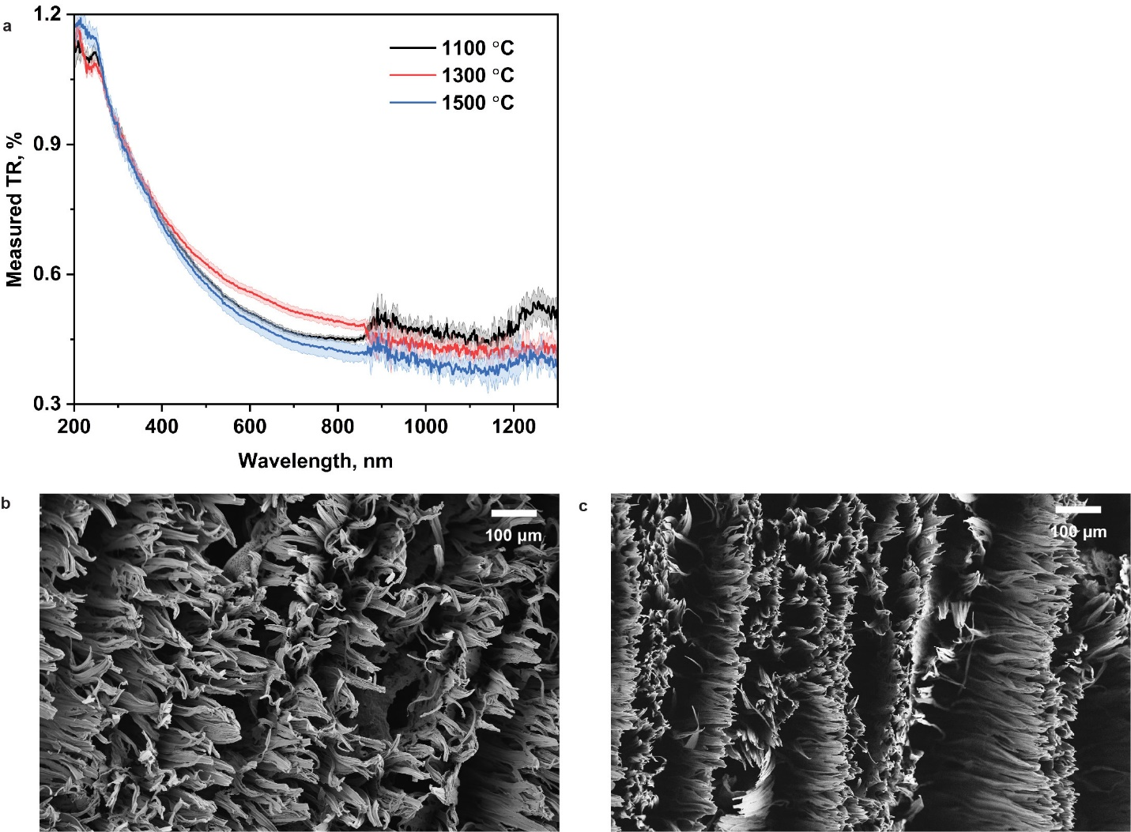
Supplementary Figure 14. (a) Total light reflectance (TR) of cross section in delignified wood that carbonized at 1100-1500 ºC, cDW. (b) SEM image showing curved and deformed carbon microfiber arrays in cDW obtained at 1100 ºC. (c) SEM image showing vertically aligned carbon microfiber arrays in cDW obtained at 1300 ºC.

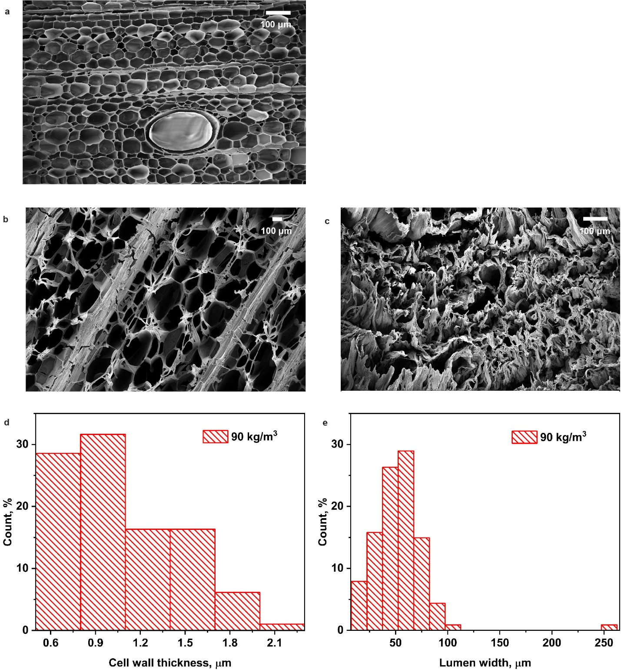
Supplementary Figure 15. Top-view SEM images showing the cross-section morphology of wood (W) (a), cW (b) and cDW (c). Both cW and cDW were obtained at 1500 ºC. The distribution of cell wall thickness (d) and lumen width (e) in balsa wood (W) with a density of 90 kg/m³.

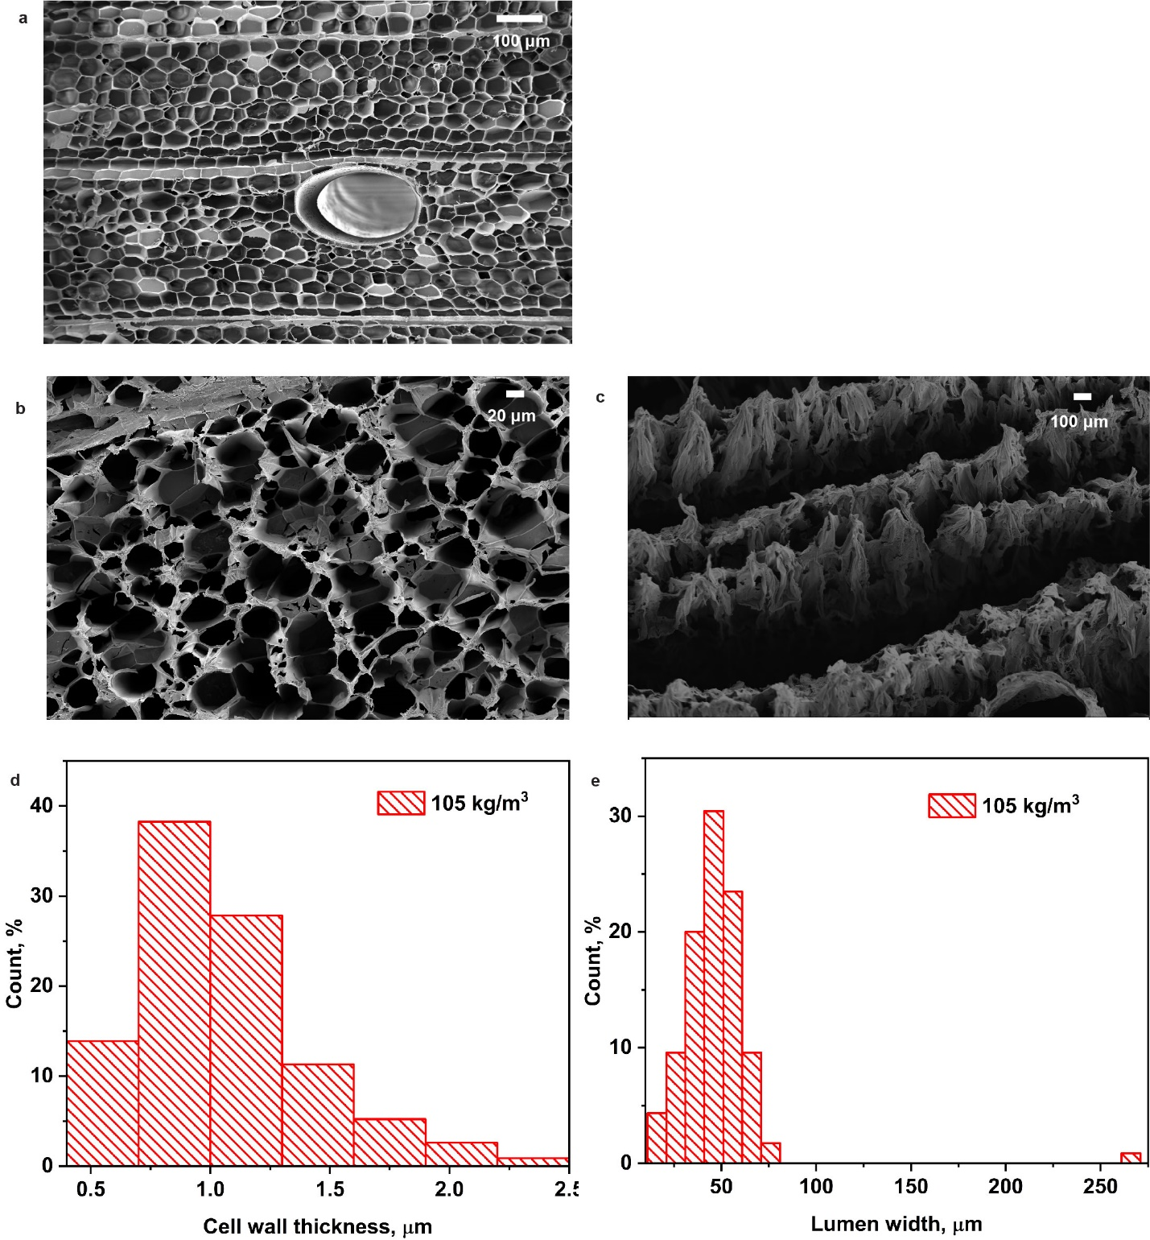
Supplementary Figure 16. Top-view SEM images showing the cross-section morphology of wood (W) (a), cW (b) and cDW (c). Both cW and cDW were obtained at 1500 ºC. The distribution of cell wall thickness (d) and lumen width (e) in balsa wood (W) with a density of 105 kg/m³.

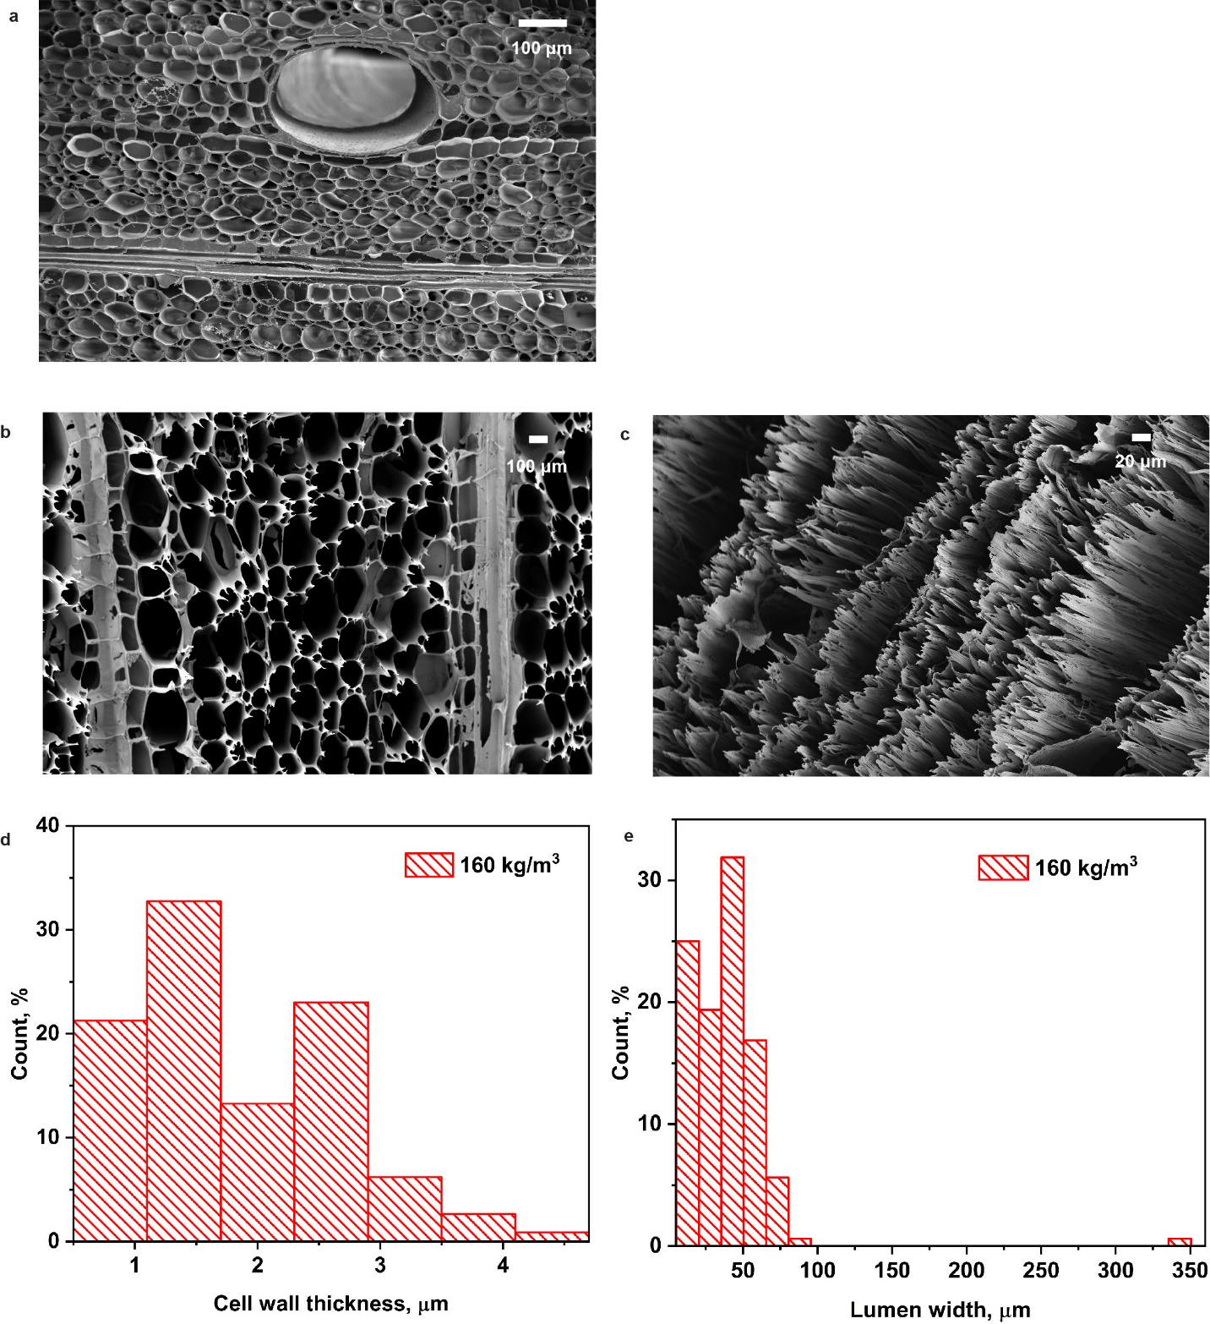
Supplementary Figure 17. Top-view SEM images showing the cross-section morphology of wood (W) (a), cW (b) and cDW (c). Both cW and cDW were obtained at 1500 ºC. The distribution of cell wall thickness (d) and lumen width (e) in balsa wood (W) with a density of 160 kg/m³.

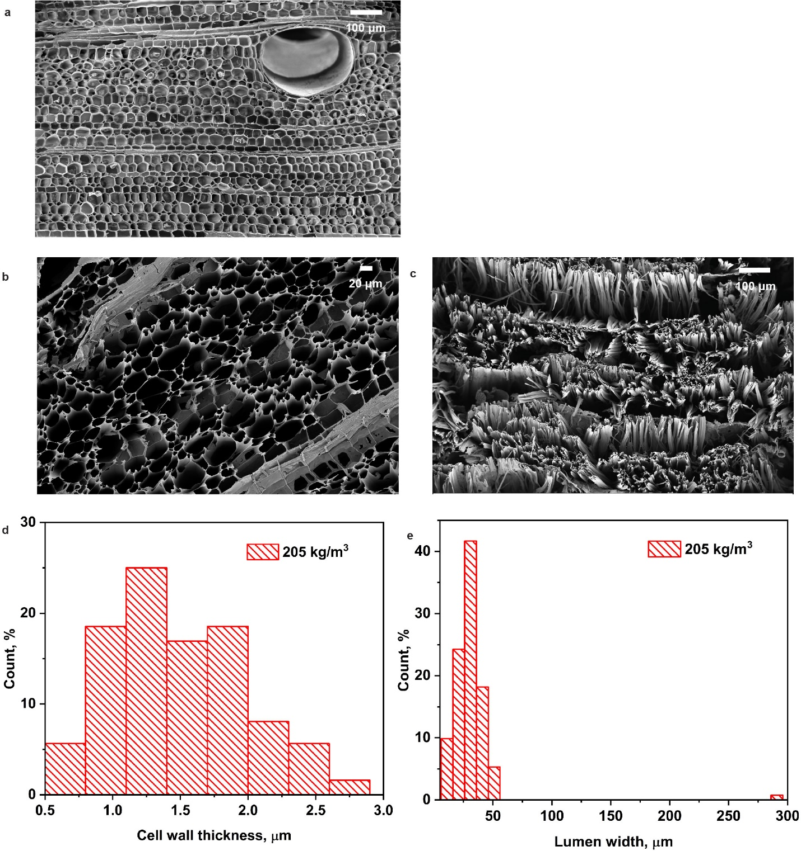
Supplementary Figure 18. Top-view SEM images showing the cross-section morphology of wood (W) (a), cW (b) and cDW (c). Both cW and cDW were obtained at 1500 ºC. The distribution of cell wall thickness (d) and lumen width (e) in balsa wood (W) with a density of 205 kg/m³.
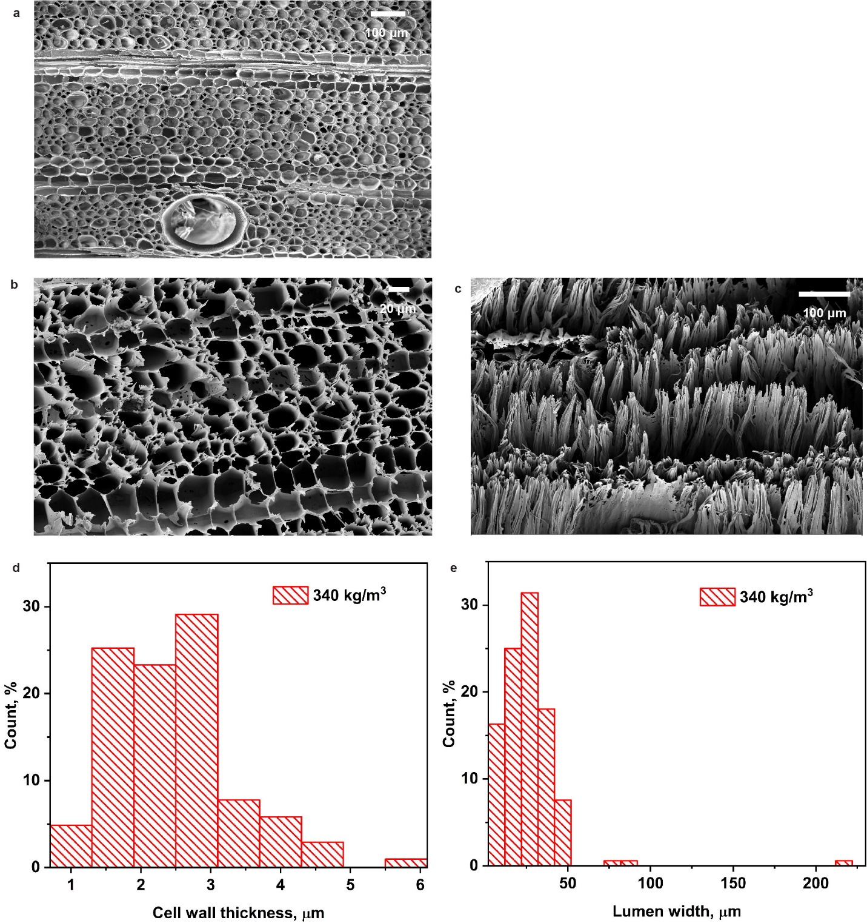
Supplementary Figure 19. Top-view SEM images showing the cross-section morphology of wood (W) (a), cW (b) and cDW (c). Both cW and cDW were obtained at 1500 ºC. The distribution of cell wall thickness (d) and lumen width (e) in balsa wood (W) with a density of 340 kg/m³.

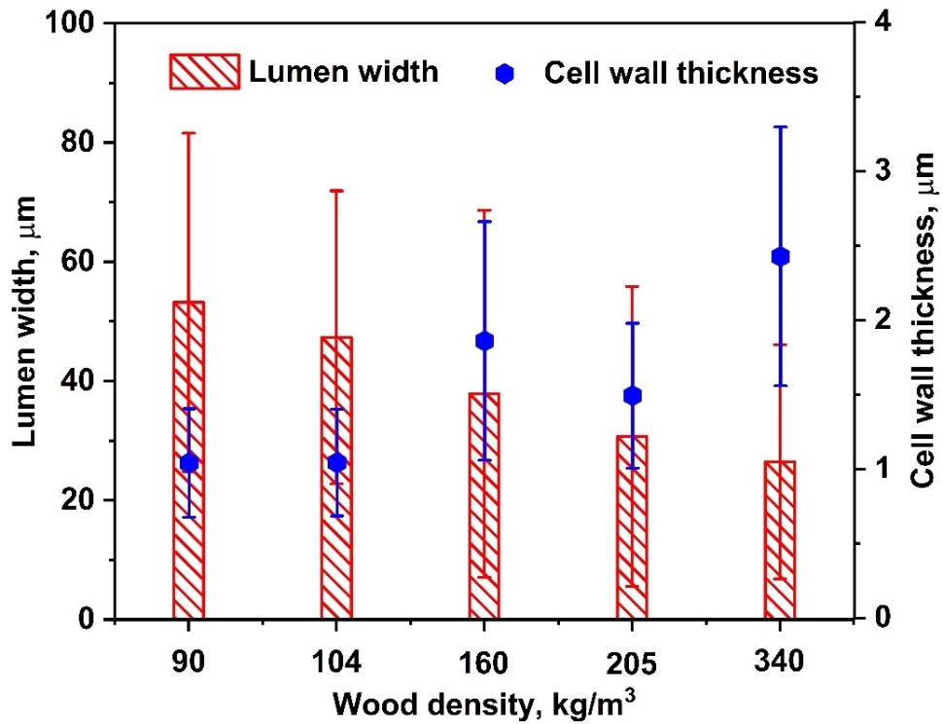
Supplementary Figure 20. The average lumen width and cell wall thickness of balsa wood with density spanning 90-340 kg/m³.

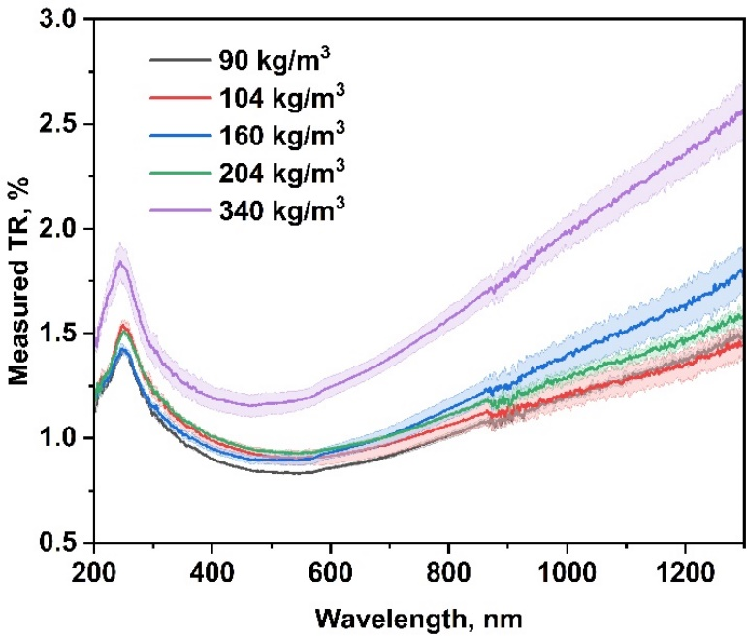
Supplementary Figure 21. Total light reflectance (TR) of cross section in cW obtained at 1500 ºC. The wood density spanning 90-340 kg/m³.

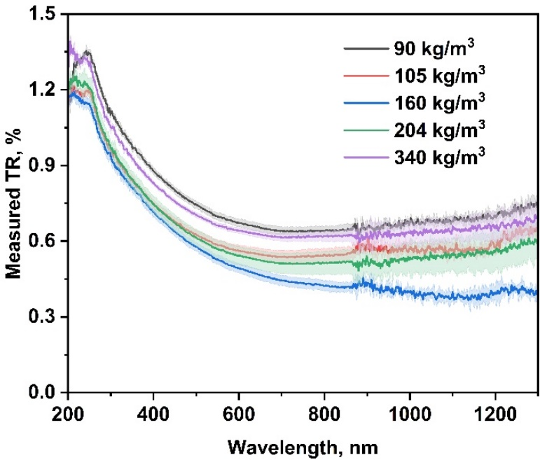
Supplementary Figure 22. Total light reflectance (TR) of cross section in cDW obtained at 1500 ºC. The wood density spanning 90-340 kg/m³.

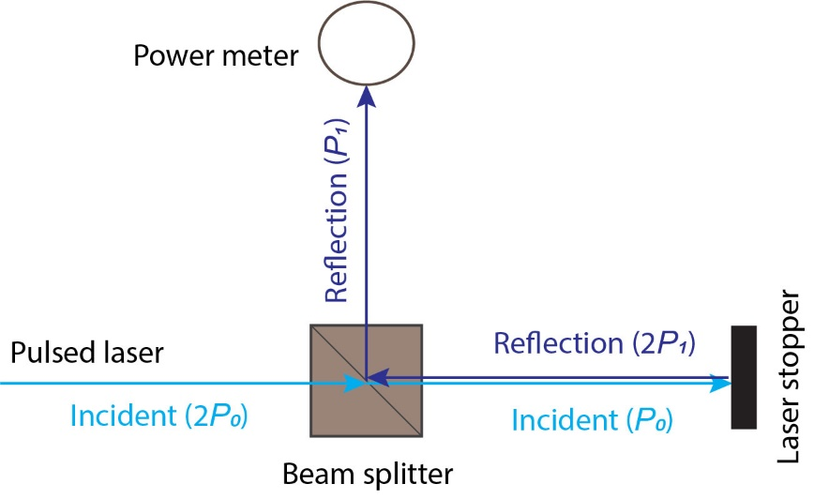
Supplementary Figure 23. A sketch of the setup used for reflectivity measurement of laser stopper.
Laser power (P₀) of both 50 mW and 100 mW (measured by power meter) illuminated laser stopper (Supplementary Figure 26) and power of reflected laser (P₁) are collected (Supplementary Table 1). The reflectivity (R₁) of the beam stopper was calculated by using Eq. 1.
$R_{1}=\frac{2P_{1}}{P_{0}}×100 \%$ (1)
P₀ is the power of laser beam illuminating the laser stopper; 2P₁ is the power of laser reflected by the laser stopper; P₁ is the power of laser that reached the power meter through the beam splitter; R₁ is the reflectivity of the laser stopper. The power (P₁) of laser reflection from the stopper was measured with five repetitions.

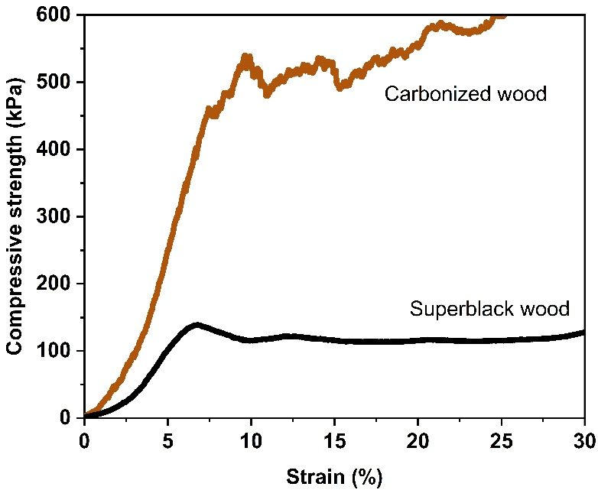
Supplementary Figure 24. Stress-strain curves of carbonized wood (cW) and superblack wood.

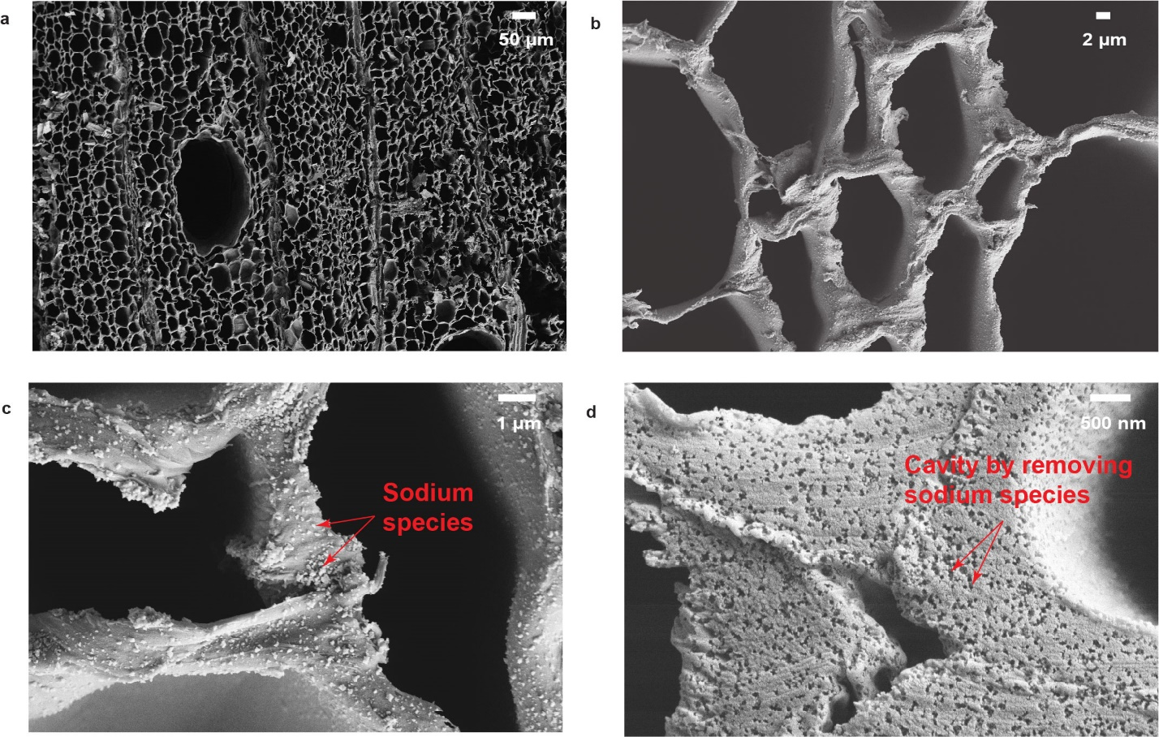

Supplementary Figure 25. SEM images showing the morphology of cross section in cDW obtained at 1500 ºC.

The DW were prepared by using NaClO₂ solution and acetic acid with 6h delignification. (a-c) As prepared cDW. (d) cDW was further washed with 1 M HCl solution at 25 ºC overnight. The cavity was believed to be created by removing sodium species during the acid wash.

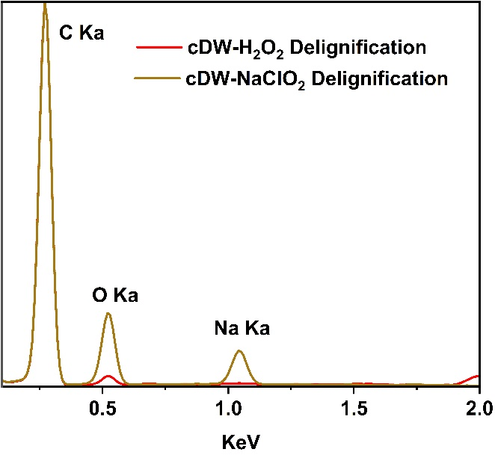
Supplementary Figure 26. Energy dispersive X-ray spectroscopy (EDS) spectra of cDW. The delignified wood (DW) was prepared using H₂O₂:CH₃COOH solution and NaClO₂ solution, respectively.

The EDS spectra clearly shows the presence of sodium species in cDW obtained from DW prepared from NaClO₂ solution, which is not the case for cDW obtained from DW that are prepared from metal-free delignification method (H₂O₂:CH₃COOH solution). The sodium species in NaClO₂ solution reside in the delignified wood matrix and account for 30 wt. % of mass fractions in the dried DW even after extended washing, which is measured gravimetrically. Note: in cDW (obtained from NaClO₂ delignification), high fraction of O species also come along with sodium species whose reduced form typically react with oxygen and water in air.
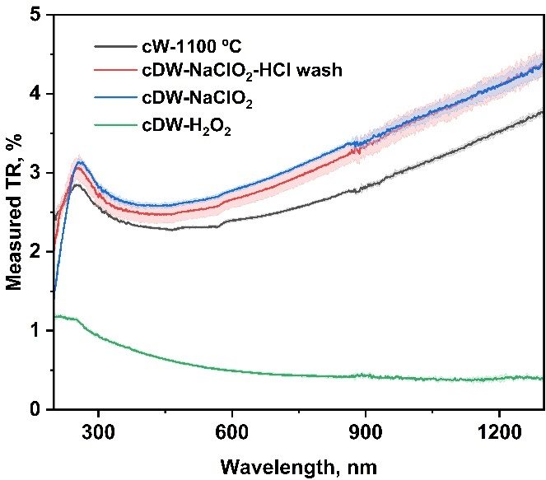
Supplementary Figure 27. Total light reflectance (TR) of cross section in cNW obtained at 1100 ºC (black line) and in cDW obtained at 1500 ºC (red, blue, and green lines). The delignified wood (DW) were prepared with different treatments: The DW were prepared by using NaClO₂ solution and acetic acid with 6h delignification (bule and red lines). cDW was further washed with 1 M HCl solution at 25 ºC overnight (red line). The DW were prepared by using H₂O₂ solution and acetic acid with 4h delignification (green line).

Supplementary Section 3. Supplementary Tables and associated supplementary discussions.

Supplementary Table 1. Measured reflection for laser stopper.
 | Superblack wood |  | Laser block (LB2/M)
P_{0,} mW | Reflected power (P₁), μW | Reflectivity (R₁), % | Reflected power (P₁), μW | Reflectivity (R₁), %
50 | 0.40 ± 0.01 | 0.0016 | 1.71 ± 0.04 | 0.00684
100 | 1.50 ± 0.03 | 0.0030 | 4.19 ± 0.12 | 0.00838

Superblack is commonly achieved with materials of low density or low filling factor (Supplementary Tables 2-5)^{12, 13}, which raises the issue of mechanical robustness for practical use. The durability test (e.g., abrasion and scratching) for superblack materials has rarely been reported^{5, 13, 17}. We evaluate their mechanical structure-property relationships in terms of compressive strength, although superblack materials do not typically act as load-bearing elements. The compressive strength is evaluated by the interplay between their intrinsic mechanical properties (e.g. metal^{18, 19} and carbon^{20, 21}) and the ensemble properties as the filling fraction (Supplementary Tables 2-5), and the structure factor (the spatial organization). While VANTA displays the lowest reported reflectance^{11, 12}, it is a fragile material (1 to 10 kPa compressive strength) (Supplementary Table 2)¹³. Metallic blacks, on the other hand, are mechanically strong but display light reflectance of over 1% (Supplementary Table 4)^{18, 22, 23, 24, 25, 26, 27}. Carbon aerogels make an intermediate case (compressive strength below 100 kPa^{20, 21, 28, 29} (Supplementary Table 3). The anisotropic structure of wood maximizes stiffness and strength at remarkably low density, a result of fibril alignment along the growth direction²⁰. Wood-based carbons show a compressive strength over 1 MPa and light reflectance of 3%, provided that the cells remain intact (Supplementary Table 5)^{30, 31}. Following the deconstruction of the wood structure into microfiber arrays, the superblack wood was still mechanically robust (compressive strength of 140 kPa) while absorbing ~99.64% of the incident light.

Supplementary Table 2. Comparison of total reﬂectance (TR) and transmittance values, CNT array height, volume filling fraction, density, and compressive strength of carbon nanotubes (CNT)-based black materials.
 | Volume filling fraction, f, % | Density, mg/cm³ | Compressive strength, kPa | CNT array height, μm | Transmittance, % | Minimum TR, % | Reference
VANTA BLACK | 3 | 15 | <2 | 800 | 0.001 | 0.045 | ¹¹
VANTA BLACK | 3 | 70 | <3 | 460 | 0.2 | 0.7 | ³²
VANTA BLACK | 2 | 15 | <2 | 162 | \ | 0.1 | ³³
VANTA BLACK | 3 | 20 | <2 | 500 | \ | 0.03 | ³⁴
VANTA BLACK | \ | \ | \ | 44 | \ | 1 | ³⁵
VANTA BLACK | \ | \ | <2 | 2000 | \ | 0.01 | ¹⁴
VANTA BLACK | 5 | 60 | <3 | 280 | 0.6 | 0.16 | ³⁶
Bamboo-like vertical CNT | 14 | 300 | <10 | 100 | \ | 0.35 | ³⁷
Free-form CNT | \ | \ | <10 | 13 | \ | 0.50 | ³⁸

Supplementary Table 3. Comparison of total reﬂectance (TR) values, carbon precursors, density, and compressive strength of carbon-based black materials.
 | Precursor | Density, mg/cm³ | Compressive strength, kPa | Minimum TR, % | Reference
Carbon aerogel | Resorcinol formaldehyde resin | \ | 50 | 0.19 | ³⁹
Carbon aerogel | Resorcinol formaldehyde resin | \ | 50 | 2.5 | ⁴⁰
Carbon aerogel | Resorcinol formaldehyde resin | 60 | <100 | 0.24 | ²⁹
Carbon aerogel | Resorcinol formaldehyde resin | 57 | 40 | 0.19 | ²⁸
Hollow Carbon Nanospheres | Resorcinol formaldehyde resin | \ | 2 | 1.5 | ⁴¹
Hollow Carbon Nanospheres | Resorcinol formaldehyde resin | \ | 2 | 0.10 | ¹⁷
Porous Carbon Spheres | (P-(VDC-co-VC) | \ | 5 | 0.14 | ⁴²
Nanocone nanowire | Graphite | \ | 3 | 0.5 | ⁴³
Carbon nanowall | H₂ and CH₄ | \ | 10 | 0.13 | ⁴⁴

Supplementary Table 4. Comparison of total reﬂectance (TR) values, density, and compressive strength of metallic black materials.
 | Structure | Density, mg/cm³ | Compressive strength, kPa | Minimum TR, % | Reference
Ni-P superblack | Microcrater | 4500 | >1000 | 0.4 | ¹⁶
Nickel black | Nanopyramid | 4500 | >1000 | 5 | ²⁴
Aluminum black | Vertical Microcolumns | >1000 | >10000 | 3.5 | ²⁵
Titanium black | Micro/nanoconical pillar | >2000 | >10000 | 1.8 | ²⁶
Alumina black | Vertical nanoporous  alumina | >500 | >1000 | 1 | ²⁷
Gold black | Superparticles | \ | 10 | 2.3 | ²²
Gold black | Vertical nanotubes | \ | >1000 | <5 | ²³

Supplementary Table 5. Comparison of total reﬂectance (TR) values, density, and compressive strength of wood-based black materials.
Precursor | Structure | Density, mg/cm³ | Compressive strength, kPa | Minimum TR, % | Reference
Cocobolo | Preserved cell wall | 1118 | 3000 | 4 | ³⁰
Poplar | Preserved cell wall | 518 | 2200 | 8 | ³⁰
Balsa | Preserved cell wall | 180 | 1500 | 3 | ³¹
Basswood | Preserved cell wall | 557 | 2400 | 2 | ⁴⁵
Basswood | Coupled with Plasmonic particles | 560 | 2400 | 1 | ⁴⁶
Balsa | Bandsaw-like microarrays | 90 | 1200 | 0.83 | This work
Delignified Balsa | Microfiber arrays | 50 | 400 | 0.36 | This work
Superblack wood fabrication from balsa wood of the dimensions 40×10×17 mm (radial ×longitudinal × tangential) was used to estimate the overall cost. In general, 30 pieces of balsa wood were delignified in 2 L solution of equal-volume mixture of H₂O₂ solution and acetic acid.
Four pieces of delignified wood (DW) samples as one batch were carbonized in the tube furnace.
Superblack wood of the dimensions 22 × 7 × 10.5 mm³ (radial × longitudinal × tangential) were obtained by Di-ionized (DI) water washing and oven drying. The DI water consumption and energy consumption for oven drying was not included in the cost estimation. The total cost of materials and energy consumption in delignification, freeze-drying, and carbonization process is shown in Supplementary Tables 6 and 7. The average cost for superblack wood fabrication was estimated to be 3.72 €/cm². Average cost for other black materials is also shown in Supplementary Table 8.

Supplementary Table 6. Reagent cost in delignification process and carbonization process for superblack wood fabrication. The cost was given based on processing 4 pieces of wood samples.
 | H₂O₂ solution (35 wt. %), €/L | Glacial Acetic acid, €/L | Balsa wood price, €/mm³ | N₂ gas, €/bottle
Price | 11.12 | 42.2 | 6.76×10⁻⁶ | 37.64
Cost for materials consumption, € | 1.48 | 5.63 | 0.18 | 7.53

Supplementary Table 7. Cost of energy consumption in delignification, freeze drying, carbonization process for superblack wood fabrication. The cost was given based on processing 4 pieces of wood samples.
 | Heating plate for delignification | Freeze drying device | Furnace for carbonization | Cooling unit for furnace
Maxi electric power, kW | 0.65 | 7.69 | 5.4 | 2.4
Cost of energy consumption, € | 0.086 | 4.71 | 5.3 | 9.41
Total cost for materials and energy consumption, € | 34.34
Average cost for superblack wood, €/cm² | 3.72

Supplementary Table 8. Average cost for superblack wood, Ni-P superblack, VANTA black and carbon-based black materials.
 | Superblack wood | Ni-P superblack¹ | VANTA black² | Carbon-based black³
Average cost, €/cm² | 3.72 | 93.50 | 1280 | 83
1. Cost estimated based on the price of Ni-P plating provided by American Elements.
2. Cost estimated based on the price of vertically aligned carbon nanotube arrays on Si substrate provided on Sigma Aldrich in Finland.
3. Cost estimated based on the price of carbon aerogels provided on buyaerogel.com.
Flammable gases, e.g., H₂, C₂H₄ and C₂H₂, are commonly used in the chemical vapor deposition (CVD) process for the synthesis of vertical carbon nanotube (CNT). Corrosive acid, e.g., HF and HNO₃ solution, is required for peeling off the CNT coatings from the substrates. Human skin exposure to CNT coatings including the residual catalysts is also highly risky to health^{12, 13}. Therefore, the overall rating of hazards for VANTA black system is very high. Ni-P superblack is manufactured by using the oxidizing acid, e.g., HNO₃ and H₂SO₄, to etch the Ni-P electroless plating. The Ni-P plating was prepared by Ni-P deposition to obtain multilayers of Ni-P with different phosphorus content^{16, 47}. The overall rating of hazards for Ni-P superblack fabrication is medium. Carbon-based black is mostly derived from pyrolysis of resorcinol-formaldehyde (RF) aerogels^{28, 29, 39, 40}. Formaldehyde is a highly toxic systemic poison, which may cause dizziness or suffocation due to the severe respiratory tract and skin irritant⁴⁸. Pyrolysis of RF aerogels in inert gas, e.g., N₂, is relatively safe. For superblack wood fabrication, high temperature carbonization of biomass, e.g., wood samples, is a common process in carbon production industry. The bleaching method in this work is widely used in the paper and pulping industry⁴⁹. Superblack wood were obtained by Di-ionized (DI) water washing and oven drying of the carbonized delignified wood. The overall rating of hazards for superblack wood production is low.

Supplementary Table 9. Comparison of the safety of superblack wood, Ni-P superblack, VANTA black and carbon-based black materials.
 | VANTA black | Ni-P superblack | Carbon-based black | Superblack wood
Reagent toxicity | High | Medium | High | Low
Risk in Processing | High | Medium | Medium | Medium
Human exposure risk | High | Low | Medium | Low
Overall rating of Hazards | Very high | Medium | Medium | Low

In VANTA black and carbon-based black fabrication, fine chemicals that are used as carbon sources were low-sustainability materials. Both CNT synthesis steps including chemical vapor deposition (CVD) and CNT transferring by HF solution etching steps are low sustainable process. Routine use of VANTA black also bring environmental issue due to their toxicity¹³. Fabrication of VANTA black clearly is a low-sustainability process. In metallic black materials, metal, e.g., is a low-sustainability materials because mining process typically causes high CO₂ emission and environmental impact⁵⁰. In addition, the complex steps in both the nickel-phosphorus (Ni-P) plating and subsequent surface etching process worsen the sustainability of Ni-P superblack fabrication process^{16, 47}. Ni-P superblack may face challenge for surface coating application due to its high density and lower their sustainability. Wood is the most sustainable material in nature, with low carbon footprint³⁰. The facile fabrication of superblack wood only involve the mild delignification process and the common carbonization process, which is considered as medium sustainability. The ash removal process from wood carbon by DI water washing show low environmental impact. For carbon aerogel black, extra step is required to first synthesize the resorcinol-formaldehyde (RF) aerogels as precursor, which lower their process sustainability. The overall rating of sustainability for different black materials are shown in Supplementary Table 10.

Supplementary Table 10. Comparison of sustainability for superblack wood, Ni-P superblack, VANTA black and carbon-based black materials.
 | Ni-P superblack | VANTA black | Carbon-based black materials | Superblack wood
Precursor | Low | Low | Low | High
Pretreatment | Medium | Medium | Medium | Medium
Synthesis | Medium | Low | Medium | Medium
Post treatment | Medium | Low | Medium | High
Overall | Medium | Low | Medium | High

REFERENCES AND NOTES

1. COMSOL 5.3: Wave Optics Module Model Application Manual). https://doc.comsol.com/5.3/doc/com.comsol.help.woptics/WaveOpticsApplicationLibraryManual.pdf.
2. Taft EA, Philipp HR. Optical Properties of Graphite. Physical Review 138, A197-A202 (1965).
3. COMSOL Blog: How to Model the Optical Properties of Rough Surfaces) (2017).
4. Amemiya K, Koshikawa H, Imbe M, Yamaki T, Shitomi H. Perfect blackbody sheets from nano-precision microtextured elastomers for light and thermal radiation management. Journal of Materials Chemistry C 7, 5418-5425 (2019).
5. Amemiya K, Shimizu Y, Koshikawa H, Shitomi H, Yamaki T. Supreme-black levels enabled by touchproof microcavity surface texture on anti-backscatter matrix. Science Advances 9, eade4853 (2023).
6. Deinega A, Valuev I, Potapkin B, Lozovik Y. Minimizing light reflection from dielectric textured surfaces. J Opt Soc Am A 28, 770-777 (2011).
7. Amemiya K, et al. Fabrication of hard-coated optical absorbers with microstructured surfaces using etched ion tracks: Toward broadband ultra-low reflectance. Nuclear Instruments and Methods in Physics Research Section B 356-357, 154-159 (2015).
8. Borrega M, Ahvenainen P, Serimaa R, Gibson L. Composition and structure of balsa (Ochroma pyramidale) wood. Wood Science and Technology 49, 403-420 (2015).
9. Borrega M, Gibson LJ. Mechanics of balsa (Ochroma pyramidale) wood. Mechanics of Materials 84, 75-90 (2015).
10. Amemiya K, Fukuda D, Numata T, Tanabe M, Ichino Y. Comprehensive characterization of broadband ultralow reflectance of a porous nickel–phosphorus black surface by numerical simulation. Appl Opt 51, 6917-6925 (2012).
11. Yang Z-P, Ci L, Bur J, Lin SH, Ajayan P. Experimental Observation of an Extremely Dark Material Made By a Low-Density Nanotube Array. Nano letters 8, 446-451 (2008).
12. Wood BD, Dyer JS, Thurgood VA, Tomlin NA, Lehman JH, Shen T-C. Optical reflection and absorption of carbon nanotube forest films on substrates. Journal of Applied Physics 118, 013106 (2015).
13. Lehman J, Yung C, Tomlin N, Conklin D, Stephens M. Carbon nanotube-based black coatings. Applied Physics Reviews 5, 011103 (2018).
14. Tomlin NA, Curtin AE, White M, Lehman JH. Decrease in reflectance of vertically-aligned carbon nanotubes after oxygen plasma treatment. Carbon 74, 329-332 (2014).
15. Yung CS, et al. Plasma modification of vertically aligned carbon nanotubes: Superhydrophobic surfaces with ultra-low reflectance. Carbon 127, 195-201 (2018).
16. Brown RJC, Brewer PJ, Milton MJT. The physical and chemical properties of electroless nickel–phosphorus alloys and low reflectance nickel–phosphorus black surfaces. Journal of Materials Chemistry 12, 2749-2754 (2002).
17. Guo J, et al. Carbon Vesicles: A Symmetry-Breaking Strategy for Wide-Band and Solvent-Processable Ultrablack Coating Materials. Advanced Functional Materials 30, 1909877 (2020).
18. Schaedler TA, et al. Ultralight Metallic Microlattices. Science 334, 962-965 (2011).
19. Meza LR, Das S, Greer JR. Strong, lightweight, and recoverable three-dimensional ceramic nanolattices. Science 345, 1322-1326 (2014).
20. Pekala RW, Alviso CT, LeMay JD. Organic aerogels: microstructural dependence of mechanical properties in compression. Journal of Non-Crystalline Solids 125, 67-75 (1990).
21. Hu B-C, et al. Robust Carbonaceous Nanofiber Aerogels from All Biomass Precursors. Advanced Functional Materials 33, 2207532 (2023).
22. Kwon N, et al. Direct Chemical Synthesis of Plasmonic Black Colloidal Gold Superparticles with Broadband Absorption Properties. Nano Letters 18, 5927-5932 (2018).
23. Ng C, Yap LW, Roberts A, Cheng W, Gómez DE. Black Gold: Broadband, High Absorption of Visible Light for Photochemical Systems. Advanced Functional Materials 27, 1604080 (2017).
24. Li P, et al. Large-Scale Nanophotonic Solar Selective Absorbers for High-Efficiency Solar Thermal Energy Conversion. Advanced Materials 27, 4585-4591 (2015).
25. Tao H, et al. Formation of strong light-trapping nano- and microscale structures on a spherical metal surface by femtosecond laser filament. Applied Physics Letters 100, 201111 (2012).
26. Iyengar VV, Nayak BK, Gupta MC. Ultralow reflectance metal surfaces by ultrafast laser texturing. Appl Opt 49, 5983-5988 (2010).
27. Zhou L, et al. Self-assembly of highly efficient, broadband plasmonic absorbers for solar steam generation. Science Advances 2, e1501227 (2016).
28. Sun W, et al. Super Black Material from Low-Density Carbon Aerogels with Subwavelength Structures. ACS Nano 10, 9123-9128 (2016).
29. Zhu J, Yang X, Fu Z, Wang C, Wu W, Zhang L. Facile fabrication of ultra-low density, high-surface-area, broadband antireflective carbon aerogels as ultra-black materials. Journal of Porous Materials 23, 1217-1225 (2016).
30. Jia C, et al. Rich Mesostructures Derived from Natural Woods for Solar Steam Generation. Joule 1, 588-599 (2017).
31. He S, et al. Nature-inspired salt resistant bimodal porous solar evaporator for efficient and stable water desalination. Energy & Environmental Science 12, 1558-1567 (2019).
32. Mizuno K, et al. A black body absorber from vertically aligned single-walled carbon nanotubes. Proceedings of the National Academy of Sciences 106, 6044-6047 (2009).
33. Lehman J, Sanders A, Hanssen L, Wilthan B, Zeng J, Jensen C. Very Black Infrared Detector from Vertically Aligned Carbon Nanotubes and Electric-Field Poling of Lithium Tantalate. Nano Letters 10, 3261-3266 (2010).
34. Yang Z-P, et al. Experimental observation of extremely weak optical scattering from an interlocking carbon nanotube array. Appl Opt 50, 1850-1855 (2011).
35. Theocharous E, et al. The partial space qualification of a vertically aligned carbon nanotube coating on aluminium substrates for EO applications. Opt Express 22, 7290-7307 (2014).
36. Yin Z, et al. Extremely Black Vertically Aligned Carbon Nanotube Arrays for Solar Steam Generation. ACS Applied Materials & Interfaces 9, 28596-28603 (2017).
37. Qi X, et al. Effective surface emissivity and heat dissipation among integrated bamboo-like super-black vertical carbon nanotube array electrodes in silicon via holes. Carbon 158, 846-856 (2020).
38. Basheer HJ, Pachot C, Lafont U, Devaux X, Bahlawane N. Low-Temperature Thermal CVD of Superblack Carbon Nanotube Coatings. Advanced Materials Interfaces 4, 1700238 (2017).
39. Ji X, Wang H, Chen T, Zhang T, Chu J, Du A. Intrinsic negative TCR of superblack carbon aerogel films and their ultrabroad band response from UV to microwave. Carbon 161, 590-598 (2020).
40. Wang H, et al. Enhanced Photothermal Conversion by Hot-Electron Effect in Ultrablack Carbon Aerogel for Solar Steam Generation. ACS Applied Materials & Interfaces 11, 42057-42065 (2019).
41. Hu Y, et al. Sprayable Ultrablack Coating Based on Hollow Carbon Nanospheres. ACS Applied Nano Materials 4, 7995-8002 (2021).
42. Guo J, et al. Cast-and-Use Super Black Coating Based on Polymer-Derived Hierarchical Porous Carbon Spheres. ACS Applied Materials & Interfaces 11, 15945-15951 (2019).
43. Sun Y, et al. Bendable, ultra-black absorber based on a graphite nanocone nanowire composite structure. Opt Express 23, 20115-20123 (2015).
44. Krivchenko VA, et al. Carbon nanowalls: the next step for physical manifestation of the black body coating. Scientific Reports 3, 3328 (2013).
45. Kuang Y, et al. A High-Performance Self-Regenerating Solar Evaporator for Continuous Water Desalination. Advanced Materials 31, 1900498 (2019).
46. Zhu M, et al. Plasmonic Wood for High-Efficiency Solar Steam Generation. Advanced Energy Materials 8, 1701028 (2018).
47. Carlesso F, et al. Physical and Optical Properties of Ultra-black Nickel–Phosphorus for a Total Solar Irradiance Measurement. The Astrophysical Journal Supplement Series 248, 4 (2020).

48. Medical Management Guidelines for Formaldehyde.. U.S. Department of Health & Human Services (2014).
49. Li J, Chen C, Zhu JY, Ragauskas AJ, Hu L. In Situ Wood Delignification toward Sustainable Applications. Accounts of Materials Research 2, 606-620 (2021).
50. Xiao S, et al. Lightweight, strong, moldable wood via cell wall engineering as a sustainable structural material. Science 374, 465-471 (2021).

