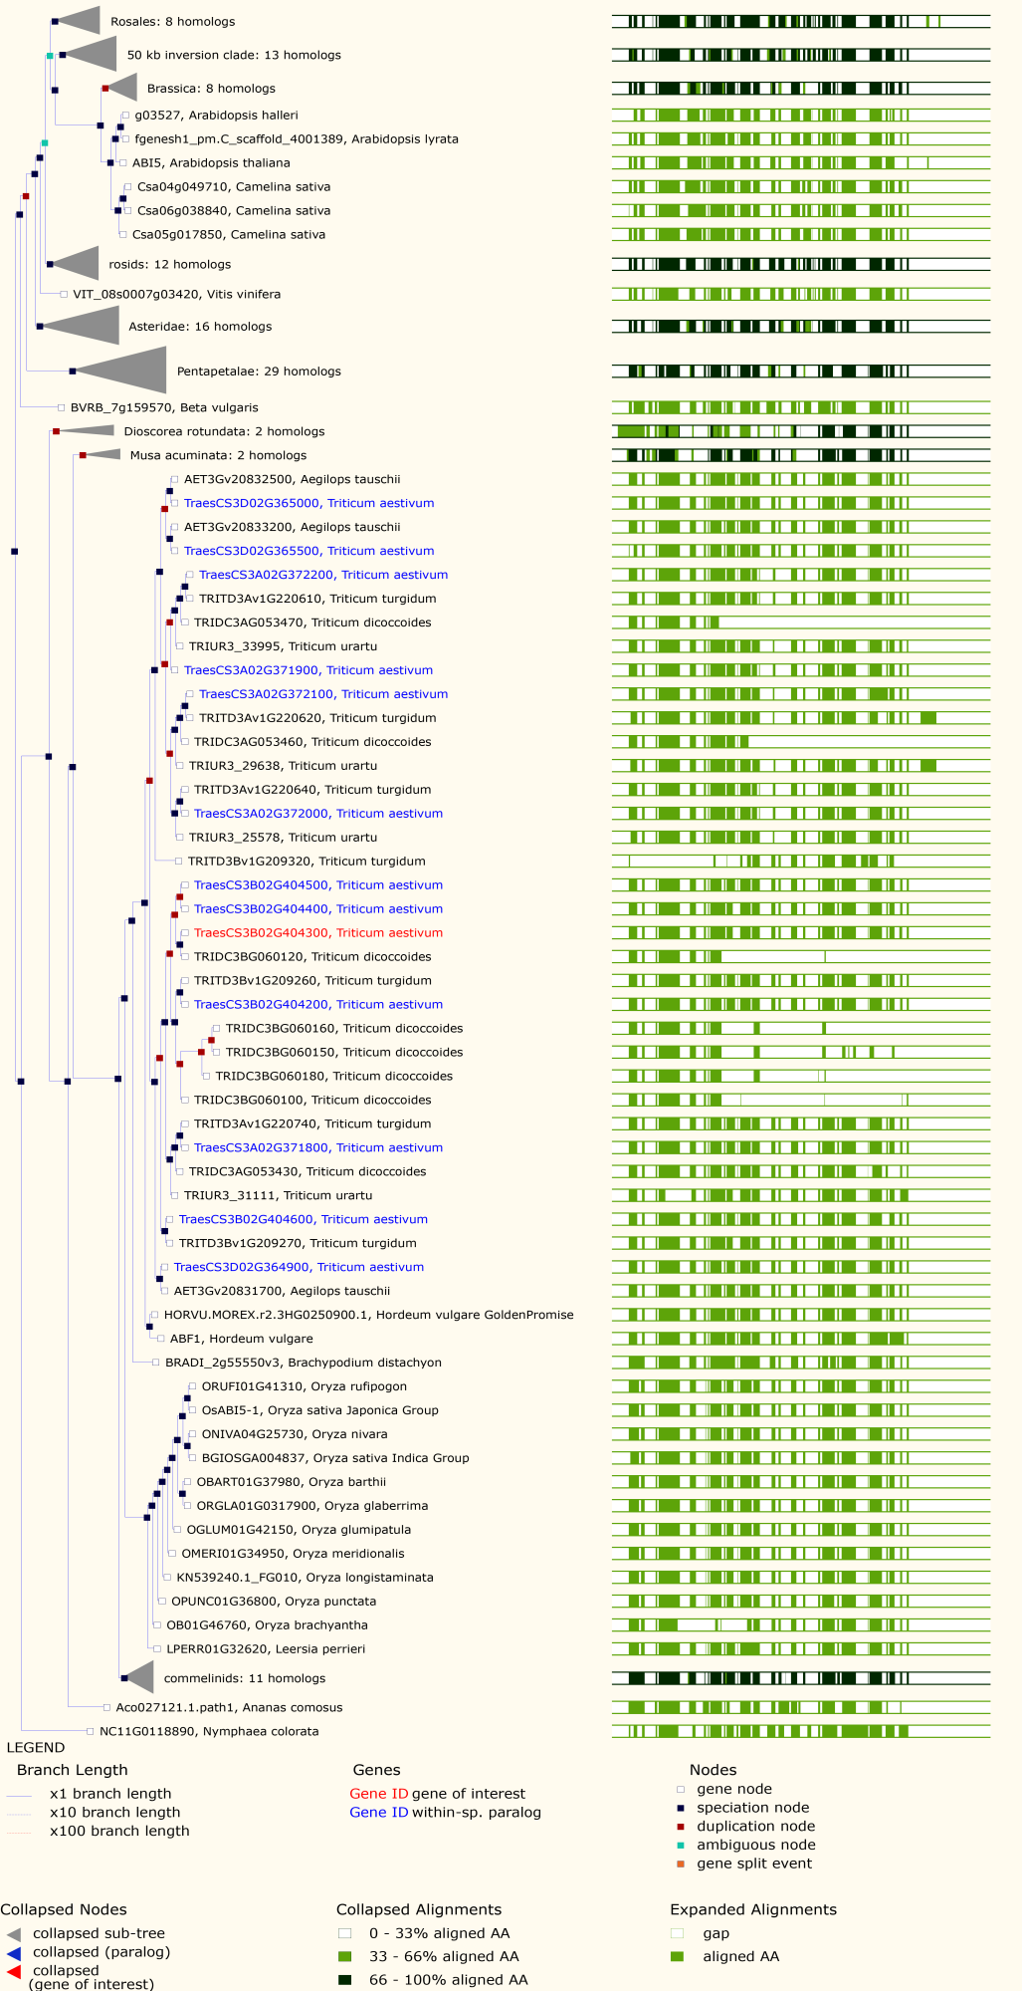
Figure S1 Phylogenetic tree of annotated gene TraesCS3B02G404300 in the target interval of QBp.caas-3BL
TraesCS3B02G404300 was used as a query for phylogenetic analysis in EnsemblPlants (http://plants.ensembl.org/index.html). As TraesCS3B02G404300, TraesCS3B02G404400, TraesCS3B02G404500 and TraesCS3B02G404600 were probably resulted from tandem duplication events and thus all were included in the phylogenetic tree.
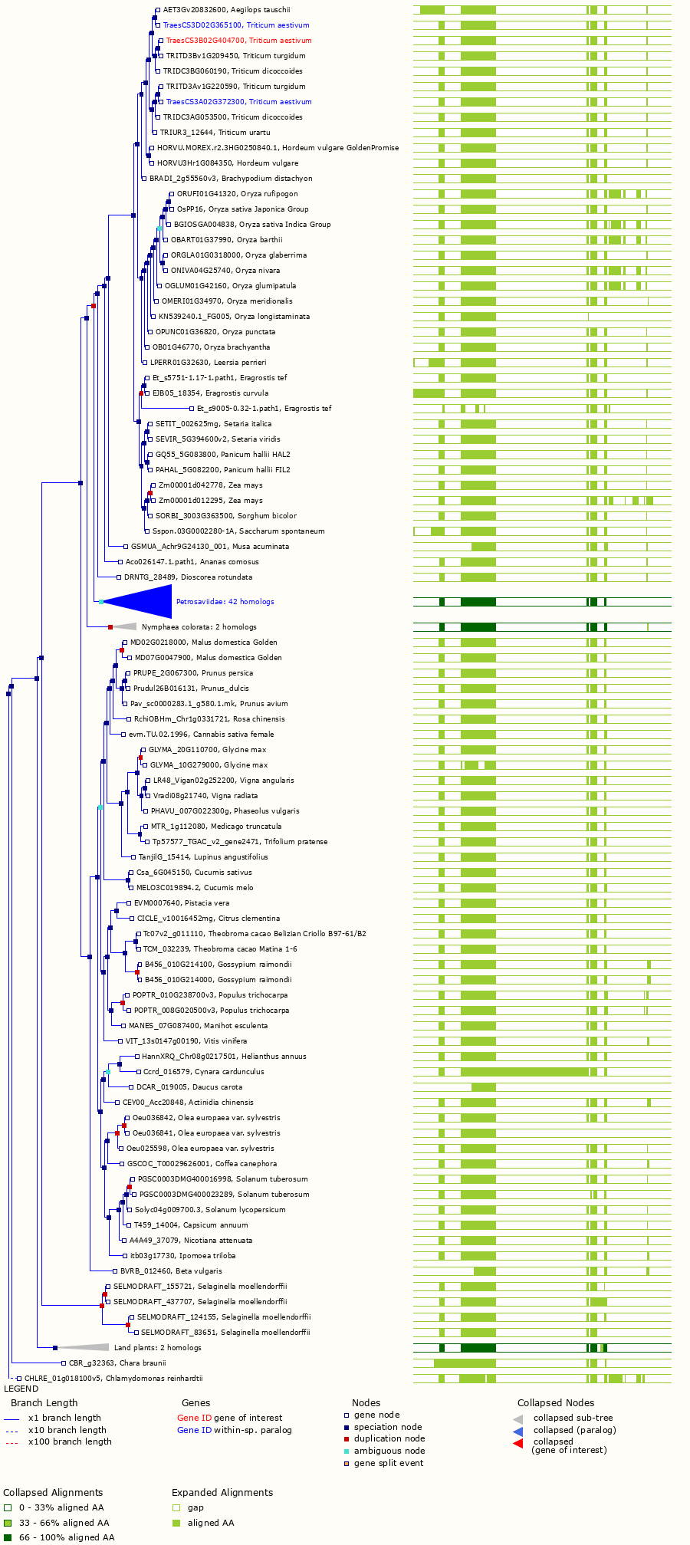
Figure S2 Phylogenetic tree of annotated gene TraesCS3B02G404700 in the target interval of QBp.caas-3BL
TraesCS3B02G404700 was used as a query for phylogenetic analysis in EnsemblPlants (http://plants.ensembl.org/index.html).
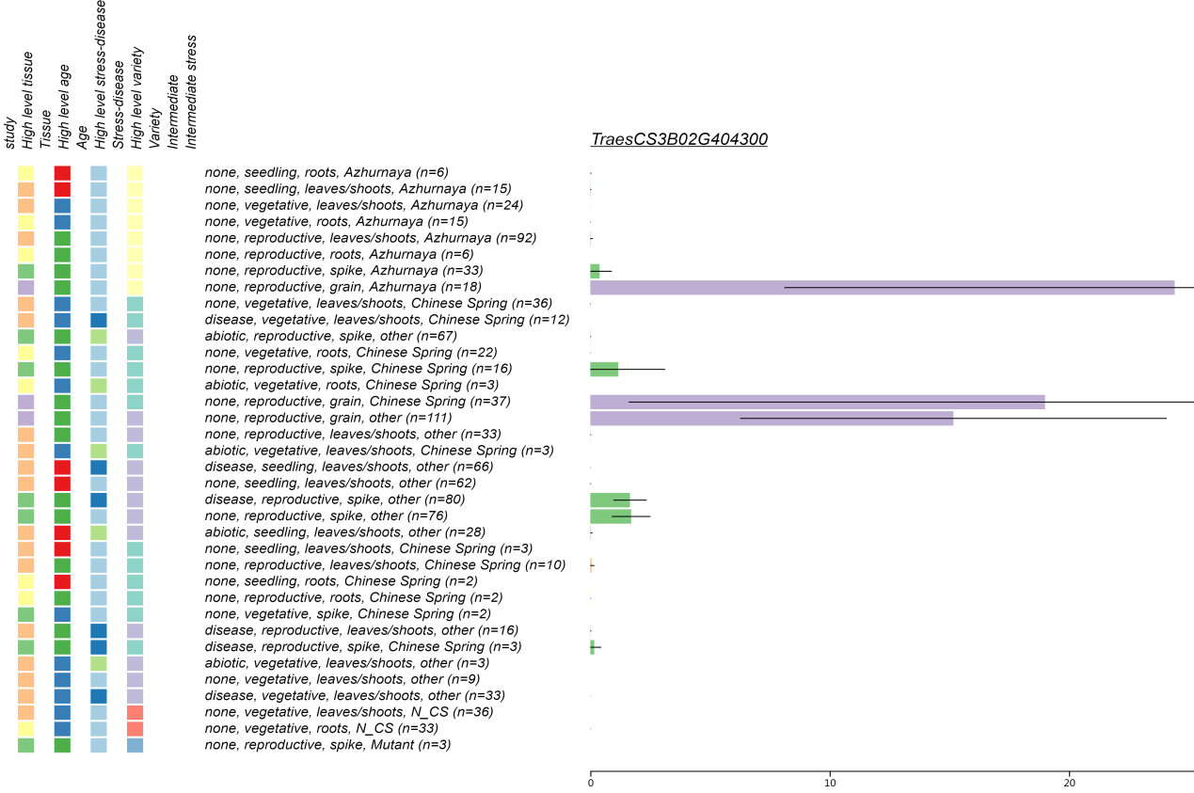Figure S3 Expression pattern of TraesCS3B02G404300 in different tissues according to Wheat Expression Browser (http://wheat-expression.com/)
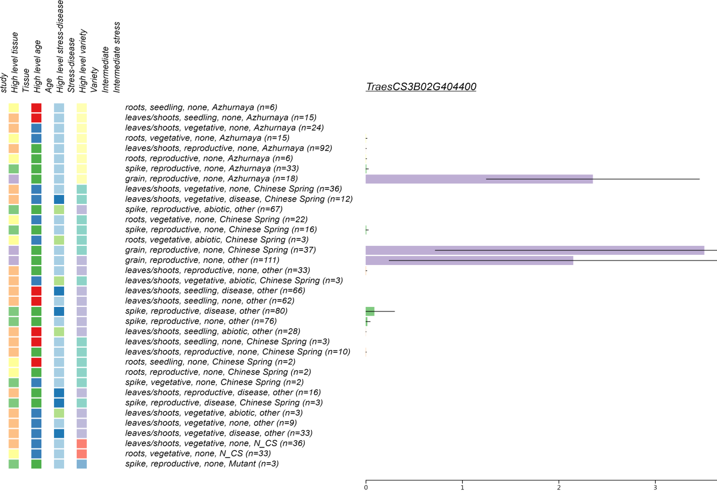 Figure S4 Expression pattern of TraesCS3B02G404400 in different tissues according to Wheat Expression Browser (http://wheat-expression.com/)
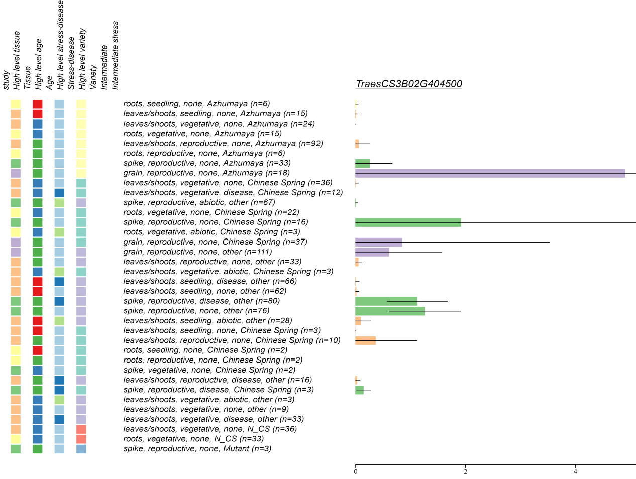
Figure S5 Expression pattern of TraesCS3B02G404500 in different tissues according to Wheat Expression Browser (http://wheat-expression.com/)
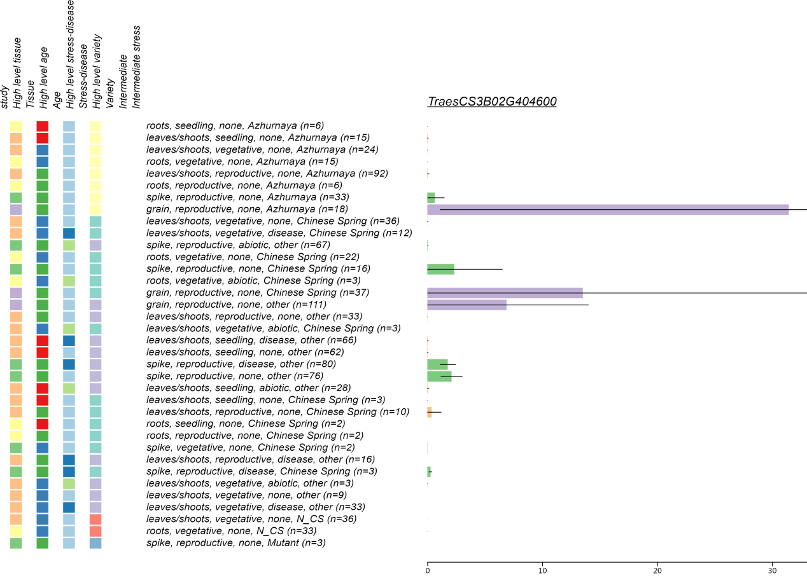
Figure S6 Expression pattern of TraesCS3B02G404600 in different tissues according to Wheat Expression Browser (http://wheat-expression.com/)
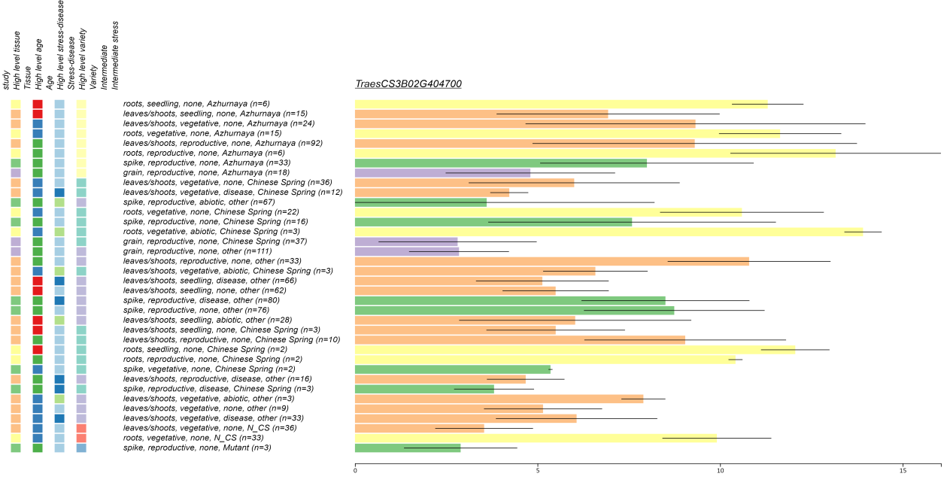
Figure S7 Expression pattern of TraesCS3B02G404700 in different tissues according to Wheat Expression Browser (http://wheat-expression.com/)

