Additional file 6 Leave-one-out plots, forest plots, and scatter plots

Supplementary Figure 1. The leave-one-out plot, forest plot, and scatter plot for the association of shingles and Alzheimer’s disease in primary analysis.
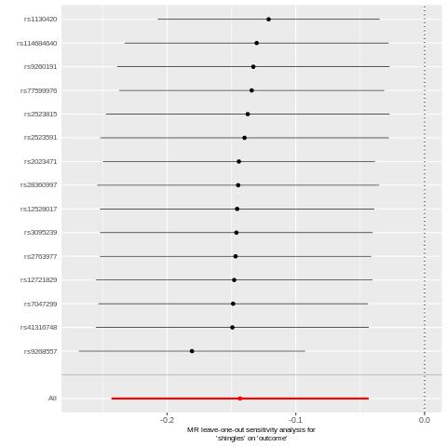
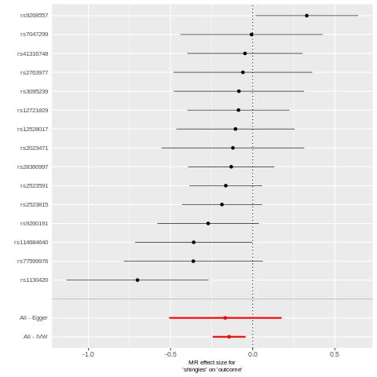
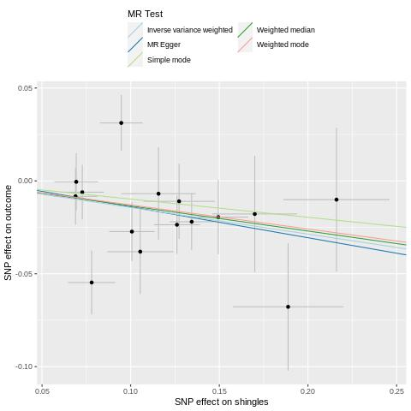

Supplementary Figure 2. The leave-one-out plot, forest plot, and scatter plot for the association of shingles and family history of Alzheimer’s disease in validation.
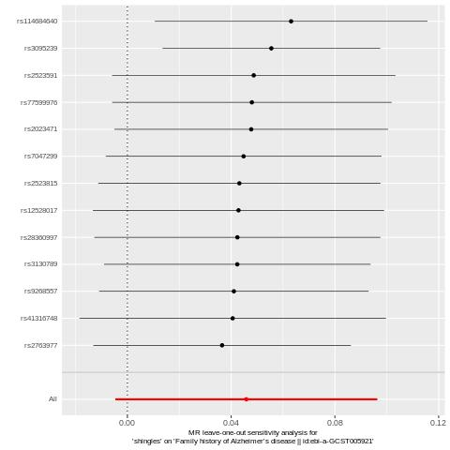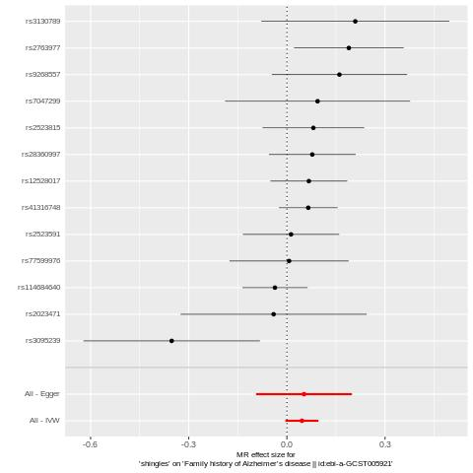
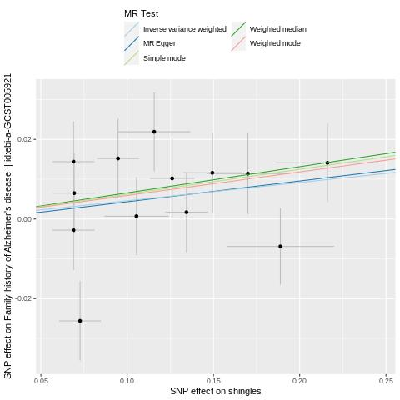

Supplementary Figure 3. The forest plot and scatter plot for the association of chickenpox and Alzheimer’s disease in primary analysis.
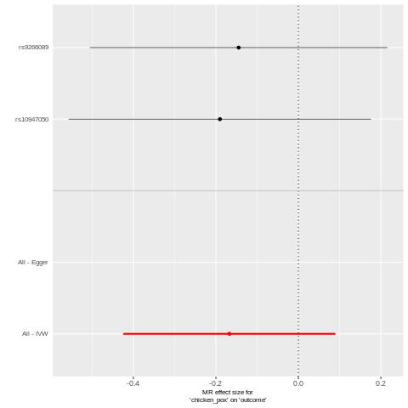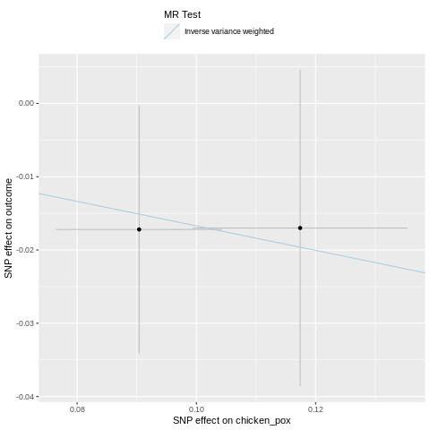

Supplementary Figure 4. The forest plot and scatter plot for the association of chickenpox and family history of Alzheimer’s disease in validation.
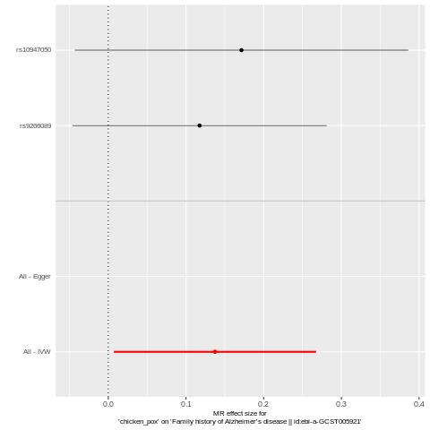
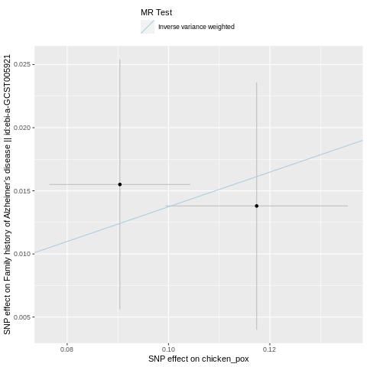

Supplementary Figure 5. The forest plot and scatter plot for the association of cold sores and Alzheimer’s disease in primary analysis.
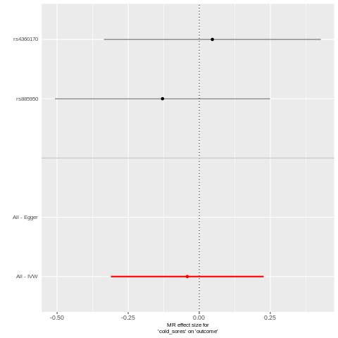
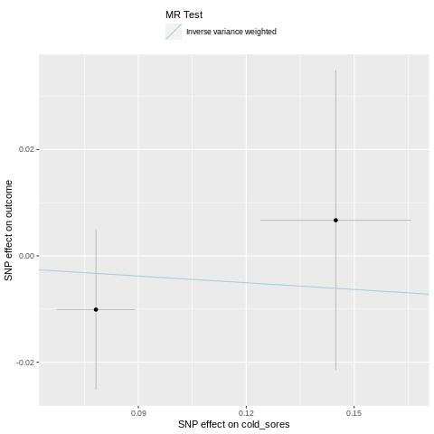

Supplementary Figure 6. The forest plot and scatter plot for the association of cold sores and family history of Alzheimer’s disease in validation.
