Supporting Information

A computational study on the complexation of Bisbenzimidazolyl derivatives with cucurbituril and cyclohexylcucurbituril

N. S. Venkataramanan,^{a,b*} A. Suvitha,^{a*} R. Sahara,^{b} Y. Kawazoe^{c}

ªSHARP Substratum,
Adavathur, Trichy.
India – 613 401
Email: nsvenkataramanan@gmail.com;
Tel: +91-9943510810

^{b}Research Center for Structural Materials,
NIMS, 1-2-1 Sengen,
Tsukuba, Ibaraki,
Japan – 305-0047

^{c}New Industry Creation Hatchry Center (NICHE),
4-4-6 Aramaki aza Aoba, Aoba-ku, Sendai 980-8579, JAPAN
Tel: +81-22-795-3670 or +81-22-795-3121
Fax:+81-22-795-3670

Figure Legend:

Figure S1. Low lying optimized structures of BI1, BI2 and BI3 guest molecules.

Figure S2. Optimized structures of low lying energy isomers for the encapsulated CB6 and CCB6 complexes with various guest molecules in their on top and lateral.

Figure S3. Optimized structures of low lying energy isomers for the encapsulated CCB6 complexes with various guest molecules in their on top and lateral.

Figure S4. Electrostatic potential maps of CB6, CCB6, BI1, BI2 and BI3 molecules superimposed on the isodensity surface of the structures (isovalue 0.001), computed at M05-2X-D3/6-311G(d,p) Level.

Figure S5. Reduced density gradient isosurfaces depicting noncovalent interaction (NCI) regions for (a,b) BI1@CCB6 (c,d) BI2@CCB6 (e,f) BI3@CCB6 The isosurfaces were constructed with RDG = 0.5 au and the blue –red colors scaling from -0.02 < sign(λ₂)ρ < -0.02. (g,h,i) Plot of RDG S versus sign(λ₂)ρ for BI1@CCB6, BI2@CCB6 and BI3@CCB6 respectively.

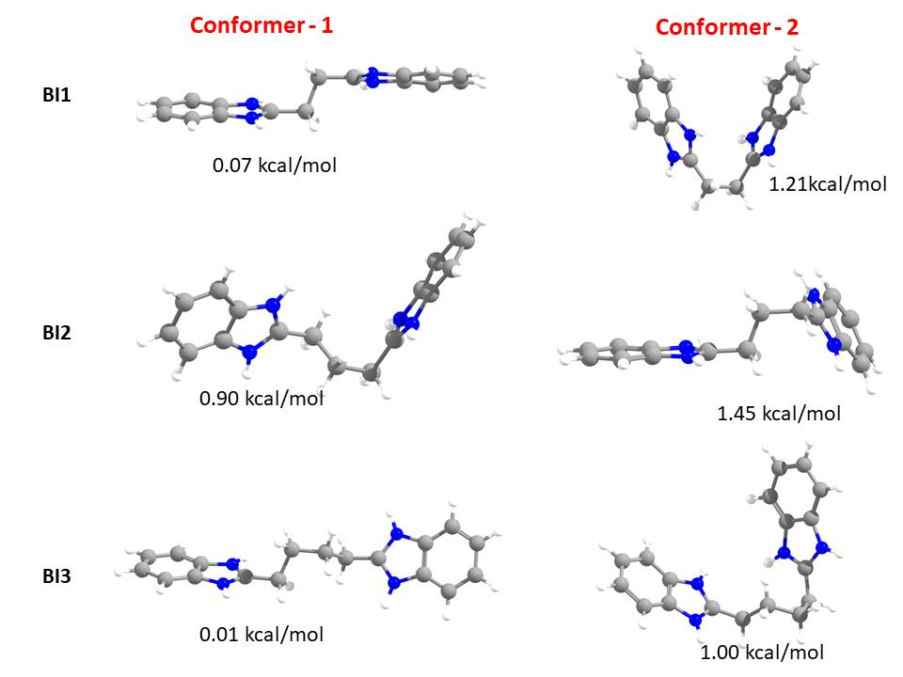

Figure S1

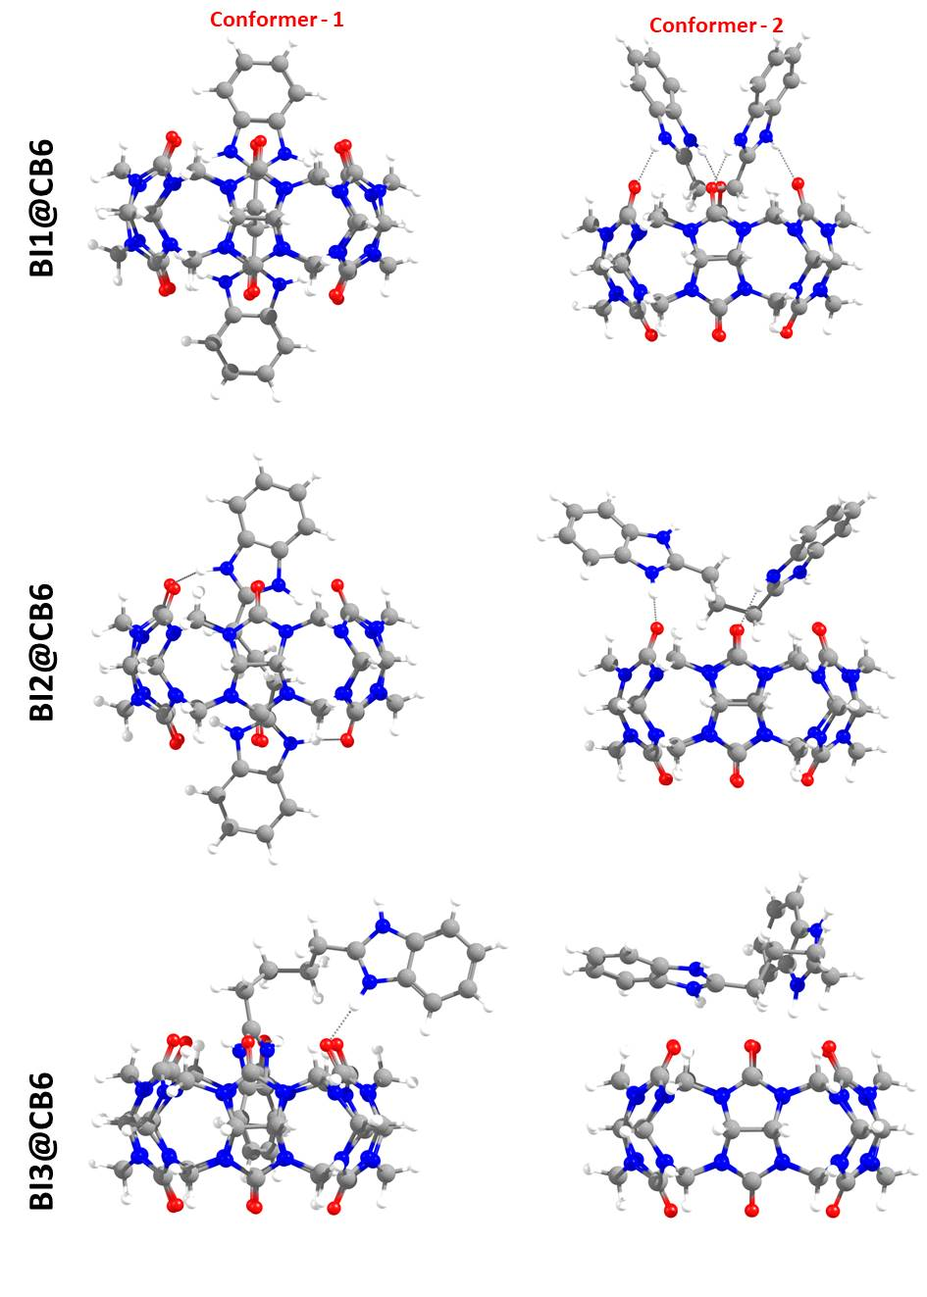
Figure S2

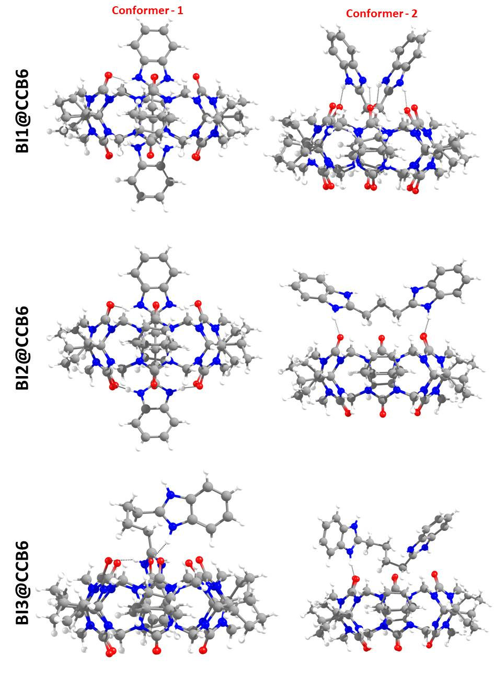
Figure S3

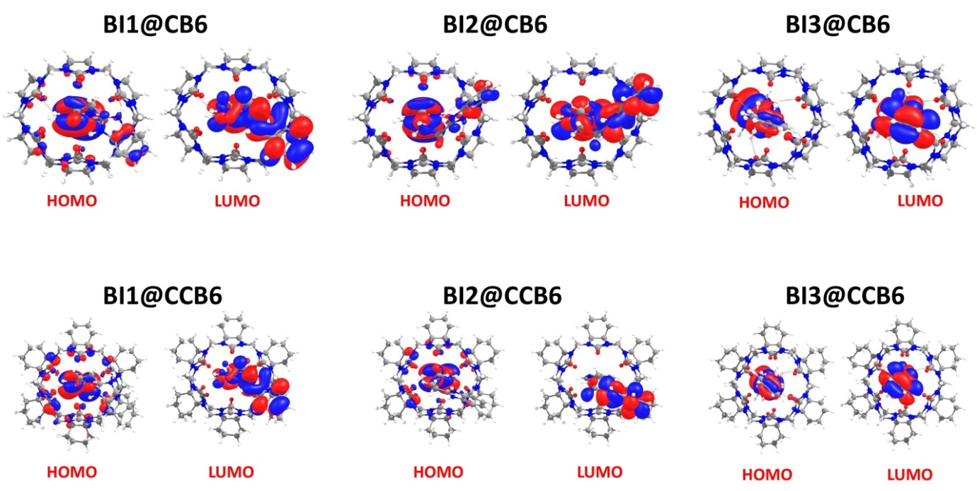

Figure S4

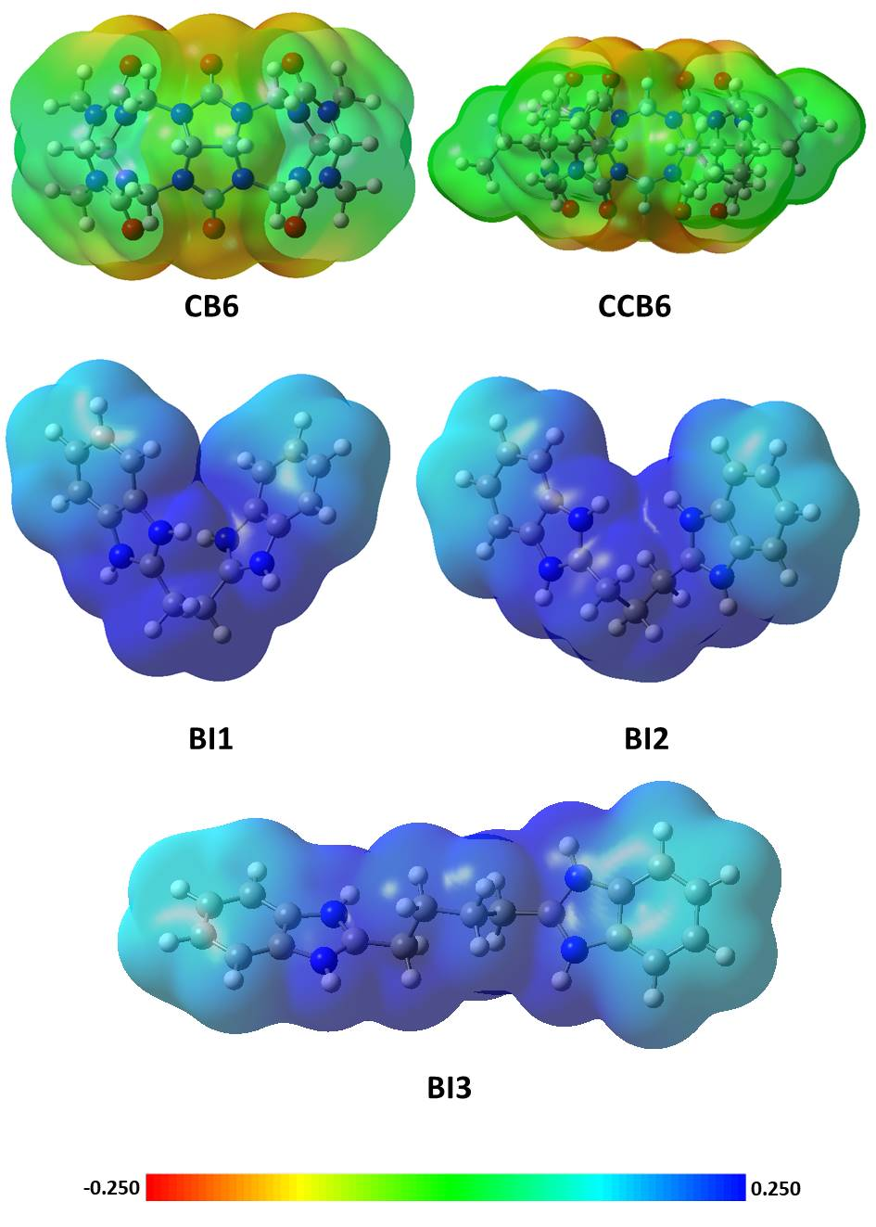Figure S5

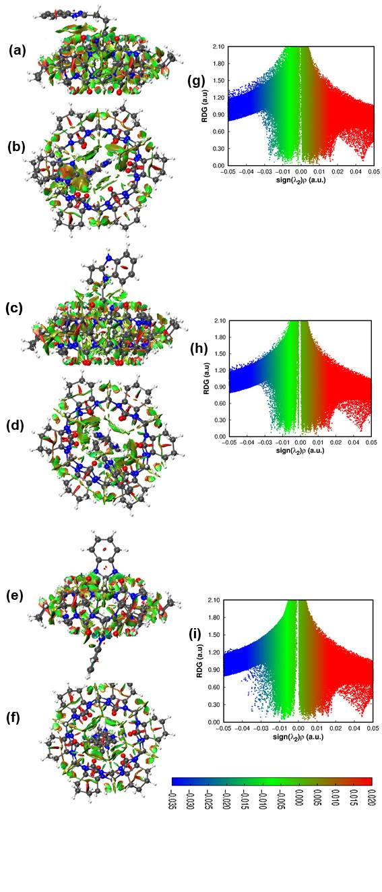
Figure S6

Bond | ρ | λ1 | λ2 | λ3 | ∇²ρ | G(ρ) | V(ρ) | H(ρ)
C138···O55 | 0.001538 | -0.000632 | -0.000423 | 0.006340 | 0.005285 | 0.000994 | -0.000667 | -0.000327
C138···O6 | 0.005369 | -0.004145 | -0.003062 | 0.025034 | 0.017827 | 0.003820 | -0.003184 | -0.000636
C138···O4 | 0.009063 | -0.007809 | -0.006902 | 0.043521 | 0.028810 | 0.006352 | -0.005501 | -0.000851
C137···O57 | 0.006208 | -0.004892 | -0.003791 | 0.028691 | 0.020007 | 0.004360 | -0.003719 | -0.000641
C137···O59 | 0.010020 | -0.008781 | -0.007701 | 0.048784 | 0.032302 | 0.007079 | -0.006082 | -0.000997
C136···N66 | 0.009320 | -0.007611 | -0.006795 | 0.040831 | 0.026426 | 0.005955 | -0.005304 | -0.000651
C136···N67 | 0.006316 | -0.002824 | -0.002505 | 0.024078 | 0.018750 | 0.004271 | -0.003855 | -0.000416
C136···N69 | 0.007730 | -0.004837 | -0.004493 | 0.031975 | 0.022645 | 0.005153 | -0.004644 | -0.000509
C136···N72 | 0.009469 | -0.007756 | -0.005866 | 0.041399 | 0.027777 | 0.006145 | -0.005345 | -0.000799
N131···O58 | 0.020628 | -0.024739 | -0.021519 | 0.128341 | 0.082083 | 0.018040 | -0.015559 | -0.002481
N131···O60 | 0.019048 | -0.021885 | -0.017068 | 0.117275 | 0.078321 | 0.016882 | -0.014183 | -0.002698
N131···O1 | 0.007923 | -0.005849 | -0.000650 | 0.036287 | 0.029787 | 0.006412 | -0.005376 | -0.001035
C130···O56 | 0.012562 | -0.008871 | -0.006629 | 0.063155 | 0.047655 | 0.010637 | -0.009361 | -0.001276
N133···O5 | 0.022153 | -0.027541 | -0.024142 | 0.140923 | 0.089239 | 0.019642 | -0.016975 | -0.002667
N133···O3 | 0.018737 | -0.021420 | -0.016726 | 0.113819 | 0.075673 | 0.016346 | -0.013774 | -0.002572
C139···N18 | 0.009231 | -0.007699 | -0.006504 | 0.040348 | 0.026145 | 0.005873 | -0.005209 | -0.000664
C139···N13 | 0.008866 | -0.006768 | -0.005465 | 0.038343 | 0.026110 | 0.005844 | -0.005161 | -0.000683
C139···N12 | 0.007825 | -0.005818 | -0.004676 | 0.032605 | 0.022111 | 0.004995 | -0.004463 | -0.000532
C124···O56 | 0.006427 | -0.005029 | -0.003238 | 0.032342 | 0.024075 | 0.005098 | -0.004178 | -0.000920
C124···O58 | 0.008594 | -0.007165 | -0.006297 | 0.043166 | 0.029705 | 0.006460 | -0.005495 | -0.000966
N121···O58 | 0.026500 | -0.036429 | -0.034290 | 0.186219 | 0.115500 | 0.025804 | -0.022733 | -0.003071
N121···O60 | 0.013268 | -0.010533 | -0.007138 | 0.073945 | 0.056274 | 0.012036 | -0.010003 | -0.002033
C110···H102 | 0.002628 | -0.002014 | -0.001332 | 0.012266 | 0.008920 | 0.001762 | -0.001294 | -0.000468
Table S1. QTAIM parameters (in atomic units) at the intermolecular BCP of BI1@CB6 inclusion complex. For atom numbering see Table S7.

Table S2. QTAIM parameters (in atomic units) at the intermolecular BCP of BI2@CB6 inclusion complex For atom numbering see Table S8.
Bond | ρ | λ1 | λ2 | λ3 | ∇²ρ | G(ρ) | V(ρ) | H(ρ)
O59···H116 | 0.004861 | -0.003335 | -0.001301 | 0.023254 | 0.018618 | 0.003805 | -0.002956 | -0.000849
O59···H122 | 0.012957 | -0.012343 | -0.008362 | 0.074743 | 0.054039 | 0.011406 | -0.009302 | -0.002104
O57···H122 | 0.029885 | -0.043035 | -0.042193 | 0.212617 | 0.127388 | 0.029348 | -0.026850 | -0.002499
H131···O59 | 0.313014 | -0.680523 | -0.594397 | 0.357712 | -0.917207 | 0.184380 | -0.598063 | -0.413682
H131···O57 | 0.012798 | -0.012347 | -0.007344 | 0.068822 | 0.049132 | 0.010639 | -0.008994 | -0.001644
C127···O2 | 0.013053 | -0.009702 | -0.006517 | 0.066052 | 0.049834 | 0.011115 | -0.009771 | -0.001344
H146···O57 | 0.010992 | -0.010143 | -0.009584 | 0.057962 | 0.038235 | 0.008284 | -0.007009 | -0.001275
H146···O56 | 0.009576 | -0.008417 | -0.007728 | 0.050092 | 0.033947 | 0.007287 | -0.006087 | -0.001200
H143···O56 | 0.006159 | -0.004513 | -0.003203 | 0.031006 | 0.023291 | 0.004947 | -0.004071 | -0.000876
N128···O56 | 0.007859 | -0.005603 | -0.001574 | 0.035766 | 0.028589 | 0.006224 | -0.005301 | -0.000923
H129···O6 | 0.020192 | -0.024225 | -0.019885 | 0.126745 | 0.082635 | 0.017910 | -0.015162 | -0.002748
H129···O4 | 0.019912 | -0.023527 | -0.019311 | 0.123504 | 0.080665 | 0.017510 | -0.014854 | -0.002656
H131···O59 | 0.028234 | -0.039530 | -0.036895 | 0.188910 | 0.112485 | 0.025870 | -0.023618 | -0.002252
H141···N66 | 0.007961 | -0.005955 | -0.004522 | 0.033309 | 0.022832 | 0.005106 | -0.004504 | -0.000602
H141···N67 | 0.007383 | -0.004835 | -0.004234 | 0.030347 | 0.021279 | 0.004848 | -0.004376 | -0.000472
H141···N69 | 0.006409 | -0.003404 | -0.002760 | 0.024915 | 0.018751 | 0.004243 | -0.003798 | -0.000445
H141···N72 | 0.009041 | -0.007273 | -0.006597 | 0.039225 | 0.025356 | 0.005730 | -0.005121 | -0.000609
C137···O60 | 0.005774 | -0.004508 | -0.003579 | 0.026621 | 0.018535 | 0.004032 | -0.003430 | -0.000602
C137···O58 | 0.009515 | -0.008247 | -0.007124 | 0.045815 | 0.030444 | 0.006683 | -0.005754 | -0.000928
C135···O1 | 0.001446 | -0.000519 | -0.000403 | 0.005902 | 0.004980 | 0.000929 | -0.000614 | -0.000316
H128···O3 | 0.005399 | -0.004159 | -0.003090 | 0.025001 | 0.017751 | 0.003813 | -0.003188 | -0.000625
H138···N12 | 0.008421 | -0.006655 | -0.005562 | 0.035921 | 0.023704 | 0.005367 | -0.004809 | -0.000559
H138···N13 | 0.005453 | -0.002306 | -0.000643 | 0.019659 | 0.016710 | 0.003784 | -0.003392 | -0.000393
H138···N15 | 0.008894 | -0.006665 | -0.005723 | 0.038467 | 0.026079 | 0.005861 | -0.005203 | -0.000658
H138···N18 | 0.008963 | -0.007069 | -0.005733 | 0.038637 | 0.025834 | 0.005774 | -0.005089 | -0.000685
H139···O5 | 0.009293 | -0.008037 | -0.007110 | 0.044672 | 0.029525 | 0.006502 | -0.005623 | -0.000879

Table S3. QTAIM parameters (in atomic units) at the intermolecular BCP of BI3@CB6 inclusion complex. For atom numbering see Table S9.
Bond | ρ | λ1 | λ2 | λ3 | ∇²ρ | G(ρ) | V(ρ) | H(ρ)
H120···O58 | 0.024123 | -0.031920 | -0.027655 | 0.161151 | 0.101576 | 0.022430 | -0.019466 | -0.002964
H120···O60 | 0.017446 | -0.019582 | -0.014102 | 0.105453 | 0.071769 | 0.015363 | -0.012783 | -0.002580
H144···N71 | 0.004557 | -0.003351 | -0.002445 | 0.017803 | 0.012007 | 0.002719 | -0.002435 | -0.000283
H143···O1 | 0.008750 | -0.004690 | -0.001527 | 0.039965 | 0.033748 | 0.006981 | -0.005525 | -0.001456
H143···N11 | 0.007201 | -0.005609 | -0.004104 | 0.029379 | 0.019666 | 0.004472 | -0.004027 | -0.000445
H122···O3 | 0.019470 | -0.023230 | -0.017140 | 0.123426 | 0.083055 | 0.017786 | -0.014809 | -0.002977
H122···O5 | 0.021620 | -0.027660 | -0.023683 | 0.142135 | 0.090793 | 0.019753 | -0.016807 | -0.002946
H146···N16 | 0.005942 | -0.004624 | -0.002682 | 0.023912 | 0.016605 | 0.003659 | -0.003167 | -0.000492
C123···O56 | 0.011037 | -0.007344 | -0.005492 | 0.054022 | 0.041186 | 0.009019 | -0.007742 | -0.001277
H147···N68 | 0.002673 | -0.001685 | -0.000394 | 0.010678 | 0.008599 | 0.001794 | -0.001438 | -0.000356
N128···O4 | 0.013565 | -0.013390 | -0.007826 | 0.076342 | 0.055126 | 0.011729 | -0.009676 | -0.002053
H129···O2 | 0.023725 | -0.031955 | -0.029528 | 0.159521 | 0.098038 | 0.021675 | -0.018840 | -0.002835
H129···O4 | 0.007053 | -0.003629 | -0.002362 | 0.030104 | 0.024113 | 0.005122 | -0.004217 | -0.000906
N128···O59 | 0.007186 | -0.005315 | -0.001015 | 0.032332 | 0.026002 | 0.005542 | -0.004583 | -0.000959
H126···O59 | 0.009304 | -0.007601 | -0.005530 | 0.044060 | 0.030929 | 0.006788 | -0.005843 | -0.000945
C124···O57 | 0.006442 | -0.003405 | -0.002116 | 0.028592 | 0.023071 | 0.004912 | -0.004055 | -0.000856
N130···O57 | 0.013751 | -0.013692 | -0.007550 | 0.079277 | 0.058035 | 0.012223 | -0.009936 | -0.002286
H131···O55 | 0.027313 | -0.039236 | -0.035581 | 0.189280 | 0.114463 | 0.025920 | -0.023224 | -0.002696
H125···O55 | 0.003971 | -0.002810 | -0.000667 | 0.017700 | 0.014224 | 0.002879 | -0.002202 | -0.000677
N130···O6 | 0.009644 | -0.007681 | -0.001888 | 0.046024 | 0.036455 | 0.007835 | -0.006556 | -0.001279
H150···N8 | 0.006946 | -0.005350 | -0.003261 | 0.028046 | 0.019435 | 0.004345 | -0.003832 | -0.000514
H150···N13 | 0.006838 | -0.005265 | -0.002733 | 0.027559 | 0.019561 | 0.004347 | -0.003805 | -0.000543
N119···O1 | 0.005928 | -0.003644 | -0.001157 | 0.026704 | 0.021902 | 0.004754 | -0.004032 | -0.000722

Table S4. QTAIM parameters (in atomic units) at the intermolecular BCP of BI1@CCB6 inclusion complex. For numbering see Table S10.
Bond | ρ | λ1 | λ2 | λ3 | ∇²ρ | G(ρ) | V(ρ) | H(ρ)
H14···O47 | 0.013511 | -0.013744 | -0.009574 | 0.079201 | 0.055884 | 0.011766 | -0.009562 | -0.002205
H18···O47 | 0.008705 | -0.007357 | -0.006250 | 0.044070 | 0.030463 | 0.006606 | -0.005597 | -0.001009
C3···O38 | 0.012965 | -0.009211 | -0.004478 | 0.065626 | 0.051938 | 0.011331 | -0.009677 | -0.001654
N11···O40 | 0.001916 | -0.001156 | -0.000959 | 0.010932 | 0.008817 | 0.001662 | -0.001120 | -0.000542
H24···O47 | 0.022017 | -0.027044 | -0.023402 | 0.139566 | 0.089121 | 0.019621 | -0.016962 | -0.002659
H24···O38 | 0.021166 | -0.025090 | -0.019209 | 0.134676 | 0.090377 | 0.019516 | -0.016439 | -0.003078
C22···O45 | 0.012622 | -0.009617 | -0.005380 | 0.064920 | 0.049923 | 0.011056 | -0.009631 | -0.001425
H26···O43 | 0.021737 | -0.027177 | -0.023142 | 0.139968 | 0.089649 | 0.019587 | -0.016761 | -0.002825
H26···O42 | 0.018397 | -0.021106 | -0.015970 | 0.113043 | 0.075967 | 0.016298 | -0.013604 | -0.002694
N23···O40 | 0.007571 | -0.005249 | -0.000483 | 0.034641 | 0.028909 | 0.006220 | -0.005213 | -0.001007
H33···N50 | 0.006595 | -0.003475 | -0.003036 | 0.025919 | 0.019408 | 0.004412 | -0.003972 | -0.000440
H33···N61 | 0.009465 | -0.007729 | -0.006914 | 0.041868 | 0.027224 | 0.006117 | -0.005428 | -0.000689
H33···N52 | 0.008645 | -0.006646 | -0.004509 | 0.036975 | 0.025819 | 0.005688 | -0.004921 | -0.000767
H33···N69 | 0.008585 | -0.006157 | -0.005706 | 0.036895 | 0.025033 | 0.005668 | -0.005079 | -0.000590
H34···O44 | 0.009514 | -0.008304 | -0.007348 | 0.046022 | 0.030371 | 0.006695 | -0.005797 | -0.000898
H34···O41 | 0.006290 | -0.005009 | -0.003940 | 0.029175 | 0.020226 | 0.004416 | -0.003775 | -0.000641
C29···O46 | 0.002157 | -0.000529 | -0.000461 | 0.007877 | 0.006888 | 0.001323 | -0.000925 | -0.000399
C29···O39 | 0.000917 | -0.000264 | -0.000201 | 0.003804 | 0.003339 | 0.000595 | -0.000356 | -0.000239
H35···O48 | 0.009725 | -0.008379 | -0.007110 | 0.046787 | 0.031297 | 0.006874 | -0.005924 | -0.000950
H33···N62 | 0.009686 | -0.007632 | -0.005674 | 0.042677 | 0.029372 | 0.006472 | -0.005602 | -0.000871
H33···N49 | 0.009648 | -0.007291 | -0.006806 | 0.042798 | 0.028701 | 0.006467 | -0.005759 | -0.000708
H33···N64 | 0.007746 | -0.004707 | -0.004312 | 0.031715 | 0.022696 | 0.005142 | -0.004609 | -0.000532
H33···N51 | 0.009528 | -0.007485 | -0.006736 | 0.042136 | 0.027915 | 0.006279 | -0.005580 | -0.000699

Table S5. QTAIM parameters (in atomic units) at the intermolecular BCP of BI2@CCB6 inclusion complex. For numbering see Table S11.
Bond | ρ | λ1 | λ2 | λ3 | ∇²ρ | G(ρ) | V(ρ) | H(ρ)
H180···O3 | 0.020604 | -0.024963 | -0.020794 | 0.130407 | 0.084650 | 0.018371 | -0.015579 | -0.002792
H180···O5 | 0.020638 | -0.024676 | -0.019586 | 0.130006 | 0.085744 | 0.018577 | -0.015718 | -0.002859
C202···O5 | 0.004906 | -0.003198 | -0.001040 | 0.023170 | 0.018932 | 0.003868 | -0.003004 | -0.000865
C183···O8 | 0.008037 | -0.005948 | -0.001188 | 0.037023 | 0.029888 | 0.006473 | -0.005474 | -0.000999
H204···O8 | 0.014495 | -0.014323 | -0.013975 | 0.083456 | 0.055158 | 0.011776 | -0.009762 | -0.002014
H189···O8 | 0.016856 | -0.020268 | -0.019822 | 0.109093 | 0.069003 | 0.014467 | -0.011683 | -0.002784
N188···O10 | 0.003468 | -0.002051 | -0.000080 | 0.016916 | 0.014786 | 0.002985 | -0.002273 | -0.000712
H198···H152 | 0.007629 | -0.007047 | -0.006650 | 0.037826 | 0.024130 | 0.004973 | -0.003913 | -0.001060
H198···O10 | 0.007128 | -0.005605 | -0.003746 | 0.034351 | 0.025000 | 0.005342 | -0.004434 | -0.000908
H182···O12 | 0.020751 | -0.025171 | -0.020486 | 0.131789 | 0.086132 | 0.018670 | -0.015807 | -0.002863
C183···O1 | 0.010439 | -0.007884 | -0.002834 | 0.052091 | 0.041372 | 0.009007 | -0.007670 | -0.001336
H177···N23 | 0.007762 | -0.005140 | -0.004314 | 0.032074 | 0.022620 | 0.005099 | -0.004544 | -0.000556
H177···N21 | 0.007728 | -0.005008 | -0.004096 | 0.031737 | 0.022634 | 0.005115 | -0.004572 | -0.000543
H177···N33 | 0.010370 | -0.008592 | -0.007738 | 0.047031 | 0.030701 | 0.006868 | -0.006061 | -0.000807
H176···N34 | 0.008692 | -0.006347 | -0.005356 | 0.037075 | 0.025371 | 0.005687 | -0.005031 | -0.000656
H176···N13 | 0.008383 | -0.005766 | -0.004899 | 0.035360 | 0.024695 | 0.005548 | -0.004922 | -0.000626
H176···N26 | 0.009684 | -0.007636 | -0.006976 | 0.043055 | 0.028443 | 0.006394 | -0.005678 | -0.000717
H176···N24 | 0.008975 | -0.006602 | -0.006139 | 0.039049 | 0.026309 | 0.005946 | -0.005315 | -0.000631
H178···O11 | 0.007411 | -0.006086 | -0.005066 | 0.034544 | 0.023392 | 0.005160 | -0.004473 | -0.000687
H178···O9 | 0.008960 | -0.007677 | -0.006531 | 0.042963 | 0.028755 | 0.006347 | -0.005505 | -0.000842
C174···O7 | 0.001450 | -0.000434 | -0.000352 | 0.005657 | 0.004870 | 0.000908 | -0.000598 | -0.000310
C174···O2 | 0.001552 | -0.000489 | -0.000372 | 0.006055 | 0.005194 | 0.000975 | -0.000651 | -0.000324
H175···O6 | 0.008191 | -0.006803 | -0.005669 | 0.038484 | 0.026013 | 0.005743 | -0.004982 | -0.000761
H175···O4 | 0.008829 | -0.007530 | -0.006472 | 0.042071 | 0.028069 | 0.006203 | -0.005390 | -0.000814

Table S6. QTAIM parameters (in atomic units) at the intermolecular BCP of BI3@CCB6 inclusion complex. For numbering see Table S12.
Bond | ρ | λ1 | λ2 | λ3 | ∇²ρ | G(ρ) | V(ρ) | H(ρ)
H189···O12 | 0.031512 | -0.048251 | -0.045126 | 0.220426 | 0.127049 | 0.029965 | -0.001797 | -0.028168
N188···O10 | 0.013374 | -0.012328 | -0.006888 | 0.075388 | 0.056172 | 0.011949 | -0.002094 | -0.009854
C189···O1 | 0.009511 | -0.006445 | -0.001733 | 0.045234 | 0.037056 | 0.007921 | -0.001343 | -0.006579
C184···O1 | 0.009695 | -0.003298 | -0.003242 | 0.044919 | 0.038379 | 0.008277 | -0.001318 | -0.006959
N190···O3 | 0.013791 | -0.013846 | -0.007869 | 0.079009 | 0.057293 | 0.012113 | -0.002210 | -0.009903
H186···O3 | 0.008387 | -0.006730 | -0.005015 | 0.038546 | 0.026801 | 0.005938 | -0.000762 | -0.005176
H191···O5 | 0.027073 | -0.038736 | -0.035493 | 0.186866 | 0.112637 | 0.025521 | -0.002638 | -0.022883
H209···N25 | 0.006720 | -0.005125 | -0.002298 | 0.027151 | 0.019729 | 0.004331 | -0.000602 | -0.003729
N190···O8 | 0.007222 | -0.005035 | -0.004396 | 0.033628 | 0.024197 | 0.005407 | -0.000642 | -0.004765
H209···O8 | 0.009522 | -0.005421 | -0.004056 | 0.043062 | 0.033585 | 0.007168 | -0.001229 | -0.005939
H210···32 | 0.005239 | -0.003762 | -0.002413 | 0.020405 | 0.014230 | 0.003228 | -0.000329 | -0.002899
H203···O11 | 0.009054 | -0.004511 | -0.002622 | 0.040726 | 0.033594 | 0.007030 | -0.001368 | -0.005662
N181···O11 | 0.007288 | -0.004833 | -0.002400 | 0.033639 | 0.026405 | 0.005790 | -0.000812 | -0.004978
H182···O2 | 0.021688 | -0.027471 | -0.022461 | 0.141916 | 0.091983 | 0.019993 | -0.003002 | -0.016991
H182···O4 | 0.020546 | -0.025369 | -0.020529 | 0.133585 | 0.087687 | 0.018889 | -0.003032 | -0.015857
H206···O4 | 0.005284 | -0.003800 | -0.001324 | 0.023083 | 0.017959 | 0.003801 | -0.000689 | -0.003112
H206···N22 | 0.005154 | -0.003709 | -0.001182 | 0.020392 | 0.015502 | 0.003340 | -0.000535 | -0.002805
C186···O6 | 0.010938 | -0.007435 | -0.004593 | 0.053582 | 0.041554 | 0.009040 | -0.001348 | -0.007692
H207···N28 | 0.002970 | -0.001927 | -0.001069 | 0.012148 | 0.009152 | 0.001926 | -0.000362 | -0.001563
H180···O7 | 0.025197 | -0.034367 | -0.030646 | 0.170260 | 0.105247 | 0.023473 | -0.002839 | -0.020634
H180···O9 | 0.017765 | -0.019887 | -0.013129 | 0.107903 | 0.074887 | 0.015963 | -0.002759 | -0.013204
H204···N33 | 0.004255 | -0.003079 | -0.001367 | 0.016213 | 0.011767 | 0.002635 | -0.000306 | -0.002329

Table S7. Showing the numbering scheme for BI1@CB6 complex.

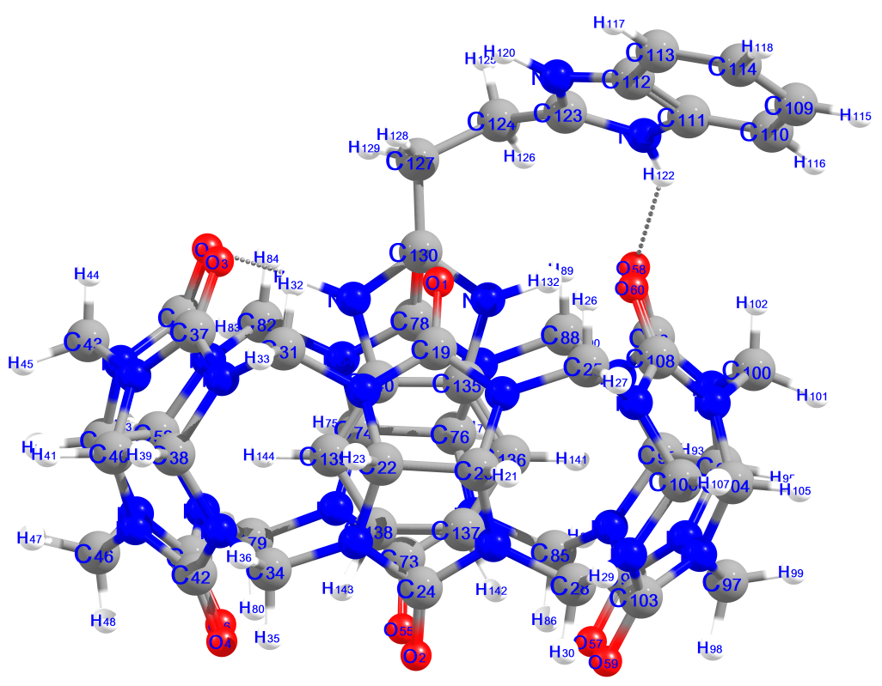

Table S8. Showing the numbering scheme for BI2@CB6 complex.

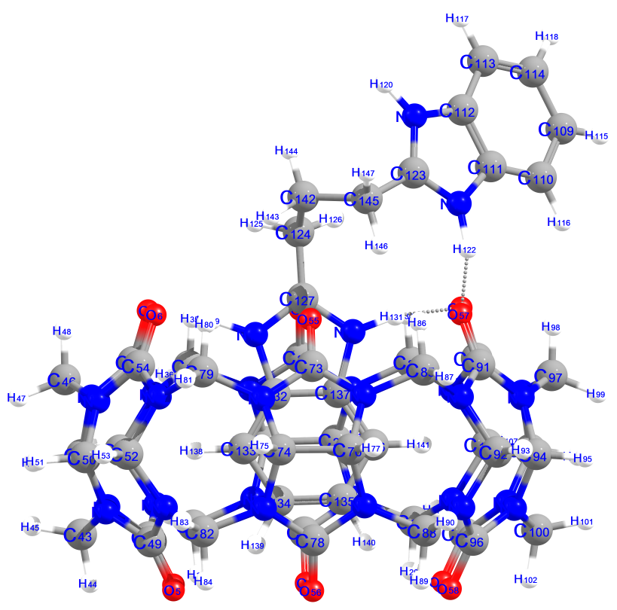

Table S9. Showing the numbering scheme for BI3@CB6 complex.

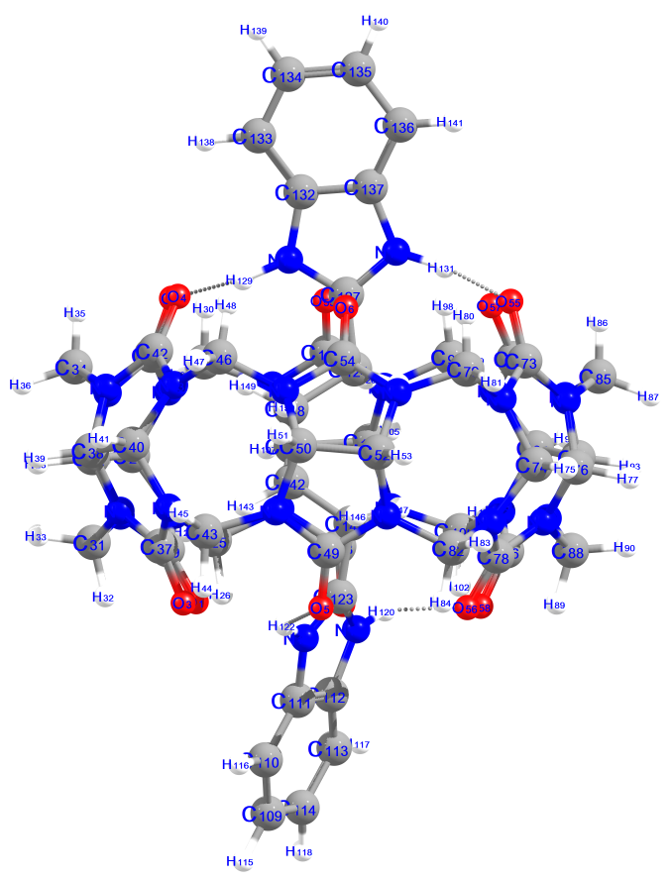

Table S10. Showing the numbering scheme for BI1@CCB6 complex.

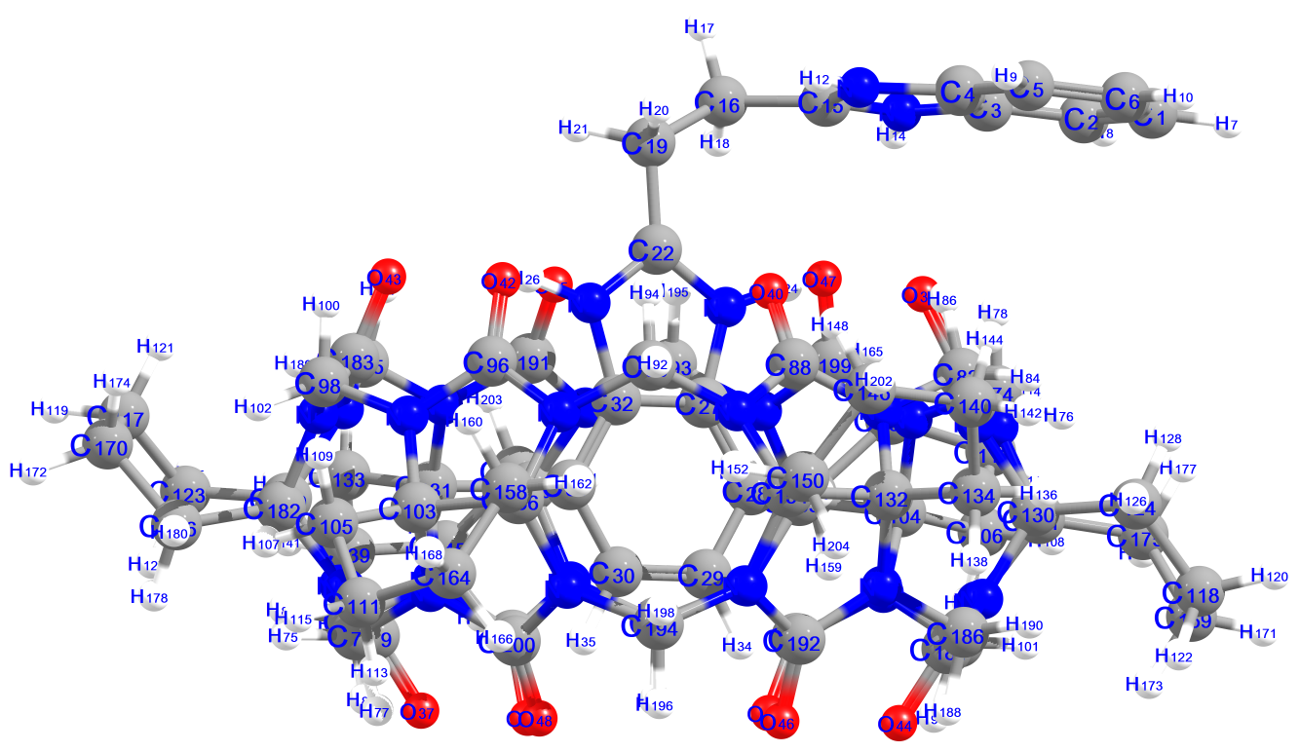

Table S11. Showing the numbering scheme for BI2@CCB6 complex.

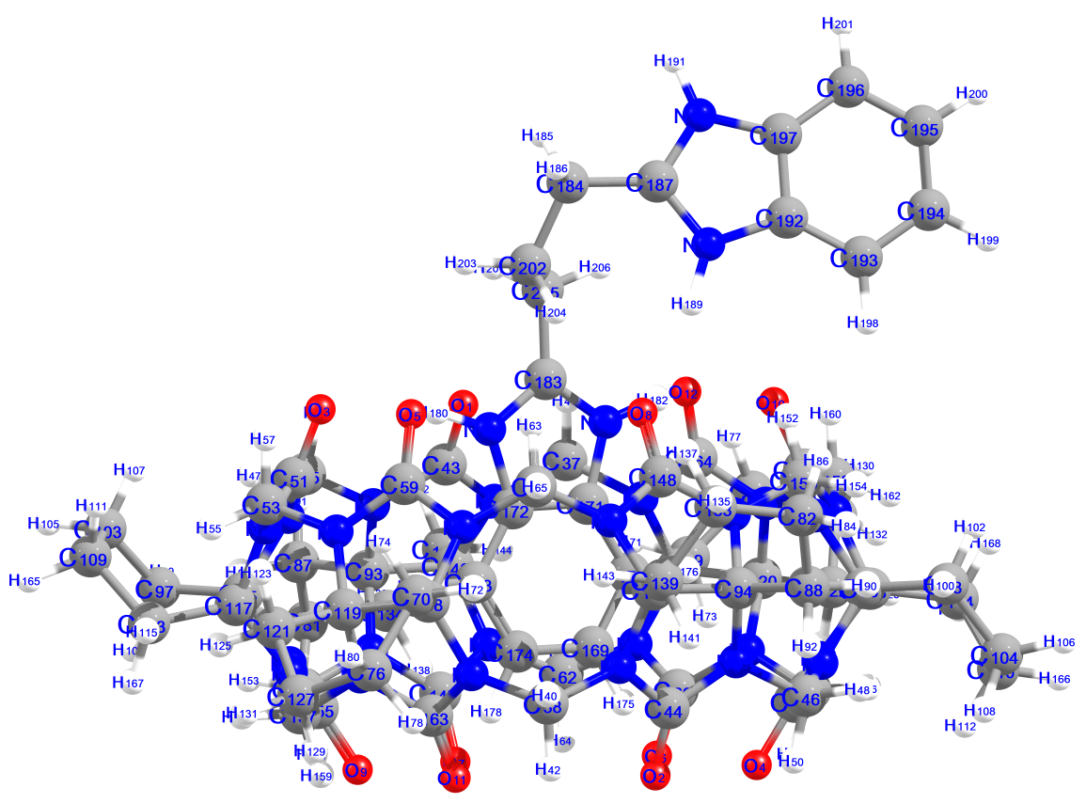

Table S12. Showing the numbering scheme for BI3@CCB6 complex.
