Supplementary Information for
Localized Kerr effect-enhanced Raman beam cleaning: Unleashing near single-mode laser generation in a rare-earth-free system
Chenchen Fan¹, Xiulu Hao¹, Tianfu Yao^{1,*}, Jingyong Leng^{1,2} and Pu Zhou^{1,**}
¹College of Advanced Interdisciplinary Studies, National University of Defense Technology, Changsha 410073, China
²Nanhu Laser Laboratory, National University of Defense Technology, Changsha 410073, China.
Corresponding author: *yaotianfumary@163.com, **zhoupu203@163.com
Supplementary Note 1 | Calculation of the pump beam field amplitude in a GRIN-fiber based Raman laser. Considering the nonlinear dynamic of Kerr effect, the refractive index of a GRIN fiber designed with a parabolic profile can be written as
 | $$\begin{aligned}n\left(r\right)=n_{0}-\frac{1}{2}{n_{0}b}^{2}r^{2}+n_{2}{\left|E\right|}^{2}\end{aligned}$$ | (1)
In a typical Raman fiber laser including pump and signal, the electric field $E$ at a distance 𝑧 can be written as
 | $$E\left(r,z,t\right)=A_{p}e^{i\left(β_{p}z-ω_{p}t\right)}+A_{s}e^{i\left(β_{s}z-ω_{s}t\right)}$$ | (2)
where $A_{p}$, $A_{s}$ is the field amplitude of pump and signal, and $β_{j}$ is the propagation constant with $j=p, s$. Considering the fraction of Raman contribution, the nonlinear part $n_{2}{\left|E\right|}^{2}$ of the refractive index can be written as¹
 | $$n_{2}{\left|E\right|}^{2}=\left(1-f_{R}\right)n_{2}{\left|E\right|}^{2}+f_{R}n_{2}\int_{0}^{∞}{h_{R}\left(t^{'}\right){\left|E\left(t-t^{'}\right)\right|}^{2}dt^{'}}$$ | (3)
where $f_{R}$ represent the fraction of Raman contribution, which has a value about 18% in silica glass. And $h_{R}\left(t^{'}\right)$ is the Raman response function, which is decided by the material used in GRIN fibers fabrication. Combining the Eq. (2) and (3), one can get the following equation
 | $$\int_{0}^{∞}{h_{R}\left(t^{'}\right){\left|E\left(t-t^{'}\right)\right|}^{2}dt^{'}}={\left|A_{s}\right|}^{2}+{\left|A_{s}\right|}^{2}+A_{p}^{*}A_{s}e^{-iδβz}{\tilde{h}}_{R}\left(Ω\right)+{A_{p}A}_{s}^{*}e^{-iδβz}{\tilde{h}}_{R}^{*}\left(Ω\right)$$ | (4)
where $δβ=β_{p}-β_{s}$,$Ω=ω_{p}-ω_{s}$and ${\tilde{h}}_{R}\left(Ω\right)$ is the Fourier transform of $h_{R}\left(t\right)$.
Substituting formulas (2)-(4) into Maxwell's equations, making the paraxial approximation as well as the reasonable assumptions that the GRIN fiber is short enough to have minimal Raman conversion and pump laser still dominates the output. Besides, the losses were neglected. Then we can get the following nonlinear equations for the pump and signal amplitudes
 | $$\frac{∂A_{p}}{∂z}+\frac{∇_{T}^{2}A_{p}}{2iβ_{p}}+\frac{i}{2}β_{p}b^{2}r^{2}A_{p}=\frac{iω_{p}}{c}n_{2}{\left|A_{p}\right|}^{2}A_{p}$$ | (5)
 | $$\frac{∂A_{s}}{∂z}+\frac{∇_{T}^{2}A_{s}}{2iβ_{s}}+\frac{i}{2}β_{s}b^{2}r^{2}A_{s}=\frac{2iω_{s}}{c}n_{2}{\left|A_{p}\right|}^{2}A_{s}+\frac{g_{R}}{2}{\left|A_{p}\right|}^{2}A_{s}$$ | (6)
The solution of Eq. (5) can be present in the form shown below, when the pump is a CW source with Gaussian beam
 | $$A_{p}\left(r, z\right)=\sqrt{{P_{p}}/{πw_{p}^{2}f_{p}}}exp\left[-\frac{r^{2}}{2w_{p}^{2}f_{p}}+iϕ_{p}\left(r, z\right)\right]$$ | (5)
References
- Agrawal, G. P. Stimulated Raman scattering. in Nonlinear Fiber Optics 297–354 (2019).
- Karlsson, M., Anderson, D. & Desaix, M. Dynamics of self-focusing and self-phase modulation in a parabolic index optical fiber. Opt. Lett. 17, 22 (1992).
Supplementary Note 2 | Periodic evolution and self-imaging of the pump intensity inside a GRIN-fiber Raman laser. The phenomenon of periodic self-imaging of optical beams, occurring inside graded-index (GRIN) fiber as a crucial role in fiber nonlinear was studies in our paper. We also discuss how self-imaging modify the output beam during stimulated Raman scattering by Kerr nonlinearity. The intensity distribution of pump light at different fiber z distances with 2 periods of compresses and expands process is calculated and shown in the Supplementary Figure 1. This well-known focusing process is called self-imaging, which takes place inside the GRIN fiber and recovers its input shape and width at period distances.
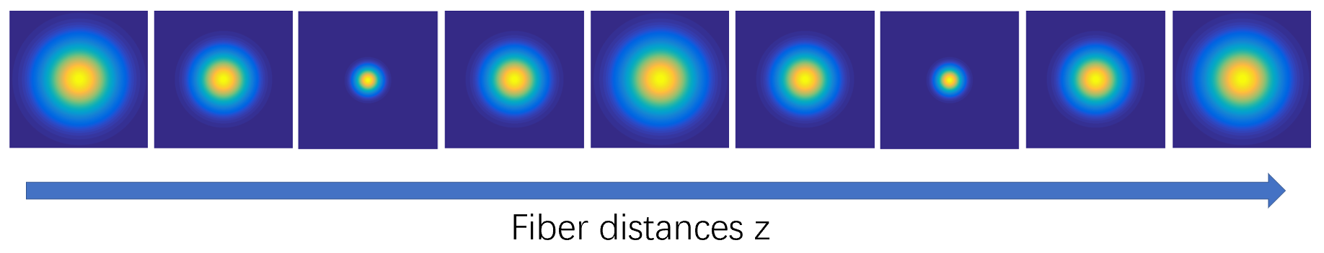
Supplementary Fig. 1. Intensity distribution of pump light at different fiber distances with 2 periods.
Supplementary Note 3 | Calculation of the signal beam width in a GRIN-fiber based Raman laser. In this paper, a nonlinear effect considered semi-analytic model of the Raman amplification process were presented. This model can simulate the propagation of both the pump and the signal Raman beams in the GRIN fiber and predict the output intensity and beam profile. From the introduction in manuscript, the nonlinear equations for the pump and signal amplitudes were in the form as following
$$\frac{∂A_{p}}{∂z}+\frac{∇_{T}^{2}A_{p}}{2iβ_{p}}+\frac{i}{2}β_{p}b^{2}r^{2}A_{p}=\frac{iω_{p}}{c}n_{2}{\left|A_{p}\right|}^{2}A_{p}$$ | (1)
$$\frac{∂A_{s}}{∂z}+\frac{∇_{T}^{2}A_{s}}{2iβ_{s}}+\frac{i}{2}β_{s}b^{2}r^{2}A_{s}=\frac{2iω_{s}}{c}n_{2}{\left|A_{p}\right|}^{2}A_{s}+\frac{g_{R}}{2}{\left|A_{p}\right|}^{2}A_{s}$$ | (2)
The solution of Eq. (1) can be present in the form shown below, when the pump is a CW source with Gaussian beam.
$$A_{p}\left(r, z\right)=\sqrt{{I_{p}}/{f_{p}}}exp\left[-\frac{r^{2}}{2w_{p}^{2}f_{p}}+iϕ_{p}\left(r, z\right)\right]$$ | (3)
Then we use it in Eq. (2) and obtain the signal amplitudes which has a similar form as
$$A_{s}\left(r, z\right)=A_{0}exp\left[-\frac{r^{2}}{2ω^{2}}+\frac{iβ_{s}h}{2}r^{2}+iψ\right]$$ | (4)
What should be noted is that parameters of $w$ and $h$ vary with the fiber length $z$. And we substitute this form of $A_{s}$ into Eq. (2), equate the real and imaginary parts on the two sides. Then the first-order differential equations for these parameters were obtain which is shown as following
$$\frac{dw}{dz}=hw-\frac{g_{R}I_{p}}{2w_{p}^{2}f_{p}^{2}}w^{3}$$ | (5)
$$\frac{dh}{dz}=\frac{1}{β_{s}^{2}w^{4}}-h^{2}-b^{2}$$ | (6)
Calculating the second derivative of 𝑤 from Eq. (5) and integrating with Eq. (6), the following equation for the signal width $w\left(z\right)$ was obtained.
$$\frac{d^{2}w}{dz^{2}}+b^{2}w=\frac{1}{β_{s}^{2}w^{3}}-\frac{{3g}_{R}P_{p}w^{2}}{2πw_{p}^{4}f_{p}^{2}}\frac{dw}{dz}$$ | (7)
Replacing $w$ with $s=w/{w_{s}}$ to get a normalized width of the signal beam, the Eq. (7) can be rewritten as
$$\frac{d^{2}s}{dτ^{2}}+s=\frac{1}{{b^{2}β}_{s}^{2}w_{s}^{4}s^{3}}-\frac{{3g}_{R}P_{p}L_{p}w_{s}^{2}s^{2}}{4π^{2}w_{p}^{4}f_{p}^{2}}\frac{ds}{dτ}$$ | (8)
where $τ=bz$, $w_{s}$ is the initial beam width of signal, $L_{p}=π/b$ is the minimum period in length of self-imaging.
To simplify the equation, two parameters of $C_{s}$ and $μ$ are defined as follow:
$$C_{s}=\frac{1}{bβ_{s}w_{s}^{2}}, μ=\frac{g_{R}P_{p}{L_{p}w}_{s}^{2}}{4π^{2}w_{p}^{4}}$$ | (9)
where $μ$ indicates the narrowing ability of the amplified Raman signal over the length of the GRIN fiber with a value of ∼10⁻⁴ and its value are inversely proportional to the fourth power of $w_{p}$, the width of the pump beam, which means that little narrowing of the signal can occur if the width of pump is much wider than signal. Then the Eq. (8) can be rewritten as
$$\frac{d^{2}s}{dτ^{2}}+\frac{3μs^{2}}{f_{p}^{2}}\frac{ds}{dτ}+s=\frac{C_{s}^{2}}{s^{3}}$$ | (10)
Supplementary Note 4 | Factor of $μ$ represents the narrowing ability of the amplified Raman signal laser. The analytically solution of normalized signal beam width takes the form as follow:
$$s\left(τ\right)=\sqrt{f_{s}\left(τ\right)}exp⁡\left(-{3μf_{s}τ}/{{2f}_{p}^{2}}\right)$$
The parameter $μ$ in the expression serves as the exponential decay term and represents the ability of beam cleanup. The evolution trend of signal beam width over the length of a fiber with 200 self-focusing cycles is shown in the figure below. When 𝜇 = 0, as depicted in figure (a), the beam width of signal laser oscillates in compresses and expands process without beam narrowing. Figure (b) shows the width of the signal beam as a function of period of self-imaging under parameter 𝜇 with different values and 𝜇3=2𝜇2=4𝜇1, from which the width of signal oscillates in a short scale under the effect of self-imaging and narrows in a long-term scale due to the beam narrowing ability of stimulate Raman scattering in the GRIN fiber, which graphically explains the principle of beam purification. What is more, the parameter 𝜇 represents the narrowing ability of the amplified Raman signal laser. The beam narrowing ability will be enhanced with the increasement of the factor 𝜇.
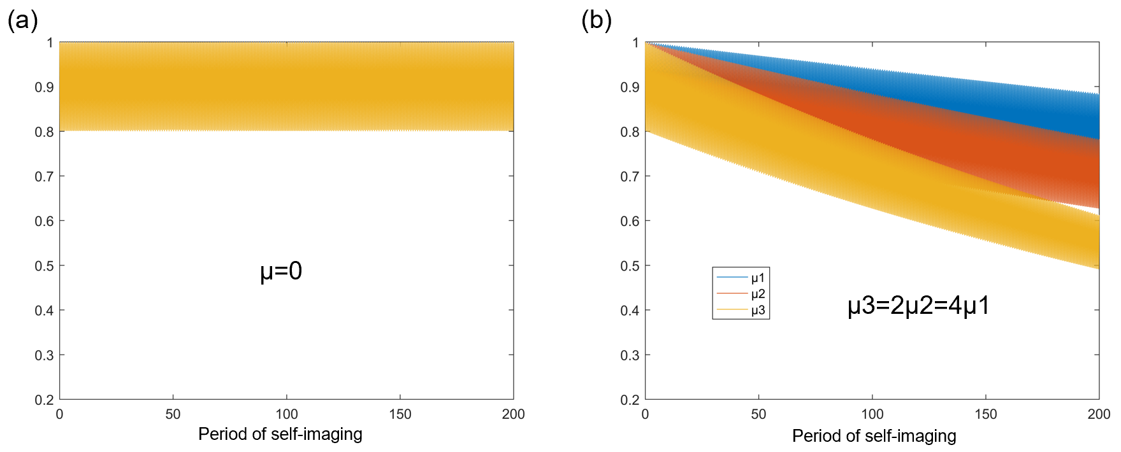
Supplementary Fig. 2. The evolution trend of signal beam width over the length of a fiber with 200 self-focusing cycles under various factor of 𝜇.
Supplementary Note 5 | Little narrowing of the signal can occur if the width of pump is much wider than signal. From the manuscript, one can find that the value of 𝜇, a parameter representing the narrowing ability, can be write in the form as
$$μ=\frac{g_{R}P_{p}{L_{p}w}_{s}^{2}}{4π^{2}w_{p}^{4}}$$
which is inversely proportional to the fourth power of pump width $w_{p}$. A much bigger pump width than signal causes a small value of 𝜇 responding to a poor narrowing ability of signal laser. The Supplementary Fig. 3 below depicts the evolution trend of signal beam width over the length of a fiber with 1000 self-focusing cycles under different pump beam width. When $ωp=ωs$, as depicted in figure (a) the beam width narrows obviously and compresses to 0.4 times of the initial one after transmitting the fiber with 1000 self-focusing cycles. As the pump beam width becomes wider to twice or triple of signal beam width, little beam narrowing of the signal can occur over the fiber length, which is shown in figure (b) and (c). So, it necessary for us to employ pump with relatively small beam width for Raman amplification to get a significant narrowing of the signal beam.
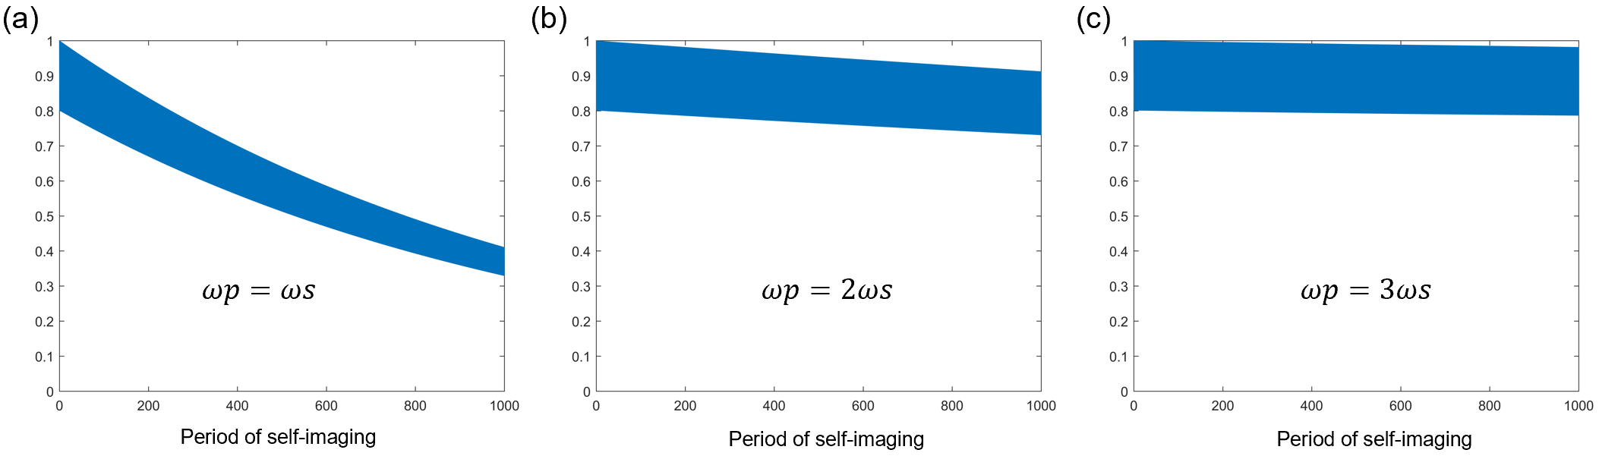
Supplementary Fig. 3. The evolution trend of signal beam width over the length of a fiber with 1000 self-focusing cycles under different pump beam width.
Supplementary Note 6 | The spectral synthesis technology-based pump is a flexible and expandable system. Each laser diode (LD) within the pump system can be controlled independently, thus the wavelength number, wavelength interval and output power can be specially designed in a want way. An appropriate number of LDs can be selected and output at a desired power level based on experimental needs, achieving optimal laser design optimization. By controlling the number of LDs, it is possible to achieve both single-spectrum output and multiple-spectrum output. As shown in supplementary Fig. 5, the spectra of the pump system with varying numbers (from 1 to 15) of LDs are presented. By employing the introduced method, a higher power of pump system at others wavelength band can be obtained in a wanted way.
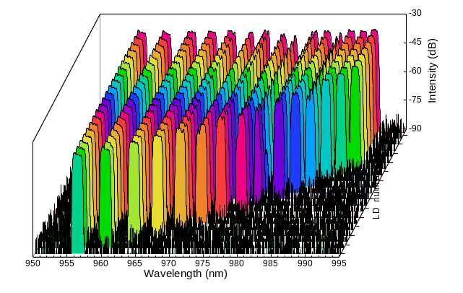
Supplementary Fig. 5. Output spectra of the spectral synthesis technology-based pump system, exhibiting high flexibility and scalability. The wavelength peaks number of the output pump can be design from 1 to 15 with central wavelength locating from 956nm to 991nm and central wavelength interval of about 3 nm.
Supplementary Note 7 | The output signal laser exhibits outstanding temporal stability. Temporal stability of fiber laser refers to the ability of a fiber laser to maintain its output parameters, such as power and wavelength pulse duration, over time in a consistent and predictable manner. This parameter is crucial in applications where precise and stable laser performance is required, such as in industrial manufacturing, medical treatment, and scientific research. In our work, we measured the temporal stability characteristics of the RFL output beams. Supplementary Fig. 6(a) shows the normalized time domain measurement result of the RFL signal output at various power levels in the time scale of 10 ms with an oscilloscope of 1 GHz bandwidth. Supplementary Fig. 6(b) depicts the referred normalized standard deviation (NSTD) of the output intensity which decreases with the power scaling to a higher power level indicating that the temporal stability of the signal laser is progressively better.
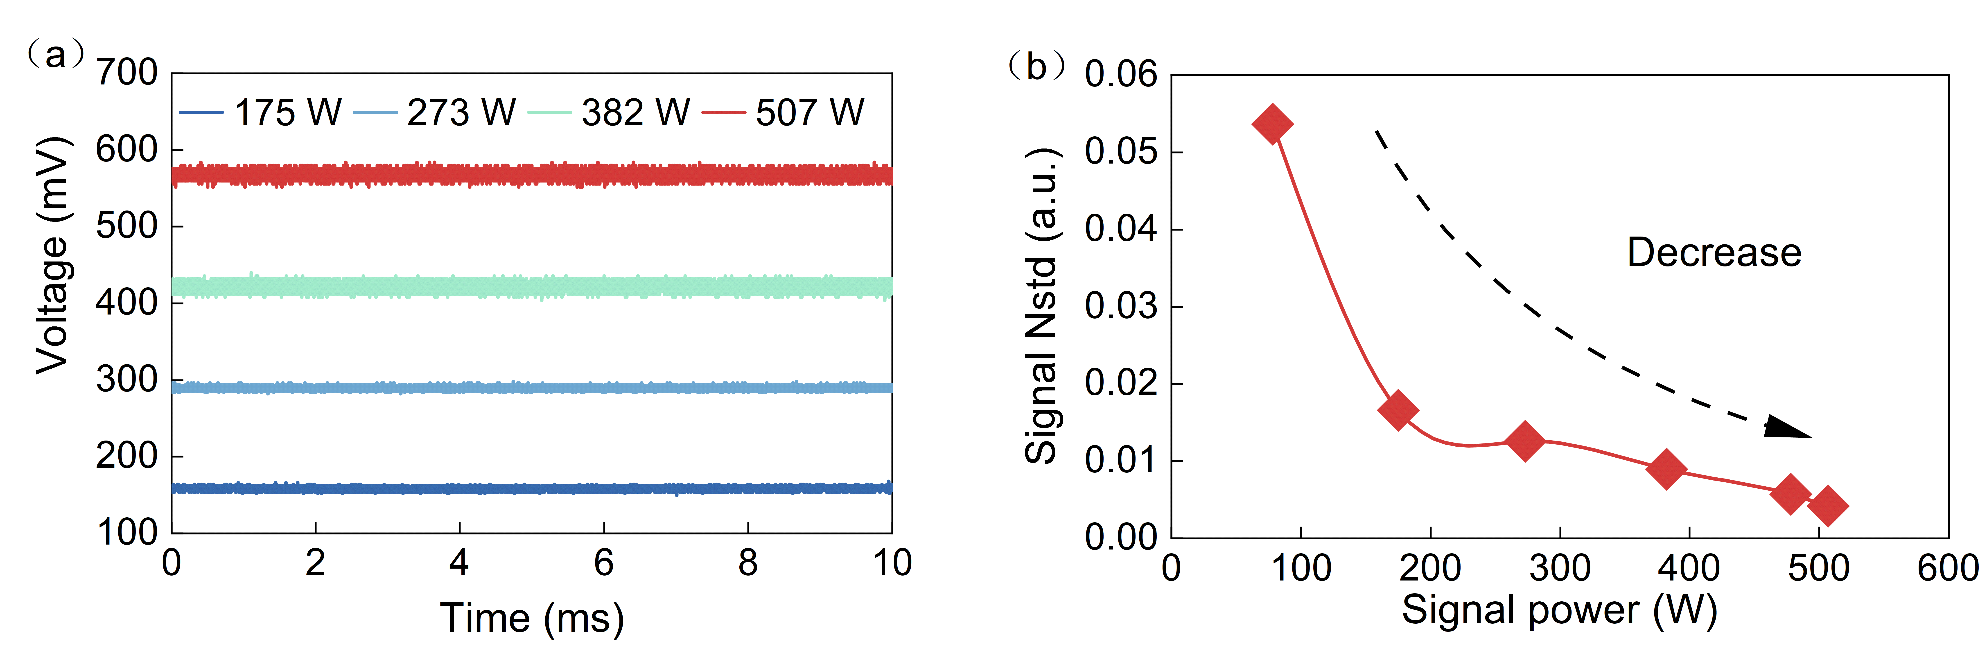
Supplementary Fig. 6. The temporal stability characteristics of the RFL output beams. (a) The normalized time domain measurement result of the RFL signal output at various power levels in the time scale of 10ms with an oscilloscope of 1 GHz bandwidth. (b) The referred normalized standard deviation (NSTD) of the output intensity indicating the great temporal stability of the signal laser.
Supplementary Note 8 | The accuracy and reliability of the MD can be verified by introducing correlation coefficient J. To confirm the reliability of the SPGD algorithm, a correlation coefficient J is employed as follow:
$$J=\left|\frac{\iint{ΔI_{re}(r,φ)ΔI_{me}(r,φ)rdrdφ}}{\sqrt{\iint{ΔI_{re}^{2}(r,φ)rdrdφ}\iint{ΔI_{me}^{2}(r,φ)rdrdφ}}}\right|$$
where $ΔI_{j}\left(r,φ\right)=I_{j}\left(r,φ\right)-{\overline{I}}_{j}\left(r,φ\right)$ with j = re, me (respectively denoting the reconstructed and measured intensity) and ${\overline{I}}_{j}$is the corresponding mean value of the intensity distribution. The value of $J$ indicates how similar is the reconstructed beam compared with the measured beam. The correlation has maximum ideal value of 1 when the reconstructed pattern is the same with the measured beam. In our MD results, the correlation coefficient J is calculated at various power through the iterative calculation of computer algorithms for 600 times (depicted in Supplementary Fig. 7(a)). The result of correlation coefficient $J$ as a function of signal power is list in Fig. 7(b) which keeps over 0.996 indicating the high accuracy of the diagnostic tool.
Supplementary Fig. 7. The value of correlation coefficient J, which is between 0 and 1. The maximum ideal value of 1 presents that the reconstructed result is same as the measured one. Through the iterative calculation of computer algorithms for 600 times, the correlation coefficient J is above 0.996 indicating the high accuracy of the diagnostic tool.
Supplementary Note 9 | Optimization of passive Raman fiber length by considering Raman conversion efficiency and high-order Raman thresholds. The output power of Raman fiber laser with different fiber length are simulated theoretically and shown in the figure below. When the fiber length is set as 80m, the Raman conversion is insufficient with value of 81.9%. With the increase of fiber length, the Raman conversion efficiency is continuously improved. When the length is 110m, the maximum value of conversion efficiency (87.8) is obtained without any generation of 2nd order Raman light. With the further increase of fiber length, the energy of signal light begins to convert to 2nd order Raman causing a decrease of Raman conversion efficiency. So, the length of 80m is the best value for the Raman system. We also compared the output power of Raman laser experimentally under various fiber length and finally determine the fiber length of 80m.
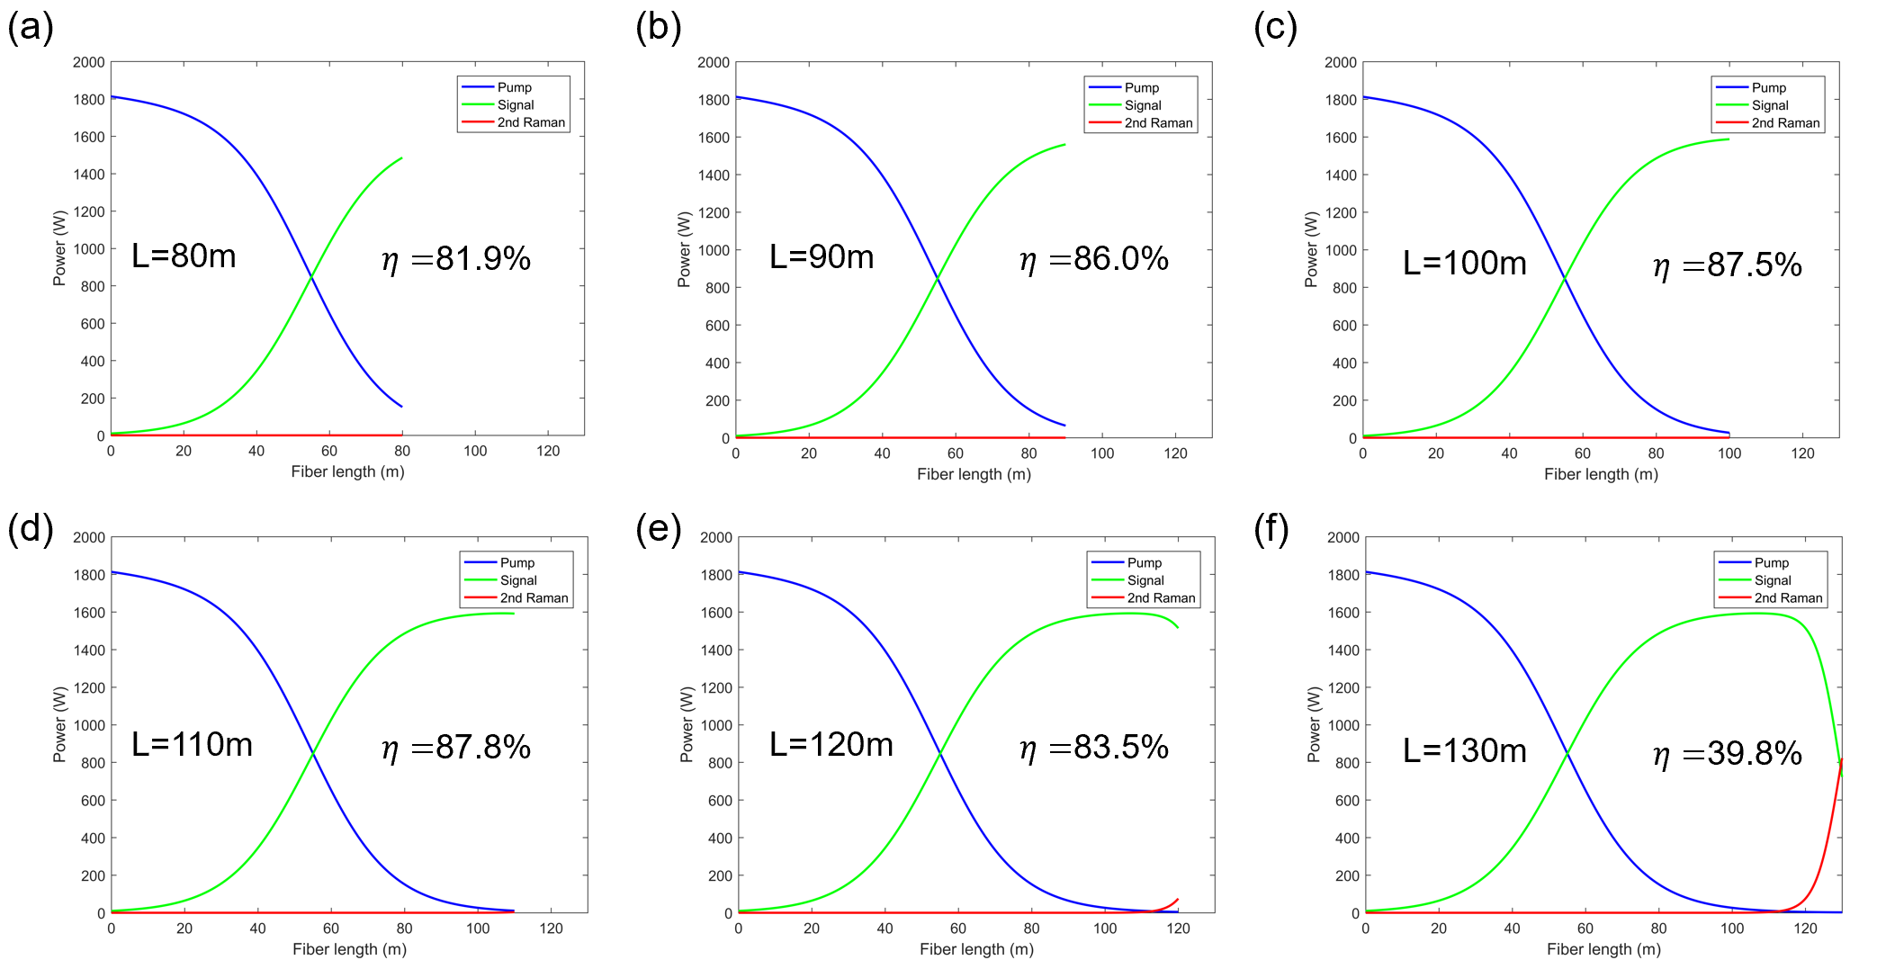
Supplementary Fig. 4. The simulation of output power of Raman fiber laser with different fiber length shows the best value of 80m.

