Direct in Situ Determination and Modulation of Asymmetric Surface Reconstruction on Rutile TiO₂ (110)

Wentao Yuan,^{1,4,5} Bingwei Chen,^{1,5} Zhong-Kang Han,^{1,2*} Ruiyang You,¹ Ying Jiang,¹ Rui Qi,¹ Guanxing Li,¹ Hanglong Wu,¹ Maria Veronica Ganduglia-Pirovano,³ Yong Wang^{1*}
¹ Center of Electron Microscopy and State Key Laboratory of Silicon Materials, School of Materials Science and Engineering, Zhejiang University, Hangzhou, 310027, China
² Fritz Haber Institute of the Max Planck Society, Faradayweg 4-6, 14195 Berlin, Germany.
³ Institute of Catalysis and Petrochemistry, ICP-CSIC, C/Marie Curie 2, 28049 Madrid, Spain.
⁴ Shanxi-Zheda Institute of Advanced Materials and Chemical Engineering, Taiyuan, 030000, China.
⁵ These authors contributed equally.
Correspondence Email: yongwang@zju.edu.cn; hanzk@zju.edu.cn

- Methods
- Preparation of rutile TiO₂ nanorods.
The rutile TiO₂ nanorods are synthesized through a facile hydrothermal method ^{1,2}, with a tunable ratio of (111) and (110) facets. In a typical synthesis process, we firstly prepare the reaction solution containing 0.015 M titanium tetrachloride (TiCl₄), by dissolving TiCl₄ directly into the hydrochloric acid (HCl) solutions (3.5 M) under strong stirring in the ice water bath. Next, 60 mL reaction solution is transferred to a teflon-lined autoclave, which is then added with 0.015 M sodium fluoride (NaF). Then the hydrothermal reaction is performed at 220 °C for 12 h in an oven. After the reaction, the autoclave is cooled down to room temperature, and the products are simply collected by centrifugal separation and are washed with deionized water 4-5 times.

- In situ STEM experiments
STEM experiments are performed in an FEI Titan G² 80-200 scanning transmission electron microscope (200 kV), with a C_{s}-corrector, providing a high spatial resolution (~0.8 Å). To acquire high quality of STEM images, all the low-order aberrations have been tuned to an acceptable level, e.g., C_{s} < 0.5 μm, A1 (2-fold astigmatism) < 2 nm, A2 (3-fold astigmatism) < 20 nm, and B2 (coma) < 20 nm. The convergence angle used in STEM imaging was ~21 mrad. The annular detection angle of high angle annular dark field (HAADF) image is set to be ~ 53-200 mrad, and the detection angle of bright field (BF) image is set to be ~ 0-20 mrad.
During the in-situ STEM experiments, the as-prepared TiO₂ nanorods are dispersed into ethanol and dropped on the heating chips, which is then moved into the TEM chamber through a double tilt heating holder (Wildfire D6, DENS solutions) with a heating rate of ~5 °C/s. Apart from directly heating our sample to 800 °C, in the step by step heating process, we set the temperature interval value to 100 °C. Because the TiO₂ crystal is extremely sensitive to the e-beam irradiation, the e-beam dose used in the experiments is set to a reasonable range.
- In situ ETEM experiments
ETEM experiments are performed in a Hitachi H-9500 environmental transmission electron microscope (300 kV), with a spatial resolution of 2 Å. A chipnova double tilt heating holder (CNT-SHBO-D) is used in our experiments. In a typical in situ heating experiment, the sample is heated to 700 °C with a heating rate of ~5 °C/s, followed by the introduction of oxygen (0.06 Pa). And the gun valve is opened only when carrying images.

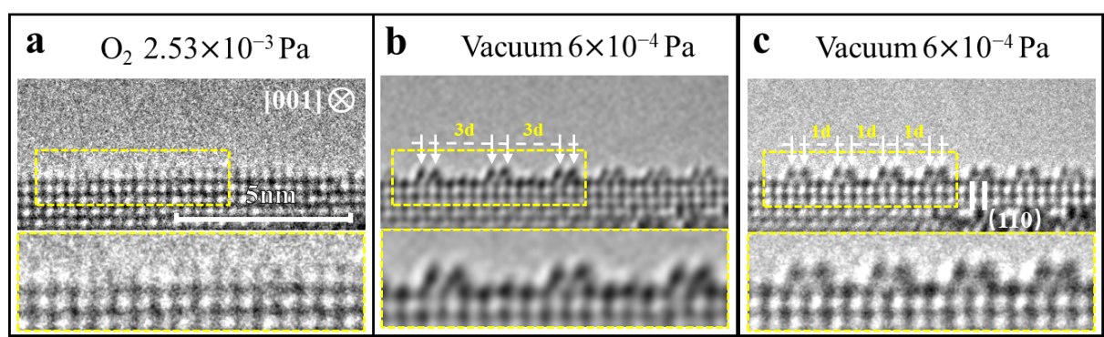
Figure S1. The ETEM images of the (1×2) reconstructed rutile TiO₂ (110) surface. (a-c) Sequential in situ ETEM images of TiO2 (110) surface at 700°C under low oxygen pressure of (a) 2.53×10⁻³ Pa and (b,c) 6.00×10⁻⁴ Pa. The enlarged images of the dotted rectangles are shown in the lower panels of (a−c), respectively. (d) Intensity profiles along the dashed lines in the lower panels of (a−c). The dash lines are acquired from the reconstructed layer. (e) Enlarged side view for the first four layers.

Figure S2. Multiple distributions of the small polarons/Ti³⁺ ions in the near-surface of the Ti₂O₃-(1×2) reconstruction. (a-f) The asymmetric Ti₂O₃-(1×2) reconstructions and (g-j) the symmetric Ti₂O₃-(1×2) reconstructions together with the spin charge density distributions. The titanium and oxygen atoms are represented by white and red balls, respectively. The energy values are relative to the most stable configuration.

Table S1. The formation energy of the asymmetric Ti₂O₃-(1×2) reconstruction relative to its symmetric counterpart at different temperatures incorporating vibrational entropy correction.
energy/eV | 0 K | 300 K | 600 K | 900 K
 | -0.31 | -0.39 | -0.47 | -0.63

Table S2. The formation energy of the asymmetric Ti₂O₃-(1×2) reconstruction relative to its symmetric counterpart for different computational setup.
energy/eV | 2×1×1 k-points; 400 eV | 2×1×1 k-points; 500 eV | 4×2×1 k-points; 400 eV | 4×2×1 k-points; 500 eV
U = 3.6 | -0.31 | -0.33 | -0.32 | -0.33
U = 4.1 | -0.31 | -0.33 | -0.33 | -0.34
U = 4.6 | -0.32 | -0.35 | -0.33 | -0.35

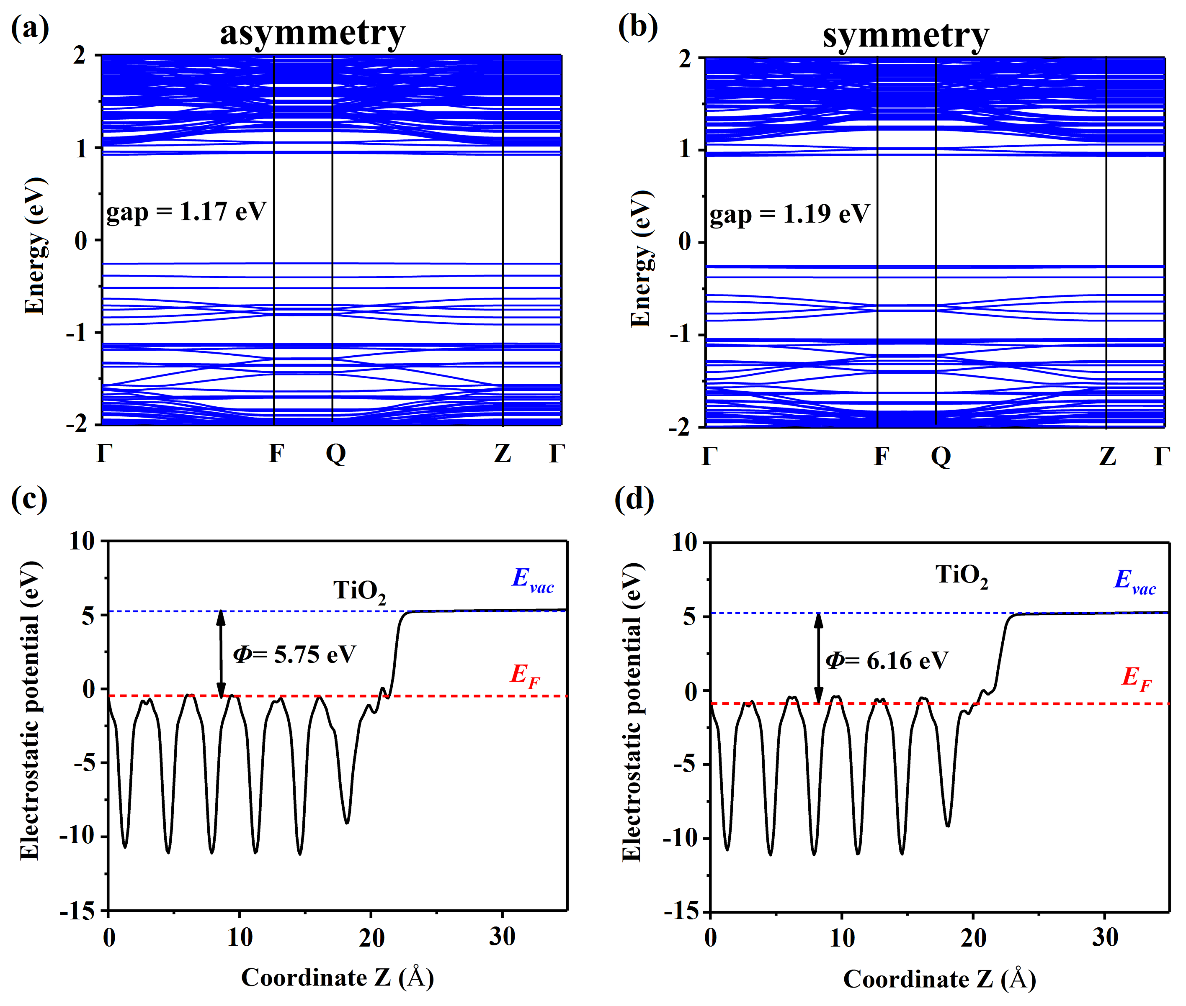Figure S3. Bandstructures and work functions of the most stable (a, c) asymmetric and (b, d) symmetric Ti₂O₃-(1×2) reconstructions.

References:
1. Lai, Z. et al. A new insight into regulating high energy facets of rutile TiO₂. J. Mater. Chem. A 1, 4182 (2013).
2. Huang, Q. et al. A Simple Route for the Synthesis of Rutile TiO₂ Nanorods. Chem. Lett. 32, 638 (2003).

