Supplementary figure S1.

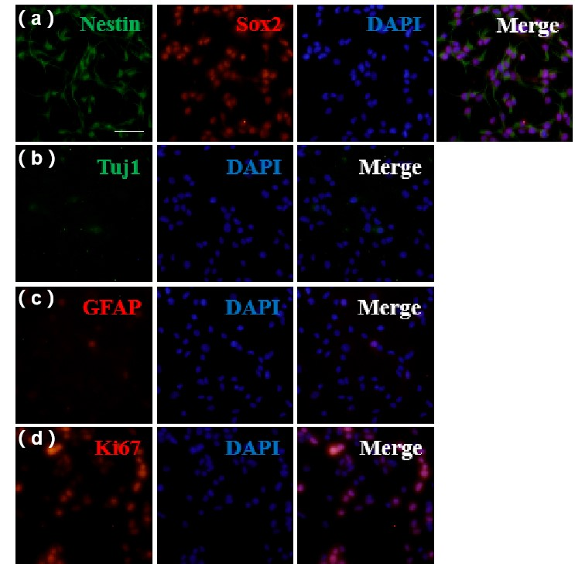
S1. Characterization of E16-NSCs Phenotypic Properties
Primary cortical neural stem cells (E16-NSC) grown at clonal density in medium generated epithelial-like clones positive for NSC markers. (a) Representative immunofluorescent images of Nestin (green) and SOX2(red) staining for NSC. (b) Representative immunofluorescent image of TUJ1 (green) staining for neuronal cells; (c) Representative images of GFAP (red) staining for astrocytes; (d) Representative immunofluorescent images of Kir67 (red) staining for the proliferation cells. DAPI was used to stain the cell nucleus (blue). Scale bar, 100 μm. n = 3 independent experiments in triplicate.

Supplementary figure S2.
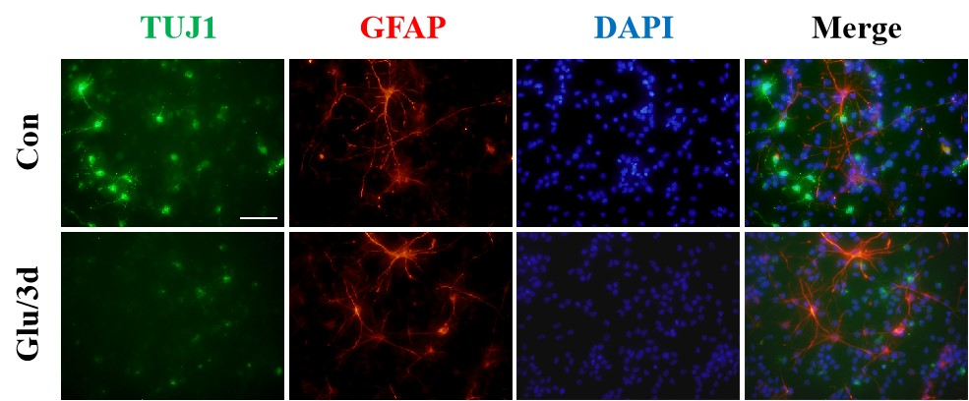

S2. Characteristics of E16-NSCs cells after glutmate stimulation
Immunostaining of Primary cortical neural stem cells (E16-NSC) after glutamate treatment. TUJ1 for neurons; GFAP for astrocytes. Nuclei were stained with DAPI (blue). Scale bars correspond to 100 μm. n = 3 independent experiments in triplicate.

