Table (1): Distribution of the students according to social and demographic characteristics (n = 400)
Demographic data | Frequency n = 400 | %
  Sex
  Male
  Female
  90
  310
  22.5
  77.5
Age (years)  18< 20  20< 22  22+ | 185  170  45 | 46.25  42.5  11.25
Min-Max  Mean± SD | 18 -24  20.02 ±1.35
Residency
Urban | 98 | 24.5
Rural | 302 | 75.5
Marital status  Single  Married | 367  33 | 91.8  8.2
Perception of monthly expense
Inadequate | 108 | 27.0
Adequate | 292 | 73.0

Table (2): Distribution of students’ academic probertites
Academic characteristics | Frequency N = 400 |  |  | %
Year of enrollment
- First | 100 |  |  | 25.0
- Second | 100 |  |  | 25.0
- Third | 100 |  |  | 25.0
- Fourth | 100 |  |  | 25.0
Student's academic achievement in previous academic year (n = 300) *
- Failure | 2 |  |  | 0.6
- Pass | 5 |  |  | 1.7
- Good | 35 |  |  | 11.7
- Very Good | 123 |  |  | 41
- Excellent | 135 |  |  | 45
Extra-curricular activities
- No  - Yes |  | 331  69 |  |  | 82.8  17.2
* First year was not among the student's grade in previous academic year.

Figure (2): Distribution of students according to total score of defensive pessimism (n = 400).

Figure (3): Distribution of students according to total score of goal orientation (n = 400).
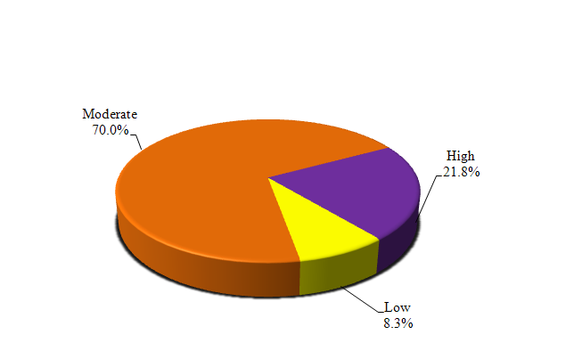
Figure (4): Distribution of students according to total score of self-esteem
(n = 400).
Table (3): Correlation between defensive pessimism, goal orientation and self-esteem among studied students (n = 400)
 | Defensive Pessimism |  | Self esteem
 | R | P | r | p
Goal Orientation | 0.291* | <0.001* | -0.041 | 0.411
- Mastery-approach goals | - | - | 0.335* | <0.001*
- Mastery-avoidance goals | - | - | -0.351* | <0.001*
- Performance-approach goals | - | - | 0.142* | <0.001*
- Performance-avoidance goals | - | - | -0.225* | <0.001*
Self esteem | -0.246* | <0.001* | - | -
r: Pearson coefficient
*: Statistically significant at p ≤ 0.05

Table (4): Relation between mean scores of defensive pessimisms, goal orientation, self-esteem, and social and demographic and academic probertites of students (n = 400)
Socio-Demographic and academic characteristics | N | Defensive pessimism |  | Goal orientation |  | Self Esteem
Socio-Demographic and academic characteristics | N | Mean ± SD. | Median | Mean ± SD. | Median | Mean ± SD. | Median
Sex
Male | 90 | 65.22 ± 13.49 | 65.48 | 61.79 ± 19.53 | 61.11 | 65.78 ± 17.26 | 70.0
Female | 310 | 63.02 ± 12.70 | 64.29 | 65.68 ± 15.21 | 65.28 | 64.70 ± 15.98 | 63.33
U(p) |  | 12614.50 (0.166) |  | 13116.0 (0.386) |  | 12078.0 (0.052)
Residency
Urban | 98 | 65.46 ± 12.56 | 66.67 | 62.90 ± 15.90 | 63.19 | 67.72 ± 15.52 | 70.0
Rural | 302 | 62.88 ± 12.96 | 64.29 | 65.42 ± 16.46 | 65.28 | 64.04 ± 16.41 | 63.33
U(p) |  | 13202.0 (0.108) |  | 12719.0* (0.036*) |  | 14133.50 (0.504)
Marital status
Single | 367 | 63.76 ± 12.99 | 64.29 | 64.90 ± 16.41 | 65.28 | 64.51 ± 16.44 | 63.33
Married | 33 | 60.79 ± 11.63 | 61.90 | 63.72 ± 15.74 | 65.28 | 69.70 ± 13.39 | 66.67
U(p) |  | 5320.50 (0.248) |  | 5032.0 (0.106) |  | 5675.50 (0.550)
Monthly expense
Inadequate | 108 | 66.24 ± 13.93 | 67.26 | 67.55 ± 15.14 | 66.67 | 60.80 ± 17.72 | 63.33
Adequate | 292 | 62.51 ± 12.36 | 64.29 | 63.78 ± 16.67 | 63.89 | 66.47 ± 15.44 | 66.67
U(p) |  | 12994.50* (0.007*) |  | 12983.0* (0.006*) |  | 13722.50* (0.046*)
Year of enrollment
First | 100 | 66.67 ± 11.62 | 66.07 | 67.15 ± 17.05 | 68.06 | 64.23 ± 19.39 | 70.0
Second | 100 | 64.14 ± 13.08 | 65.48 | 65.01 ± 13.61 | 65.28 | 66.70 ± 15.50 | 70.0
Third | 100 | 61.02 ± 14.09 | 63.10 | 64.86 ± 17.65 | 65.97 | 62.33 ± 15.71 | 63.33
Fourth | 100 | 62.23 ± 12.12 | 63.69 | 62.18 ± 16.61 | 62.50 | 66.50 ± 13.76 | 66.67
H(p) |  | 11.066* (0.011*) |  | 5.413 (0.144) |  | 5.700 (0.127)
Student's academic achievement in previous academic year
Failure | 2 | 71.43 ± 0.0 | 71.43 | 69.44 ± 0.0 | 69.44 | 56.67 ± 0.0 | 56.67
Pass | 5 | 60.0 ± 2.99 | 59.52 | 61.39 ± 19.40 | 73.61 | 46.67 ± 30.0 | 46.67
Good | 35 | 60.51 ± 15.32 | 63.10 | 64.76 ± 22.10 | 70.83 | 55.52 ± 18.86 | 56.67
Very Good | 123 | 61.09 ± 13.59 | 63.10 | 62.37 ± 16.96 | 62.50 | 64.99 ± 14.79 | 63.33
Excellent | 135 | 65.46 ± 11.90 | 66.67 | 66.32 ± 14.77 | 66.67 | 66.88 ± 15.70 | 70.0
H(p) |  | 15.334* (0.004*) |  | 14.435* (0.006*) |  | 5.704 (0.222)
Extra-curricular activities
No | 331 | 62.91 ± 13.04 | 64.29 | 65.09 ± 16.24 | 65.28 | 64.12 ± 16.02 | 63.33
Yes | 69 | 66.43 ± 11.82 | 66.67 | 63.41 ± 16.87 | 62.50 | 68.89 ± 16.94 | 70.0
U(p) |  | 9192.0* (0.011*) |  | 9318.50* (0.016*) |  | 10399.0 (0.242)

SD: Standard deviation U: Mann Whitney test H: H for Kruskal Wallis test
p: p value for comparing between the studied categories *: Statistically significant at p ≤ 0.05.

