Supplementary Documents

Table S1, Additional file 1. Primers used for amplifying SeHAS and the variants in this study.
Primer Sequence  5' 3' | Deleted domains | Construct name
F: ggaattcCATATGagaacattaaaaaacctcataactg  R: cccgCTCGAGtaataattttttacgtgttcc | None | SeHAS
F: acgCATATGagaacattaaaaaacctc  R: cgaCTCGAGatcaaattctctgacattgc | TMD5 TMD4 | HAS₁₂₃
F: gatCATATGgctaaaggaagcttgtcaatttatgg  R: cgaCTCGAGatcaaattctctgacattgc | TMD1  TMD4 TMD5 | HAS₂₃
F: tacCATATGaagccatttaagggaagg  R: ataCTCGAGaggattgttcatgattttcttaacag | TMD1 TMD2  TMD3  TMD4  TMD5 | HAS_{Intra}

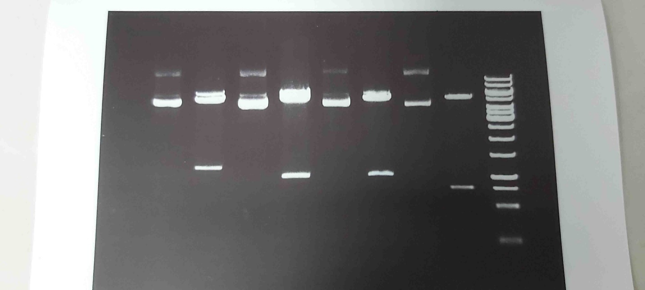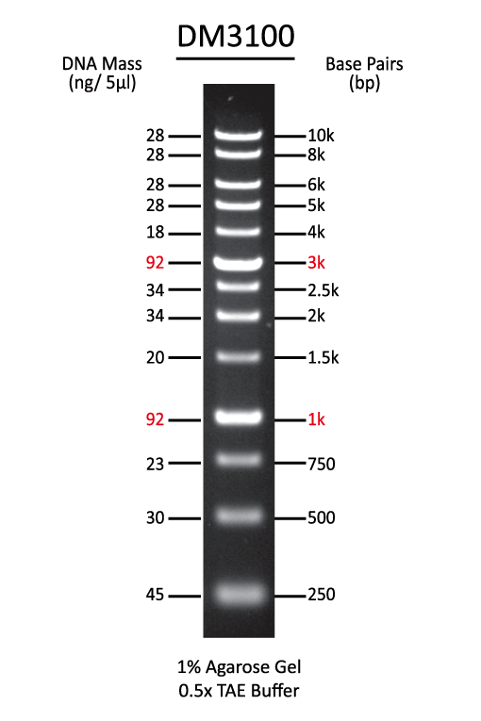
1271 bp
807 bp
1065 bp
981 bp
1 2 3 4 5 6 7 8 M
Fig. S1, Additional file 2. Restriction map analysis of recombinant plasmids using XbaI and NdeI restriction enzymes [Lane 1: undigested pET-28a(+)-SeHAS plasmid, Lane 2: digested pET-28a(+)-SeHAS, Lane 3: undigested pET-28a(+)-HAS₂₃ plasmid, Lane 4: digested pET-28a(+)-HAS₂₃ plasmid, Lane 5: undigested pET-28a(+)-HAS₁₂₃ plasmid, Lane 6: digested pET-28a(+)-HAS₁₂₃ plasmid, Lane 7: undigested pET-28a(+)-HAS_{Intra} plasmid, Lane 8: digested pET-28a(+)-HAS_{Intra} plasmid, and M: DNA marker.]

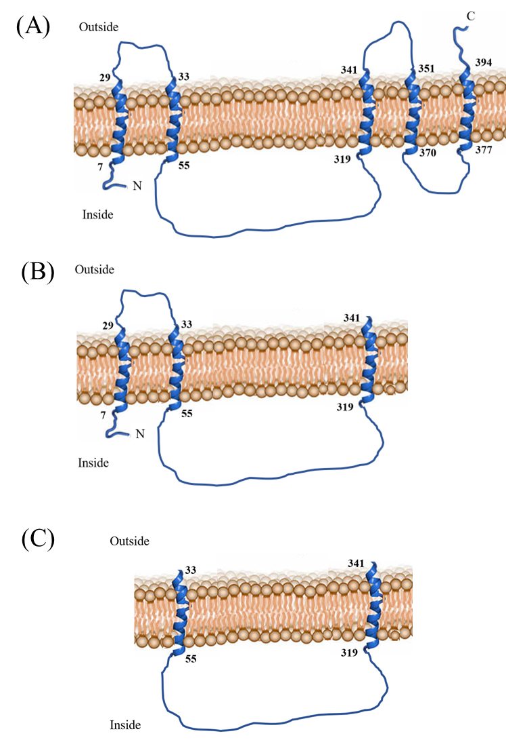
Fig. S2, Additional file 3. Membrane-topology models for (A) seHAS, (B) HAS₁₂₃, and (C) HAS₁₂. The numbers within each TMD indicate the starting and ending residues.
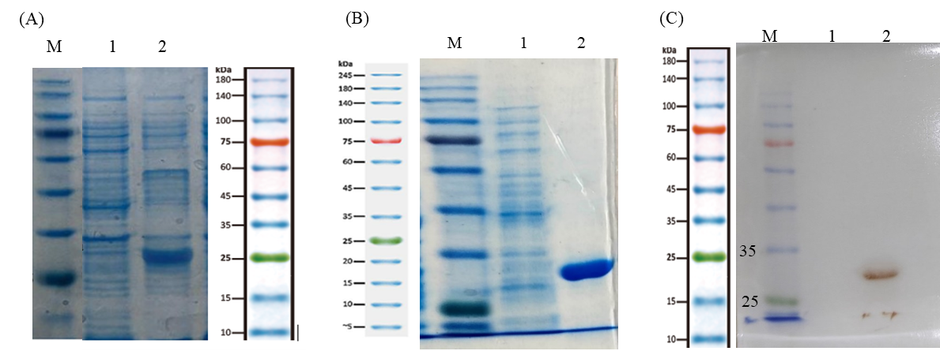

Fig. S3, Additional file 4. 12% SDS-PAGE and western blot analysis of recombinant HAS_{Intra}. [(A) Lane 1: uninduced cell lysate; Lane 2: induced cell lysate. (B) Lane 1: uninduced cell lysate; Lane 2: eluted fraction, (C) Lane 1: uninduced cell lysate; Lane2: eluted fraction, and Lane M; protein marker].

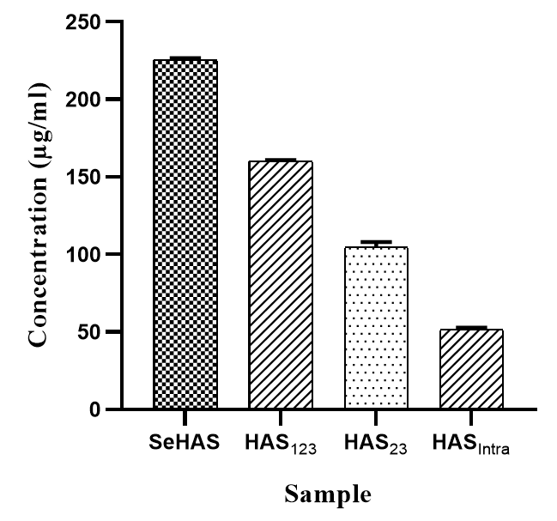
Fig. S4, Additional file 5. Quantitative measurement of HA synthesized in the enzymatic reactions after purification. Data are represented as Mean ± SD from three independent measurements.

