Supplemental Information

Materials and Methods
Cell Culture and Virus Growth
Vero E6 cells modified to stably express TMPRSS2 (Vero E6/TMPRSS2 cell, obtained from NIBSC, UK) and Vero E6 cells modified to stably express human ACE2 and TMPRSS2 (Vero E6/ACE2/TMPRSS2 (VAT) cells (25)) are cultured in Dulbecco’s Modified Eagle Medium (DMEM, high glucose; Sigma, UK) supplemented with 10% foetal bovine serum (FBS, Sigma) at 37°C and 5% CO_{2(g)}, 100 units/ml penicillin (Gibco, UK), 100 µg/ml streptomycin (Gibco, UK), and L-glutamine (Gibco, UK).

Viral stocks of the B.1.617.2 (Delta) (GISAID ID: EPI_ISL_1731019) and Omicron (BA.2) VOCs are prepared using VAT cells grown to confluence in T75 flasks. The cells are infected at different multiplicities of infection (MOI) of 0.01 and 0.1 and the infected cells grown in Eagle’s Minimal Essential Medium (MEM) supplemented with 2% FBS for either 24-hours (for Delta) or 72-hours (for BA.2) post-infection for virus production. After the incubation (37°C, 5% CO₂) period, the culture supernatant is collected, centrifuged (250 g, 10 minutes), filtered (0.22 µm), aliquoted and frozen (-80 °C). The Delta VOC (TCID₅₀/mL of 3.4 × 10⁷) grows to a higher titre than the BA.2 VOC (TCID₅₀/mL of 3.1 × 10⁶).

CELEBS – Airborne Longevity Measurements
The airborne stability of SARS-CoV-2 variants is measured using the Controlled Electrodynamic Levitation and Extraction of Bioaerosol onto a Substrate (CELEBS) technique. This has been described in detail previously for the study of both bacterial (1, 2) and viral species (3-5). Briefly, a starting formulation containing the virus is loaded into a droplet-on-demand dispenser. Depending on the magnitude and pulse width used to activate the dispenser, the starting radius of the droplet will range between ~17 to ~25 microns. The dispenser is positioned near an induction electrode such that during droplet generation, ion migration (e.g. Na⁺) in the jet results in the production of an individual droplet with a slight net charge (<5fC from ion imbalance) when the jet collapses. The individual droplets are then levitated by the electrodynamic fields produced by the ring electrodes within the core of the CELEBS.

A laminar air flow is passed over the region in which the droplets are levitated such that the chemical composition, relative humidity and temperature of the air can be controlled and monitored. After a set time period, ranging from <5 seconds through to 40 minutes, the electric fields are manipulated such that the droplets are deposited into a Petri dish filled with 6 mL of DMEM containing 2% FBS. Within 15 minutes post deposition (typically under 5 minutes), the 6 mL of virus containing medium is added in 100 µL aliquots to the central 60 wells (containing confluent Vero-E6/TMPRSS2 cells) of a 96 well plate. After 3-5 days incubation (in 37ºC, >99% RH, 5% CO₂), the number of wells showing the characteristic cytopathic effect (CPE) of SARS-CoV-2 are tabulated, and the number of viral particles that maintained their infectivity throughout the levitation process is calculated as previously described (3). Each day, the infectivity is normalized to the infectious units per droplet of those levitated at 90% RH and <5 seconds (conditions under which no loss of viral infectivity is seen), termed the time (T)=0 point.

We previously reported that the physicochemical properties of aerosol particles composed of MEM and artificial saliva are similar (14, 15). As well as broad similarities in composition, these properties include the aerosol pH, which changes from neutral to >10 following generation (resulting from a similar initial bicarbonate concentration), as well as a variability in particle phase and morphology when the RH is between the deliquescence (~75%) and efflorescence (~50%) RHs of the aerosol. For MEM, all aerosol particles are homogeneous liquids containing no precipitate above an RH of 85%, while all particles contain a large proportion of crystalline salt below 45% RH. Indeed, initially formed droplets of MEM and saliva have similar concentrations of salts (to ensure a stable osmotic pressure for cell growth) and NaHCO₃ (because both are at equilibrium with ~5% CO₂). Thus, MEM can be considered a good proxy for saliva as they share the underlying physicochemical properties that govern viral aerostability. Indeed, we have shown that the infectivity recorded at high and low RH and over the first 120s of levitation (enough time for the majority of the viral infectivity to be lost) there are not significant in their differences. As a consequence, MEM is used as the droplet medium in this study and infectivity measurements were undertaken in conditions where the structure of the particles are known to be homogeneous, specifically at RHs of 40% and 90%.

Bulk Stability Measurements
The stability of the Delta and BA.2 variants in bulk solutions is assessed either by TCID₅₀ assay detection of infectious virus or by immunostaining. In the TCID₅₀ assay, the virus stock is first diluted 1 in 10,000 in DMEM with 2% FBS which is adjusted to a pH of 11 with NaOH. After a set incubation period at 20°C in open air, the sample is then serially diluted into neutral DMEM containing 2% FBS and the TCID₅₀/ml of each sample is then measured. For all samples, the TCID₅₀/ml is normalised to a sample that is not exposed to a change in the growth medium pH.

In the immunostaining approach, the virus stock is diluted 1:40 in DMEM with 2% FBS (pH 11). After a set incubation period, the sample is then diluted 1:15 in DMEM with 2% FBS (pH 7.0). 100 µL of the diluted virus is then added to well of a 96 well plate seeded with Vero E6/TMPRSS2 cells the day prior. After an 18 hour incubation (37ºC, 5% CO₂), the cells are fixed in 4% (v/v) paraformaldehyde for 60 minutes. Fixed cells are then permeabilized (0.1% Triton-X100 in PBS) and blocked (1% (w/v) bovine serum albumin) prior to being stained with a monoclonal antibody against the SARS-CoV-2 nucleocapsid protein (N) (1:2000 dilution; 200-401-A50, Rockland) followed by an appropriate Alexa Fluor-conjugated secondary antibody (ThermoFisher) and DAPI (Sigma Aldrich). Images of the wells are collected (ImageExpress Pico automated imaging platform (6)), and the number of infected cells tabulated.

Statistical Analysis
Error bars provided in the figures are reporting standard error. Significance was measured using a two-sample t-test with equal variance, where the p-values are reported as being less than 0.5, 0.05 or 0.005. When multiple variables were explored, a two-way ANOVA was used to assess the interaction between them (e.g. effect of [CO_{2(g)}] and RH on aerostability).

Results
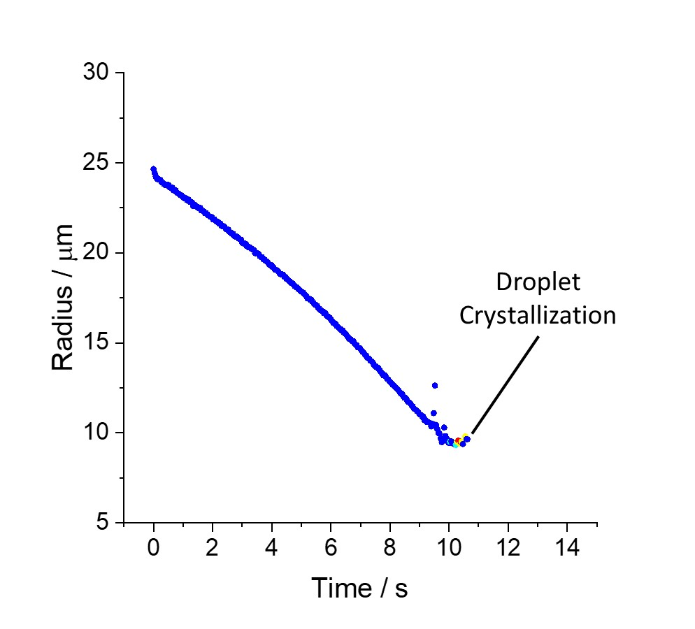
Supplemental Figure 1: The evaporation profile of MEM droplets containing 2X the amount of NaCl when injected into an airflow where the RH was 69% measured with a comparative kinetic electrodynamic balance (CK-EDB) as described previously (7). Once the droplet becomes a non-spherical/non-homogeneous/amorphous solid, the droplet is no longer spherical and thus cannot be sized using Mie theory.

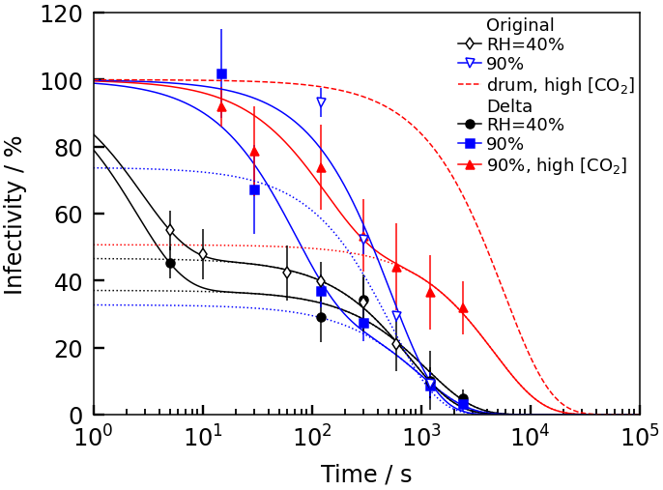
Supplemental Figure 2: Decay profile fits to the CELEBS infectivity data with two exponentially decaying functions, to capture the distinct short and long decays. We show the complete fits of the data from a two-step exponential decay (solid lines), and also just the longer time part of this fit (dotted lines). We show also the standard 1.1hr decay assumed in the literature from drum studies (dashed red).

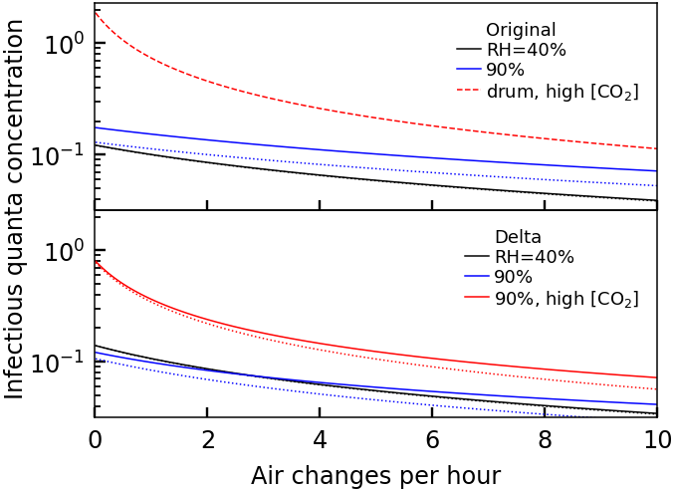
Supplemental Figure 3: Concentration of infectious quanta in a 300m³ classroom using two-step decay fits to CELEBS data (solid lines) and just the longer time one-step decay (dotted lines). The incomplete latter fit captures the behavior very well at 40% RH, but deviates at 90% because the two-timescales in the complete fit are not neatly separated. We show also the standard 1.1hr decay assumed in the literature from drum studies (dashed red in top panel).

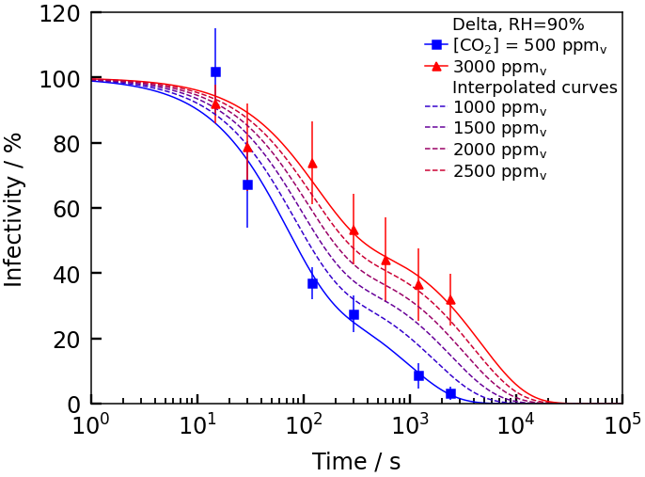
Supplemental Figure 4: Delta data fits (solid lines) and their crude linear interpolation across CO₂ concentration for illustration purposes (dotted lines).

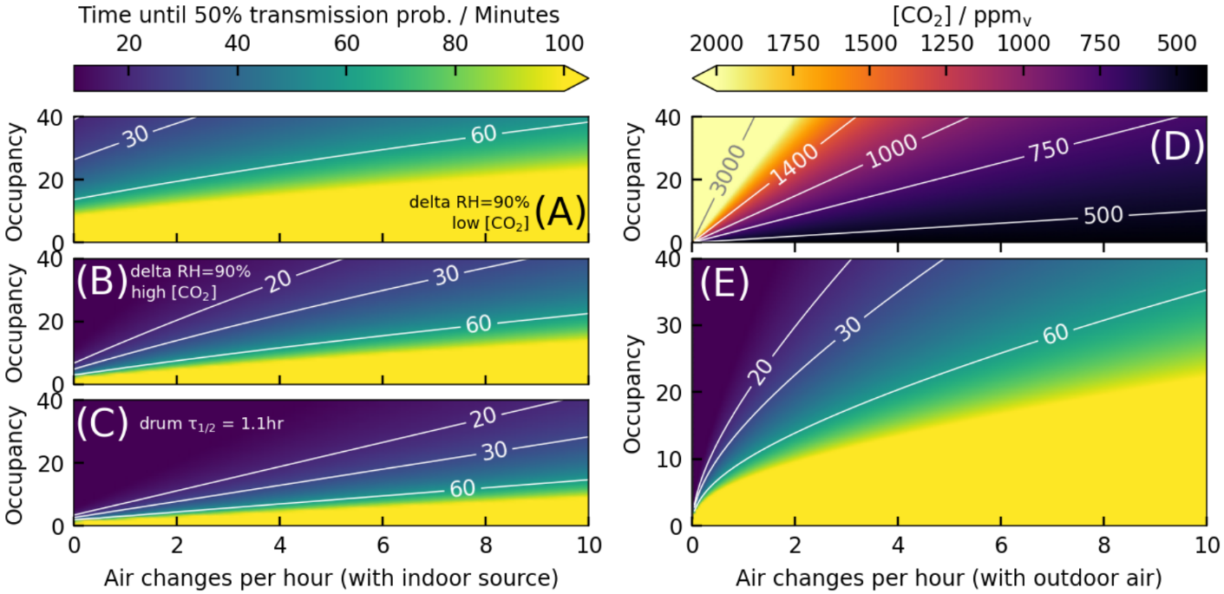
Supplemental Figure 5: (A-C) Time until there is a 50% chance that at least one susceptible person will have become infected in an occupied classroom containing a single infected individual. We neglect the coupling between ventilation and [CO₂], instead using the fits to the data at fixed [CO₂], so this models air exchange with an interior source. (D) Variation in [CO₂] with occupancy and ventilation. (E) Sketch of how factoring in CO2 changes the time using the linear interpolation shown in Supplemental Figure 4 for delta at 90% RH. This interpolation is purely intended to illustrate the nonlinear role of ventilation qualitatively, and so the numbers in (E) should not be taken literally. An infectious quanta production rate of 0.1s⁻¹ is assumed in (A-C,E).

Fits of experimental data
For the Wells-Riley calculation, we fit each experimental dataset to a double exponential decay model which is more convenient for calculations. Specifically, we perform a least-squares fit of the infectivity to
$$I\left(t\right)=Aexp\left(\frac{-t}{τ_{1}}\right)+\left(1-A\right)exp\left(\frac{-t}{τ_{2}}\right)$$
where t is time, τ₁ and τ₂ are characteristic decay times, and A is a dimensionless factor representing the relative amplitude of each decay mode. The first term represents an initial short-time decay, whereas the second term represents slower decay at longer times. In Supplemental Figure 2 we show the results of fitting the raw data (solid lines) and just the slower decay at longer times (dotted lines) to show the relative size of the second mode.
Infectious quanta concentration
For the Wells-Riley calculations we must calculate the expected concentration of infectious quanta in the well-mixed environment. A droplet produced at some time Δt before the present will still be around and infectious with probability p_{active} I. The total number of droplets still around at time 𝑡 is then obtained by integrating over all Δt>0 i.e. over all the past. Writing α as the rate of production, we therefore find the concentration is:
$$c=α\int_{0}^{∞}{p_{active}\left(Δt\right)I\left(Δt\right)dΔt}$$
We show the result of this calculation in Supplemental Figure 3 for our assumed quanta production rate of α = 0.1s⁻¹.

Varying CO₂
For the Delta variant at 90% relative humidity we have two datasets at CO₂ concentrations of 500ppm and 3000ppm. To obtain use data at intermediate concentrations for illustration purposes we interpolate the fit parameters (A, τ₁, τ₂) and insert them into the same fitting function. The results of this interpolation are shown in Supplemental Figure 4.
To estimate the CO₂ concentration in a room of N occupants at fixed volume, we again assume the air is well-mixed so the concentration is uniform and that the CO₂ produced by the occupants is constant. We take the average per-person CO₂ production rate typical of a high school classroom as R=0.0065l/s [2]. The expected [CO₂] is then
$$\left[CO_{2}\right]={\left[CO_{2}\right]}_{0}+N\frac{R}{Q}$$
where Q is the volumetric flow rate out of the room, and we take the background [CO₂]₀ as 420ppm for direct exchange with outdoor air. The resulting concentration for the 300m3 classroom with different occupancies and ventilation rates is shown in Supplemental Figure 5D.
Finally, we calculate the time until the risk of transmission reaches 50% for occupancies in the range of 0-40 at fixed [CO₂] in Supplemental Figure 5A-C, and with varying [CO₂] using the interpolations of Supplemental Figure 4 and the calculation above for the [CO₂]. These contour plots show the same data as in the main text but across the full range of occupancies.

Supplemental References

1. M. O. Fernandez et al., Assessing the airborne survival of bacteria in populations of aerosol droplets with a novel technology. J R Soc Interface 16, (2019).
2. M. O. Fernandez, R. J. Thomas, H. Oswin, A. E. Haddrell, J. P. Reid, Transformative Approach To Investigate the Microphysical Factors Influencing Airborne Transmission of Pathogens. Appl Environ Microb 86, (2020).
3. H. P. Oswin et al., Measuring stability of virus in aerosols under varying environmental conditions. Aerosol Sci Tech 55, 1315-1320 (2021).
4. H. P. Oswin et al., The dynamics of SARS-CoV-2 infectivity with changes in aerosol microenvironment. Proc Natl Acad Sci U S A 119, e2200109119 (2022).
5. R. W. Alexander et al., Mucin Transiently Sustains Coronavirus Infectivity through Heterogenous Changes in Phase Morphology of Evaporating Aerosol. Viruses 14, 1856 (2022).
6. A. Haddrell et al., Differences in airborne stability of SARS-CoV-2 variants of concern is impacted by alkalinity of surrogates of respiratory aerosol. J R Soc Interface 20, 20230062 (2023).
7. A. Haddrell, G. Rovelli, D. Lewis, T. Church, J. Reid, Identifying time-dependent changes in the morphology of an individual aerosol particle from its light scattering pattern. Aerosol Sci Tech 53, 1334-1351 (2019).

