Supplementary File
Household-level effects of seasonal malaria chemoprevention in the Gambia
Soremekun et al

STable 1. Entomological baseline study
Entomological collections were conducted over the period survey July 2021-December 2021 in 10 communities in the Upper River Region of the Gambia. Three-monthly nightly catches took place in a random selection of 6 households in each village, using Centre for Disease Control (CDC) light traps.
Trap location | Mean nightly biting rate* | Min-max
CDC light trap | 0.97 (1.41) | 0-4.94
*Anopheles gambiae s.l. and Anopheles funestus combined.
STable 2. Temperature and rainfall data from Basse Meteorological Station 2019-2021
Month and year | Maximum temperatures (°C) per month | Mean rainfall (mm) per month
2019 malaria transmission season
July 2019 | 33.3 | 86.7
August 2019 | 32.8 | 343.8
September 2019 | 32.1 | 357
October 2019 | 33.8 | 76.9
November 2019 | 36.4 | 0
December 2019 | 36.4 | 0
January 2020 | 33.5 | 0
2020 malaria transmission season
July 2020 | 32.9 | 314.5
August 2020 | 31.0 | 211.2
September 2020 | 30.8 | 565.7
October 2020 | 35.1 | 95
November 2020 | 35.6 | 0
December 2020 | 36.7 | 0
January 2021 | 37.2 | 0
2021 malaria transmission season
July 2021 | 36.5 | 130.5
August 2021 | 32.9 | 271.4
September 2021 | 33.6 | 212
October 2021 | 35.2 | 99.4
November 2021 | 34.5 | 0
December 2021 | 35.2 | 0

STable 3. Akaike and Bayesian Information Criteria (AIC and BIC) for SMC coverage models by low-group cut-off value for i) the percentage of all children aged 0-9 years in a household who received one or more rounds of SMC and ii) the mean number of SMC rounds per child.
i
Group cut-offs for % children at least 1 round SMC (low; medium; high coverage) | Ages 10 + years |  | Ages 0-9 years |  | Number of households  low; medium; high coverage groups
 | AIC | BIC | AIC | BIC | Number of households  low; medium; high coverage groups
0-24%; 25-79%; 80%+ | 1285.74 | 1358.40 | 745.11 | 813.02 | 13; 59; 57
0-29%; 30-79%; 80%+ | 1285.74 | 1358.40 | 745.32 | 813.14 | 14; 58; 57
0-34%; 35-79%; 80%+ | 1287.94 | 1360.59 | 745.38 | 813.17 | 18; 54; 57
0-39%; 40-79%; 80%+ | 1288.88 | 1361.53 | 745.72 | 813.51 | 19; 53; 57
0-44%; 45-79%; 80%+ | 1290.40 | 1363.05 | 747.07 | 814.86 | 23; 49; 57
0-49%; 50-79%; 80%+ | 1290.94 | 1363.60 | 747.06 | 814.85 | 24; 48; 57
0-54%; 55-79%; 80%+ | 1289.81 | 1362.46 | 747.05 | 814.84 | 34; 38; 57

ii
Group cut-offs for mean number SMC rounds/child (low; medium; high coverage) | Ages 10 + years |  | Ages 0-9 years |  | Number of households  low; medium; high coverage groups
 | AIC | BIC | AIC | BIC | Number of households  low; medium; high coverage groups
<0.3; 0.3-2; >2 | 1285.72 | 1358.37 | 745.54 | 813.42 | 13; 62; 54
<0.4; 0.4-2; >2 | 1286.13 | 1358.78 | 745.65 | 813.70 | 14; 61; 54
<0.5; 0.5-2; >2 | 1287.15 | 1359.80 | 745.98 | 813.76 | 15; 60; 54
<0.6; 0.6-2; >2 | 1287.55 | 1360.01 | 745.88 | 813.66 | 20; 55; 54
<0.7; 0.7-2; >2 | 1287.78 | 1360.44 | 746.12 | 813.91 | 23; 52; 54
<0.8; 0.8-2; >2 | 1287.78 | 1360.44 | 746.12 | 813.91 | 23; 52; 54
<0.9; 0.9-2; >2 | 1288.12 | 1360.77 | 746.04 | 813.83 | 25; 50; 54

AICs and BICs are calculated following multilevel Cox models of the association between household level SMC coverage and clinical malaria in older non-recipients (ages 10+ years) and eligible children (ages 0-9 years). Models account for multiple clinical malaria episodes per person. Models adjust for village ID, ratio of children 0-9:10+ yrs, average household bed net usage over 2021 malaria transmission season and total number of household residents. Models with low-group cutoffs above 0 and less than 25% (table i) or less than 0.3 (table ii) are identical in household distribution and IC scores and are therefore not shown. Final cut-offs were chosen based on lowest IC values (25% and 0.3).

STable 4. Characteristics of households by household-level coverage of seasonal malaria chemoprevention in children 0-9 years (% mean number SMC rounds per child) during the 2021 malaria transmission season, Upper River Region The Gambia
Characteristic | Overall | Household level coverage of SMC in children aged 0-9 years – mean rounds per child
Characteristic | Overall | <0.3 rounds/child | 0.3-2 rounds/child | 2+ rounds/child
Total households | 129 | 13 | 62 | 54
Total participants | 2120 | 133 | 990 | 1087
% Households with 1+ malaria case over 2021 MTS | 86.8% (112) | 76.9% (10) | 83.9 (52) | 92.6% (50)
% Households with children 0-15yrs (% total households) | 100.0% (129) | 100.0% (13) | 100.0% (62) | 100.0% (54)
Children aged 0-4yrs | 89.9% (116) | 69.2% (9) | 88.7% (55) | 96.3% (52)
Children aged 5-9yrs | 96.9% (125) | 84.6% (11) | 100.0% (59) | 96.3% (52)
Children aged 10-15yrs | 93.0% (120) | 84.6% (11) | 91.9% (57) | 96.3% (52)
% Households with participants age 16+ (% total households) | 100.0% (129) | 100.0% (13) | 100.0% (59) | 100.0% (56)
% Households with Female inhabitants | 100.0% (129) | 100.0% (13) | 100.0% (59) | 100.0% (56)
% Households with Male inhabitants | 100.0% (129) | 100.0% (13) | 98.3% (58) | 100.0% (56)
Average percentage of household inhabitants Fula ethnicity (standard deviation) | 48.2 (41.4) | 59.5 (37.6) | 51.0 (39.7) | 42.6 (44.0)
% Long lasting net LLITN coverage in household* (% total households)
<25% | 51.2% (66) | 46.1% (6) | 56.5% (35) | 43.3% (25)
25% - 54% | 38.0% (49) | 38.5% (5) | 33.9% (21) | 42.6% (23)
55-79% | 7.0% (9) | 7.7% (1) | 6.5% (4) | 7.4% (4)
80%+ | 3.9% (5) | 7.7% (1) | 3.2% (2) | 3.7% (2)
SMC Coverage
Household level % coverage (% children in household with 1+ rounds SMC)**
<25% | 10.1% (13) | 100.0% (13) | 0.0% (0) | 0.0% (0)
25-79% | 45.7% (59) | 0.0% (0) | 80.7% (50) | 16.7% (9)
80%+ | 44.2% (57) | 0.0% (0) | 19.4% (12) | 83.3% (45)
Household level number rounds of SMC (mean number rounds/child) (SD)
<0.3 | 10.1% (13) | 100.0% (13) | 0.0% (0) | 0.0% (0)
0.3 - <2 | 48.0% (62) | 0.0% (0) | 100.0% (13) | 0.0% (0)
>2-4 | 41.9% (54) | 0.0% (0) | 0.0% (0) | 100.0% (54)
Average number persons per household (SD) | 17.1 (13.2) | 10.2 (9.9) | 16.0 (12.8) | 20.1 (13.8)
Average number children <10 yrs old per household (SD) | 6.2 (5.2) | 3.5 (4.2) | 5.7 (4.7) | 7.4 (5.5)
Average ratio of children to adults per household (0-9 yrs : 10+ yrs) (SD) | 0.7 (0.45) | 0.7 (0.74) | 0.7 (0.50) | 0.7 (0.29)
Average number of An. gambiae s.l./household/night (SD) | 1.4 (1.5) | 1.0 (1.0) | 1.0 (1.2) | 1.9 (1.6)
% households by INDIE intervention arm
% Control | 19.4% (25) | 23.1% (3) | 27.4% (17) | 9.3% (5)
% Fever screen and treat (July-December 2021) | 26.4% (34) | 23.1% (3) | 27.4% (17) | 25.9% (14)
%n Mass us-RDT screen and treat (July-December 2021) | 24.8% (33) | 23.1% (3) | 14.5% (9) | 37.0% (20)
% Mass drug administration (April-June 2021) | 29.5% (38) | 30.8% (4) | 30.7% (19) | 27.8% (15)
Household behaviours – malaria care seeking and treatment (person/household)
Mean proportion inhabitants with symptoms who sought care | 0.39 (0.29) | 0.38 (0.39) | 0.44 (0.32) | 0.34 (0.22)
Mean proportion of visits with reported inhabitant antimalarial use in last 3 weeks | 0.06 (0.05) | 0.05 (0.06) | 0.05 (0.05) | 0.06 (0.05)
* Percentage of total visits to each household inhabitant at which inhabitants slept under a long lasting insecticide treated bed net the night before **Three households no SMC data collected during 2021 (MTS)

SFigure 1 Kaplan Meyer plots for clinical malaria events in a) all children aged 0-9 years; b) children aged 0-4 years; c) children aged 5-9 years by number of SMC rounds received during the 2021 malaria transmission season in the Upper River Region the Gambia. Grey vertical lines indicate the first reported day of each monthly round of SMC.
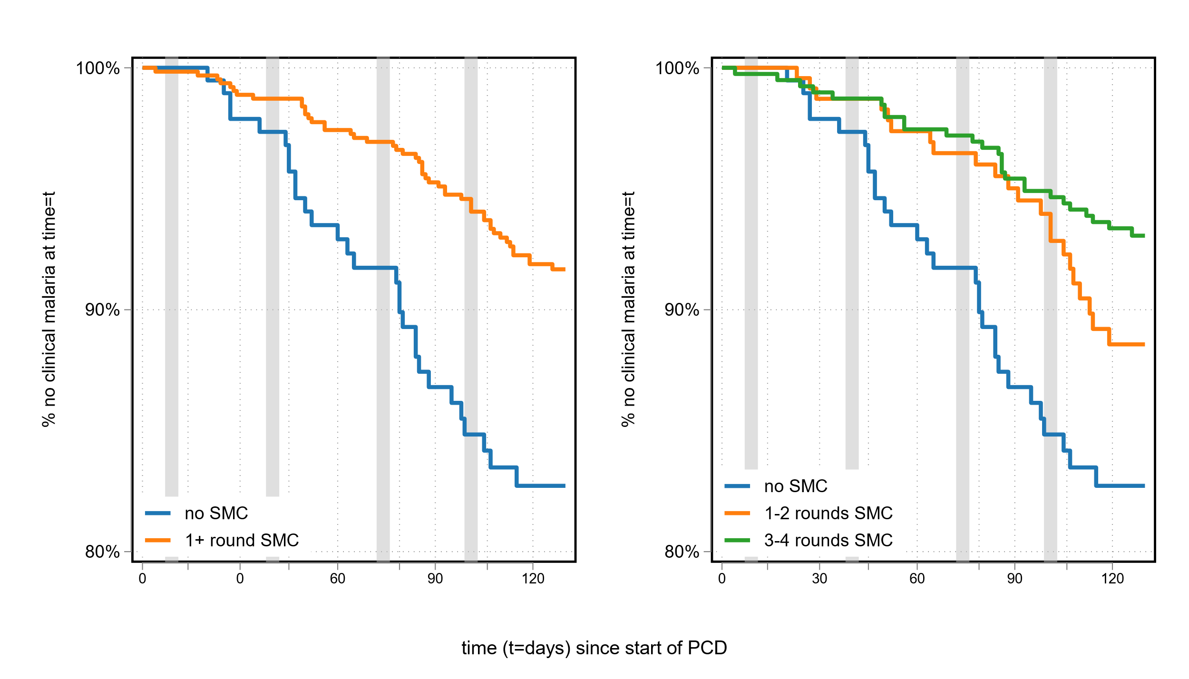
a)

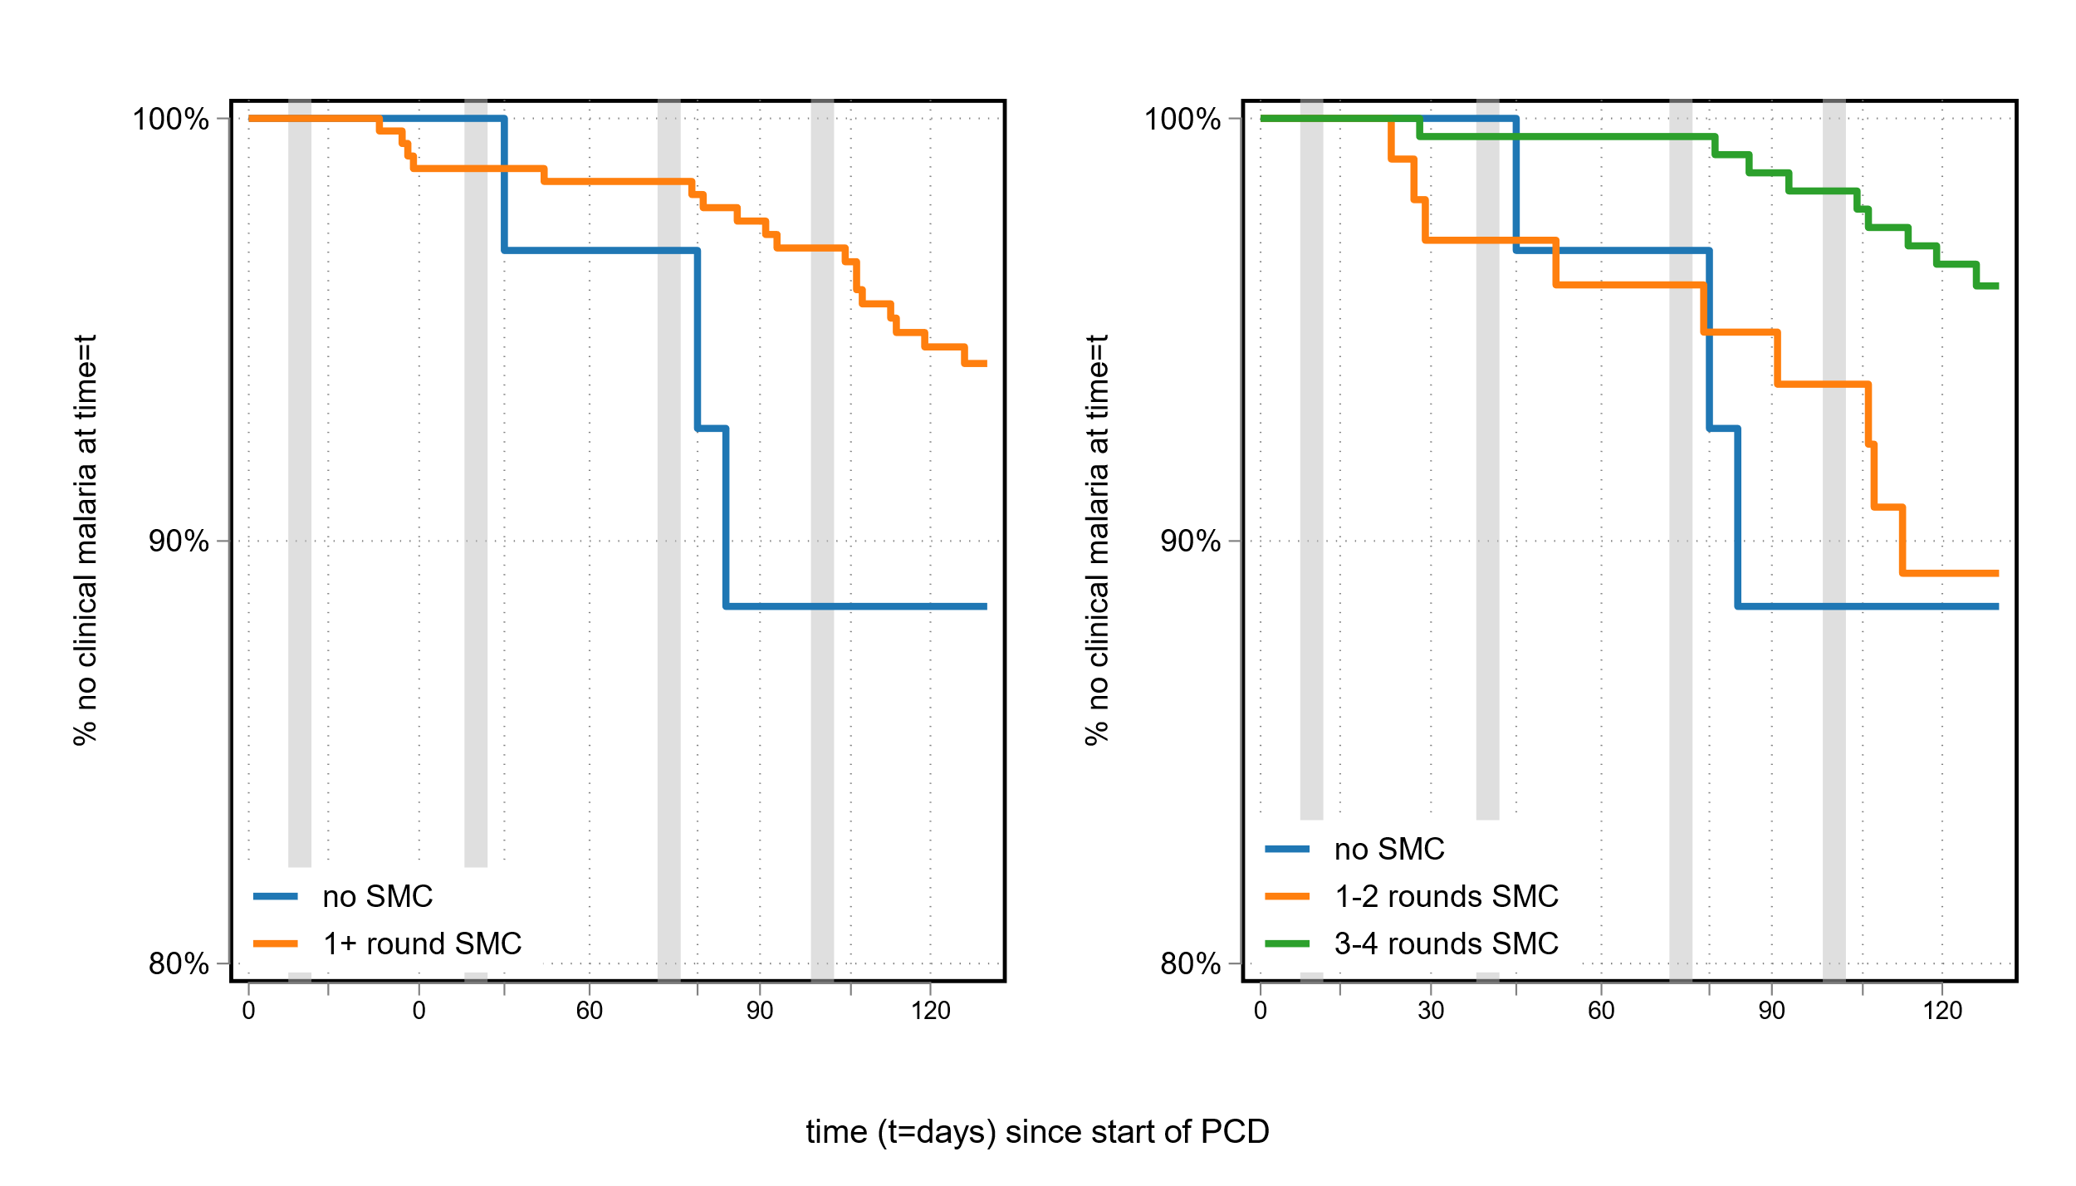
b)

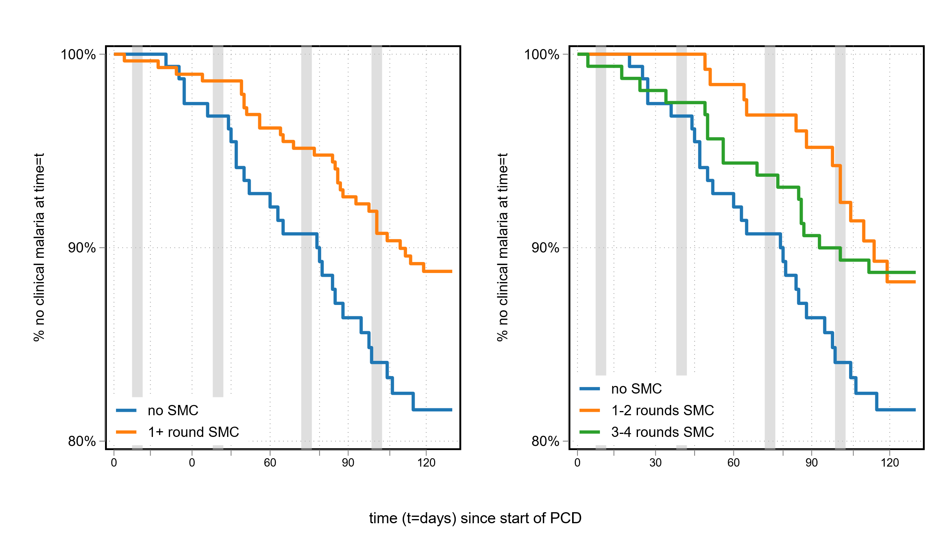
c)

STable 5. Prevalence and risk ratios for asymptomatic infections in 684 children aged 0-9 years, by individual number of SMC rounds received. Children were screened during cross sectional surveys conducted late in the peak malaria transmission season (27th September-27th November 2021).

Individual SMC Coverage | Prevalence asymptomatic infection n/N (%) | Unadjusted |  | Fully adjusted |  | Prevalence high density infection n/N (%)*
Individual SMC Coverage | Prevalence asymptomatic infection n/N (%) | RR (95% Ci) p | RR (95% Ci) p | RR (95% Ci) p | RR (95% Ci) p | Prevalence high density infection n/N (%)*
No SMC | 6/136 (4.4%) | comparator |  | comparator |  | 2/6 (33.3%)
Any SMC | 22/548 (4.0%) | 0.91 (0.38-2.20)  0.834 |  | 1.74 (0.68-4.46)  0.248 |  | 10/22 (45.5%)
1-2 rounds | 13/201 (6.5%) | 1.47 (0.57-3.76)  0.426 | comparator | 2.05 (0.78-5.37)  0.146 | comparator | 6/13 (46.2%)
3-4 rounds | 9/347 (2.6%) | 0.59 (0.21-1.62)  0.304 | 0.40 (0.17-0.92)  0.031 | 1.31 (0.42-4.14)  0.642 | 0.64 (0.26-1.60)  0.340 | 4/9 (44.4%)
n/N is the total children with an asymptomatic infection out of the total children visited during the cross sectional survey. Fully adjusted models included village ID and the % of nights during the season the child used an insecticide treated net the night before when asked. * Due to small cell sizes models assessing SMC impact on risk of high density infections have been omitted.

STable 6. Timing of SMC: Percentage and number of children who received SMC during each monthly round, by the total number of SMC rounds received.
age group | total rounds SMC received | % (and number) of children received SMC at each monthly round
age group | total rounds SMC received | August | September | October | November | N
age 0-4yrs | 0 | 0% (0) | 0% (0) | 0% (0) | 0% (0) | 0
age 5-9yrs | 0 | 0% (0) | 0% (0) | 0% (0) | 0% (0) | 0
age 0-4yrs | 1 | 37.2% (16) | 41.9% (18) | 11.6% (5) | 9.3% (4) | 43
age 5-9yrs | 1 | 23.1% (18) | 39.7% (31) | 23.1% (18) | 14.1% (11) | 78
age 0-4yrs | 2 | 34% (36) | 23.6% (25) | 27.4% (29) | 15.1% (16) | 106
age 5-9yrs | 2 | 21.4% (21) | 30.6% (30) | 31.6% (31) | 16.3% (16) | 98
age 0-4yrs | 3 | 28.4% (98) | 30.7% (106) | 19.4% (67) | 21.4% (74) | 345
age 5-9yrs | 3 | 21.6% (68) | 31.4% (99) | 28.6% (90) | 18.4% (58) | 315
age 0-4yrs | 4 | 25% (110) | 25% (110) | 25% (110) | 25% (110) | 440
age 5-9yrs | 4 | 25% (54) | 25% (54) | 25% (54) | 25% (54) | 216

STable 7. Incidence and hazard ratios for clinical malaria in 825 children aged 0-9 years stratified by SMC coverage in all children 0-9 years in the same household over the 2021 malaria transmission season in the Upper River Region of The Gambia.
SMC coverage | Incidence rates per 100 person-months (cases/PM) |  | Unadjusted HR (95% CI) p |  | Fully adjusted HR (95% CI) p
SMC coverage | 0-9years: all | 0-9years: no SMC* | 0-9years: all | 0-9years: no SMC | 0-9years: all | 0-9years: no SMC
% Children in household received at least 1 round SMC
25% | 4.26 (11/259) | 5.00 (11/220) | 1 (ref) | 1 (ref) | 1 (ref) | 1 (ref)
25%-75% | 2.12 (46/2166) | 2.33 (17/729) | 0.41 (0.21, 0.81)  0.010 | 0.45 (0.21, 0.96)  0.038 | 1.25 (0.51, 3.08)  0.620 | 0.70 (0.21, 2.34)  0.558
80% | 1.35 (28/2070) | 2.40 (3/125) | 0.25 (0.12, 0.51)  <0.001 | 0.29 (0.06, 1.31)  0.107 | 0.91 (0.35, 2.33)  0.844 | 0.89 (0.11, 7.04)  0.913
SMC Rounds/child in household
<0.3 | 4.23 (11/259) | 5.00 (11/220) | 1 (ref) | 1 (ref) | 1 (ref) | 1 (ref)
0.3 - <2 | 2.39 (48/2006) | 3.16 (20/634) | 0.46 (0.24, 0.91)  0.026 | 0.57 (0.28, 1.21)  0.145 | 1.40 (0.57, 3.39)  0.460 | 0.98 (0.29, 3.31)  0.979
>2-4 | 1.17 (26/2231) | 0.00 (0/220) | 0.21 (0.10, 0.44)  <0.001 | 0.03x10-¹⁴  p<0.001 | 0.86 (0.34, 2.20)  0.756 | 0.05x10⁻¹⁴ p<0.001
Adjusted models included village ID, household size, ratio of children to adults, age in years, household ID, baseline (dry season) infection prevalence in household, % of nights household used insecticide treated nets and individual number of SMC rounds. Columns “Aged 0-9 years: no SMC” restricts analysis to children who personally received no SMC.
STable 8. Asymptomatic infection prevalence in 684 of 825 children 0-9 years visited in a late season survey 27th Sept to 27th November by household level of SMC coverage in all children 0-9 years in the same household during the 2021 malaria transmission season in the Upper River Region of The Gambia.
SMC coverage | Prevalence of asymptomatic infection n/N (%) | Prevalence of high density asymptomatic infection n/N (%) | Risk of asymptomatic infection*
SMC coverage | Prevalence of asymptomatic infection n/N (%) | Prevalence of high density asymptomatic infection n/N (%) | Unadjusted RR (95% CI) p |  | Adjusted RR (95% CI) p
% Children in household received at least 1 round SMC
25% | 1/38 (2.6%) | 0/1 (0.0%) | 1 (ref) | 1 (ref)
25%-75% | 19/313 (6.1%) | 8/19 (42.1%) | 0.85 (0.47, 1.52) 0.584 | 0.70 (0.34, 1.47) 0.344
80% | 8/333 (2.4%) | 4/8 (50.0%) | 0.67 (0.37, 1.19) 0.169 | 0.95 (0.44, 2.07) 0.900
SMC Rounds/child in household
<0.3 | 1/38 (2.6%) | 0/1 (0.0%) | 1 (ref) | 1 (ref)
0.3 - <2 | 18/286 (6.3%) | 8/18 (44.4%) | 0.93 (0.52, 1.65) 0.807 | 0.78 (0.37, 1.65) 0.509
>2-4 | 9/360 (2.5%) | 4/9 (44.4%) | 0.60 (0.34, 1.05) 0.071 | 0.87 (0.40, 1.87) 0.709
Regression models of asymptomatic infection prevalence against SMC coverage both at household-level in children 0-9 years were used where multilevel models with household random effects failed to converge. Due to small cell sizes models assessing household SMC impact on risk of high density infections have been omitted. Adjusted models included village ID, household size, age in years, household ID, week of visit, baseline (dry season) infection prevalence in household, % of nights household used insecticide treated nets, and individual number of SMC rounds.
SFigure 2: Geolocations of 129 study households by community. Marker colour indicates SMC status in children in household; marker size indicates the mean incidence of clinical malaria or prevalence of asymptomatic infection in children 0-9 years or participants 10+ years (ineligible for SMC) in household over the 2021 transmission season in the Upper River Region of The Gambia. Map axes: Y axis = latitude; X axis = longitude. Missing compounds Fula Mori Bochi=2; Bolibana=0; Madina SS=4; Tabajang=3; Njayel=6 Banni Kunda/Temanto=1; S Demba DardoS /Biram=0; Njum Bakary=2
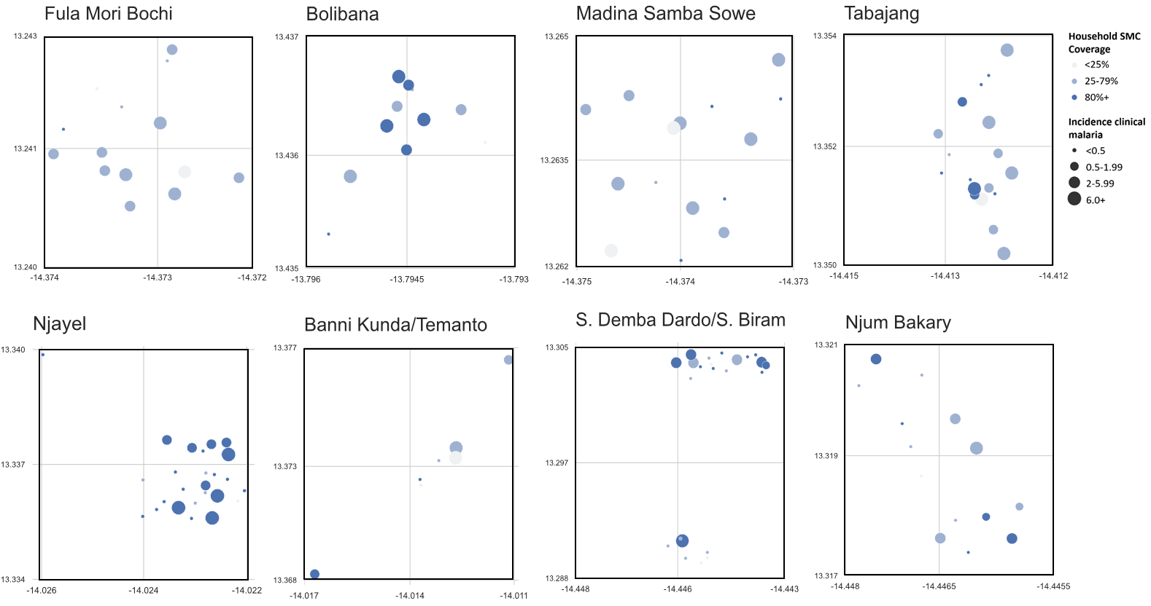
a) Incidence of clinical malaria in participants 10+ years of age by the percentage of children in household who received one or more rounds of SMC.

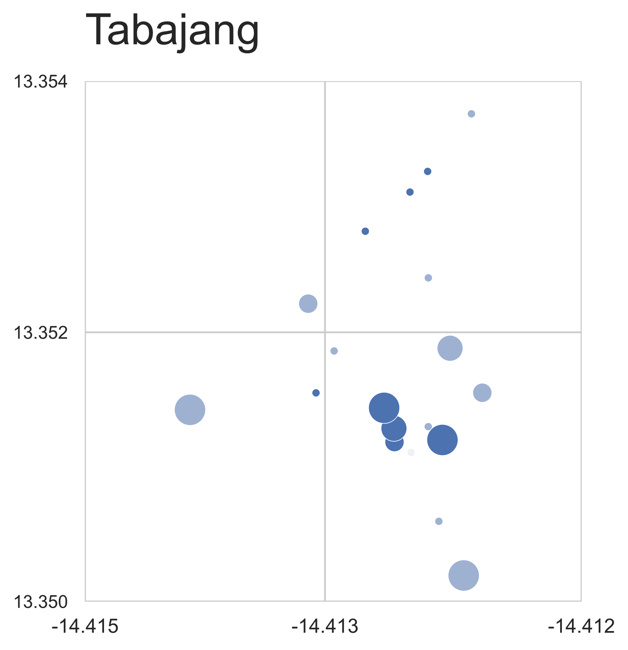
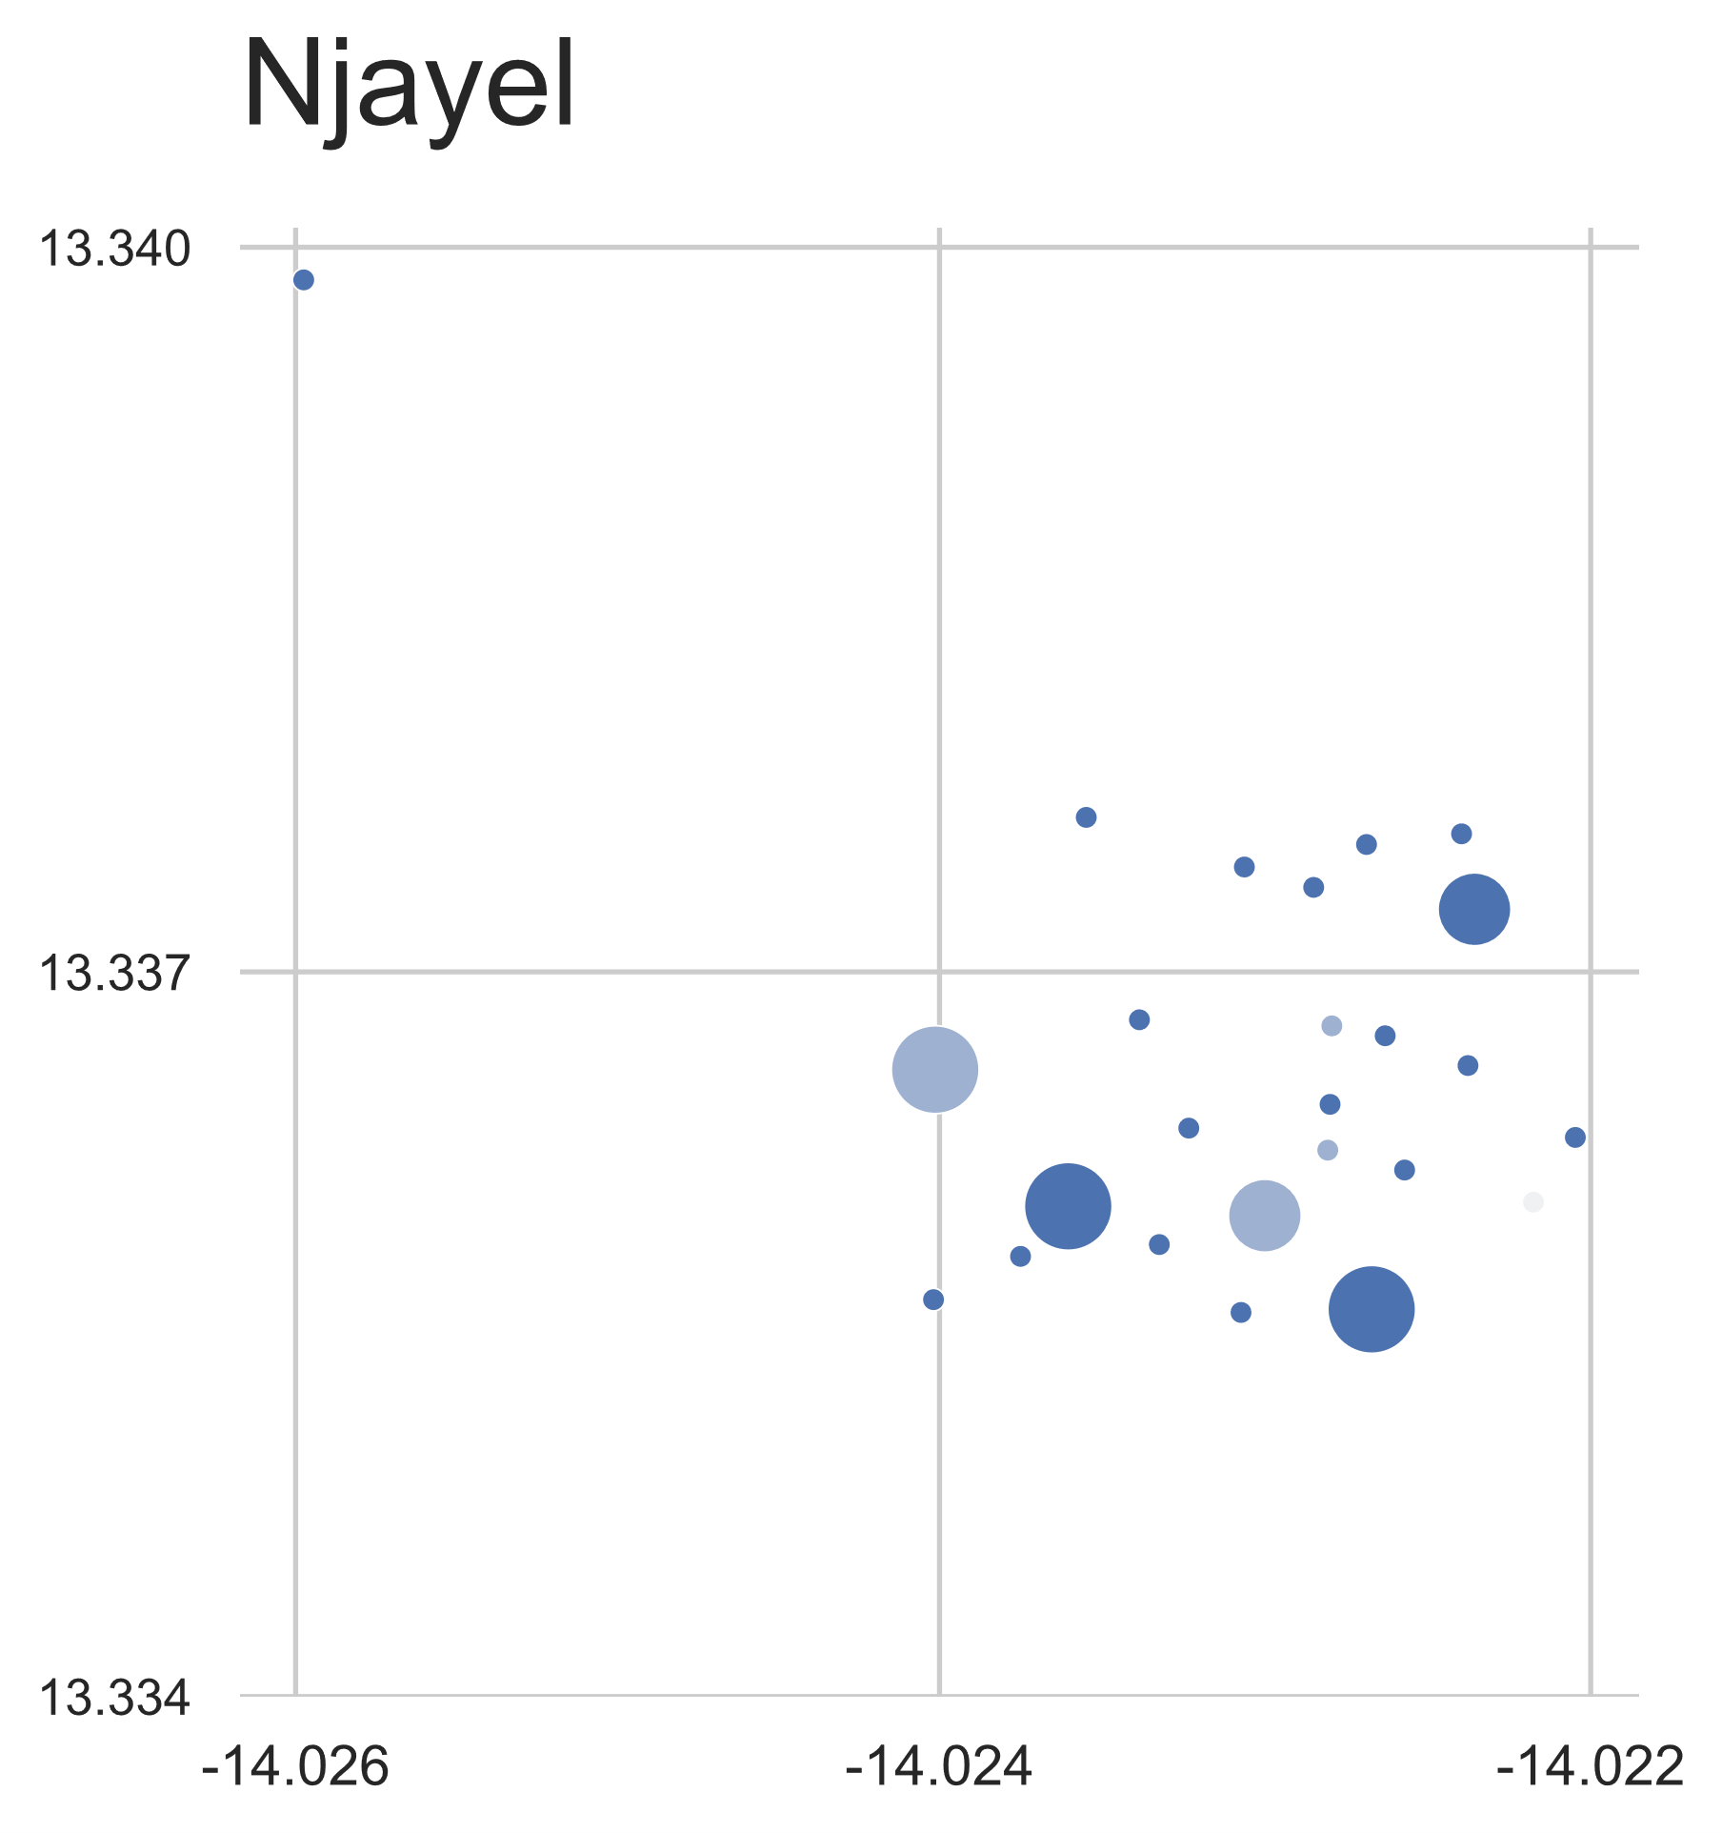
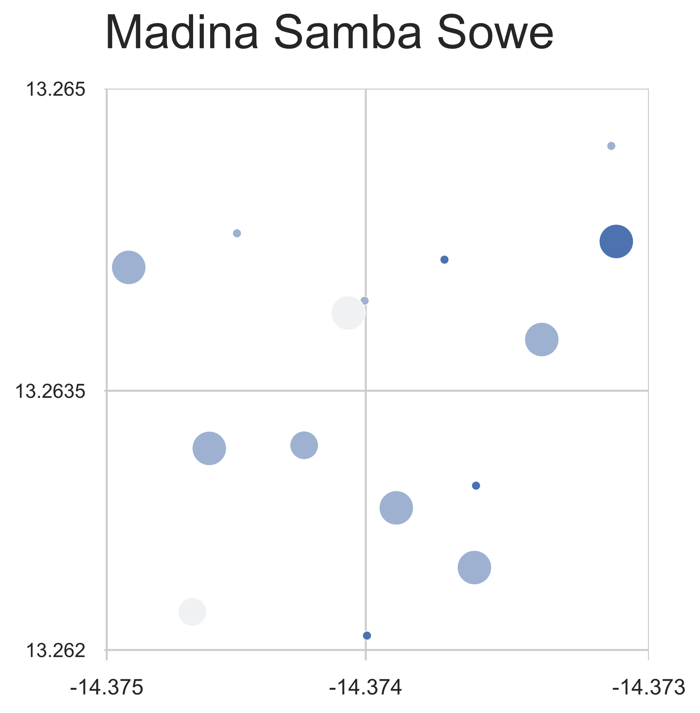
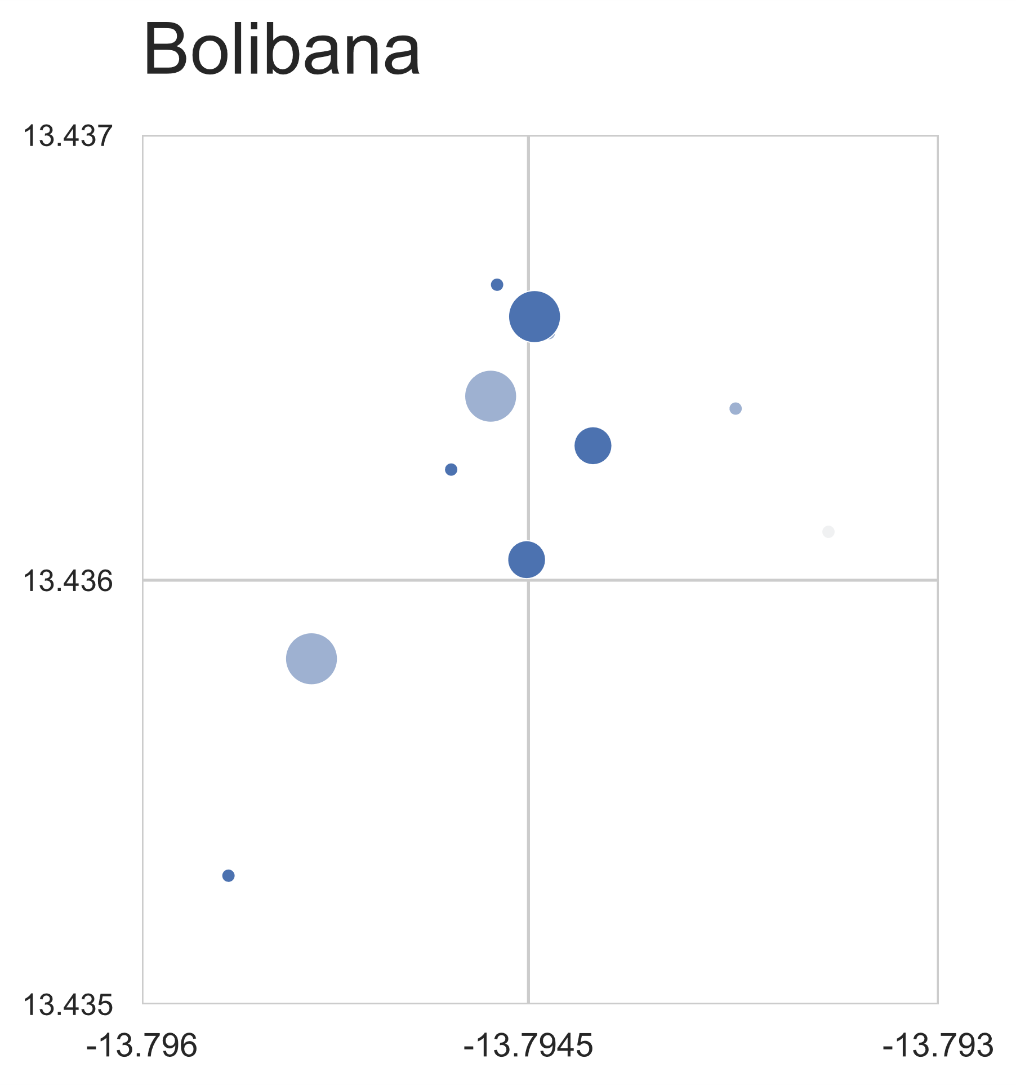
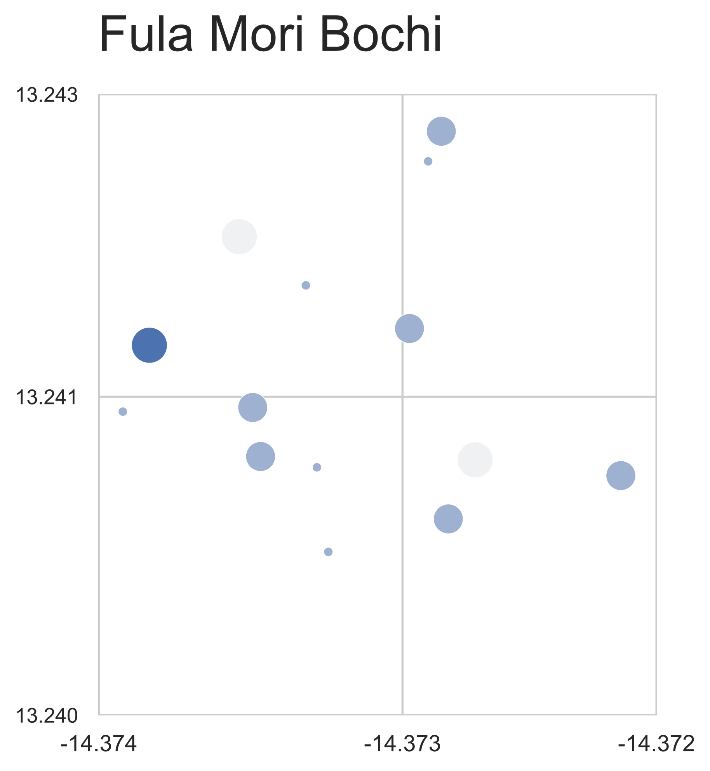
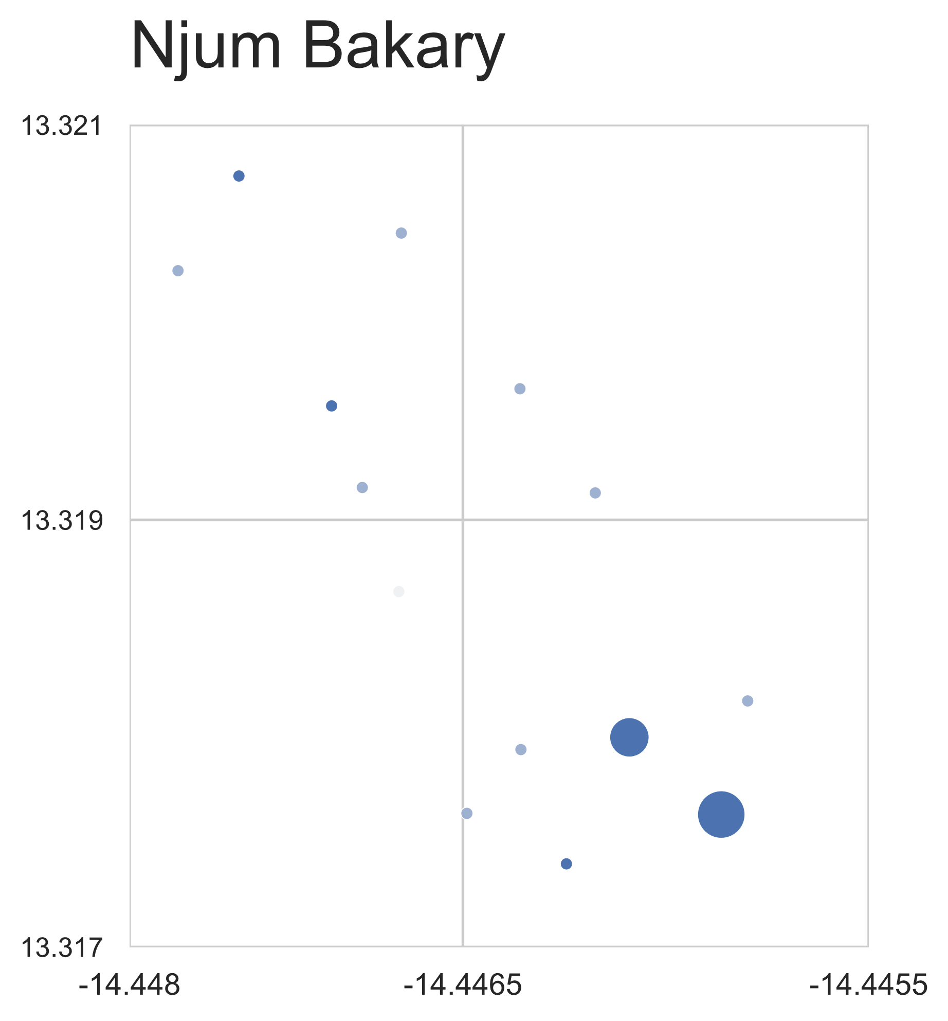
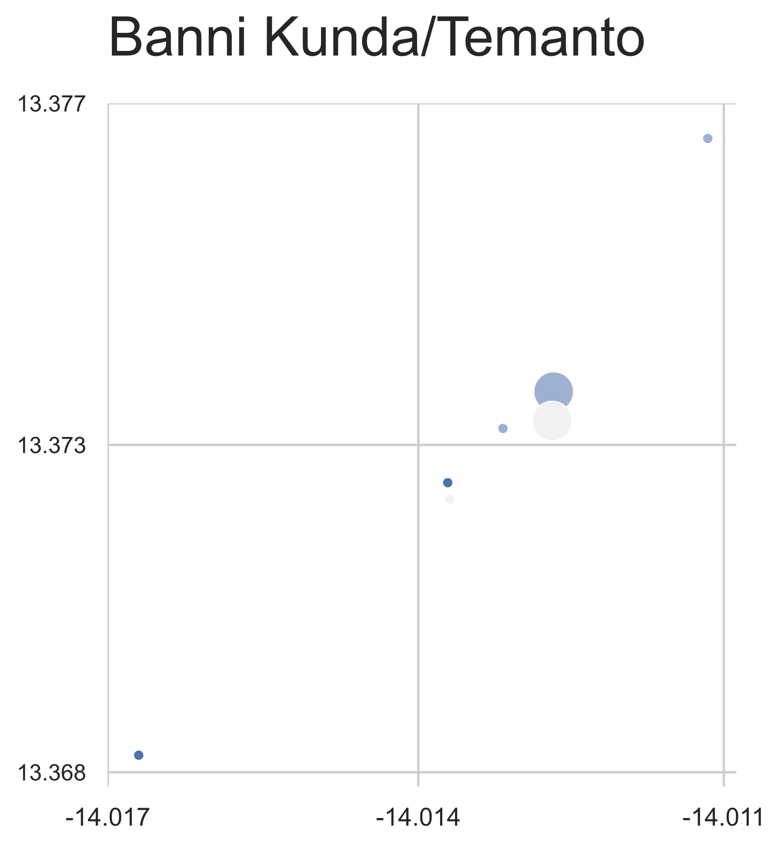
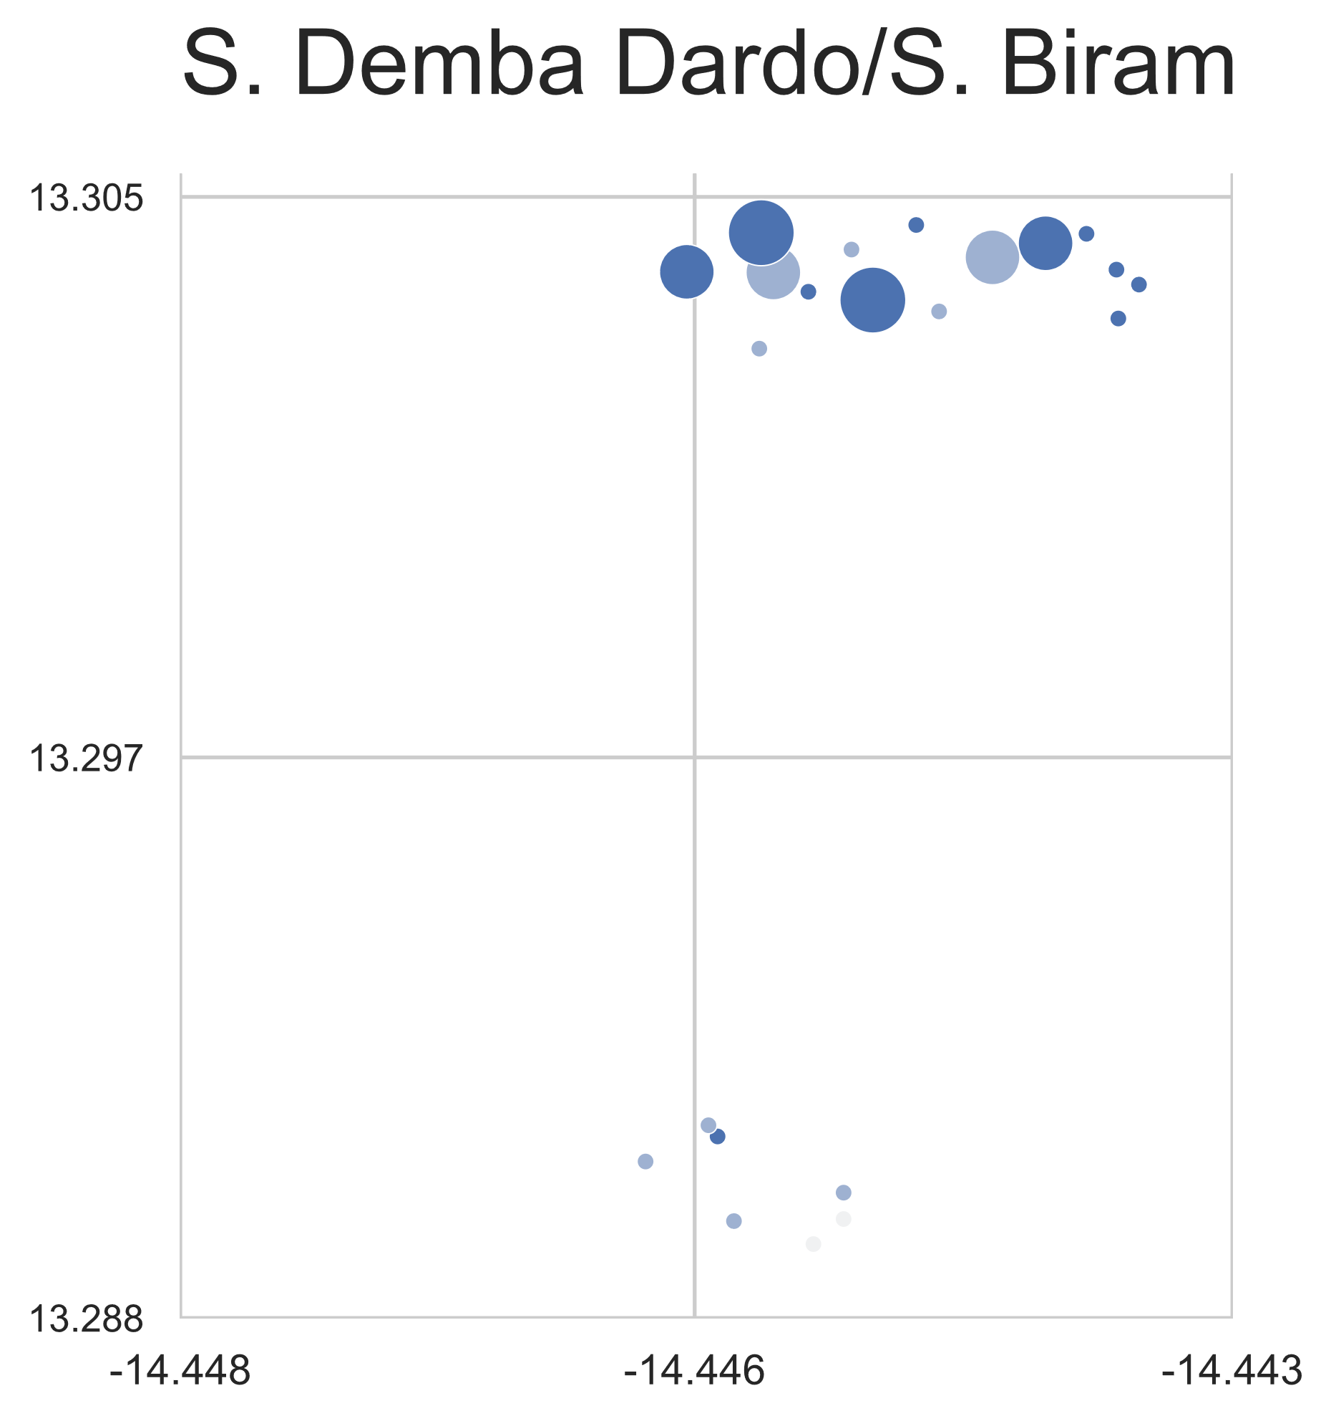
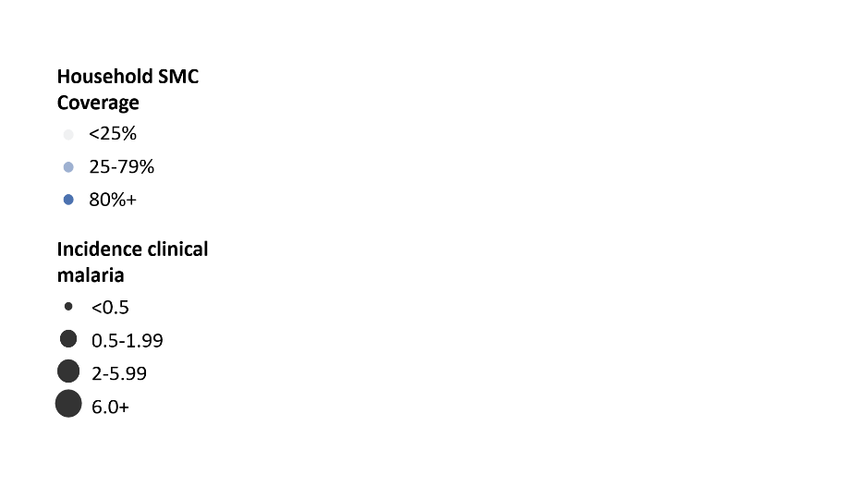
b) Incidence of clinical malaria in children 0-9 years of age by the percentage of children in household who received one or more rounds of SMC.

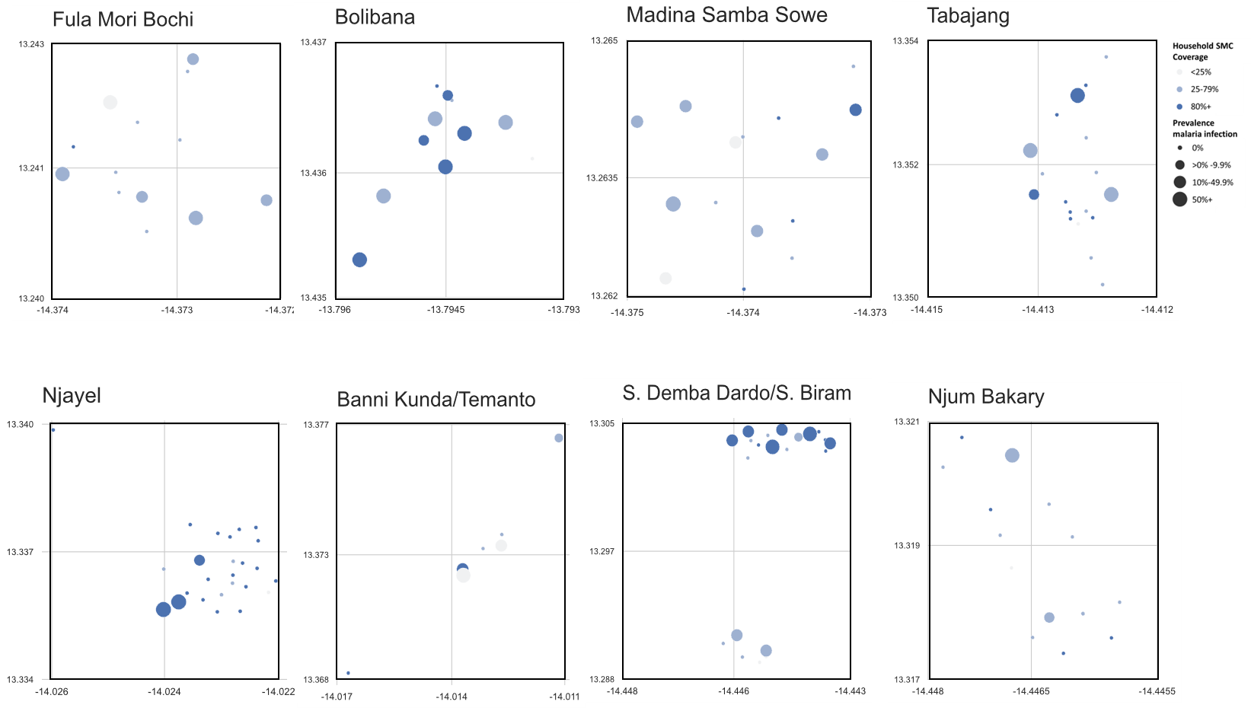
C) Prevalence of asymptomatic P. falciparum infection detected by qPCR in participants 10+ years of age from a late seasons survey 27th Sept-27th Dec 2021. By the percentage of children in household who received one or more rounds of SMC.

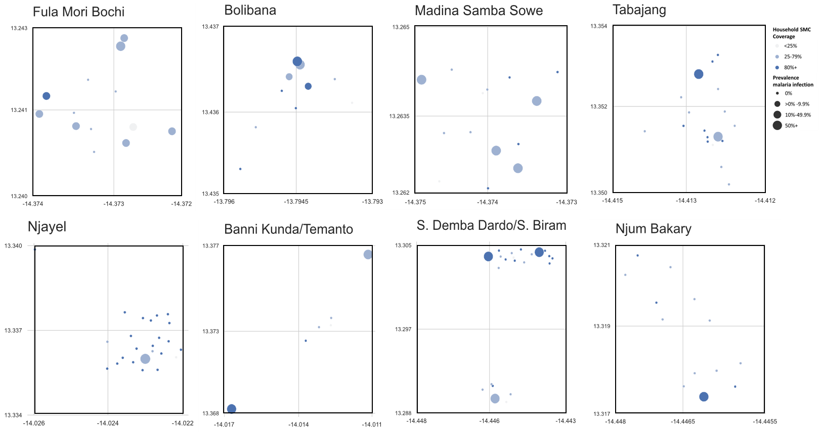
D) Prevalence of asymptomatic P. falciparum infection in participants 0-9years detected in qPCR samples from a late seasons survey 27th Sept-27th Dec 2021. By the percentage of children in household who received one or more rounds of SMC

SFigure 3: P-values from Global Moran I tests for spatial autocorrelation in household-level regression models of malaria incidence and prevalence in participants aged 0-9yrs or 10+yrs by household coverage of SMC.
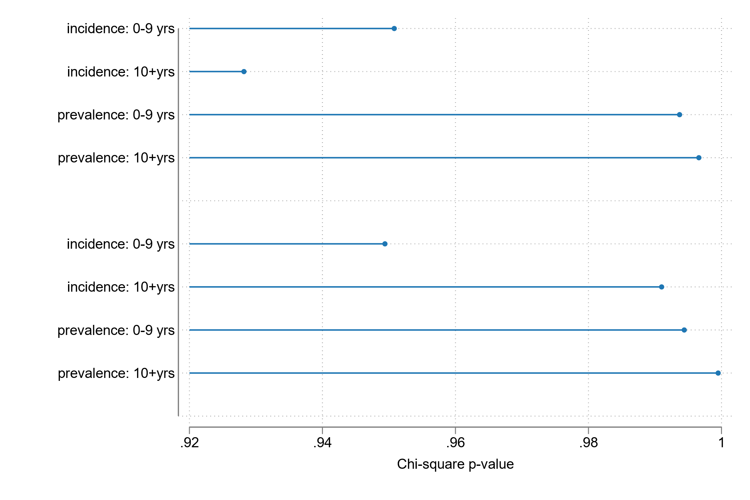
SMC Coverage I: Percentage of children 1+ round SMC in household
SMC Coverage II: Mean number SMC rounds/child

Models regressed household-level malaria outcomes (mean incidence per person in house, or household prevalence at a late season survey 27th Sept-27th Nov 2021) against independent variables measuring household coverage of SMC in eligible children defined in two ways - either the percentage of children in house who received 1+ rounds of SMC (i) or the mean rounds of SMC per eligible child (ii). Models included fixed effects for village ID, ratio of participants 0-9:10+ years, number of instances of reported treated bed net usage the night before out of all instances asked to household members, and the size of household. Post-estimation Moran I tests use the distance matrix for the study site, generated as the inverse weighted distances between households to calculate the probability of spatial autocorrelation in regression errors. P-values above 0.05 indicate the null hypothesis, that there is no spatial autocorrelation, cannot be rejected.

