Supplementary Figures
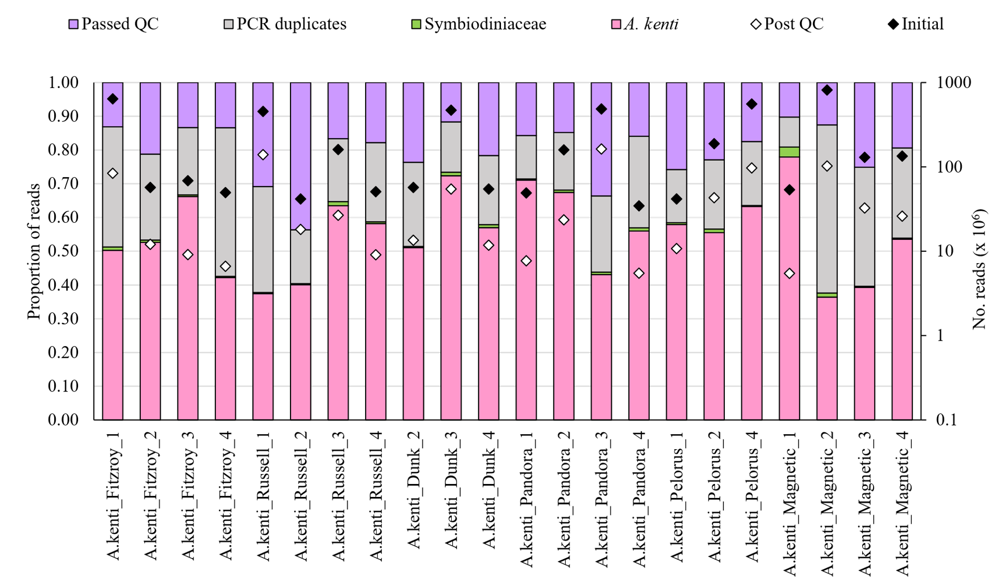
Figure S1. Proportions of microbiome enriched-metagenomic reads removed and retained (‘Passed QC’) from A. kenti metagenomes during the rigorous quality control workflow.

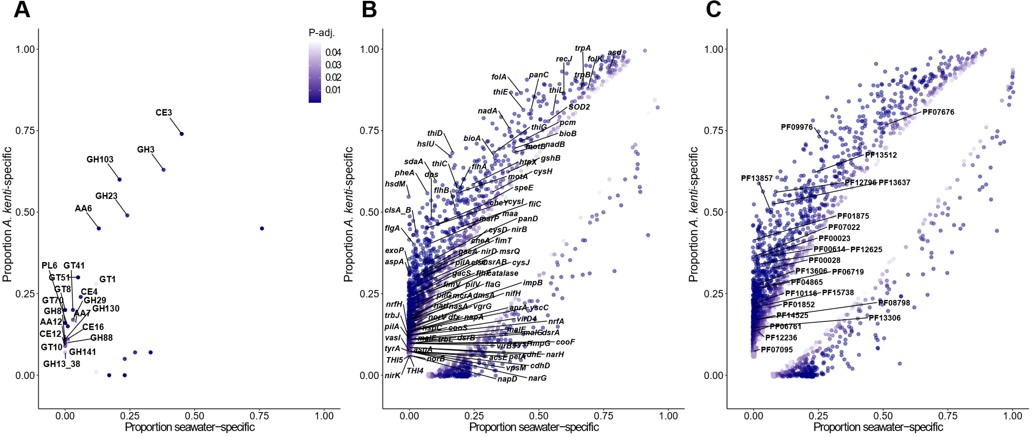

Figure S2. Distribution of significantly enriched functional genes between the A. kenti-specific and seawater-specific MAGs (n = 82 and n = 119, respectively) annotated with A) CAZy, B) KO, and C) Pfam databases. Points are shown as the proportion of total MAGs encoding that functional gene within each category. For clarity, only key genes enriched in A. kenti-specific MAGs discussed in the main text are labelled. Full details are provided in Table S2.

