Plant Cell, Tissue and Organ Culture
Biomass and metabolite production via hairy root culture using different genotypes of Panax ginseng
Nguyen Van Binh^{1,2}, Min Jung Kim¹, Vo Ngoc Linh Giang¹, Yun Sun Lee¹, Murukarthick Jayakodi¹, Hyun-Seung Park¹, Padmanaban Mohanan¹, Kyo Bin Kang³, Byeol Ryu³, Eun Jin Park³, Tae Kyu Park³, and Tae-Jin Yang^{1,4}*
¹Department of Plant Science, Plant Genomics and Breeding Institute, Research Institute for Agriculture and Life Sciences, College of Agriculture and Life Sciences, Seoul National University, Seoul 08826, Republic of Korea
²Faculty of Biology, Dalat University, Dalat 670000, Vietnam
³College of Pharmacy and Research Institute of Pharmaceutical Science, Seoul National University, Seoul 08826, Republic of Korea
⁴Crop Biotechnology Institute/GreenBio Science and Technology, Seoul National University, Pyeongchang 25354, Republic of Korea
*Corresponding author: Tae-Jin Yang (tjyang@snu.ac.kr),
Tel: +82-2-880-4547
Fax: +82-2-873-2056

Fig. S1 Growth rate of transgenic hairy and adventitious roots in liquid medium with or without indole-3-butyric acid (IBA) supplements. Dry weight of hairy and adventitious roots in medium supplemented with or without 3 mg/L IBA. T-YP, hairy roots of ‘Yunpoong’; T-GH, hairy roots of ‘Ganghwa’; A-YP, adventitious roots of ‘Yunpoong’, and A-GH, adventitious roots of ‘Ganghwa’. The different lowercase letters (a, b, c) indicate significant differences between values based on Tukey’s multiple comparison test (P-values ≤ 0.05)
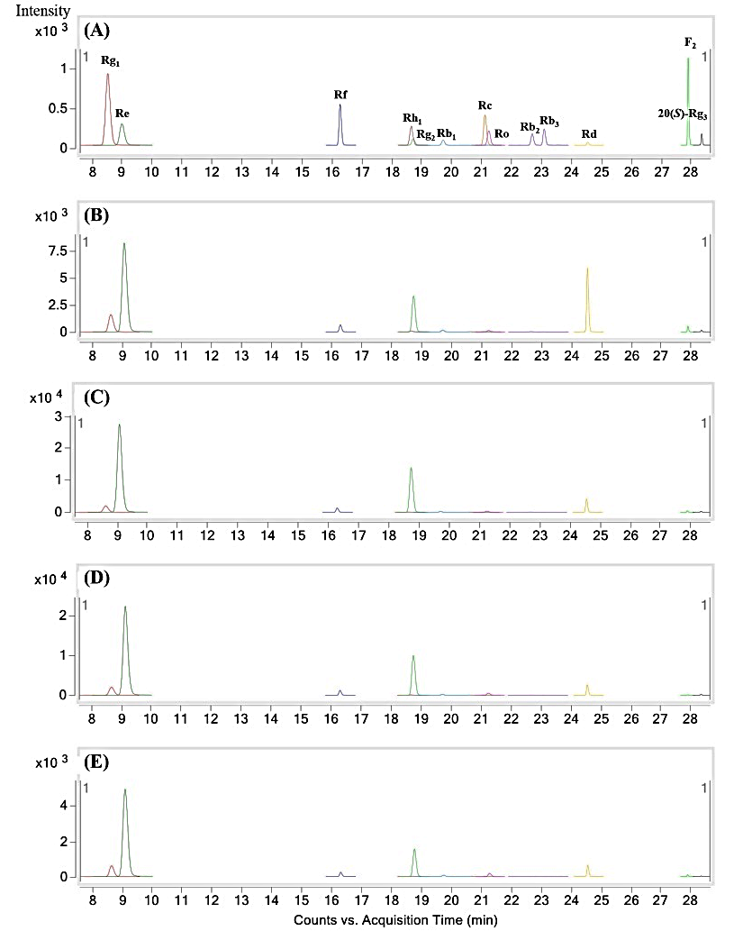
Fig. S2 Representative multiple reaction-monitoring chromatogram of ginsenosides in ginseng roots. (A) Mixture of 13 ginsenoside reference standards; (B) transgenic hairy roots of ‘Ganghwa’; (C) adventitious roots of ‘Ganghwa’; (D) transgenic hairy roots of ‘Yunpoong’; and (E) adventitious roots of ‘Yunpoong’

