Supporting Information for
Evaluation of the Binding Properties of A New Phenylurea Appended Carbazole Compound to Pepsin/Trypsin by Computational and Multi-Spectral Analysis

Elmas Gökoğlu^{1*}. Bensu Doyuran¹. Gülşah Özen¹. Halil Duyar². Tugba Taskin-Tok³⁻⁴ . Zeynel Seferoğlu⁵

¹ Hacettepe University, Department of Chemistry, 06800, Ankara, Turkey
² Gebze Technical University, Department of Chemistry, 41400, Kocaeli, Turkey
³ Gaziantep University, Department of Chemistry, 27310, Gaziantep, Turkey
⁴ Gaziantep University, Department of Bioinformatics and Computational Biology, 27310, Gaziantep, Turkey
⁵ Gazi University, Department of Chemistry, 06800, Ankara, Turkey

*Corresponding Author: Elmas Gökoğlu, E-Mail: gokoglu@hacettepe.edu.tr

Figures

- Spectral characterization of Cpu.

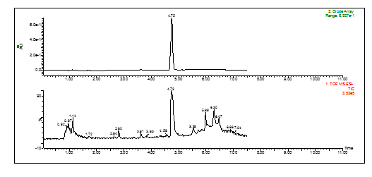

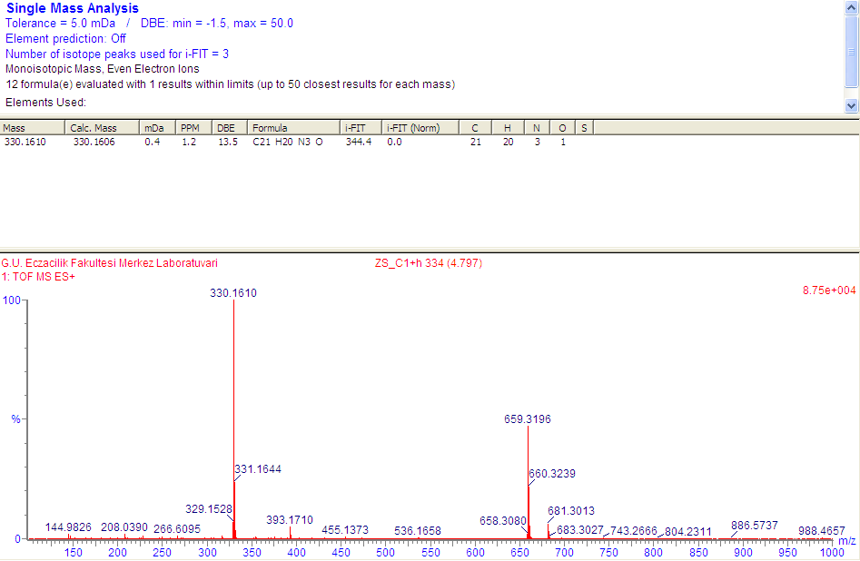
Fig. S1 HRMS spectrum of Cpu.

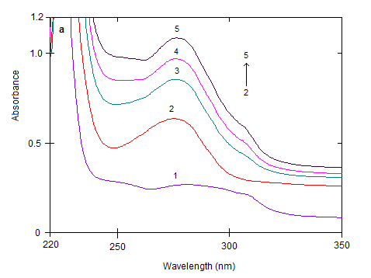
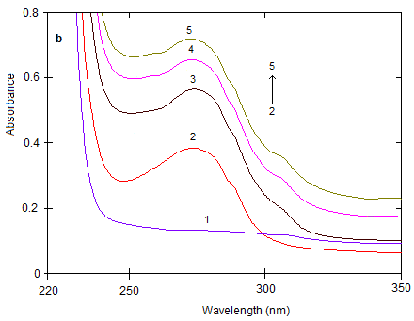
Fig. S2 UV absorption spectra of (a) 1.0x10⁻⁵ M pepsin (spectrum 2) (pH 2.0) and (b) 1.0x10⁻⁵ M trypsin (spectrum 2) (pH 7.4) in the presence of Cpu. The spectra show (from 2 to 5) addition increasing amount of Cpu which are 0.0; 0.63; 1.3; 2.0 (x10⁻⁶) M. (Spectrum 1 shows free 1.0x10⁻⁵ M Cpu).

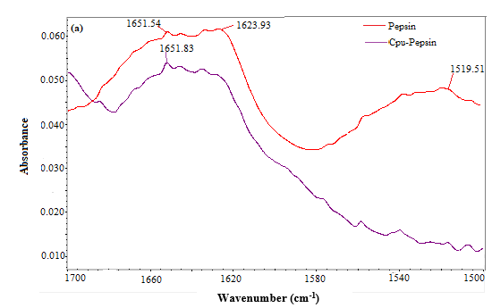

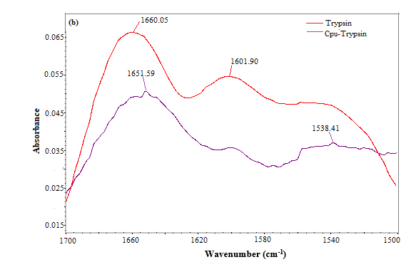
Fig. S3. FT-IR results for binding Ci with (a) pepsin and (b) trypsin.

Table S2. Standart orientation of the compound Cpu at DFT/B3LYP/6-311G* level in G09.
Standard orientation:
---------------------------------------------------------------------
Center Atomic Atomic Coordinates (Angstroms)
Number Number Type X Y Z
---------------------------------------------------------------------
1 6 0 -5.236376 -2.817723 0.428287
2 6 0 -6.203678 -1.807792 0.302121
3 6 0 -5.844705 -0.486030 0.057162
4 6 0 -4.484549 -0.188299 -0.064163
5 6 0 -3.494253 -1.198616 0.064938
6 6 0 -3.883719 -2.518335 0.311201
7 7 0 -3.865621 1.027670 -0.319470
8 6 0 -2.488602 0.825627 -0.337492
9 6 0 -2.215717 -0.545432 -0.110693
10 6 0 -1.450384 1.734361 -0.541807
11 6 0 -0.138810 1.273171 -0.531323
12 6 0 0.146666 -0.087611 -0.304251
13 6 0 -0.894029 -0.992659 -0.090292
14 7 0 1.467994 -0.602419 -0.328106
15 6 0 2.646831 0.093369 -0.106596
16 7 0 3.763347 -0.731368 -0.196048
17 6 0 5.118474 -0.389638 -0.007896
18 8 0 2.700289 1.286272 0.129403
19 6 0 6.072757 -1.371852 -0.314881
20 6 0 7.428916 -1.123957 -0.138992
21 6 0 7.861182 0.109984 0.344733
22 6 0 6.913511 1.084618 0.648490
23 6 0 5.549922 0.851253 0.479335
24 6 0 -4.535945 2.310548 -0.458760
25 6 0 -4.731306 3.049315 0.867859
26 1 0 -5.549769 -3.838336 0.620682
27 1 0 -7.254630 -2.060597 0.399825
28 1 0 -6.606062 0.281444 -0.030857
29 1 0 -3.140072 -3.303257 0.411686
30 1 0 -1.639708 2.789389 -0.707086
31 1 0 0.675576 1.965819 -0.680423
32 1 0 -0.676027 -2.041869 0.093855
33 1 0 5.749256 -2.338457 -0.694332
34 1 0 8.147769 -1.899475 -0.383583
35 1 0 8.919010 0.307288 0.481411
36 1 0 7.233222 2.051063 1.025529
37 1 0 4.825863 1.616787 0.712180
38 1 0 -3.952995 2.920033 -1.154165
39 1 0 -5.499079 2.135076 -0.945135
40 1 0 -5.241784 4.002303 0.700594
41 1 0 -5.333332 2.459123 1.562732
42 1 0 -3.772614 3.258106 1.348352
43 1 0 3.617122 -1.667828 -0.541522
44 1 0 1.518793 -1.609773 -0.331474
---------------------------------------------------------------------

Table S3. Interactions types and distances of pepsin-Cpu and trypsin-Cpu complexes.
Distance Å | Bonding | Bonding Types |  | Binding site of pepsin |  | Binding site of ligand
2.80591 | Hydrogen Bond | Conventional Hydrogen Bond |  | B:GLN118:O |  | Cpu:H43
2.92773 | Hydrophobic | Pi-Sigma |  | A:THR77:HG21 |  | Cpu
2.88456 | Hydrophobic | Pi-Lone Pair |  | B:GLN121:O |  | Cpu
5.39523 | Hydrophobic | Pi-Pi Stacked |  | A:PHE111 |  | Cpu
4.01347 | Hydrophobic | Pi-Pi Stacked |  | A:PHE111 |  | Cpu
4.73416 | Hydrophobic | Pi-Pi Stacked |  | A:PHE111 |  | Cpu
4.03503 | Hydrophobic | Alkyl |  | A:LEU220 |  | Cpu:C25
Distance Å | Bonding |  | Bonding Types |  | Binding site of trypsin | Binding site of ligand
2.10816 | Hydrogen Bond |  | Conventional Hydrogen Bond |  | A:GLY193:HN | Cpu:O18
1.61554 | Hydrogen Bond |  | Carbon Hydrogen Bond |  | A:GLN192:HA | Cpu:O18
2.30058 | Hydrogen Bond |  | Carbon Hydrogen Bond |  | A:ASP189:OD2 | Cpu:H10
2.09974 | Hydrogen Bond |  | Carbon Hydrogen Bond |  | A:SER190:O | Cpu:H10
2.28006 | Hydrogen Bond |  | Carbon Hydrogen Bond |  | A:GLY219:O | Cpu:H11
2.95674 | Hydrophobic |  | Pi-Lone Pair |  | A:SER190:OG | Cpu
4.63559 | Hydrophobic |  | Pi-Pi T-shaped |  | A:TYR228 | Cpu
3.62919 | Hydrophobic |  | Amide-Pi Stacked |  | A:TRP215:C,O;GLY216:N | Cpu
3.43086 | Hydrophobic |  | Amide-Pi Stacked |  | A:TRP215:C,O;GLY216:N | Cpu
4.31459 | Hydrophobic |  | Amide-Pi Stacked |  | A:TRP215:C,O;GLY216:N | Cpu
4.58007 | Hydrophobic |  | Pi-Alkyl |  | A:VAL213 | Cpu
5.20099 | Hydrophobic |  | Pi-Alkyl |  | A:CYS42 | Cpu

