Biologically and Catalytically Active Cubic Silver Chloride-anchored Palladium/Gold Bimetallic Nanomaterials
Prashant D. Sarvalkarª, Apurva S. Vadanagekarª, Omkar S. Karvekar^{b}, Shivanand B. Teli^{c}, Deepti N. Kurhe^{d}, Mansingraj S. Nimbalkar^{e}, Neeraj R. Prasadª, Kiran Kumar K. Sharmaª*
ªSchool of Nanoscience and Biotechnology, Shivaji University, Kolhapur-416004 (MH), India.
^{b}Department of Physical Chemistry, Faculty of Science, Palacký University, 17. listopadu 12, Olomouc CZ-77146, Czech Republic.
^{c}Department of Industrial Chemistry, Shivaji University, Kolhapur-416004 (MH), India.
^{d}Department of Biochemistry, Shivaji University, Kolhapur-416004 (MH), India.
^{e}Department of Botany, Shivaji University, Kolhapur-416004 (MH), India.
*Corresponding author: Prof. Kiran Kumar K. Sharma (kks.snst@unishivaji.ac.in)

- Reaction mechanism
According to Le Chatelier's principle, this will result in more AgCl formation by shifting equilibrium to the left. i.e., the presence of a common ion will suppress the solubility of a marginally soluble salt. When, all precursor are mixed, Cl- ions from PdCl₂ and HAuCl₄ react to Ag⁺ and form AgCl salt. The reduction potential of Ag⁺ is 0.80 V, and the standard free energy of formation of AgCl is -1.136969 V (Ks_{(AgCl)} is 1.6 × 10⁻¹⁰ mol²/L²), indicating that production of AgCl is easier than reduction of Ag⁺ to Ag⁰.

- Rietveld refinement
The Rietveld refinement approach using the Fullprof program was used to conduct the crucial structural study of the polycrystalline AgCl. Initial refinement input parameters came from the crystallographic input file (CIF) that was generated. We obtained the necessary background by an automatic background in fullprof utilizing the observed diffraction profile. Peak shape was determined using the pseudo-Voiget function, with the number of refinement cycles (20) being constant for every refinement. Each refinement included quantitative and visual examination to track the goodness of fit (χ²) and variance between calculated and observed values. One by one, the different parameters, such as scale factor, lattice parameters (a, b, and c), backdrop points, FWHM parameters (U and W), overall B-factor, orientation, instrumental parameters, etc., were refined.
The main goal was to reduce the χ² value and obtain a flat, structured plot that showed the discrepancy between the calculated and actual outcomes. The output parameters that were reached after thorough refinement include cell volume, expected weighted profile factor (R_{exp}), lattice parameters, weight profile factor (R_{wp}), Bragg factor (RB), Reduced chi-square (χ²), profile factor (R_{p}), and material density, as shown in Table S1. The lattice parameters of AgCl, Au and Pd were discovered to be comparable to those stated in the JCPDS No. (01-085-1355), (00-001-1174) and (01-087-0643).
R-factors that have been determined show that experimental and theoretical data agree well. Only about 4.42,0 and 0% of the derived χ² values, respectively were deemed acceptable by the basic goodness of fit criteria. Fitting between theoretically determined values and experimentally verified data is shown in Figure S1. The Triclinic crystal structure of AgCl is shown in Figure 1 which is visualized by VESTA software. AgCl crystals were perfectly nano-dimensional in size and have an average crystal size of 17.1063 nm.

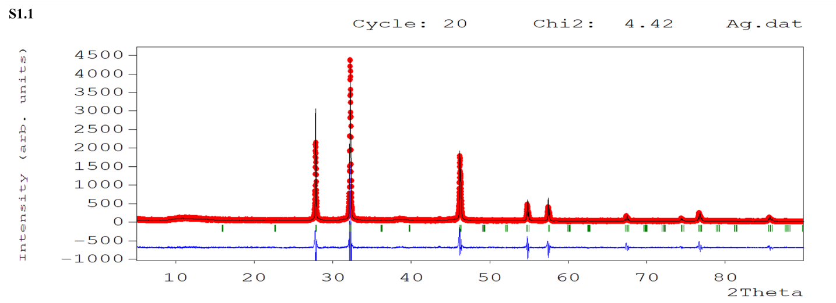

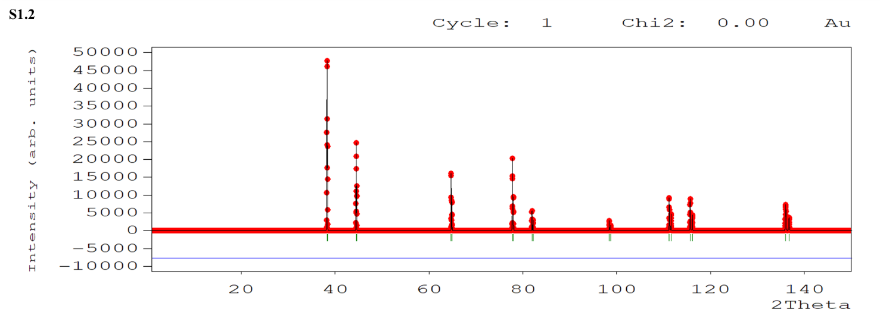

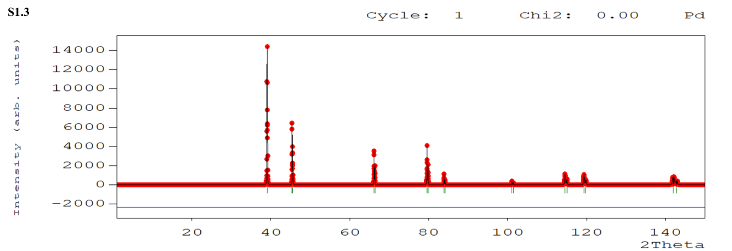

Figure S1: Rietveld refinement plots of (S1.1)AgCl, (S1.2) Au and (S1.3) Pd.

Table S1. Output parameters after Rietveld refinement
Sample | Lattice parameter |  |  | Density (g/cm³) | Cell Volume  (Å) | R_{wp}  (%) | R_{p}  (%) | R_{exp}  (%) | χ²
Sample | a (Å) | b (Å) | c (Å)
AgCl | 5.56290 | 5.54533 | 5.54533 | 5.565 | 171.063 | 44.7 | 50.8 | 21.25 | 4.42
Au | 4.0640 | 4.0640 | 4.0640 | 19.37 | 67.12 | - | - | - | 0
Pd | 3.9080 | 3.9080 | 3.9080 | 11.87 | 59.68 | - | - | - | 0

- Morphological Index (M.I.)
With a small deviation, the calculated data show that MI is directly proportional to particle size in nm and obtained results are shown in figure S2 and Table S2, respectively. The variations and interrelations between them are indicated by linear fit.

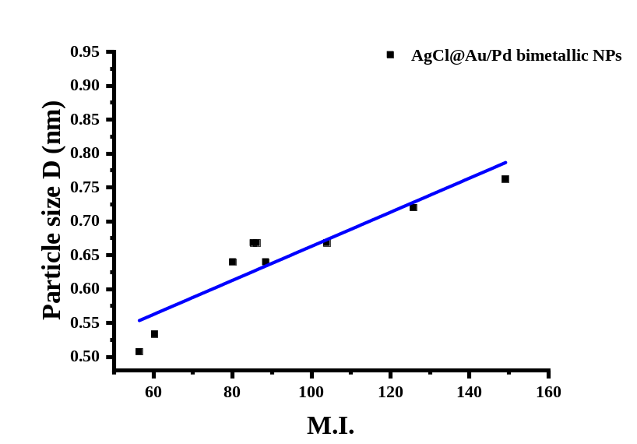
Figure S2: M.I vs particle size for AgCl@Au/Pd bimetallic NPs.

Table no. S2: Displays the MI, range of experimental AgCl@Au/Pd bimetallic NPs.
2ϴ | FWHM (°) | FWHM [radian] | particle size | d-spacing | M.I.
27.8074 | 0.096 | 0.001675 | 85.26088 | 3.2057 | 0.668
32.2115 | 0.096 | 0.001675 | 86.14377 | 2.77674 | 0.668
46.1919 | 0.108 | 0.001884 | 80.09902 | 1.96369 | 0.64
54.7896 | 0.06 | 0.001047 | 149.1461 | 1.67413 | 0.7619
57.4513 | 0.072 | 0.001256 | 125.8369 | 1.60273 | 0.7272
67.3982 | 0.108 | 0.001884 | 88.42577 | 1.38835 | 0.64
74.3911 | 0.096 | 0.001675 | 103.8981 | 1.2742 | 0.668
76.6636 | 0.168 | 0.002931 | 60.28948 | 1.24199 | 0.5333
85.5697 | 0.192 | 0.003349 | 56.38488 | 1.13405 | 0.5074

- Raman
The Raman spectra of as synthesized AgCl@Au/Pd bimetallic NPs is given the figure S3. The I_{D}/I_{G} ratio obtained was 0.88 accordingly. The calculated I_{D}/I_{G} ratio is relatively less than 1 i.e., the AgCl@Au/Pd bimetallic NPs have no any defects. The higher the ratio the sp² crystal size of the cluster also increases as they directly proportional to each other. But in the case of AgCl@Au/Pd bimetallic NPs the ratio is less than 1 and the cluster size also decreases.
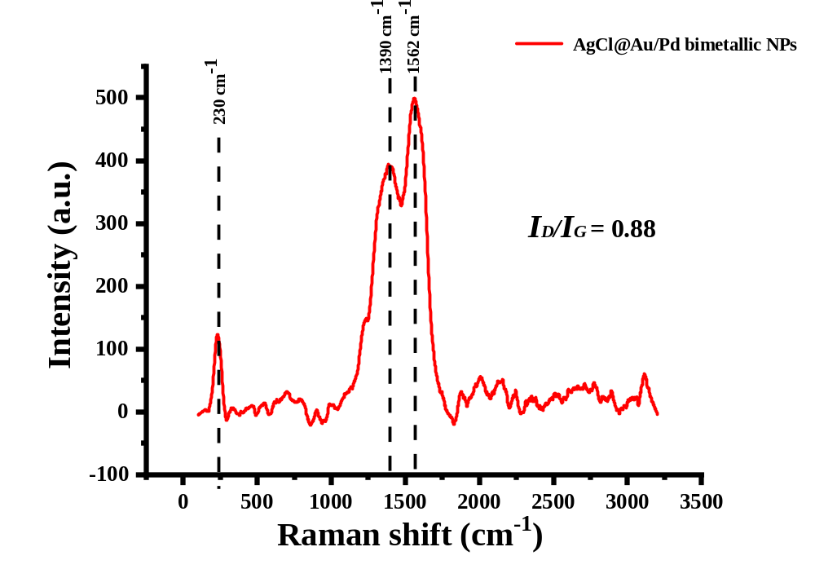
Figure S3: Raman spectra of AgCl@Au/Pd bimetallic NPs.

- EDS
The presence of constitute elements such as Ag, Cl, Au and Pd are confirmed by energy dispersive analysis spectroscopy and the recorded spectrum is presented in Figure S4. Spectrum clearly illustrate the strong signals of the four Ag, Cl, Au and Pd atoms at appropriate KeV confirm the formation of AgCl@Au/Pd bimetallic NPs. Furthermore, it was found that the weight percent yields of Ag, Cl, Au, and Pd in AgCl@Au/Pd bimetallic NPs are in the range of 81.23, 4.75, 13, and 1.30 %, respectively.
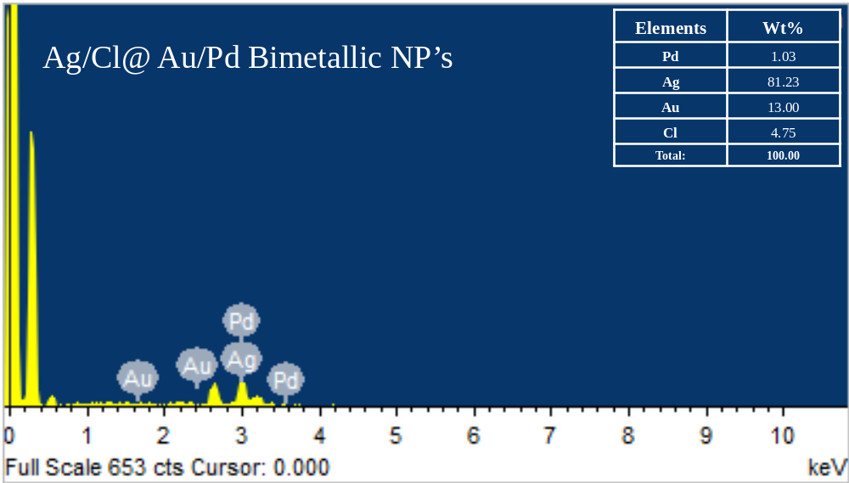
Figure S4: EDAX of AgCl@Au/Pd bimetallic NPs.

- Elemental mapping
Information about elemental mapping of AgCl@Au/Pd bimetallic NPs was found that the nanoparticles are dispersed uniformly over the length of cubic nanoparticles as presented in Figure S5 (a-f). Resulted into, Ag, Au and Pd were distributed well over the surface of nanotubes and provides the conformation of nanocomposites structure formation.
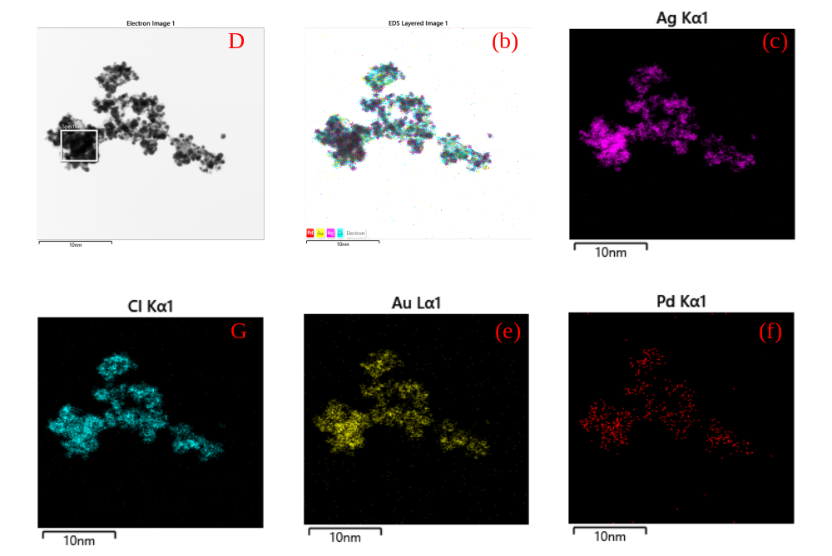
Figure S5: Elemental mapping of AgCl@Au/Pd bimetallic NPs.

- Dye degradation study for RhB, MO and CR
The reaction follows the Langmuir-Hinshelwood model with pseudo-first-order kinetics. The figure S6 represents the UV-Vis absorption spectra of reduction of rhodamine B without AgCl@Au/Pd bimetallic NPs, percentage degradation of RhB dye with and without catalyst is given in figure S7. The UV-Vis absorption spectra and degradation of dyes CR and MO without catalyst AgCl@Au/Pd bimetallic NPs is given in figure S8 and S9 respectively.
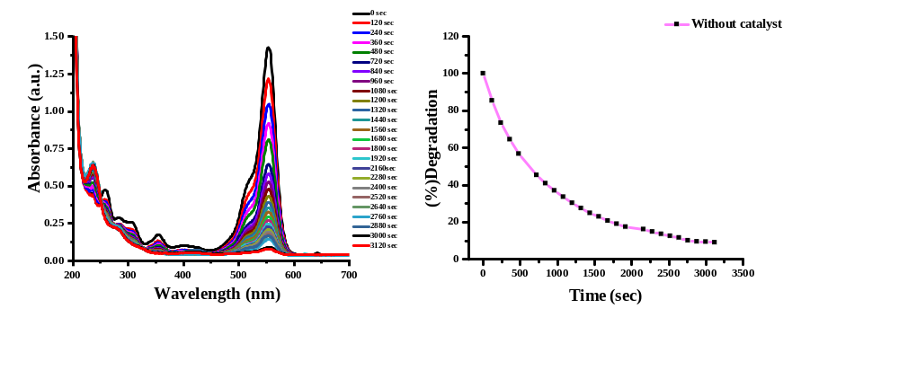
Figure S6: UV-Vis absorption spectra of reduction of RhB without catalyst, percentage degradation of RhB dye.

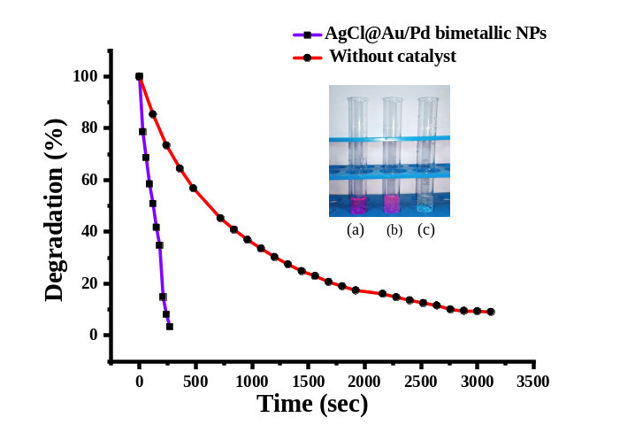
Figure S7: Percentage degradation of Rhodamine B with AgCl@Au/Pd bimetallic NPs and without AgCl@Au/Pd bimetallic NPs (a) Rhodamine B with AgCl@Au/Pd bimetallic NPs and NaBH₄ (b) After few minutes light color of dye (c) complete degradation of rhodamine B.

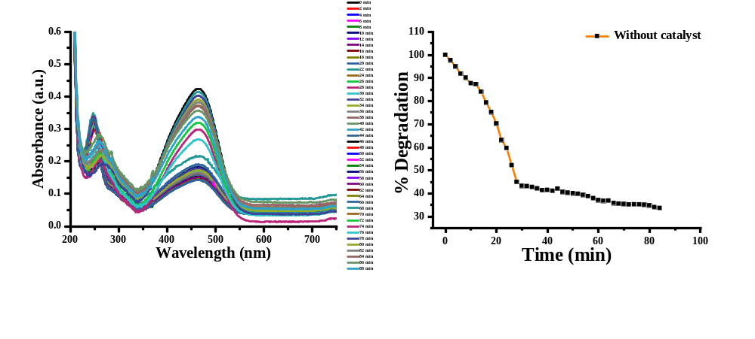
Figure S8: UV-Vis absorption spectra of reduction of MO without AgCl@Au/Pd bimetallic NPs, percentage degradation of MO dye.

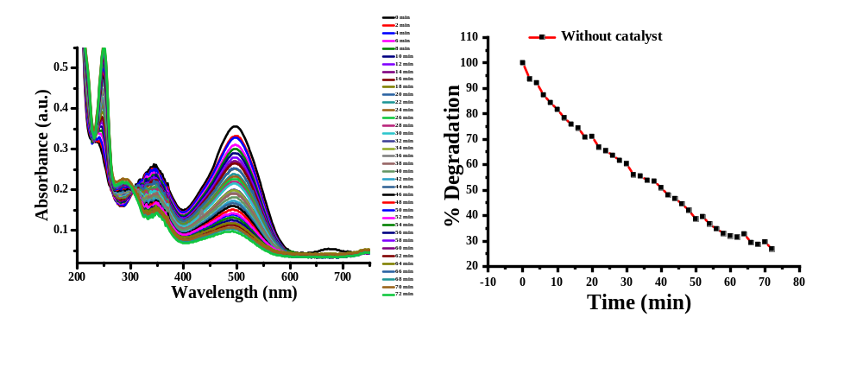
Figure S9: UV-Vis absorption spectra of reduction of CR without AgCl@Au/Pd bimetallic NPs, percentage degradation of CR dye.

- Antimicrobial Activity of Au/Pd decorated AgCl NPs
Figure S10 shows photographs revealing the antimicrobial activity of the synthesized nanomaterials. A higher zone of inhibition is observed for E. coli as compared to S. aureus. This could be due to a difference in cell wall thickness.
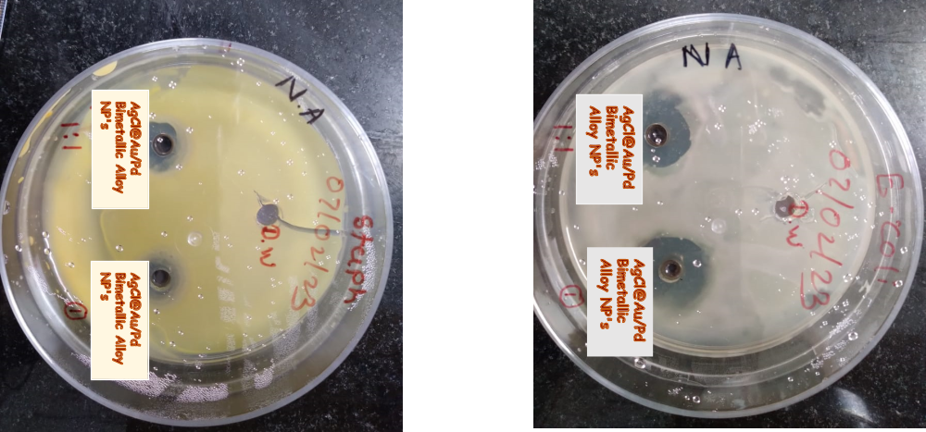
Figure S10: Antimicrobial activity of NPs (a) AgCl@Au/Pd bimetallic NPs on S. aureus, (b) AgCl@Au/Pd bimetallic NPs on E. coli, Distilled water was used for control.

