Supplementary materials

Supplementary Table 1. Summary of genetic variants (n=19) used to estimate the effect of RA on HF in MR analyses.
NO. | SNP | Chr | Pos | EA | OA | β | SE | p
1 | rs10040327 | 5 | 55435220 | A | C | -0.287682 | 0.0440339 | 6.65E-11
2 | rs106287 | 6 | 31935750 | A | G | -0.634878 | 0.0580076 | 5.24E-27
3 | rs12662632 | 6 | 32578383 | C | G | -0.527633 | 0.0858348 | 8.19E-10
4 | rs13209944 | 6 | 33005373 | T | C | -0.287682 | 0.0440339 | 2.43E-10
5 | rs2021719 | 6 | 30449482 | A | G | 0.254642 | 0.0237476 | 8.84E-25
6 | rs2071554 | 6 | 32784676 | T | C | 0.850151 | 0.0510821 | 1.41E-61
7 | rs2476601 | 1 | 114377568 | G | A | -0.662688 | 0.0381065 | 6.22E-71
8 | rs2517512 | 6 | 31029685 | T | C | -0.248461 | 0.0393242 | 6.23E-11
9 | rs2859078 | 6 | 32702449 | G | A | -0.446287 | 0.0319294 | 2.21E-46
10 | rs3087243 | 2 | 204738919 | A | G | -0.139262 | 0.0234742 | 2.24E-08
11 | rs3135006 | 6 | 32667119 | C | T | 0.693147 | 0.0306491 | 7.35E-124
12 | rs3909134 | 6 | 29699253 | G | A | 0.530628 | 0.0838021 | 1.57E-10
13 | rs4810485 | 20 | 44747947 | G | T | 0.162519 | 0.0300467 | 5.69E-09
14 | rs6920220 | 6 | 138006504 | A | G | 0.198851 | 0.0293062 | 2.49E-12
15 | rs8283 | 6 | 32083300 | G | A | -0.510826 | 0.0340641 | 3.82E-51
16 | rs9258811 | 6 | 29832526 | C | T | -0.210721 | 0.0315342 | 1.60E-12
17 | rs9268145 | 6 | 32257284 | G | T | 1.05779 | 0.0265972 | 1.00E-200
18 | rs9277463 | 6 | 33053307 | T | C | -0.356675 | 0.0291863 | 1.10E-39
19 | rs9366817 | 6 | 33104286 | A | G | -0.162519 | 0.0300467 | 1.60E-08
SNP, single nucleotide polymorphisms; Chr, chromosome; Pos, position; EA, effect allele.; OA, other allele.
Supplementary Table 2. Summary of genetic variants (n=9) used to estimate the effect of HF on RA in MR analyses.
NO. | SNP | Chr | Pos | EA | OA | β | SE | p
1 | rs1027840 | 3 | 36859083 | G | A | -0.0805 | 0.03184742 | 0.353336
2 | rs11124555 | 2 | 37189296 | A | G | -0.0672 | 0.02925796 | 0.733789
3 | rs11943177 | 4 | 56582514 | C | T | -0.0675 | 0.024898049 | 0.0393858
4 | rs16876172 | 6 | 86106092 | C | T | -0.096 | 0.038969168 | 0.188089
5 | rs2825469 | 21 | 20644817 | T | C | 0.1516 | 0.045848026 | 0.177152
6 | rs28361819 | 18 | 25930286 | A | G | 0.1284 | 0.15118085 | 0.139942
7 | rs34360072 | 3 | 189696186 | G | A | -0.0669 | 0.031047507 | 0.748599
8 | rs6817105 | 4 | 111705768 | C | T | 0.1322 | 0.037321297 | 0.051837
9 | rs7332565 | 13 | 29258325 | A | G | 0.0922 | 0.029940429 | 0.308998
SNP, single nucleotide polymorphisms; Chr, chromosome; Pos, position; EA, effect allele.; OA, other allele.
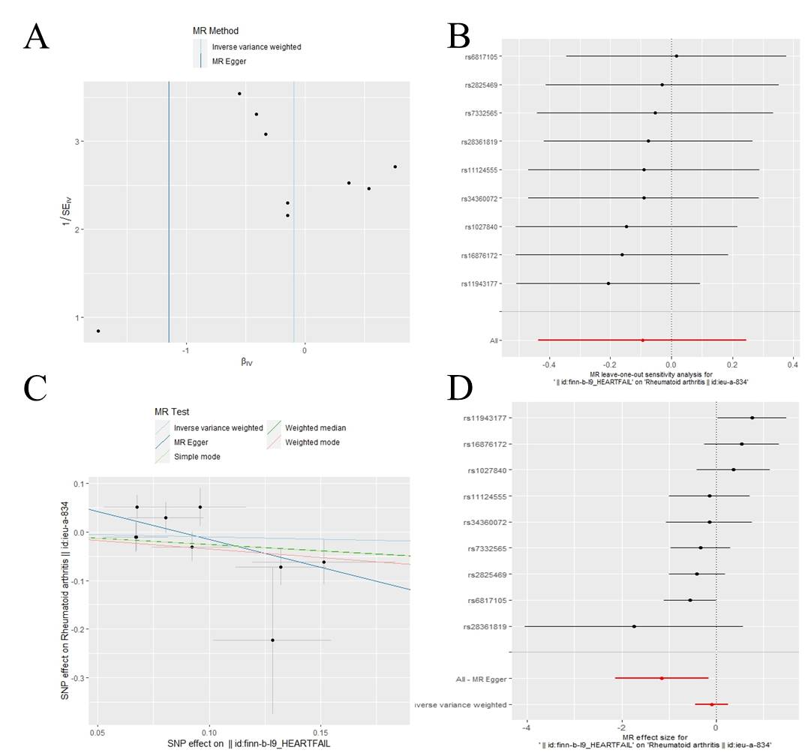
Supplementary Figure 1 Funnel plot of the causal effect of HF on RA (A). Leave-one-out analysis of the causal effect of HF on RA. Red lines represent estimations from the IVW test. RA, rheumatoid arthritis; IVW, inverse variance weighted; HF, heart failure (B). Scatter plot (C) and forest plot (D) of causal effects for HF on RA. Summary of the Mendelian randomization (MR) result derived from the inverse-variance weight, MR-Egger and weighted median method.

