Resource 1
Information relating to PROs and sample size calculation for secondary outcomes
The HADS is a valid measure for anxiety and depression in hospital and community settings [1]. Studies based on a range of cancer tumour types have reported Cronbach alpha coefficients of 0.80 – 0.89 for the Anxiety scale and 0.77 – 0.82 for the Depression scale [2, 3]. Anchor-derived criteria have been used to establish the minimal clinically important difference (MID) of 1.5 points for the HADS (both scales) [4] and 1.7 (both scales) [5]. With a final sample size of 326, the power to detect the minimal clinically important difference was estimated to be 92% for the HADS [6].
The CBI-B is a valid and reliable measure of self-efficacy, confidence and quality of life for people coping with cancer. A number of versions of the CBI exist: the 14 item CBI-B was derived from the CBI-L with 33 items, with the 14 item also further modified to a 12 item scale with total scale alpha coefficients ranging from 0.84 – 0.88 [7, 8, 9]. MIDs or effect sizes were not available at the time of development of the trial. A meta-analysis of 3,120 cancer patients across 37 controlled studies that used psychosocial measures to assess a range of cancer interventions reported an average effect size of 0.31 (95%CI: -0.13–0.75) [10], which was used in this study, similar to the effect size of 0.27 reported in a meta-analysis of interventions to enhance self-efficacy in cancer patients [11] and to the effect size of 0.28 proposed for the 14 item CBI-B by Giesler et al (2017) [12]. The sample size of 326 had 80% power to detect an effect size of 0.31 for the CBI-B [13] (G*Power 3.1.9.7 (Faul et al, 2009)).
The EORTC QLQ-C30 is an internationally used cancer specific questionnaire measuring physical, role, emotional, cognitive and social function as well as cancer symptoms and global quality of life. Reliability coefficients of 0.62- 0.92 have been reported [14]. MID for the EORTC QLQ-C30 has been reported as 10 points or more on the function and symptom scales [15, 16]. Using a minimum of 10 points and median standard deviations provided in [16], power ranged from 63.6 to 99.0, with an average of 92% [6] (StudySize 3.0 (Olofsson, 2001-2013)).
Resource 2
Additional information relating to delays in treatment.
In the intervention group 26 patients (15%) had delays >7 days: 12 due to treatment toxicity or disease progression, 1 due to hospital admission from an unplanned presentation, 9 due to planned surgery and 4 due to social reasons. In the control group, 21 patients (12%) had delays >7 days: 12 due to toxicity or disease progression, 5 due to hospital admission from an unplanned presentation, 4 due to planned surgery or other planned procedure, and none due to social reasons. Planned surgery included procedures such as hysterectomy, debulking (removal of as much of a tumour as possible) and laparotomy. Social reasons included attending family functions and caring duties.

Resource 3 EORTC analysis
Analysis shows no significant difference on any of the 15 scales.
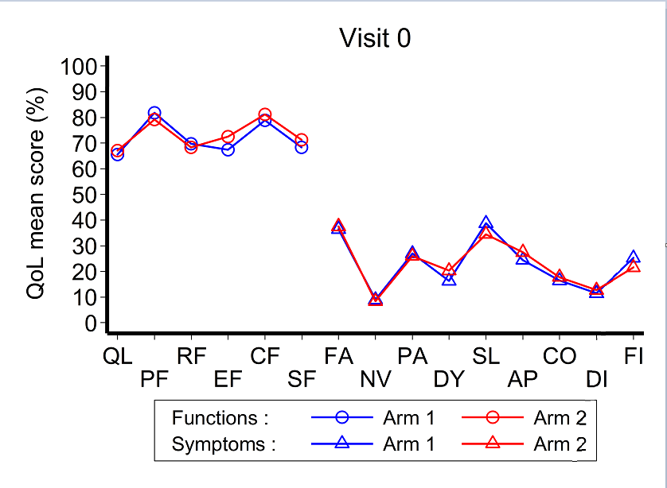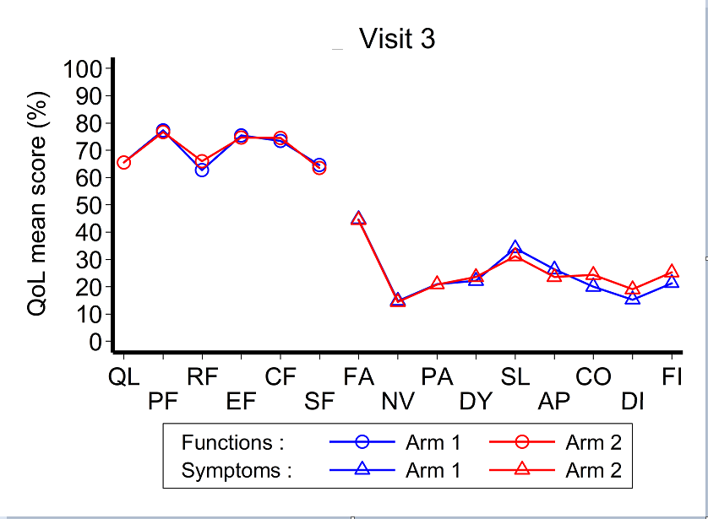
Arm 1 = Intervention; Arm 2 = Control

QL: Global health status (QoL) – 2 items DY: Dyspnea – 1 item
PF: Physical Functioning – 5 items SL: Insomnia – 1 item
RF: Role Functioning – 2 items AP: Appetite loss – 1 item
EF: Emotional Functioning – 4 items CO: Constipation – 1 item
C F: Cognitive functioning – 2 items DI: Diarrhea – 1 item
SF: Social functioning – 2 items FI: Financial difficulties – 1 item
FA: Fatigue – 3 items
NV: Nausea and vomiting – 2 items
PA: Pain – 2 items
These are the scales of greatest interest

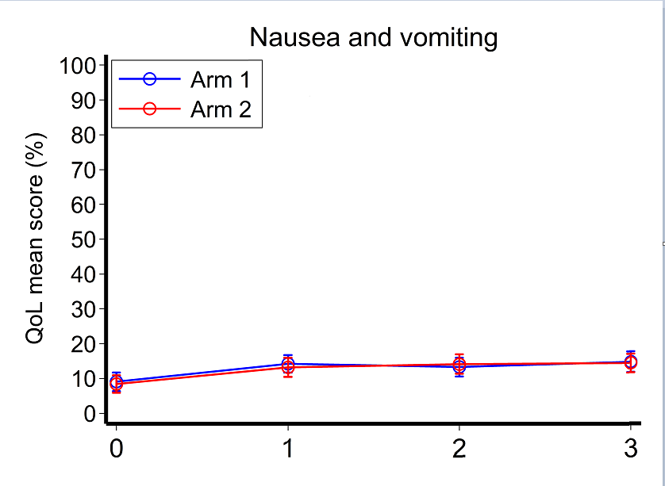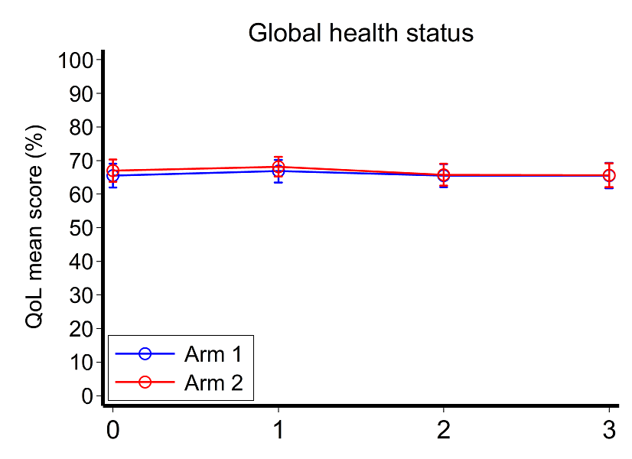
Arm 1 = Intervention; Arm 2 = Control
Australian reference values can be found at:

https://www.mja.com.au/journal/2019/210/11/eortc-quality-life-questionnaire-cancer-patients-qlq-c30-australian-general

References for online resources

1. Snaith, R.P. (2003) The Hospital Anxiety And Depression Scale. Health Qual Life Outcomes 1: 29. https://doi.org/10.1186/1477-7525-1-29
2. Zittoun R, Achard S, Ruszniewski M. (1999) Assessment of quality of life during intensive chemotherapy or bone marrow transplantation. Psychooncology 8(1): 64-73.
3. Lloyd-Williams M, Friedman T, Rudd, N. (2001) An Analysis of the Validity of the Hospital Anxiety and Depression Scale as a Screening Tool in Patients with Advanced Metastatic Cancer. J Pain Symptom Manage 22(6):990-996. doi:10.1016/s0885-3924(01)00358-x
4. Puhan, M., et al. (2008) The minimal important difference of the hospital anxiety and depression scale in patients with chronic obstructive pulmonary disease. Health Qual Life Outcomes, 6(1): 46. https://doi.org/10.1186/1477-7525-6-46
5. Lemay KR, Tulloch HE, Pipe AL, Reed JL(2019) Establishing the Minimal Clinically Important Difference for the Hospital Anxiety and Depression Scale in Patients With Cardiovascular Disease. J Cardiopulm Rehabil Prev. http://doi.org/10.1097/HCR.0000000000000379
6. StudySize 3.0, CREOSTAT HB, Sweden. https://www.studysize.com/
7. Heitzmann et al. (2011) Assessing self-efficacy for coping with cancer: development and psychometric analysis of the brief version of the Cancer Behaviour Inventory (CBI-B) Psychooncology 20(3):302-312. https://doi.org/10.1002/pon.1735
8. Chirico et al (2017) A meta-analytic review of the relationship of cancer coping self-efficacy with distress and quality of life. Oncotarget 8(22):pp 36800-36811. https://doi.org/10.18632/oncotarget.15758
9. Pereira M, Izdebski P, Pereira MG (2021) Validation of the Brief Version of the Cancer Behavior Inventory in Breast Cancer Portuguese Patients. J Clin Psychol Med Settings 28:491-502. https://doi.org/10.1007/s10880-021-09773-5
10. Rehse, B. and Pukrop, R. (2003) Effects of psychosocial interventions on quality of life in adult cancer patients: meta analysis of 37 published controlled outcome studies. Patient Educ Couns 50(2):179-186. https://doi.org/ 10.1016/s0738-3991(02)00149-0
11. Merluzzi TV et al (2019) Interventions to enhance self‐efficacy in cancer patients: A meta‐analysis of randomized controlled trials. Psycho‐Oncology 28(9):1781-1790. https://doi.org/10.1002/pon.5148
12. Giesler JM et al (2017) Effect of a Website That Presents Patients’ Experiences on Self-Efficacy and Patient Competence of Colorectal Cancer Patients:Web-Based Randomized Controlled Trial J Med Internet Res 19(10). https://doi.org/10.2196/jmir.7639

13. Faul F, Erdfelder E, Lang AG, Buchner A (2007). G*Power 3: A flexible statistical power analysis for the social, behavioral, and biomedical sciences. Behavior Research Methods, 39, 175-191. https://www.psychologie.hh u.de/arbeitsgruppen/allgemeine-psychologie-und-arbeitspsychologie/gpower
14. King et al. (2007). Validity, reliability and responsiveness of the EORTC QLQ-C30 and the EORTC QLQ-LC13 in Australians with early stage non-small cell lung cancer, CHERE Working Paper 2007/13. CHERE, University of Technology, Sydney, Working Papers.
15. Osoba D et al (1998) Interpreting the significance of changes in health-related quality-of- life scores. J Clinical Oncol 16(1): 139-144. https://doi.org/ 10.1200/JCO.1998.16.1.139
16. King M (1996) The interpretation of scores from the EORTC quality of life questionnaire QLQ-C30. Qual Life Res 5:555-567. https://doi.org/10.1007/BF00439229

