Supplementary Information
Genetic Resources and Crop Evolution Journal

The genetic diversity of wild grapes in Mexico
Karla G. Huerta-Acosta¹, Summaira Riaz¹, Omar Franco-Mora², Juan G. Cruz-Castillo³, M. Andrew Walker¹*
Author affiliation
1: Department of Viticulture and Enology, University of California, Davis.
2: Laboratorio de Horticultura, Facultad de Ciencias Agrícolas, Universidad Autónoma del Estado de México. Campus Universitario El Cerrillo. Toluca, México. C. P. 50200.
3: Centro Regional Universitario Oriente, Universidad Autónoma Chapingo. Huatusco, Veracruz, México.
*Corresponding author (Telephone: 530-752-0902; Fax: 530-752-0382; email: awalker@ucdavis.edu)

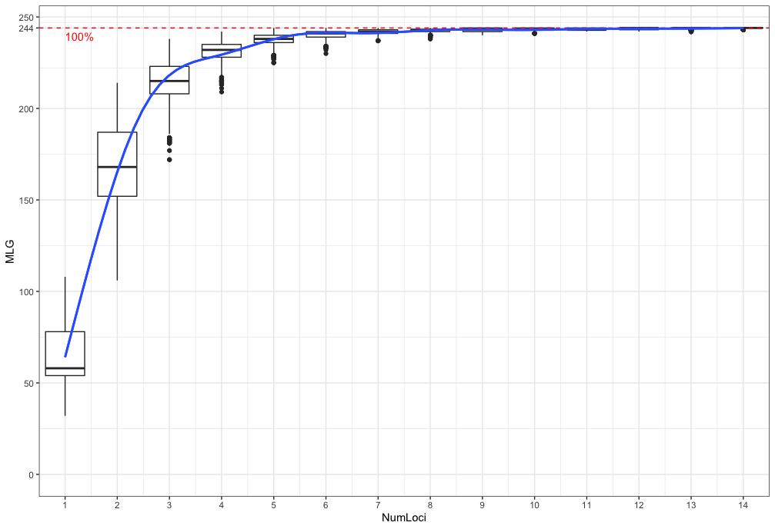
Supplementary Fig. 1 Genotype accumulation curve using 15 SSR markers. The x-axis reflects number of loci and y-axis reflects multilocus genotypes (MLGs) that can be distinguished

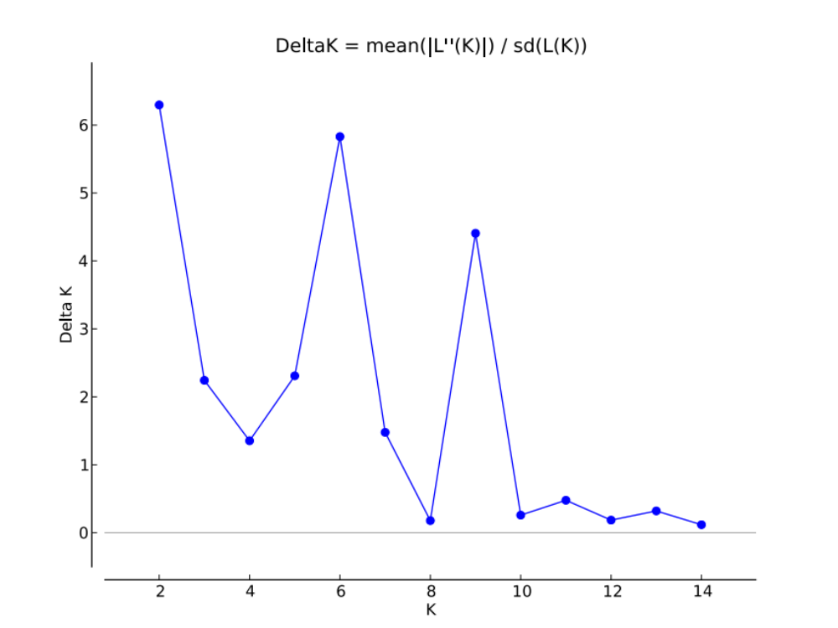
Supplementary Fig. 2 STRUCTURE HARVESTER graph results using the Delta K method. Peaks at K=2 and K=6 indicates most clusters using 15 SSR markers. These results are comparable with the Evanno’s method shown in Appendix S5, showing K=2 and K=6 as the most probable numbers of genetic groups

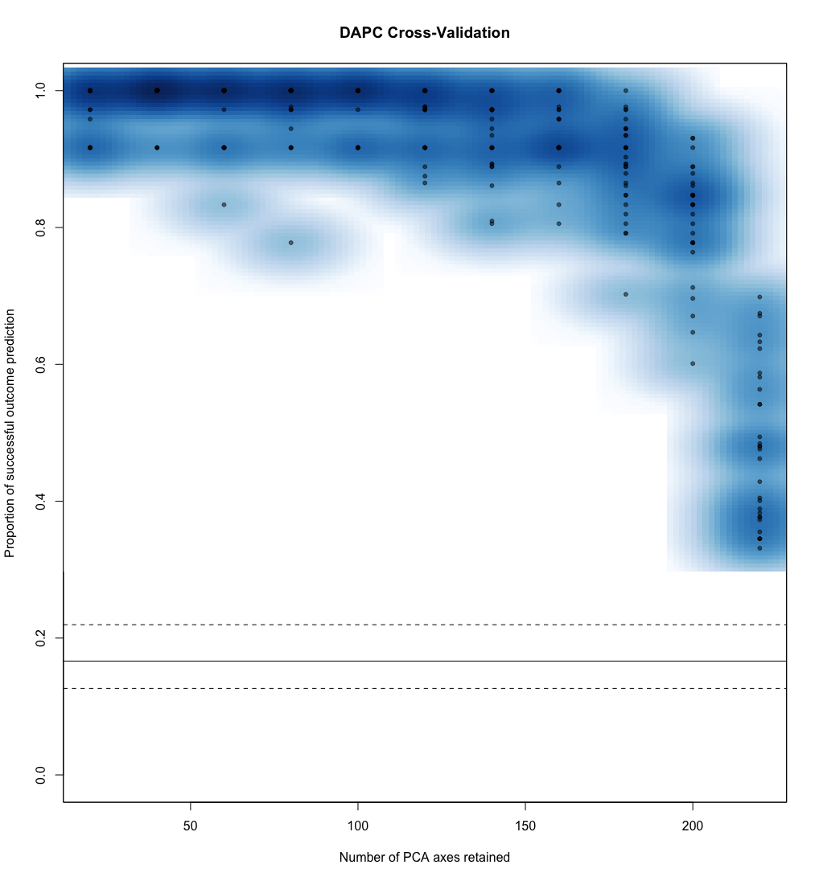
Supplementary Fig. 3 First cross-validation for discriminant analysis of principal component (DAPC) using 247 accessions in the study. The analysis showed 40 Principal Component (PCs) to have the highest proportion of successful outcome prediction (0.991667) and the lowest Mean Squared Error (0.026352). Dots represent the replicates in the analysis

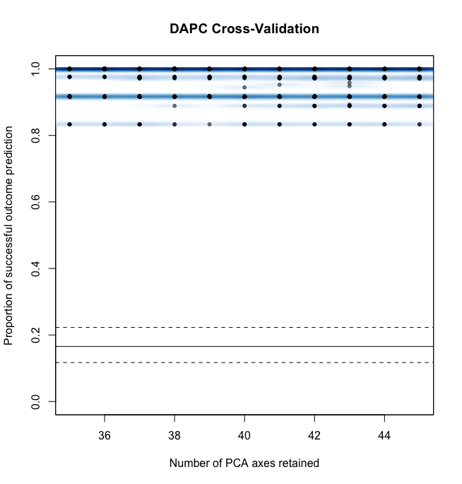
Supplementary Fig. 4 Second cross-validation DAPC analysis reran with narrowed PCA number going from 35 to 45 PCs retained. The graph shows a straight line where the highest outcome prediction and the Lowest Mean Squared Error was 36 PCs retained

