Supplementary information
Increasing the thermal stability of α-diimine nickel (II) catalyst by camphorquinone as a great backbone and investigating the steric effects of this backbone in ethylene polymerization
Zahra Issaabadiª, Hassan Arabi^{a,*}, Majid Karimiª
ªDepartment of Polymerization Engineering, Iran Polymer and Petrochemical Institute (IPPI), Tehran, Iran.
Email: H.arabi@ippi.ac.ir

Table of Contents:
- ¹HNMR, ¹³CNMR, 2D HNMR of α-diimine ligands (H₁, H₂)
- FT-IR of ligands (H₁, H₂)
- FT-IR of α-diimine Ni(II) complexes (C₁, C₂)
¹HNMR, ¹³CNMR, 2D HNMR of α-diimine ligands (H₁, H₂)
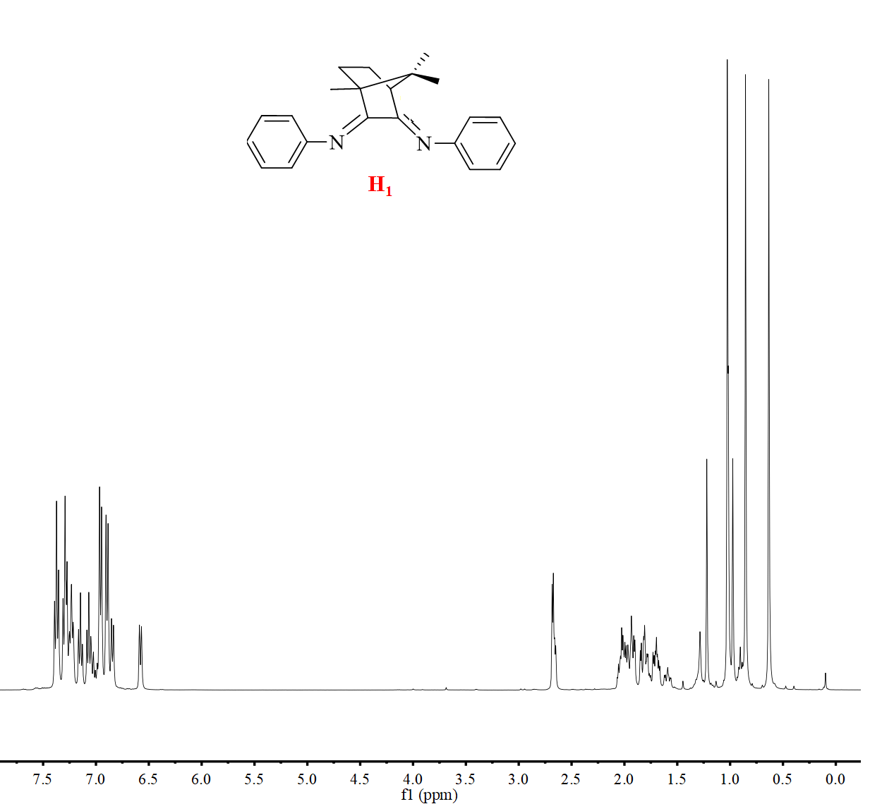
Figure S1. The ¹HNMR of H₁
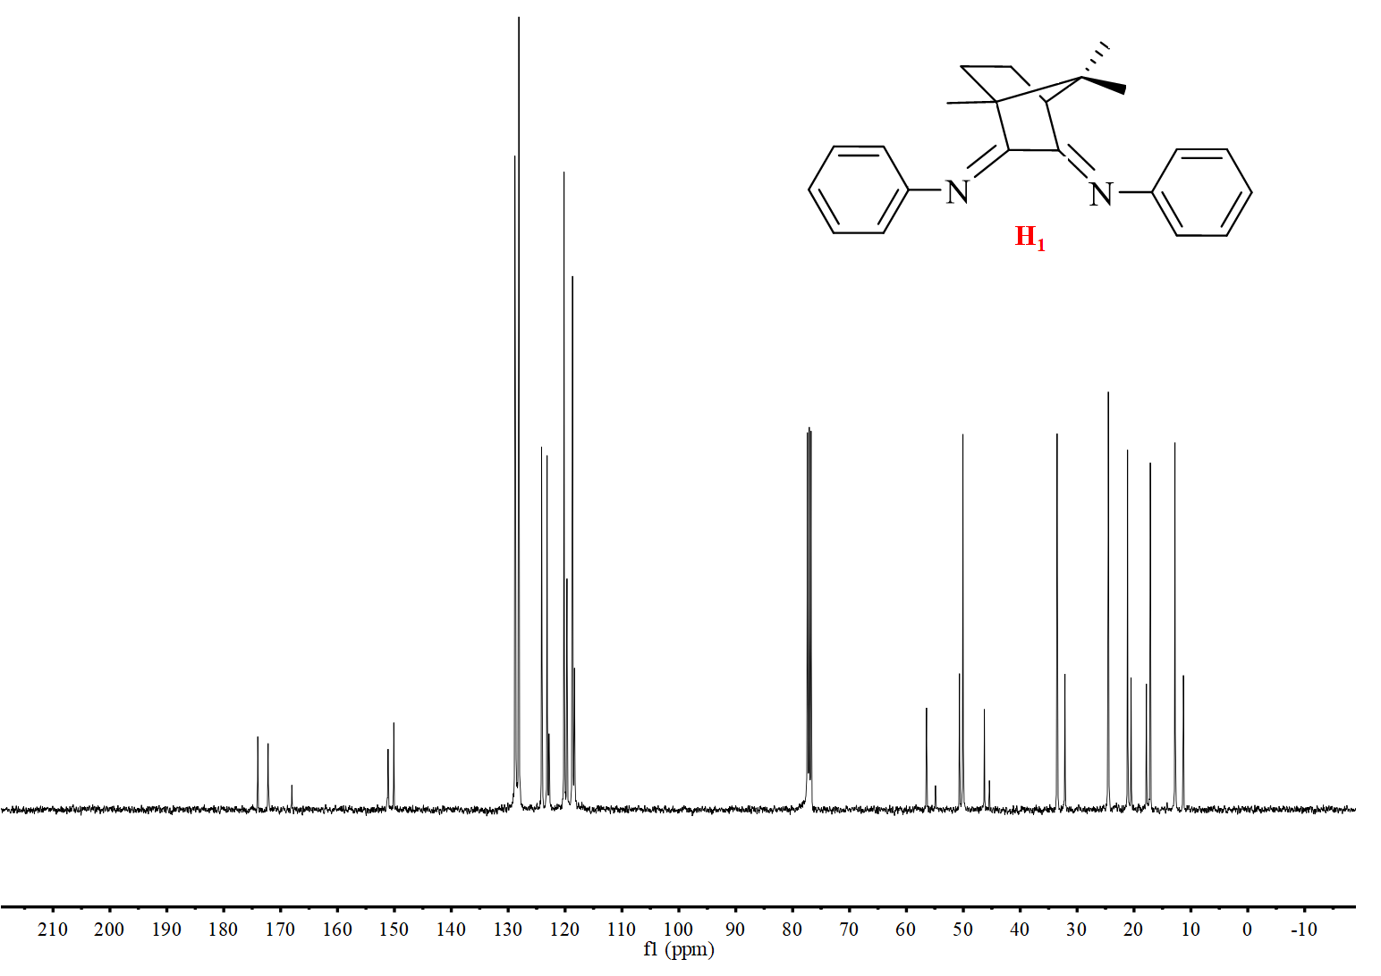
Figure S2. The ¹³CNMR of H₁
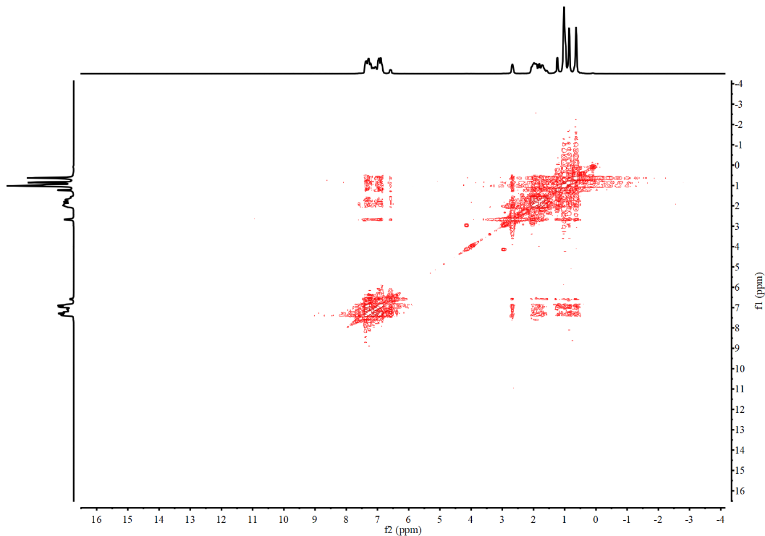
Figure S3. The H-H COSY of H₁
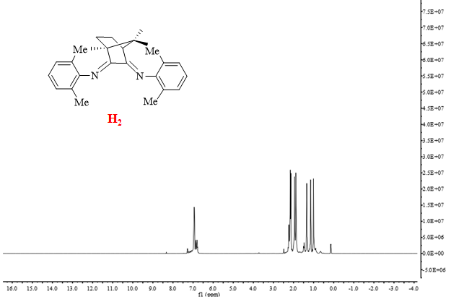
Figure S4. The ¹HNMR of H₂
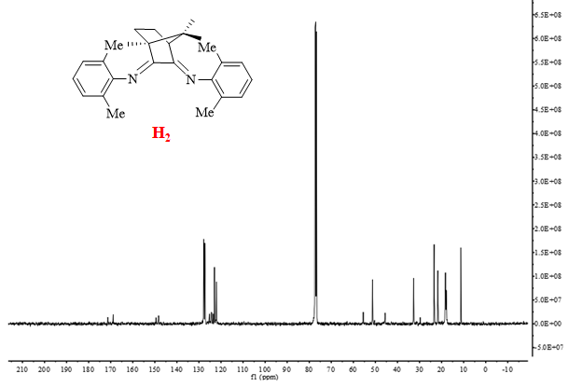
Figure S5. The ¹³CNMR of H₂
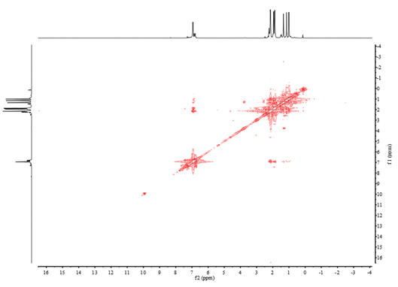
Figure S6. The H-H COSY of H₂
FT-IR of ligands (H₁, H₂)
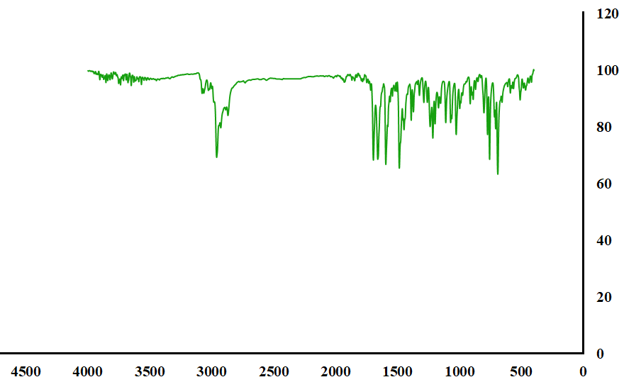
Figure S7. The FT-IR spectrum of H₁
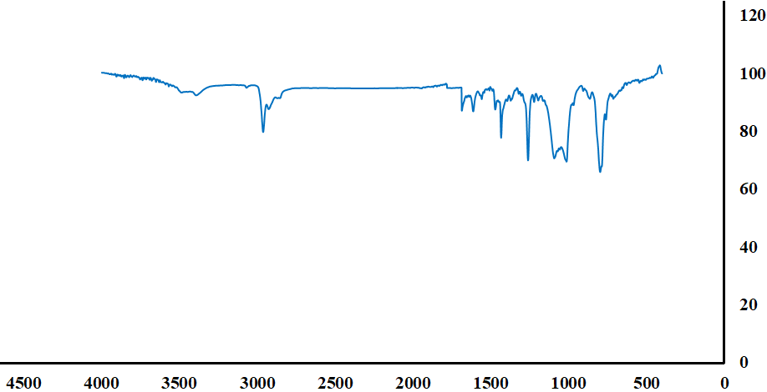
Figure S8. The FT-IR spectrum of H₂
FT-IR of α-diimine Ni(II) complexes (C₁, C₂)
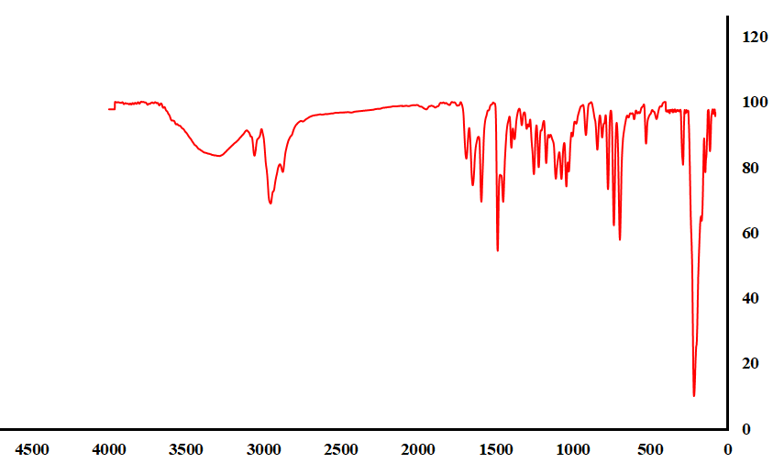
Figure S9. The FT-IR spectrum of C₁
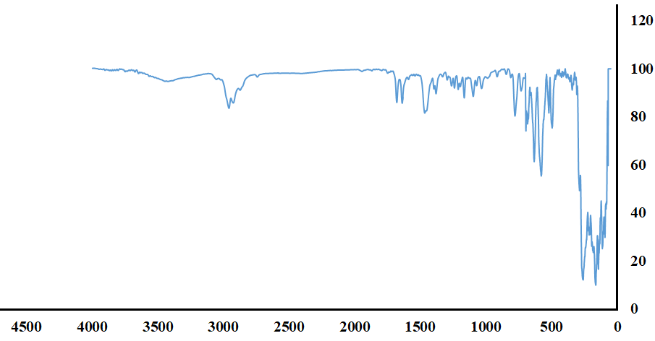
Figure S10. The FT-IR spectrum of C₂

