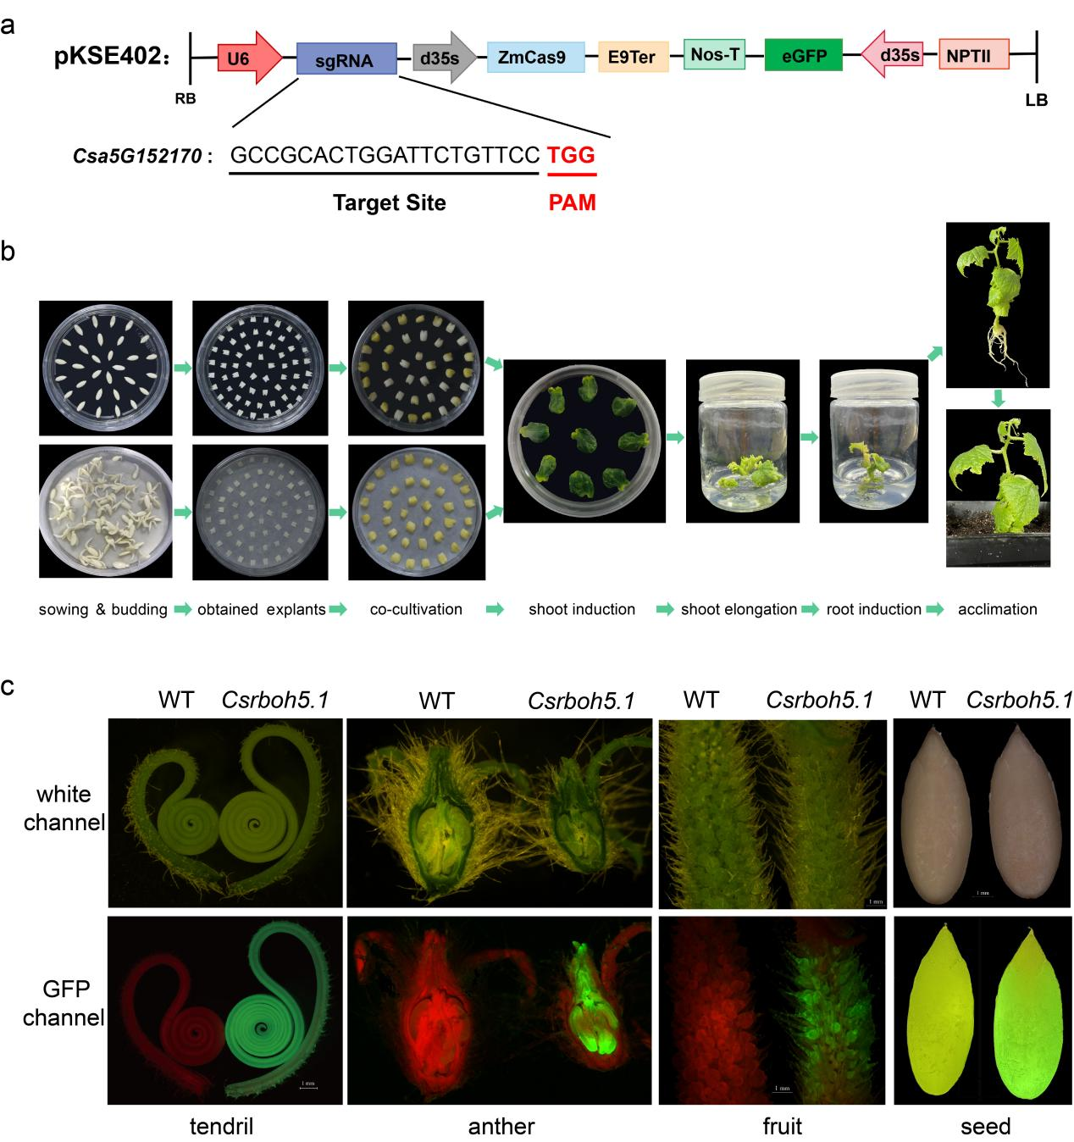
Extended Data Fig.1| The process of obtaining the Csrboh5.1 mutant cucumber. a, The information of vector and the single target site sequence. b, The process of infection of cucumber explants by Agrobacterium transformation to obtain the positive cucumber seedlings. c, The observation of GFP fluorescence condition throughout the whole process including transformation and domestication.

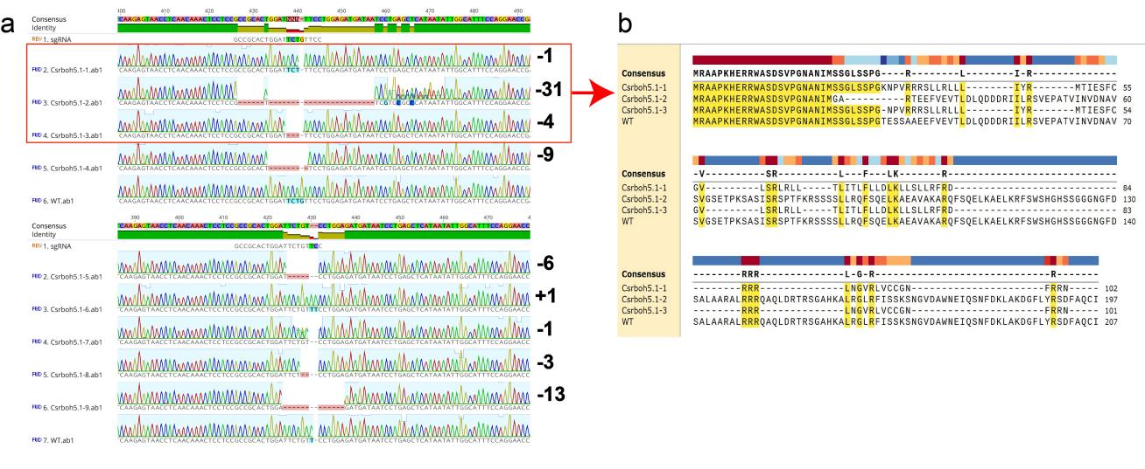
Extended Data Fig.2| The situation of gene editing about the progeny of obtained transgenic cucumber lines. a, A total of nine types of CsRBOH5.1-edited lines were obtained. b, The protein sequence of screened three CsRBOH5.1 knockout lines (-1 bp, Csrboh5.1-1; -31 bp, Csrboh5.1-2; -4 bp, Csrboh5.1-3).

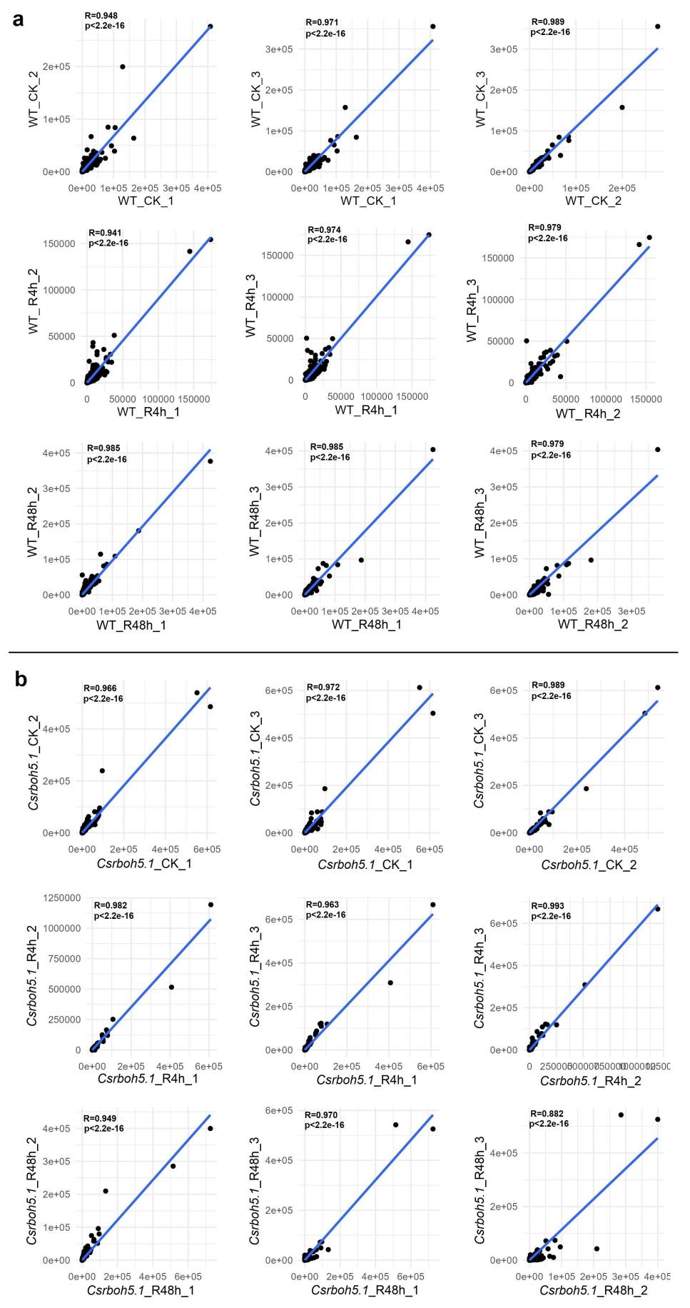
Extended Data Fig.3| Correlation analysis between three biological replicates of RNA-seq data about the WT (a) and the Csrboh5.1 mutant (b) in cucumber seedlings. CK: unacclimated seedlings. R4h: during recovery at 4 h after CS-ACC. R48h: during recovery at 48 h after CS-ACC.

Extended Data Fig.4| The expression of some key cold response genes. CK: unacclimated seedlings. R4h: during recovery at 4 h after CS-ACC. R48h: during recovery at 48 h after CS-ACC. The “*” represented that there was significant difference between WT and Csrboh5.1 in CK, R4h or R48h. The “ns” represented that there was no significant difference between WT and Csrboh5.1 in CK, R4h or R48h. The “*” indicated significant differences as assessed by the Student’s t test. “*” represented the 0.05 level, “**” represented the 0.01 level and “***” represented the 0.001 level.

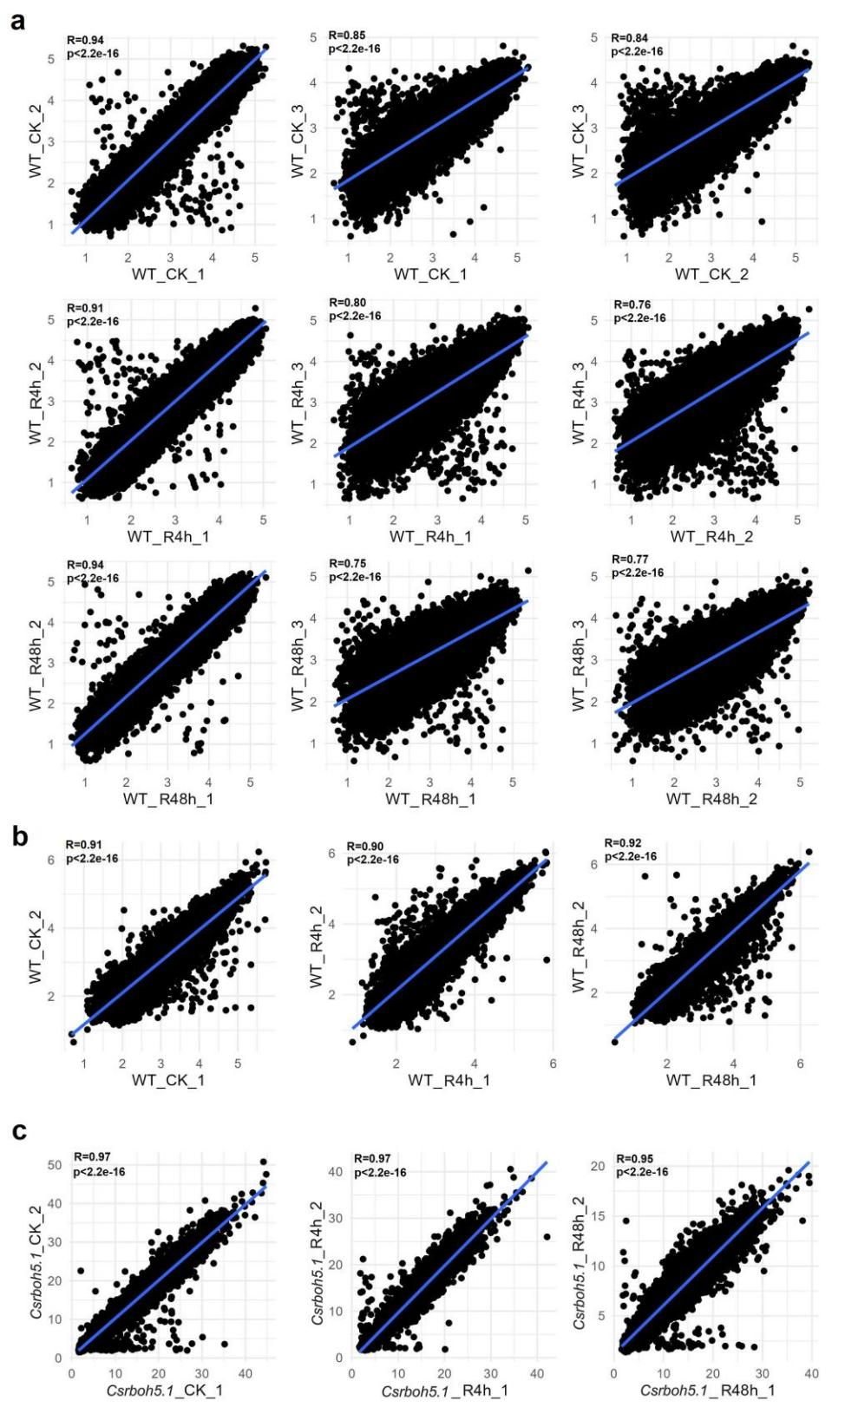
Extended Data Fig.5| Correlation analysis between biological replicates of ChIP-seq data in cucumber seedlings. a, The correlation analysis between replicates of H3K4me3 in WT seedlings. b, The correlation analysis between replicates of H3K27me3 in WT seedlings. c, The correlation analysis between replicates of H3K4me3 in Csrboh5.1 mutants. CK: unacclimated seedlings. R4h: during recovery at 4 h after CS-ACC. R48h: during recovery at 48 h after CS-ACC.

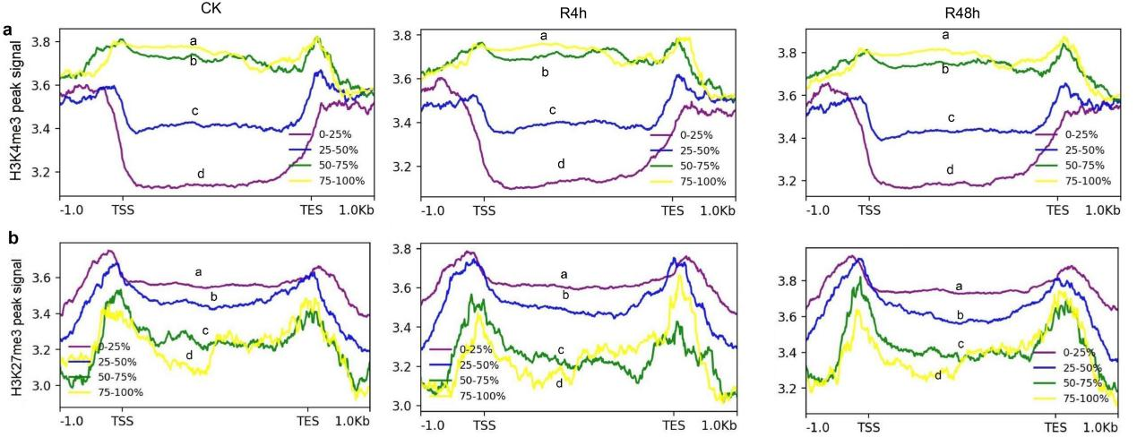
Extended Data Fig.6| Analysis of the peak signal for H3K4me3 (a) and H3K27me3 (b) in WT for different expression levels of genes. CK: unacclimated seedlings. R4h: during recovery at 4 h after CS-ACC. R48h: during recovery at 48 h after CS-ACC. The different letters were significantly different by Wilcoxon rank sum tests, and then the p values were adjusted by Holm method (q < 0.05).

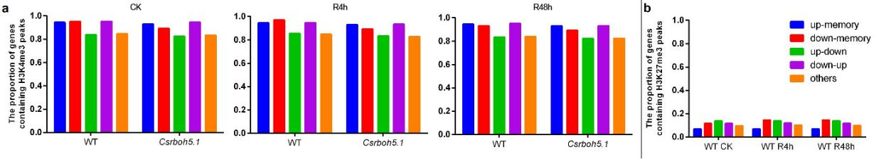
Extended Data Fig.7| The statistics of the presence of H3K4me3 peaks on different types genes in WT and Csrboh5.1 mutants (a) and H3K27me3 peaks on different types genes in WT seedlings. CK: unacclimated seedlings. R4h: during recovery at 4 h after CS-ACC. R48h: during recovery at 48 h after CS-ACC.

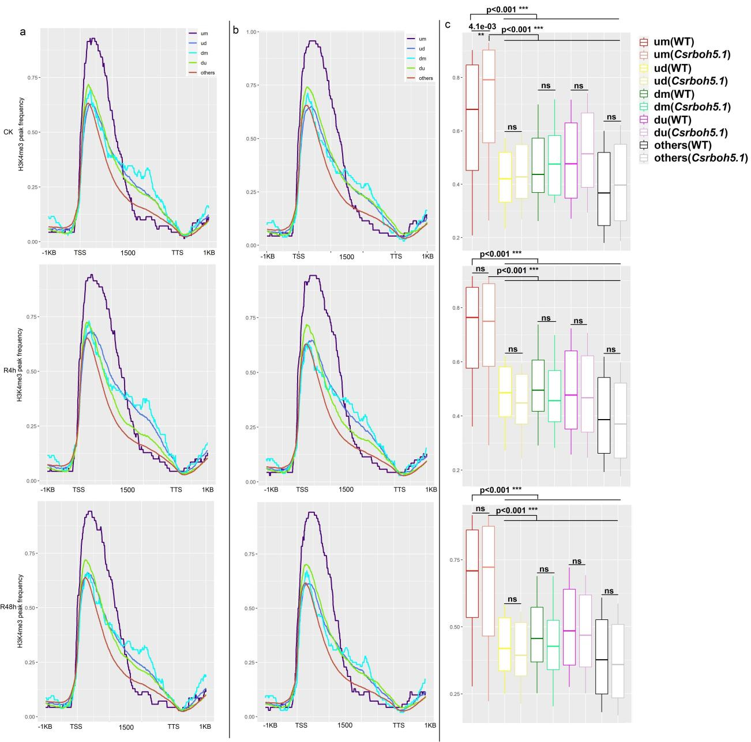
Extended Data Fig.8| The H3K4me3 peak frequencies of different types genes. a, WT. b, Csrboh5.1 mutants. c, The statistics of the H3K4me3 peak frequencies of WT and Csrboh5.1 mutant. CK: unacclimated seedlings. R4h: during recovery at 4 h after CS-ACC. R48h: during recovery at 48 h after CS-ACC. The “*” indicated significant differences as assessed by Wilcoxon rank sum tests, and then the p values were adjusted by Holm method. “*” represented the 0.05 level and “**” represented the 0.01 level and “***” represented the 0.001 level. “ns” represented no significance.

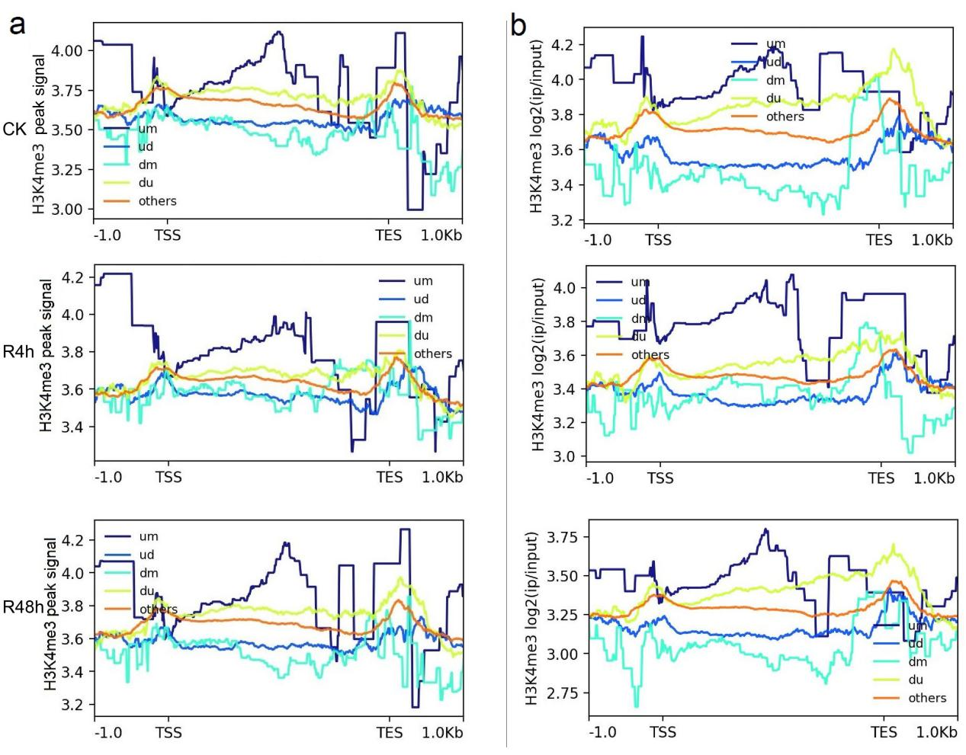
Extended Data Fig.9| The H3K4me3 peak signal of different types of genes. a, WT. b, Csrboh5.1 mutants. CK: unacclimated seedlings. R4h: during recovery at 4 h after CS-ACC. R48h: during recovery at 48 h after CS-ACC.

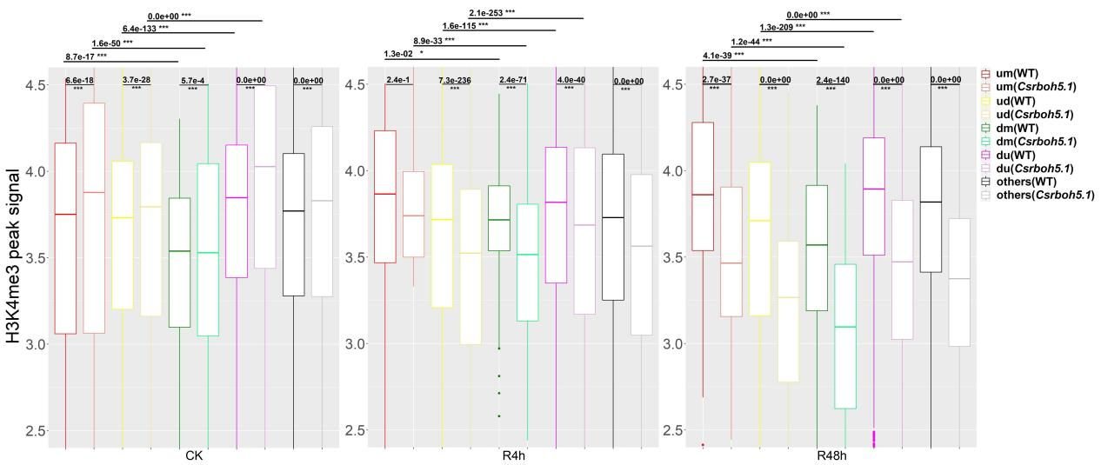
Extended Data Fig.10| The H3K4me3 peak signal near the TES regions of genes. The “*” indicated significant differences as assessed by Wilcoxon rank sum tests, and then the p values were adjusted by Holm method. “*” represented the 0.05 level and “**” represented the 0.01 level and “***” represented the 0.001 level. “ns” represented no significance.

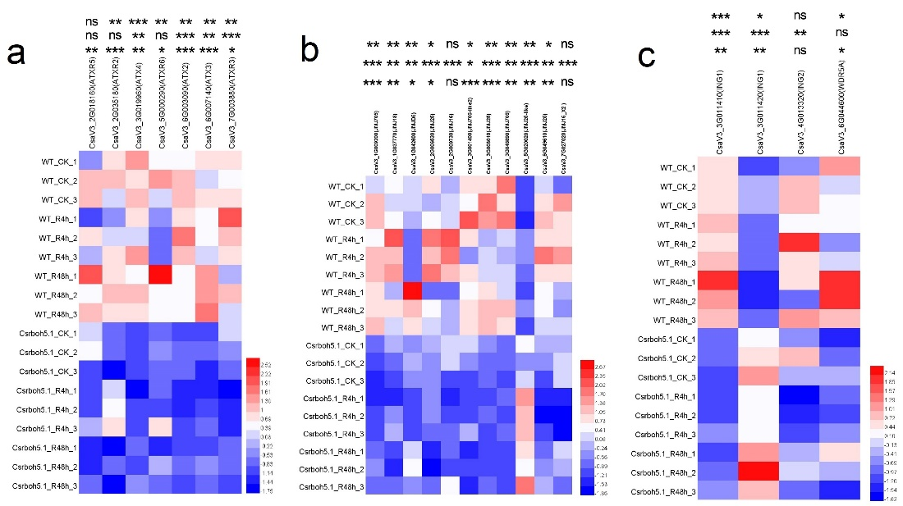
Extended Data Fig.11| The expression of genes related to H3K4me3 regulation. The expression of histone methyltransferase “writers” (f), histone demethylase “erasers” (g) and the histone modification “readers” (h) genes. The “*” represented that there was significant difference between WT and Csrboh5.1 in CK, R4h or R48h. The “ns” represented that there was no significant difference between WT and Csrboh5.1 in CK, R4h or R48. The “*” indicated significant differences as assessed by the Student’s t test. “*” represented the 0.05 level, “**” represented the 0.01 level and “***” represented the 0.001 level.

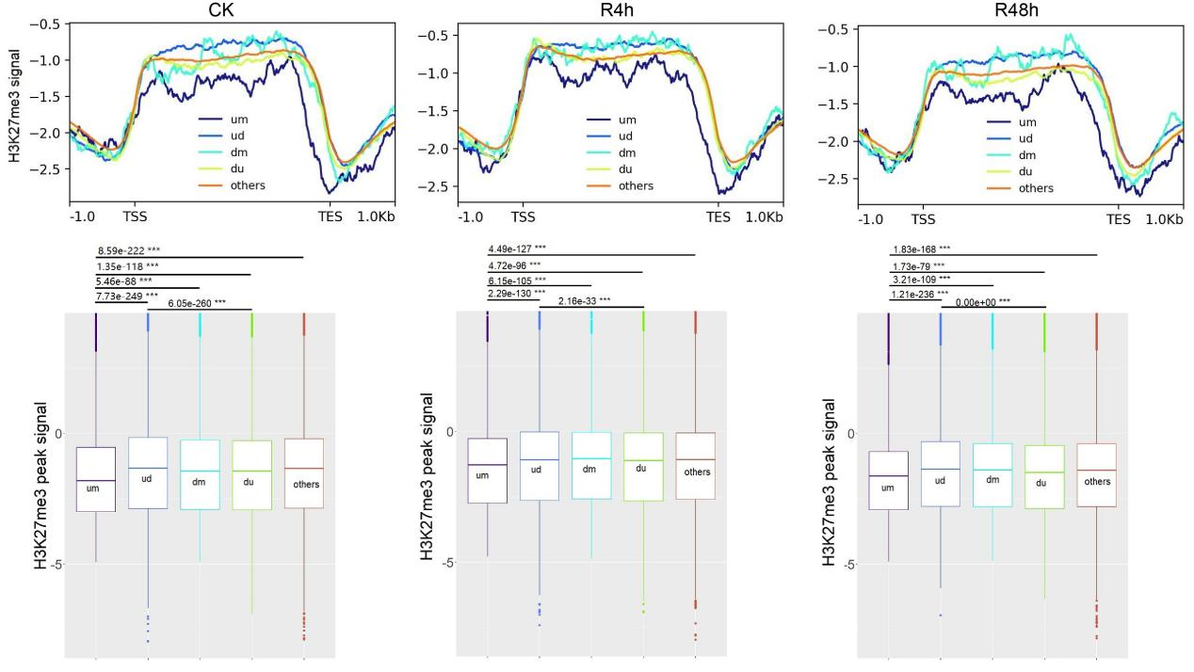
Extended Data Fig.12| The H3K27me3 signal of different types of genes in WT. The “*” indicated significant differences as assessed by Wilcoxon rank sum tests, and then the p values were adjusted by Holm method. “*” represented the 0.05 level and “**” represented the 0.01 level and “***” represented the 0.001 level. “ns” represented no significance.

