Materials and Methods
Data acquisition
We extracted sixty FRGs from previous literature[8] and provided the details in Supplementary Table S1. RNA-seq data and clinical profiles of 548 CRC patients were obtained from The Cancer Genome Atlas (TCGA) web data resource up to September 15, 2020 (https://portal.gdc.cancer.gov/). The R software (version 4.0.2) was used to normalize and process the data. Additionally, a cohort of 122 CRC patients from the GEO web data resource (https://www.ncbi.nlm.nih.gov/geo/) (GSE38832) was applied as an independent external test set. The "limma" R package was utilized to normalize the gene expression matrix. Both TCGA and GEO data are publicly accessible, and our research adheres to their policies and guidelines.
Construction and validation of prognostic models based on FRGs
To identify the DEGs between tumour tissues and neighbouring non-tumourous tissues in the TCGA data set, we employed the "limma" R package, setting the cutoff false discovery rate (FDR) at 0.05. Additionally, we conducted univariate Cox analyses to identify the FRGs associated with OS and DFS in CRC. Subsequently, we utilized the STRING web data resource (version 11.0) to construct an interaction network to further investigate the prognostic FRGs[9], removed nodes of the genes that had no connection to any other nodes, and set the cut-off as 0.150. We then built the prognostic models using the package “glmnet” and formed the OS-linked as well as DFS-linked estimation formulas based on LASSO Cox regression algorithm[10]. To prevent overfitting, we utilized the minimum partial likelihood deviance criteria to determine the penalty parameter (λ) of the model through cross-validation. For each patient in both models, we calculated the risk score using the formula: $\text{risk score=}\sum_{\text{j=1}}^{\text{n}}{\text{Coef}\text{j}\text{*}\text{X}\text{j}}$$\text{risk score=}\sum_{\text{j=1}}^{\text{n}}{\text{Coef}\text{j}\text{*X}\text{j}}$, where Coefj denotes the coefficient and Xj represents the relative expression level of each FRG. Afterwards, we divided the patients into high- and low-risk groups based on the median value of the risk score. To investigate the distribution of these groups, we utilized the "prcomp" tool in the "stats" R package to conduct PCA, and the "Rtsne" R package was used to perform t-SNE test. We employed the Kaplan-Meier (KM) method with a two-sided log-rank test to compare the survival differences between the high- and low-risk groups. The predictive performance of the novel models was evaluated by calculating the area under the receiver-operator characteristic curve (AUC-ROC) using the "survivalROC" package in R, while the independent prognostic prediction potential of the risk score was assessed via MultiCox analysis. Additionally, we examined the relationship between the risk score and clinicopathological parameters. Finally, we validated the prognostic prediction models in an independent CRC cohort (GSE38832).
Functional enrichment analyses
We utilized the "clusterProfiler" R package to perform enrichment analyses of Kyoto Encyclopaedia of Genes and Genomes (KEGG) and Gene Ontology (GO) based on the differentially expressed FRGs (FDR < 0.05). To evaluate BP, CC, MF, and KEGG enrichment between the two distinct risk groups identified by our innovative prognostic models (FDR < 0.05, |NES| > 1), we employed GSEA (Gene Set Enrichment Analysis) from the following website: http://software.broadinstitute.org/gsea/. Lastly, we computed the infiltrating score for 16 immune cells and 13 immune-linked cascades using the "gsva" R package's ssGSEA function.
Development of nomogram
To integrate various risk factors and quantify individual risk in a clinical context, a nomogram was developed using the R packages "survival" and "rms"[11]. After excluding cases with incomplete clinical data, a nomogram was established by combining the risk score with clinicopathological parameters (TMN, stage, age, and gender) to estimate the probabilities of one-year and three-year OS and DFS for CRC patients. Calibration plots were employed to evaluate the agreement between the predicted and observed survival outcomes.
Identification of candidate drugs
In order to screen potential candidate drugs, we utilized the CMap web data resource (https://clue.io) [12]. CMap is a valuable chemical genomics web tool that encompasses gene expression patterns of human cells treated with various small molecules. It enables the identification of small molecules capable of reversing specific gene expression trends. Following an exploration of CMap, the candidate compounds were converted into their respective NSC (National Science Center) numbers. These NSC numbers were then investigated within the CellMiner web data resource (https://discover.nci.nih.gov/cellminer). Drug activity levels obtained from all NCI60 experiments that successfully passed the quality control assessment were analyzed and presented.
Cell culture and transfection
The NCM460 and FHC cell lines, representative of human colorectal cancer (CRC) mucosal epithelial cells, were acquired from the American Type Culture Collection, together with seven additional CRC cell lines: HCT8, HCT116, SW480, SW620, SW1463, RKO, and HT29. All cell lines were cultured in DMEM medium (Gibco) supplemented with 5% penicillin/streptomycin (Gibco, Thermo Fisher Scientific) and 10% fetal bovine serum (Gibco, Thermo Fisher Scientific, Waltham, MA) at a temperature of 37°C.
We then silenced FDFT1 expression using small-interfering RNAs (siRNA). RiboBio Co. (Guangzhou, China) provided three siRNAs specifically targeting FDFT1 (si-h-FDFT1_001: 5-GCAGAATCTTCCCAACTGT-3; si-h-FDFT1_002: 5-GTGCCTGAATGAACTTATA-3; si-h-FDFT1_003: 5-GGAGCAGGTATGTTAAGAA-3), along with a non-specific siRNA used as a negative control. Following the manufacturer’s instructions, siRNA duplexes were inserted into CRC cells through transfection with a Lipofectamine 3000 system (Invitrogen, USA). CRC cells were also transfected with FDFT1-overexpression plasmids or empty vector DNA via the X-treme GENE HP DNA Transfection Reagent (Roche; Indianapolis, IN, USA), as directed by the manufacturer.
Patient specimens and real-time PCR
In Xijing Hospital of Digestive Diseases, CRC specimens and corresponding neighboring non-tumor tissues were obtained from a cohort of 15 individuals who underwent CRC surgery between January 2019 and January 2020. Prior to participation, informed consent was obtained from all patients, and the research was approved by the ethics committee of Xijing Hospital, Fourth Military Medical University. Total RNA extraction from both CRC tissues and neighboring non-tumor tissues was performed using the TRIzol reagent (Invitrogen). Subsequently, the isolated RNA (2 μg) was reversely transcribed into cDNA using the PrimeScript RT reagent Kit (TaKaRa). Quantitative real-time PCR (qRT-PCR) analysis of AKR1C1, ALOX12C, ATP5MC3, FDFT1, and CRYAB gene expressions was conducted on the CFX96 Real-Time System (Bio-Rad, USA) using SYBR Premix Ex Taq II (TaKaRa). The primer sequences can be found in Table S2. Relative expression levels were analyzed using the 2^{−ΔΔCt} method.
Cell proliferation assay and in vitro drug sensitivity assay
Cell proliferation was assessed using the Cell Counting Kit-8 assay (Dojindo). In brief, 96-well culture plates were utilized, and suspensions of cells (2 × 10³ cells/well) were added. The plates were then incubated for a period of 5 days to allow cell growth. Subsequently, 10 µL of CCK-8 solution was added to each well, and the cells were allowed to grow for an additional 2 hours. The optical density at 450 nm was measured using a microplate reader.
To determine drug sensitivity, the CCK-8 assay was employed. Overnight incubation was carried out with suspensions of cells (5 × 10³ cells/well) in 96-well plates. Prior to each experiment, Erastin was prepared, and cells were exposed to Erastin at various concentrations after adhesion. After 48 hours, 10 µL of the CCK-8 solution (Dojindo) was added to each well, and the cells were allowed to grow for an additional 2 hours. The absorbance at 450 nm was then measured using a microplate reader.
Transwell migration and invasion assay
To examine cell migration, Transwell inserts (Corning) with a chamber pore size of 8.0 μm were utilized. In a serum-free medium, cells at a concentration of 5 × 104 cells/mL were resuspended and added to the upper chamber of the insert. Subsequently, a complete medium with a volume of 500 μL was introduced to the lower compartment. After 36 hours, the cells were fixed using 4% paraformaldehyde, followed by staining with Giemsa (Boster Ltd.). Images of the cells on the bottom layer were captured using an Olympus inverted microscope (DP72) at a magnification of 100× after removing the top layer of the membrane. Visualization of five randomly selected fields was performed, and the ImageJ software was used for assessment. The average number of migrating cells through the compartments was recorded as the representative value for each group.
In the invasion assay, the Transwell membrane was coated with 40111ES08 Matrigel matrix gel (Yisheng Biotechnology Co., Ltd.). Subsequently, the upper area of the Boyden chambers was seeded with 1 × 10⁵ CRC cells. After the elapse of 36 h of incubation, we wiped off the superficial cell layer using cotton balls. Subsequent steps were similar as described above.
Malondialdehyde (MDA) assay
Lipid peroxidation levels were assessed using a colorimetric kit (#S0131, Beyotime) that specifically quantifies malondialdehyde (MDA), as per the manufacturer's instructions. The absorbance was measured at 532 nm using a microplate reader, and the concentration of MDA was determined by reference to a standard curve.
Statistical analysis
Statistical analyses were conducted using R software 4.0.2, encompassing various methods, such as DEG analysis, univariate and multivariate Cox regression analyses. All statistical tests were two-sided, and a significance level of p < 0.05 was considered statistically significant.
Table S1. Sixty ferroptosis-related genes
Ferrotosis-related genes | Name
ACSL4 | acyl-CoA synthetase long-chain family member 4
AKR1C1 | aldo-keto reductase family 1 member C1
AKR1C2 | aldo-keto reductase family 1 member C2
AKR1C3 | aldo-keto reductase family 1 member C3
ALOX15 | arachidonate 15-lipoxygenase
ALOX5 | arachidonate 5-lipoxygenase
ALOX12 | arachidonate 12-lipoxygenase
ATP5MC3 | ATP synthase membrane subunit c locus 3
CARS | cysteinyl tRNA synthetase
CBS | cystathion ine beta synthase
CD44 | CD44 molecule
CHAC1 | ChaC glutathione- specific gamma-glutamyl cyclotransferase 1
CISD1 | CDGSH iron sulfur domain 1
CS | citrate synthase
DPP4 | dipeptidyl-dippeptidase-4
FANCD2 | Fanconi anemia comple mentation group D2
GCLC | glutamate-cysteine ligase catalytic subunit
GCLM | glutamate-cysteine ligase modifier subunit
GLS2 | glutaminase 2
GPX4 | glutathio ne peroxidase 4
GSS | glutathione synthetase
HMGCR | 3-hydroxy-3- methylglutaryl-CoA reductase
HSPB1 | heat shock protein beta 1
CRYAB | heat shock protein beta 5
LPCAT3 | lysophosp hatidylcholine acyltransferase 3
MT1G | metallothionein-1G
NCOA4 | nuclear receptor coactiva tor 4
PTGS2 | prostagla ndin-endoperoxide synthase 2
RPL8 | ribosomal protein L8
SAT1 | spermidine/spermine N1-acetyltra nsferase 1
SLC7A11 | solute carrier family 7 member 11
FDFT1 | farnesyl-diphosphate farnesyltransferase 1
TFRC | transferrin receptor
TP53 | tumor protein 53
EMC2 | ER membrane protein complex subunit 2
AIFM2 | apoptosis inducing factor mitochondria associated 2
PHKG2 | phospho rylase kinase ,g2
HSBP1 | heat-shock 27-k Da protein 1
ACO1 | aconitase 1
FTH1 | ferritin heavy chain 1
STEAP3 | six-transm embrane epithelial antigen of prostate 3
NFS1 | cysteine desulfurase
ACSL3 | acyl-CoA synthetase long-chain family member 3
ACACA | Acetyl-CoA carboxylase alpha
PEBP1 | phosphatidy lethanolamine-binding protein 1
ZEB1 | zinc finger E-box-binding homeobox 1
SQLE | squalene monooxygenase
FADS2 | fatty acid desaturase 2/acyl-CoA 6-desaturase
NFE2L2 | nuclear factor, erythroid 2 like 2
KEAP1 | kelch-like ECH- associated protein 1
NQO1 | quinone oxidoreductas e-1
NOX1 | NADPH oxidase 1
ABCC1 | ATP binding cassette subfamily C member 1
SLC1A5 | solute carrier family 1 member 5
GOT1 | glutamic-oxa loacetic transaminase 1
G6PD | glucose-6-phosphate dehydrogenas e
PGD | phosphoglycerate dehydrogenas e
IREB2 | iron response element-binding protein 2
HMOX1 | heme oxygenase 1
ACSF2 | acyl-CoA synthetase family member 2

Table S2. Primers design and their sequences of FRGs
Gene | Forward primer | Reverse primer
AKR1C1 | TGTTGCATAATGCCTGGGCTA | TTGGAAAGGCAGCGAAGGAT
ALOX12 | GCCCAAAGCTGTGCTAAACC | TGGGGGAGGAAATAGAGCCT
ATP5MC3 | GGAAGGTAAGTGGAGGGCAC | ATATTGGGTGACAGGCGACG
FDFT1 | CCTGTGAGCAGGTCGTGTAT | TGGAGACCAGAAGACCAAACG
CRYAB | TGGATAGAAGGGGGACAAGG | CTAGGTGAGTGTGAGGGGTCA

Table S3. Clinical characteristics of the CRC patients used in this study
 | TCGA Cohort | GSE38832 Cohort
 | (N=548) | (N=122)
Age
<=65 | 237 (43.2%) | NA
>65 | 311 (56.8%) | NA
Gender
Female | 256 (46.7%) | NA
Male | 292 (53.3%) | NA
Stage
Stage I | 96 (17.5%) | 18 (14.8%)
Stage II | 210 (38.3%) | 35 (28.7%)
Stage III | 149 (27.2%) | 39 (32.0%)
Stage IV | 78 (14.2%) | 30 (24.6%)
Unknow | 15 (2.7%) | 0 (0%)
M
M0 | 408 (74.5%) | NA
M1 | 77 (14.1%) | NA
MX | 55 (10.0%) | NA
Unknow | 8 (1.5%) | NA
N
N0 | 323 (58.9%) | NA
N1 | 130 (23.7%) | NA
N2 | 95 (17.3%) | NA
T
T1 | 15 (2.7%) | NA
T2 | 96 (17.5%) | NA
T3 | 373 (68.1%) | NA
T4 | 63 (11.5%) | NA
Unknow | 1 (0.2%) | NA
Event
Alive | 439 (80.1%) | 94 (77.0%)
Dead | 109 (19.9%) | 28 (23.0%)

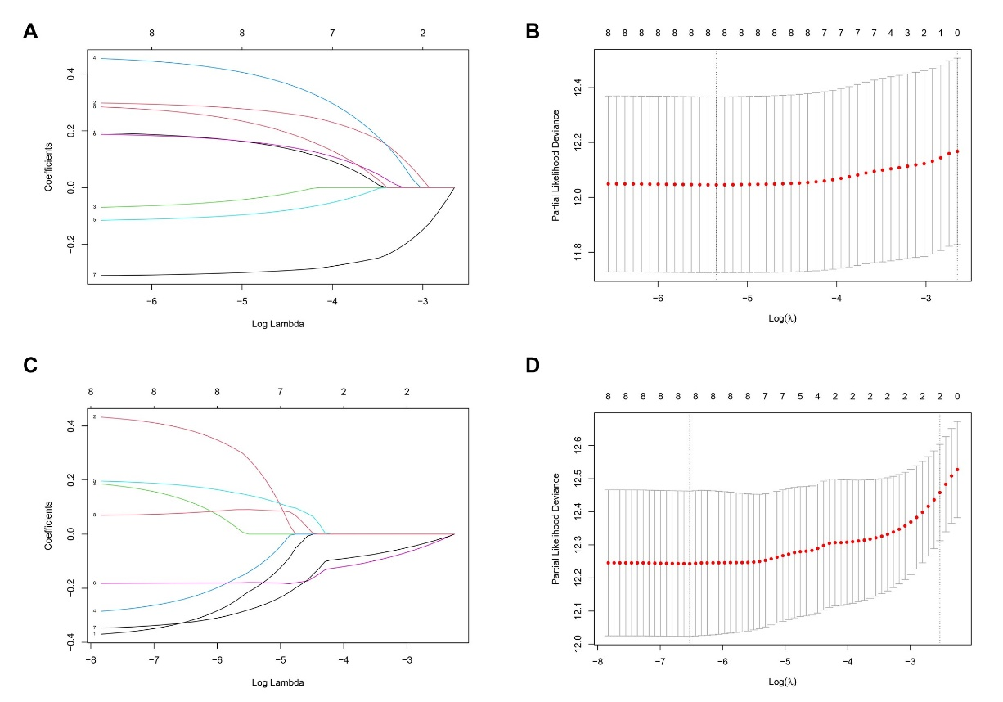
Figure S1. Construction of 8-gene signature models in the TCGA cohort. (a) LASSO coefficient profiles of the expression of 8 candidate OS-related FRGs. (b) Selection of the penalty parameter (λ) in the LASSO model via cross-validation. (c) LASSO coefficient profiles of the expression of 8 candidate DFS-related FRGs. (d) Selection of the penalty parameter (λ) in the LASSO model via cross-validation. The dotted vertical lines are plotted at the optimal values following the minimum criteria (left) and “one standard error” criteria (right).

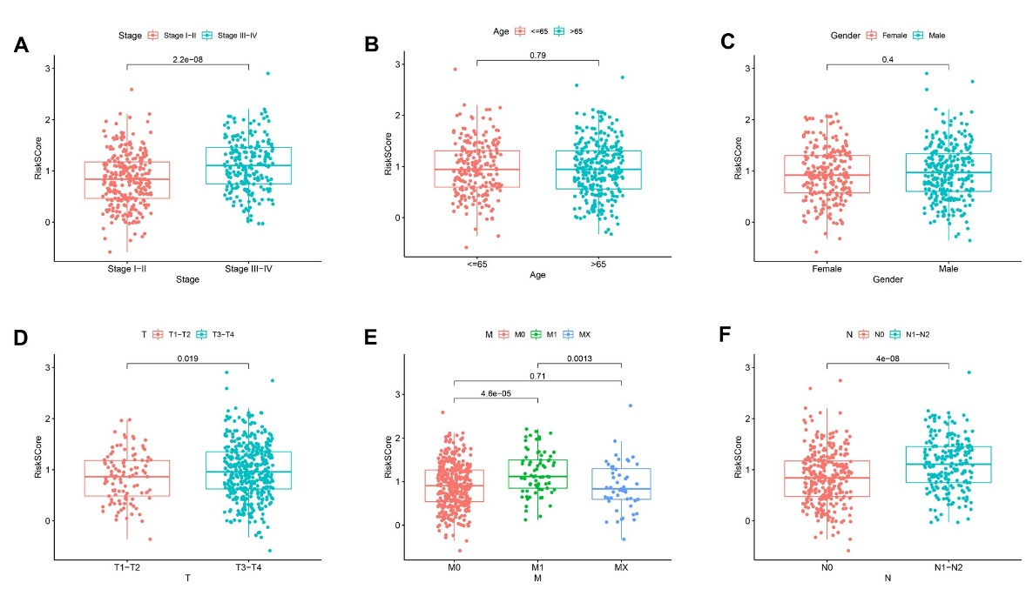
Figure S2. The association between the clinicopathological parameters and the risk score predicted by the OS model. a-f are stage, age, gender, T, M and N.

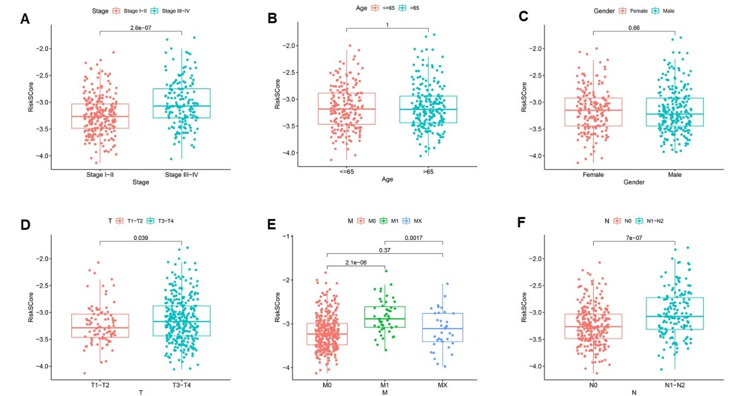
Figure S3. The association between the clinicopathological parameters and the risk score predicted by the DFS model. a-f are stage, age, gender, T, M and N.

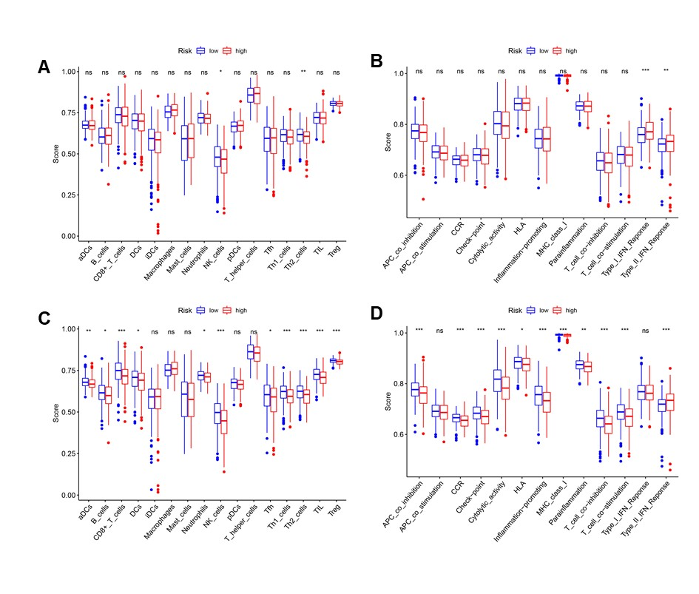
Figure S4. Comparison of the ssGSEA scores between different risk groups in the TCGA cohort predicted by the OS model and DFS model (a, b) and DFS model (c, d). The scores of 16 immune cells (a, c) and 13 immune-related functions (b, d) are displayed in boxplots. (CCR, cytokine-cytokine receptor. Adjusted P values were showed as: ns, not significant; *, P< 0.05; **, P< 0.01; ***, P< 0.001.)

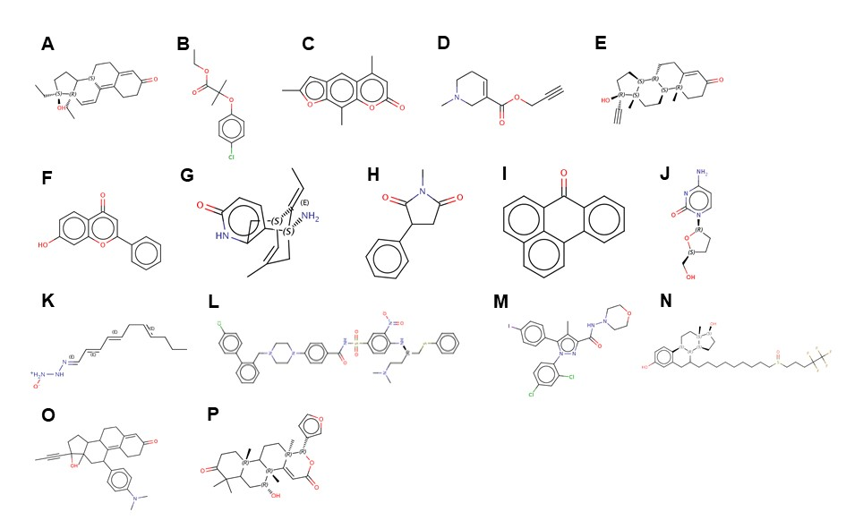
Figure S5. The chemical structures of candidate drugs identified by the Cmap database. (a)-(p) are gestrinone, clofibrate, trioxsalen, arecaidine, ethisterone, NSC-94258, huperzine-a, phensuximide, benzanthrone, zalcitabine, triacsin-c, ABT-737, AM-281, fulvestrant, mifepristone, dihydro-7-desacetyldeoxygedunin, respectively.
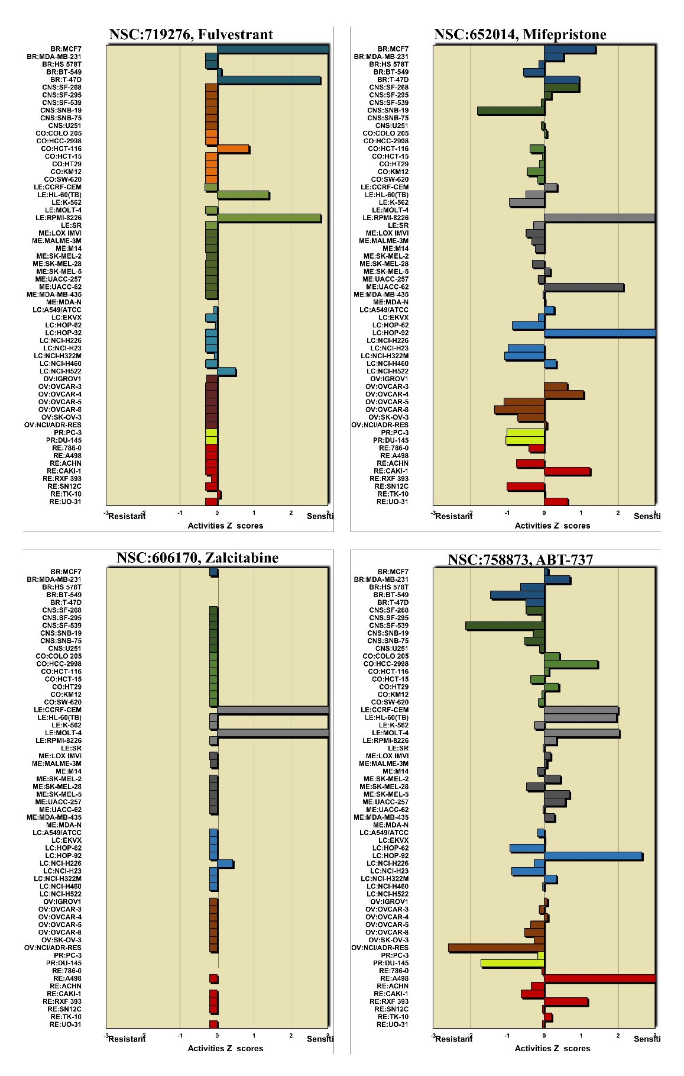
Figure S6: Z scores of drug activity levels among NCI60 cell lines in the CellMiner database

Figure S7: Genetic alteration of 5 ferroptosis-related genes in the CRC cohort (TCGA, PanCancer Atlas)

