Supplementary Material
Subjective Fitness Ratings for Deviants
After completing the Go/Nogo task in Experiment 1, the participants were asked to rate how well the final chord of a sequence fit the preceding musical context on a seven-point scale (1 = not fit at all, 7 = fit very well). In four trials, one for each of the four conditions (one standard and three deviants) were presented in random keys. The fitness ratings were submitted to a one-way repeated measures analysis of variance (ANOVA) with a factor of condition (standard, harmonic deviant, intensity deviant, and double deviant). Greenhouse‐Geisser ε correction was applied to compensate for the violation of sphericity. The Bonferroni correction was applied to multiple comparisons in post hoc testing. Supplementary Figure S1 shows the participants’ fitness ratings for each condition. Supplementary Table S1 shows the mean ratings and SDs of the four conditions. A significant main effect of the condition was obtained: F(3, 156) = 197.31, p < .001, ε = .738, η_{p}² = .791. The post hoc t-tests revealed that fitness ratings were significantly lower for the harmonic, intensity, and double deviants than for the standard (all ps <.001). Moreover, the ratings were significantly lower for the harmonic deviant than for the intensity and double deviants (ps < .001), respectively. These results suggest that the participants recognized all types of deviants and that harmonic deviance had the largest effect among them.

Supplementary Figure S1
Fitness ratings for the final chords in the four conditions
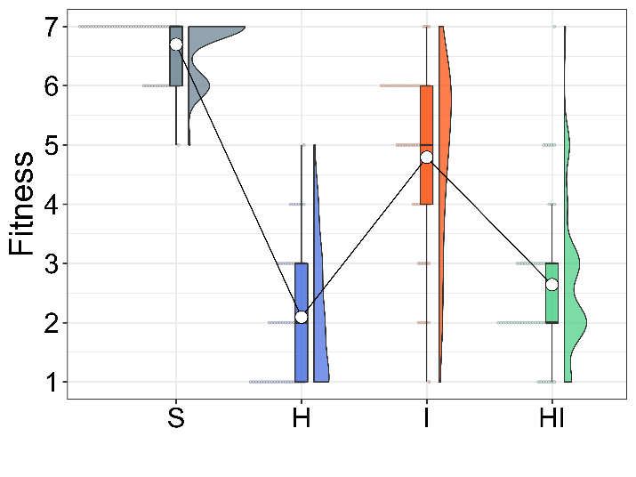
Note. White dots indicate mean ratings. Colored dots indicate an individual’s ratings. S indicates standard, H indicates harmonic deviant, and I indicates intensity deviant.

Supplementary Table S1
Means and SDs of the fitness rating for the final chord in each condition
 | Conditions (N = 53)
 | S | H | I | HI
Mean | 6.7 | 2.1 | 4.8 | 2.7
SD | 0.5 | 1.5 | 1.5 | 1.2
Note. S indicates the standard, H indicates the harmonic deviant, and I indicates the intensity deviant.

Simulation of null hypothesis rejection rates in Experiment 2
To validate the planned sample size (59) in Experiment 2, we conducted a post hoc simulation of null hypothesis rejection rates under a coactivation model. Based on the mean RTs and SDs of Experiment 1 (H: M = 583, SD = 118; I: M = 572, SD = 98; HI: M = 514; SD = 99), we randomly generated RTs of each participant following the inverse Gaussian distribution using “statmod” (Smyth et al., 2017, version 1.5.0), which is an R package. After the calculation of the CDFs from the generated RTs, we submitted the first five decile points were submitted to the permutation test. When the sample size was 59, the number of deviant trials was 25, and the iteration was 10,000, the null hypothesis rejection rate was 99.93%. Thus, these results indicate that the sample size of Experiment 2 was large enough to detect a violation of RMI.

Test of a different type of RMI: Ineq. 4 of Gondan and Vorberg (2021)
We conducted an exploratory analysis of the triple-deviant RMI of Ineq. 4 (Gondan & Vorberg, 2021), which considers two coactivations by combinations of two of three signals. This analysis was conducted to examine whether Gondan and Vorberg’s Ineq. 4 could model the present results, where coactivation was selectively observed in HI and HT, but not in IT. Ineq. 4 of Gondan and Vorberg (2021) is defined as follows: $\begin{aligned}F_{HIT}\left(t\right)≤F_{HI}\left(t\right)+F_{HT}\left(t\right)-F_{H}\left(t\right)\#\left(1\right)\end{aligned}$
$$\begin{aligned}F_{HIT}\left(t\right)≤F_{HI}\left(t\right)+F_{IT}\left(t\right)-F_{I}\left(t\right)\#\left(2\right)\end{aligned}$$
$$\begin{aligned}F_{HIT}\left(t\right)≤F_{HT}\left(t\right)+F_{IT}\left(t\right)-F_{T}\left(t\right)\#\left(3\right)\end{aligned}$$
This definition can be formed in three different ways, and each version considers two coactivations: (1) coactivation of HI and HT; (2) coactivations of HI and IT; and (3) coactivation of HT and IT. Based on the distinct signal coactivation model (Ulrich & Miller, 1997, Table 1), in which coactivation is represented by an additional racer, it was expected that (2) and (3) would be violated because the coactivation of HI and HT is suggested in the double-deviant RMI. The CDFs calculated based on (1) to (3) are illustrated in Supplementary Figure S2. The CDFs were divided into 10 deciles, and the first five decile points were submitted to the permutation test for each form. However, none of the forms of RMI were violated: t_{max} = 1,73, t_{crit} = 2.30, p = .148 for (1), t_{max} = 1.56, t_{crit} = 2.27, p = .192 for (2), and t_{max} = 1.00, t_{crit} = 2.28, p = .389 for (3). The faster response to timbre deviance and the contamination of response competition might have caused these unclear results. Future research should examine selective violations of Ineq. 4, such as by controlling for the competition or salience of responses.

Supplementary Figure S2
CDFs for each deviant condition in Experiment 2
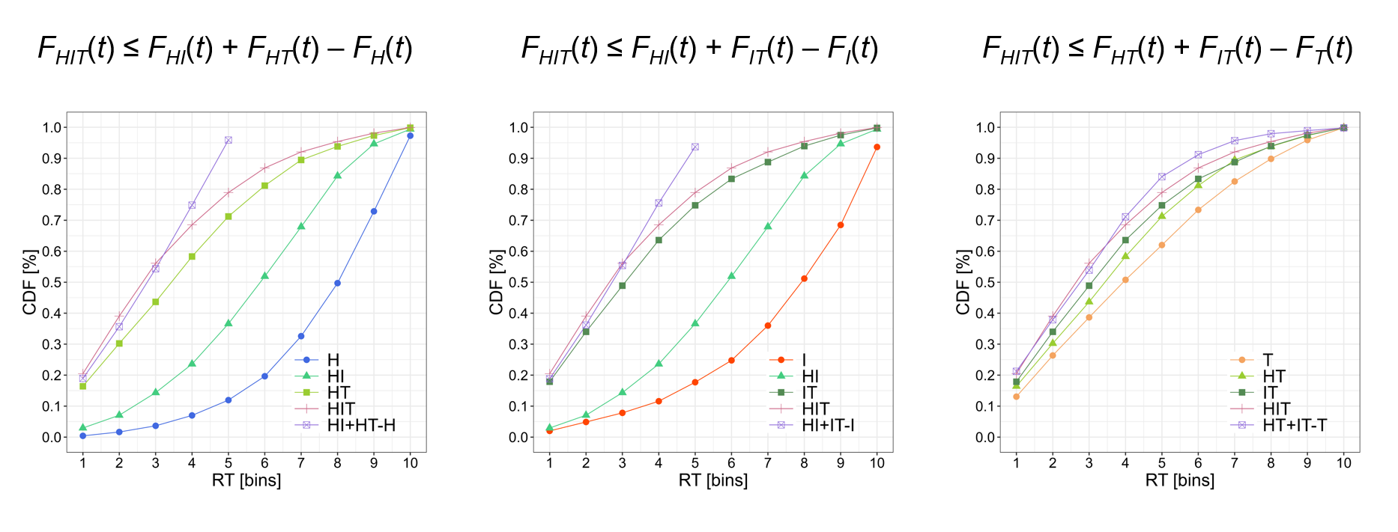
Note. The horizontal axis indicates bins of RTs arranged in order of decreasing time and separated into 10 deciles. The vertical axis indicates the cumulative probability. The purple CDFs, calculated by summation and subtraction, exceeded 1.0 and were truncated before reaching 1.0.

