Supplementary Information
CdS with tunable crystalline phase structures: controllable preparation and enhanced photocatalytic properties
Na Qin,* Linqiang Li, Haoran Zheng, Qingxue Cui
*Henan Key Laboratory of Functional Salt Materials, Center for Advanced Materials Research, Zhongyuan University of Technology, Zhengzhou, 450007 P. R. China.
E-mail addresses: qina@zut.edu.cn.

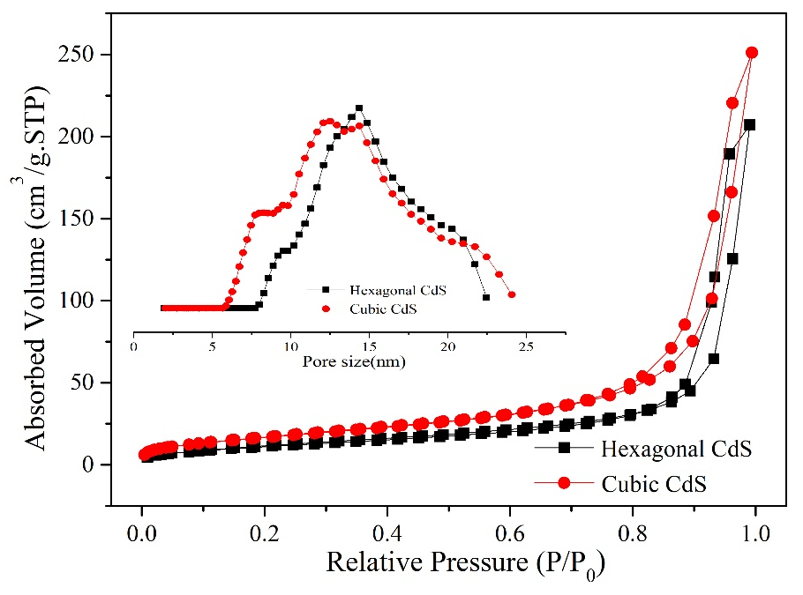
Fig. S1. N₂ sorption curves of cubic CdS and hexagonal CdS (inset: pore size distribution).

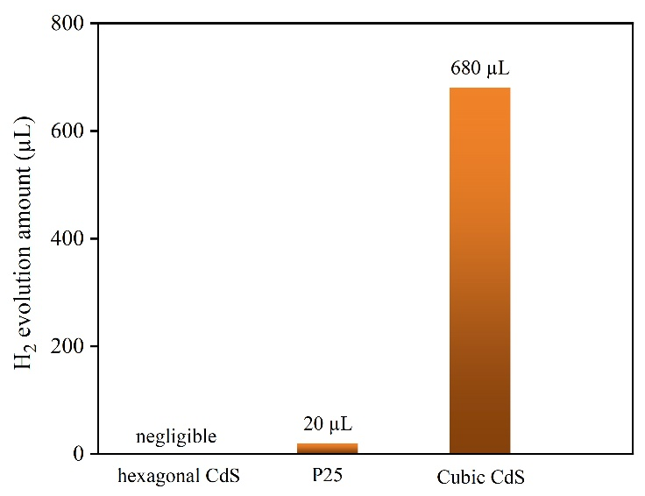
Fig. S2. Photocatalytic hydrogen production over hexagonal CdS, P25 and cubic CdS.

