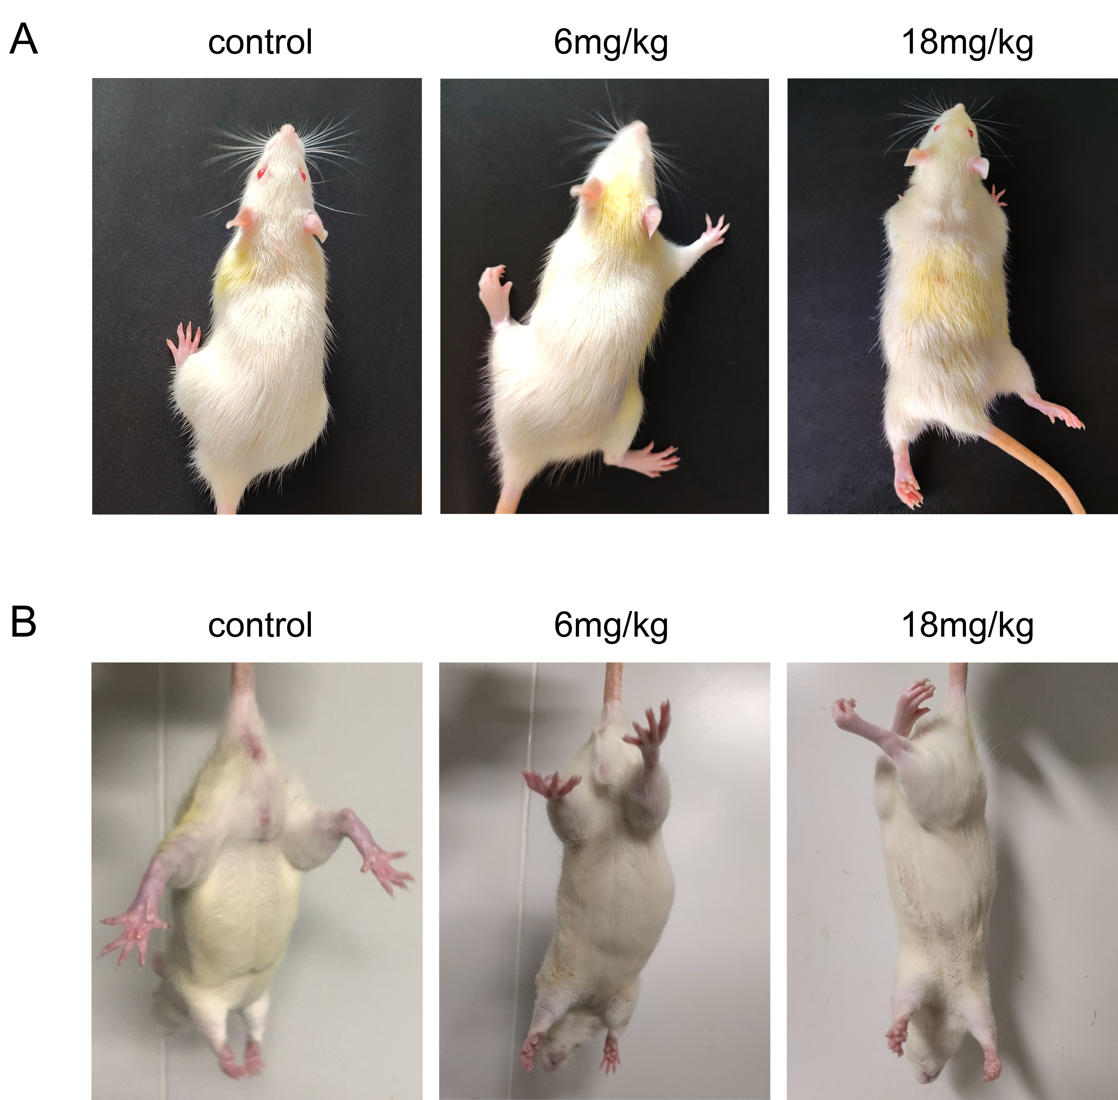
Supplementary Fig 1. Observation of hindlimb support and hindlimb clasping effect in rats after ACR treatment. (A) Observation of general behavior in rats; (B) Hindlimb clasping test.
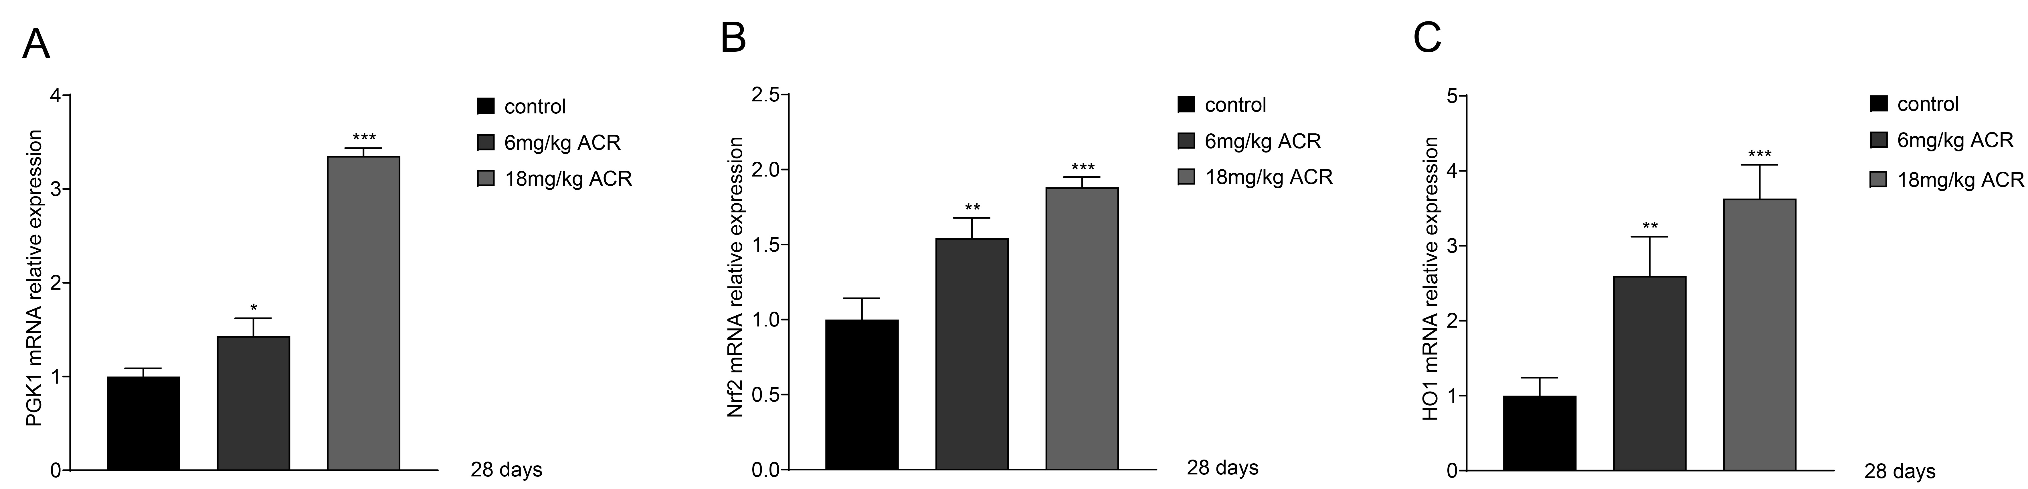
Supplementary Fig 2. The mRNA levels of related factors in the hippocampus of rats after ACR treatment. (A) (B) (C) The mRNA expression levels of Nrf2, HO-1 and PGK1 in the hippocampus of rats treated with different doses of ACR, as analyzed by RT-qPCR. Data are expressed as means ± SD. n = 3.*p<0.05, **p<0.01, ***p<0.001 versus the control group.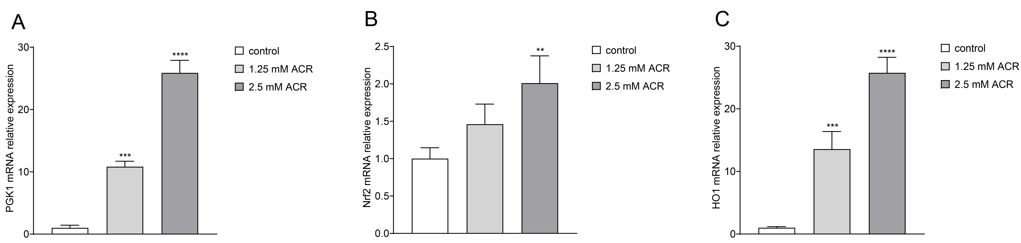

Supplementary Fig 3. The mRNA levels of related factors in ACR-treated PC12 cells. (A) (B) (C) The mRNA expression levels of Nrf2, HO-1 and PGK1 in PC12 cells treated with different concentrations of ACR, as analyzed by RT-qPCR. Data are expressed as means ± SD. n = 3. **p<0.01, ***p<0.001, ****p<0.0001 versus the control group.
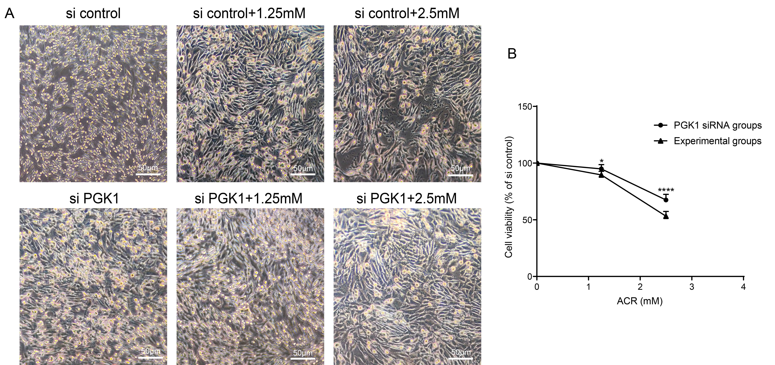
Supplementary Fig 4. Experiment group and PGK1 siRNA transfection group induced cytotoxicity in PC12 cells. (A) Cell morphology was observed under a microscope, scale bar: 50 μm; (B) Cell viability was determined by CCK-8 assay as preciously described in cells treated with Experiment group and PGK1 siRNA transfection group for 24 h. Data are expressed as means ± SD. n = 6. *p<0.05, ****p<0.0001 versus the control group; #p<0.05, ####p<0.0001 versus the same concentration experimental group.

