Supporting Information
CuFeNi LDHs/magnetic biochar composite as peroxymonosulfate activator for removal of enrofloxacin
Xinrui Gan^{1, ‖}, Yang You^{2, ‖}, Weibao Liu², Shengwen Zhou², Jiangwei Shang^{1, 2}, Xiuwen Cheng^{1, 2, *}

^{1.} College of Chemistry and Environmental Science, Xinjiang Laboratory of Phase Transitions and Microstructures of Condensed Matter Physics, Yili Normal University, Yining 835000, P.R. China
^{2.} Key Laboratory for Environmental Pollution Prediction and Control, Gansu Province, College of Earth and Environmental Sciences, Lanzhou University, Lanzhou, 730000, P.R. China
‖ These authors contributed equally to this work.
*Corresponding author address:
Prof. & Dr. Xiuwen Cheng
College of Chemistry and Environmental Science, Xinjiang Laboratory of Phase Transitions and Microstructures of Condensed Matter Physics, Yili Normal University, Yining 835000, P.R. China
E-mail: chengxw@lzu.edu.cn (X. Cheng)

Submitted to
Environmental Science Pollution Research
Aug., 2023
Figures captions
Fig.S1 The schematic diagram of BC、MBC、MC-1、MC-2 and CuFeNi LDHs preparation
Fig S2 Kinetic curve of (a) material optimization, (b) different systems activated peroxymonosulfate to degrade ENR, (c) different catalyst concentrations, (d) different PMS concentrations, (e) different pH, (f) different HA concentrations, (g) different Cl⁻ concentrations, (h) different HCO₃⁻ concentrations, (i) different NO₃⁻ concentrations
Fig.S3 Metal ion precipitation rate of MC-1&PMS reaction system
Fig.S4 Identification of intermediate products of ENR in MC-1&PMS reaction system

Tables captions
Table S1 Nitrogen adsorption data for MBC、MC-1 and MC-2 samples
Table S2 Previous reports about the degradation of ENR via different treatment process
Table S3 Table of detected transformation products and related parameters.

Text S1 Experimental Materials
Copper nitrate (Cu(NO₃)₂∙3H₂O), ferric nitrate (Fe(NO₃)₃∙9H₂O), nickel nitrate (
Ni(NO₃)₃∙6H₂O), Potassium PMS were all purchased from Kermel Chemical Reagent Co., Ltd (Tianjin, China). Besides, ENR was brought from Aladdin Chemistry Co. Ltd (Shanghai, China). 2,2,6,6-tetramethyl-4-piperidone (TEMP, 98%) and 5,5-Dimethyl-1-pyrrolidine N-oxide (DMPO, 97%) were bought from Aladdin Industry Corporation (Shanghai, China). P-benzoquinone (PBQ), tert-butyl alcohol (TBA), furfuryl Alcohol and ethanol (EtOH) were bought from Aladdin Industry Corporation (Shanghai, China). All chemicals were of analytical grade. Moreover, deionized water was used throughout the experiment.

Text S2 Characterization of catalysts
The surface morphology of MC-1、MC-2 and CuFeNi LDHs were characterized by a scanning electron microscope (SEM) and energy dispersive spectrometer (EDS, JSM-5600LV) at 20kV. A high-resolution transmission electron microscope (HRTEM, JEM-1200EX, Japan) was employed to measure the crystalline structures. X-ray diffractometer (XRD, x'pert Pro) under the conditions of 3KW, 60kV, 60mA was used to measure the crystal structure of the sample. The FTIR spectrophotometer (Thermo Scientific Nicolet 6700) was utilized to record the infrared spectrum of MC-1、MC-2 and CuFeNi LDHs in order to identify the functional groups and bonding in the synthesis catalyst with the scanning ranging from 400 to 4000 cm⁻¹.Operated at a power of 600 W with an energy resolution of 0.48eV@400kcps, X-ray photoelectron spectroscopy (XPS, PHI-5300, ESCA) was used to measure the element composition and electronic structure of the prepared MC-1、MC-2 and CuFeNi LDHs. Brunauer-Emmett-Teller (BET) surface areas of the catalysts were analyzed using a
standard low-temperature nitrogen method at 77 K (Micromeritics Tristar II 3020,
USA). The magnetic properties of the synthesized catalysts were determined at 25℃
using a vibrating sample magnetometer (VSM, Lake Shore 7404, USA). The measurement of the amount of metal leached from the reaction system was based on the ICP-MS method of Agilent 7700.

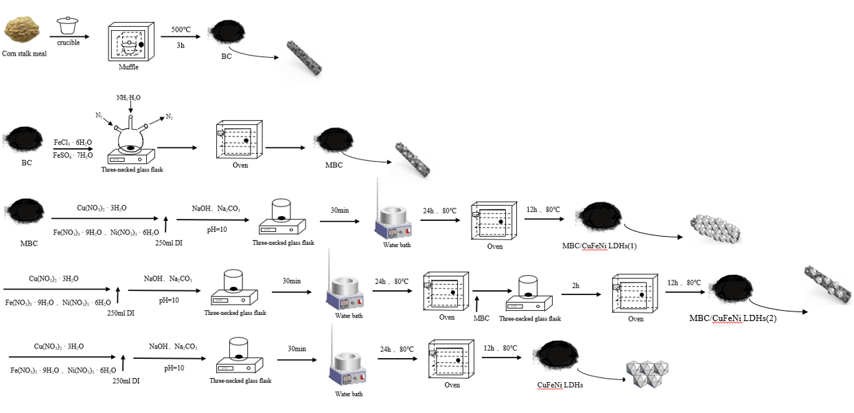
Fig S1 The schematic diagram of BC、MBC、MC-1、MC-2 and CuFeNi LDHs preparation

Fig S2 Kinetic curve of (a) material optimization, (b) different systems activated peroxymonosulfate to degrade ENR, (c) different catalyst concentrations, (d) different PMS concentrations, (e) different pH, (f) different HA concentrations, (g) different Cl⁻ concentrations, (h) different HCO₃⁻ concentrations, (i) different NO₃⁻ concentrations

Fig S3 Metal ion precipitation rate of MC-1&PMS reaction system

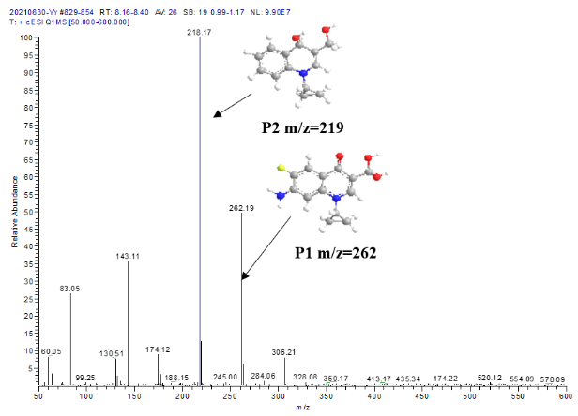
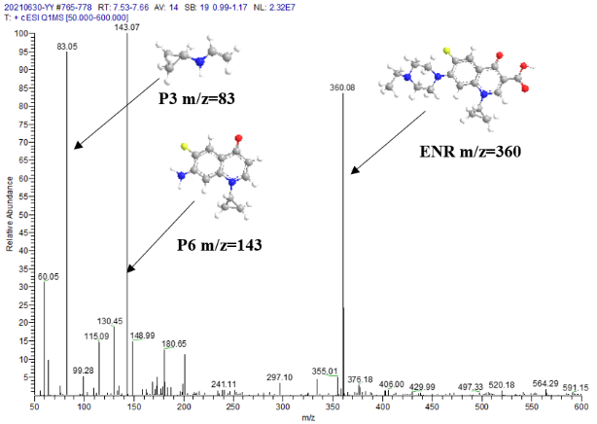
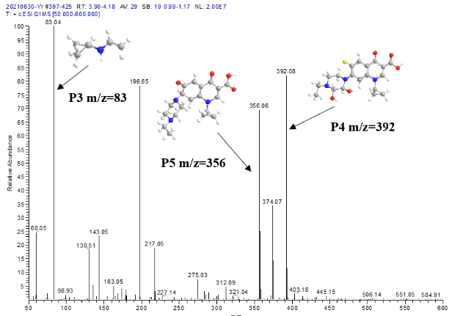
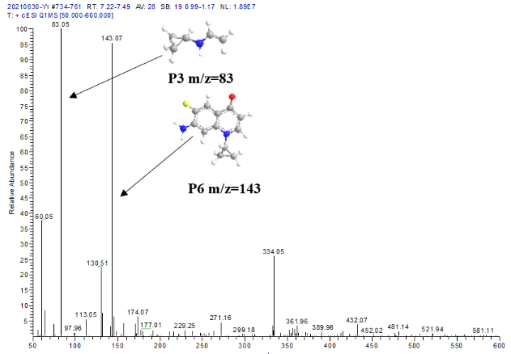
Fig S4 Identification of intermediate products of ENR in MC-1&PMS reaction system

Table S1 Nitrogen adsorption data for MBC、MC-1 and MC-2 samples
Samples | S_{BET}  [m²g⁻¹] | The total pore volume [m³/g]
MBC | 44.3 | 0.08
MC-1 | 122.8 | 0.13
MC-2 | 17.9 | 0.08

Table S2 Previous reports about the degradation of ENR via different treatment process
Treatment process | Catalyst | Removal rate | Reaction conditions | Ref.
Persulfate | Fe₃O₄/MMT | 90.86 % | [C₀] = 30mg/L  Time=60min  [catalyst] = 0.1 g·L⁻¹ | (Peng et al. 2019)
Peroxymonosulfate | Fe(VI) | 48 % | [C₀] = 30 μmol/L  Time=30min  [catalyst] = 50 ml·L⁻¹ | (Feng et al. 2017)
Peroxymonosulfate | Co_{m}Fe_{n}-LDHs | 83.9 % | [C₀] = 20 mg/L  Time=12 min  [catalyst] = 0.5 g·L⁻¹ | (Yang et al. 2021)
Peroxymonosulfate | MC-1 | 91.6 % | [C₀] = 10 mg/L  Time=20 min  [catalyst] = 0.6 g·L⁻¹ | This study

Table S3 Table of detected transformation products and related parameters.
Intermediate products | Molecular formula | m/z | Structural formula
ENR | C₁₉H₂₂FN₃O₃ | 360
P1 | C₁₃H₁₁FN₂O₃ | 262
P2 | C₁₂H₁₅NO₂ | 219
P3 | C₅H₉N | 83
P4 | C₁₉H₂₂N₃O₅F | 392
P5 | C₁₉H₂₃N₃O₄ | 356
P6 | C₁₂H₁₁N₂OF | 143

References
Feng, M., L. Cizmas, Z. Wang, and V. K. Sharma. 2017. Synergistic effect of aqueous removal of fluoroquinolones by a combined use of peroxymonosulfate and ferrate(VI). Chemosphere 177:144-148.
Peng, G., T. Li, B. Ai, S. Yang, J. Fu, Q. He, G. Yu, and S. Deng. 2019. Highly efficient removal of enrofloxacin by magnetic montmorillonite via adsorption and persulfate oxidation. Chemical Engineering Journal 360:1119-1127.
Yang, Z., X. Li, Y. Huang, Y. Chen, A. Wang, Y. Wang, C. Li, Z. Hu, and K. Yan. 2021. Facile synthesis of cobalt-iron layered double hydroxides nanosheets for direct activation of peroxymonosulfate (PMS) during degradation of fluoroquinolones antibiotics. Journal of Cleaner Production 310:127584.

