Visualization of photothermal therapy by semiconducting polymer dots mediated photoacoustic detection in NIR II

Xiangwei Lin^{1#}, Zhourui Xu^{1#}, Jiangao Li², Hongji Shi¹, Zhenyu Fu¹, Yuqing Chen¹, Haoming Lin¹, Gaixia Xu¹, Xin Chen¹, Siping Chen¹, Mian Chen^{1*}

1 National-Regional Key Technology Engineering Laboratory for Medical Ultrasound, Guangdong Key Laboratory for Biomedical Measurements and Ultrasound Imaging, School of Biomedical Engineering, Shenzhen University Medical School, Shenzhen University, Shenzhen, 518055 China
2 Center for AIE Research, Shenzhen Key Laboratory of Polymer Science and Technology, College of Material Science and Engineering, Shenzhen University, Shenzhen, 518060, China

Supporting Figures
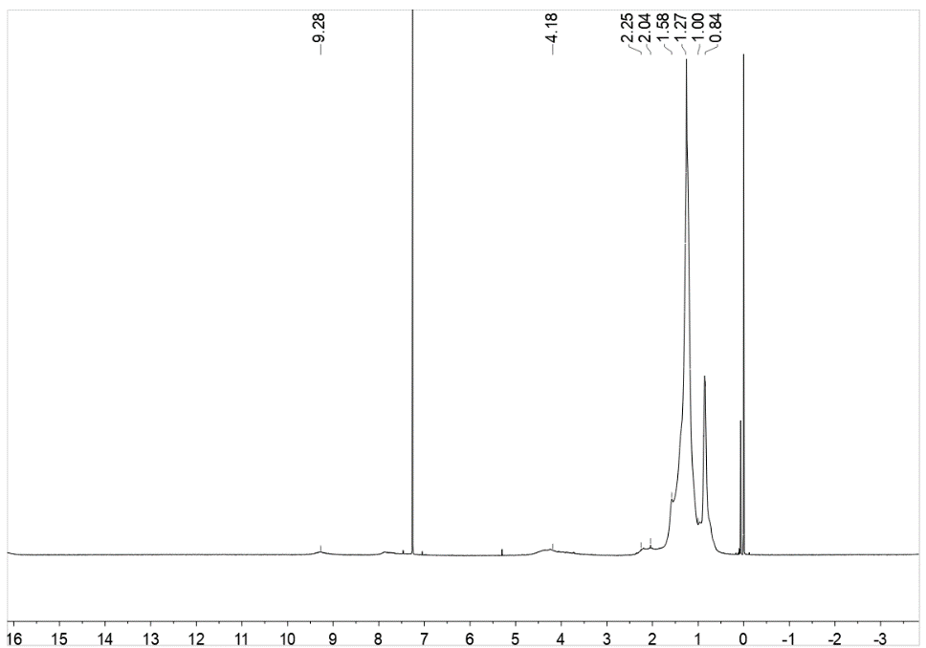
Figure S1. ¹H NMR spectrum of NT polymer.
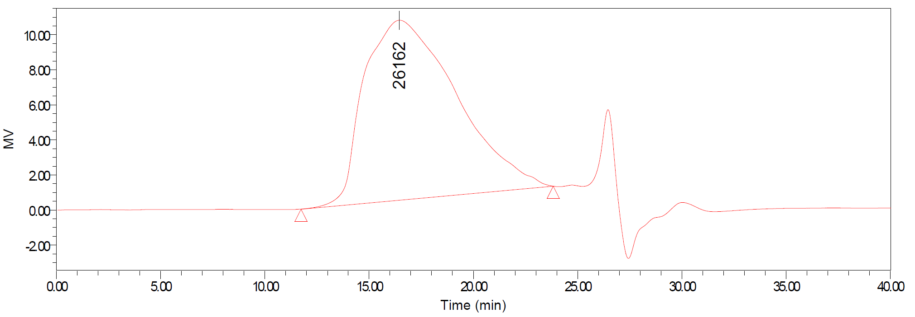
Figure S2. GPC measurement of NT polymer, using THF as eluent and polystyrene as a standard. Mn: 13484 g/mol, PD: 2.26.

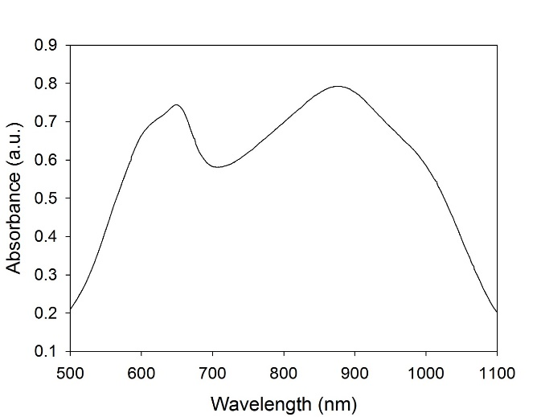
Figure S3. The absorption spectrum of NT polymer in tetrahydrofuran solution.
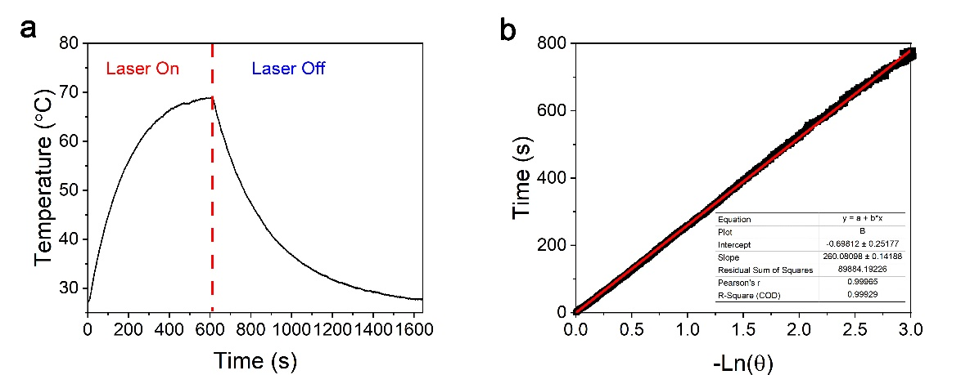
Figure S4. The heat conversion efficiency analysis of SPD. (a) Lasering and natural cooling curve of SPD. (b) Time constant for heat transfer from the system was determined to be τ_{s} =260.1s.
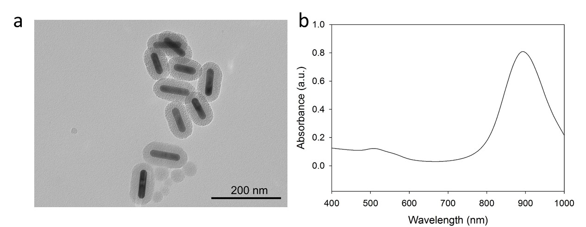
Figure S5. (a) TEM image and (b) absorption spectrum of silica-coated AuNRs.
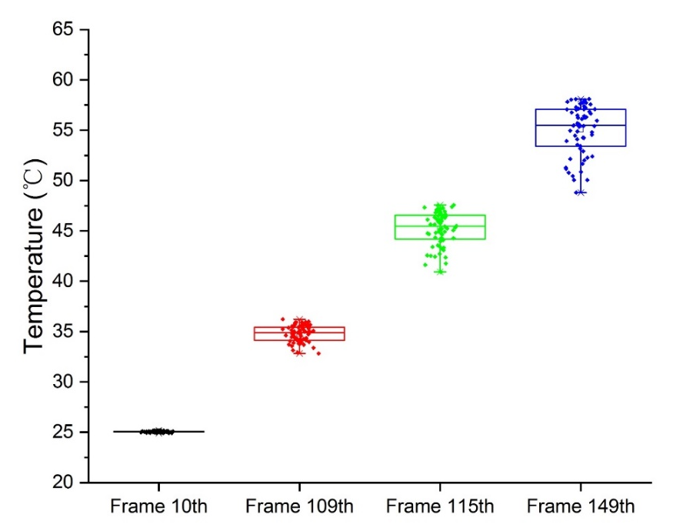
Figure S6. Statistics of temperature distribution detected by ITC in the ROI area with 13 × 5 pixels.
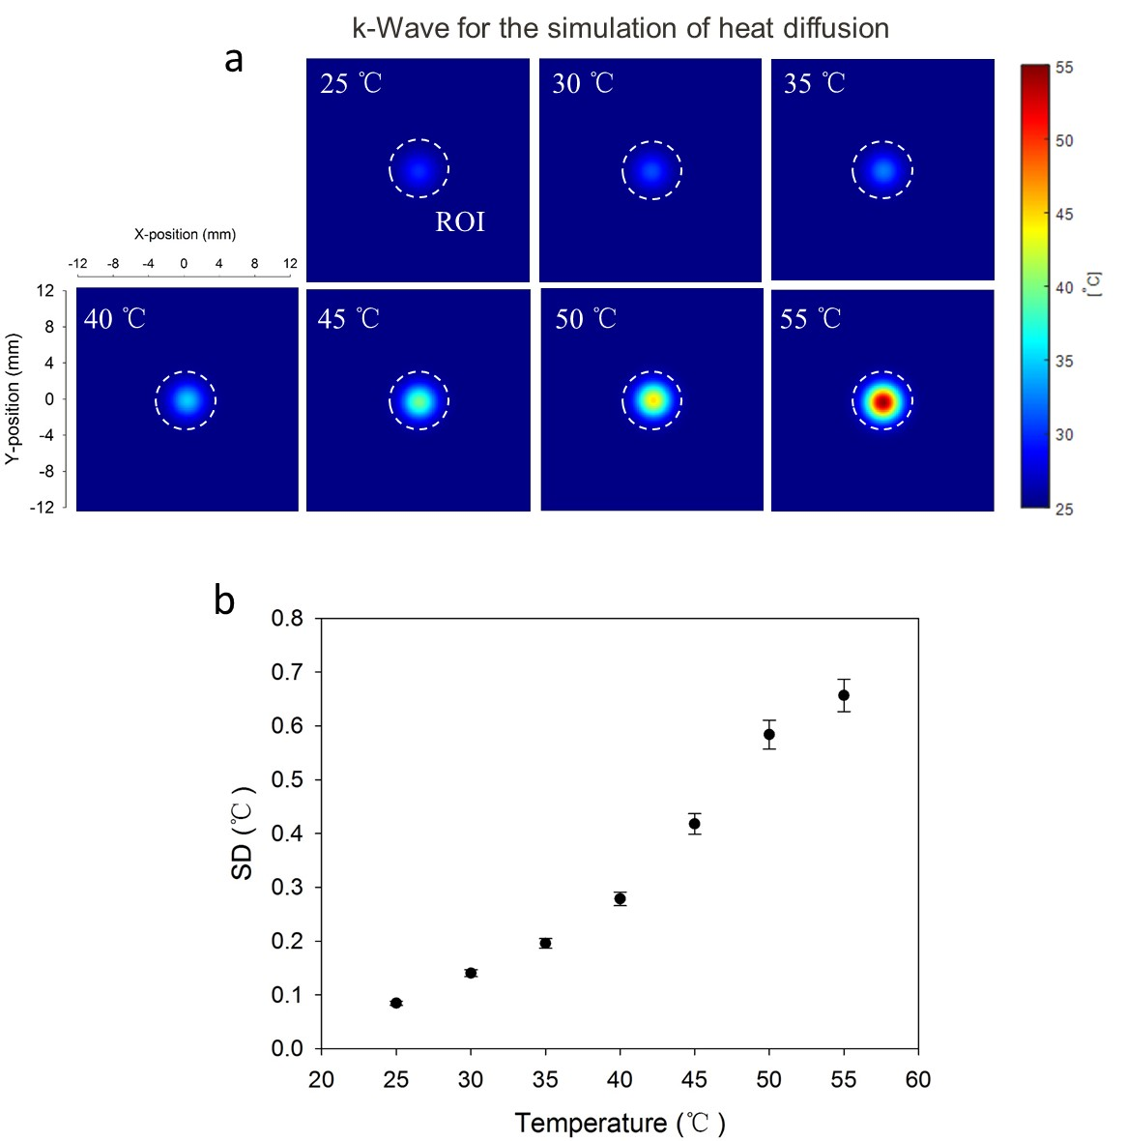
Figure S7. (a) The simulation of heat diffusion by using k-Wave. (b) The standard deviation (SD) of temperature distribution in the ROI area from k-Wave simulation.
Supporting Videos
SI Video 1.
The temperature imaging of the SPD solution detected by ITC in the cyclic PTT process. The video was captured at 3 fps and was played at 30 fps.
SI Video 2.
The temperature imaging of a heating plate that is partially covered with a 9 mm thickness phantom by using ITC. The video was captured at 3 fps and was played at 3 fps.
SI Video 3.
The temperature mapping of intratumoral SPD in PTT process, which was constructed by the estimation of PA signal. EG: Experimental group, which was under irradiation by 1064 nm CW laser. CG: Control group, which was without irradiation by 1064 nm CW laser. The video was played at 0.5 fps.

