Supplementary Information for
Natural history model predicts benefits associated with screening for lung cancer by detecting circulating tumor DNA
Giulia Simoni1,2, Stefano Avanzini1, Nora Pashayan³, Johannes G. Reiter1,2,*,
Sylvia K. Plevritis2
1Canary Center for Cancer Early Detection, Department of Radiology, Stanford University School of Medicine, Palo Alto, CA-94304, USA
2Department of Biomedical Data Science, Stanford University School of Medicine, Stanford, USA
³Department of Applied Health Research, Institute of Epidemiology and Healthcare, University College London, London, UK

*Current address: Natera Inc, San Carlos, CA-94070, USA.

Corresponding authors: Johannes G Reiter and Sylvia K Plevritis

Supplementary Methods

Model assumptions
We built a new natural history model of lung cancer evolution and ctDNA shedding based on the following assumptions. The number of healthy stem cells remains constant during the simulations¹, while all the others cells N_{i} reproduce at birth rate b_{i} and die at rate d_{i} per day with i=1,…,3. From the healthy stem cells, a first mutation event occurs with probability u₀₁ and gives rise to a premalignant cell that, through the birth-death process, can yield a population of premalignant cells or become extinct. From initiated premalignant cells, a second mutation event with probability u₁₂ can generate the first malignant cell that can grow into a primary tumor. The population N₂ of primary tumor cells seed metastatic cells with probability γ, which is assumed to capture all required steps from intravasation to colonization. Once a population of metastatic cells is initiated, its survival probability is determined by the cells birth and death rates (b₃ and d₃), which is assumed to be influenced by the microenvironment of the metastatic site^{2–6}. While the two mutation probabilities u₀₁ and u₁₂ are constant, the metastatic seeding probability γ is sampled from a lognormal distribution with parameters γ₁ and γ₂ (Supplement Table 1). Whenever a cell of type i, with i=1,…,3, undergoes death, ctDNA is shed into the bloodstream with a shedding probability of $q_{i,d}= λ/{d_{i}}$ with $λ$ equal to the shedding rate computed in Figure 3c. We assumed that the shedding probability of premalignant cells q_{1,d} is negligible compared to the shedding probability of malignant and metastatic cells q_{2,d} and q_{3,d} , respectively. Thus, we conservatively assumed that q_{1,d} is 0 while q_{2,d} is equal to q_{3,d}.

In the absence of screening, for each patient, the tumor becomes symptomatic, and the patient is diagnosed at a certain age either due to the primary tumor or due to the metastatic lesion, depending on which population of cells first reaches a symptomatic detection threshold. The detection size of primary tumors is sampled from a bivariate lognormal distribution that correlates primary tumor size and primary tumor growth rate. The parameters of the bivariate distribution are estimated from the distribution of primary tumor sizes reported in SEER. During the optimization procedure, we also estimated the mean detection size of metastatic lesions to 109 number of cells (equal to a diameter of 1.2 cm, assuming a spherical approximation).

At the time of diagnosis, the clinical stage depends on the number of metastatic cells. Cancers are defined as early vs late stage if the number of metastatic cells is less vs more, respectively, than an estimated threshold (metastatic stage threshold, Supplement Table 1). We estimated the metastatic stage threshold to be 0.5x108 metastatic cells to match the distribution of early and late stages reported in SEER. Early stage includes stages I and II, while late stage includes stages III and IV as defined in the American Joint Committee on Cancer (AJCC) TNM system 7th edition. Similarly, depending on the number of metastatic cells present at diagnosis, we categorized subjects into curable patients (i.e. those who will survive) and not curable patients (i.e. those that who die because of lung cancer), in the absence of competing causes of death. The threshold for this event (metastatic cure threshold, Supplement Table 1) is estimated to 2x105 metastatic cells to fit the distribution of survival time from SEER data. We defined the survival time as the time between diagnosis and disease-specific death. We modeled the death due to lung cancer for each patient as a lethal metastatic threshold size sampled from a lognormal distribution (parameters s₁ and s₂ in Supplement Table 1). We estimated the parameters of the distribution to match the distribution of disease-specific survival in SEER. Notice that the definitions of curable and not curable hold within our model as we have not currently included other causes of mortality for the population; thus, lung cancer is the only possible cause of death we account for. Also, we only indirectly modeled treatment in the sense that if a patient is diagnosed with very few undetectable metastatic cells, the treatment will be 100% effective and the patient will not die because of the tumor.
·

Optimization method

For estimation purpose, we discretized in bins the National Cancer Institute’s Surveillance, Epidemiology and End Results (SEER)⁷ data about detection size, age at diagnosis and cancer-specific survival time. We discretized the primary tumor diameter at clinical detection (D) into 8 bins (0-1.9,2-2.9, …,7-7.9,8-∞ cm), the age at diagnosis (T) into 10 bins (0-39,40-44,45-50,55-60, …,75-80 years) and the cancer-specific survival (S) into 11 bins (0-0.9,1-1.9, …,9-9.9,10-∞ years). Moreover, we grouped the stage at diagnosis (A) between early (I+II) and late (III+IV) stage.
Parameters were estimated by the maximum likelihood method. We defined the empirical likelihood function to maximize based on simulations according to Lin and Plevritis⁸ as:
$$L\left(Θ\right)= \prod_{i}{\prod_{j}{\prod_{k}{\prod_{l}{\hat{Pr}}{(…)}^{N_{ijkl}}}}}$$
where $Θ$ is the vector of 13 unknown parameters, $N_{ijkl}$ is the number of patients in SEER that belongs to the corresponding (i,j,k,l) bins and the probability $\hat{Pr}(…)$ is defined as

$$\hat{Pr}\left(…\right)= \hat{Pr}\left(D\left(Θ\right)∈\left[d_{i},d_{i+1}\right),T\left(Θ\right)∈\left[t_{j},t_{j+1}\right),A\left(Θ\right)=k,S(Θ)∈\left[s_{l},s_{l+1}\right) \right) .$$

We estimated the probability $\hat{Pr}(…)$ by simulating a population of 400,000 healthy subjects and counting the proportion of patients that are described by the indexes (i,j,k,l) as:

$$\hat{Pr}\left(…\right)=\frac{1}{N}\sum_{w=1}^{N}{I}\left(D_{w}∈\left[d_{i},d_{i+1}\right),T_{w}∈\left[t_{j},t_{j+1}\right),A_{w}=k,S_{w}∈\left[s_{l},s_{l+1}\right) \right)$$
where N is the subset of the population who developed a primary tumor during the lifetime of 80 years, and I is the indicator function. We refer to Lin and Plevritis⁸ for further details about the objective function.

The optimization procedure to estimate the parameter values was firstly conducted with the genetic algorithm⁹ to find the best global solution inside the parameter space. Then, we further refine the solution with the Nelder-Mead simplex algorithm¹⁰. We implemented and run the optimizations with Matlab 2020b.

Sensitivity analysis

To estimate how the variability of the biological parameters (Figure 2a,b and c) affects detection through ctDNA, we performed a sensitivity analysis on tumor diagnosis size with a simpler model¹¹. We compared tumor diagnosis size for three scenarios: (1) without screening (Figure 2d), (2) with annual ctDNA screening (Figure 2e) and (3) with annual ctDNA screening and limited biological variability (Figure 2f). In the second scenario, we included the probability distribution for growth rate, number of clonal mutations and the ctDNA shedding probability, meaning that for each simulated patient we sampled a parameter value from the corresponding distribution. In the third scenario, with limited biological variability, we fixed for the entire population the values of the three parameters as the mean value of the corresponding distribution. Moreover, we simulated additional six scenarios where we included one or two distributions and fixed the remaining ones as the mean value of the corresponding distribution (Figure S3).

The variability of biological parameters affects not only detection size but detection probability as well. To quantify the effect on the ctDNA detection sensitivity, we varied two parameters at the time and compute the corresponding sensitivity values for a range of specificity values from 0% to 100%. The corresponding ROC curve and AUC values are used to estimate the sensitivity on ctDNA detection probability (Figure 2g and Figure S4). We considered a range of number of mutation covered by the sequencing panel (1,5,10,15,20) and we varied the tumor diameter at detection (1,1.5,2,3 and 5 cm), the shedding probability (1.4e-04,1.7e-04,1.9e-04,2.2e-04 and 2.5e-04 hGE per cell death), the primary tumor growth rate (0.57%, 0.68%, 0.79%, 0.91% and 1.02% per day) and the primary tumor cell death rate (0.094, 0.1132, 0.1320, 0.1509 and 0.1697 per day). We varied the values of mutation load and one other parameter at the time, while all the other parameter values were fixed (baseline values are 2 cm for tumor diameter, 1.4e-04 hGE per cell per day for the shedding probability, 0.57% for the growth rate per day and 0.0943 for the death rate per day).

Supplementary Tables

Model parameters
Parameter symbol | Description | Value | Note
N₀ | Lung stem cells | 10^8 | ¹
u01 | Initiation probability | 6x10^-7 | Opt.
r₁ | Premalignant cells growth rate | 0.00037 | Opt.
d₁ | Premalignant cells death rate | 0.0943 | ¹¹
u12 | Progression probability | 2x10^-8 | Opt.
µ₁ | Mean of detection volume for primary tumor (bivariate lognormal distribution) | 3 | Opt.
µ₂ | Mean of primary tumor growth rate (bivariate lognormal distribution) | 0.0015 | Opt.
σ₁ | Variance of detection volume for primary tumor (bivariate lognormal distribution) | 5.6 | Opt.
σ₂ | Variance of primary tumor growth rate (bivariate lognormal distribution) | 2.1x10^-5 | Opt.
ρ | Correlation between detection volume for primary tumor and growth rate (bivariate lognormal distribution) | 0.14 | Opt.
d₂ | Primary tumor death rate | 0.0943 | ¹¹
γ₁ | Shape of metastasis seeding probability (lognormal distribution) | 6x10^-9 | Opt.
γ₂ | Scale of metastasis seeding probability (lognormal distribution) | 3.3 | Opt.
d₃ | Metastatic cells death rate | 0.0943 | ¹¹
r3,sf | Metastatic cells growth rate scaling factor (r3 = r3,sf · r2) | 2.5 | Opt.
s₁ | Shape of metastasis survival threshold (lognormal distribution) | 1.4 | Opt.
s₂ | Scale of metastasis survival threshold (lognormal distribution) | 3.2 | Opt.
md,th | Metastatic diagnosis threshold | 10^9 | Opt.
ms,th | Metastatic stage threshold | 0.5x10^8 | Opt.
mc,th | Metastatic cure threshold | 2x10^5 | Opt.
Table S1: Model parameters for tumor evolution. We used the model parameters for ctDNA shedding as estimated in Avanzini et al.¹¹.

Supplementary Figures

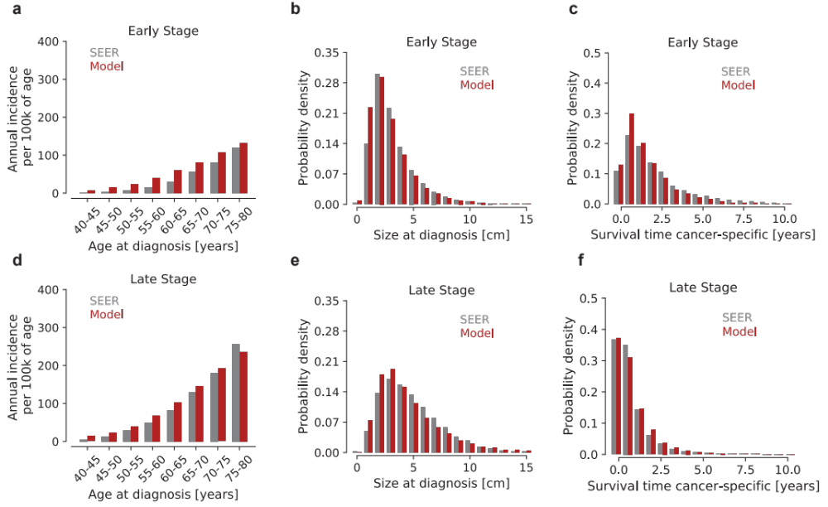

Figure S1: Results from the optimization procedure: comparison between SEER data and model simulations. We estimated the parameters of the NHM using SEER data between 2005 and 2016 for early (I and II) and late (III and IV) stages. a-d Lung cancer incidence adjusted to number of people alive at any given age. b-e Primary tumor diameter at symptomatic diagnosis. c-f Cancer-specific survival time from the time of diagnosis.

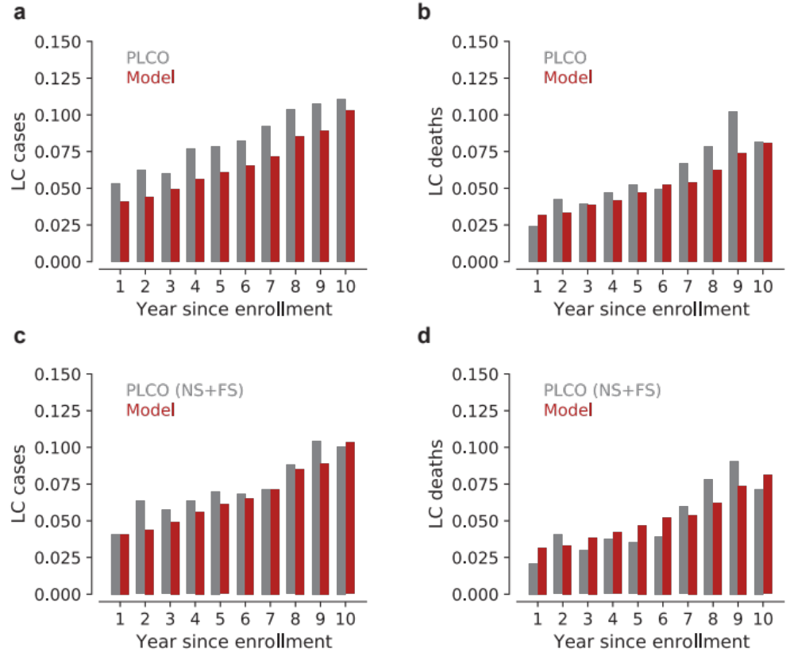
Figure S2: Model validation results compared with the PLCO data for the control arm (no screening). PLCO¹² enrolled 154,887 participants of which 77,444 were in the control arm (detection with usual care instead of screening). In the control group 1,816 patients were diagnosed with lung cancer and used for the validation. We considered the number of lung cancer cases and deaths in the first ten years since enrolment in the PLCO control arm. The number of cases and deaths is normalized by the number of patients alive for each time bin. a-b Comparison between the model results and the PLCO data. c-d Comparison between the model results and the PLCO data for never-smokers (NS) and former-smokers (FS).

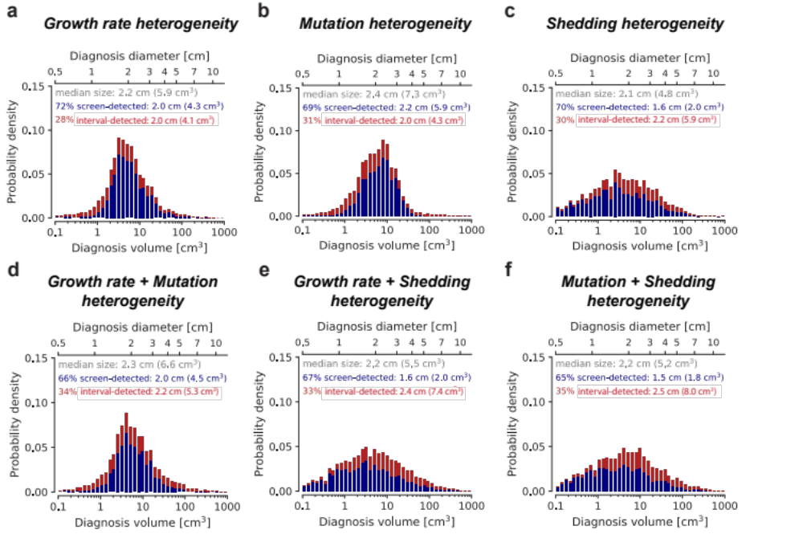
Figure S3: Cancer heterogeneity affects tumor detection size. Distributions of primary lung tumor diagnosis size when patients are detected through an annual ctDNA-based screening protocol (blue distributions) or interval-detected (red distributions). We included one (panels a,b and c) or two (panels d,e and f) sources of variability at time and left the others equal to the mean value of the distributions in Figure 2 (7 clonal mutations, growth rate of 0.57%, shedding probability of 0.02%).

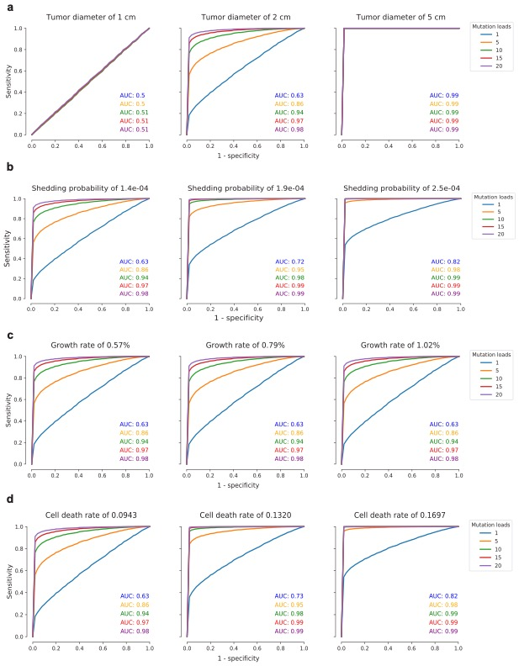
Figure S4. Sensitivity analysis on the biological parameter variability. ROC curves for ctDNA detection by varying two parameters at the time. One of the parameters is always the number of clonal mutations, which ranged from 1 to 20. A) We considered the size of the tumors at the time of detection equal to 1,2 and 5 cm of diameter. The other parameters are fixed as following: shedding probability = 1.4e-04, growth rate = 0.57%, cell death rate = 0.0943. Small tumors (1 cm) have a 50% chance to be detected regardless of the mutation load. On the contrary, big tumors (5 cm) have a 99% to be detected regardless of the mutation load. For tumors with a diameter of 2 cm, the mutation load has a big impact on the detection probability. B) We considered shedding probability equal to 1.4e-04, 1.9e-04 and 2.5e-04 hGE per cell death. The other parameters are fixed as following: tumor size = 2 cm, growth rate = 0.57%, cell death rate = 0.0943. As the shedding probability increases, thus the detection probability increases for a fixed mutation load. However, for a mutation load equal to 15 and 20, the AUC is equal to 0.99 regardless of the shedding probability values. C) We considered primary tumor growth rate equal to 0.57%, 0.79% and 1.02%. The other parameters are fixed as following: tumor size = 2 cm, shedding probability = 1.4e-04, cell death rate = 0.0943. With a fixed death rate (associated to the shed of ctDNA), the ctDNA detection increases for bigger values of mutation load but is not affected by the increasing values of the tumor growth rate. D) We considered cells death rate equal to 0.094, 0.1320 and 0.1696 per day. The other parameters are fixed as following: tumor size = 2 cm, shedding probability = 1.4e-04, growth rate = 0.57%. Cell death rate affects ctDNA detection probability with the same sensitivity of the shedding probability.

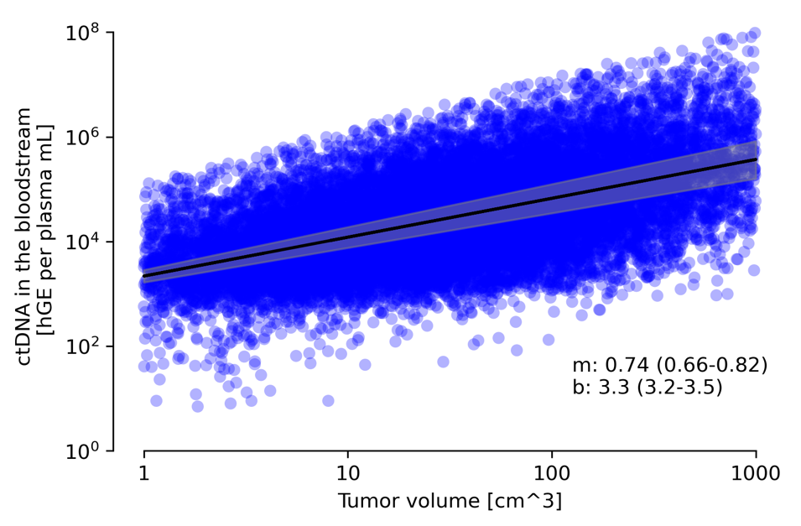
Figure S5. Tumor volume and ctDNA level in the bloodstream at time of detection with usual care (without screening) for a test specificity of 95%.

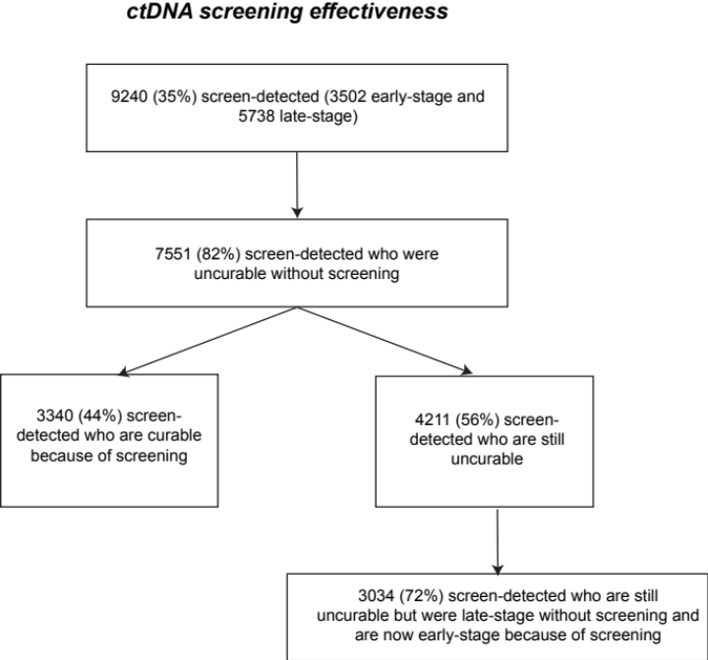
Figure S6. Effectiveness for an annual ctDNA screening test for asymptomatic individuals between 50 and 80. Screening effectiveness is evaluated as the percentage of patients that because of screening early detection will not die because of lung cancer (cured fraction)

References
1. Hazelton, W. D. et al. Longitudinal multistage model for lung cancer incidence, mortality, and CT detected indolent and aggressive cancers. Math. Biosci. 240, 20–34 (2012).
2. Athreya, K. B. & Ney, P. E. Branching Processes. (Springer-Verlag Berlin Heidelberg, 1972).
3. Durrett, R. Branching process models of cancer. (Springer, 2015).
4. Haeno, H. et al. Computational modeling of pancreatic cancer reveals kinetics of metastasis suggesting optimum treatment strategies. Cell 148, 362–375 (2012).
5. Reiter, J. G. et al. Minimal functional driver gene heterogeneity among untreated metastases. Science 361, 1033–1037 (2018).
6. Reiter, J. G. et al. Lymph node metastases develop through a wider evolutionary bottleneck than distant metastases. Nat. Genet. 52, 692–700 (2020).
7. NCI SEER. Surveillance, Epidemiology, and End Results (SEER) Research Data 1973-2015 - ASCII Text Data. (2018).
8. Lin, R. S. & Plevritis, S. K. Comparing the benefits of screening for breast cancer and lung cancer using a novel natural history model. Cancer Causes Control 23, 175–185 (2012).
9. Goldberg, D. E. Genetic algorithms in search, optimization, and machine learning. Choice Rev. Online 27, 27-0936-27–0936 (1989).
10. Nelder, J. A. & Mead, R. A Simplex Method for Function Minimization. Comput. J. 7, 308–313 (1965).
11. Avanzini, S. et al. A mathematical model of ctDNA shedding predicts tumor detection size. Sci. Adv. 6, eabc4308 (2020).
12. Oken, M. M. et al. Screening by chest radiograph and lung cancer mortality: the Prostate, Lung, Colorectal, and Ovarian (PLCO) randomized trial. JAMA 306, 1865–1873 (2011).

