The Effectiveness of applying for Formative Assessment Objective Structured Clinical Examination (OSCE)for Undergraduate Students in Faculty of Medicine King Abdul Aziz University, Jeddah, Kingdom of Saudi Arabia
Rajaa Fahad Allhiani
Sumaiah Ali AL-Abulwahib
Sultan Hassan Alamri

Abstracts
The use of formative and summative assessment for students have been always a concern for medical professionals such as teachers and students especially when students are at graduating level. This can be supported with increasing the effectiveness and comprehensiveness of the students with appropriate clinical training using a defined structure with questionnaire-based system defined in the methodology to support student’s skills using clinical competencies to form perspective. It has been found that with Objective Structured Clinical Examination can be used as the method to assess the adequacy to support clinical skills of medical students following their competence level. This can be used to support a variety of tests to work on underpinning emergency procedures to interpret investigational data to ensure in-depth and breadth coverage of clinical skills following 5th-year medical students.
Keywords: OSCE, formative Assessment, Clinical, Undergraduate medical.

Introduction
Assessment in this era is seen as a learning experience by medical institutions. The assessment is said to be an effective way to identify the individual’s skills and development of a medical student using formative assessment tools and techniques such as objective structured clinical examination role positively with their final summative examination performance at a point through student perception from formative OSCE. Abraham et al have highlighted the effects of formative OSCE is a randomised controlled design used for the benefit for institutions considering the establishment of this assessment tool designed to assess the knowledge skills of students giving them constructive feedback in the course of teaching and learning. In undergraduate medical education, it is important to understand the requirement of using this tool for student training to satisfy accreditation requirement such as implementing a professional training culture where a constructive feedback support development at all levels.
Using the performance-based assessment, the Objective Structured Clinical Examination has increased the reliability of the summative and formative manner measuring clinical competence of students. Lee et al found that the development of clinical skills requires time and practice where the progress rate of students can be accelerated by offering adequate feedback optimising experiential learning. It supports future performance of learner in clinical practice following a reflection period giving them feedback when required. Abraham et al stated that the use of formative assessment in medical schools in the recent time has institutionalised so that it can be systematically carried out while giving feedbacks, however, in Mediterranean countries, the use is not consistent. The fact is that the educational institutions in Saudi Arabia are undergoing a transformational period, especially with undergraduate medical programs. Day et al determined that the process is followed with the change in the curriculum process using a competency-based medical education and formative assessment as a requirement to comply the process successfully.
The process is now focused on Competency-based medical education and formative assessment to meet the requirement of the assessment following the curriculum. The traditional one followed assessment in 5th year with 50% marks for written test, 30% for OSCE, 10% for the logbook, and 10% for history taking skills of medical students in a practical scenario. It is important for students in 5th year to record the case history, examine patients, setting provisional diagnosis, investigate and interpret cases, and communicate with patients and their families given under a time frame. It is also important for students to present case findings to the faculty, teachers are required to actively participate in feedback sessions actively observing with the actual performance of students based on their skills and competencies following the actual purpose of formative assessment, if not fully met. It is also found that the use of formative assessment in medical professions can support teacher to identify the gaps in student learning and overcome the problem.
Since Harden et al introduced the objective structured clinical examination (OSCE) in 1975 as a means of assessing clinical competence by direct observation; it is being used increasingly for both under- and postgraduate students. Students are expected to perform a variety of clinical tasks within a specified time period and are judged against an objectively predefined set of criteria. It proved to be a reliable, valid, and reproducible test. The OSCE is a station-based exam introduced in the mid-1970s to assess clinical competencies among medical students. This study of monitoring the effectiveness of the formative OSCE was conducted over five years from 2014 until 2018 and still this monitoring is going on for 2019. The OSCE is a form of performance-based testing used to measure candidates’ specific clinical competencies. As the OSCE developed throughout the years, there was a debate about its applicability as an assessment tool especially in terms of its validity and reliability. In recent decades, educational institutions within arrange of countries, including the United States. China. Australia and Spain have adopted the OSCE to assess cognitive, psychomotor, and affective abilities of students.
The acceptability of structured clinical examination is followed with adopting a robust method of performance in the medical field to use the tool as a learning opportunity for 5th-year medical trainees, with variety of challenges in implementing OSCEs within medical curricula. The tool gives assessor the opportunity to identify the challenges with financial cost associated with the implementation of this tool. It can be said that these expenses are followed with the compensation of standardised patients and examiners to support the staff in leading OSCE. With formative assessment, the stakes are low, it can anxiety-induced experience for students to implement a mock OSCE within clinical practice to organise the team base feedback helping participants, examiners, and students accomplishing their targets successfully. In addition, it further involves the use of student to work on scoping review with peer-assessment within OSCE inappropriate formative setting to promote learning among students to accomplish reliable and cost-effective SPs informative setting for OSCE to seek good learning experience during the assessment encounter.
Considering the institutional goal of this tool to develop a sustainable learning intervention approach to increase the opportunities to support OSCE practices. This can be done by designing and implementing to students in synthesizing the concept according to peer evaluator and SPs to work on the feasibility and acceptability of the concept with educational event based on the undergraduate medical program. Based on the strengths of the assessment tool, it is found that students are required to work on formative and summative OSCEs to seek support passing marks for the assessment based on the standardised passing marks. The method is found strong because it is very easy for the application and offer excellent assessment method to prepare students for their professional role in the future. In addition, the method is strong because the results are highly valid and reliable offering good results. The method is high objective for student’s skills and knowledge rather than focused on subjective matter which requires the teachers to train students on clinical conditions to meet the real standards.
Furthermore, the method offers enough flexibility to encourage the ability among students to support the areas when were traditionally not possible with former methods such as basic communication skills. The method is also strong because it encourages the ability of students to highlight the areas to support integration of knowledge, clinical skills, and communication among students while dealing with patients in clinical setting. The method is strong because it encourages students to actively participate in learning process with flexible and adaptable examination to work on subject and department requirement with controlled testing environment. The method can help students to develop the clinical skills of students so that they cannot compromise patient’s assessment and safety while adopting a fair system on uniformed criteria to maintain transparency. Meanwhile, the assessment tool is also found motivating learning experience for medical students so that they can implement wide-ranging skills with no harms to patients.
The method enhances the ability to underpin a number of skills and topics to cover the whole curriculum skills and provide the faculty to underpin assessment tool to custom fit the specific need of the clinical program. To improve the efficiency of the results, students are required to work on the application of skills in mastering clinical setting which further allows them to support auditing skills. It encourages the students to improve their ability for emergency and critical skills with practical demonstration and training to work on the opportunity of teaching and assessment on different levels of trainee. Apart from the uncountable strengths of this method, there are some limitations to this tool, for example, it is a resource-demanding method require evaluation and continuous planning to organise the details about patient’s history, case, and others. Besides, the method is quite expensive and require funding, the method is required to work on intensive examiners and training to handle the feedback process.
It is also found that with this intervention method, there is always high change of leaking the station. Besides, the lack of focus can result in examining specific nursing competencies and weaken holistic approach, furthermore, it requires the students to work on long-time case history to build cases and scoring checklists. Students are also required to consider station-based scenario in handling real-life situation which increases student’s anxiety and stress. To accomplish adequate results, students are requiring two examiners every station to accomplish the required objectivity. Confidentiality is always considered an issue, it also requires a large number of assessors for intensive training on scoring tools. The end results are usually difficult to run accomplishing their writers.

The purpose of this study
Educational institutions and universities across the world usually follow the Traditional practical Examination for the evaluation of practical or clinical skills to assess the knowledge criteria of students (especially undergraduate students) to make sure that they have the right set of skills for development. It is believed that the use of traditional methods to assess the knowledge and skill-set of students were considered flawed because of inter-examiner market variable, subjectivity, giving marks for difficult level, and others. Educational specialists are said to be using methods like Objective Structured Practical Examination to reduce the flaws from the marking criteria.
The purpose of the study is to identify the effectiveness of OSPE as a formative assessment tool, its strengths, and weaknesses in comparison to traditional assessment tools to understand the perception for teachers giving perception about the knowledge and skill-set for students towards this assessment tool through their academic learning. To accomplish the purpose, the research aims to outline a process for OSCE design to meet the need of assessment program, involve trainees, and meet the requirement of regulating agencies to follow continuous evaluation of the program to be performed and alter according to the program need.

Objectives
Following the purpose of the study, the researcher has put together the key objectives for further research to be considered while collecting and analysing data for this subjective theme. It has been found that two types of assessment are undertaken in educational institutions – summative and formative to evaluate the student’s learning progress and give them concrete grades to improve their learning behaviour. The objective is to determine the effectiveness of applying formative assessment objective structured clinical examination (OSCE) for the undergraduate 5th-year medical students in clinical module. The initiative was applied for the formative OSCE had invited residents to participate and practise their assessment skills to measure the effectiveness of Self Direct learning (SDL) session. The objectives include,
- To test the effectiveness of formative assessment (OSCE) for undergraduate students
- To determine the acceptability of the formative (OSCE) since it’s not compulsory
- To identify the strengths and weaknesses of the formative (OSCE) on undergraduate students

Methods
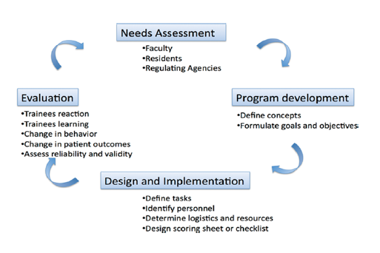
The OSCE design for this considered research article is followed with the process of Objective Structured Clinical Examination design begins with a needs assessment of the program, its faculty, the involved trainees, and the requirements from regulating agencies. During program development phase, key concepts to be evaluated are identified and specific goals and objectives are formulated. In the design and implementation phase, specific tasks and their corresponding scoring sheets are designed, and location, personnel, equipment, finances, and duration of the Objective Structured Clinical Examination stations are decided. Throughout the process, continuous evaluation of the program is performed and the program altered as needed.
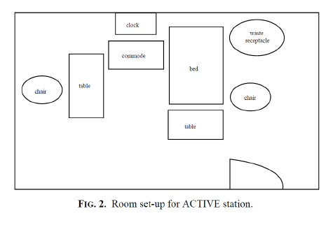
Once this committee was established the location for the examination (Fig.1), and the room set up for active (Fig. 2) and inactive stations (Fig. 3) were determined as can be seen from the floor plan (Fig. 1) there were three identical lines of rooms which allowed three simultaneous examination lines.
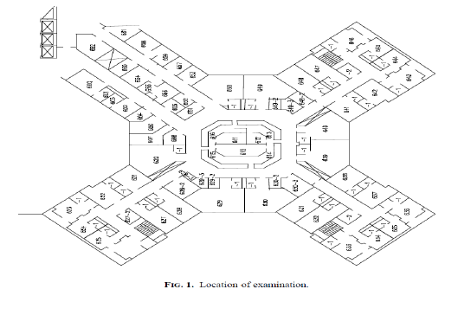
The rooms for active stations contained a patient bed, a comfortable chair for the examiner with a table where the instruction sheet for the examiner and a stock of mark sheets are placed.
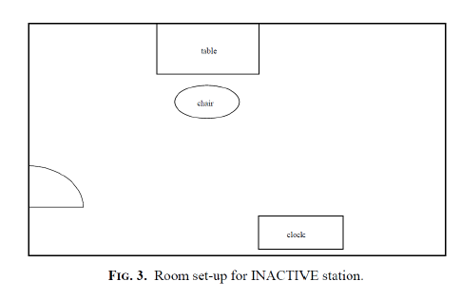
On the other side, a chair for the examinee is there with a small table where the instruction sheet for the student is mounted. The patient' instruction sheet is kept in the commode beside the bed. A clock is mounted on the wall.
The room for an inactive station contains a chair for the student and table or desk with the instruction sheet and a stock of answer sheets and clock on the wall.
On the table, there is, according to the subject of this station, an X-ray viewing box or a computer, or an instrument. Letters were sent to the administration; detailing room set up for the stations, for waiting areas, secretarial areas, to help furnish the rooms accordingly. The deadline for completion of the area set up was 3 days before the actual examination date. A department meeting was called. The subjects for the OSCE stations were determined and the authors for these stations agreed upon. Deadlines for submission of the stations (including instruction sheets for examiners, patients and students and mark sheets) were fixed. As can be seen from (Fig. 1), there were 3 parallel lines with 10 OSCE stations each day. For each of the active stations, 5 examiners were made available (including the station author). Once the station writing was finalized the author met with his co-examiners to discuss the scenario and agree on a unified mark scheme.
For this purpose, a checklist of 10 questions survey (questionnaire) was distributed to all undergraduate medical students who had participated in the formative (OSCE)so to measure their competency and proficiency. In the clinical skills and simulation centre (CSSC), the twelve rooms were set up for the formative OSCE. Since there were three identical panels of rooms, so six rooms were assigned for inactive stations that contained instructions to how to answer the questions and others had X-ray films to comment. The other six rooms were active stations that contained standardized patients (SP) and Manikins. The formative OSCE lasted for one day and residents were involved as examiners. This method was applied in 2014 and sustained until 2016. In 2018 this method was amended to accept more challenges in inviting house officers (interns) to be examiners . Since most of the standardized patients (SP) who are participating in the formative OSCE from Interns who have finished their rotations in all the clinical departments and were retained in the inactive stations.

Results
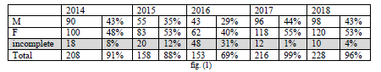
The analyses were done thru cross-tabulation by (NCSS) similar to SPSS version 20 of all the survey, and the data were summarized in the following table (Fig.1):

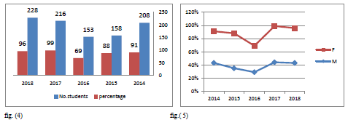
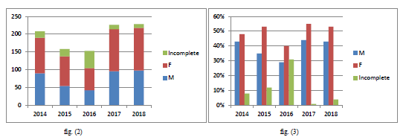
In 2014, the number of students was 208 (95 males& 113 females) who participated in the formative assessment who all of them reported not enough time since the allotted time for each station of formative (OSCE) was 5 minutes, it should more than 10 minutes. About 8% were incomplete questionnaire nothing to report.43% of the students reported that it was the helpful highlighted area of weaknesses in their clinical skills and 48% felt safe with care-team to make errors without accountability and confidentiality. But students had reported difficulty with the residents; they were inexperience to provide feedback and debriefing since they were not involved in their teaching plane(fg.2). Residents should be involved in teaching undergraduate to practice their teaching skills.

In 2015 and 2016, about 50% of the students did not participate in the formative assessment OSCE since it was not compulsory(fig.3). According to adult learning theory, there are several key differences to consider with applying formative OSCE:
(1) Adults are self-regulated meaning that they decide what and when they want and need to learn,
(2) adult learners are intrinsically motivated, often by their self-efficacy or their belief in their ability to complete a task, their feelings of competence and their psychological safety
(3) adults use analogical reasoning in learning and practice [7].
In2017, after observing the withdraw of students from participating in formative OSCE, corrective actions were taken by conducting workshops of orientation and pre-briefing, set ground rules and clarified the expectations of the Formative OSCE to all the students. After participation in the formative assessment, 99% were motivated after allowing enough time for each station where they can learn(fig.4). In 2018, we have accepted more challenges in inviting house officers (interns) to be examiners. 96% they had faced this challenge by accepting interns as their peers who had assisted them in learning and in overcoming their weakness (fig.5). All the incomplete surveys were discarded and omitted from the analysis.
Following a literature review, the concepts of Competence, Clinical Competence and OSCE are the foundations of this framework. We conclude this chapter by specifying the specific objectives of the trial. The methodological choices we have made to meet the specific objectives. In more detail, we outline our methodological approach, participants, data collection techniques and instruments, the course of the trial, the data analysis process, the means to ensure rigour and scientific and finally, ethical considerations. In chapter four, we present the results of the analysis of ams1 data as their interpretation. These results stem from the validation of the OSCE conducted with teachers who agreed to participate in the data collection of the journal. The conclusion offers a reminder of the highlights of the trial. The benefits and limitations of the trial are discussed. Finally, we end up proposing some lines of research to explore for future research.
The integration of this approach in Faculty of Medicine King Abdul Aziz University has encountered difficulties. On the one hand, at the time of the reform, the teaching staff did not receive any in-service training to allow a better understanding of this approach and the impacts on their practice. It was, therefore, unrealistic to think that teachers would be good at teaching skills simply by presenting a skill-based curriculum. On the other hand, another difficulty lies in the fact that no initial training in pedagogy is required to teach at the college level, which is certainly desirable, but not mandatory. Indeed, many teachers may be engaged on the basis of professional experience and teaching skills. Nevertheless, teachers must comply with the measures imposed by this reform, even if their pedagogical background does not allow them to understand the ins and outs of this reform.
The program team did by specifying, within the program booklet, the educational intentions by adopting the aims of the study program. In particular, it is stated that graduates of the Medical program must be able to perform all the technical acts under their responsibility in a manner consistent with professional ethics. Good clinical judgment when making decisions. Then, based on this frame of reference, the curriculum and targeting some departmental values, the teaching staff of Faculty of Medicine King Abdul Aziz University of the time decided that the summative synthesis activity would be a written research work. inspired by the admission examination of the professional order where the essential theoretical knowledge is evaluated. By this choice of evaluation, the teaching staff of this department wanted the students to revise the theoretical notions acquired during the courses of the specific training in order to better prepare them for the examination of admission to the profession.
This method is very important for student education. To this end, the CEEC specifies that it allows them, through an integrative activity, to certify their mastery of all the skills of the program, both specific and general training. With the CEEC by recalling that the objective of the ESP is to determine whether students have achieved the objectives and standards prescribed by the program of study by assessing them in a situation. real. It should be noted that the actual situation refers to a situation that is as close as possible to the professional environment. The evaluation in authentic situations as one of the fundamental concepts to be integrated into our evaluation practices as part of a competency-based approach.

Discussion
The formative-OSCE introduction did not result in a considerable change in the overall summative-OSCE pass rate in the intervention group compared with the control group, but it improved the students mean score in the intervention group if compared with their formative-OSCE mean. This finding supports the work of other studies in this area linking medical student’s review of formative-OSCE scores and their performance in summative-OSCE. However, it is contradictory to other researches that appreciate the role of formative assessment in improving the overall performance in OSCE.
One criticism of much of the literature on formative assessment effectiveness is that it does not depend merely on its availability. It rather relies upon the quality and communication tools of the assessment feedback. In this study, the authors in form of comments and numerical scores provided feedback on students’ performance in formative-OSCE. Even though it is difficult to disagree with the efficiency of numerical scores for summative purposes, its use for formative purposes that guide progress in learning has long been argued. Numerical scores and letter grades would tend to direct students’ concentration to the self and away from the task, thus leading to a negative impact on performance. According to cognitive evaluation theory; Feedback could be immediate or delayed according to its timing. When it is planned to facilitate lower-order learning outcomes, for example, the recall of facts, prompt feedback works best.
However, when higher-order learning outcomes are a concern and necessitate the transfer of what has been learned to a new situation, delayed feedback probably works better. In this study, feedback was given when the results were released (delayed); although, it is suggested that students prefer immediate feedback. Another factor is that having four summative-OSCEs for the four groups of the 5th year students might have contributed to possible difference in summative examination difficulty; although, all the OSCEs had the same blueprint. This was noticed when comparison was made between the mean summative-OSCE scores gained by the intervention group with what was gained by the excluded students from the intervention group.

Conclusion
Overall, 5th-year medical students' feedback was in favour of having formative (OSCE) more often in clinical module. The formative assessment is powerful tools had assisted them in learning and to overcome their weakness and gave them the opportunity to improve and to prepare them for the summative (OSCE), as result repetition of this module was reduced. Also suggested that residents should be involved in teaching the curriculum to be familiar with student’s syllabus. Faculty had diversity of opinion about for formative OSCE which was reported that it's time-consuming, budget consumption and lack of incentive; on the other hand, students expressed high satisfaction with this type of examination and their outcome after participating was found remarkably.

Abraham, R.M. and Singaram, V.S., 2019. Using deliberate practice framework to assess the quality of feedback in undergraduate clinical skills training. BMC medical education, 19(1), p.105.
Fouad, S., Gouda, E., Nasser, A.A. and Kamal, D., 2019. Perception of Students, Staff and Simulated Patients towards Objective Structured Clinical Examination (OSCE). Education in Medicine Journal, 11(2).
Lee, C.B., Madrazo, L., Khan, U., Thangarasa, T., McConnell, M. and Khamisa, K., 2018. A student-initiated objective structured clinical examination as a sustainable cost-effective learning experience. Medical education online, 23(1), p.1440111.
ibid
Day, C., Barker, C., Bell, E., Sefcik, E. and Flournoy, D., 2018. Flipping the objective structured clinical examination: A teaching innovation in graduate nursing education. Nurse educator, 43(2), pp.83-86.
ibid
ibid
Harden RM, Gleeson FA. Assessment of clinical competence usingan objective structured clinical examination (OSCE). Med Educ 1979 Jan;13(1):41-54. PubMedPMID:763183.
Rushforth HE. Objective structured clinical examination (OSCE): review of literature and implications for nursing education. Nurse education today. 2007 Jul 1;27(5):481-90.
Marcyjanik,D.L.,Johnson,N.L.,2016.UseofObjectiveStructuredClinicalExamination inaSeniorBaccalaureateNursingCourseforAssessmentofEnd-Of-Program Outcomes.
Rushforth HE. Objective structured clinical examination (OSCE): review of literature and implications for nursing education. Nurse education today. 2007 Jul 1;27(5):481-90.
Obizoba,C.,2018.MitigatingtheChallengesofObjectiveStructuredClinical Examination(OSCE)inNursingEducation:APhenomenologicalResearchStudy. Nurseeducationtoday.
Shen,L.,Zeng,H.,Jin,X.,Yang,J.,Shang,S.,Zhang,Y.,2018.Aninnovativeevaluation infundamentalnursingcurriculumfornovicenursingstudents:anobservational research.J.Prof.Nurs.34(5),412–416.https://doi.org/10.1016/j.profnurs.2018. 05.002.
Massey,D.,Byrne,J.,Higgins,N.,Weeks,B.,Shuker,M.A.,Coyne,E.,Mitchell,M., Johnston,A.N.,2017.EnhancingOSCEpreparednesswithvideoexemplarsinundergraduatenursingstudents.Amixedmethodstudy.NurseEduc.Today54,56–61. https://www.ncbi.nlm.nih.gov/pubmed/28477564.
Solà,M.,Pulpón,A.M.,Morin,V.,Sancho,R.,Clèries,X.,Fabrellas,N.,2017.Towardsthe implementationofOSCEinundergraduatenursingcurriculum:aqualitativestudy. NurseEduc.Today49,163–167.
Sulaiman, N.D., Shorbagi, S.I., Abdalla, N.Y., Daghistani, M.T., Mahmoud, I.E. and Al-Moslih, A.M., 2018. Group OSCE (GOSCE) as a formative clinical assessment tool for pre-clerkship medical students at the University of Sharjah. Journal of Taibah University Medical Sciences, 13(5), pp.409-414.
ibid
Lyngå, P., Masiello, I., Karlgren, K. and Joelsson-Alm, E., 2019. Experiences of using an OSCE protocol in clinical examinations of nursing students-A comparison of student and faculty assessments. Nurse education in practice, 35, pp.130-134.
ibid
ibid
Madrazo, L., Lee, C.B., McConnell, M. and Khamisa, K., 2018. Self-assessment differences between genders in a low-stakes objective structured clinical examination (OSCE). BMC research notes, 11(1), p.393.
ibid
Madrazo, L., Lee, C.B., McConnell, M. and Khamisa, K., 2018. Self-assessment differences between genders in a low-stakes objective structured clinical examination (OSCE). BMC research notes, 11(1), p.393.
Madrazo, L., Lee, C.B., McConnell, M. and Khamisa, K., 2018. Self-assessment differences between genders in a low-stakes objective structured clinical examination (OSCE). BMC research notes, 11(1), p.393.
ibid
ibid
Escudier, M.P., Woolford, M.J. and Tricio, J.A., 2018. Assessing the application of knowledge in clinical problem‐solving: The structured professional reasoning exercise. European Journal of Dental Education, 22(2), pp.e269-e277.
Alghamdi K, Katib B, Alhoqail A, Al-khatib T. Perception and acceptance of senior medical students at King Abdulaziz University of the use of Objective Structured Clinical Examination as A tool of assessment. Med Ed Publish /mep.2016.000074.
Salwa Alaidarousa, Tarig Awad Mohamedb , Emad Masuadic, Siraj Walid Abdullah AlMalkia . Saudi Internal Medicine Residents' Perceptions of the Objective Structured Clinical Examination as a Formative Assessment Tool.Health ProfessionsEducation2 (2016)121–129
ibid
ibid
Escudier, M.P., Woolford, M.J. and Tricio, J.A., 2018. Assessing the application of knowledge in clinical problem‐solving: The structured professional reasoning exercise. European Journal of Dental Education, 22(2), pp.e269-e277.
Ling, C., Fuller, A., Taylor, L. and Johnson, H., 2018. Triangulation of Multifactorial Assessment: Bringing Objectivity to Objective Structured Clinical Examination Evaluation. Clinical Simulation in Nursing, 16, pp.40-47.
ibid
ibid

