Supporting Information

Ultrafast, Miniature Soft Actuators

Onur Bas^{1,2}*, Benjamin Gorissen³, Simon Luposchainsky^{2,4}, Tara Shabab², Katia Bertoldi³, Dietmar W. Hutmacher^{1,2}*

¹ ARC Industrial Transformation Training Centre in Additive Biomanufacturing, Queensland University of Technology (QUT), Brisbane, QLD 4059, Australia.

² School of Mechanical, Medical and Process Engineering, Queensland University of Technology (QUT), Brisbane, QLD 4001, Australia.

³ Harvard John A. Paulson School of Engineering and Applied Sciences, Harvard University, Cambridge, MA 02138, USA.

⁴ Department of Functional Materials in Medicine and Dentistry, University of Würzburg,
Pleicherwall 2, Würzburg, 97070, Germany.

Characterisation of printing accuracy
The deposition accuracy of the fibres, as well as the wall thickness of the silicon body of the actuators, were evaluated an image processing software ImageJ (National Institutes of Health, USA) on scanning electron microscopy micrographs. The distance between the helical fibres (pitch size) of bending, twinning and elongation-type actuators was measured. Arc angle between the longitudinal places fibres of contraction type (from cross-section views) was measured.

Mechanical characterisation of the soft actuators
The performance (bending, pulling, holding, pushing, contraction force) of the actuators were characterised using Instron MicroTester (Instron, Australia) equipped with 5N load cell. The displacement rate of 1mm/sec was applied holding force of bending and twining actuators.

Design and development of the flycatcher
For the fabrication of the flycatcher, three bending-type actuators were placed in a triangular pattern around a 3D-printed base (Polylactic acid) (see Figure S8 for the technical drawing of the flycatcher). All the actuators were connected to a single syringe via tubing and activated all together by pushing the piston of a syringe. We used meat to attract a fly to the centre of the flycatcher.

Finite element analyses
The responses of all actuators upon inflation was modelled using the Finite Element (FE) method, using the commercial package ABAQUS (2019/Standard). Three different type of simulations were run throughout the research:
- The eccentric void actuators (see Figure 1), was discretized using second-order hybrid tetrahedral elements (C3D10H). The material was modelled as an incompressible Arruda-Boyce rubber with an initial shear modulus of 30 kPa and a locking stretch λ_{m} of 3.9. Geometrical parameters were taken from [Ref 11]
- The corrugated membrane actuators (see Figure 1) consist of an elastomeric part that is bonded to a layer of paper. Geometrical and material parameters were taken from [Ref 12]. The elastomer discretized using second-order hybrid tetrahedral elements (C3D10H), the paper using triangular thin shell elements (STRI65).
- All fibre-reinforced actuators in the manuscripts consist out of an elastomeric tube surrounding by strain-limiting fibres. we have discretised the cylinder using second-order hybrid tetrahedral elements (C3D10H), while the fibres were discretised using 3-node quadratic beam elements (B32). We modelled the material of the cylinder as neo-Hookean, while the fibres are assumed to be linear elastic with a Poisson’s ratio of 0.3. Regarding the fibre-reinforced actuator of Figure 1, the geometrical and material parameters were taken from [Ref 13].

Writing QUT logo
To show the versatility of our fabrication process, and the fact that fibre arrangements do not have to be constant over the actuator length, we designed three linear actuators that transform into the shape of “QUT” (the acronym of the Queensland University of Technology) when actuated (Movie S12). By segmenting the letters into zones of constant deformation, we can convert the intricate shapes into an axial combination of archetypical deformations. We designed each segment independently to reach its final deformation at a certain pressure that is fixed along all connected segments. This is done using finite element modelling where a scripted program is used to a cycle of different fibre arrangements. The resulting fibre arrangement is then axially stitched together and printed using our MEW process. When pressurizing the three actuators, we indeed see the three letters (QUT) emerging.

Endoscopic device
By axially combining three elongating actuators into a monolithic structure, we end up with a 3 DOF (2DOF bending + extension) soft robot that is able to navigate through complex and constrained environments (Figure S11 and Movie S13). While the general motion of this robot is determined by a global pushing movement, the actuators are used for steering. As our production process is compatible with medical-grade rubbers and fibre materials, we can envision using this robot for catheterisations and other minimally invasive operations. Movie S13 show the experimental validation of this system in a 3D constrained environment. By selectively inflating one, two or all supply channels in coordination, we can steer the robot throughout a mock-up setup, and reach all the different branches rapidly.

This endoscopic device was assembled by glueing three miniaturised version (inner diameter 800 µm instead of 1 mm) of the elongation-type soft actuators described in the previous sections using a silicone rubber (Sil-Poxy™, Smooth-On Inc., USA). A fibre optic cable was placed at the centre of these actuators. Each actuator in the assembly was connected to a separate microtubing and independently activated using a syringe. For the development of the mock setup, several layers of acrylic sheets were laser-cut and glued together to attain network of 3 mm x 3 mm square channels.

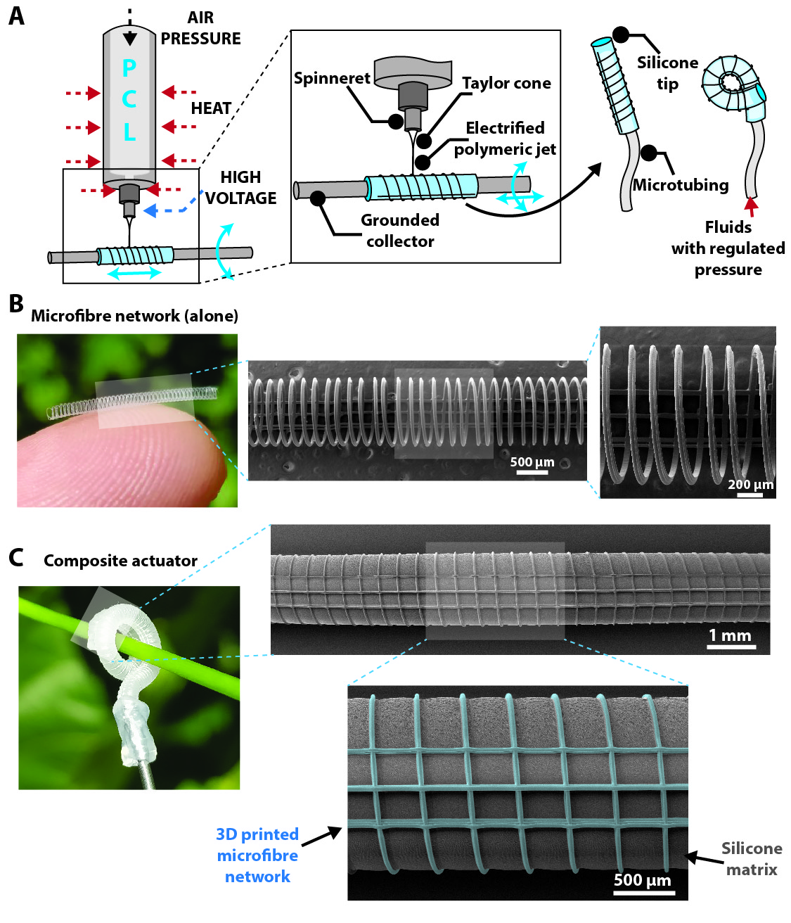
Figure S1. A) Schematic illustration of the fabrication steps of composite soft actuators via melt electrowriting (MEW). (B) A representative image of a melt electrowritten fibrous network (only fibres) on a finger as well as its scanning electron (SEM) micrographs. (C) An exemplary actuator that is twining around a plant stem with a diameter of ~1.5mm. SEM micrographs of the composite actuator with an inset (the fibrous network was false coloured to enhance visualisations in the inset).

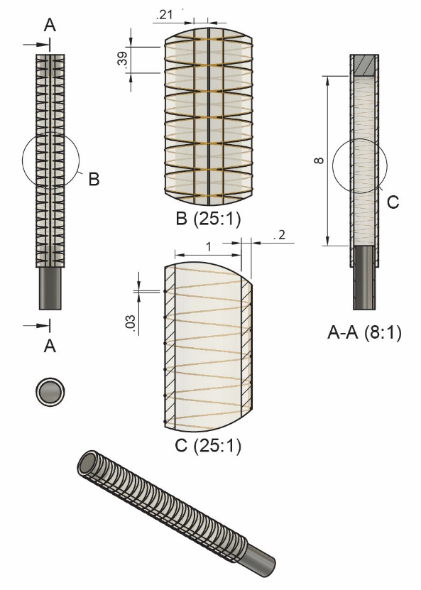
Figure S2. Technical drawing of bending actuators (units mm).

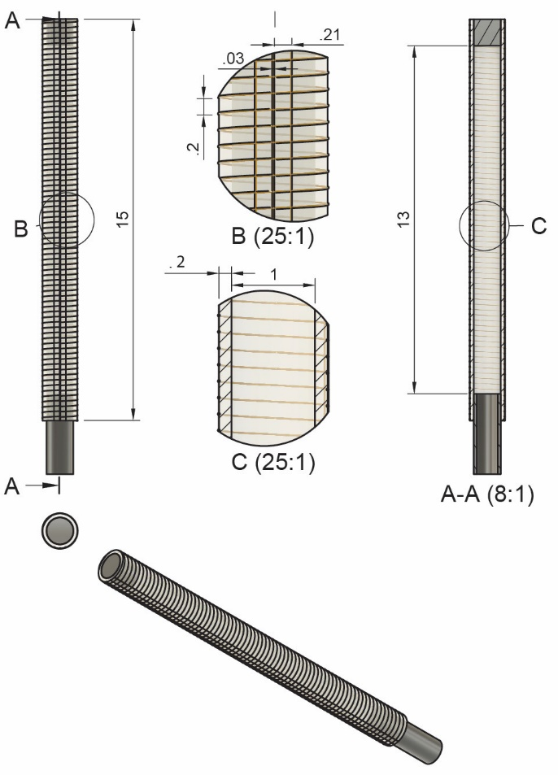
Figure S3. Technical drawing of twining actuators (units mm).
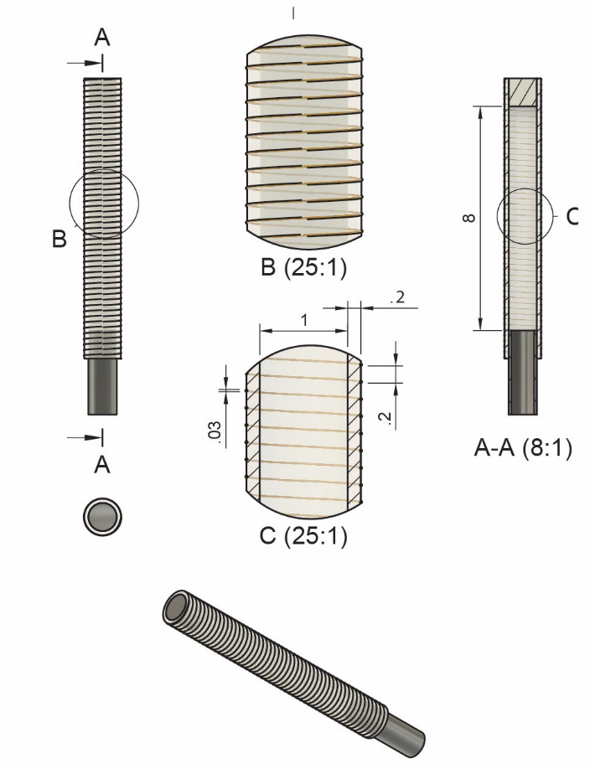
Figure S4. Technical drawing of elongation actuators (units mm).

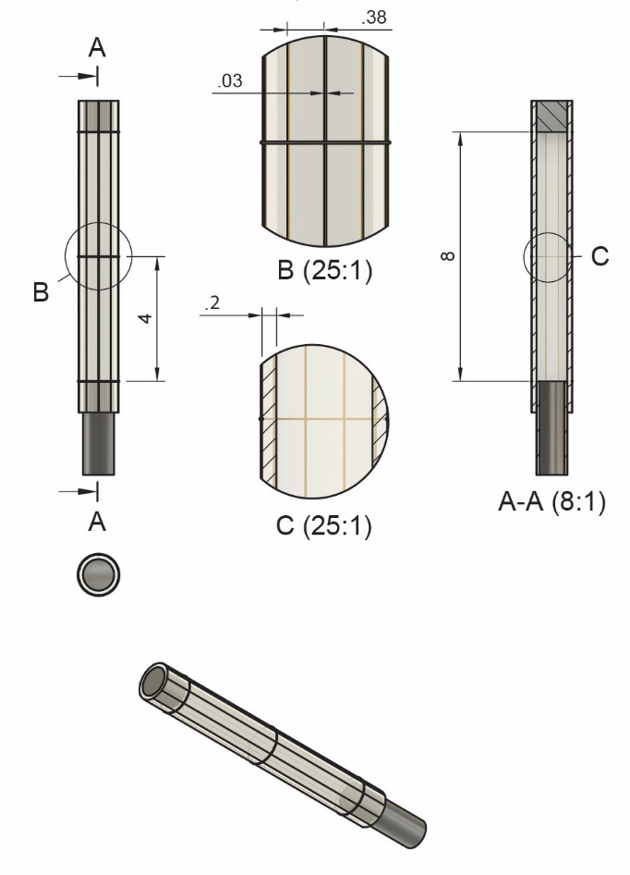
Figure S5. Technical drawing of contraction actuators (units mm).
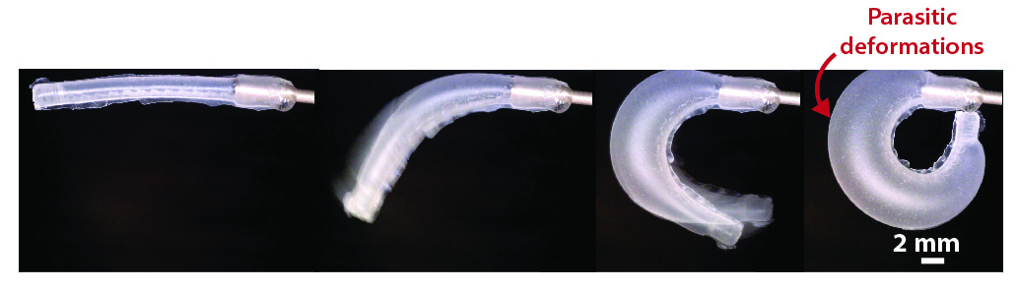Figure S6. Bending actuator without helical fibres exhibiting large parasitic deformations

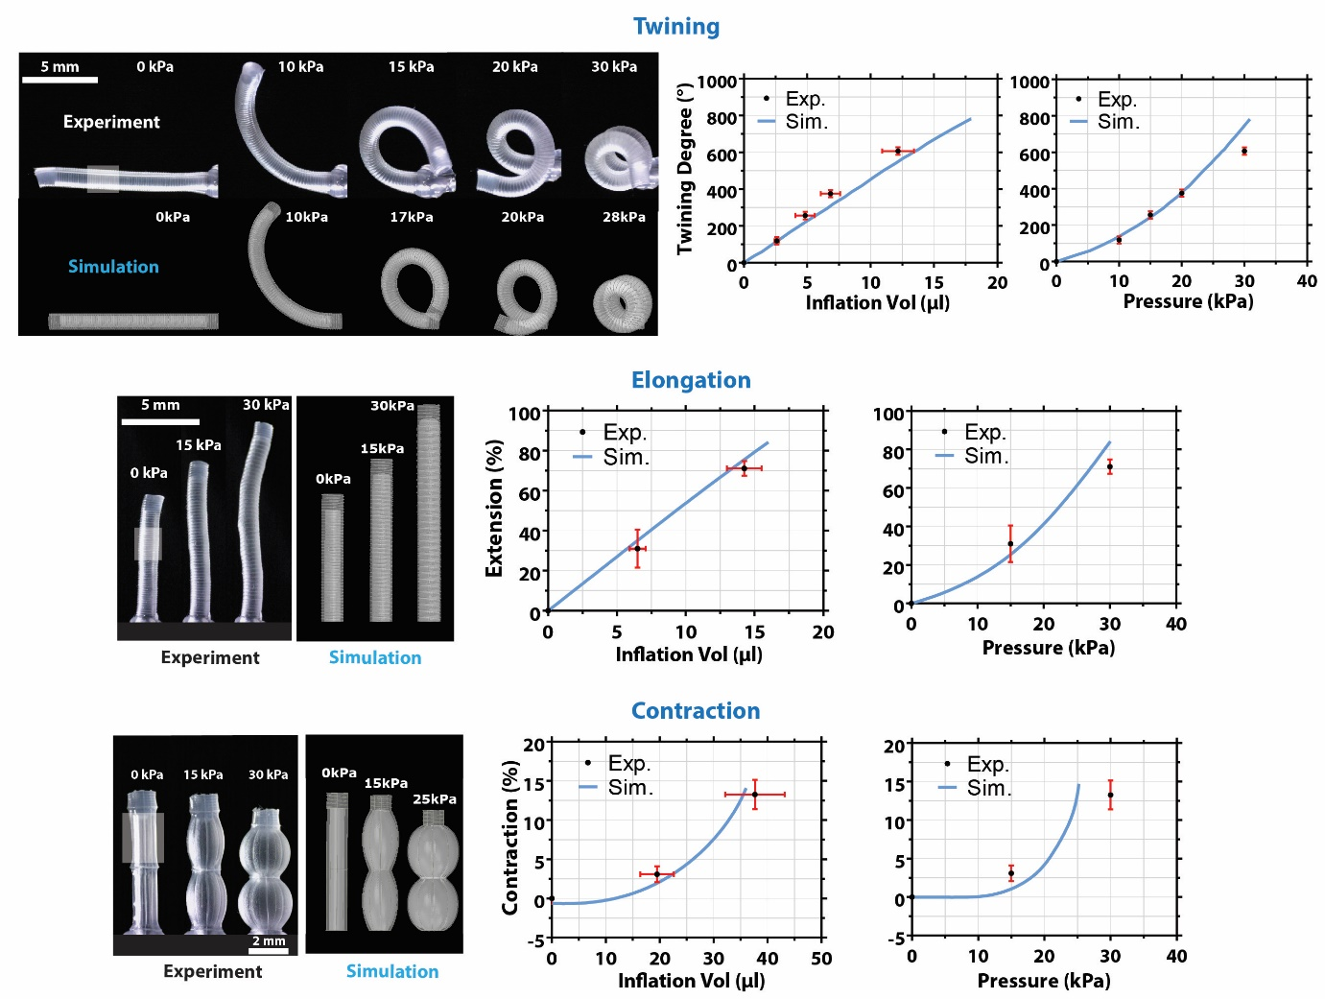
Figure S7. Deformation behaviour and actuation performance of various composite soft actuators. (A-D) Representative twining-, elongation- and contraction-type actuators with their scanning electron microscopy images as well as their simulated deformation behaviour. Graphs of inflation volume vs deformation and input pressure vs deformation obtained via experiments (n=3) and simulations are also shown.
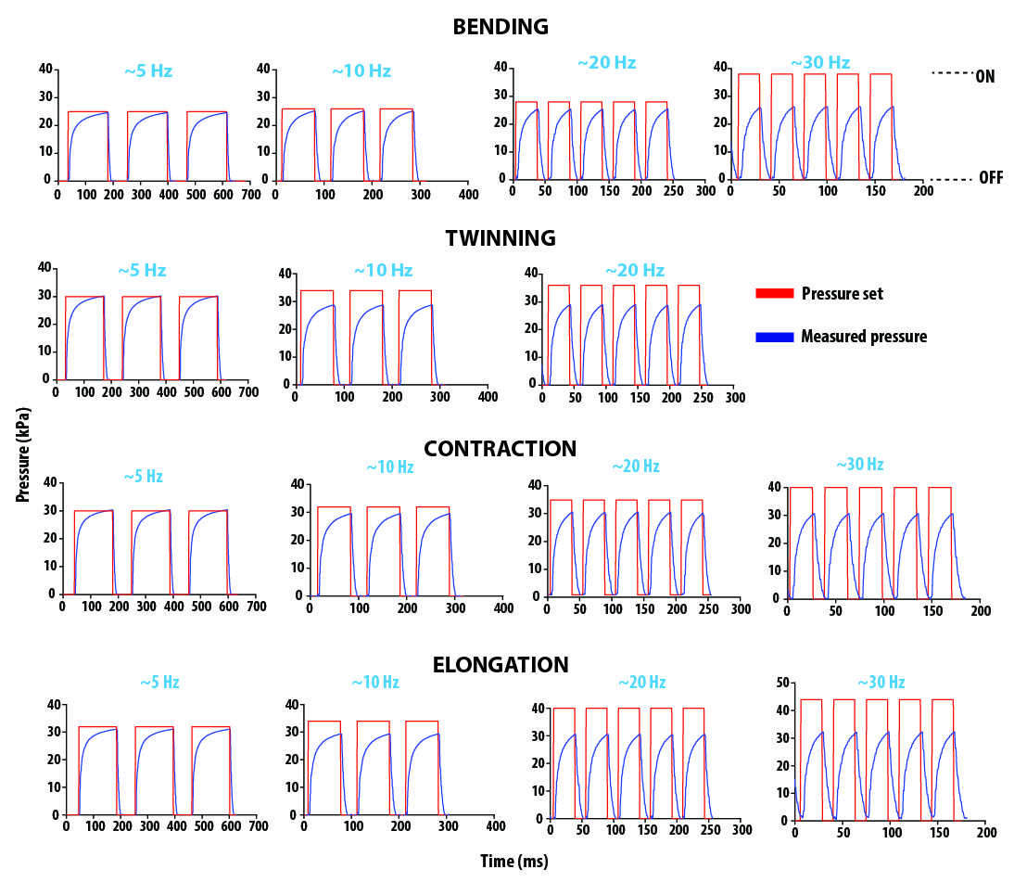
Figure S8. Air pressure values measured while characterising the actuation performance of the actuators at different actuation frequencies (5, 10, 20 to 30 Hz). At frequencies > ~10 Hz, pressure values exceeding the regular actuation pressure requirements of the actuators were applied to be able to reach the desired pressure levels within each actuation cycle. The duty cycle was kept constant (on-to-off duration ratio of 2) for all the experiments.

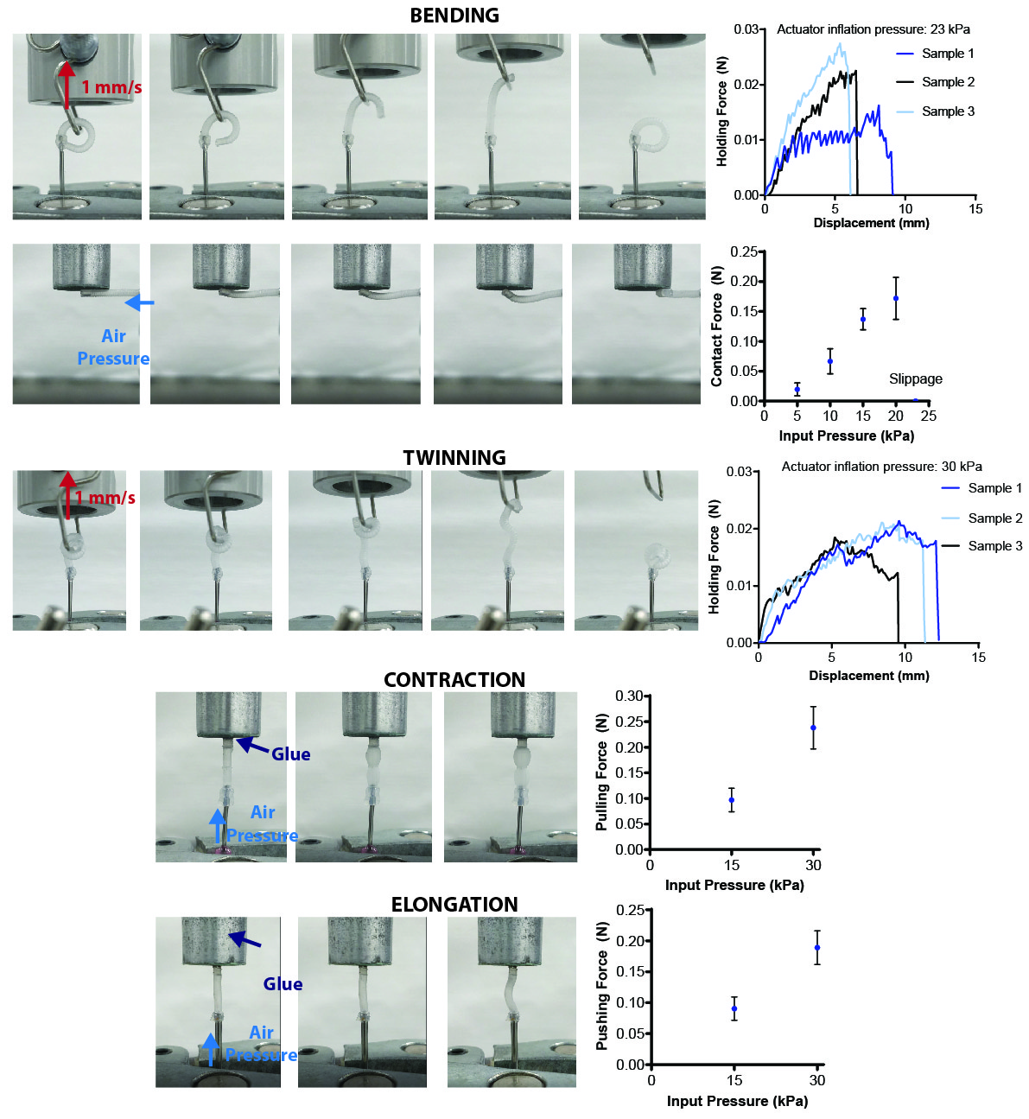
Figure S9. Two bending-type soft actuators with a diameter of (A) 600µm and (B) 10.5mm.

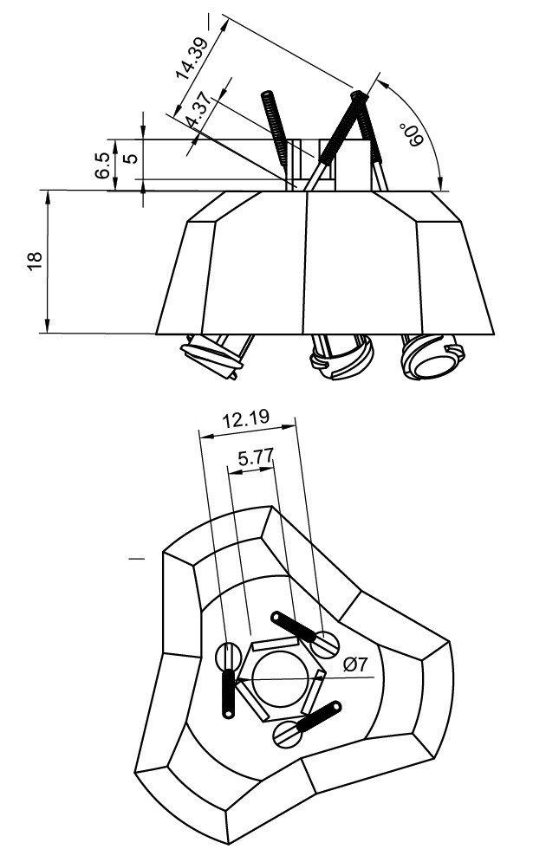
Figure S10. Technical drawing of the flycatcher.

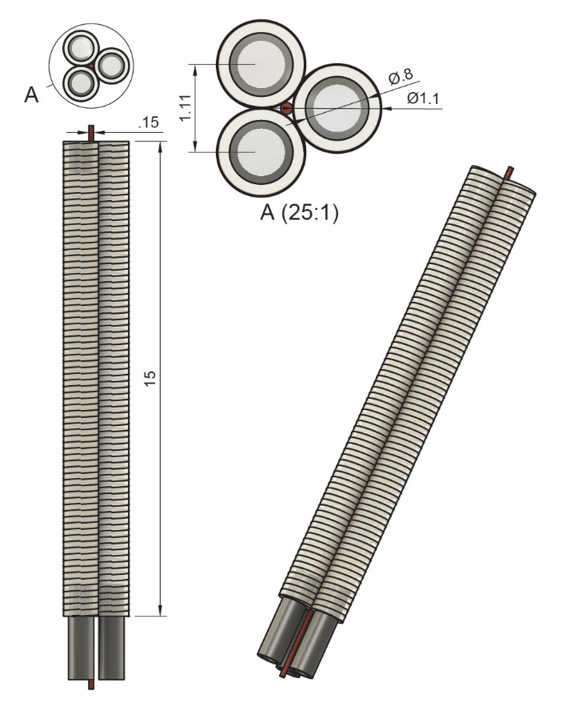
Figure S11. Technical drawing of the endoscopic device.

Table S1. Characterisation of the fabricated soft actuators
Actuator Type | Fibre Distance (helical fibres) (µm) |  |  | Silicone Wall Thickness (µm)
 | Target | Fabricated  (n=10) |  | Target | Fabricated (n=6)
Bending | 390 | 380.12 ± 11.78 |  | 200 | 206.57 ± 4.28
Twinning | 200 | 192.05 ± 10.04 |  | 200 | 187.62 ± 7.88
Elongation | 200 | 192.13 ± 7.91 |  | 200 | 212.27 ± 4.72
 | Arc angle (longitudinal fibres) (°) |  |  | Silicone Wall Thickness (µm)
 | Target | Fabricated  (n=10) |  | Target | Fabricated (n=6)
Contraction | 36 | 36.08 ± 1.41 |  | 200 | 210.57 ± 6.53

Table S2. GCodes used for the additive manufacturing of the actuators

 | ARCHETYPICAL ACTUATORS
OPERATIONS | BENDING | TWINING | ELONGATION | CONTRACTION
INITIALISATION | G18 G91 | G18 G91 | G18 G91 | G18 G91
SILICONE SPREADING | F375  G1 Y31 X15  M98 P1250 L5  G92 Z0  G1 Y-5 | F375  G1 Y31 X15  M98 P1250 L5  G92 Z0  G1 Y-5 | F375  G1 Y31 X15  M98 P1250 L5  G92 Z0  G1 Y-5 | F375  G1 Y31 X15  M98 P1250 L5  G1 Y-5
RETURN TO PRINT SETUP | G90  G1 X0 Y0  F165  G91 | G90  G1 X0 Y0  F165  G91 | G90  G1 X0 Y0  F165  G91  G92 Z0 | G90  G1 X0 Y0  F165  G91
PRINTING THE FIBROUS NETWORKS | M98 P1266 L3  G90  G1 X0  M30 | M98 P1266 L3  G90  G1 X0  M30 | M98 P1266 L3  G1 Y15  G90  G1 X0  G91  M30 | G1 X15 Z240  G92 Z0  M98 P1266 L6  G90  G1 X0  M30
FIBRE PRINT LOOP SUB-PROGRAM | O1266  G90  F165  G1 X-5 Z50  G1 X0 Z0  G1 X75 Z600  G1 Y23  G1 Z650  G1 X0  G1 Y0  G1 Z600  G1 X-5 Z650  G1 X0 Z600  G1 X75 Z0  G1 Z0.5  G1 X1  G1 X0  G1 Z0.7  G1 X75  G1 Z0.3  G1 X0  G1 Z0  F165  G91  M99 | O1266  G1 X65 Z1040  G1 X1  F500  G1 X6 Z-1040  F165  G90  G1 X15  G92 Z0  G1 Z 0.2  G1 X66  G1 Z-0.2  G1 X0  G1 Z0  G91  M99 | O1266  G1 X65 Z1040  G1 Y20  F500  G1 X-65 Z-1040  F165  G1 Y-20  G1 X-2  G1 X2  M99 | O1266  G1 X50  G1 Z0.3142  G1 X-50  G1 Z0.3142  G1 X50  G1 Z0.3142  G1 X-50  G1 Z0.3142  G1 X50  G1 Z0.3142  G1 X-50  G1 Z0.3142  G1 X50  G1 Z0.3142  G1 X-50  G1 Z0.3142  G1 X50  G1 Z0.3142  G1 X-1.5  G1 X-1.5 Z-25.136  G1 Z-12.568  G1 X-4  G4 P0.5  G1 Z12.568  G1 X-4  G4 P0.5  G1 Z-12.568  G1 X-1.5 Z-25.136  G1 X-1  G1 X-1.5 Z-25.136  G1 Z-12.568  G1 X-4  G4 P0.5  G1 Z12.568  G1 X-4  G4 P0.5  G1 Z-12.568  G1 X-1.5 Z-25.136  G1 X-1  G1 X-1.5 Z-25.136  G1 Z-12.568  G1 X-4  G4 P0.5  G1 Z12.568  G1 X-4  G4 P0.5  G1 Z-12.568  G1 X-1.5 Z-25.136  G1 X-1  G1 X-1.5 Z-25.136  G1 Z-12.568  G1 X-4  G4 P0.5  G1 Z12.568  G1 X-4  G4 P0.5  G1 Z-12.568  G1 X-1.5 Z-25.136  G1 X-1.5  G90  G1 X0 Z0  G1 X15  G91  M99
SILICONE SPREADING LOOP SUB-PROGRAM | O1250  G1 X50 Z-100  G1 X-50 Z-100  M99 | O1250  G1 X50 Z-100  G1 X-50 Z-100  M99 | O1250  G1 X50 Z-100  G1 X-50 Z-100  M99 | O1250  G1 X50 Z-100  G1 X-50 Z-100  M99

