Supplementary Information:
Visualising nanoscale bias-induced degradation in halide perovskite solar absorbers
Jordi Ferrer Orri,^{1,2,3} Affan N. Iqbal,^{1,2} Terry C.J. Yang,¹ Tiarnan A.S. Doherty,^{1,2} Thomas A. Selby,^{1,3} Yu-Hsien Chiang,^{1,2} Miguel Anaya,^{1,2} Christopher S. Allen,^{4,5} Samuel D. Stranks^{1,2*}, Caterina Ducati^{3*}

¹ Department of Chemical Engineering and Biotechnology, University of Cambridge, Cambridge, UK.
² Department of Physics, Cavendish Laboratory, University of Cambridge, Cambridge, UK.
³ Department of Materials Science and Metallurgy, University of Cambridge, Cambridge, UK.
⁴ Electron Physical Sciences Imaging Centre, Diamond Light Source Ltd, Didcot, UK.
⁵ Department of Materials, University of Oxford, Oxford, UK.
*Corresponding authors: sds65@cam.ac.uk, cd251@cam.ac.uk

Experimental methods

Sample Preparation
All procedures were followed inside a N₂-filled glovebox to avoid exposure of precursors and deposited films to oxygen and water. Two different perovskite compositions with nominal stoichiometries of FAPbI₃ (FA-pure) and mixed cation lead mixed halide FA_{0.7}Cs_{0.3}Pb(I_{0.9}Br_{0.1})₃ (FA-rich) were thermally evaporated.

All depositions were done using a CreaPhys PEROvap evaporator inside an MBraun N₂ glovebox (O₂ and H₂O levels below 0.5 ppm) following the evaporation method reported by Chiang et al..¹ In short, the chamber was pumped down to a pressure lower than 2$×$ 10⁻⁶ mbar for the deposition and the evaporator walls, source shutters and shields were kept at -20 ºC.

For both FA-pure composition an FA-rich compositions, FAI (GreatCell Solar, fresh powder for every deposition) and lead iodide (TCI, >98% metal-trace based purity) were filled into two different crucibles. Deposition rates for each source were set for FAI, and PbI₂ at 0.45 Å/s, and 0.90 Å/s, respectively, as measured with calibrated quartz crystal microbalances. For the FA-rich composition, FAI, lead iodide and caesium bromide (Sigma) were filled into three different crucibles. Deposition rates for each source were set for FAI, CsBr, and PbI₂ at 0.6 Å/s, 0.1 Å/s, and 1.20 Å/s, respectively, as measured with calibrated quartz crystal microbalances. Substrate temperature was 18 ºC, the sources-substrate distance was 35 cm, and the chamber pressure was approximately 2$×$10⁻⁶ mbar or less during deposition.

For the FAPbI₃ film, a thin layer of the hole transport layer MeO-2PACz was spin-coated prior to evaporation, to ensure the optimal growth of the perovskite film, as the evaporation was optimized for devices. The MeO-2PACz powder (TCI >98.0%, molar weight 335.30 g/mol) was dissolved in anhydrous ethanol (Sigma) at a concentration of 0.34 mg/ml and stirred for >10 mins. For the spin-coating, 120 μl of MeO-2PACz solution was dropped onto the center of the substrate, followed by a wait time of approximately 10 s (static method) before starting the spin-coating process. The spin speed was 4000 rpm (1000 rpm/s ramp) for 30 s with the spin-coater lid open. The substrates were then placed on a metal hotplate at 100 °C for 10 mins to evaporate the solvent. Immediately after, they were placed inside the evaporation chamber. The spin-coater and evaporator are both situated inside a N₂ glovebox. The addition of MeO-2PACz was not necessary for the FA-rich samples.

All perovskite films were deposited on MEMS-based biasing chips designed by HennyZ with 8 platinum electrodes deposited on a ~200 nm low-stress amorphous silicon nitride window (a Ta adhesion layer is also present between Pt and SiN, with Ta diffused into the Pt with thermal annealing at about 800° C during nanofabrication). The perovskite layer thickness was set to be ~90-100 nm, to ensure the overall specimen thickness did not surpass 300 nm, thus still being electron-transparent for the 200 keV beam. The edges of the grid were masked during evaporation, to ensure clean metallic contacts between MEMS-chip electrodes and macroscopic biasing pins.

To check the quality of the evaporated films, X-ray diffraction (XRD) and photoluminescence (PL) were measured and compared with those obtained from 500 nm thick perovskite film analogues evaporated on glass and ITO substrates. These had been cleaned with soap, deionized water, acetone, and isopropanol in a sonication bath for 15 minutes at each step. After that, the substrates were treated by UV-Ozone for 15 minutes, prior to the sample fabrication. A thin layer of MeO-2PACz was also spin-coated to check the effect of substrate on the quality of the film evaporation for FAPbI₃ samples. These results are seen in Supplementary Figure 2, in which the thinner 100 nm films for both compositions have the same XRD and PL emission as the thicker 500 nm analogues. Moreover, a comparison of thin FAPbI₃ films on different substrates is shown where ITO and MeO-2PACz substrates yield better films due to optimized evaporation for such device-relevant substrates.

Biasing
The HennyZ device, connected to a Keithley power supply achieves an electrical noise below 4 pA. Only 2 of the 8 available contacts described above were biased at any one time during the in situ experiments. One contact (the first on the left in Figure 1l) was connected to either the positive or the negative terminal, while the neighbouring contact was maintained at 0 V. The other contacts were kept at a floating potential and were not used in this investigation. We assume that their contribution to the measured currents is negligible.

4D-STEM
During 4-dimensional scanning TEM microscopy (4D-STEM), a 2D electron diffraction pattern was measured at every probe position of an electron beam in STEM mode. The data was acquired on the JEOL ARM300CF E02 instrument at ePSIC (Diamond Light Source, Didcot-Oxford, UK). A pixellated Merlin/Medipix direct electron detector was used to acquire fast low-dose 4D datasets. These direct electron detectors allow for better SNR under lower doses due to the superior quantum efficiency compared to traditional CCD systems. The detector was set to 6-bit, to maintain the targeted electron fluence and fast acquisition readout rate. An acceleration voltage of 200 kV, nanobeam alignment (convergence semi-angle ≈1 mrad), electron probe ≈5 nm, probe current ≈3.54 pA, scan dwell time 1 ms, and camera length 20 cm.

An estimated electron fluence of <11 e⁻Å⁻² per frame acquired, when approximating the beam cross section as a disk with a diameter of about 5 nm. This accumulated dose is lower than the reported damage threshold for FAPbI₃ (66 e⁻Å⁻²) or FA-rich (200 e⁻Å⁻²) compositions.^{2,3} The in situ movies were created by acquiring 18 consecutive frames over the same region, resulting in cumulative fluences up to ~200 e⁻Å⁻², for each biasing experiment. Since electron dose is a critical parameter in these studies, additional datasets were acquired from regions that were only exposed to the electron beam once before biasing (dose 2 $×$11 e⁻Å⁻²), and from other regions that were only exposed post biasing (dose 11 e⁻Å⁻²). All these areas show the same degradation features observed in the in situ movies (see Supplementary Figure 13), validating that these datasets were acquired below critical beam-induced damage thresholds.

Post-processing of the diffraction data was done using pyXem 0.14.2 (an open-source Python library based on HyperSpy-based for crystallographic electron microscopy) and py4dstem 0.13.6.^{4,5} All diffraction patterns were distortion-corrected and calibrated with an Au cross grating using the standard pyXem calibration pipeline. The drift in the beam position of the unscattered (direct) beam was corrected and centered, first using the center-of-mass method from py4dstem, followed by a linear cross-correlation with a subpixel factor of 4 pixels. Dead pixels and detector junctions were masked. Sample drift correction during biasing movies was applied using linear cross-correlation with a subpixel factor of 100 pixels.

Virtual bright-field images (vBF) were constructed by mapping the intensity of the direct beam as a function of probe position. Virtual dark-field images (vDF) were constructed by mapping the intensity of a Bragg-diffracted spot from the 2D diffraction pattern as a function of probe position, thus containing information solely electrons scattered to specific Bragg angles. The range of the semi-angle of detection (𝜃) can be estimated from the camera length (20 cm), the pixel size (for the Merlin/Medipix detector is 55 μm), and the pixel radius as follows:

$${θ=tan}^{-1}\left(\frac{\left|\vec{k}\right|in detector pixel length \left(pixel range*pixel size\right)}{CL:camera length}\right)$$

For vBF and vDF images, the pixel range taken was 0-0.04 Å⁻¹ (8 pixels in the detector, each 0.005 Å⁻¹) and 0.04-1.3 Å⁻¹ (256 pixels in the detector), respectively. Therefore, the semi-angle of detection is 0-2 and 2-70 mrad, respectively. Note that some pixels at the unscattered beam position saturate. Note that, due to the broad nature of the central unscattered beam, the virtual aperture for the vBFs cannot contain the whole direct beam but is selected to the maximum size before any elastically scattered spots are detected.

All diffraction patterns in this work are reported in “ordinary” wavevectors (k = 1/d). Note that these units differed from the “angular” wavevectors definition (q = 2π/d) by a factor of 2π, which is often used in X-ray crystallography literature.

Crystal Structure Library
All diffraction patterns from this work could be closely indexed to a pseudo-cubic/tetragonal perovskite unit cell (P4/mbm) with lattice parameters of a = b = 9.00 and c = 6.36 Å, as reported by Macpherson et al..⁶ Despite the stoichiometry of the FA-rich sample being the more complex double-cation double-halide perovskite composition, it could be approximated as a simpler unit cell made from the predominant ion at each site (C, Pb and I). All diffraction patterns were indexed within the reciprocal-space resolution of 4D-STEM technique (under acquisition conditions one pixel in the detector was 0.005 Å⁻¹).

Additional crystal structures were also considered: the hexagonal 4H-PbI₂ crystal phase (P63mc, lattice parameters of a = b = 4.56 and c = 13.96 Å, COD ID: 9009140) and the cubic Pb experimentally-measured crystal structure (Fm̅3m, lattice parameters a=b=c= 4.951 Å, COD ID: 9008477). The structure files can be retrieved from the crystallography open database and the Material Project website.^{7,8} Intermediate perovskite polytype phases were also observed. In Ramsdell notation, close-packed structures can be designated by specifying the number of layers in the hexagonal unit cell followed by a H, R or C to denote the lattice type. For example, 2H represents a structure with 2 layers in its primitive hexagonal unit cell. Only the three common polytypes of 2H, 4H and 6H were considered, as reported by Gratia et al.,⁹ which are structures that interface the photoactive α-phase (3R) with the yellow δ-phase (2H).

All diffraction simulations were performed using Single Crystal 4 (CrystalMaker Software Limited), adjusting the simulation parameters to resemble the experimental data (200 keV, detector spot size 0.025 Å^{–1}, saturation 10, gamma 2). Simulation files in “.scdx” format can be found in the Supporting Data.

Hyperspectral PL
Wide-field hyperspectral photoluminescence microscopy (PL) measurements were carried out after 4D-STEM measurements using a Photon etc. IMA system. For all measurements, ×100 air, chromatic aberration corrected objective lenses from Olympus were used. A 405-nm continuous wave laser, filtered by a dichroic mirror, was used for luminescence excitation. The emitted light from the sample was incident on a volume Bragg grating, which splits the light spectrally onto a CCD camera. The detector was a 1,040 × 1,392 resolution silicon CCD camera kept at 0 °C with a thermoelectric cooler and has an operational wavelength range of 600–900 nm. By scanning the angle of the grating relative to the incident light, the spectrum of light coming from each point on the sample could be obtained. PL spectra were acquired for 1 second exposure per angle, with a spectral resolution of 2 nm. The monochromatic excitation power was set to be equivalent to 1 sun (AM 1.5G spectrum). Calibrations followed as per the procedure previously reported.¹⁰

STEM-HAADF and STEM-EDX
High-angle annular dark field imaging (HAADF) was acquired after 4D-STEM acquisition using the JEOL ARM300CF E02 in standard STEM mode (in nanobeam alignment, as described for 4D-STEM at 1 mrad convergence angle) using an annular dark field detector at camera length of 10 cm, a dwell time of 4 μs and 1024px scans at various magnifications of 25-200 kx. The collection angle for HAADF was between 74.3± 0.3 and 233.3± 1.5 mrad. The electron fluence during these scans is estimated to be significantly higher than the electron-beam induced damage thresholds for halide perovskites, by at least 2 orders of magnitude.

Compositional mapping using energy-dispersive X-ray spectroscopy (STEM-EDX) was acquired from a FEI Tecnai Osiris FEG-(S)TEM operated at 200 kV. These maps were acquired on regions similar but not identical to the areas imaged by HAADF with the JEOL microscope. In this experiment, a standard STEM probe with a beam current of 140 pA (70 μm C2 aperture, spot size 6, and gun lens 5) was used. HAADF images were acquired with a Fischione detector, with a spatial sampling of 4 nm per pixel and a dwell time of 0.5 s. EDX spectra were obtained with Bruker Super-X SDDs with a total collection solid angle of ≈0.9 sr, a spatial sampling of 10 nm per pixel, a dwell time of 50 ms, and a spectral resolution of 5 eV per channel. For EDX the electron dose is estimated as <7,000 e⁻Å⁻²s⁻¹. All EDX spectra were spectrally rebinned to 20 eV per channel, then denoised with PCA/NMF and processed in HyperSpy 1.7.3.¹¹ Compositional maps were obtained using the integrated line intensities for Pb_La, I_La, and Br_Ka (instead of Br_La, since the tail of Br_La overlaps with the Si_La dominating peak) and the Cliff-Lorimer method using the calibrated K/L-factors from Bruker.

X-ray diffraction (XRD)
Bulk XRD measurements were performed on a Bruker XRay D8 Advance diffractometer employing Cu Kα radiation (λ = 1.54 Å), operated in a θ-θ fixed sample mode. Note that diffraction profiles are reported in “ordinary” wavevectors (k = 1/d).

Estimation of electrical bias metrics

Supplementary Table 1- Measured and estimated values during in-situ biasing at + 20 V.
Data | Mean value (from min and max) | Unit
Voltage | 20 | V
Current | 4.00E-08 | A
Width (x) | 1.00E-05 | m
Length (y) | 5.00E-06 | m
Depth (z) | 1.00E-07 | m
Number of contacts | 4
Experiment time | 90 | min
Charge flow | 2.48E+11 | e- s-1
Total volume | 2.00E-17 | m3
Surface (cross section) | 4.00E-12 | m2
Charge carrier density flow | 1.24E+28 | e- m-3 s-1
 | 1.24E+22 | e- cm-3 s-1
 | 12 | e- nm-3 s-1
Total flown charge carrier density | 6.70E+25 | e- cm-3
 | 66,960 | e- nm-3
Total flown current flux | 1.00E+04 | A m-2
 | 1.00E+07 | mA m-2
 | 1,000 | mA cm-2
 | 50 | x times the Jsc for a PV
Electric field | 4.00E+06 | V m-1
 | 4 | V µm-1

Supplementary Movies
Supplementary movies showing the time series frames from virtual bright filed images acquired during bias application in situ. Both FA-pure and FA-rich compositions are shown. Simple and a reversed polarity experiments are shown, with the +V contact always on the top of the images.

Supplementary Table 2- Description of the supplementary movies.
Movie name | Description
movie_01_fa_fwd_vBF | FAPbI₃ film biased at +20 V for 90 min.  Frame every 5 min.
movie_02_fa_fwd_rev_vBF | FAPbI₃ film biased at +20 V for 90 min and at -20 V for 90 min more.  Frame every 10 min.
movie_03_dc_fwd_vBF | FA-rich alloyed film biased at +20 V for 90 min.  Frame every 5 min.
movie_04_dc_fwd_vBF | FA-rich alloyed film biased at +20 V for 90 min and at -20 V for 90 min more.  Frame every 10 min.

Supplementary figures
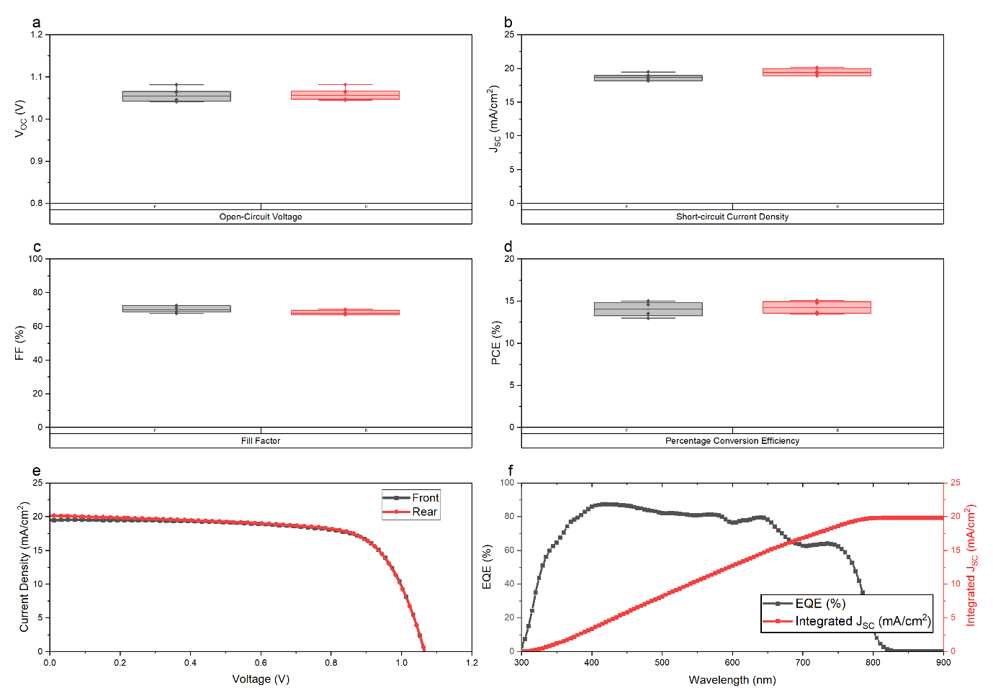
Supplementary Figure 1- Perovskite solar cell baseline for a 500 nm FAPbI₃ composition on MeO2Pacz, the compositions analysed in this work. Different parameters are shown for both from (grey) and rear (red) parts of the device: (a) open-circuit voltage, (b) short-circuit current, (c) fill factor and (d) percentage conversion efficiency. Such parameters are taken from (e) the J-V curve. (f) The external quantum efficiency (EQE) and the integrated dependence of the short-circuit current over wavelength of irradiation. Device architecture is ITO (glass substrate)| MeO-2PACz (monolayer)| FAPbI₃ (500 nm)| C₆₀ (25 nm)| BCP (10 nm)| Cu (120 nm).
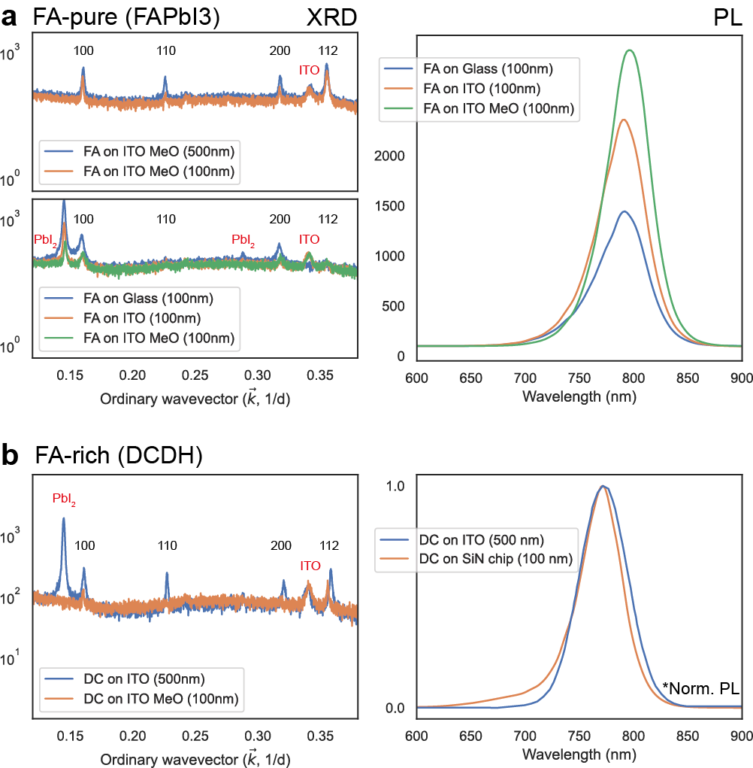
Supplementary Figure 2- Sample pre-checks for both (a) FA-pure and FA-rich (double-cation double-halide) compositions. It shows XRD and PL for both thin and thick evaporations. XRD comparison of thin FAPbI₃ films on different substrates, where ITO and MeO-2Pac substrates yield better films due to optimized evaporation. All peaks are indexed to the canonical cubic perovskite structure. PL spectra comparison of the same films, showing similar emissions to thicker analogues.
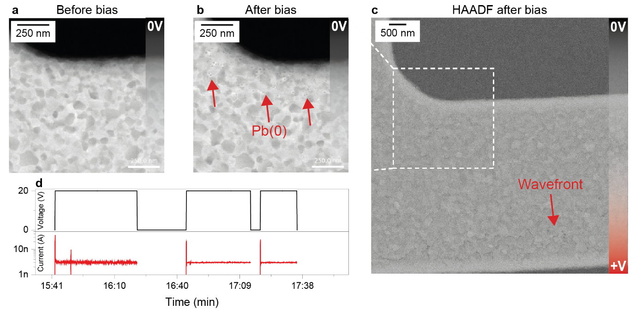
Front
Supplementary Figure 3- Similar biasing-induced changes are observed in a different FAPbI₃ sample, showing reproducibility of phenomena reported. (a-b) The appearance of small dark dots is visible in the vBF before and after biasing, and (c) a degradation front formation is observed at the +V contact (as seen from HAADF). (d) Current profile during this validation experiment, being linear and at nA range (80 min at 20V).
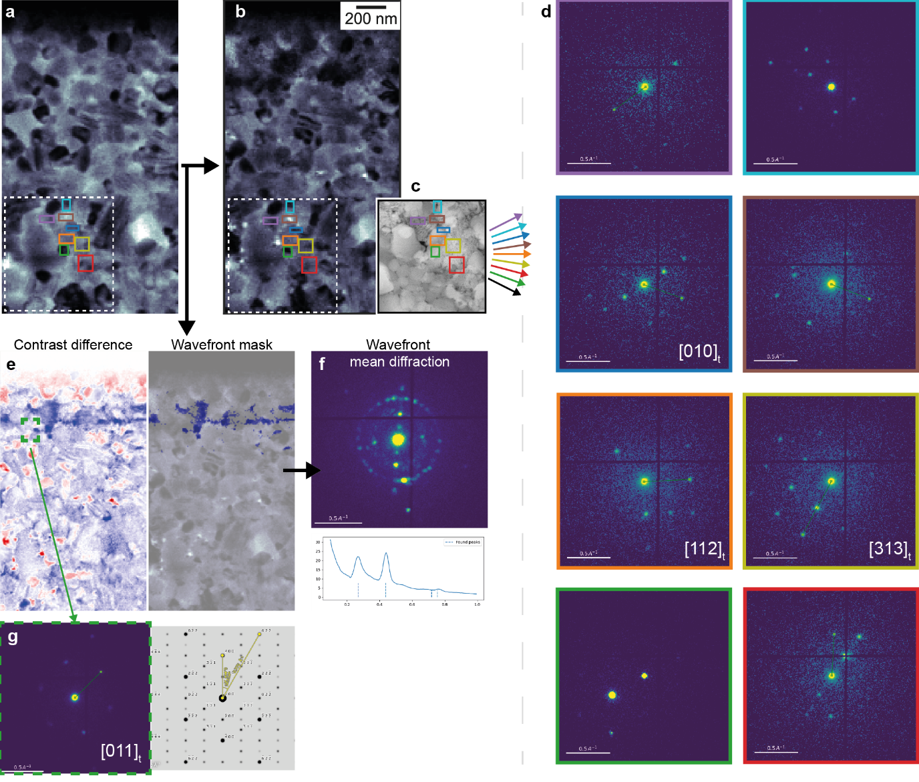
Supplementary Figure 4- A more detailed study of the crystallography of grains at the degradation front for the FA-pure biasing experiment. From the vBF images (a) before and (b) after biasing, a series of grains (c) at the degradation front can be selected. (d) Diffraction patterns match the tetragonal perovskite phase and no phase difference distinguish the transformed from the unmodified grains (they are not linked to the presence of extended defects or polytypes). Qualitatively, grain orientations corresponding to lower index tetragonal zone-axes (such as [001] or [112]) seem to be less affected by degradation (as seen from post-biasing HAADF images in Figure 2 in the main text). Grain orientations corresponding to higher index zone axes (such as [313]), appear consistently more affected by degradation, possibly due surface terminations that may result in higher chemical reactivity during the biasing. Moreover, from (e) a contrast image generated from the difference between the end and the start vBFs (b minus a), the degradation front can be better observed and masked, to yield (f) a mean diffraction pattern also indexable to the perovskite structure. This suggests that not all crystallinity of the pristine perovskite grains has been destroyed.
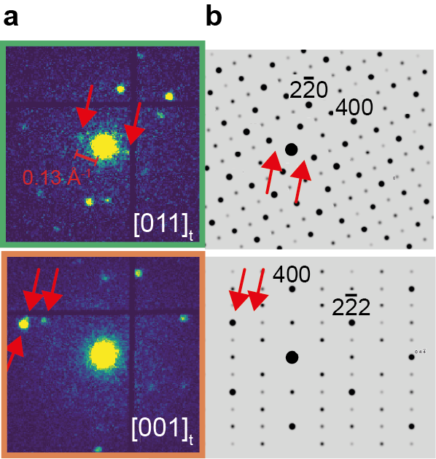
Supplementary Figure 5- (a) Experimental diffraction patterns obtained from the regions shown in Figure 2 in the main text, exhibiting additional reflections marked with red arrows. These reflections, with diffraction lengths below 0.16 A⁻¹, cannot fully be indexed to (b) the simulated diffraction patterns for the pristine perovskite, thus hinting at the presence of defective phases.

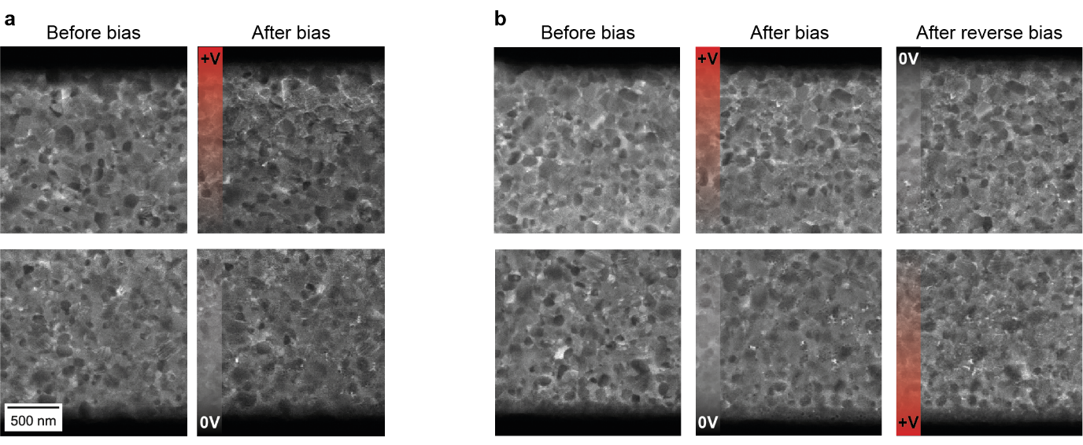
Supplementary Figure 6- A series of vBF images obtained from the FA-pure biased sample at different regions from the ones presented in the main figures in the text. (a) Before and after biasing for regions near the positive and negative contacts. (b) Before, after and after reversing the bias once more (overall 90 + 90 = 180 minutes of bias), showing how degradation is dependent on the polarity of the metallic contact. When the polarity of the contact is reversed, then the morphological changes appear in both sides.

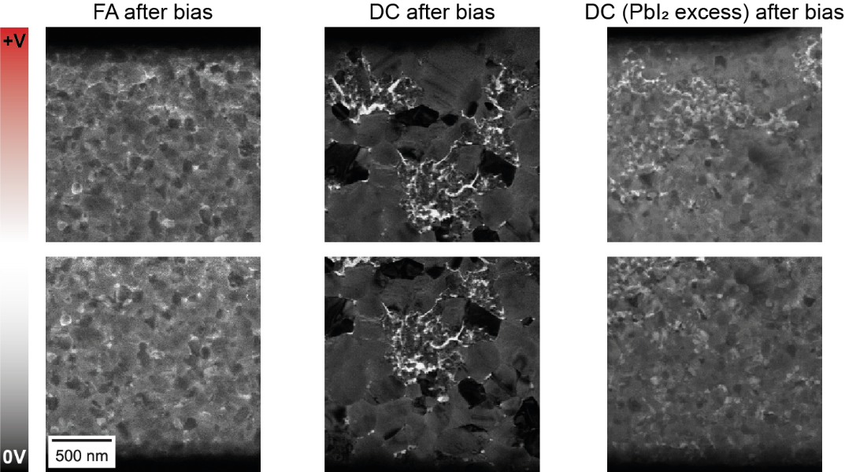
Supplementary Figure 7- In order to understand if the morphological changes were caused by the electron beam exposure, a series of vBF images were taken only after biasing. These regions were never exposed to the electron beam before, nor during biasing, only post biasing. The same morphological feature changes can be seen as the ones shown in the main text, suggesting the reported changes are not induced by the electron beam.

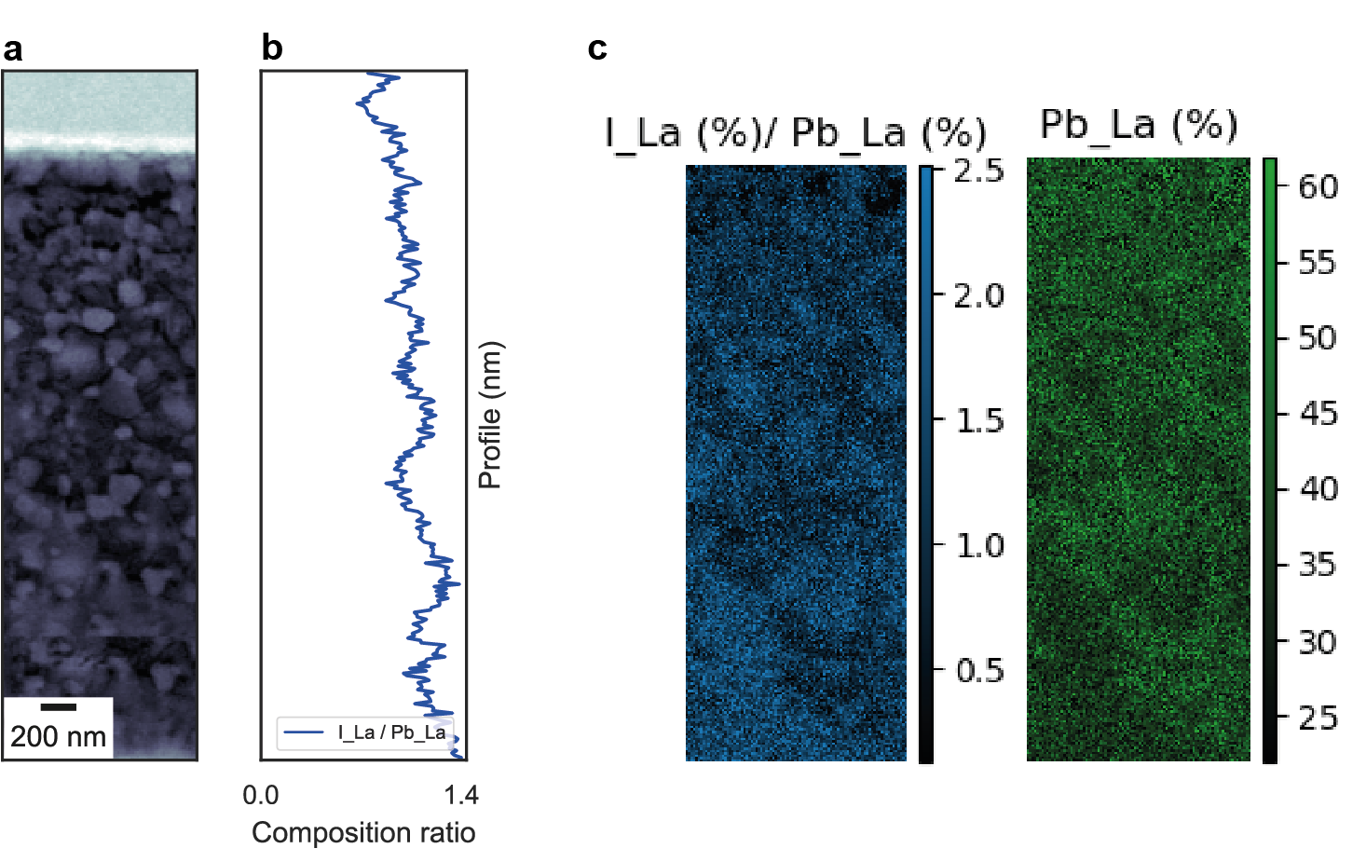
Supplementary Figure 8- Figure showing the (a) HAADF and composition mapping from EDX for I and Pb. (b) The line profile across the contacts shown as a I/Pb ratio, and (c) the respective compositional maps.

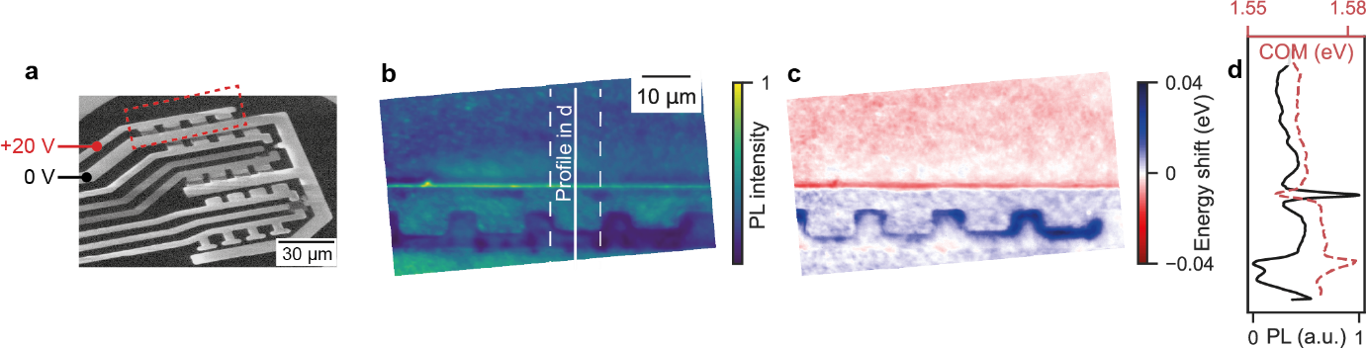
Supplementary Figure 9- (a) Schematic of the complete MEMS biasing chip, without the perovskite layer, as seen from a scanning electron microscope (SEM), showing the different platinum contacts that can be biased. (b) Map of the PL intensity of the FA-pure film near the lateral biasing contact: it consists of the pristine perovskite on the top part of the maps, as only the regions between the metal contacts were biased (from the dashed red line in the SE image in panel a). The region between the metal contacts was biased for 90 min at 20 V. (c) Shift from the center-of-mass (COM) of the PL emission, showing bluer COM emission at the region between the contacts (biased), compared to the non-biased film (unbiased). (d) A profile taken from the line shown in panel b shows the inverse relationship between the PL intensity (in black) and the COM energy (in red, dashed). The edges on the opposite side to where the biasing was applied show brighter PL and redshifts, also observed for the as-deposited films without any biasing applied (see Supplementary Figure 10). These shifts are not linked to biasing but may be attributed to morphological height difference from the MEMS chip which forces perovskite grains to form on the metallic edge as opposed to the flat substrate.
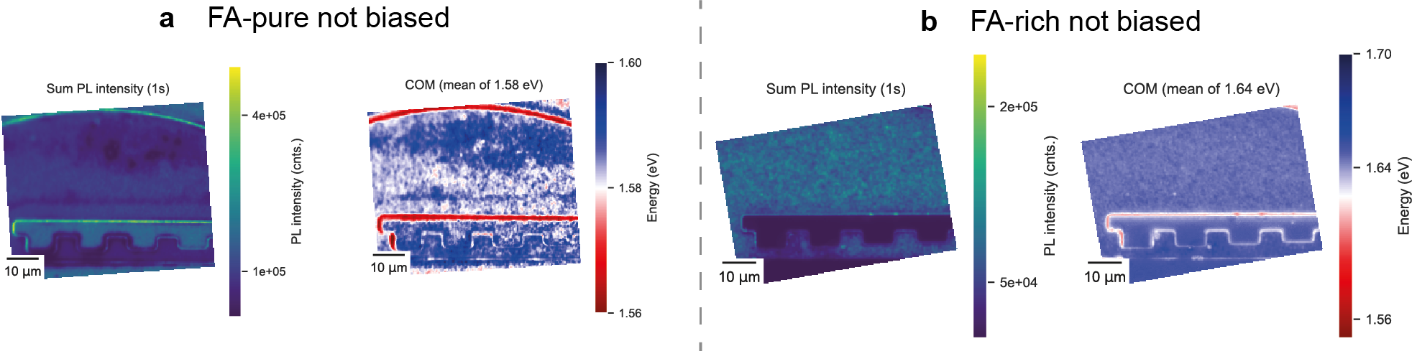
Supplementary Figure 10- SI_FADC_NO_BIAS_EDGE_PL_EFFECTS: The PL emission at the edges of each metallic contact shows edge effects even prior to any biasing for both the FA-pure and the FA-rich samples. These changes are linked to the morphology of the substrate, as shown in the Supplementary Figure 11.
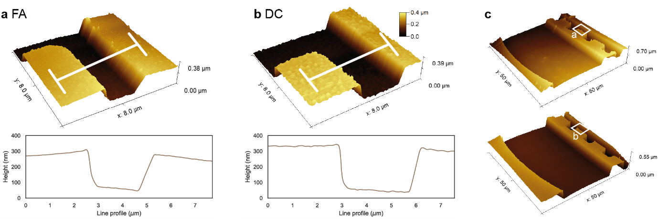
Supplementary Figure 11- Atomic probe microscope profiles for both the FA-pure (FA) and the FA-rich (DC for double-cation) samples. Data acquired using MFP-3D AFM System (Oxford Instruments) at field of views of 8 and 50 μm, 256 points per line and at a scanning speed of 1 and 0.1 lines per second, respectively. Data processing was done using Gwyddion 2.62 where each scan was row aligned using median of differences, the minimum data value was shifted to 0 and line profiles with a width of 100 px are shown.

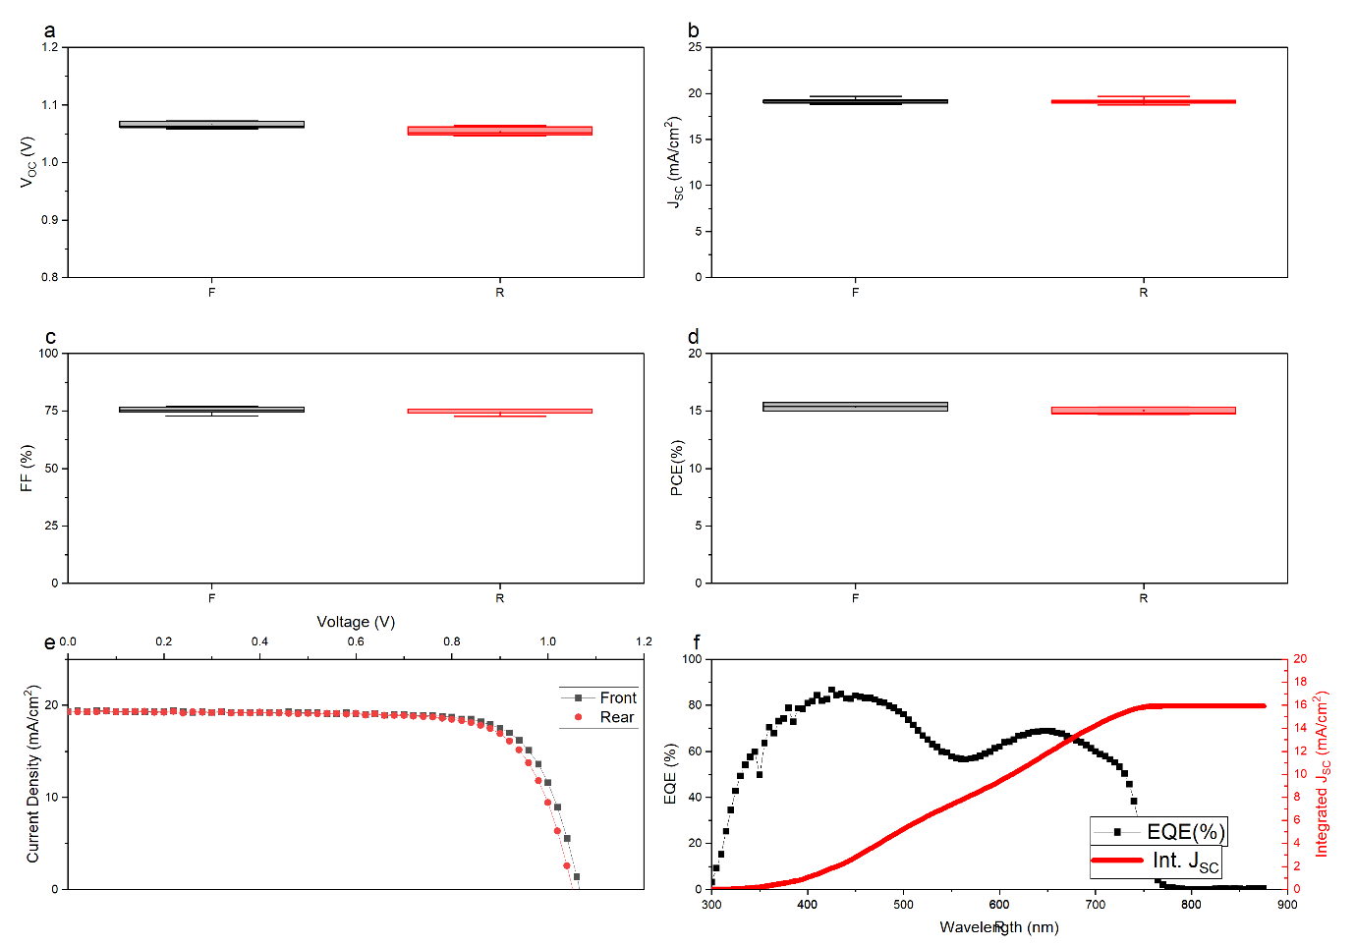
Supplementary Figure 12- Perovskite solar cell baseline for a 100-nm alloyed double-cation double-halide composition, the same composition analysed in this work. Different parameters are shown for both front (grey) and rear (red) parts of the device: (a) open-circuit voltage, (b) short-circuit current, (c) fill factor and (d) percentage conversion efficiency. Such parameters are taken from (e) the J-V curve. (f) The external quantum efficiency (EQE) and the integrated dependence of the short-circuit current over wavelength of irradiation.

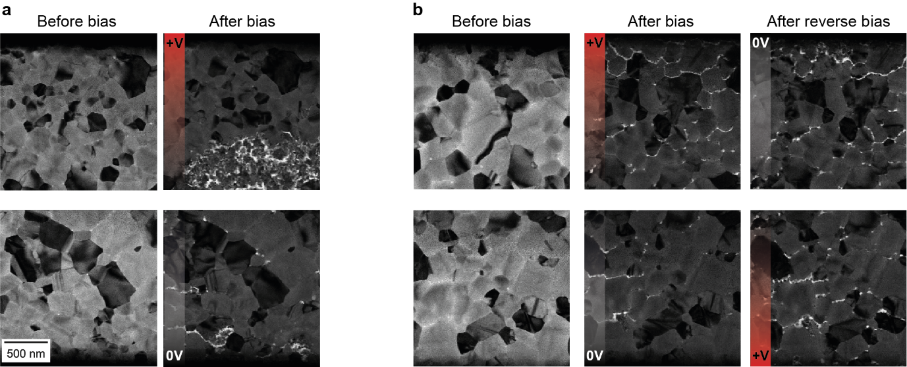
Supplementary Figure 13- A series of vBF images obtained from the FA-rich double-cation double-halide biased sample at different regions from the ones presented in the main figures in the text. (a) Before and after biasing for regions near the positive and negative contacts. (b) Before, after and after reversing the bias once more (overall 90 + 90 = 180 minutes of bias), showing how degradation is not dependent on the polarity of the metallic contact. Degradation is observed at both sides of the contacts throughout the film.

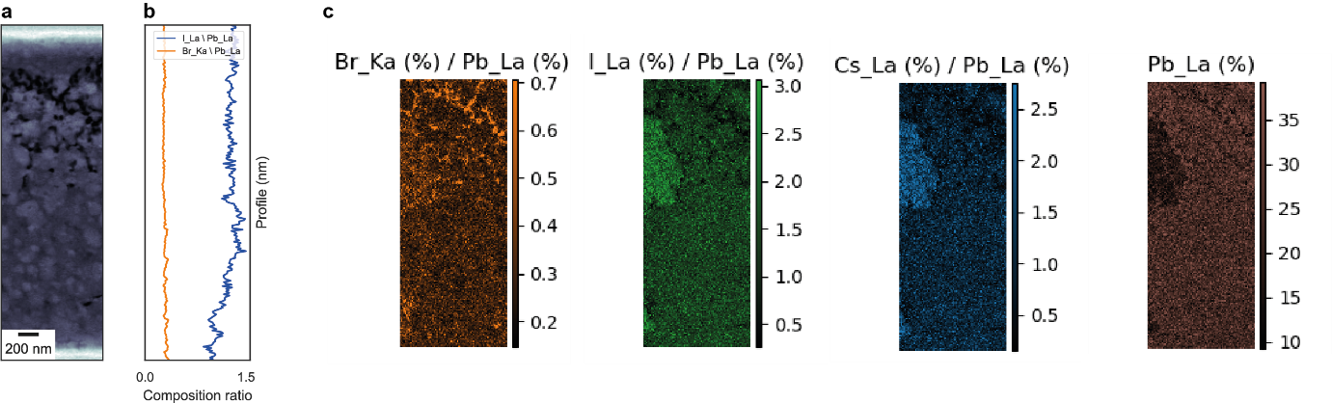
Supplementary Figure 14- Figure showing the (a) HAADF and composition mapping from EDS for Br, I, Cs and Pb. (b) The line profile across the contacts shown as a I/Pb and Br/Pb ratio, and (c) the respective compositional maps Note that the nominal quantification of Cs is very high, attributed to the difficult of measuring Cs due to its low stoichiometric concentration in the composition under investigation, and the energy of the peak overlapping with the stronger signal from the iodine ($I_{Lβ}$).

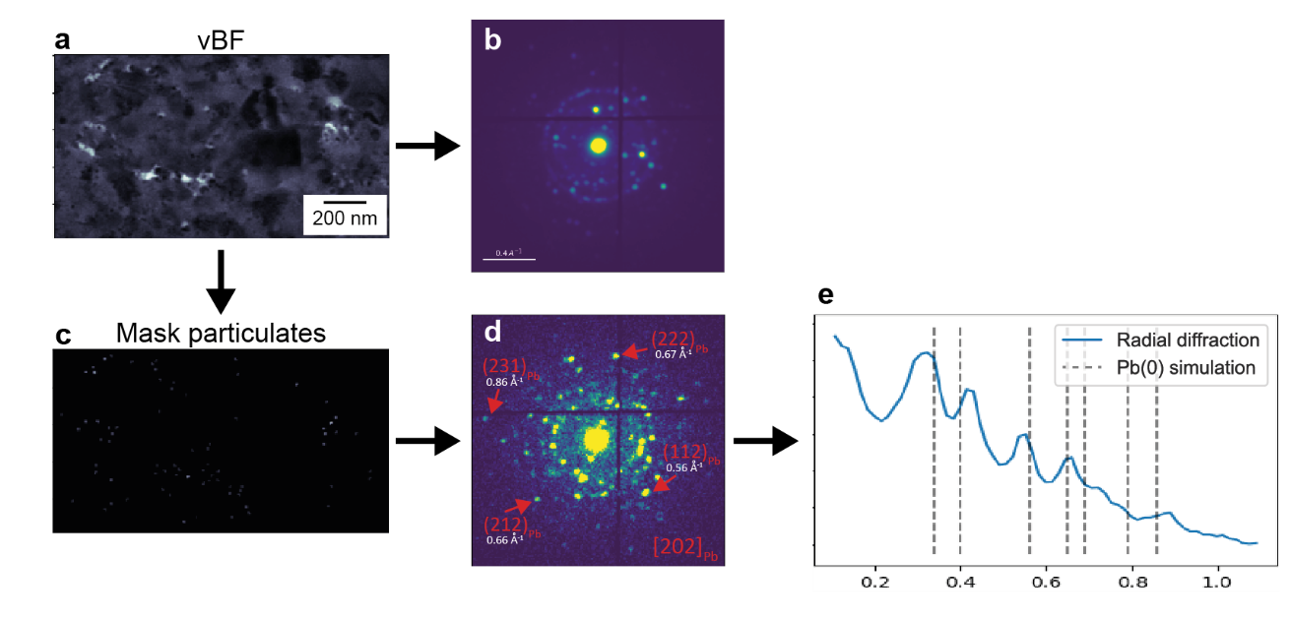
Supplementary Figure 15- The formation of Pb0 particulates is also observed for the double-cation double-halide composition, as shown from masking (b) the mean diffraction pattern form (a) the vBF image. (c) From the mask contains the particulate formation, (d) the diffraction pattern better shows diffraction spots indexable to Pb0 planes, and (e) radially integrated.

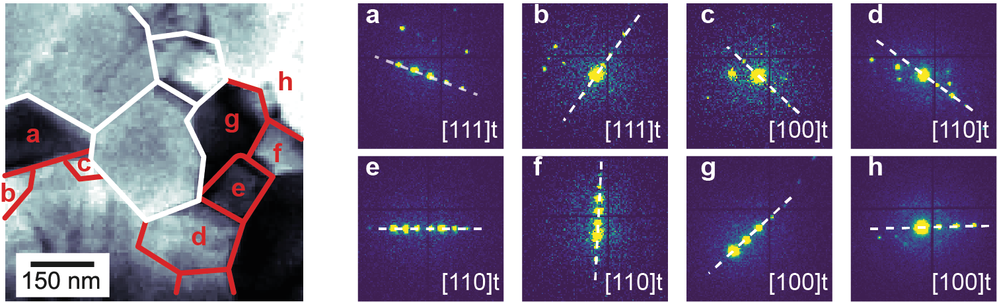
Supplementary Figure 16 - The grains near the area in Figure 3 in the main text, where most degradation happens, show diffraction patterns indexable to high-angle grain boundaries to the [111]t zone axis grains (1,2,3 in Figure 3). Degradation expands in this zone axis, leaving the grains at high-angle grain boundaries mostly unaffected.

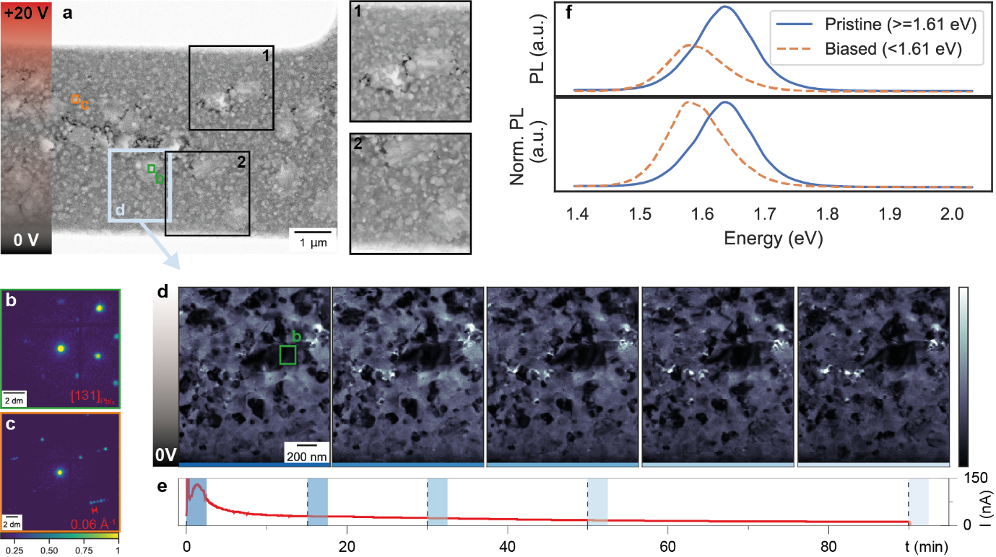
Supplementary Figure 17- Lateral biasing processes in FA-rich compositions with initially more segregated composition, as seen in the nanoscale. a) HAADF images acquired post-biasing, across the whole region between metallic contacts, show the formation of cracks (darker contrast) near brighter islands (brighter Z-contrast). Zoomed-in HAADF images are shown in panel d, showing no clear differences between the positive and 0 V contacts. The diffraction of the denser islands in b-c) shows 4D-STEM diffraction indexable to PbI₂ and polytypes, obtained from the first scan from the regions marked in panel d. d) The vBF images generated from 4D-STEM datasets after 0, 15, 30, 50, and 90 min of biasing near the 0 V metallic contact. The vBF images show, again, the formation of cracks near the denser islands. e) The current profile measured while 20 V was applied over 90 min shows exponential decay. f) Absolute PL intensity spectra for the pristine (in blue) and biased regions (in orange, dashed) show quenching and a red-shifted emission after biasing, as seen in the normalized PL intensity spectra. Diffraction intensity has been raised to the power law of 0.33 (cube root) to better distinguish the weak diffraction features from the bright central beam.
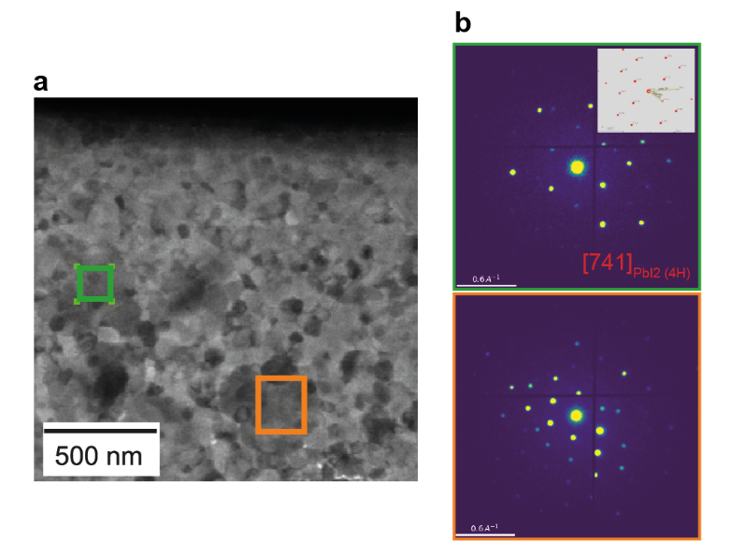
Supplementary Figure 18- Two diffraction patterns from other biased regions also showing PbI₂ grains in (a) the vBF image and (b) the indexed diffraction patterns. Taken from alloyed films with initially more segregated composition.

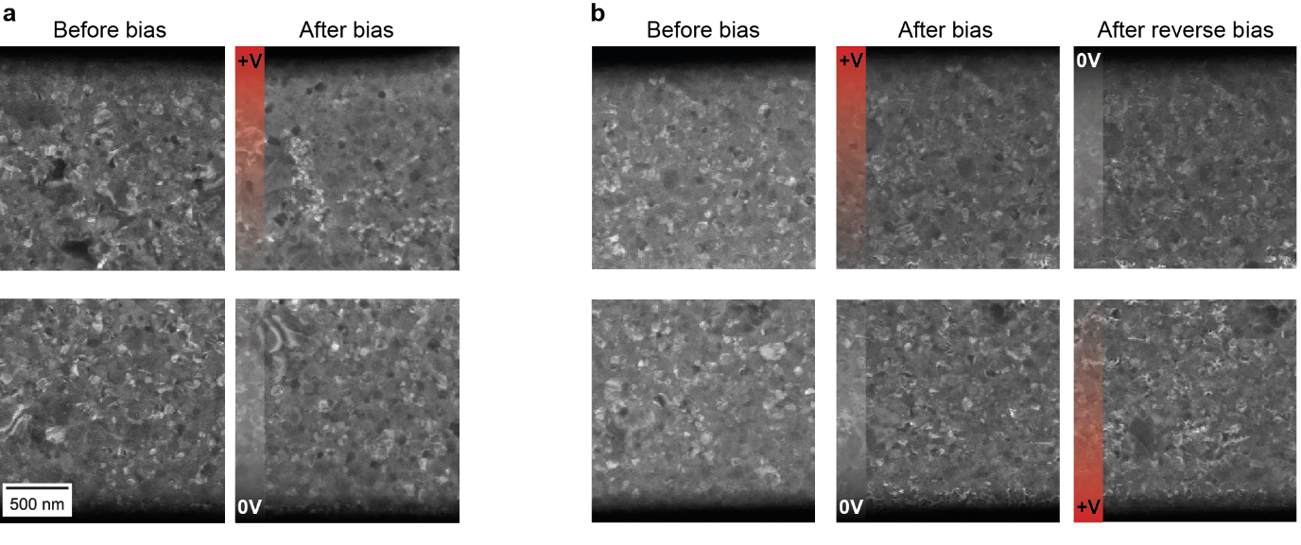
Supplementary Figure 19- A series of vBF images (similar to Supplementary Figure 13) obtained from a repeated biasing experiment in a sub-optimal alloyed double-cation double-halide sample with initially more segregated composition. (a) Before and after biasing for regions near the positive and negative contacts. (b) Before, after and after reversing the bias once more (overall 90 + 90 = 180 minutes of bias). With the excess PbI₂, the sample composition is suboptimal, and the degradation is heavily driven near the PbI₂ excess islands. Degradation is not dependent on the polarity of the metallic contacts.

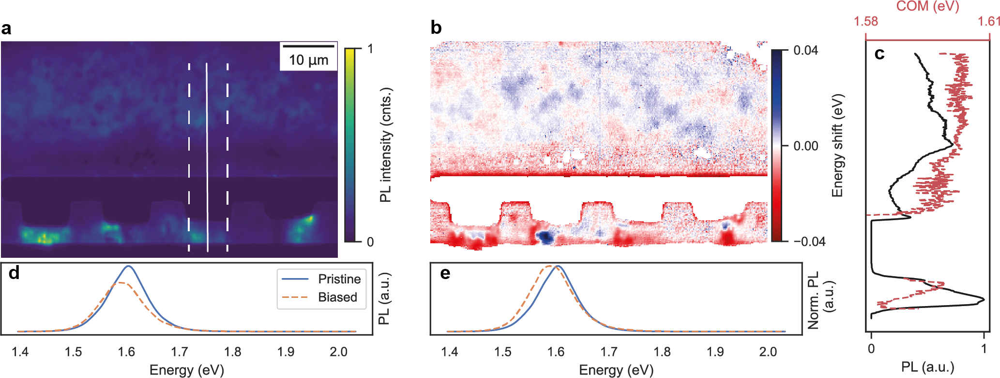
Supplementary Figure 20- PL maps of the emission of the FA-rich double-cation double-halide, shown in Figure 3 in the main text. (a) The PL intensity map and (b) the COM map, showing a small red-shift in the emission at the biased area (between contacts) compared to the unbiased region (top half of the map).A line profile taken from the shown in panel a shows these trends. The red-shift observed at the top side of the metal contact is observed before biasing due to the sample geometry, thus it is not caused from biasing (see Supplementary Figure 10).

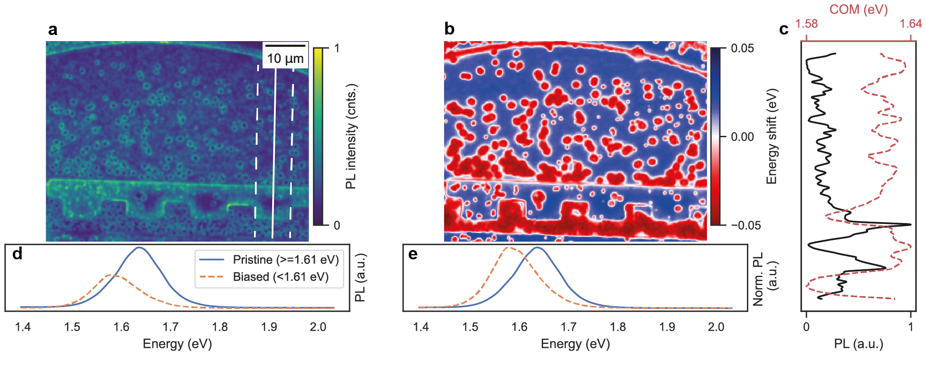
Supplementary Figure 21- PL maps of the emission of the FA-rich alloyed double-cation double-halide with sub-optimal composition and initially more segregated composition. (a) The PL intensity map and (b) the COM map, showing larger red-shift in the emission at the biased area (between contacts) compared to the unbiased region (top half of the map). Clear phase segregation in the form of CsPbI₃ crystallites are observed as islands showing red-shifted emission. A line profile taken from the shown in panel a show these trends. Here, the imaging windows were thinned down using FIB, which may add additional features between the contacts.
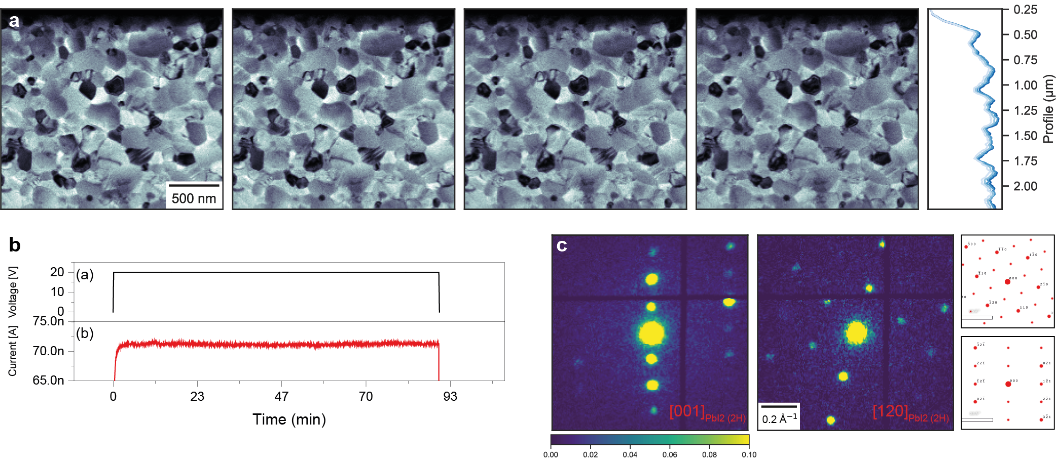
Supplementary Figure 22- Another biasing experiment was run on a PbI₂-only film for 20 V and 90min of continuous biasing. (a) The vBF image evolution, showing no discernible morphological changes. (b) The current kept a constant value throughout the experiment. (c) Diffraction from grains indexable to the 2H-PbI₂ phase in the [001] zone axis. Other gains can also be observed in the [120] zone axis.

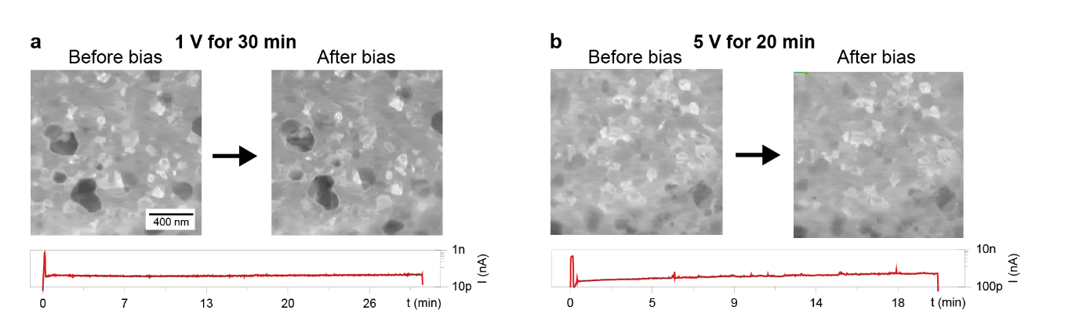
Supplementary Figure 23- Voltage dependence after applying constant voltage for (a) 30 minutes, 1 V, and (b) 20 minutes, 5 V for the FA-rich alloyed composition. If the applied voltage is low, the measured current drops and no discernible morphological changes can be observed in the vBF images between before and after bias. The current profiles are also shown.

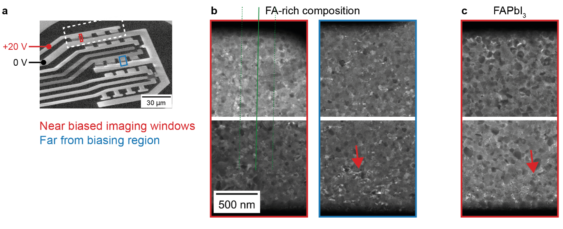
Supplementary Figure 24- Current leakage outside the positions where metal contacts are the closest to each other, such as (a) the positions shown in red and blue. Morphological changes as seen from vBF after biasing are observed for both (b) double-cation double-halide FA-rich and (c) FA-pure compositions. These images show bias-induced changes visible far away from the imaging windows. This is only true near the biased metallic contact, so such changes are not observed near metallic contacts which were not biased.

References
1. Chiang, Y.-H., Anaya, M. & Stranks, S. D. Multisource Vacuum Deposition of Methylammonium-Free Perovskite Solar Cells. ACS Energy Lett. 2498–2504 (2020) doi:10.1021/acsenergylett.0c00839.
2. Rothmann, M. U. et al. Atomic-scale microstructure of metal halide perovskite. Science 370, (2020).
3. Ferrer Orri, J. et al. Unveiling the Interaction Mechanisms of Electron and X-ray Radiation with Halide Perovskite Semiconductors using Scanning Nanoprobe Diffraction. Adv. Mater. 34, 2200383 (2022).
4. Johnstone, D. et al. pyxem/diffsims: diffsims 0.2.3. (2020) doi:10.5281/zenodo.3698032.
5. Savitzky, B. H. et al. py4DSTEM: A Software Package for Four-Dimensional Scanning Transmission Electron Microscopy Data Analysis. Microsc. Microanal. 27, 712–743 (2021).
6. Macpherson, S. et al. Local nanoscale phase impurities are degradation sites in halide perovskites. Nature 607, 294–300 (2022).
7. Zemann, J. Crystal structures, 2nd edition. Vol. 1 by R. W. G. Wyckoff. Acta Crystallogr. 18, 139–139 (1965).
8. Jain, A. et al. The Materials Project: A materials genome approach to accelerating materials innovation. APL Mater. 1, 11002 (2013).
9. Gratia, P. et al. The Many Faces of Mixed Ion Perovskites: Unraveling and Understanding the Crystallization Process. ACS Energy Lett. 2, 2686–2693 (2017).
10. Frohna, K. et al. Nanoscale chemical heterogeneity dominates the optoelectronic response of alloyed perovskite solar cells. Nat. Nanotechnol. 17, 190–196 (2022).
11. Francisco de la Peña et al. hyperspy/hyperspy: HyperSpy v1.5.2. (2019) doi:10.5281/zenodo.3396791.

