SVision-pro: comparative sequence-to-image representation and instance segmentation for de novo and somatic structural variant discovery

Supplementary tables, files and notes

- List of Supplementary Tables
Supplementary Table S1. Benchmark dataset used by SVision-pro
Supplementary Table S2. Performance evaluation and comparison on HG002 ground-truth SSVs and simulated CSVs.
Supplementary Table S3. CSV subcomponent and breakpoint evaluation on simulated CSVs
Supplementary Table S4. Mendelian consistency comparison on six family datasets
Supplementary Table S5. Twin discordancy comparison on ChineseQuartet
Supplementary Table S6. Performance evaluation and comparison on simulated trio dataset with de novo/inherited CSVs
Supplementary Table S7. Overlapping of Sniffles2 de novo calls with SVision-pro
Supplementary Table S8. Performance evaluation and comparison on simulated somatic SSVs and CSVs

- List of Supplementary Files
Supplementary File 1. Verification of the 32,549bp deletion in chromosome 1 Supplementary File 2. Verification of the complex locus at chr11:34,686,676 Supplementary File 3. Verification of 26 de novo SVs of SVision-pro
Supplementary File 4. Verification of 19 false-positive de novo calls of Sniffles2
Supplementary File 5. Retrieved eight CSVs from HCC1395 normal-paired cell lines

- List of Supplementary Figures
Supplementary Fig 1. Examples of different alignment mapping conditions
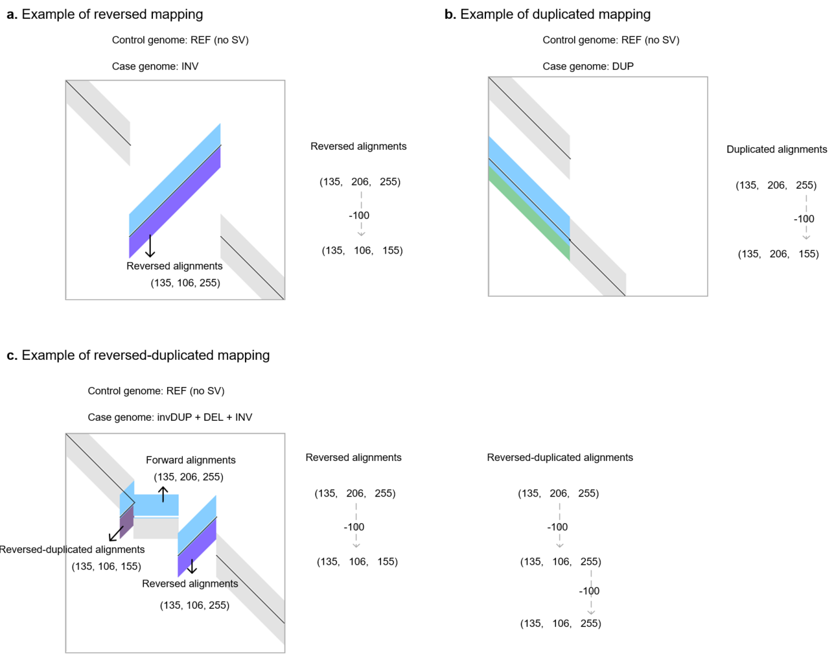

Supplementary Fig 2. Examples of insertion-related representation
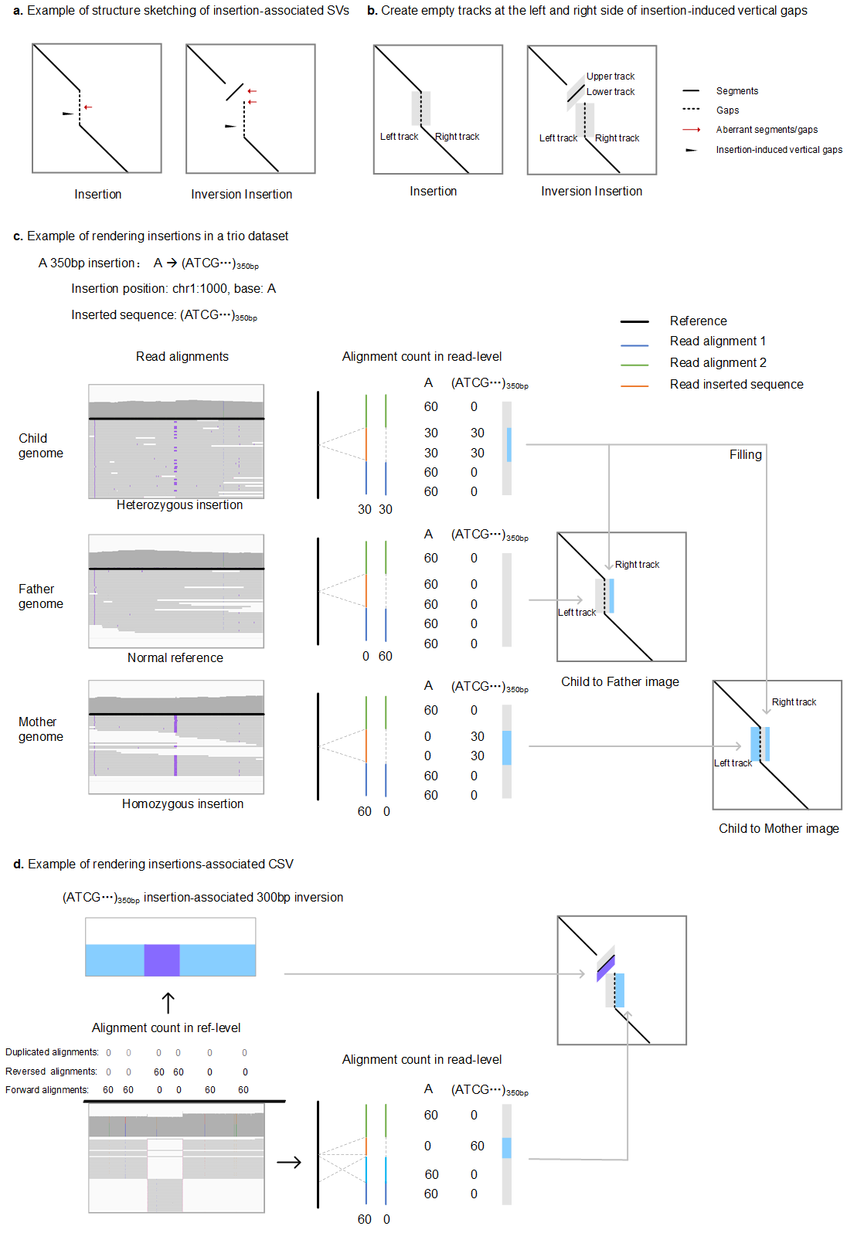
Supplementary Fig 3. CSV component and breakpoint comparison
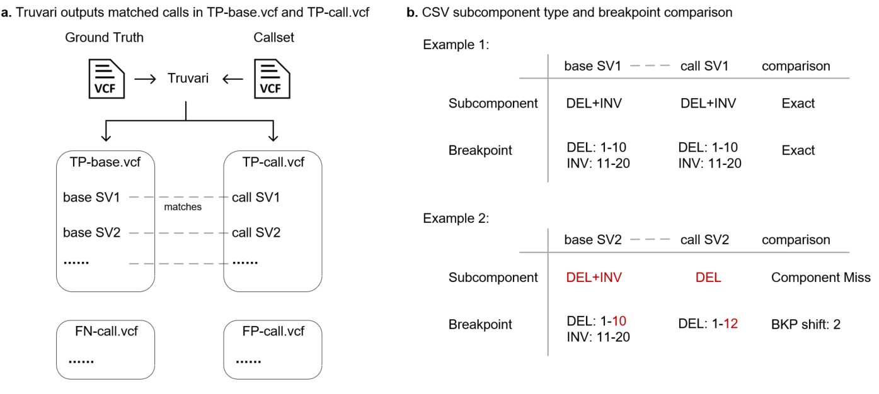

- List of Supplementary Notes

Supplementary Note 1. Aligner and Caller version and parameters
For aligners, including Minimap2 (v2.20-r1061) and NGMLR (v0.2.7), only sequence technology relevant parameters are set while other parameters are default. For minimap2, ‘-x map-pb/map-ont’ is used and for NGMLR, ‘-x pacbio/ont’ is used. For callers, default or recommended parameters were set, except three filter-relevant parameters: minimun_support_read_number, minimum_detectable_AF and minimum_map_quality.
- For HG002 ground-truth SSVs, simulated 3000 CSVs, six family datasets and simulated trio dataset:
minimun_support_read_number: 10
minimum_detectable_AF: default
minimum_map_quality: 20
- For simulated somatic SSVs and CSVs:
minimun_support_read_number: 1
minimum_detectable_AF: 0.01
minimum_map_quality: 20
- For HCC1395 normal-tumor paired cell lines:
minimun_support_read_number: 2
minimum_detectable_AF: 0.01
minimum_map_quality: 0
Command lines for each callers are listed as follows.
SVision (v1.3.9)
SVision -o /path/to/output -b /path/to/sample.bam -m /path/to/model.ckpt -g /path/to/referece.fasta -n sample_name -s minimun_support_read_number --min_mapq minimum_map_quality --min_sv_size 50
Sniffles2 (v2.0.7)
Single sample mode:
sniffles --input /path/to/sample.bam --vcf /path/to/output.vcf --minsupport minimun_support_read_number --mapq minimum_map_quality --minsvlen 50
Multiple samples mode:
sniffles --input /path/to/sample1.bam --snf /path/to/sample1.snf --minsupport minimun_support_read_number --mapq minimum_map_quality --minsvlen 50
sniffles --input /path/to/sample2.bam --snf /path/to/sample1.snf --minsupport minimun_support_read_number --mapq minimum_map_quality --minsvlen 50
sniffles --input /path/to/sample1.snf /path/to/sample2.snf --vcf /path/to/output.vcf --minsupport minimun_support_read_number --mapq minimum_map_quality --minsvlen 50
Somatic (Non-germline) mode
sniffles --input /path/to/sample.bam --vcf /path/to/output.vcf --minsupport minimun_support_read_number --mapq minimum_map_quality --minsupport-auto-mult minimum_detectable_AF --minsvlen 50 --non-germline
cuteSV (v2.0.2)
For HiFi long reads:
cuteSV /path/to/sample.bam /path/to/referece.fasta /path/to/output -s minimun_support_read_number -q minimum_map_quality --min_size 50 --genotype --max_cluster_bias_INS 1000 --diff_ratio_merging_INS 0.9 --max_cluster_bias_DEL 1000 --diff_ratio_merging_DEL 0.5
For ONT long reads
cuteSV /path/to/sample.bam /path/to/referece.fasta /path/to/output -s minimun_support_read_number -q minimum_map_quality --min_size 50 --genotype --max_cluster_bias_INS 100 --diff_ratio_merging_INS 0.3 --max_cluster_bias_DEL 100 --diff_ratio_merging_DEL 0.3
pbsv (v2.9.0)
pbsv discover /path/to/sample.bam /path/to/sample.svsig.gz
pbsv call --ccs -A minimun_support_read_number -O minimun_support_read_number -S 0 -P 1 -m 50 /path/to/referece.fasta /path/to/sample.svsig.gz /path/to/output.vcf
debreak (v1.0.2)
debreak –bam /path/to/sample.bam -o /path/to/output --ref /path/to/referece.fasta --min_size 50 --min_support minimun_support_read_number --rescue_large_ins --rescue_dup --poa
SVDSS (v1.0.5)
SVDSS smooth --reference /path/to/referece.fasta --bam /path/to/sample.bam --workdir /path/to/output
samtools sort -T sample_name.sort-tmp /path/to/output/smoothed.selective.bam > /path/to/output/smoothed.selective.sorted.bam
samtools index /path/to/output/smoothed.selective.sorted.bam
SVDSS search --index /path/to/referece.fasta.fmd --bam /path/to/output/smoothed.selective.sorted.bam --workdir /path/to/output –assemble
n=$(ls /path/to/output/solution_batch_*.assembled.sfs | wc -l)
SVDSS call --reference /path/to/referece.fasta --bam /path/to/output/smoothed.selective.sorted.bam --workdir /path/to/output –batches n –min-sv-length 50 --min-cluster-weight minimun_support_read_number
bcftools sort /path/to/output/svs_poa.vcf > /path/to/output.vcf
nanomonsv (0.5.0)
nanomonsv parse /path/to/tumor.bam /path/to/tumor.prefix
nanomonsv parse /path/to/normal.bam /path/to/normal.prefix
nanomonsv get -median_mapQ_thres minimum_map_quality --min_tumor_variant_read_num minimun_support_read_number --min_tumor_VAF minimum_detectable_AF --control_prefix /path/to/normal.prefix --control_bam /path/to/normal.bam /path/to/tumor.prefix /path/to/tumor.bam /path/to/reference.fasta

Supplementary Note 2. Merging approaches version and parameters
The two popular callset-merging approaches, Jasmine and SURVIVOR, were applied to generate consensus callset from multiple.
For Jasmine (v1.1.5), we set ‘--output_genotypes’ parameter to output genotypes of every merged sample:
jasmine --output_genotypes file_list= sample_list_file out_file=/path/to/consensus.vcf genome_file=/path/to/reference.fasta
For SURVOVOR (v1.0.7), we used the recommended parameters:
SURVIVOR merge sample_list_file 1000 1 1 1 0 50 /path/to/consensus.vcf

