Supplementary information
Water-stable boroxine structure with dynamic covalent bonds
Xiaopei Li^{1,2,#}, Yongjie Zhang^{2,#}, Zhenqiang Shi¹, Dongdong Wang¹, Hang Yang¹, Yahui Zhang¹, Haijuan Qin³, Wenqi Lu¹, Junjun Chen¹, Yan Li¹ and Guangyan Qing^{1,4,}*
¹CAS Key Laboratory of Separation Science for Analytical Chemistry, Dalian Institute of Chemical Physics, Chinese Academy of Sciences, Dalian, P. R. China.
²Instrumental Analysis Center, School of Textile and Material Engineering, Dalian Polytechnic University, Dalian, P. R. China.
³Research Centre of Modern Analytical Technology, Tianjin University of Science &
Technology, Tianjin, P. R. China
⁴College of Chemistry and Chemical Engineering, Wuhan Textile University, Wuhan, P. R. China.
*Corresponding authors: qinggy@dicp.ac.cn
#X.L. and Y.Z. contributed equally to this work

Table of contents

Supplementary Materials and Measurements 2
Supplementary Figures 1–26 4
Supplementary Tables 1–9 34
References 46

Supplementary Materials and Measurements
Materials: Ethylenediamine (>99%), 2-hydroxyphenylboronic acid (HO-PBA, 97%), 10-hydroxybenzo[h]quinoline (HBQ, 98%), 4-formylphenylboronic acid (97%), boron tribromide (99.9% metals basis), and glycidyl methacrylate (GMA, 97%) were purchased from Aladdin reagent (Shanghai, China). 2-hydroxy-5-methylphenylboronic acid (CH₃-HO-PBA, 97%) was purchased from Bide Pharmatech (Shanghai, China). 2-hydroxy-4-(trifluoromethyl)phenylboronic acid (CF₃-HO-PBA, 98%) and (4-Formyl-2-methoxyphenyl)boronic acid (98%) were purchased from Leyan (Shanghai, China). 4-cyano-4-(phenylcarbonothioylthio)pentanoic acid (CPA, >97%) and dry methanol (99.9%, Water≤50 ppm) were purchased from macklin (Shanghai, China). Dry dichloromethane (99.9%, Water≤30 ppm) was obtained from J&K Scientific. Poly(ethylene glycol) methyl ether acrylate (PEGMEA, average M_{n} 480) was purchased from Sigma–Aldrich. Azobisisobutyronitrile (AIBN) was obtained from Tianjin guangfu fine chemical research institute. Other reagents and solvents were obtained from commercial suppliers. Unless otherwise noted, chemicals were used as received.
Measurements: Fluorescence spectra were measured on a PerkinElmer FL6500 fluorescence spectrometer with a 1 cm path−length quartz cell. Fluorescence absolute quantum yields of the liquid and solid samples were determined by an Edinburgh FLS980 spectrometer with an integrating sphere. Scanning electron microscope (SEM) measurements were carried out on a JEOL JSM−7800F instrument. For the liquid samples, SEM samples were prepared by dropping one droplet of water–THF (2:3, v/v) solution of HO-PBA, CH₃-HO-PBA or CF₃-HO-PBA onto clean silicon wafers and evaporating the solvent at room temperature and in open air. For solid samples, SEM samples were prepared by directly sticking the powder on the carbon tapes. Powder X-ray diffraction (XRD) patterns were collected by a PANAlytical X'pert Pro Powder X−ray diffractometer. The single−crystal XRD data were collected on a Bruker D8 Venture CMOS−based diffractometer (Mo–Kα radiation, λ=0.71073 Å) using the SMART and SAINT programs at 120 K. Final unit cell parameters were based on all observed reflections from integration of all frame data. The structures were solved in the space group by direct method and refined by the full−matrix least−squares using SHELXTL−97 fitting on F². All non−hydrogen atoms were refined anisotropically. The hydrogen atoms were located geometrically and assigned fixed isotropic thermal parameters¹. All nuclear magnetic resonance (NMR) experiments were performed on a Bruker AVANCE III 400 spectrometer equipped with a 5 mm BBFO probe. Fourier transform infrared (FT-IR) spectra were recorded on a Nicolet iS50 Fourier transform infrared (FT-IR) spectrometer equipped with an attenuated total reflection (ATR) accessory. The electrospray ionization quadrupole time-of-flight (ESI-Q-TOF) mass spectra were obtained on an Agilent 6540 Q-TOF mass spectrometer, and acetonitrile was used as mobile phase. Samples were dissolved in the solvent and ionized using an electrospray ionization (ESI) source in a negative mode. The ESI source parameters were as following: gas temperature 325 ºC, drying gas 8 L·min⁻¹, nebulizer 35 psig, capillary voltage 3500 V and m/z range 20–2000. An AB SCIEX TOF/TOF 5800 equipped with a neodymium: yttrium aluminum garnet (Nd: YAG) laser (349 nm wavelength) was used for matrix-assisted laser desorption ionization (MALDI)-TOF MS experiments. Trans-2-[3-(4-tert-butylphenyl)-2-methyl-2-propenylidene]malononitrile (DCTB) was used as a MALDI matrix. Silver trifluoroacetate (AgTFA) was used as cationization reagent. The sample (20 mg·mL⁻¹), matrix (20 mg·mL⁻¹) and cationization reagent (10 mg·mL⁻¹) were, respectively, dissolved in dry THF. These solutions were mixed at a volume ratio of sample: matrix: cationization agent =1:10:1. The mixture solution (0.5 uL) was deposited on a MALDI sample plate, and the spots were dried in air at room temperature. The spectra were obtained in a negative reflector mode. UV–Raman spectra were recorded using a home-made single stage UV–Raman spectrograph with a spectral resolution of 2 cm⁻¹. The single-frequency UV laser line at 244 nm was from an efficient external cavity frequency doubler (Wavetrain, Spectra-Physics) of the single-frequency laser at 488 nm laser (Genesis, CX 488, Coherent). The exciting source was with an output of 10 mW and the power of the laser at the sample was about 5.0 mW. Gel permeation chromatography (GPC) was performed on a PL-GPC220 chromatograph with N,N-dimethylformamide as the solvent. A MesoMR23-060V-I NMR analyzer (Suzhou Niumag Analytical Instrument Corporation, Suzhou, China) with a permanent magnet having resonance frequency 21 MHZ was used to measure the transverse spin-spin relaxation time (T₂). The boron contents in poly(PEGMEA-co-AMA-PBA) and poly(PEGMEA-co-AMA-(HO-PBA)) were measured by using a PerkinElmer optima 8000 inductively coupled plasma optical emission spectrometer (ICP–OES). Theoretical calculations were calculated by the density functional theory (DFT) method with B3LYP density functional and 6-31G* basis set using the Gaussian 09 program.

Supplementary Figures 1–26
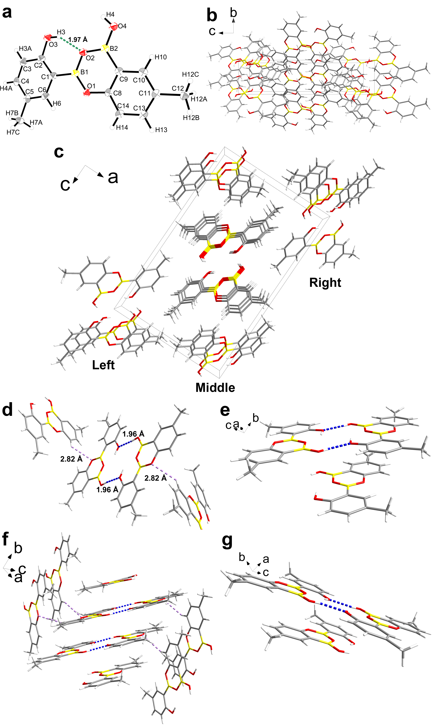
Supplementary Fig. 1 Crystal structure of CH₃-HO-PBA dimer. a Crystal structure of CH₃-HO-PBA dimer with thermal ellipsoids (CCDC 2280485). The dashed green line represents an intramolecular O–H…O hydrogen bond. b,c Packing mode of CH₃-HO-PBA dimers viewed along the a axis (b) and b axis (c). d Packing interactions of CH₃-HO-PBA dimers. The dashed blue and purple lines represent intramolecular O–H…O and C–H…O hydrogen bonds, respectively. e-g Packing mode of CH₃-HO-PBA dimers in the left part (e), middle part (f), and right part (g) of (c).

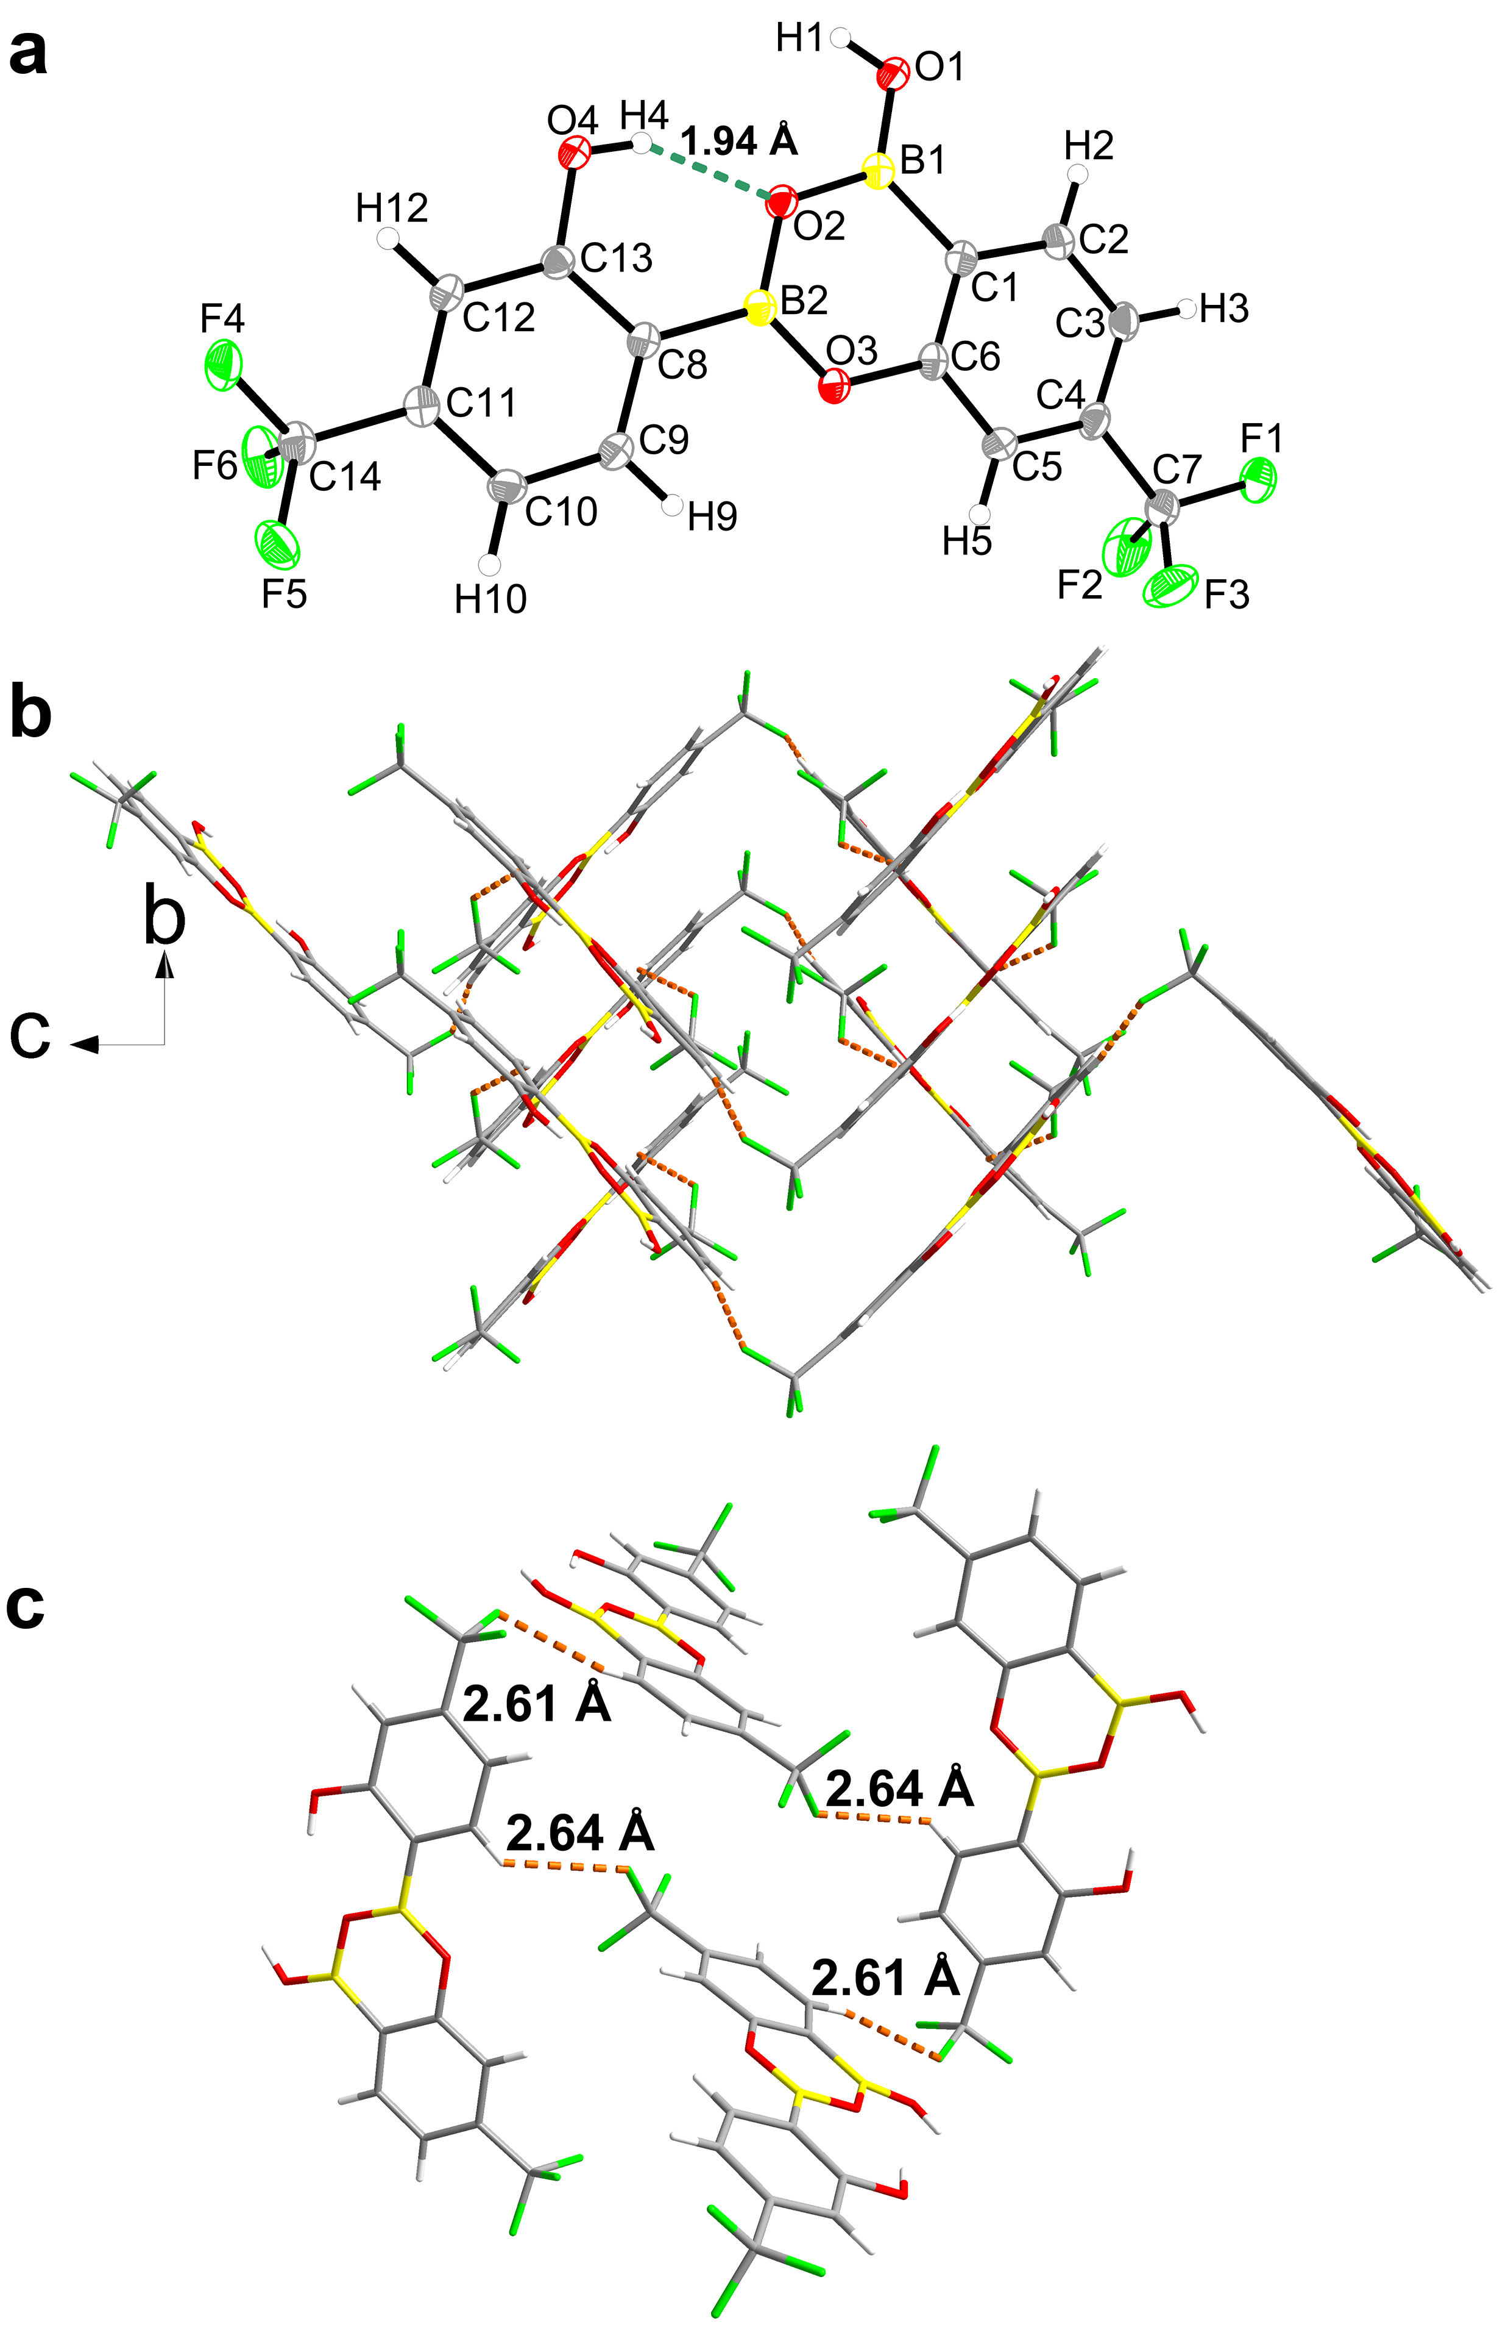
Supplementary Fig. 2 Crystal structure of CF₃-HO-PBA dimer. a Crystal structure of CF₃-HO-PBA dimer with thermal ellipsoids (CCDC 2280486). The dashed green line represents an intramolecular O–H…O hydrogen bond. b Packing mode of CF₃-HO-PBA dimers viewed along the a axis. c Packing interactions of CF₃-HO-PBA dimers. The dashed orange line represents an intramolecular C–H…F hydrogen bond.

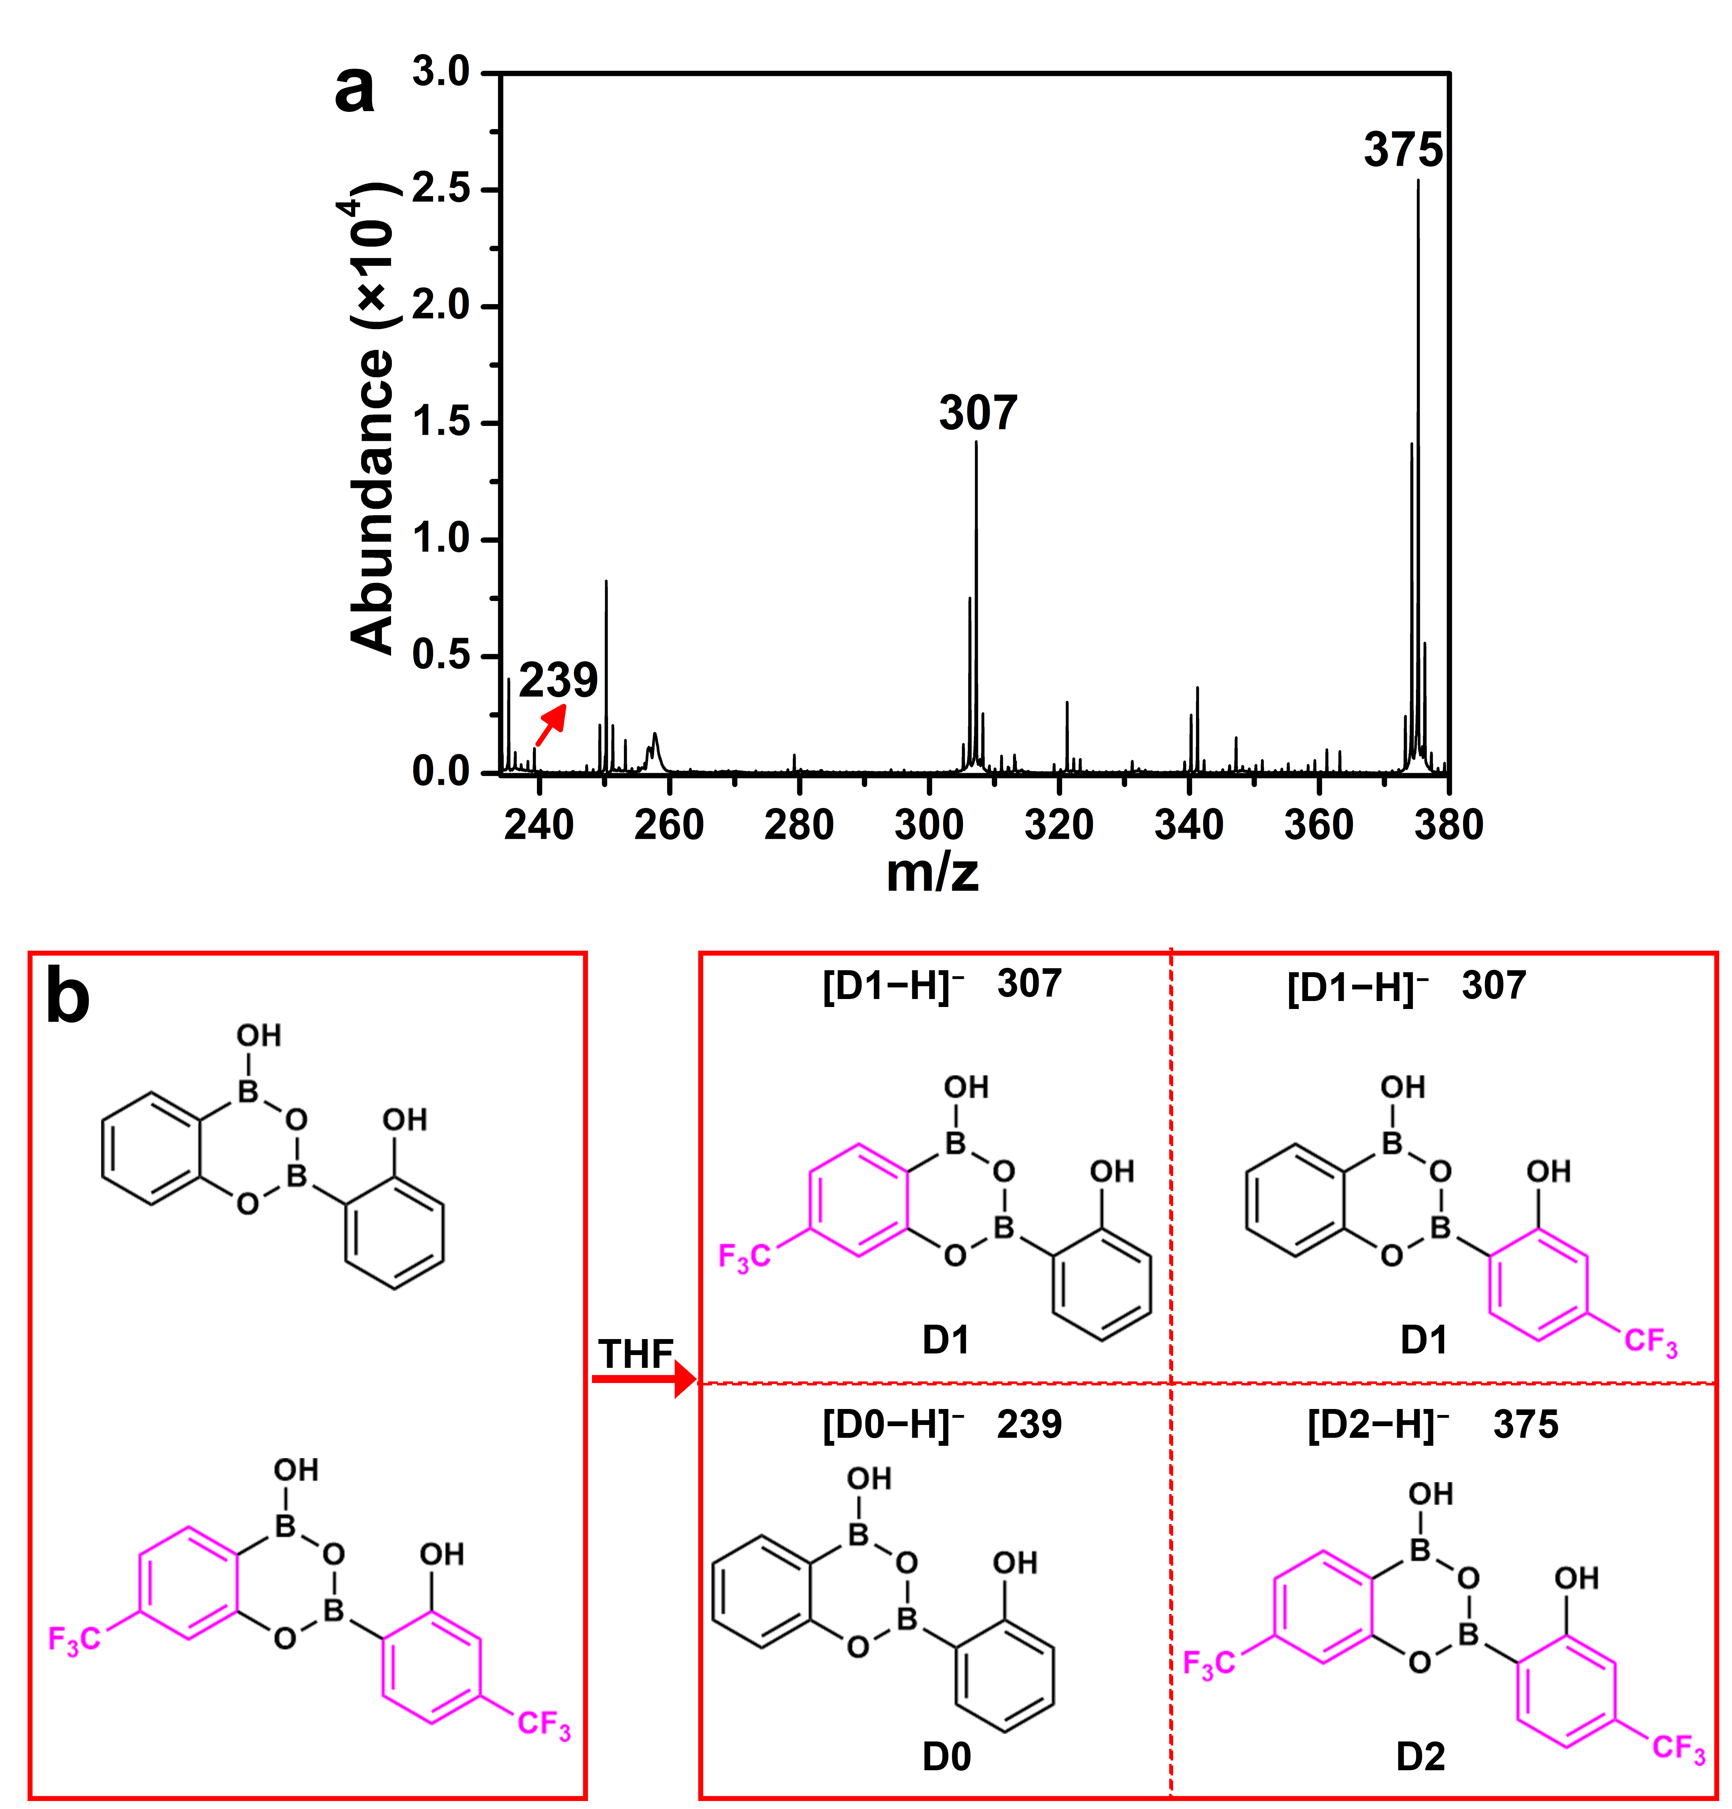
Supplementary Fig. 3 Exchange reaction between HO-PBA dimers and CF₃-HO-PBA dimers. a MALDI-TOF mass spectrum of products from the mixture of HO-PBA dimers and CF₃-HO-PBA dimers, acquired in a negative mode. b Illustration of the dynamic exchange between HO-PBA dimer and CF₃-HO-PBA dimer.

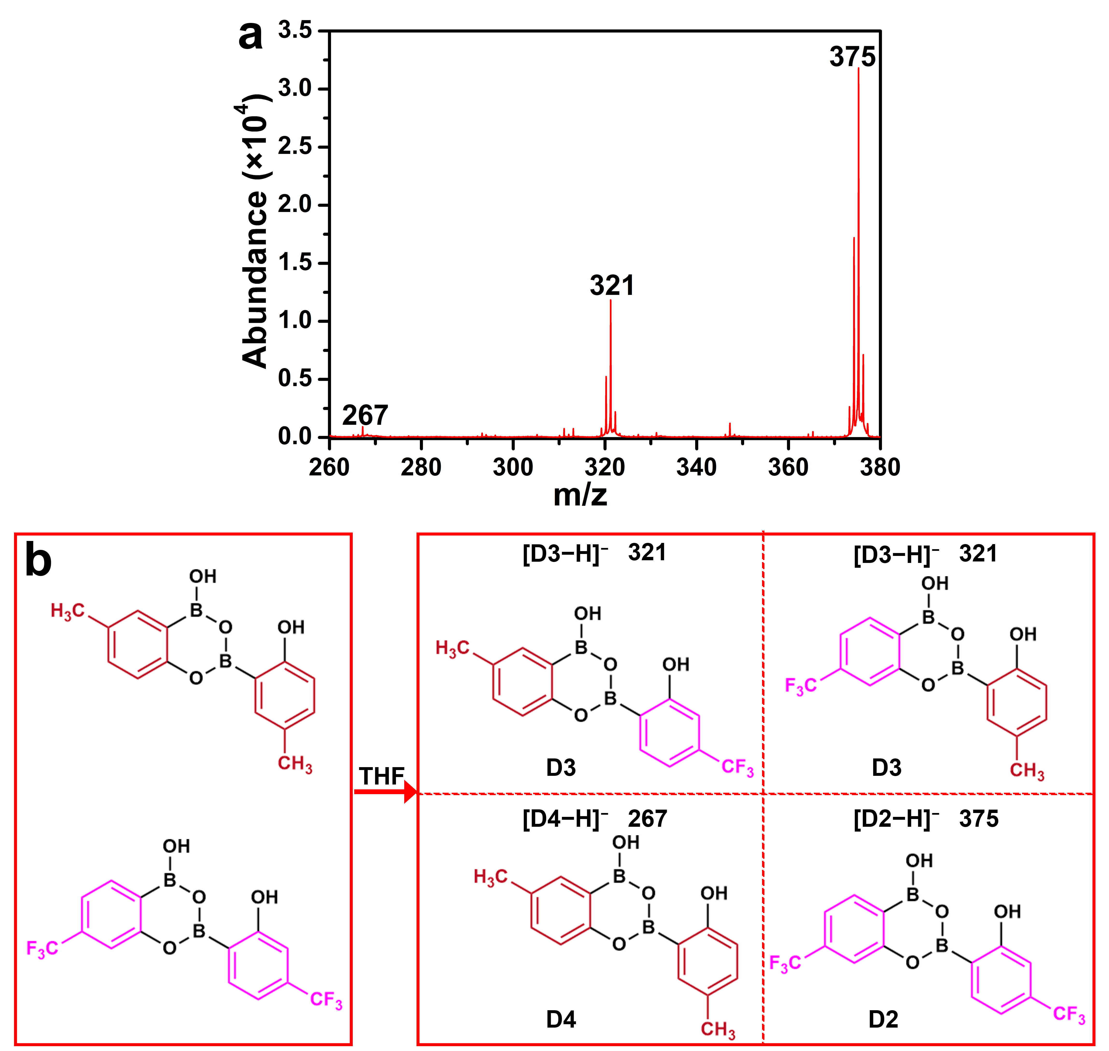
Supplementary Fig. 4 Exchange reaction between CH₃-HO-PBA dimers and CF₃-HO-PBA dimers. a MALDI-TOF mass spectrum of products from the mixture of CH₃-HO-PBA dimers and CF₃-HO-PBA dimers, acquired in a negative mode. b Illustration of the dynamic exchange between CH₃-HO-PBA dimer and CF₃-HO-PBA dimer.

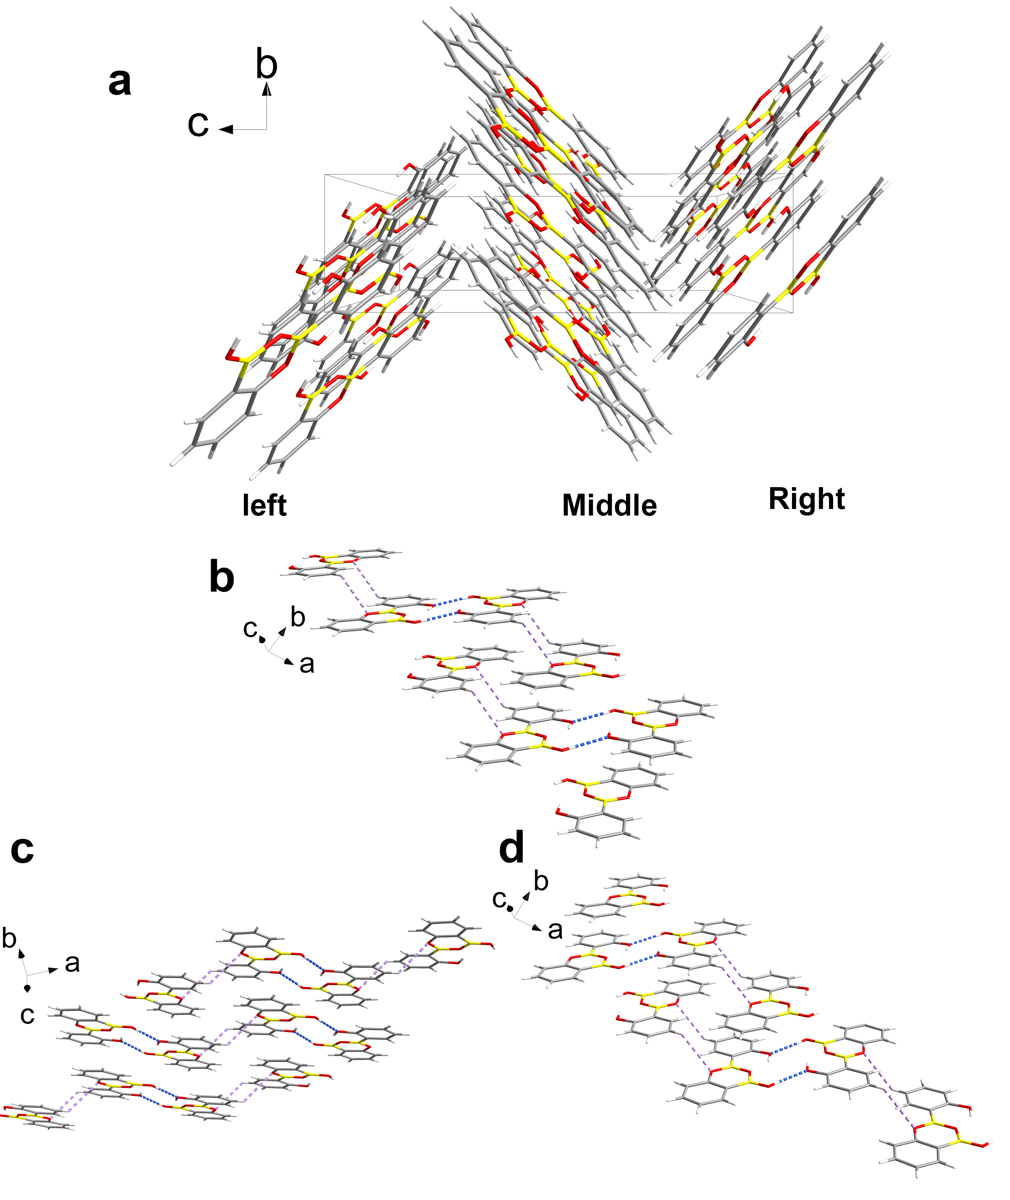
Supplementary Fig. 5 Crystal structure of HO-PBA dimer. a Packing mode of HO-PBA dimers viewed along the a axis. b-d Packing mode of HO-PBA dimers in the left part (b), the middle part (c) and right part (d) of (a).

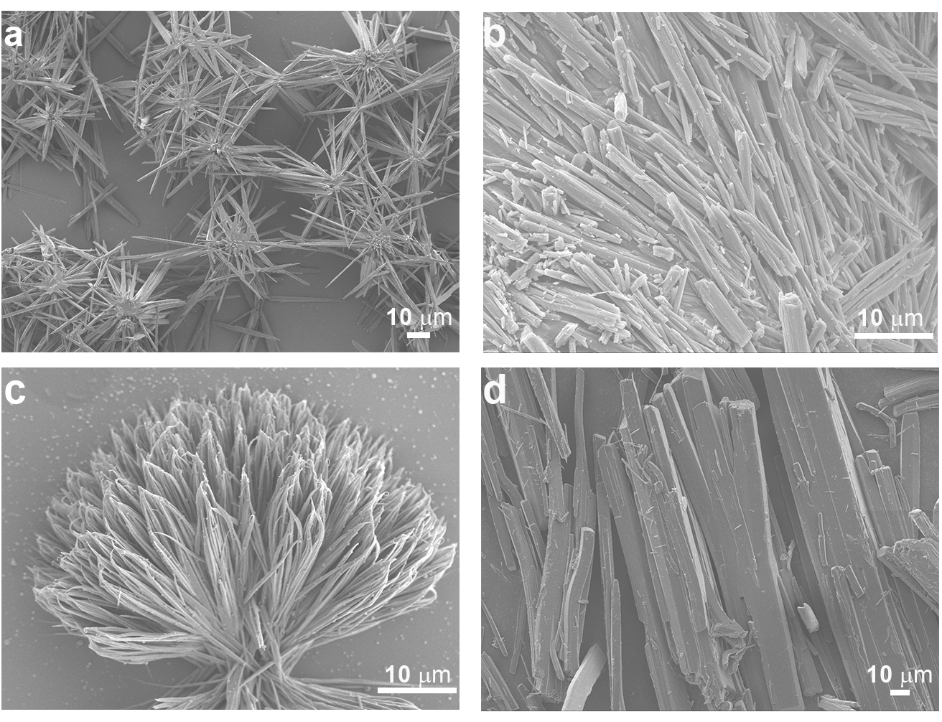
Supplementary Fig. 6 SEM images of CH₃-HO-PBA dimer and CF₃-HO-PBA dimer. a,c SEM images displaying assembled morphology of CH₃-HO-PBA dimer (a) and CF₃-HO-PBA dimer (c), where the sample was prepared by dropping one droplet of CH₃-HO-PBA or CF₃-HO-PBA solution on a silicon wafer. b,d SEM images of the solid CH₃-HO-PBA dimer (b) and CF₃-HO-PBA dimer (d) sample.

Supplementary Fig. 7 XRD patterns of the solid CH₃-HO-PBA dimer and CF₃-HO-PBA dimer sample.

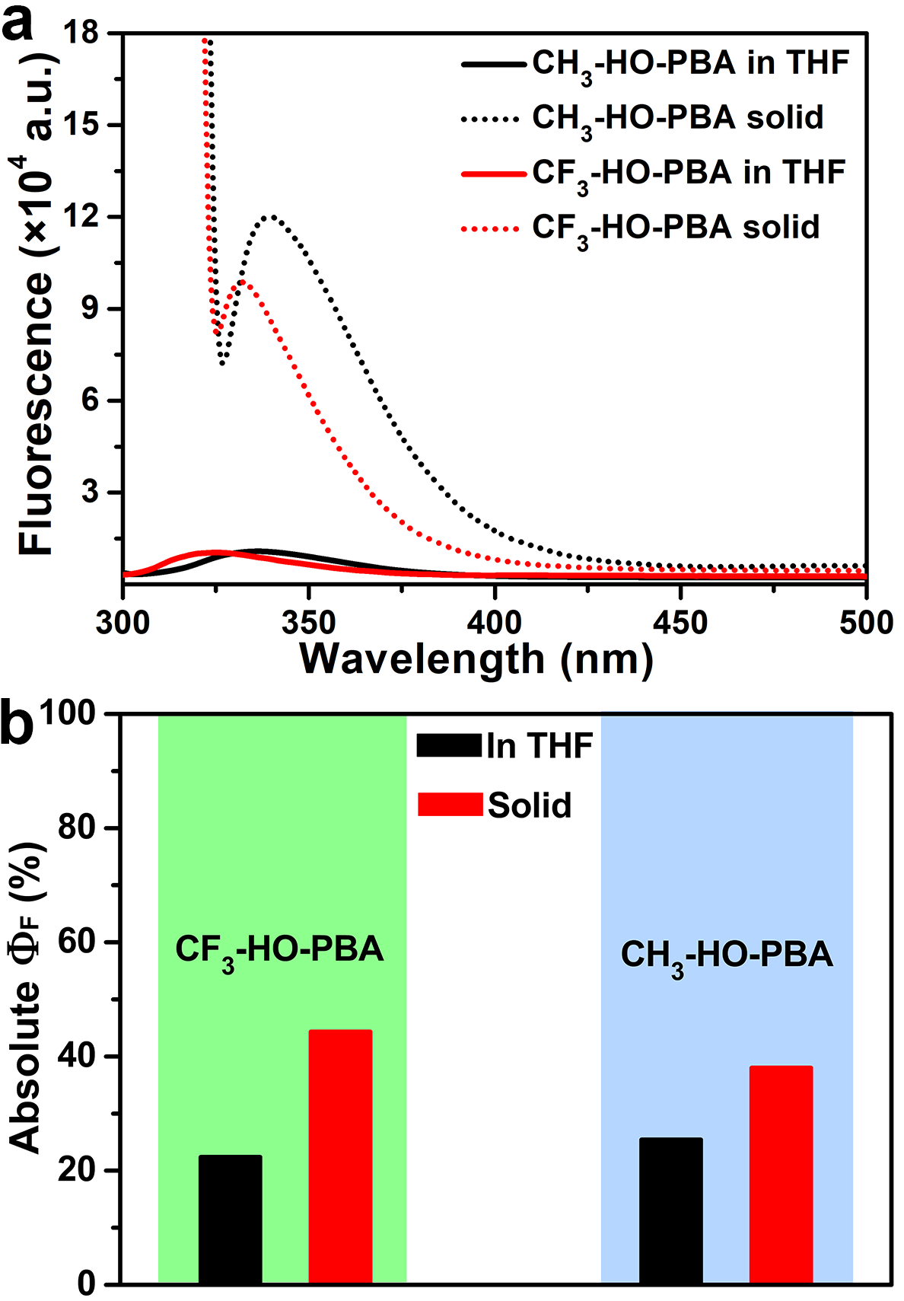
Supplementary Fig. 8 Luminescent behavior of CH₃-HO-PBA dimer and CF₃-HO-PBA dimer. a Fluorescence spectra of CH₃-HO-PBA dimer (2×10⁻⁵ mol·L⁻¹, λ_{ex}=298 nm) and CF₃-HO-PBA dimer (2×10⁻⁵ mol·L⁻¹, λ_{ex}=295 nm) in THF solution, as well as the solid CH₃-HO-PBA dimer (λ_{ex}=320 nm) and CF₃-HO-PBA dimer (λ_{ex}=318 nm) sample. b The absolute quantum yield (Φ_{F}) of CH₃-HO-PBA dimer and CF₃-HO-PBA dimer in THF solution and in the solid state.

Supplementary Fig. 9 Fluorescent spectra and intensity changes (at 316 nm and 368 nm, inset) of HO-PBA dimer (2×10⁻⁵ mol·L⁻¹) in methanol–water mixtures with different amounts of water (volume%), λ_{ex}=288 nm.
Supplementary Fig. 10 a,b Calculated ¹H (a) and ¹³C (b) NMR spectra of HO-PBA trimer in water by Gaussian at the B3LYP/6-31G* level.
Supplementary Fig. 11 Transformation of CH₃-HO-PBA dimer into trimer upon exposure to water. a Fluorescence spectra and intensity changes (at 328 and 372 nm, inset) of CH₃-HO-PBA dimer (2×10⁻⁵ mol·L⁻¹) in THF–water mixtures with different amounts of water (volume%), λ_{ex}=298 nm. b-e ¹H (b, d) and ¹³C (c, e) NMR spectra of CH₃-HO-PBA dimer in THF−d₈ (b, c) and in D₂O–THF−d₈ (2:1, v/v) mixture (d, e) at room temperature, concentration: 8 mg·mL⁻¹.The signals with heart and star mark correspond to H₂O and THF, respectively. f ESI-Q-TOF mass spectrum of CH₃-HO-PBA dimer in the methanol–water (5:1, v/v) solution, acquired in a negative mode. g UV–Raman spectra of the solid CH₃-HO-PBA dimer sample (black) and CH₃-HO-PBA trimer in an ACN–water (1:2, v/v) solution (red). h Relative fluorescence intensity at 372 nm of CH₃-HO-PBA trimer (F/F_{max}) as a function of pH value.

Supplementary Fig. 12 Fluorescence spectra and intensity changes (at 325 and 384 nm, inset) of CF₃-HO-PBA dimer (2×10⁻⁵ mol·L⁻¹) in THF–water mixtures with different amounts of water (volume%), λ_{ex}=295 nm.

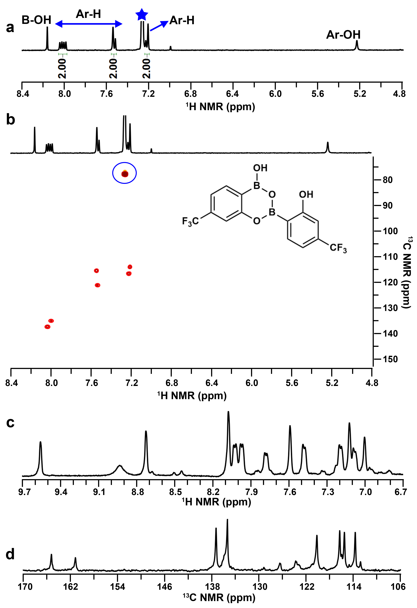
Supplementary Fig. 13 NMR spectra of CF₃-HO-PBA dimer in CDCl₃ and THF−d₈. a,b ¹H (a) and ¹H -¹³C HSQC (b) NMR spectra of CF₃-HO-PBA dimer in CDCl₃ at room temperature. The signal with star mark (a) and that enclosed in blue circle (b) correspond to CHCl₃. c,d ¹H (c) and ¹³C (d) NMR spectra of CF₃-HO-PBA dimer in THF−d₈ at room temperature, concentrations: 8 mg·mL⁻¹.
Discussion: In CDCl₃, CF₃-HO-PBA dimer exhibits six sets of signals in its ¹H NMR spectrum (Supplementary Fig. 13a). The low solubility of CF₃-HO-PBA dimer in CDCl₃ makes it challenging to obtain a clear ¹³C NMR spectrum. As an alternative, a ¹H-¹³C HSQC spectrum with higher sensitivity was measured, which displays six cross peaks (Supplementary Fig. 13b). The numbers of signals in both ¹H NMR and ¹H-¹³C HSQC spectrum of CF₃-HO-PBA dimer in CDCl₃ are consistent with the numbers of H atoms present in CF₃-HO-PBA dimer. However, when CF₃-HO-PBA dimer was dissolved in THF−d₈, both ¹H and ¹³C NMR spectrum display more sets of signals than the numbers of H and C atoms in CF₃-HO-PBA dimer (Supplementary Fig. 13c,d). That is because a portion of CF₃-HO-PBA dimer transforms into CF₃-HO-PBA trimer due to the presence of a small amount of water in THF−d₈ (Supplementary Fig. 11b), resulting in the coexisting of CF₃-HO-PBA dimer and trimer. Upon addition of water into this THF−d₈ solution, CF₃-HO-PBA dimer completely transforms into CF₃-HO-PBA trimer. Consequently, the numbers of ¹H and ¹³C NMR signals in CF₃-HO‑PBA dimer are reduced to three and five sets, respectively (Supplementary Fig. 14). Unlike CF₃-HO-PBA dimer, both HO-PBA dimer (Fig. 3b,c in text) and CH₃-HO-PBA dimer (Supplementary Fig. 11b,c) remain stable in THF−d₈, despite the presence of a small amount of water in THF−d₈ (Supplementary Fig. 11b). This result indicates that electron-withdrawing group of −CF₃ improves the sensitivity of the dimeric structure to water.

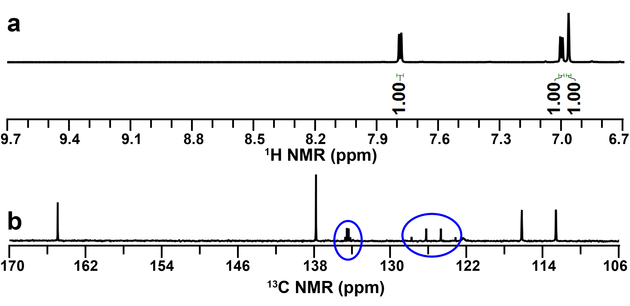
Supplementary Fig. 14 a,b ¹H (a) and ¹³C (b) NMR spectra of CF₃-HO-PBA dimer in D₂O–THF−d₈ (2:1, v/v) mixture at room temperature, concentrations: 8 mg·mL⁻¹.

Discussion: The two quartets enclosed in blue circle arise (Supplementary Fig. 14b) from the C-F coupling. The first quartet around 125.5 ppm with a large J-coupling corresponds to the carbon of the –CF₃ group, and the second quartet around 134.5 ppm corresponds to the carbon bonded to the –CF₃ group.

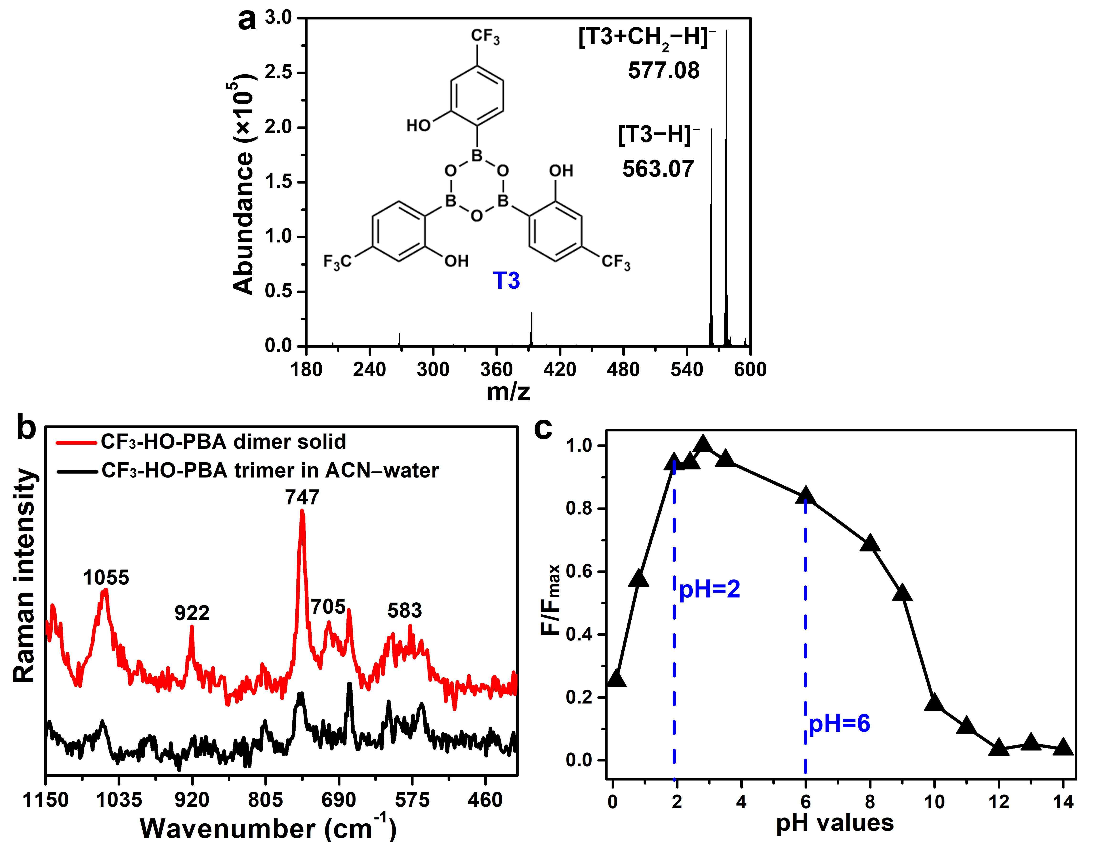
Supplementary Fig. 15 CF₃-HO‑PBA trimer and its structure characterization. a ESI-Q-TOF mass spectrum of CF₃-HO-PBA dimer in the methanol–water (5:1, v/v) solution, acquired in a negative mode. b UV–Raman spectra of the solid CF₃-HO-PBA dimer sample (black) and CF₃-HO-PBA trimer in an ACN–water (1:2, v/v) solution (red). c Relative fluorescence intensity at 384 nm of CF₃-HO-PBA trimer (F/F_{max}) as a function of pH value.

Supplementary Fig. 16 a,b Photos of the phenol, CF₃-HO-PBA trimer and CH₃-HO-PBA trimer solution after addition of Br₂ (a) and FeCl₃ (b).
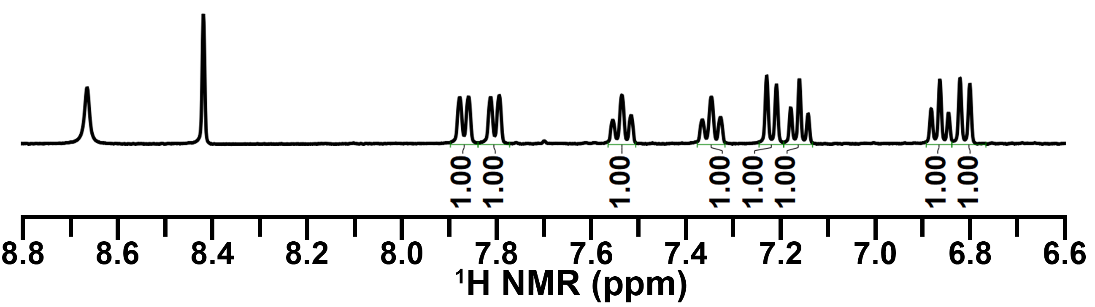
Supplementary Fig. 17 ¹H NMR spectrum of product in THF−d₈ from lyophilization of the THF–water (1:2, v/v) solution of HO-PBA trimer at room temperature, concentrations: 8 mg·mL⁻¹.
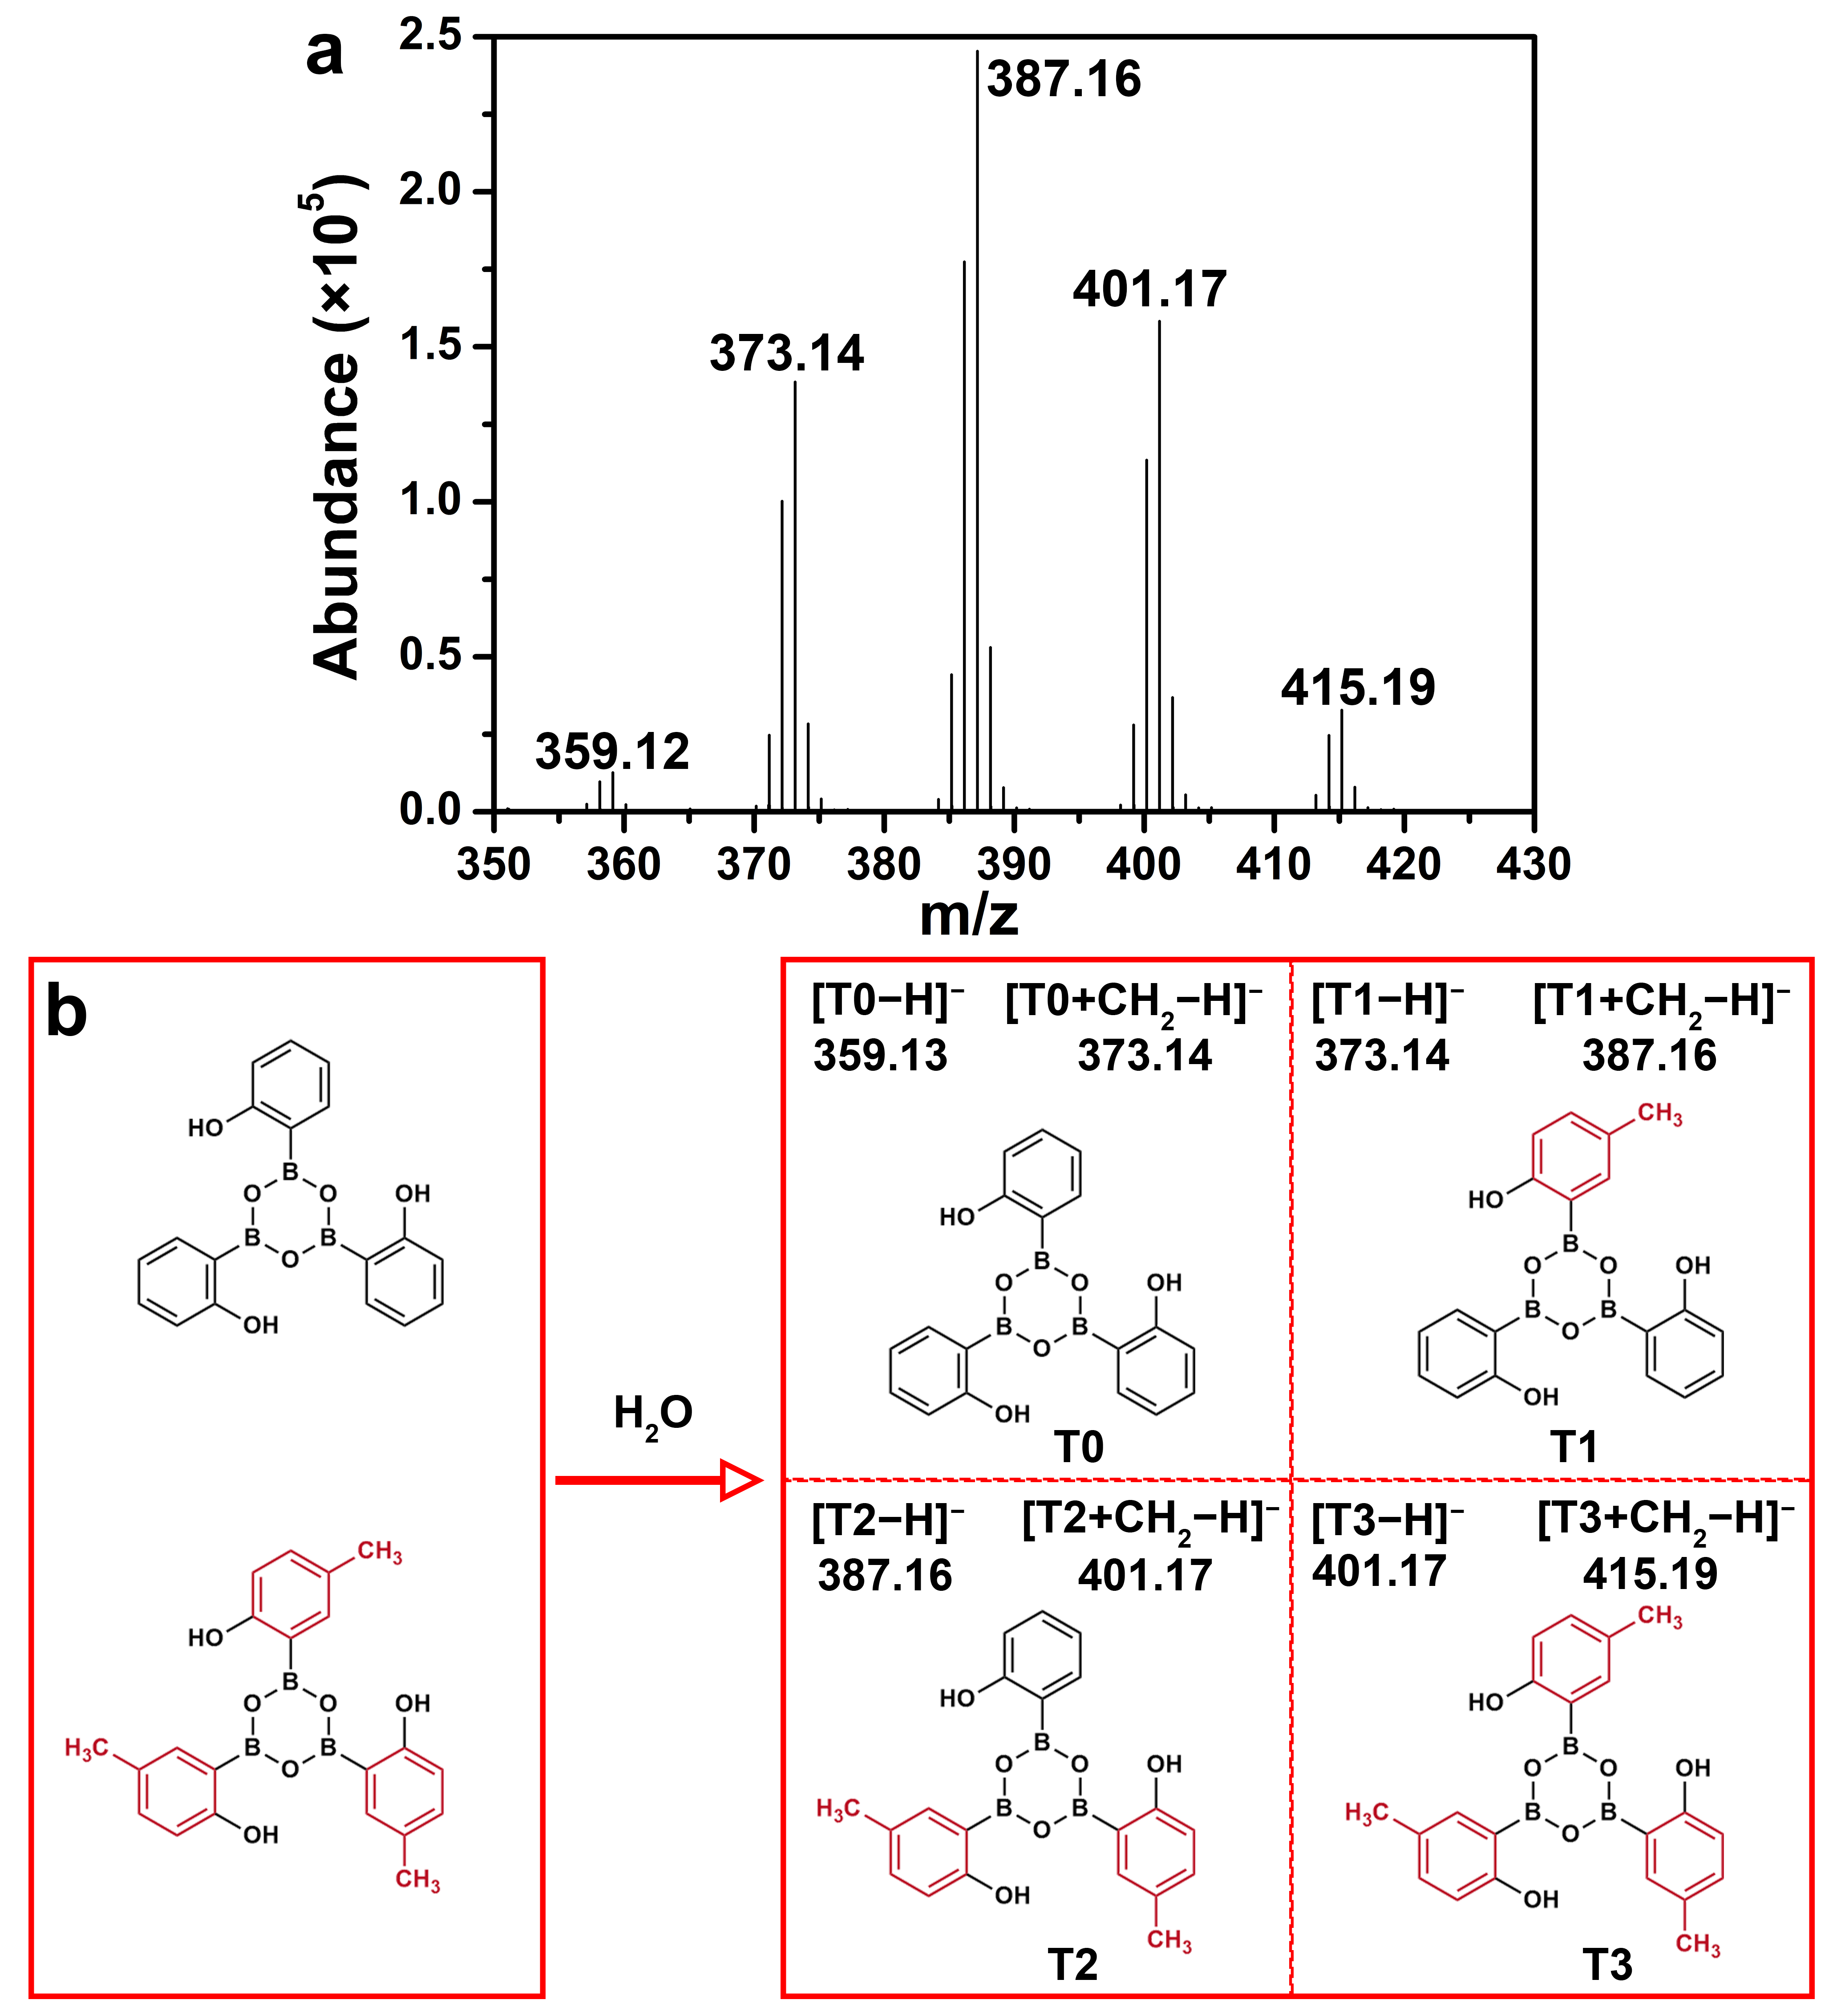
Supplementary Fig. 18 Exchange reaction between HO-PBA trimers and CH₃-HO-PBA trimers. a ESI-Q-TOF mass spectrum of products from mixing HO‑PBA dimers and CH₃-HO‑PBA dimers together in the methanol–water (5:1, v/v) solution, acquired in a negative mode. b Illustration of the dynamic exchange between HO‑PBA trimer and CH₃-HO‑PBA trimer.

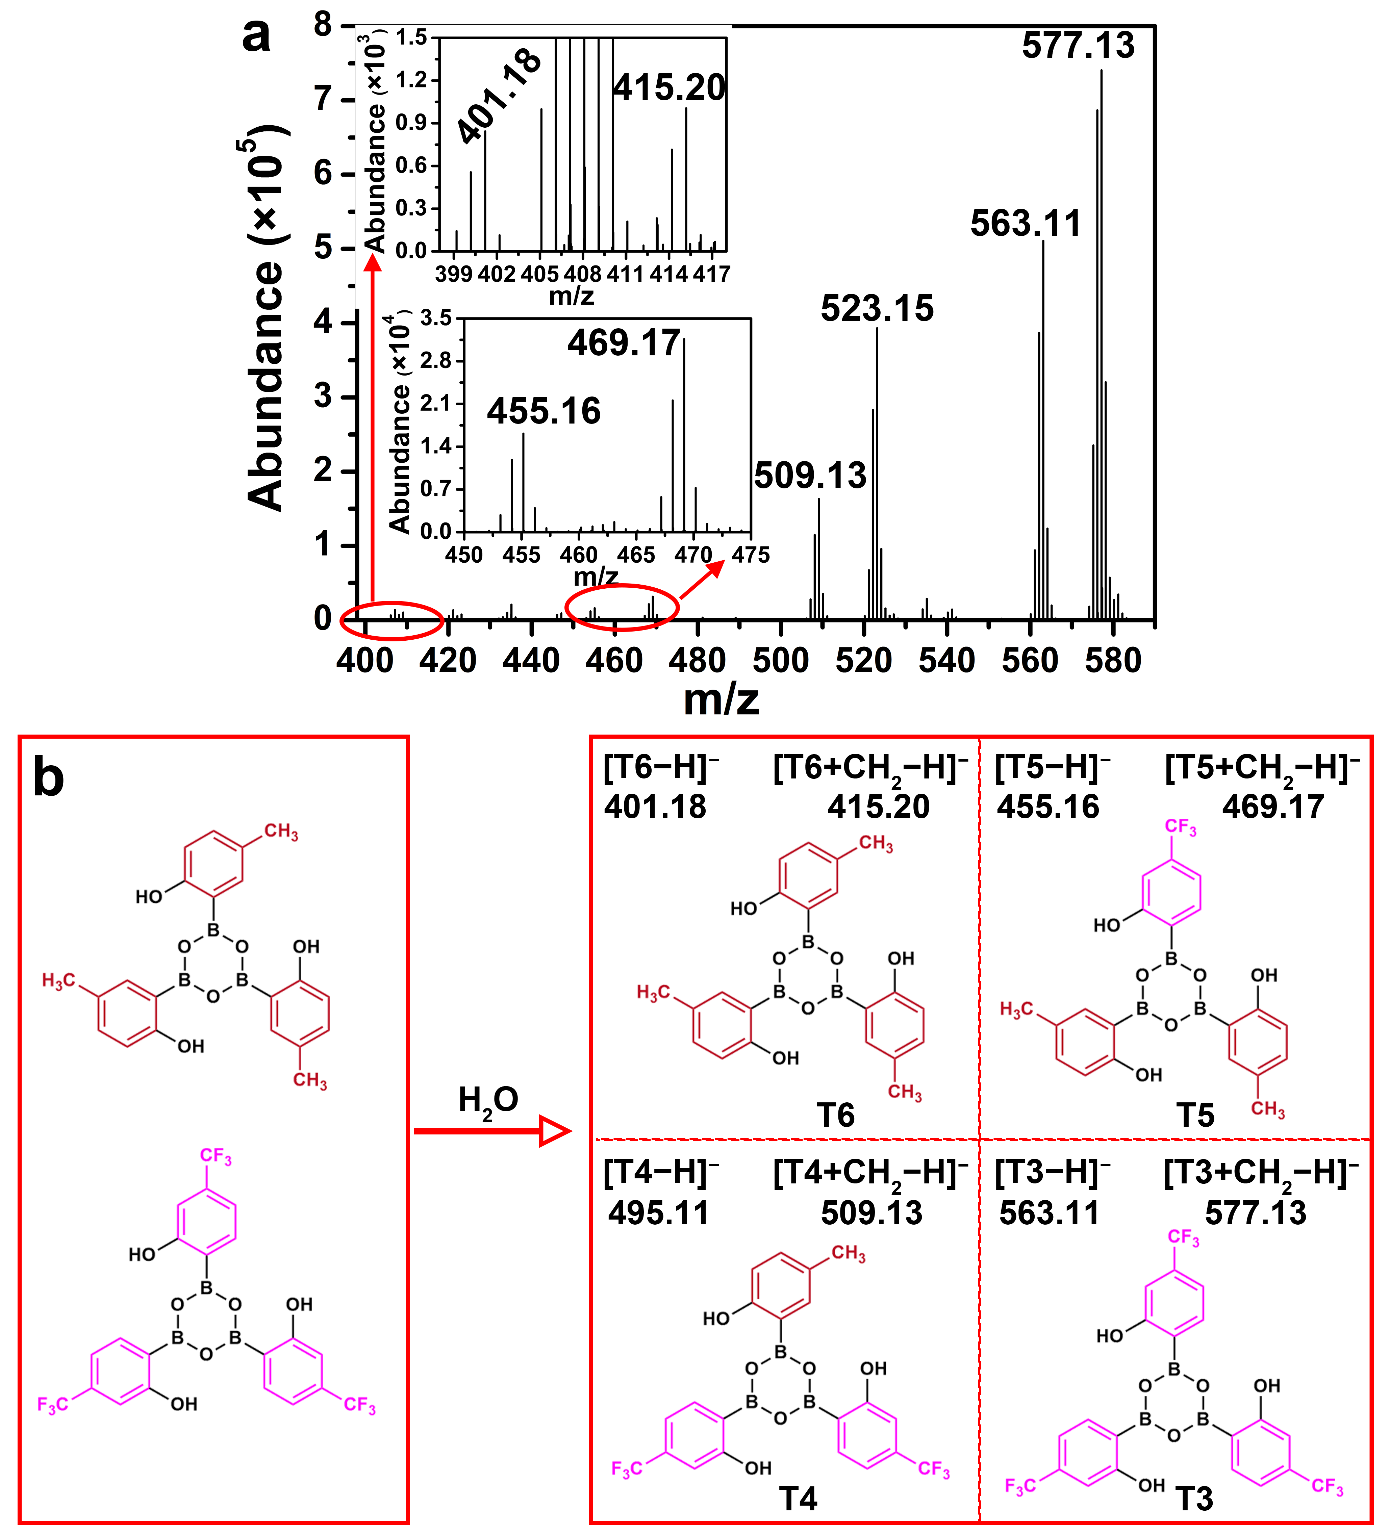
Supplementary Fig. 19 Exchange reaction between CF₃-HO-PBA trimers and CH₃-HO-PBA trimers. a ESI-Q-TOF mass spectrum of products from mixing CF₃-HO‑PBA dimers and CH₃-HO‑PBA dimers together in the methanol–water (5:1, v/v) solution, acquired in a negative mode. b Illustration of the dynamic exchange between CF₃-HO‑PBA trimer and CH₃-HO‑PBA trimer.

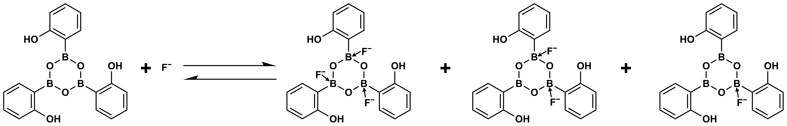
Supplementary Fig. 20 Equilibration between HO‑PBA trimer–F⁻ complexes and HO‑PBA trimer.

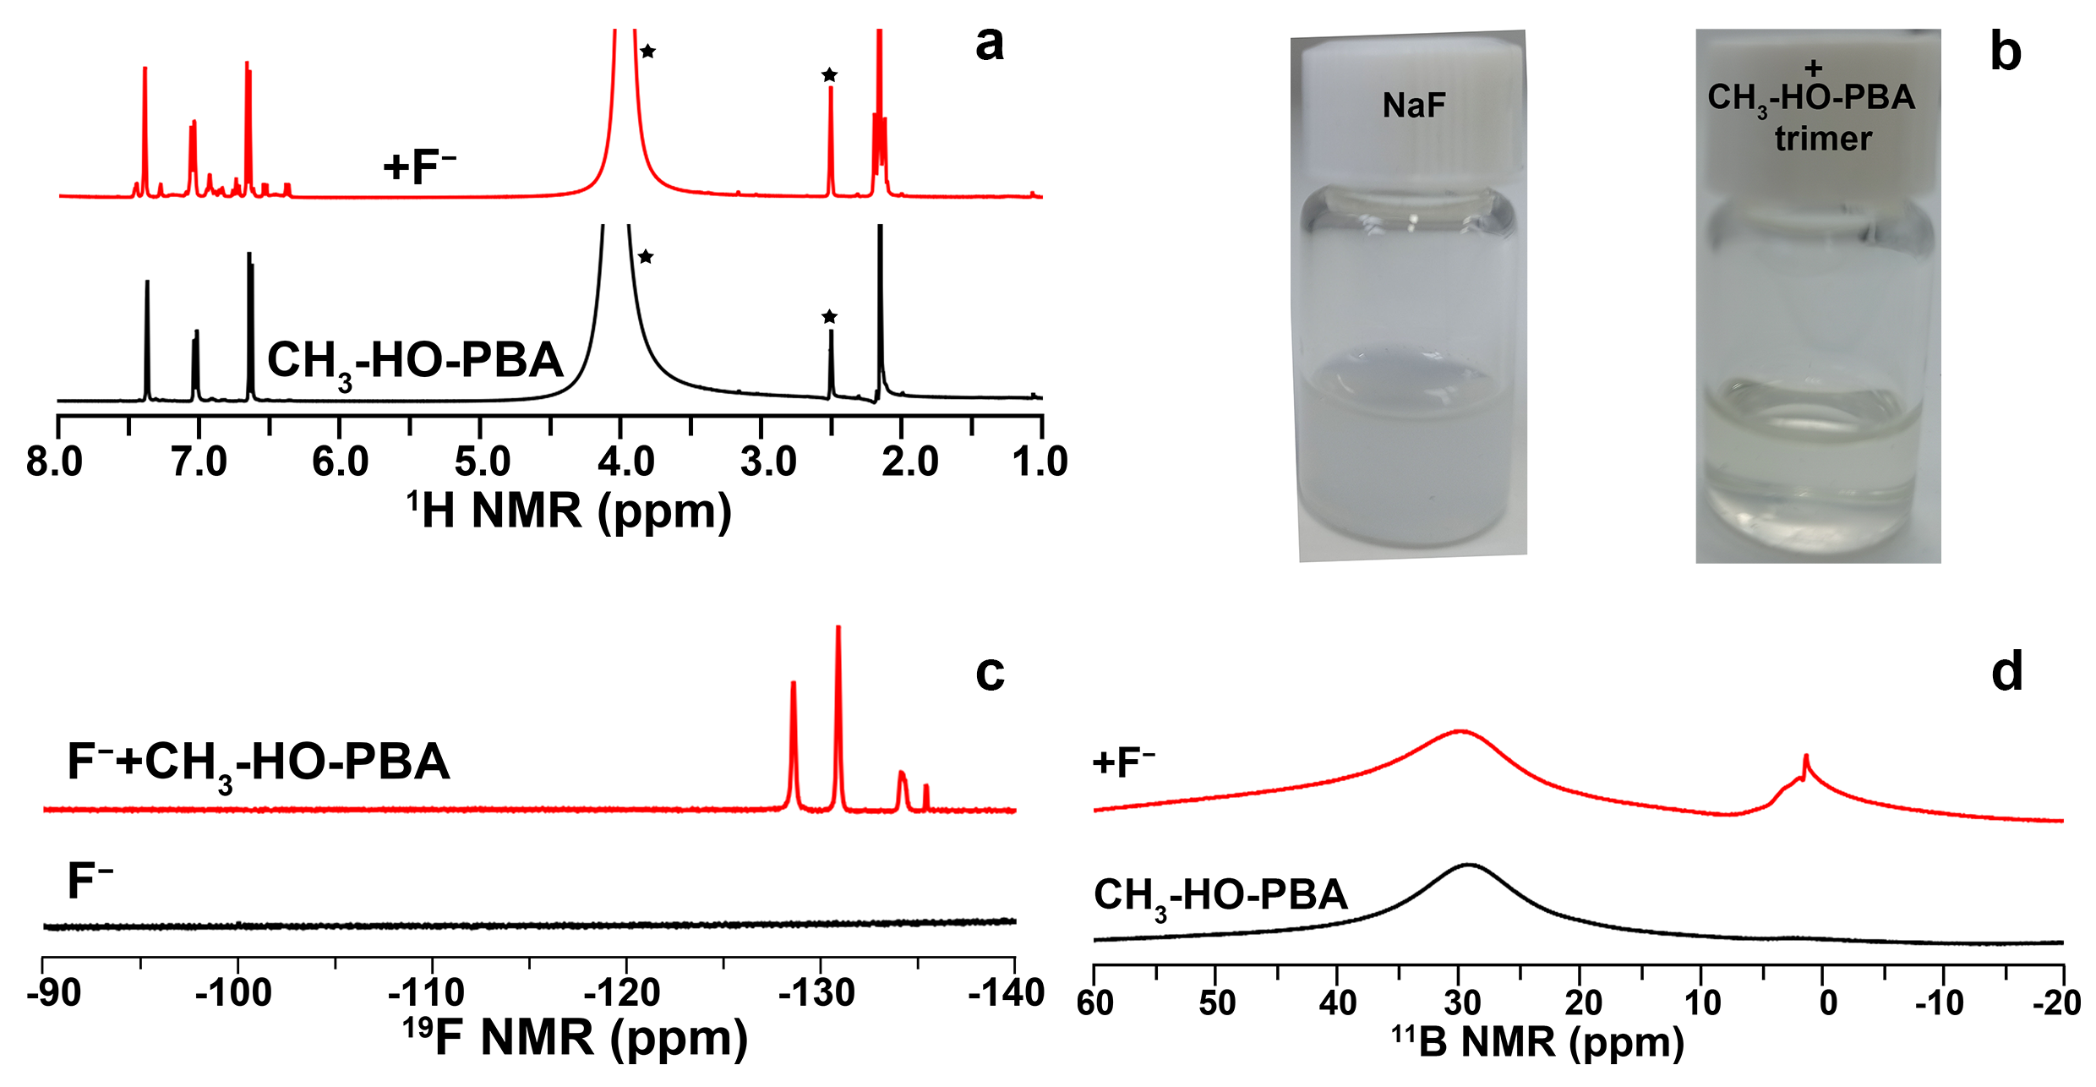
Supplementary Fig. 21 Ultra-strong binding capacity of CH₃-HO‑PBA trimer toward F⁻ in aqueous media. a ¹H NMR spectra of CH₃-HO‑PBA trimer (120 mmol·L⁻¹) before and after the addition of one molar equivalent of NaF. The signals with star mark correspond to DMSO (2.5 ppm) and H₂O, respectively. b,c Photos (b) and ¹⁹F NMR spectra (c) of NaF (120 mmol·L⁻¹) before and after addition of one molar equivalent of CH₃-HO‑PBA trimer. d ¹¹B NMR spectra of CH₃-HO‑PBA trimer (120 mmol·L⁻¹) before and after addition of one molar equivalent NaF. All NMR measurements were carried out at room temperature using D₂O–DMSO−d₆ (1:6, v/v) mixtures as solvents.

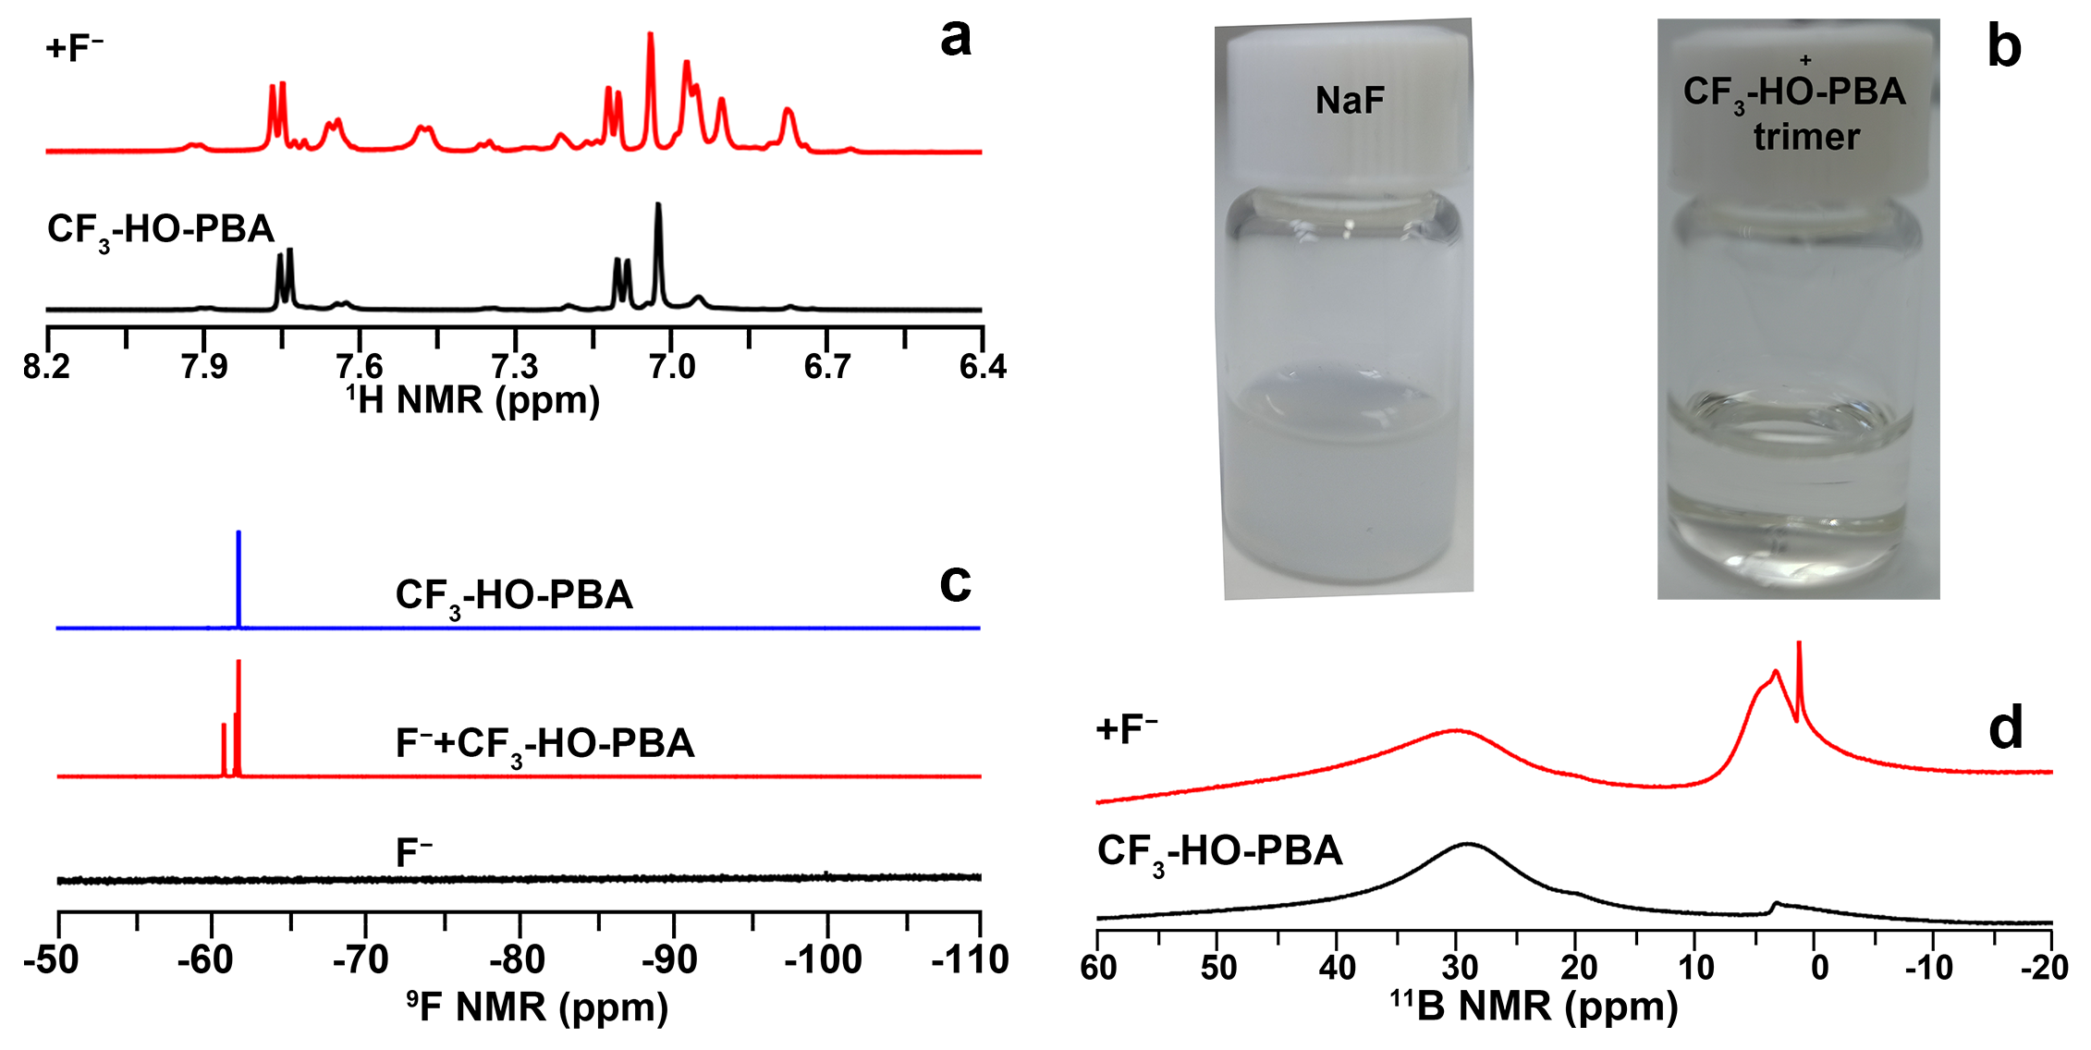
Supplementary Fig. 22 Ultra-strong binding capacity of CF₃-HO‑PBA trimer toward F⁻ in aqueous media. a ¹H NMR spectra of CF₃-HO‑PBA trimer (120 mmol·L⁻¹) before and after the addition of one molar equivalent of NaF. b,c Photos (b) and ¹⁹F NMR spectra (c) of NaF (120 mmol·L⁻¹) before and after addition of one molar equivalent of CF₃-HO‑PBA trimer. d ¹¹B NMR spectra of CF₃-HO‑PBA trimer (120 mmol·L⁻¹) before and after addition of one molar equivalent NaF. All NMR measurements were carried out at room temperature using D₂O–DMSO−d₆ (1:6, v/v) mixtures as solvents.

Supplementary Fig. 23 Synthesis of poly(PEGMEA-co-GMA), poly(PEGMEA-co-AMA), poly(PEGMEA-co-AMA-PBA), poly(PEGMEA-co-AMA-(CH₃O-PBA)) and poly(PEGMEA-co-AMA-(HO-PBA)).

Supplementary Fig. 24 GPC profiles of poly(PEGMEA-co-GMA).

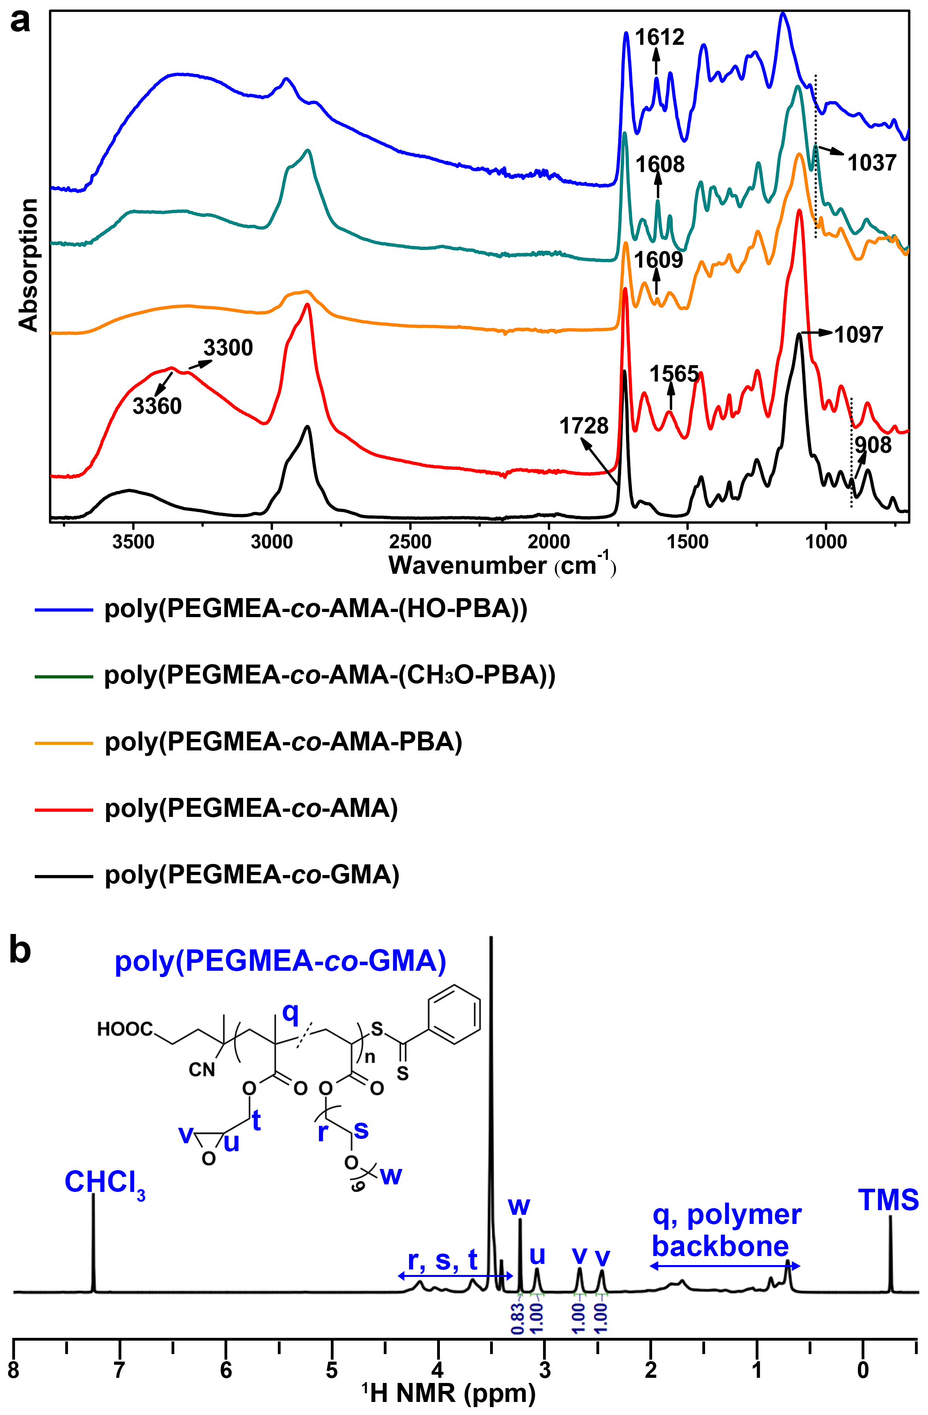
Supplementary Fig. 25 Characterization of polymers. a ATR-FTIR spectra of poly(PEGMEA-co-GMA) (black), poly(PEGMEA-co-AMA) (red), poly(PEGMEA-co-AMA-PBA) (orange), poly(PEGMEA-co-AMA-(CH₃O-PBA)) (cyan) and poly(PEGMEA-co-AMA-(HO-PBA)) (blue). b ¹H NMR spectra of poly(PEGMEA-co-GMA) in CDCl₃ at room temperature.
Discussion: In the ATR-FTIR spectrum of poly(PEGMEA-co-GMA) (Supplementary Fig. 25a, black line), the peak at 908 cm⁻¹ corresponds to the epoxy groups of GMA, the peak at 1728 cm⁻¹ is ascribed to the stretching vibrations of the ester groups in both GMA and PEGMEA²⁻⁴, and the peak at 1097 cm⁻¹ originates from the stretching vibration of the ether bonds of PEGMEA. These peaks collectively indicate the presence of both GMA and PEGMEA fragments within the copolymer, indicating the successful synthesis of poly(PEGMEA-co-GMA). In the ¹H NMR spectra of poly(PEGMEA-co-GMA) (Supplementary Fig. 25b), the signals at 2.62 (v) and 2.82 (v) ppm attribute to –CH₂–of the epoxy ring in GMA unit. The signals at 3.21 (u) and 3.37 (w) ppm attribute to –CH– of the epoxy ring in GMA unit and –CH₃ in PEGMEA unit, respectively^{2,5}. By calculating the ratio of the integral of the signal at 3.21 (u) to that at 3.37 (w) ppm, the molar ratio of GMA to PEGMEA was determined to be 1:0.28 (poly(PEGMEA_{0.28m}-co-GMA_{m})).
Upon reacting with ethylenediamine, the peak at 908 cm⁻¹ associated with epoxy vibration disappears, and three new bands originating from N-H vibrations appear at 3360, 3300 and 1565 cm⁻¹ in the ATR-FTIR spectrum of poly(PEGMEA-co-AMA) (Supplementary Fig. 25a, red line). These changes suggest the complete reaction of the epoxy group with ethylenediamine in the synthesis of poly(PEGMEA-co-AMA). Thus, the molar ratio of AMA to PEGMEA in poly(PEGMEA-co-AMA) is also 1:0.28 (poly(PEGMEA_{0.28m}-co-AMA_{m})).
In the ATR-FTIR spectrum of poly(PEGMEA-co-AMA-PBA) (Supplementary Fig. 25a, orange line), a peak corresponding to the aromatic C=C stretching vibration is observed at 1609 cm⁻¹, indicating the successful functionalization of PBA into poly(PEGMEA-co-AMA). The mass percentage of boron in poly(PEGMEA-co-AMA-PBA) was determined to be 1.49% using ICP–OES. Based on the boron content, the molar ratio of AMA to PBA in poly(PEGMEA-co-AMA-PBA) was calculated to be ca. 1:0.57 (poly(PEGMEA_{0.28m}-co-AMA_{m}-PBA_{0.57m}).
In the ATR-FTIR spectrum of poly(PEGMEA-co-AMA-(CH₃O-PBA)) (Supplementary Fig. 25a, cyan line), the appearance of peaks at 1608 cm⁻¹, corresponding to the aromatic C=C stretching vibration, and at 1037 cm⁻¹, corresponding to the stretching vibration of the Ar-O-C groups, provides strong evidences for the successful functionalization of CH₃O-PBA into poly(PEGMEA-co-AMA). After reacting poly(PEGMEA-co-AMA-(CH₃O-PBA)) with BBr₃, the aromatic C=C stretching vibration shifts to 1612 cm⁻¹, as shown in the ATR-FTIR spectrum of poly(PEGMEA-co-AMA-(HO-PBA) (Supplementary Fig. 25a, blue line). Moreover, the stretching vibration of the Ar-O-C groups at 1037 cm⁻¹ disappears, indicating the complete conversion of poly(PEGMEA-co-AMA-(CH₃O-PBA)) into poly(PEGMEA-co-AMA-(HO-PBA).
The mass percentages of boron in poly(PEGMEA-co-AMA-(HO-PBA)) was determined to be 1.06% using ICP–OES. Based on the boron content, the molar ratio of AMA to HO-PBA in poly(PEGMEA-co-AMA-(HO-PBA)) was calculated to be ca. 1:0.39 (poly(PEGMEA_{0.28m}-co-AMA_{m}-(HO-PBA)_{0.39m}). The molar ratio of CH₃O-PBA to AMA in poly(PEGMEA-co-AMA-(CH₃O-PBA)) is also 1:0.39 (poly(PEGMEA_{0.28m}-co-AMA_{m}-(CH₃O-PBA)_{0.39m})), since (poly(PEGMEA_{0.28m}-co-AMA_{m}-(HO-PBA)_{0.39m} was synthesized by adopting BBr₃ to convert methoxy groups of CH₃O-PBAs in poly(PEGMEA-co-AMA-(CH₃O-PBA)) into hydroxyl groups.

Supplementary Fig. 26 The proportion of peak areas of the three peaks, T₂₁, T₂₂ and T₂₃, in T₂ distribution curves of poly(PEGMEA-co-AMA-PBA) (1), poly(PEGMEA-co-AMA-(CH₃O-PBA)) (2) and poly(PEGMEA-co-AMA-(HO-PBA)) (3) in water at room temperature.

Supplementary Tables 1–9
Supplementary Table 1 Crystal data and structure refinements for HO-PBA
Empirical formula | C₁₂H₁₀B₂O₄
Formula weight | 239.82
Temperature (K) | 120
Crystal size (mm³) | 0.16 x 0.12 x 0.12
Crystal system | monoclinic
Space group | C 12/c 1
a (Å) | 25.308(5)
b (Å) | 5.0812(10)
c (Å) | 17.183(4)
α (°) | 90
β (°) | 91.498(9)
γ (°) | 90
V (Å³ ) | 2208.9(8)
Z | 8
Density ( g/cm³) | 1.442
F (000) | 992.0
Theta range for data collection | 2.83 to 27.18
Index ranges | −32<=h<=32, −6<=k<=6, −22<=l<=22
Reflections collected | 18588
Independent reflections | 2557 [R(int)= 0.0681]
Final R indices [I>2sigma(I)] | R1= 0.0476, wR2=0.1056
R indices (all data) | R1= 0.0764, wR2= 0.1198
Goodness−of−fit on F² | 1.034
Highest difference peak and deepest hole (e Å⁻³) | 0.254 and -0.224

Supplementary Table 2 Bond lengths (Å) and angles for HO-PBA
O2−B2 | 1.379(2) | C11−C12−O4 | 116.04(15)
O2−B1 | 1.407(2) | C11−C12−C7 | 122.32(16)
O3−C1 | 1.389(2) | C1−C2−C3 | 117.37(16)
O3−B2 | 1.370(2) | C1−C2−B1 | 117.76(15)
O1−H1 | 0.8400 | C3−C2−B1 | 124.87(16)
O1−B1 | 1.338(2) | C12−C7−B2 | 122.88(15)
O4−H4 | 0.8400 | C8−C7−C12 | 116.39(16)
O4−C12 | 1.387(2) | C8−C7−B2 | 120.72(16)
C1−C2 | 1.394(2) | C12−C11−H11 | 120.3
C1−C6 | 1.388(2) | C10−C11−C12 | 119.43(17)
C12−C7 | 1.402(2) | C10−C11−H11 | 120.3
C12−C11 | 1.382(2) | C2−C3−H3 | 119.5
C2−C3 | 1.406(2) | C4−C3−C2 | 120.94(16)
C2−B1 | 1.545(3) | C4−C3−H3 | 119.5
C7−C8 | 1.402(2) | C7−C8−H8 | 119
C7−B2 | 1.552(3) | C9−C8−C7 | 122.02(17)
C11−H11 | 0.9500 | C9−C8−H8 | 119
C11−C10 | 1.379(3) | C1−C6−H6 | 120.8
C3−H3 | 0.9500 | C5−C6−C1 | 118.38(16)
C3−C4 | 1.387(2) | C5−C6−H6 | 120.8
C8−H8 | 0.9500 | C3−C4−H4A | 120.2
C8−C9 | 1.388(3) | C3−C4−C5 | 119.55(16)
C6−H6 | 0.9500 | C5−C4−H4A | 120.2
C6−C5 | 1.381(2) | C6−C5−C4 | 121.22(16)
C4−H4A | 0.9500 | C6−C5−H5 | 119.4
C4−C5 | 1.388(2) | C4−C5−H5 | 119.4
C5−H5 | 0.9500 | C11−C10−H10 | 119.7
C10−H10 | 0.95 | C11−C10−C9 | 120.53(17)
C10−C9 | 1.385(3) | C9−C10−H10 | 119.7
C9−H9 | 0.95 | C8−C9−H9 | 120.4
B2−O2−B1 | 121.16(14) | C10−C9−C8 | 119.29(17)
B2−O3−C1 | 121.78(14) | C10−C9−H9 | 120.4
B1−O1−H1 | 109.5 | O2−B2−C7 | 119.49(15)
C12−O4−H4 | 109.5 | O3−B2−O2 | 121.77(16)
O3−C1−C2 | 120.73(15) | O3−B2−C7 | 118.74(16)
C6−C1−O3 | 116.73(15) | O2−B1−C2 | 116.73(15)
C6−C1−C2 | 122.54(16) | O1−B1−O2 | 120.43(16)
O4−C12−C7 | 121.63(15) | O1−B1−C2 | 122.83(16)

Supplementary Table 3 Hydrogen bond data for HO-PBA
D−H...A | d(D−H) | d(H...A) | d(D...A) | <(DHA)
O4−H4...O2 | 0.8401 (14) | 1.9355 (11) | 2.6926 (19) | 149.371 (105)
O1-H1...O4^{i} | 0.8401 (14) | 1.9755 (15) | 2.7982 (21) | 166.092 (105)
C9−H9...O3^{ii} | 0.9500 (18) | 3.0058 (12) | 3.6799 (22) | 129.128 (110)
Symmetry codes: (i) 0.5−x, 0.5+y, 0.5−z; (ii) x, 2-y, -0.5+z.

Supplementary Table 4 Crystal data and structure refinements for CH₃-HO-PBA
Empirical formula | C₁₄H₁₄B₂O₄
Formula weight | 267.87
Temperature (K) | 120
Crystal size (mm³) | 0.15 x 0.12 x 0.12
Crystal system | monoclinic
Space group | P 1 21/n 1
a (Å) | 12.8607(14)
b (Å) | 5.0210(5)
c (Å) | 19.993(2)
α (°) | 90
β (°) | 91.001(5)
γ (°) | 90
V (Å³ ) | 1290.8(2)
Z | 4
Density ( g/cm³) | 1.378
F (000) | 560.0
Theta range for data collection | 3.17 to 27.17
Index ranges | −16<=h<=16, −6<=k<=6, −25<=l<=25
Reflections collected | 15819
Independent reflections | 2964 [R(int)= 0.0943]
Final R indices [I>2sigma(I)] | R1= 0.0513, wR2= 0.1112
R indices (all data) | R1= 0.1077, wR2= 0.1322
Goodness−of−fit on F2 | 1.016
Highest difference peak and deepest hole (e Å⁻³) | 0.288 and -0.264

Supplementary Table 5 Bond lengths (Å) and angles for CH₃-HO-PBA
O2−B1 | 1.379(2) | C11−C10−C9 | 122.45(18)
O2−B2 | 1.397(3) | C11−C10−H10 | 118.8
O1−C8 | 1.387(2) | C8−C14−H14 | 120.7
O1−B1 | 1.378(3) | C8−C14−C13 | 118.59(18)
O3−H3 | 0.8400 | C13−C14−H14 | 120.7
O3−C2 | 1.382(2) | C10−C11−C13 | 118.06(18)
O4−H4 | 0.8400 | C10−C11−C12 | 121.44(18)
O4−B2 | 1.342(2) | C13−C11−C12 | 120.49(18)
C9−C8 | 1.391(2) | O3−C2−C1 | 121.77(17)
C9−C10 | 1.405(3) | O3−C2−C3 | 116.75(18)
C9−B2 | 1.549(3) | C3−C2−C1 | 121.47(18)
C8−C14 | 1.384(3) | C5−C6−H6 | 118.4
C10−H10 | 0.9500 | C5−C6−C1 | 123.29(19)
C10−C11 | 1.385(3) | C1−C6−H6 | 118.4
C14−H14 | 0.9500 | C6−C5−C4 | 117.64(18)
C14−C13 | 1.385(3) | C6−C5−C7 | 120.41(18)
C11−C13 | 1.392(3) | C4−C5−C7 | 121.94(18)
C11−C12 | 1.507(3) | C2−C1−C6 | 116.75(17)
C2−C1 | 1.397(3) | C2−C1−B1 | 123.14(17)
C2−C3 | 1.384(3) | C6−C1−B1 | 120.11(18)
C6−H6 | 0.9500 | C14−C13−C11 | 121.58(18)
C6−C5 | 1.387(3) | C14−C13−H13 | 119.2
C6−C1 | 1.399(3) | C11−C13−H13 | 119.2
C5−C4 | 1.389(3) | C2−C3−H3A | 120.1
C5−C7 | 1.509(3) | C2−C3−C4 | 119.71(19)
C1−B1 | 1.545(3) | C4−C3−H3A | 120.1
C13−H13 | 0.9500 | C5−C4−H4A | 119.4
C3−H3A | 0.9500 | C3−C4−C5 | 121.14(18)
C3−C4 | 1.386(3) | C3−C4−H4A | 119.4
C4−H4A | 0.9500 | C11−C12−H12A | 109.5
C12−H12A | 0.9800 | C11−C12−H12B | 109.5
C12−H12B | 0.9800 | C11−C12−H12C | 109.5
C12−H12C | 0.9800 | H12A−C12−H12B | 109.5
C7−H7A | 0.9800 | H12A−C12−H12C | 109.5
C7−H7B | 0.9800 | H12B−C12−H12C | 109.5
C7−H7C | 0.9800 | C5−C7−H7A | 109.5
B1−O2−B2 | 121.88(16) | C5−C7−H7B | 109.5
B1−O1−C8 | 122.00(15) | C5−C7−H7C | 109.5
C2−O3−H3 | 109.5 | H7A−C7−H7B | 109.5
B2−O4−H4 | 109.5 | H7A−C7−H7C | 109.5
C8−C9−C10 | 116.81(18) | H7B−C7−H7C | 109.5
C8−C9−B2 | 118.01(17) | O2−B1−C1 | 120.84(18)
C10−C9−B2 | 125.14(17) | O1−B1−O2 | 121.07(18)
O1−C8−C9 | 120.54(17) | O1−B1−C1 | 118.09(17)
C14−C8−O1 | 116.96(16) | O2−B2−C9 | 116.48(17)
C14−C8−C9 | 122.50(18) | O4−B2−O2 | 120.83(18)
C9−C10−H10 | 118.8 | O4−B2−C9 | 122.69(18)

Supplementary Table 6 Hydrogen bond data for CH₃-HO-PBA
D−H...A | d(D−H) | d(H...A) | d(D...A) | <(DHA)
O3−H3...O2 | 0.8401 (14) | 1.9743 (14) | 2.7307 (20) | 149.334 (103)
O4-H4...O3^{i} | 0.8399 (14) | 1.9635 (14) | 2.7942 (20) | 169.816 (103)
C14-H14...O1^{ii} | 0.9501 (18) | 2.8202 (12) | 3.5042 (22) | 129.697 (112)
Symmetry codes: (i) x, 1+y, z; (ii) 1−x, 1-y, 1−z.

Supplementary Table 7 Crystal data and structure refinements for CF₃-HO-PBA
Empirical formula | C₁₄H₈B₂F₆O₄
Formula weight | 375.82
Temperature (K) | 120
Crystal size (mm³) | 0.15 x 0.1 x 0.1
Crystal system | monoclinic
Space group | P 1 21/c 1
a (Å) | 15.995(3)
b (Å) | 4.9175(9)
c (Å) | 18.567(3)
α (°) | 90
β (°) | 92.217(7)
γ (°) | 90
V (Å³ ) | 1459.3(4)
Z | 4
Density ( g/cm³) | 1.711
F (000) | 752
Theta range for data collection | 2.50 to 27.42
Index ranges | −20<=h<=14, −5<=k<=6, −24<=l<=24
Reflections collected | 11314
Independent reflections | 3297 [R(int)= 0.0399]
Final R indices [I>2sigma(I)] | R1= 0.0615, wR2= 0.1545
R indices (all data) | R1= 0.0722, wR2= 0.1610
Goodness−of−fit on F² | 1.102
Highest difference peak and deepest hole (e Å⁻³) | 0.338 and -0.359

Supplementary Table 8 Bond lengths (Å) and angles for CF₃-HO-PBA
F4−C14 | 1.338(3) | C12−C11−C14 | 118.9(2)
F5−C14 | 1.338(3) | C10−C11−C14 | 120.0(2)
F6−C14 | 1.344(3) | C6−C1−C2 | 118.2(2)
O2−B1 | 1.401(3) | C6−C1−B1 | 117.6(2)
O2−B2 | 1.376(3) | C2−C1−B1 | 124.2(2)
O1−H1 | 0.8400 | O3−C6−C1 | 121.1(2)
O1−B1 | 1.336(4) | O3−C6−C5 | 116.9(2)
O4−H4 | 0.8400 | C5−C6−C1 | 122.0(2)
O4−C13 | 1.369(3) | C10−C9−H9 | 118.8
F1−C7 | 1.331(3) | C10−C9−C8 | 122.4(2)
O3−C6 | 1.384(3) | C8−C9−H9 | 118.8
O3−B2 | 1.371(3) | C11−C10−H10 | 120.5
F3−C7 | 1.336(4) | C9−C10−C11 | 119.0(2)
F2−C7 | 1.327(4) | C9−C10−H10 | 120.5
C12−H12 | 0.9500 | C1−C2−H2 | 119.4
C12−C13 | 1.393(4) | C3−C2−C1 | 121.1(3)
C12−C11 | 1.389(4) | C3−C2−H2 | 119.4
C13−C8 | 1.415(3) | C2−C3−H3 | 120.5
C11−C10 | 1.393(4) | C2−C3−C4 | 118.9(3)
C11−C14 | 1.502(4) | C4−C3−H3 | 120.5
C1−C6 | 1.397(4) | C6−C5−H5 | 121
C1−C2 | 1.401(4) | C6−C5−C4 | 118.0(3)
C1−B1 | 1.561(4) | C4−C5−H5 | 121
C6−C5 | 1.390(4) | C3−C4−C7 | 120.2(3)
C9−H9 | 0.9500 | C5−C4−C3 | 121.8(2)
C9−C10 | 1.381(4) | C5−C4−C7 | 118.1(3)
C9−C8 | 1.401(4) | C13−C8−B2 | 121.9(2)
C10−H10 | 0.9500 | C9−C8−C13 | 116.9(2)
C2−H2 | 0.9500 | C9−C8−B2 | 121.2(2)
C2−C3 | 1.386(4) | F4−C14−F6 | 106.5(2)
C3−H3 | 0.9500 | F4−C14−C11 | 112.5(2)
C3−C4 | 1.392(4) | F5−C14−F4 | 106.8(2)
C5−H5 | 0.9500 | F5−C14−F6 | 106.8(2)
C5−C4 | 1.391(4) | F5−C14−C11 | 112.5(2)
C4−C7 | 1.508(4) | F6−C14−C11 | 111.4(2)
C8−B2 | 1.558(4) | F1−C7−F3 | 105.9(3)
B2−O2−B1 | 122.0(2) | F1−C7−C4 | 112.9(2)
B1−O1−H1 | 109.5 | F3−C7−C4 | 112.0(3)
C13−O4−H4 | 109.5 | F2−C7−F1 | 106.5(3)
B2−O3−C6 | 121.5(2) | F2−C7−F3 | 107.2(3)
C13−C12−H12 | 120.5 | F2−C7−C4 | 111.8(3)
C11−C12−H12 | 120.5 | O2−B1−C1 | 115.8(2)
C11−C12−C13 | 119.1(2) | O1−B1−O2 | 121.4(2)
O4−C13−C12 | 115.9(2) | O1−B1−C1 | 122.7(3)
O4−C13−C8 | 122.6(2) | O2−B2−C8 | 119.2(2)
C12−C13−C8 | 121.5(2) | O3−B2−O2 | 121.9(2)
C12−C11−C10 | 121.0(2) | O3−B2−C8 | 118.9(2)

Supplementary Table 9 Hydrogen bond data for CF₃-HO-PBA
D−H...A | d(D−H) | d(H...A) | d(D...A) | <(DHA)
O4−H4...O2 | 0.8398 (19) | 1.9338 (18) | 2.6896 (19) | 149.177 (139)
C9-H9...F3^{i} | 0.9500 (26) | 2.6448 (22) | 3.3071 (34) | 127.221 (162)
Symmetry codes: (i) 1−x, -0.5+y, 0.5−z.

References
- Jiang, W., Jiao, C., Meng, Y., Zhao, L., Liu, Q. & Liu, T. Switching single chain magnet behavior via photoinduced bidirectional metal-to-metal charge transfer. Chem. Sci. 9, 617-622 (2018).
- Tzoumani, I., Soto Beobide, A., Iatridi, Z., Voyiatzis, G. A., Bokias, G. & Kallitsis, J. K. Glycidyl methacrylate-based copolymers as healing agents of waterborne polyurethanes. Int. J. Mol. Sci. 23, 8118 (2022).
- Zhang, G., Zhang, Q., Cheng, T., Zhan, X. & Chen, F. Polyols-infused slippery surfaces based on magnetic Fe₃O₄-functionalized polymer hybrids for enhanced multifunctional anti-icing and deicing properties. Langmuir 34, 4052-4058 (2018).
- Yang, W. J., Pranantyo, D., Neoh, K.-G., Kang, E.-T., Teo, S. L.-M. & Rittschof, D. Layer-by-layer click deposition of functional polymer coatings for combating marine biofouling. Biomacromolecules 13, 2769-2780 (2012).
- Xia, J., Lu, D., Han, Y., Wang, J., Hong, Y., Zhao, P., Fang, Q. & Lin, Q. Facile multifunctional IOL surface modification via poly(PEGMA-co-GMA) grafting for posterior capsular opacification inhibition. RSC Adv. 11, 9840-9848 (2021).

