Effects of polyphosphates with different chain lengths on carcass quality, intestinal environment, and cecum microbiota inbroiler chickens

Yi-Qiang Chang¹, Yan-Qing Wang¹, Seung-Gyu Moon¹, Soo-Hyun Kim² & Soo-Ki Kim¹

¹Department of Animal Science and Technology, Konkuk University, 120 Neungdong-ro, 8 Gwangjin-gu, Seoul 05029, Republic of Korea
²Laboratory of Cytokine Immunology, College of Veterinary Medicine, 120 Neungdong-ro, 10 Gwangjin-gu, Seoul 05029, Republic of Korea

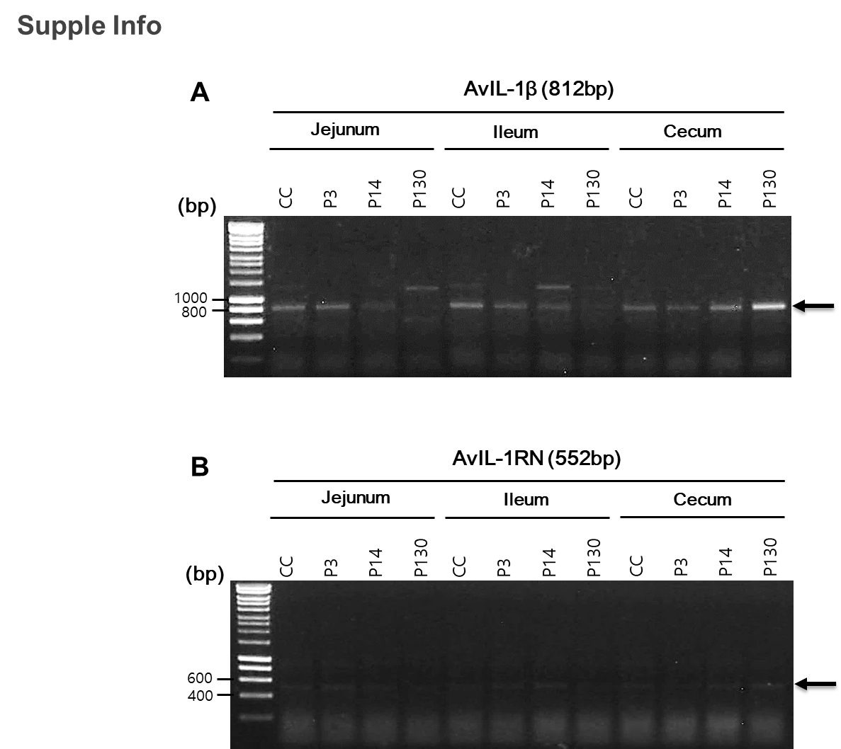

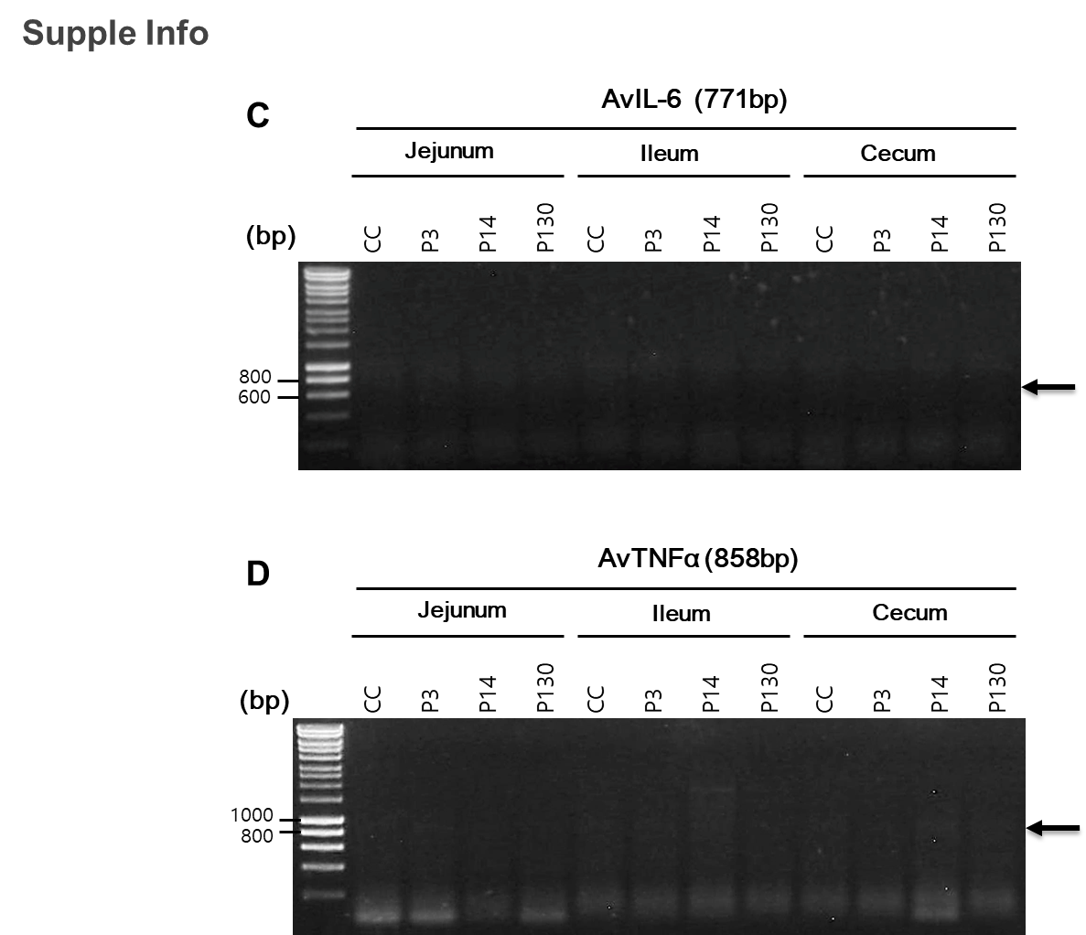
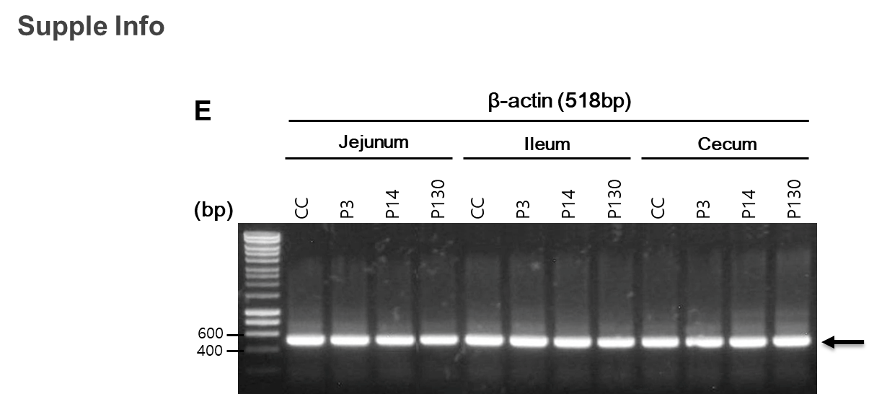
Supplementary Information
RT-PCR of avian cytokines
Total RNA was isolated with Tri-Reagent (Sigma, St. Louis, MO) from jejunum, ileum, and cecum according to manufacturer’s instruction. A pair of avian IL-1β (accession number: MF000729) sense primer, 5′- agagatggcgttcgttccc -3′ and reverse primer, 5′ -taagtgggcgctgactgc -3′, avian IL-1RN (accession number: NM_001397705) sense primer, 5′- attggggcatctcatgggtg -3′ and reverse primer, 5′- tacttccagctgtgctgagc -3′, avian IL-6 ( accession number: NM_204628) sense primer, 5′- agaagccgcaccatgaactt -3′ and reverse primer, 5′- tggtaacagaggattgtgccc -3′ , avian TNFα (accession number: MF000729) sense primer, 5′- atgaccacgctctttccgt -3′ and reverse primer, 5′- ttaatccactcccaccaccc -3′, and beta actin (accession number: NM_001101) sense primer, 5′- accaactgggacgacatgga -3′ and reverse primer, 5′- gtgatgacctggccgtcag -3′, was used for the RT-PCR. Each cytokine and beta actin gene accession number were obtained from NCBI reference sequence. MMLV-RT (Beams Bio, Korea) was used for converting 2μg of total RNA to first strand cDNA and then PCR reaction was performed at 94°C for 45 sec, 70°C for 2 min, and 55°C for 1 min for 30 cycles. The expected size of PCR product was indicated by arrow.

