Supplementary Information
Ag₂Se Nanowire Network as an Effective In-Materio Reservoir Computing Device

Takumi Kotooka, Sam Lilak, Adam Z. Stieg, James K. Gimzewski, Naoyuki Sugiyama,
Yuichiro Tanaka, Hakaru Tamukoh, Yuki Usami and Hirofumi Tanaka*

T. Kotooka, Y. Tanaka, H. Tamukoh, Y. Usami, H. Tanaka
Department of Human Intelligence Systems, Graduate School of Life Science and Systems Engineering, Kyushu Institute of Technology (Kyutech), Kitakyushu 808-0196, Japan.

S. Lilak, J. K. Gimzewski
Department of Chemistry and Biochemistry, University of California Los Angeles (UCLA), Los Angeles, CA 90095, U.S.A.

A. Z. Stieg, J. K. Gimzewski
California NanoSystems Institute, University of California Los Angeles (UCLA), Los Angeles, CA 90095, U.S.A.
A. Z. Stieg, J. K. Gimzewski, WPI Center for Materials Nanoarchitectonics (MANA), National Institute for Materials Science (NIMS), Tsukuba 305-0044, Japan.
Y. Tanaka
Japan Society for Promotion of Science, Tokyo 1020083, Japan

J. K. Gimzewski, H. Tamukoh, Y. Usami, H. Tanaka
Research Center for Neuromorphic AI Hardware, Kyutech, Kitakyushu 8080196, Japan.

N. Sugiyama
Transmission Electron Microscopy Station, National Institute for Materials Science (NIMS), Tsukuba, Ibaraki, 3050044, Japan.

N. Sugiyama
Toray Research Center Inc. Morphological Research Laboratory 3-3-7 Sonoyama, Otsu, Japan

*Corresponding author: tanaka@brain.kyutech.ac.jp

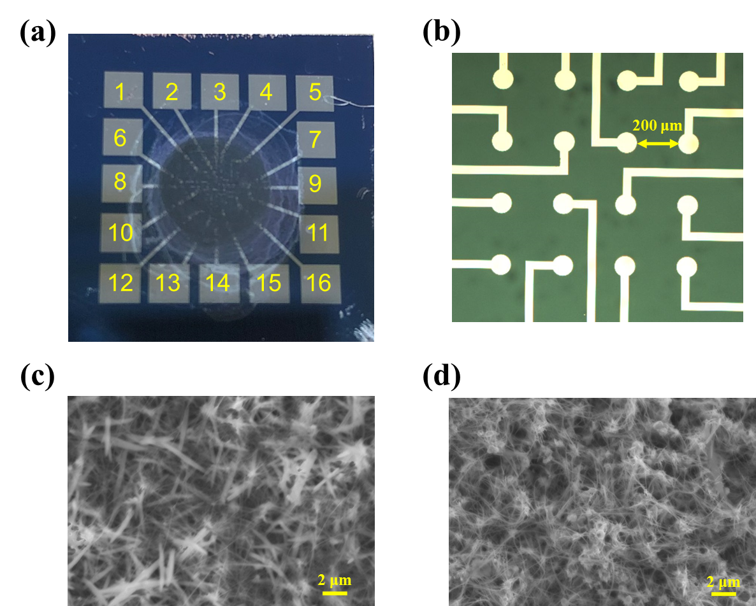
Supplementary Figure S1 a, Fabricated device after drop-casting of the Ag₂Se nanowire solution. The electrodes positions were labeled in figure. b, Magnified diagram of the center of the fabricated device. c, d, SEM image of Se and Ag₂Se nanowires. Se and Ag₂Se nanowires formed random networks. Even after Se nanowires react with silver, the shape of nanowires was maintained.

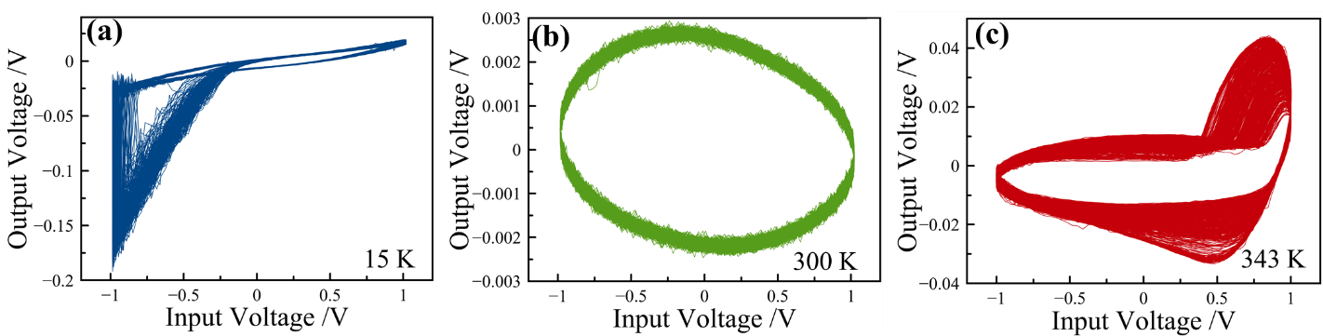
Supplementary Figure S2 a, b, c, Lissajous curves at 15, 300, and 343 K. Switching occurred at 15 K, as indicated by the angular shape of the curve. At 300 K (approximately room temperature), no switching occurred, as indicated by the almost elliptical curve. At 343 K, the curve shape was a combination of angular and elliptical.

Waveform learning at different temperatures
Figures S3, S4, and S5 show the results of waveform generation tasks at different temperatures (323, 343, and 363 K), while Fig. 4(d) displays the NMSEs at different temperatures. These tasks produced specific training target waveforms. Then, the waveforms were predicted by trained synaptic weight via the method described in Fig. 4(a). The specific waveforms selected were the cosine, triangle, sawtooth, and square waveforms. Figure 4(d) shows the relationship between NMSE and temperature for the waveform generation tasks. The NMSEs of the cosine and triangle waveforms displayed low values at approximately room temperature, while the sawtooth and square waveforms displayed lower NMSEs at high temperatures. These results correspond to the accuracy results in Fig. 4(c). Figures S6, S7, and S8 show the PSD for a device responding to an input signal each electrode at different temperatures. The HHG number increased with the temperature relative to room temperature (300 K), as shown in Fig. 3(b).

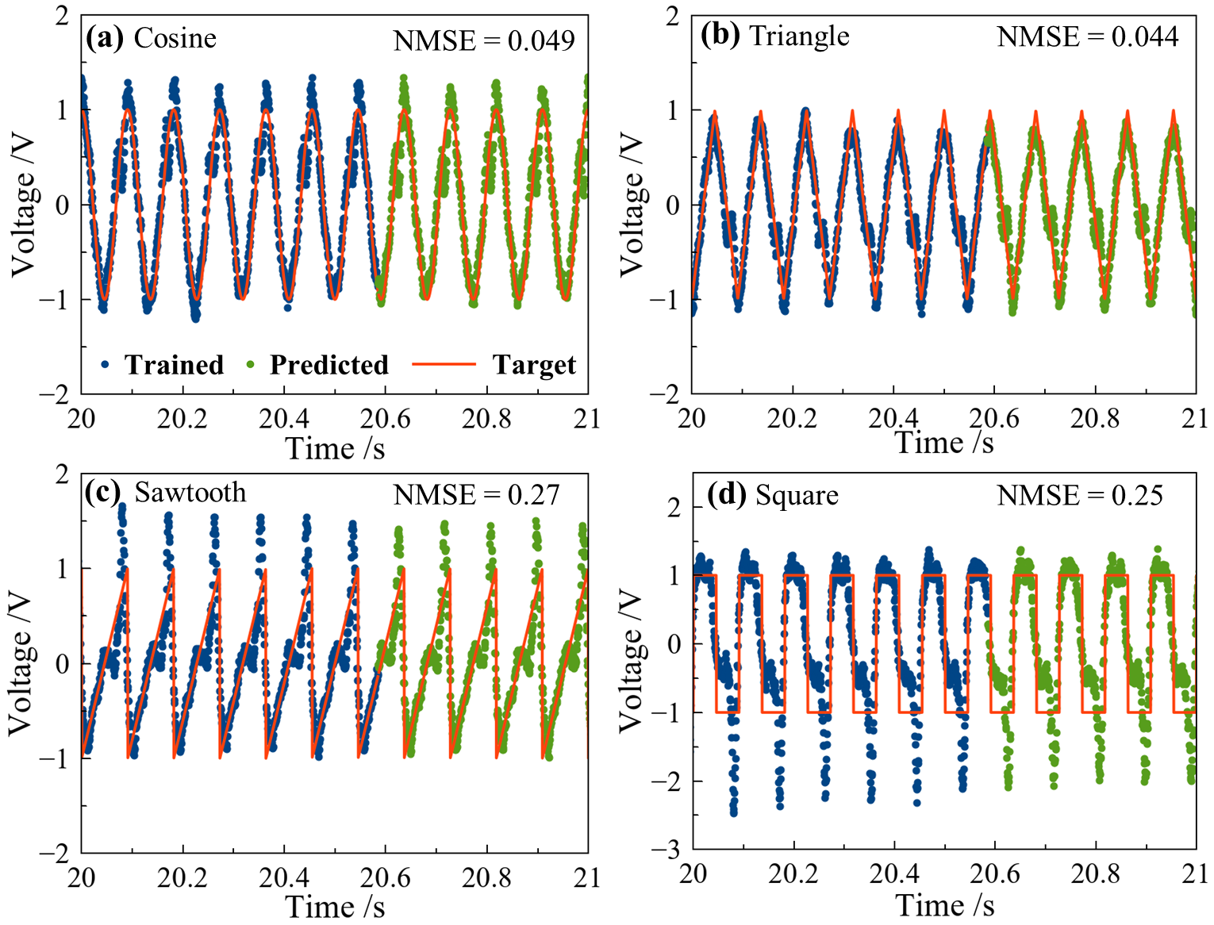
Supplementary Figure S3 Results of the waveform generation task at 323 K. The target waveforms were a cosine, b triangle, c sawtooth, and d square. The orange line indicates the target waveform, while the trained and predicted waveforms are represented by blue and green dots, respectively.

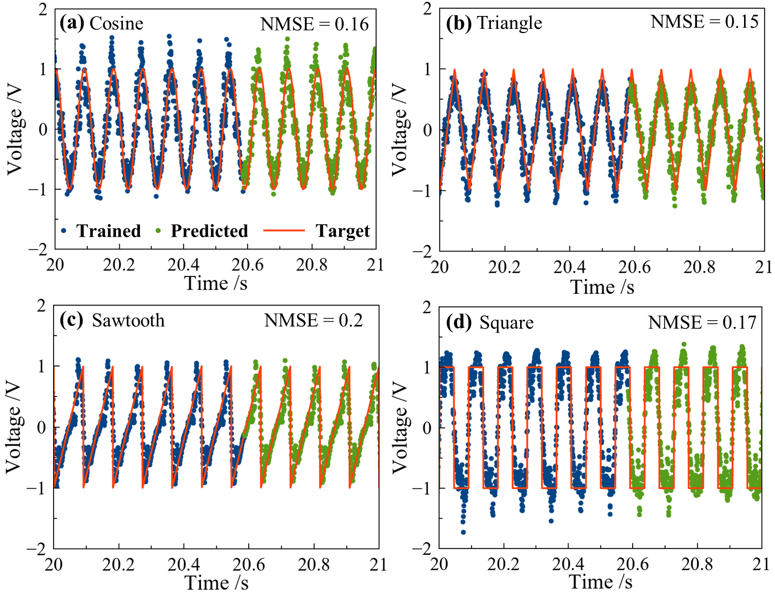
Supplementary Figure S4 Results of the waveform generation task at 343 K. The target waveforms were a cosine, b triangle, c sawtooth, and d square. The orange line indicates the target waveform, while the trained and predicted waveforms are represented by blue and green dots, respectively.

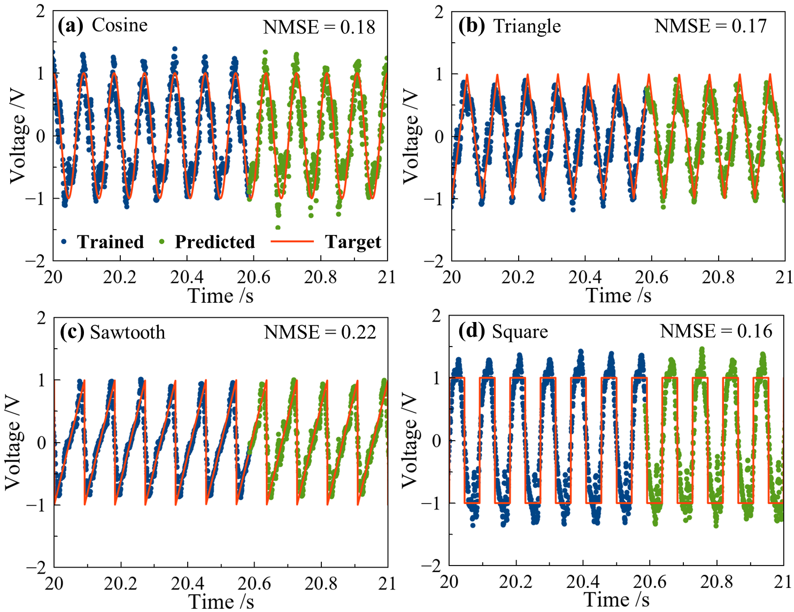
Supplementary Figure S5 Results of the waveform generation task at 363 K. The target waveforms were a cosine, b triangle, c sawtooth, and d square. The orange line indicates the target waveform, while the trained and predicted waveforms are represented by blue and green dots, respectively.

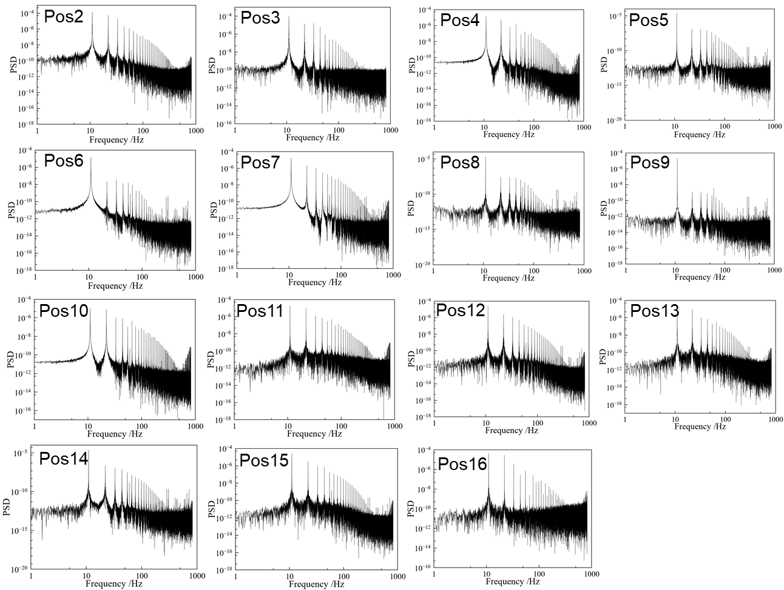
Supplementary Figure S6 PSD for a device responding to an input signal each electrode at 323 K where the input signal was a sinusoidal voltage (amplitude: ±1 V, frequency: 11 Hz).

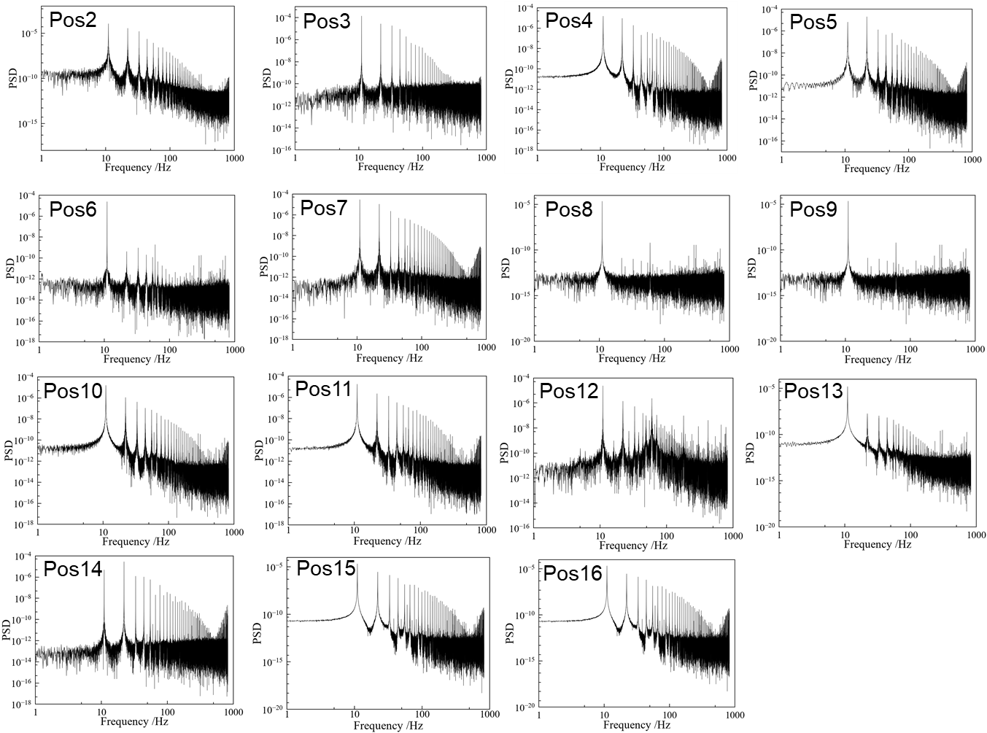
Supplementary Figure S7 PSD for a device responding to an input signal each electrode at 343 K where the input signal was a sinusoidal voltage (amplitude: ±1 V, frequency: 11 Hz).

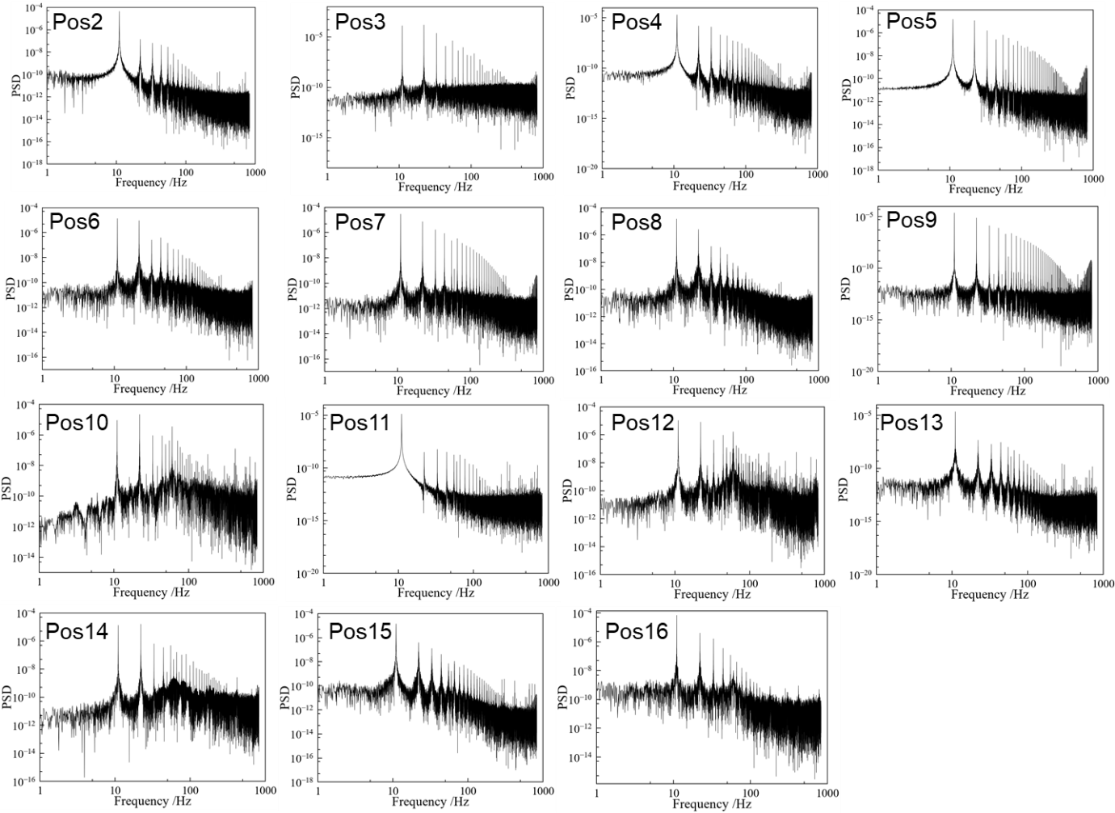
Supplementary Figure S8 PSD for a device responding to an input signal each electrode at 363 K where the input signal was a sinusoidal voltage (amplitude: ±1 V, frequency: 11 Hz).

Voice classification task at different temperature
Figure S9 shows the voice classification task results at different temperatures (323 K, 343 K, 363 K). The confusion matrices at different temperatures indicated the classification results almost did not change because the diagonal values were high compared to other values. Figures S9(g), (h) indicated the classification scores of 10 numbers and six persons classification tasks at 300 K, 323 K, 343 K, and 363 K. Comparing these scores, the classification performance is not changed by the temperature range and indicate the Ag₂Se device has the stability of relatively high temperature range.
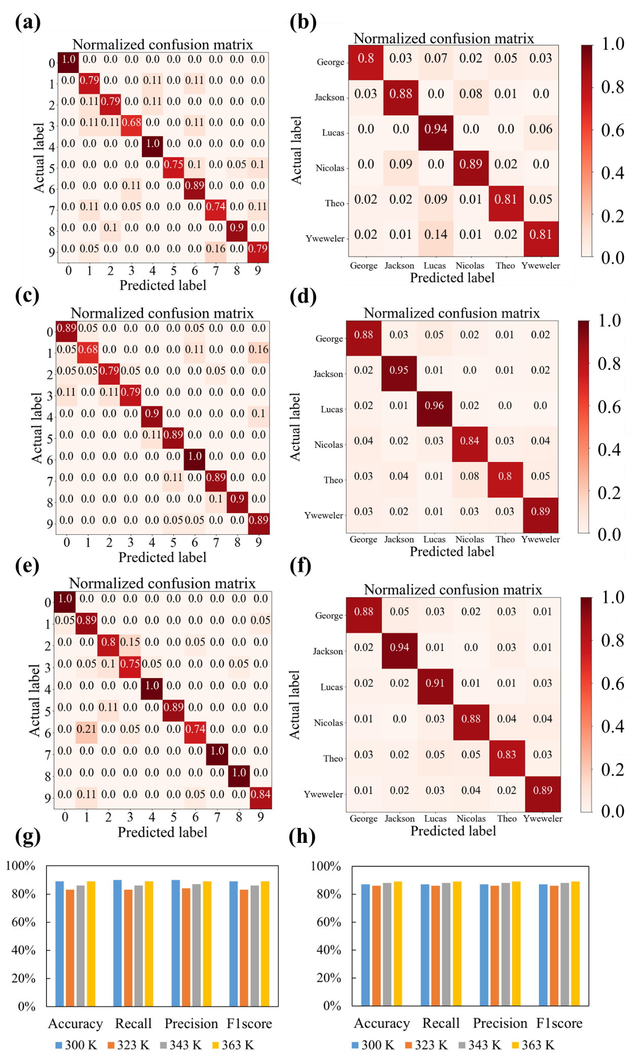
Supplementary Figure S9 a,b, Confusion matrices at 323 K of classifying ten numbers from zero to nine spoken Jackson and six persons. c,d, Confusion matrices at 343 K of classifying ten numbers from zero to nine spoken Jackson and six persons. e,f, Confusion matrices at 363 K of classifying ten numbers from zero to nine spoken Jackson and six persons. g,h, Classification scores at different temperatures for g ten numbers and h six speakers.

