Mutifunctional Fucoidan-loaded Zn-MOF Encapsulated Microneedles for MRSA Infected Wound Healing

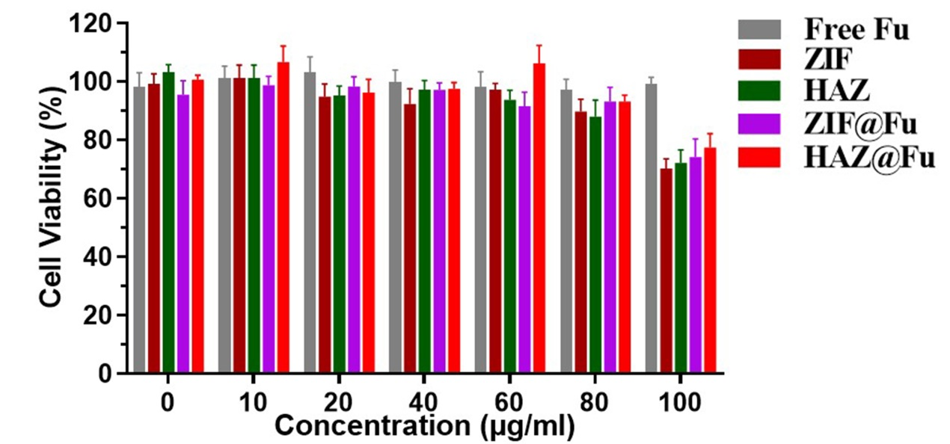
Fig. S1. Cell viability of RAW 264.7 treated with various concentrations of Fu and Fu-loading NPs for 24 h.

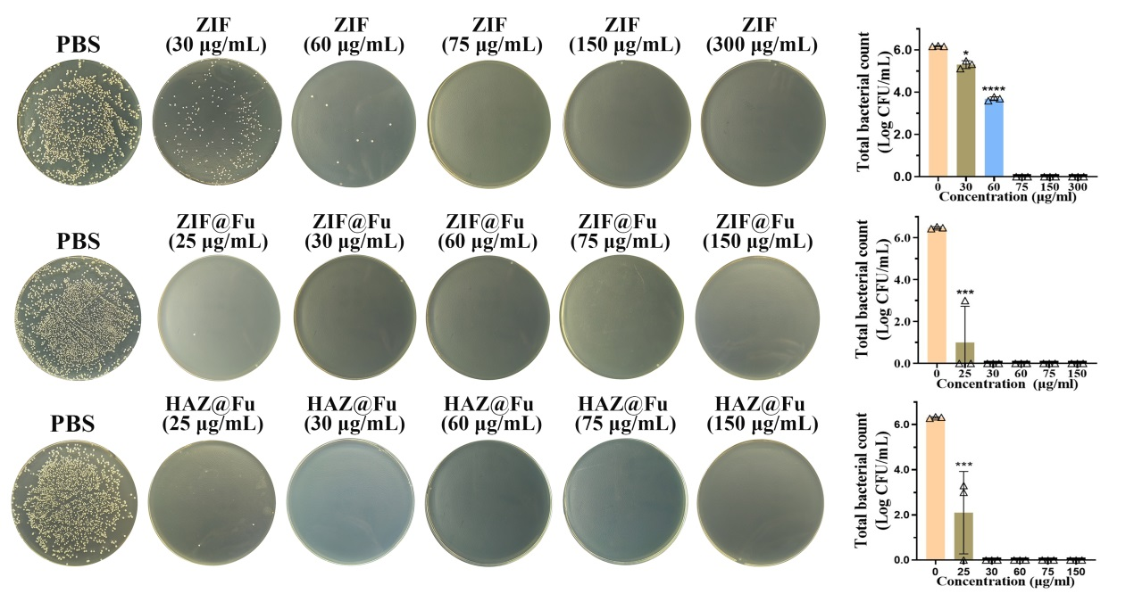
Fig. S2. In vitro MRSA strains (1×10⁶ CFU/mL) resuspend in PBS incubated with ZIF, ZIF@Fu and HAZ@Fu for 16 h, then serially diluted (100×) in sterile PBS and inoculated onto LB agar plates and incubated for 24 h.

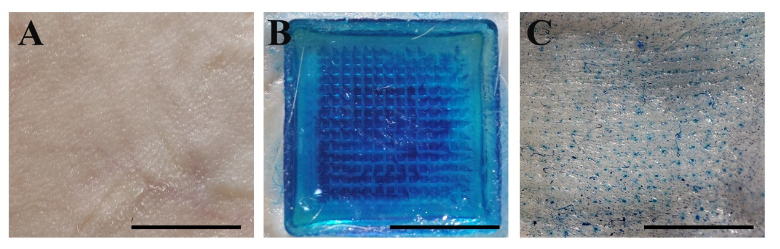
Fig. S3. Photograph of A) mice back skin, B) methylene blue-stained GelMA-MNs (10% w/v) applied to mice back skin. (C) The traces left after removing the applied MNs. Scale bar: 5 mm

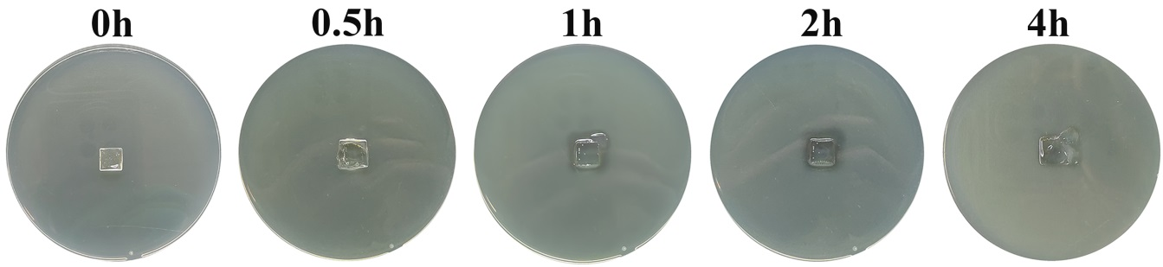
Fig. S4. Dissolution process of HAZ@Fu MN after inserting into the LB agar plate at 37°C.

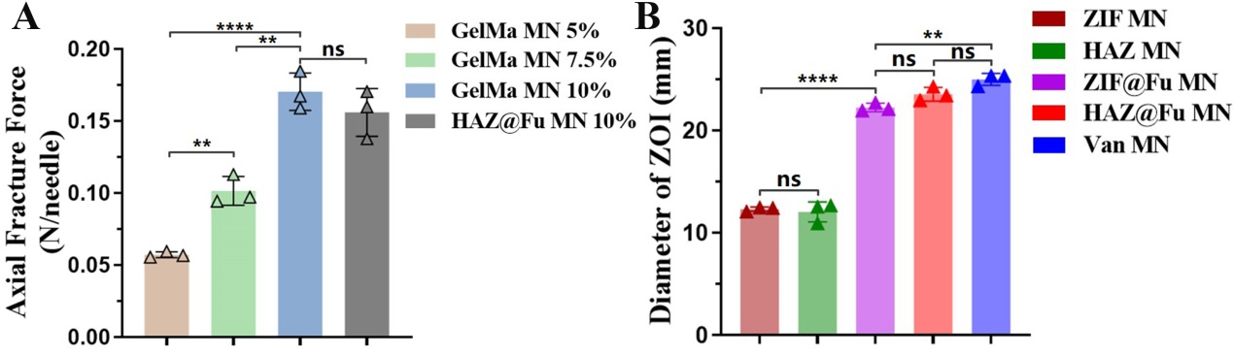
Fig. S5. A) The axial fracture forces of the different MNs. B) Result of ZOI diameters of ZIF MNs, HAZ MNs, ZIF@Fu MNs, HAZ@Fu MNs and Van MNs against MRSA.

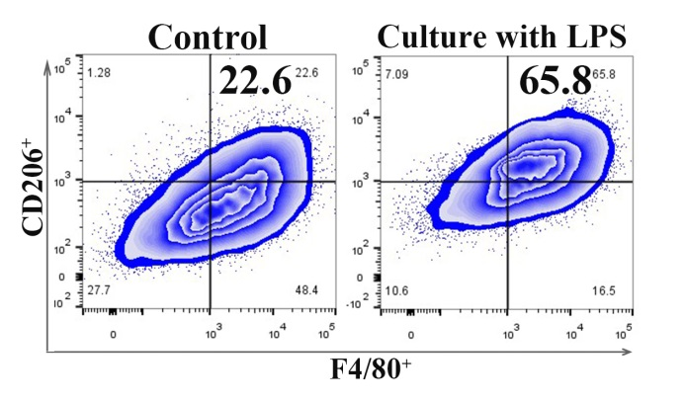
Fig. S6. FCM results of RAW 264.7 cells cultured with normal medium and medium with LPS (100 ng/mL) after 24 h, stained with M2 maker CD206.

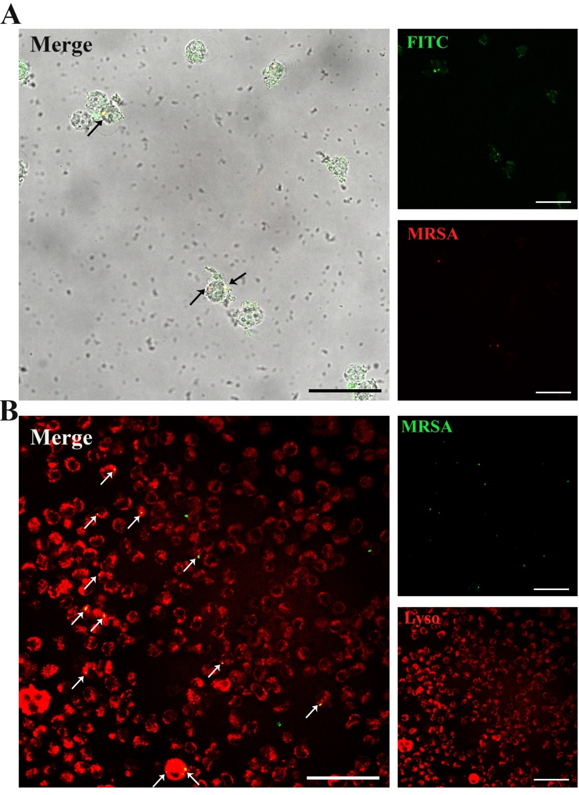
Fig. S7. A) HAZ NPs colocalization with intracellular MRSA, RAW 264.7 were incubated with MRSA (transferred by GFP), removed extracellular bacteria and washed with PBS, further incubated with 80 μg/mL HAZ@FITC NPs for 3 h, washed twice for confocal laser scanning microscope (scale bar: 50 μm). B) RAW 264.7 cells were infected by MRSA (transferred by GFP) and removed extracellular bacteria. Slides were washed with PBS and treated with Lyso-Tracker Red for 5 min at 37 °C. Images were immediately recorded on living cells (scale bar: 50 μm).

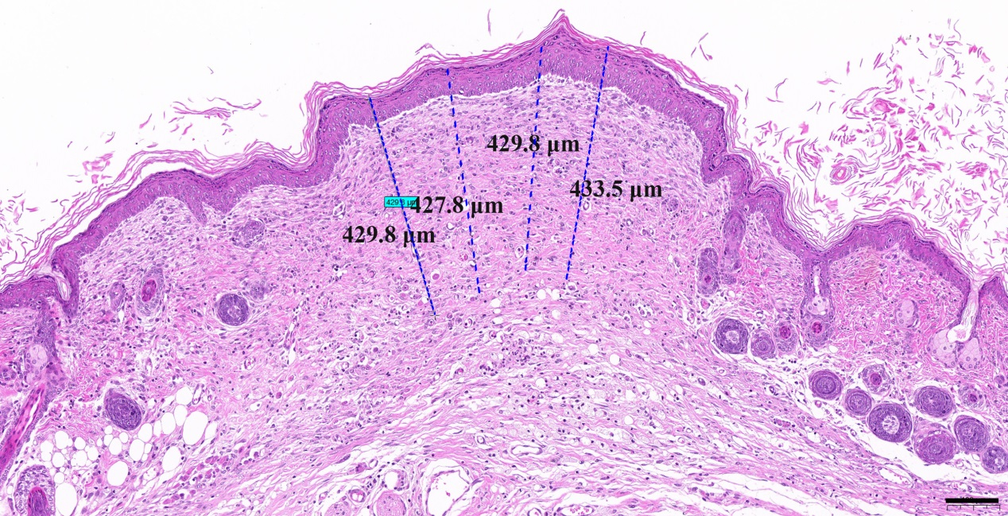
Fig. S8. Example of dectection of granulation tissues in HAZ@Fu MN groups, randomly select three to four positions to measure and take the average value for every sample (scale bar: 100 μm).

