Supplementary Information
Askelund et al. The genetic architecture of differentiating
behavioural and emotional problems in early life

Supplementary Methods

Measures of behavioural and emotional problems and traits
When the children were aged 1.5, 3, and 5 years, mothers responded to items on the Child Behavior Checklist (CBCL) using a 3-point scale ranging from “Not true” to “Often true” rating their children’s behavioural and emotional problems. The behavioural problems subscale included 8 items assessing attention problems and aggressive behaviour. The emotional problems subscale included 5 items assessing emotional reactivity, anxiety/depression, somatic complaints, and the extent to which the child was withdrawn.

When the children were aged 8, mothers responded to 13 items on depression from the Short Mood and Feelings Questionnaire (SMFQ) and 5 items on anxiety from the Screen for Child Anxiety Related Disorders (SCARED) using a 3-point scale ranging from “Not true” to “True” to describe their children’s traits. Mothers also responded to a 34-item version of the Rating Scale for Disruptive Behaviour Disorders (RS-DBD) assessing traits associated with hyperactivity, inattention, conduct disorder (CD), and oppositional defiant disorder (ODD) using a 4-point scale ranging from “Never/rarely” to “Very often”.

Diagnostic codes
We linked to the Norwegian Patient Registry (NPR) and Control and Payment of Health Refunds (KUHR) to obtain psychiatric diagnoses from medical records. KUHR covers primary health care (using codes from The International Classification of Primary Care; ICPC-2), and NPR covers all public specialist health-care services in Norway (using codes from ICD-10). We extracted information on diagnoses of depression (ICPC-2: P76; ICD-10: F32-F33, F34.1), anxiety disorders (ICPC-2: P74, P79, P82; ICD-10: F40-F44, F93.0-F93.2), ADHD (ICPC-2: P81; ICD-10: F90), and DBD (including conduct disorder and oppositional defiant disorder; ICPC-2: P23; ICD-10: F91-F92).

Definition/removal of outliers
We retained all valid responses. If participants ticked multiple boxes on a single-response item, their response on this item was set to missing. If respondents completed less than half of the items for a given scale, their scale score was not computed and was considered missing.

Latent growth modelling
Using latent growth modelling, we estimated longitudinal trajectories of the relative level of behavioural versus emotional problems across three time points (when the children were 1.5, 3 and 5 years of age; see Supplementary Figure S2). Individual differences in the extent and rate of differentiation of behavioural and emotional problems were captured by latent intercept and slope factors. The intercept was set at 5 years to index the endpoint of the children’s trajectories, and this endpoint was the main focus of interpretations for all analyses. To enable comparisons with the overall level of problems throughout (which is orthogonal to differentiation), we included total behavioural and emotional problems in all models. In some cases, we included differentiation and total problems in separate models to facilitate model convergence. Since the differentiation and total scores are independent, this does not lead to substantive differences in results.

Genomic SEM model fit comparisons
We tested whether each factor in the structural models - or its indicators - best explained the genetic associations with differentiation or total problems. This was done by conducting a chi-square model fit comparison between a ‘common pathway model’ and an ‘independent pathway model’. The common pathway models included paths from the factors to differentiation or total problems, whereas the independent pathway models, in each case, included direct paths from the indicators of one of the factors to differentiation or total problems. The chi-square metric was used to assess the heterogeneity of effects. If the p-value from this test was significant, this indicated heterogeneity in the associations; if the p-value was not significant, this indicated that the associations were homogenous. For the correlated factor model, this resulted in four model fit comparisons (for both differentiation and total problems), between the common pathway model and independent pathway models for each of the four factors. For the hierarchical p-factor model, this resulted in one model fit comparison between the models with a path from “p” to differentiation (or total problems), and a model with paths from its indicators - in this case, the four sub-factors. This analysis is like the Grotzinger et al. (2022) “Q-trait” analysis apart from that here, the paths are specified from the structural model to the external traits and not the other way around, as in a “Q-trait” analysis.

Inference criteria and equivalence testing
We used equivalence testing to quantify support for the null hypothesis of no effect, since null hypothesis testing cannot support substantive interpretations of null results. Note that 90% CIs are used to preserve a 5% alpha, because they correspond to two one-tailed tests, for the lower and upper equivalence bounds respectively. A significant result in either test would result in the rejection of the null hypothesis of the existence of values at least as extreme as the SESOI. If the 90% CIs fall within the region between the equivalence bounds, the effect is declared practically equivalent to zero based on the selected SESOI. If the 90% CIs do not fall entirely within the region of practical equivalence to zero, the effect is declared to be of a meaningful magnitude.
Null hypothesis significance tests were used in conjunction with equivalence testing to determine whether effects were null (within the region of practical equivalence to zero), non-null (statistically significant and not entirely within the region of practical equivalence to zero), or undecided (not statistically significant and not entirely within the region of practical equivalence to zero).

Polygenic score creation
To guard against inflated Type I error from overfitting, we did not test associations across all the 11 PGS thresholds; instead, we performed a principal component (PC) analysis on this set of 11 PGS and used the first PGS-PC for each of the 11 conditions as predictor variables in the latent growth models. The first PC reweights the variants included to achieve maximum variation across all the 11 PGS thresholds used.

Deviations from preregistration
We made the following deviations from the preregistration, which is available here.
- We did not include multilevel models accounting for unobserved familial risk, although still clustering on maternal ID in all models (accounting for the sibling relatedness structure in MoBa). Instead of conducting multilevel modelling, we used the trio PGS design to obtain direct effect estimates not inflated by gene-environment correlations, assortative mating, and population structure.
- We did not derive general and condition-specific genetic risk scores from the genomic SEM models, both for computational reasons and since preliminary analyses indicated that the condition-specific scores (derived from residuals) were unreliable. Instead, we tested associations between differentiation and total problems and the genomic ‘p-factor’ and/or 4 specific factors based on previously established structural models from Grotzinger et al. (2022).
- Since we did not derive general and condition-specific genetic risk scores, the mediation models were instead run with the 11 PGS as predictors.
- As in Grotzinger et al. (2022), we used the 1st wave Psychiatric Genomics Consortium PTSD GWAS (Duncan et al., 2018) instead of the 2nd wave GWAS (Nievergelt et al., 2019), as including the summary statistics from the 2nd wave GWAS in genomic SEM analyses resulted in estimation issues.

Supplementary Tables
Table S1. Overview of all phenotype variables with information about processing.
Variable | Role | Measure | Items | Processing
Behavioural/ emotional problems differentiation and total problems | Growth model variable | CBCL | 15 | behavioural & emotional scale scores calculated as mean (available items)*number of items (IF available items > number of items/2) at age 1.5, 3 & 5; differentiation = behavioural - emotional, total problems = behavioural + emotional
Depression | Outcome | SMFQ | 13 | depression score calculated as mean (available items)*number of items (IF available items > number of items/2) at age 8y
Anxiety | Outcome | SCARED | 5 | anxiety score calculated as mean (available items)*number of items (IF available items > number of items/2) at age 8y
Hyperactivity | Outcome | RS-DBD | 9 | hyperactivity score calculated as mean (available items)*number of items (IF available items > number of items/2) at age 8y
Inattention | Outcome | RS-DBD | 9 | inattention score calculated as mean (available items)*number of items (IF available items > number of items/2) at age 8y
Conduct | Outcome | RS-DBD | 8 | CD score calculated as mean (available items)*number of items (IF available items > number of items/2) at age 8y
Oppositional | Outcome | RS-DBD | 8 | ODD score calculated as mean (available items)*number of items (IF available items > number of items/2) at age 8y
Diagnoses | Outcome | NPR/KUHR |  | 2x ICPC-2 (P76; P74; P79; P82; P81; P23) or 2x ICD-10 (F32-F33; F34.1; F40-F44; F93.0-F93.2; F90; F91-F92)
Sex | Covariate | MBRN | 1 | sex registered at birth, dummy coded: m=0, f=1
CBCL, Child Behaviour Checklist; SMFQ, Short Mood and Feelings Questionnaire; SCARED, Screen for Child Anxiety and Related Disorders; RS-DBD, Parent/ Teacher Rating Scale for Disruptive Behaviour Disorders; CD, conduct disorder; ODD, oppositional defiant disorder.

Table S2. Ordinal alphas for Child Behavior Checklist subscales.
Variable | Age | Ordinal alpha
Behavioural problems | 1.5yr | 0.70
Behavioural problems | 3yr | 0.77
Behavioural problems | 5yr | 0.81
Emotional problems | 1.5yr | 0.66
Emotional problems | 3yr | 0.68
Emotional problems | 5yr | 0.73

Table S3. Ordinal Cronbach’s alphas for 8-year trait scales.
Variable | Ordinal alpha
Hyperactivity | 0.91
Inattention | 0.92
Conduct disorder | 0.88
Oppositional defiant disorder | 0.91
Anxiety | 0.76
Depression | 0.92

Table S4. Model fit statistics from phenotypic latent growth model.
X² | df | P | CFI | TLI | RMSEA | SRMR
282.491 | 9 | <0.001 | 0.99 | 0.98 | 0.03 | 0.01
Note that by convention, CFI and TLI values over 0.95, RMSEA less than 0.05,
and SRMR below 0.1 implies a good fit; the chi-square test is sensitive to sample
size; X², scaled chi-square test statistic; df, degrees of freedom; P, p-value (chi-
square); CFI, comparative fit index; TLI, Tucker-Lewis index; SRMR, standardised
root mean square residual; RMSEA, root mean square error of approximation.

Table S5. Model fit statistics from genomic latent growth model.
X² | df | P | CFI | SRMR
0.48 | 3 | 0.92 | 1 | 0.06
Note that by convention, CFI values over 0.95 and SRMR below 0.1 implies
a good fit; X², chi-square test statistic; df, degrees of freedom; P, p-value (chi-
square); CFI, comparative fit index; SRMR, standardised root mean square
residual.

Table S6. Genome-wide sig. hits from multivariate GWAS of differentiation and total.
Outcome | rsID | BETA | SE | P | Genes
Differentiation | rs72695269 | 0.067 | 0.012 | 1.452648e-08 | Intergenic
Total problems | rs62143001 | -0.024 | 0.004 | 1.981981e-08 | EFR3B, DNAJC27, ADCY3
SE, standard error; P, p-value; Genes, mapped genes; EFR3B, EFR3 homolog B; DNAJC27, DnaJ heat shock protein family (Hsp40) member C27; ADCY3, adenylate cyclase 3.
Table S7. Results of model with 4 factors predicting differentiation and total.
 | Differentiation |  |  | Total problems
Latent factor | STD_EST | P_{FDR} | Q_{pval} | STD_EST | P_{FDR} | Q_{pval}
Compulsive | 0.33 | 0.49 | 0.90 | 0.41 | 0.40 | 1.00
Psychotic | -0.07 | 0.58 | 1.00 | -0.22 | 0.62 | 0.37
Neurodevelopmental | 1.33 | 0.01 | 0.80 | 1.05 | 0.42 | <0.01
Internalising | -0.91 | 0.37 | 0.01 | -0.47 | 0.08 | 0.07
Note that since the necessary components to obtain sandwich corrected standard errors in
genomic SEM are not available for endogenous factors at present, the standardised estimate
is reported without a standard error. STD_EST, standardised path estimate; P_{FDR}, False
Discovery Rate-corrected p-values; Q_{pval}, p-value from the chi-square model fit comparison
between the common and independent pathway models.

Table S8. Results of model with 5 factors predicting differentiation and total.
 | Differentiation |  |  | Total problems
Predictor | STD_EST | P_{FDR} | Q_{pval} | STD_EST | P_{FDR} | Q_{pval}
P-factor | 0.22 | 0.01 | <0.01 | 0.40 | <0.01 | <0.01
Compulsive | -0.31 | 0.09 |  | -0.12 | 0.47
Psychotic | 0.06 | 0.55 |  | -0.11 | 0.38
Neurodevelopmental | 1.12 | <0.01 |  | 0.59 | <0.01
Internalising | -0.47 | 0.19 |  | 0.13 | 0.47
Note that since the necessary components to obtain sandwich corrected standard errors are
not, at present, available for endogenous factors, the standardised estimate is reported
without a standard error. STD_EST, standardised path estimate; P_{FDR}, False Discovery Rate-
corrected p-values; Q_{pval}, p-value from the chi-square model fit comparison between the
common and independent pathway models for the p-factor.

Table S9. Child PGS associations with differentiation and total problems.
 | Differentiation |  |  |  | Total problems
PGS | EST | LCI | UCI | P_{FDR} | EST | LCI | UCI | P_{FDR}
ADHD | 0.09 | 0.08 | 0.11 | <0.01 | 0.05 | 0.04 | 0.06 | <0.01
Autism | 0.00 | -0.01 | 0.02 | 0.86 | 0.01 | 0.00 | 0.03 | 0.12
SCZ | -0.02 | -0.04 | -0.01 | <0.01 | 0.02 | 0.01 | 0.03 | 0.02
Bipolar | 0.01 | -0.01 | 0.02 | 0.59 | -0.02 | -0.04 | -0.01 | <0.01
MDD | 0.01 | -0.01 | 0.02 | 0.49 | 0.04 | 0.02 | 0.05 | <0.01
Anxiety | -0.01 | -0.02 | 0.00 | 0.29 | 0.01 | 0.00 | 0.02 | 0.21
Alcohol | 0.02 | 0.00 | 0.03 | 0.07 | 0.02 | 0.01 | 0.03 | 0.02
PTSD | -0.01 | -0.02 | 0.00 | 0.21 | -0.01 | -0.02 | 0.01 | 0.34
OCD | 0.00 | -0.02 | 0.01 | 0.74 | 0.00 | -0.01 | 0.01 | 0.93
Anorexia | -0.02 | -0.03 | 0.00 | 0.03 | 0.00 | -0.01 | 0.01 | 0.93
Tourette's | -0.01 | -0.03 | 0.00 | 0.18 | 0.03 | 0.01 | 0.04 | <0.01
PGS, polygenic score; EST, standardised estimate; LCI, lower 95% confidence interval;
UCI, upper 95% confidence interval; P_{FDR}, False Discovery Rate-corrected p-values.

Table S10. Direct genetic effects on differentiation and total problems.
 | Differentiation |  |  |  | Total problems
PGS | EST | LCI | UCI | P_{FDR} | EST | LCI | UCI | P_{FDR}
ADHD | 0.09 | 0.06 | 0.11 | <0.01 | 0.06 | 0.03 | 0.08 | <0.01
Autism | -0.01 | -0.03 | 0.02 | 0.77 | -0.01 | -0.03 | 0.01 | 0.94
SCZ | -0.04 | -0.06 | -0.01 | 0.06 | 0.02 | -0.01 | 0.04 | 0.58
Bipolar | 0.02 | -0.01 | 0.05 | 0.53 | -0.03 | -0.05 | -0.01 | 0.15
MDD | 0.01 | -0.02 | 0.04 | 0.72 | 0.02 | -0.01 | 0.04 | 0.58
Anxiety | 0.01 | -0.02 | 0.03 | 0.72 | 0.00 | -0.02 | 0.03 | 0.94
Alcohol | 0.02 | -0.01 | 0.04 | 0.54 | 0.02 | -0.01 | 0.04 | 0.58
PTSD | -0.02 | -0.04 | 0.01 | 0.60 | 0.00 | -0.02 | 0.02 | 0.94
OCD | 0.00 | -0.03 | 0.02 | 0.90 | -0.01 | -0.03 | 0.02 | 0.94
Anorexia | -0.04 | -0.07 | -0.02 | 0.01 | 0.01 | -0.02 | 0.03 | 0.94
Tourette's | 0.00 | -0.03 | 0.02 | 0.94 | 0.03 | 0.00 | 0.05 | 0.16
Standardised direct effects of child’s PGS adjusted for both parent’s PGS. For
differentiation, positive values indicate relatively more behavioural than emotional
problems, and the inverse for negative values. PGS, polygenic score; EST, estimate;
LCI, lower 95% confidence interval; UCI, upper 95% confidence interval; P_{FDR}, False
Discovery Rate-corrected p-values.

Table S11. Direct effects of child’s PGS in univariate trio PGS analyses.
 | Differentiation |  |  |  | Total problems
PGS | EST | LCI | UCI | P_{FDR} | EST | LCI | UCI | P_{FDR}
ADHD | 0.09 | 0.06 | 0.11 | <0.01 | 0.06 | 0.04 | 0.08 | <0.01
Autism | 0.01 | -0.01 | 0.04 | 0.57 | 0.01 | -0.01 | 0.03 | 0.75
SCZ | -0.02 | -0.05 | 0.00 | 0.41 | 0.02 | 0.00 | 0.04 | 0.41
Bipolar | 0.02 | -0.01 | 0.04 | 0.47 | -0.01 | -0.04 | 0.01 | 0.53
MDD | 0.02 | 0.00 | 0.05 | 0.34 | 0.03 | 0.01 | 0.05 | 0.06
Anxiety | 0.02 | -0.01 | 0.04 | 0.47 | 0.02 | -0.01 | 0.04 | 0.46
Alcohol | 0.02 | 0.00 | 0.04 | 0.41 | 0.02 | 0.00 | 0.04 | 0.38
PTSD | -0.02 | -0.04 | 0.00 | 0.41 | -0.01 | -0.03 | 0.01 | 0.75
OCD | -0.01 | -0.03 | 0.02 | 0.80 | 0.00 | -0.03 | 0.02 | 0.85
Anorexia | -0.04 | -0.06 | -0.01 | 0.04 | 0.01 | -0.01 | 0.03 | 0.53
Tourette's | 0.00 | -0.02 | 0.03 | 0.92 | 0.03 | 0.01 | 0.05 | 0.06
Sensitivity analysis using univariate analyses with child PGS predicting differentiation
and total problems, adjusting for parent’s PGS. PGS, polygenic score; EST, standard-
ised estimate; LCI, lower 95% confidence interval; UCI, upper 95% confidence interval;
P_{FDR}, False Discovery Rate p-values.

Table S12. Indirect effects of parent’s PGS in univariate trio PGS analyses.
 |  | Differentiation |  |  |  | Total problems
Parent | PGS | EST | LCI | UCI | P_{FDR} | EST | LCI | UCI | P_{FDR}
Mother | Anorexia | 0.01 | -0.02 | 0.03 | 0.79 | -0.01 | -0.03 | 0.01 | 0.75
Mother | OCD | 0.01 | -0.01 | 0.03 | 0.73 | -0.01 | -0.03 | 0.01 | 0.78
Mother | Tourette's | 0.00 | -0.03 | 0.02 | 0.80 | -0.01 | -0.03 | 0.01 | 0.75
Mother | SCZ | 0.00 | -0.02 | 0.02 | 0.92 | 0.00 | -0.02 | 0.02 | 0.85
Mother | Bipolar | -0.03 | -0.05 | -0.01 | 0.12 | 0.00 | -0.02 | 0.02 | 0.93
Mother | Alcohol | -0.01 | -0.03 | 0.01 | 0.57 | 0.00 | -0.02 | 0.02 | 0.85
Mother | ADHD | 0.01 | -0.01 | 0.03 | 0.49 | 0.00 | -0.02 | 0.02 | 0.87
Mother | Autism | 0.01 | -0.01 | 0.03 | 0.57 | 0.03 | 0.01 | 0.05 | 0.04
Mother | PTSD | 0.01 | -0.01 | 0.03 | 0.73 | 0.00 | -0.02 | 0.02 | 0.91
Mother | MDD | -0.01 | -0.03 | 0.01 | 0.71 | 0.02 | 0.00 | 0.04 | 0.20
Mother | Anxiety | -0.01 | -0.03 | 0.01 | 0.49 | 0.01 | -0.01 | 0.03 | 0.71
Father | Anorexia | 0.02 | 0.00 | 0.04 | 0.41 | 0.01 | -0.01 | 0.03 | 0.53
Father | OCD | -0.01 | -0.03 | 0.01 | 0.61 | 0.00 | -0.02 | 0.02 | 0.96
Father | Tourette's | 0.00 | -0.03 | 0.02 | 0.80 | 0.00 | -0.01 | 0.02 | 0.85
Father | SCZ | 0.00 | -0.02 | 0.02 | 0.92 | 0.01 | -0.01 | 0.03 | 0.75
Father | Bipolar | -0.01 | -0.03 | 0.01 | 0.56 | 0.01 | 0.00 | 0.03 | 0.46
Father | Alcohol | 0.01 | -0.01 | 0.03 | 0.56 | 0.01 | -0.01 | 0.03 | 0.75
Father | ADHD | -0.02 | -0.04 | 0.00 | 0.43 | 0.00 | -0.01 | 0.02 | 0.85
Father | Autism | 0.00 | -0.02 | 0.02 | 0.87 | 0.02 | 0.00 | 0.04 | 0.38
Father | PTSD | 0.00 | -0.02 | 0.02 | 0.80 | 0.00 | -0.02 | 0.02 | 1.00
Father | MDD | -0.01 | -0.03 | 0.01 | 0.56 | 0.01 | 0.00 | 0.03 | 0.46
Father | Anxiety | -0.02 | -0.05 | 0.00 | 0.19 | 0.01 | -0.01 | 0.03 | 0.53
Sensitivity analysis using univariate analyses with parent-offspring trio PGS predicting differentiation and total; PGS, polygenic score; EST, standardised estimate; LCI, lower 95% confidence interval; UCI, upper 95% confidence interval; P_{FDR}, False Discovery Rate-corrected p-values.
Table S13. Indirect effects of parent’s PGS in multivariate trio PGS analyses.
 |  | Differentiation |  |  |  | Total problems
PARENT | PGS | EST | LCI | UCI | P_{FDR} | EST | LCI | UCI | P_{FDR}
Mother | ADHD | 0.02 | -0.01 | 0.04 | 0.58 | -0.01 | -0.03 | 0.01 | 0.94
Mother | Autism | 0.01 | -0.01 | 0.03 | 0.72 | 0.03 | 0.01 | 0.05 | 0.04
Mother | SCZ | 0.01 | -0.01 | 0.03 | 0.71 | 0.00 | -0.02 | 0.02 | 0.94
Mother | Bipolar | -0.03 | -0.05 | -0.01 | 0.06 | 0.00 | -0.03 | 0.02 | 0.94
Mother | MDD | 0.00 | -0.02 | 0.02 | 0.90 | 0.02 | 0.00 | 0.04 | 0.31
Mother | Anxiety | -0.01 | -0.04 | 0.01 | 0.61 | 0.00 | -0.02 | 0.02 | 0.98
Mother | Alcohol | -0.01 | -0.03 | 0.01 | 0.71 | 0.00 | -0.02 | 0.02 | 0.94
Mother | PTSD | 0.01 | -0.01 | 0.03 | 0.72 | 0.00 | -0.02 | 0.02 | 0.94
Mother | OCD | 0.01 | -0.01 | 0.03 | 0.72 | -0.01 | -0.03 | 0.01 | 0.94
Mother | Anorexia | 0.01 | -0.01 | 0.03 | 0.72 | -0.01 | -0.03 | 0.01 | 0.87
Mother | Tourette's | 0.00 | -0.03 | 0.02 | 0.81 | -0.01 | -0.03 | 0.01 | 0.94
Father | ADHD | -0.02 | -0.04 | 0.00 | 0.49 | 0.00 | -0.02 | 0.02 | 0.94
Father | Autism | 0.01 | -0.01 | 0.03 | 0.72 | 0.02 | 0.00 | 0.04 | 0.58
Father | SCZ | 0.01 | -0.02 | 0.03 | 0.73 | 0.00 | -0.02 | 0.02 | 0.94
Father | Bipolar | -0.01 | -0.03 | 0.01 | 0.71 | 0.01 | -0.01 | 0.03 | 0.87
Father | MDD | 0.00 | -0.03 | 0.02 | 0.90 | 0.01 | -0.01 | 0.03 | 0.94
Father | Anxiety | -0.02 | -0.05 | 0.00 | 0.27 | 0.01 | -0.01 | 0.03 | 0.94
Father | Alcohol | 0.01 | -0.01 | 0.03 | 0.61 | 0.00 | -0.01 | 0.02 | 0.94
Father | PTSD | 0.00 | -0.02 | 0.02 | 0.90 | 0.00 | -0.02 | 0.02 | 0.98
Father | OCD | -0.01 | -0.03 | 0.01 | 0.71 | 0.00 | -0.02 | 0.02 | 0.98
Father | Anorexia | 0.02 | 0.00 | 0.04 | 0.30 | 0.01 | -0.01 | 0.03 | 0.94
Father | Tourette's | 0.00 | -0.02 | 0.02 | 0.89 | 0.00 | -0.02 | 0.02 | 0.94
Standardised indirect genetic effects of each parent’s PGS adjusted for the other parent’s and
child’s PGS; for differentiation, positive values indicate relatively more behavioural than
emotional problems, and negative values indicate relatively more emotional than behavioural problems; PGS, polygenic score; EST, estimate; LCI, lower 95% confidence interval; UCI,
upper 95% confidence interval; P_{FDR}, False Discovery Rate-corrected p-values.

Table S14. Direct effects of child’s PGS in the unrelated trio sample.
 | Differentiation |  |  |  | Total problems
PGS | EST | LCI | UCI | P_{FDR} | EST | LCI | UCI | P_{FDR}
ADHD | 0.09 | 0.06 | 0.12 | <0.01 | 0.05 | 0.03 | 0.08 | <0.01
Autism | -0.01 | -0.04 | 0.02 | 0.80 | -0.02 | -0.05 | 0.00 | 0.63
SCZ | -0.04 | -0.07 | -0.01 | 0.12 | 0.01 | -0.01 | 0.04 | 0.88
Bipolar | 0.02 | -0.01 | 0.05 | 0.61 | -0.03 | -0.06 | -0.01 | 0.14
MDD | 0.01 | -0.02 | 0.04 | 0.80 | 0.03 | 0.00 | 0.06 | 0.16
Anxiety | 0.00 | -0.02 | 0.03 | 0.91 | 0.01 | -0.02 | 0.03 | 0.96
Alcohol | 0.01 | -0.01 | 0.04 | 0.80 | 0.01 | -0.02 | 0.03 | 0.96
PTSD | -0.02 | -0.05 | 0.00 | 0.29 | 0.00 | -0.03 | 0.02 | 0.96
OCD | -0.01 | -0.03 | 0.02 | 0.91 | -0.01 | -0.03 | 0.02 | 0.96
Anorexia | -0.04 | -0.07 | -0.02 | 0.02 | 0.00 | -0.02 | 0.03 | 0.96
Tourette's | -0.01 | -0.04 | 0.02 | 0.80 | 0.03 | 0.01 | 0.06 | 0.09
Sensitivity analysis with child PGS predicting differentiation and total problems, adjust-
ing for parent’s PGS; PGS, polygenic score; EST, standardised estimate; LCI, lower
95% confidence interval; UCI, upper 95% confidence interval; P_{FDR}, False Discovery
Rate p-values.

Table S15. Indirect genetic effects of parent’s PGS in the unrelated trio sample.
 |  | Differentiation |  |  |  | Total problems
Parent | PGS | EST | LCI | UCI | P_{FDR} | EST | LCI | UCI | P_{FDR}
Mother | ADHD | 0.02 | -0.01 | 0.04 | 0.61 | 0.00 | -0.03 | 0.02 | 0.96
Mother | Autism | 0.00 | -0.02 | 0.02 | 0.98 | 0.04 | 0.01 | 0.06 | 0.03
Mother | SCZ | 0.01 | -0.02 | 0.03 | 0.80 | 0.00 | -0.02 | 0.02 | 0.96
Mother | Bipolar | -0.03 | -0.06 | -0.01 | 0.12 | 0.00 | -0.02 | 0.02 | 0.96
Mother | MDD | 0.00 | -0.03 | 0.02 | 0.97 | 0.01 | -0.01 | 0.04 | 0.82
Mother | Anxiety | 0.00 | -0.03 | 0.02 | 0.97 | 0.00 | -0.02 | 0.02 | 0.96
Mother | Alcohol | -0.01 | -0.04 | 0.01 | 0.76 | 0.01 | -0.01 | 0.03 | 0.96
Mother | PTSD | 0.01 | -0.02 | 0.03 | 0.91 | 0.00 | -0.03 | 0.02 | 0.96
Mother | OCD | 0.01 | -0.02 | 0.03 | 0.80 | -0.01 | -0.03 | 0.01 | 0.96
Mother | Anorexia | 0.01 | -0.02 | 0.03 | 0.91 | -0.01 | -0.03 | 0.01 | 0.82
Mother | Tourette's | 0.00 | -0.02 | 0.02 | 0.97 | -0.01 | -0.03 | 0.01 | 0.82
Father | ADHD | -0.02 | -0.05 | 0.00 | 0.28 | 0.00 | -0.02 | 0.02 | 0.96
Father | Autism | 0.01 | -0.02 | 0.03 | 0.80 | 0.02 | -0.01 | 0.04 | 0.72
Father | SCZ | 0.00 | -0.02 | 0.03 | 0.97 | 0.00 | -0.02 | 0.03 | 0.96
Father | Bipolar | 0.00 | -0.03 | 0.02 | 0.91 | 0.01 | -0.01 | 0.04 | 0.82
Father | MDD | 0.00 | -0.02 | 0.03 | 0.91 | 0.00 | -0.02 | 0.03 | 0.96
Father | Anxiety | -0.03 | -0.05 | 0.00 | 0.20 | 0.00 | -0.02 | 0.02 | 0.96
Father | Alcohol | 0.02 | 0.00 | 0.04 | 0.29 | 0.00 | -0.02 | 0.02 | 0.96
Father | PTSD | 0.01 | -0.01 | 0.03 | 0.76 | 0.00 | -0.02 | 0.02 | 0.96
Father | OCD | -0.01 | -0.03 | 0.01 | 0.80 | 0.00 | -0.02 | 0.02 | 0.96
Father | Anorexia | 0.02 | -0.01 | 0.04 | 0.46 | 0.01 | -0.01 | 0.03 | 0.83
Father | Tourette's | 0.00 | -0.02 | 0.02 | 0.97 | 0.00 | -0.02 | 0.02 | 0.96

Sensitivity analysis with unrelated parent-offspring trio PGS predicting differentiation and total;
PGS, polygenic score; EST, standardised estimate; LCI, lower 95% confidence interval; UCI,
upper 95% confidence interval; P_{FDR}, False Discovery Rate-corrected p-values.

Table S16. Results of mediation model with inattention traits as the outcome.
 | Unmediated |  |  |  | Mediated via  differentiation |  |  |  | Mediated via  total problems
PGS | EST | LCI | UCI | P_{FDR} | EST | LCI | UCI | P_{FDR} | EST | LCI | UCI | P_{FDR}
ADHD | 0.02 | 0.01 | 0.03 | <0.01 | 0.02 | 0.02 | 0.02 | <0.01 | 0.02 | 0.02 | 0.03 | <0.01
Autism | 0.01 | 0.00 | 0.02 | 0.31 | 0.00 | 0.00 | 0.00 | 0.88 | 0.01 | 0.00 | 0.01 | 0.13
SCZ | 0.01 | 0.00 | 0.02 | 0.51 | -0.01 | -0.01 | 0.00 | <0.01 | 0.01 | 0.00 | 0.01 | 0.02
Bipolar | 0.00 | -0.01 | 0.02 | 0.71 | 0.00 | 0.00 | 0.00 | 0.51 | -0.01 | -0.02 | 0.00 | <0.01
MDD | 0.00 | -0.01 | 0.01 | 0.94 | 0.00 | 0.00 | 0.00 | 0.37 | 0.02 | 0.01 | 0.02 | <0.01
Anxiety | 0.00 | -0.01 | 0.01 | 0.93 | 0.00 | -0.01 | 0.00 | 0.26 | 0.00 | 0.00 | 0.01 | 0.21
Alcohol | 0.00 | -0.01 | 0.01 | 0.93 | 0.00 | 0.00 | 0.01 | 0.08 | 0.01 | 0.00 | 0.01 | 0.02
PTSD | 0.00 | -0.01 | 0.01 | 0.79 | 0.00 | 0.00 | 0.00 | 0.24 | 0.00 | -0.01 | 0.00 | 0.37
OCD | -0.01 | -0.02 | 0.00 | 0.56 | 0.00 | 0.00 | 0.00 | 0.72 | 0.00 | -0.01 | 0.01 | 1.00
Anorexia | -0.01 | -0.02 | 0.00 | 0.11 | 0.00 | -0.01 | 0.00 | 0.02 | 0.00 | -0.01 | 0.00 | 0.74
Tourette's | 0.00 | -0.02 | 0.01 | 0.71 | 0.00 | -0.01 | 0.00 | 0.21 | 0.01 | 0.01 | 0.02 | <0.01

PGS, polygenic score; EST, standardised estimate; LCI, lower 95% confidence interval; UCI, upper 95% confidence interval; P_{FDR}, False Discovery Rate-corrected p-values.

Table S17. Results of mediation model with hyperactivity traits as the outcome.
 | Unmediated |  |  |  | Mediated via differentiation |  |  |  | Mediated via total problems
PGS | EST | LCI | UCI | P_{FDR} | EST | LCI | UCI | P_{FDR} | EST | LCI | UCI | P_{FDR}
ADHD | 0.02 | 0.01 | 0.04 | <0.01 | 0.03 | 0.02 | 0.03 | <0.01 | 0.02 | 0.02 | 0.03 | <0.01
Autism | 0.00 | -0.01 | 0.01 | 0.93 | 0.00 | 0.00 | 0.00 | 0.88 | 0.01 | 0.00 | 0.01 | 0.13
SCZ | 0.00 | -0.02 | 0.01 | 0.71 | -0.01 | -0.01 | 0.00 | <0.01 | 0.01 | 0.00 | 0.02 | 0.02
Bipolar | 0.02 | 0.00 | 0.03 | 0.04 | 0.00 | 0.00 | 0.01 | 0.51 | -0.01 | -0.02 | 0.00 | <0.01
MDD | 0.00 | -0.01 | 0.01 | 0.93 | 0.00 | 0.00 | 0.01 | 0.37 | 0.02 | 0.01 | 0.03 | <0.01
Anxiety | 0.00 | -0.01 | 0.01 | 0.94 | 0.00 | -0.01 | 0.00 | 0.26 | 0.01 | 0.00 | 0.01 | 0.21
Alcohol | 0.00 | -0.01 | 0.01 | 0.94 | 0.00 | 0.00 | 0.01 | 0.08 | 0.01 | 0.00 | 0.01 | 0.02
PTSD | 0.00 | -0.01 | 0.01 | 0.93 | 0.00 | -0.01 | 0.00 | 0.24 | 0.00 | -0.01 | 0.00 | 0.37
OCD | 0.00 | -0.01 | 0.01 | 0.93 | 0.00 | -0.01 | 0.00 | 0.72 | 0.00 | -0.01 | 0.01 | 1.00
Anorexia | -0.01 | -0.02 | 0.00 | 0.56 | -0.01 | -0.01 | 0.00 | 0.02 | 0.00 | -0.01 | 0.00 | 0.74
Tourette's | 0.00 | -0.01 | 0.01 | 0.79 | 0.00 | -0.01 | 0.00 | 0.21 | 0.01 | 0.01 | 0.02 | <0.01

PGS, polygenic score; EST, standardised estimate; LCI, lower 95% confidence interval; UCI, upper 95% confidence interval; P_{FDR}, False Discovery Rate-corrected p-values.

Table S18. Results of mediation model with conduct traits as the outcome.
 | Unmediated |  |  |  | Mediated via differentiation |  |  |  | Mediated via total problems
PGS | EST | LCI | UCI | P_{FDR} | EST | LCI | UCI | P_{FDR} | EST | LCI | UCI | P_{FDR}
ADHD | 0.01 | 0.00 | 0.02 | 0.45 | 0.02 | 0.02 | 0.03 | <0.01 | 0.02 | 0.01 | 0.02 | <0.01
Autism | 0.02 | 0.00 | 0.03 | 0.06 | 0.00 | 0.00 | 0.00 | 0.88 | 0.00 | 0.00 | 0.01 | 0.13
SCZ | 0.02 | 0.01 | 0.03 | 0.01 | -0.01 | -0.01 | 0.00 | <0.01 | 0.01 | 0.00 | 0.01 | 0.02
Bipolar | 0.02 | 0.01 | 0.03 | 0.01 | 0.00 | 0.00 | 0.01 | 0.51 | -0.01 | -0.01 | 0.00 | <0.01
MDD | 0.01 | 0.00 | 0.02 | 0.45 | 0.00 | 0.00 | 0.01 | 0.37 | 0.01 | 0.01 | 0.02 | <0.01
Anxiety | 0.00 | -0.01 | 0.01 | 0.94 | 0.00 | -0.01 | 0.00 | 0.26 | 0.00 | 0.00 | 0.01 | 0.21
Alcohol | 0.01 | 0.00 | 0.02 | 0.58 | 0.00 | 0.00 | 0.01 | 0.08 | 0.01 | 0.00 | 0.01 | 0.02
PTSD | 0.00 | -0.01 | 0.01 | 0.93 | 0.00 | -0.01 | 0.00 | 0.24 | 0.00 | -0.01 | 0.00 | 0.37
OCD | 0.00 | -0.01 | 0.02 | 0.75 | 0.00 | 0.00 | 0.00 | 0.72 | 0.00 | 0.00 | 0.00 | 1.00
Anorexia | -0.01 | -0.02 | 0.00 | 0.58 | 0.00 | -0.01 | 0.00 | 0.02 | 0.00 | 0.00 | 0.00 | 0.74
Tourette's | -0.01 | -0.02 | 0.00 | 0.10 | 0.00 | -0.01 | 0.00 | 0.21 | 0.01 | 0.00 | 0.01 | <0.01

PGS, polygenic score; EST, standardised estimate; LCI, lower 95% confidence interval; UCI,
upper 95% confidence interval; P_{FDR}, False Discovery Rate-corrected p-values.

Table S19. Results of mediation models with oppositional traits as the outcome.
 | Unmediated |  |  |  | Mediated via differentiation |  |  |  | Mediated via total problems
PGS | EST | LCI | UCI | P_{FDR} | EST | LCI | UCI | P_{FDR} | EST | LCI | UCI | P_{FDR}
ADHD | 0.00 | -0.01 | 0.02 | 0.71 | 0.02 | 0.02 | 0.03 | <0.01 | 0.02 | 0.02 | 0.03 | <0.01
Autism | 0.00 | -0.01 | 0.02 | 0.71 | 0.00 | 0.00 | 0.00 | 0.88 | 0.01 | 0.00 | 0.01 | 0.13
SCZ | 0.01 | 0.00 | 0.03 | 0.07 | -0.01 | -0.01 | 0.00 | <0.01 | 0.01 | 0.00 | 0.02 | 0.02
Bipolar | 0.02 | 0.01 | 0.03 | <0.01 | 0.00 | 0.00 | 0.00 | 0.51 | -0.01 | -0.02 | 0.00 | <0.01
MDD | 0.00 | -0.01 | 0.01 | 0.93 | 0.00 | 0.00 | 0.01 | 0.37 | 0.02 | 0.01 | 0.03 | <0.01
Anxiety | 0.00 | -0.01 | 0.01 | 0.94 | 0.00 | -0.01 | 0.00 | 0.26 | 0.01 | 0.00 | 0.01 | 0.21
Alcohol | -0.01 | -0.02 | 0.01 | 0.71 | 0.00 | 0.00 | 0.01 | 0.08 | 0.01 | 0.00 | 0.01 | 0.02
PTSD | 0.01 | 0.00 | 0.02 | 0.44 | 0.00 | -0.01 | 0.00 | 0.24 | 0.00 | -0.01 | 0.00 | 0.37
OCD | 0.00 | -0.01 | 0.01 | 0.82 | 0.00 | 0.00 | 0.00 | 0.72 | 0.00 | -0.01 | 0.01 | 1.00
Anorexia | 0.00 | -0.01 | 0.01 | 0.93 | 0.00 | -0.01 | 0.00 | 0.02 | 0.00 | -0.01 | 0.00 | 0.74
Tourette's | 0.00 | -0.01 | 0.01 | 0.94 | 0.00 | -0.01 | 0.00 | 0.21 | 0.01 | 0.01 | 0.02 | <0.01

PGS, polygenic score; EST, standardised estimate; LCI, lower 95% confidence interval; UCI, upper 95% confidence interval; P_{FDR}, False Discovery Rate-corrected p-values.

Table S20. Results of mediation models with depression traits as the outcome.
 | Unmediated |  |  |  | Mediated via differentiation |  |  |  | Mediated via total problems
PGS | EST | LCI | UCI | P_{FDR} | EST | LCI | UCI | P_{FDR} | EST | LCI | UCI | P_{FDR}
ADHD | 0.00 | -0.01 | 0.01 | 0.99 | 0.01 | 0.01 | 0.01 | <0.01 | 0.02 | 0.02 | 0.03 | <0.01
Autism | 0.00 | -0.01 | 0.01 | 0.99 | 0.00 | 0.00 | 0.00 | 0.88 | 0.01 | 0.00 | 0.01 | 0.13
SCZ | 0.01 | 0.00 | 0.02 | 0.51 | 0.00 | 0.00 | 0.00 | 0.01 | 0.01 | 0.00 | 0.01 | 0.02
Bipolar | 0.01 | 0.00 | 0.02 | 0.25 | 0.00 | 0.00 | 0.00 | 0.51 | -0.01 | -0.02 | 0.00 | <0.01
MDD | 0.02 | 0.01 | 0.03 | 0.01 | 0.00 | 0.00 | 0.00 | 0.37 | 0.02 | 0.01 | 0.02 | <0.01
Anxiety | 0.02 | 0.00 | 0.03 | 0.04 | 0.00 | 0.00 | 0.00 | 0.27 | 0.00 | 0.00 | 0.01 | 0.21
Alcohol | 0.00 | -0.02 | 0.01 | 0.71 | 0.00 | 0.00 | 0.00 | 0.09 | 0.01 | 0.00 | 0.01 | 0.02
PTSD | 0.01 | 0.00 | 0.02 | 0.39 | 0.00 | 0.00 | 0.00 | 0.24 | 0.00 | -0.01 | 0.00 | 0.37
OCD | 0.00 | -0.01 | 0.02 | 0.71 | 0.00 | 0.00 | 0.00 | 0.72 | 0.00 | -0.01 | 0.01 | 1.00
Anorexia | 0.00 | -0.01 | 0.01 | 0.94 | 0.00 | 0.00 | 0.00 | 0.02 | 0.00 | -0.01 | 0.00 | 0.74
Tourette's | 0.00 | -0.01 | 0.01 | 1.00 | 0.00 | 0.00 | 0.00 | 0.21 | 0.01 | 0.01 | 0.02 | <0.01

PGS, polygenic score; EST, standardised estimate; LCI, lower 95% confidence interval; UCI, upper 95% confidence interval; P_{FDR}, False Discovery Rate-corrected p-values.

Table S21. Results of mediation model with anxiety traits as the outcome.
 | Unmediated |  |  |  | Mediated via differentiation |  |  |  | Mediated via total problems
PGS | EST | LCI | UCI | P_{FDR} | EST | LCI | UCI | P_{FDR} | EST | LCI | UCI | P_{FDR}
ADHD | -0.01 | -0.02 | 0.00 | 0.56 | -0.02 | -0.03 | -0.02 | <0.01 | 0.01 | 0.01 | 0.02 | <0.01
Autism | 0.00 | -0.01 | 0.01 | 0.93 | 0.00 | 0.00 | 0.00 | 0.88 | 0.00 | 0.00 | 0.01 | 0.13
SCZ | 0.02 | 0.01 | 0.03 | 0.01 | 0.01 | 0.00 | 0.01 | <0.01 | 0.01 | 0.00 | 0.01 | 0.02
Bipolar | -0.01 | -0.02 | 0.01 | 0.71 | 0.00 | -0.01 | 0.00 | 0.51 | -0.01 | -0.01 | 0.00 | <0.01
MDD | 0.01 | 0.00 | 0.03 | 0.12 | 0.00 | -0.01 | 0.00 | 0.37 | 0.01 | 0.01 | 0.01 | <0.01
Anxiety | 0.01 | -0.01 | 0.02 | 0.71 | 0.00 | 0.00 | 0.01 | 0.26 | 0.00 | 0.00 | 0.01 | 0.21
Alcohol | -0.01 | -0.02 | 0.01 | 0.71 | 0.00 | -0.01 | 0.00 | 0.08 | 0.00 | 0.00 | 0.01 | 0.02
PTSD | 0.00 | -0.01 | 0.01 | 0.93 | 0.00 | 0.00 | 0.01 | 0.24 | 0.00 | -0.01 | 0.00 | 0.37
OCD | 0.02 | 0.01 | 0.03 | 0.01 | 0.00 | 0.00 | 0.00 | 0.72 | 0.00 | 0.00 | 0.00 | 1.00
Anorexia | 0.01 | 0.00 | 0.02 | 0.24 | 0.00 | 0.00 | 0.01 | 0.02 | 0.00 | 0.00 | 0.00 | 0.74
Tourette's | 0.00 | -0.01 | 0.01 | 0.94 | 0.00 | 0.00 | 0.01 | 0.21 | 0.01 | 0.00 | 0.01 | <0.01

PGS, polygenic score; EST, standardised estimate; LCI, lower 95% confidence interval; UCI, upper 95% confidence interval; P_{FDR}, False Discovery Rate-corrected p-values.

Table S22. Results of mediation model with ADHD diagnosis as the outcome.
 | Unmediated |  |  |  | Mediated via differentiation |  |  |  | Mediated via total problems
PGS | EST | LCI | UCI | P_{FDR} | EST | LCI | UCI | P_{FDR} | EST | LCI | UCI | P_{FDR}
ADHD | -0.07 | -0.15 | 0.00 | 0.10 | 0.05 | 0.04 | 0.06 | <0.01 | 0.04 | 0.03 | 0.05 | <0.01
Autism | -0.04 | -0.12 | 0.03 | 0.25 | 0.00 | -0.01 | 0.01 | 0.36 | 0.01 | 0.00 | 0.02 | 0.04
SCZ | 0.02 | -0.05 | 0.09 | 0.39 | -0.01 | -0.02 | -0.01 | <0.01 | 0.01 | 0.00 | 0.03 | 0.01
Bipolar | 0.02 | -0.06 | 0.10 | 0.39 | 0.00 | 0.00 | 0.01 | 0.36 | -0.02 | -0.03 | -0.01 | <0.01
MDD | -0.06 | -0.13 | 0.01 | 0.14 | 0.00 | 0.00 | 0.01 | 0.20 | 0.03 | 0.02 | 0.04 | <0.01
Anxiety | -0.01 | -0.08 | 0.06 | 0.41 | 0.00 | -0.01 | 0.00 | 0.20 | 0.01 | 0.00 | 0.02 | 0.07
Alcohol | -0.09 | -0.16 | -0.03 | 0.04 | 0.01 | 0.00 | 0.01 | 0.03 | 0.01 | 0.00 | 0.03 | 0.01
PTSD | 0.01 | -0.05 | 0.08 | 0.41 | -0.01 | -0.01 | 0.00 | 0.09 | -0.01 | -0.02 | 0.00 | 0.12
OCD | 0.01 | -0.06 | 0.07 | 0.43 | 0.00 | -0.01 | 0.01 | 0.38 | 0.00 | -0.01 | 0.01 | 0.44
Anorexia | -0.01 | -0.07 | 0.06 | 0.45 | -0.01 | -0.02 | 0.00 | 0.01 | 0.00 | -0.01 | 0.01 | 0.44
Tourette's | -0.04 | -0.12 | 0.03 | 0.25 | 0.00 | -0.01 | 0.00 | 0.12 | 0.02 | 0.01 | 0.04 | <0.01

PGS, polygenic score; EST, standardised estimate; LCI, lower 95% confidence interval; UCI, upper 95% confidence interval; P_{FDR}, False Discovery Rate-corrected p-values.

Table S23. Results of mediation model with disruptive diagnosis as the outcome.
 | Unmediated |  |  |  | Mediated via differentiation |  |  |  | Mediated via total problems
PGS | EST | LCI | UCI | P_{FDR} | EST | LCI | UCI | P_{FDR} | EST | LCI | UCI | P_{FDR}
ADHD | 0.03 | -0.03 | 0.08 | 0.30 | 0.02 | 0.01 | 0.02 | <0.01 | 0.02 | 0.02 | 0.03 | <0.01
Autism | 0.02 | -0.03 | 0.06 | 0.34 | 0.00 | 0.00 | 0.00 | 0.36 | 0.01 | 0.00 | 0.01 | 0.04
SCZ | -0.03 | -0.08 | 0.03 | 0.28 | 0.00 | -0.01 | 0.00 | <0.01 | 0.01 | 0.00 | 0.01 | 0.01
Bipolar | 0.02 | -0.03 | 0.07 | 0.34 | 0.00 | 0.00 | 0.00 | 0.36 | -0.01 | -0.02 | 0.00 | <0.01
MDD | 0.02 | -0.03 | 0.08 | 0.30 | 0.00 | 0.00 | 0.00 | 0.20 | 0.02 | 0.01 | 0.03 | <0.01
Anxiety | 0.05 | 0.00 | 0.10 | 0.10 | 0.00 | 0.00 | 0.00 | 0.20 | 0.01 | 0.00 | 0.01 | 0.07
Alcohol | -0.03 | -0.07 | 0.02 | 0.26 | 0.00 | 0.00 | 0.01 | 0.03 | 0.01 | 0.00 | 0.01 | 0.01
PTSD | 0.02 | -0.02 | 0.07 | 0.30 | 0.00 | 0.00 | 0.00 | 0.09 | 0.00 | -0.01 | 0.00 | 0.12
OCD | 0.01 | -0.04 | 0.06 | 0.39 | 0.00 | 0.00 | 0.00 | 0.38 | 0.00 | -0.01 | 0.00 | 0.44
Anorexia | -0.04 | -0.09 | 0.00 | 0.12 | 0.00 | -0.01 | 0.00 | 0.01 | 0.00 | -0.01 | 0.01 | 0.44
Tourette's | -0.03 | -0.08 | 0.01 | 0.19 | 0.00 | 0.00 | 0.00 | 0.12 | 0.01 | 0.01 | 0.02 | <0.01

PGS, polygenic score; EST, standardised estimate; LCI, lower 95% confidence interval; UCI, upper 95% confidence interval; P_{FDR}, False Discovery Rate-corrected p-values.

Table S24. Results of mediation model with depression diagnosis as the outcome.
 | Unmediated |  |  |  | Mediated via differentiation |  |  |  | Mediated via total problems
PGS | EST | LCI | UCI | P_{FDR} | EST | LCI | UCI | P_{FDR} | EST | LCI | UCI | P_{FDR}
ADHD | 0.20 | 0.11 | 0.28 | <0.01 | -0.01 | -0.02 | -0.01 | <0.01 | 0.02 | 0.01 | 0.02 | <0.01
Autism | 0.06 | 0.00 | 0.13 | 0.14 | 0.00 | 0.00 | 0.00 | 0.36 | 0.00 | 0.00 | 0.01 | 0.04
SCZ | -0.07 | -0.14 | 0.02 | 0.15 | 0.00 | 0.00 | 0.01 | <0.01 | 0.01 | 0.00 | 0.01 | 0.01
Bipolar | 0.07 | 0.01 | 0.13 | 0.06 | 0.00 | 0.00 | 0.00 | 0.36 | -0.01 | -0.01 | 0.00 | <0.01
MDD | 0.10 | 0.02 | 0.17 | 0.05 | 0.00 | 0.00 | 0.00 | 0.20 | 0.01 | 0.01 | 0.02 | <0.01
Anxiety | 0.02 | -0.06 | 0.09 | 0.39 | 0.00 | 0.00 | 0.00 | 0.20 | 0.00 | 0.00 | 0.01 | 0.07
Alcohol | 0.01 | -0.06 | 0.08 | 0.41 | 0.00 | 0.00 | 0.00 | 0.03 | 0.01 | 0.00 | 0.01 | 0.01
PTSD | -0.08 | -0.15 | -0.01 | 0.06 | 0.00 | 0.00 | 0.00 | 0.09 | 0.00 | -0.01 | 0.00 | 0.12
OCD | 0.01 | -0.08 | 0.09 | 0.45 | 0.00 | 0.00 | 0.00 | 0.38 | 0.00 | 0.00 | 0.00 | 0.44
Anorexia | -0.02 | -0.09 | 0.06 | 0.41 | 0.00 | 0.00 | 0.01 | 0.01 | 0.00 | 0.00 | 0.00 | 0.44
Tourette's | -0.07 | -0.14 | -0.01 | 0.06 | 0.00 | 0.00 | 0.00 | 0.12 | 0.01 | 0.00 | 0.01 | <0.01

PGS, polygenic score; EST, standardised estimate; LCI, lower 95% confidence interval; UCI, upper 95% confidence interval; P_{FDR}, False Discovery Rate-corrected p-values.

Table S25. Results of mediation model with anxiety diagnosis as the outcome.
 | Unmediated |  |  |  | Mediated via differentiation |  |  |  | Mediated via total problems
PGS | EST | LCI | UCI | P_{FDR} | EST | LCI | UCI | P_{FDR} | EST | LCI | UCI | P_{FDR}
ADHD | 0.14 | 0.06 | 0.21 | <0.01 | -0.02 | -0.03 | -0.02 | <0.01 | 0.02 | 0.02 | 0.03 | <0.01
Autism | 0.02 | -0.03 | 0.08 | 0.34 | 0.00 | 0.00 | 0.00 | 0.36 | 0.00 | 0.00 | 0.01 | 0.04
SCZ | -0.06 | -0.13 | 0.02 | 0.15 | 0.01 | 0.00 | 0.01 | <0.01 | 0.01 | 0.00 | 0.01 | 0.01
Bipolar | 0.04 | -0.01 | 0.11 | 0.15 | 0.00 | 0.00 | 0.00 | 0.36 | -0.01 | -0.02 | 0.00 | <0.01
MDD | 0.06 | -0.01 | 0.12 | 0.15 | 0.00 | 0.00 | 0.00 | 0.20 | 0.02 | 0.01 | 0.02 | <0.01
Anxiety | 0.02 | -0.04 | 0.09 | 0.34 | 0.00 | 0.00 | 0.01 | 0.20 | 0.00 | 0.00 | 0.01 | 0.07
Alcohol | 0.00 | -0.07 | 0.06 | 0.48 | 0.00 | -0.01 | 0.00 | 0.03 | 0.01 | 0.00 | 0.01 | 0.01
PTSD | -0.05 | -0.11 | 0.01 | 0.19 | 0.00 | 0.00 | 0.01 | 0.09 | 0.00 | -0.01 | 0.00 | 0.12
OCD | 0.02 | -0.06 | 0.09 | 0.39 | 0.00 | 0.00 | 0.00 | 0.38 | 0.00 | -0.01 | 0.00 | 0.44
Anorexia | 0.00 | -0.06 | 0.07 | 0.49 | 0.00 | 0.00 | 0.01 | 0.01 | 0.00 | 0.00 | 0.01 | 0.44
Tourette's | -0.07 | -0.14 | -0.02 | 0.04 | 0.00 | 0.00 | 0.01 | 0.12 | 0.01 | 0.01 | 0.02 | <0.01

PGS, polygenic score; EST, standardised estimate; LCI, lower 95% confidence interval; UCI, upper 95% confidence interval; P_{FDR}, False Discovery Rate-corrected p-values.

Table S26. Child-only PGS effects on the slope of differentiation and total.
 | Differentiation |  |  |  | Total problems
PGS | EST | LCI | UCI | P_{FDR} | EST | LCI | UCI | P_{FDR}
ADHD | 0.06 | 0.04 | 0.07 | <0.01 | 0.02 | 0.00 | 0.04 | 0.16
Autism | 0.01 | -0.01 | 0.03 | 0.33 | 0.02 | 0.00 | 0.03 | 0.19
SCZ | -0.02 | -0.04 | 0.00 | 0.16 | 0.01 | -0.01 | 0.03 | 0.62
Bipolar | 0.02 | 0.00 | 0.03 | 0.23 | 0.00 | -0.02 | 0.02 | 0.97
MDD | 0.01 | -0.01 | 0.03 | 0.62 | 0.02 | 0.00 | 0.04 | 0.16
Anxiety | 0.00 | -0.02 | 0.02 | 0.84 | 0.02 | 0.00 | 0.04 | 0.16
Alcohol | 0.01 | 0.00 | 0.03 | 0.23 | 0.02 | 0.00 | 0.04 | 0.15
PTSD | -0.01 | -0.03 | 0.00 | 0.23 | 0.00 | -0.02 | 0.01 | 0.84
OCD | 0.00 | -0.02 | 0.02 | 0.84 | 0.00 | -0.02 | 0.01 | 0.84
Anorexia | 0.00 | -0.02 | 0.01 | 0.84 | 0.00 | -0.02 | 0.02 | 0.93
Tourette's | -0.02 | -0.04 | 0.00 | 0.15 | 0.02 | 0.01 | 0.04 | 0.11

PGS, polygenic score; EST, standardised estimate; LCI, lower 95% confidence interval;
UCI, upper 95% confidence interval; P_{FDR}, False Discovery Rate-corrected p-values.

Table S27. Trio-PGS direct effects on the slope of differentiation and total.
 | Differentiation |  |  |  | Total problems
PGS | EST | LCI | UCI | P_{FDR} | EST | LCI | UCI | P_{FDR}
ADHD | 0.07 | 0.03 | 0.10 | <0.01 | 0.04 | 0.01 | 0.07 | 0.15
Autism | 0.02 | -0.01 | 0.05 | 0.77 | 0.01 | -0.02 | 0.04 | 0.85
SCZ | -0.03 | -0.06 | 0.00 | 0.54 | 0.00 | -0.03 | 0.04 | 0.88
Bipolar | 0.02 | -0.02 | 0.05 | 0.79 | -0.01 | -0.04 | 0.02 | 0.85
MDD | 0.01 | -0.02 | 0.05 | 0.79 | 0.01 | -0.02 | 0.04 | 0.88
Anxiety | 0.01 | -0.02 | 0.04 | 0.90 | 0.01 | -0.02 | 0.04 | 0.85
Alcohol | 0.00 | -0.03 | 0.03 | 0.94 | 0.02 | -0.01 | 0.05 | 0.77
PTSD | 0.00 | -0.03 | 0.03 | 0.94 | 0.00 | -0.03 | 0.03 | 0.95
OCD | 0.00 | -0.03 | 0.03 | 0.95 | -0.02 | -0.05 | 0.00 | 0.58
Anorexia | -0.03 | -0.06 | 0.00 | 0.54 | 0.00 | -0.03 | 0.03 | 0.88
Tourette's | -0.02 | -0.05 | 0.01 | 0.67 | 0.03 | 0.01 | 0.06 | 0.35

PGS, polygenic score; EST, standardised estimate; LCI, lower 95% confidence interval;
UCI, upper 95% confidence interval; P_{FDR}, False Discovery Rate-corrected p-values.

 |  | Differentiation |  |  |  | Total problems
Parent | PGS | EST | LCI | UCI | P_{FDR} | EST | LCI | UCI | P_{FDR}
Mother | ADHD | 0.01 | -0.02 | 0.04 | 0.79 | -0.02 | -0.05 | 0.00 | 0.58
Mother | Autism | -0.01 | -0.03 | 0.02 | 0.93 | 0.01 | -0.01 | 0.04 | 0.85
Mother | SCZ | 0.01 | -0.02 | 0.04 | 0.79 | 0.00 | -0.02 | 0.03 | 0.88
Mother | Bipolar | -0.03 | -0.06 | 0.00 | 0.54 | 0.01 | -0.02 | 0.04 | 0.85
Mother | MDD | 0.00 | -0.03 | 0.03 | 0.94 | 0.02 | -0.01 | 0.04 | 0.85
Mother | Anxiety | -0.02 | -0.05 | 0.01 | 0.67 | -0.01 | -0.04 | 0.02 | 0.85
Mother | Alcohol | 0.00 | -0.03 | 0.02 | 0.94 | 0.01 | -0.02 | 0.03 | 0.85
Mother | PTSD | -0.01 | -0.04 | 0.02 | 0.85 | 0.00 | -0.03 | 0.02 | 0.88
Mother | OCD | 0.00 | -0.02 | 0.03 | 0.94 | 0.00 | -0.02 | 0.03 | 0.88
Mother | Anorexia | 0.02 | 0.00 | 0.05 | 0.55 | 0.00 | -0.03 | 0.02 | 0.88
Mother | Tourette's | 0.01 | -0.02 | 0.03 | 0.90 | -0.02 | -0.04 | 0.01 | 0.78
Father | ADHD | -0.03 | -0.05 | 0.00 | 0.54 | -0.02 | -0.05 | 0.00 | 0.58
Father | Autism | 0.00 | -0.02 | 0.03 | 0.94 | 0.01 | -0.02 | 0.03 | 0.88
Father | SCZ | 0.01 | -0.02 | 0.04 | 0.90 | -0.01 | -0.04 | 0.02 | 0.85
Father | Bipolar | 0.00 | -0.03 | 0.03 | 0.95 | 0.02 | 0.00 | 0.05 | 0.58
Father | MDD | 0.00 | -0.03 | 0.03 | 0.94 | 0.00 | -0.03 | 0.03 | 0.94
Father | Anxiety | -0.01 | -0.04 | 0.01 | 0.79 | 0.01 | -0.02 | 0.04 | 0.85
Father | Alcohol | 0.02 | -0.01 | 0.05 | 0.63 | -0.01 | -0.04 | 0.01 | 0.85
Father | PTSD | -0.01 | -0.04 | 0.02 | 0.79 | 0.00 | -0.03 | 0.02 | 0.88
Father | OCD | -0.02 | -0.04 | 0.01 | 0.67 | 0.01 | -0.02 | 0.03 | 0.85
Father | Anorexia | 0.02 | -0.01 | 0.04 | 0.67 | 0.01 | -0.01 | 0.04 | 0.85
Father | Tourette's | 0.00 | -0.03 | 0.03 | 0.95 | -0.01 | -0.03 | 0.02 | 0.85
Table S28. Trio-PGS indirect effects on the slope of differentiation and total.

PGS, polygenic score; EST, standardised estimate; LCI, lower 95% confidence interval; UCI,
upper 95% confidence interval; P_{FDR}, False Discovery Rate-corrected p-values.

Supplementary Figures

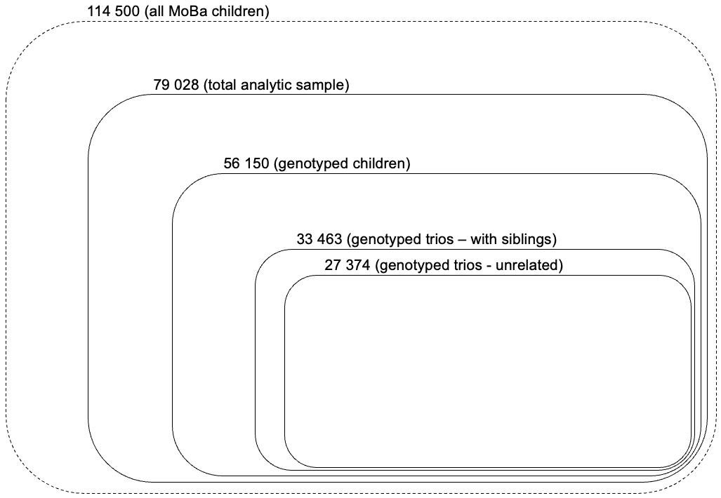
Figure S1. Overview of the number of participants for different analytic components.
The full MoBa sample includes 114 500 children, of which 79 028 had Child Behaviour Checklist data
on at least one time point, such that they could be included in the latent growth models; of those with phenotype data, 56 150 were genotyped; 33 463 mother, father, and child trios had available phenotype and genotype data; analyses were also repeated in 27 374 unrelated trios (with siblings in the parent and child generations excluded) as a sensitivity.

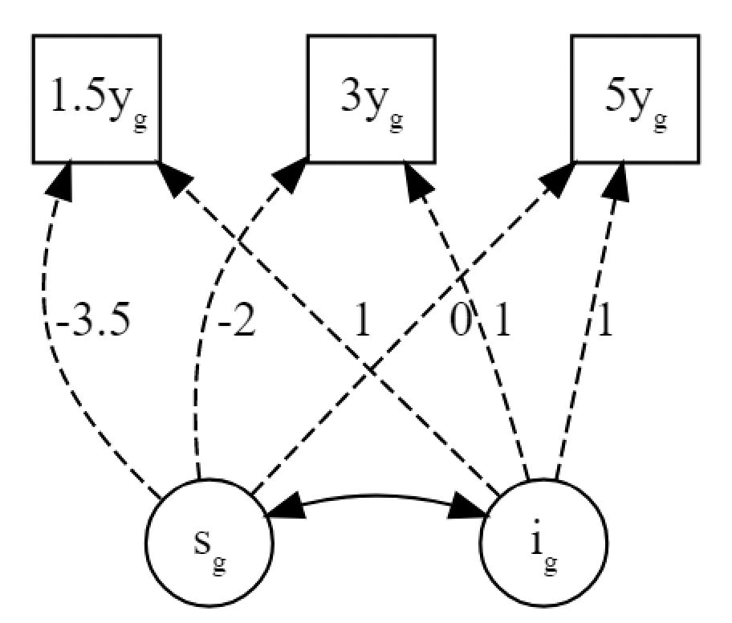
Figure S2. Illustration of latent growth model.
The _{g} subscript denotes components that are defined
by genomic variance; the intercept is specified at the
end of the growth process, meaning that this factor
reflects the endpoint of the children’s trajectories; s,
slope factor; i, intercept factor.
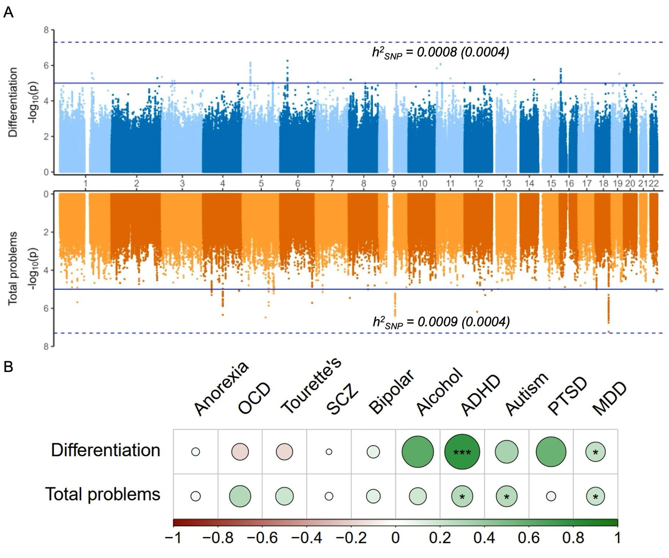
Figure S3. Genomic analyses of linear change in differentiation (in blue) and total problems (in orange), and genetic correlations of slope with 11 psychiatric conditions.
A, Results of multivariate GWAS of the differentiation slope (top) and total problem slope (bottom).
B, LDSC genetic correlations of 11 psychiatric and neurodevelopmental conditions with linear change in differentiation and total problems. The size and colour of each circle corresponds to the strength of the genetic correlation. For differentiation, positive values (in green) indicate relatively more behavioural than emotional problems, and negative values (brown) indicate relatively more emotional than behavioural problems. Note that anxiety was not included because genetic correlations could not be estimated. h²_{SNP} = single nucleotide polymorphism heritability (liability scale); OCD, obsessive- compulsive disorder; SCZ, schizophrenia; ADHD, attention-deficit hyperactivity disorder; PTSD, post-traumatic stress disorder; MDD, major depression. *p <.05; **p <.01; ***p <.001.

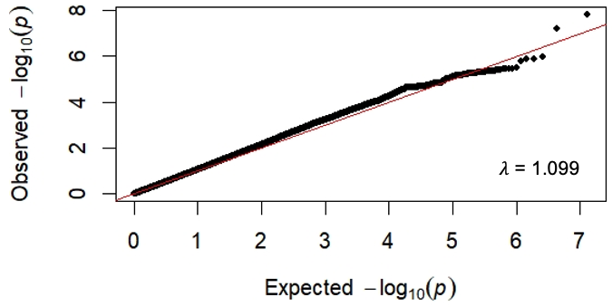
Figure S4. QQ plot for the multivariate GWAS of differentiation.
𝜆, lambda genomic inflation factor.

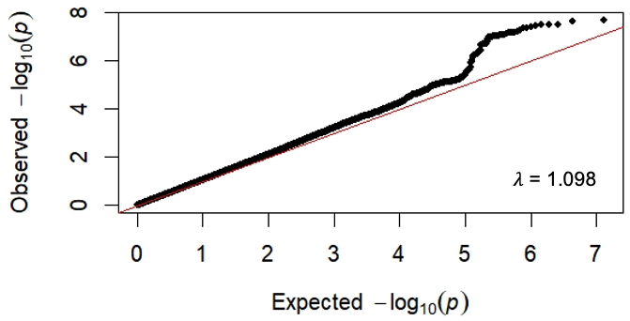
Figure S5. QQ plot for the multivariate GWAS of total problems.
𝜆, lambda genomic inflation factor.

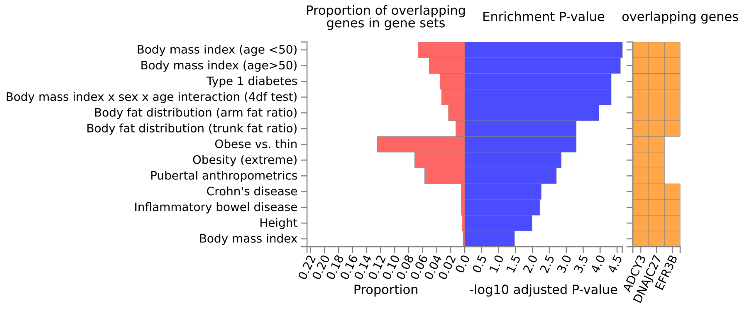Figure S6. Previously reported phenotypic associations with the three mapped genes.
Associations with the mapped genes previously reported in the GWAS catalogue, based on functional annotation conducted in FUMA. ADCY3, Adenylate Cyclase 3; DNAJC27, DnaJ Heat Shock Protein Family (Hsp40) Member C27; EFR3B, EFR3 Homolog B.
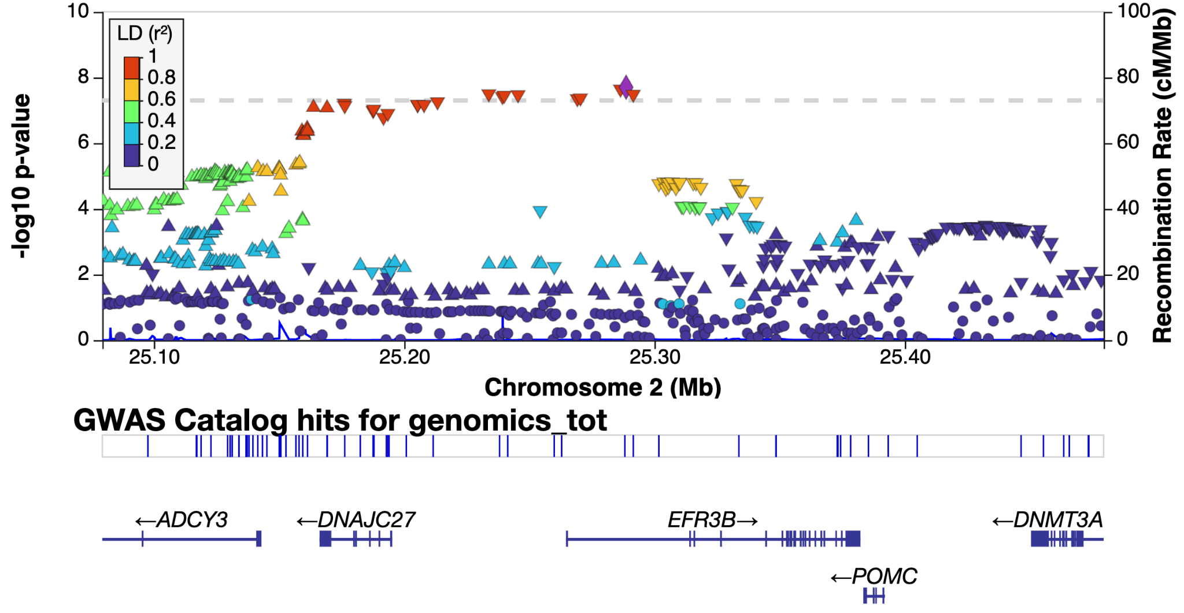
Figure S7. Locus zoom plot of LD structure for genomic hit linked to total problems.
LD structure plot generated by LocusZoom; LD, linkage disequilibrium; r², r squared.
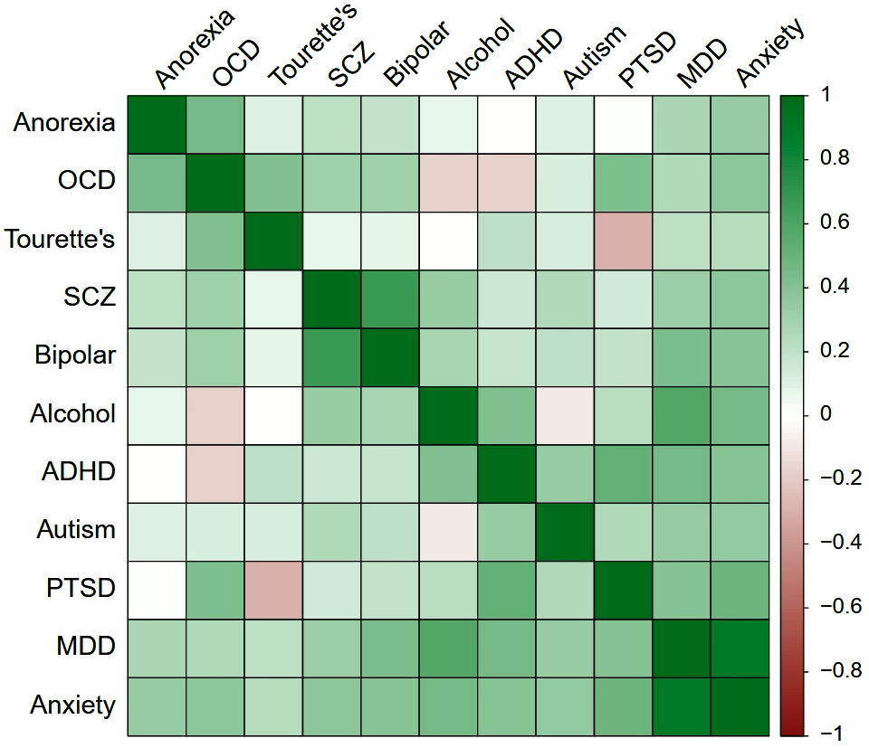
Figure S8. Genetic correlations among 11 psychiatric/neurodevelopmental conditions.
OCD, obsessive- compulsive disorder; SCZ, schizophrenia; ADHD, attention-deficit hyperactivity disorder; PTSD, post-traumatic stress disorder; MDD, major depression.

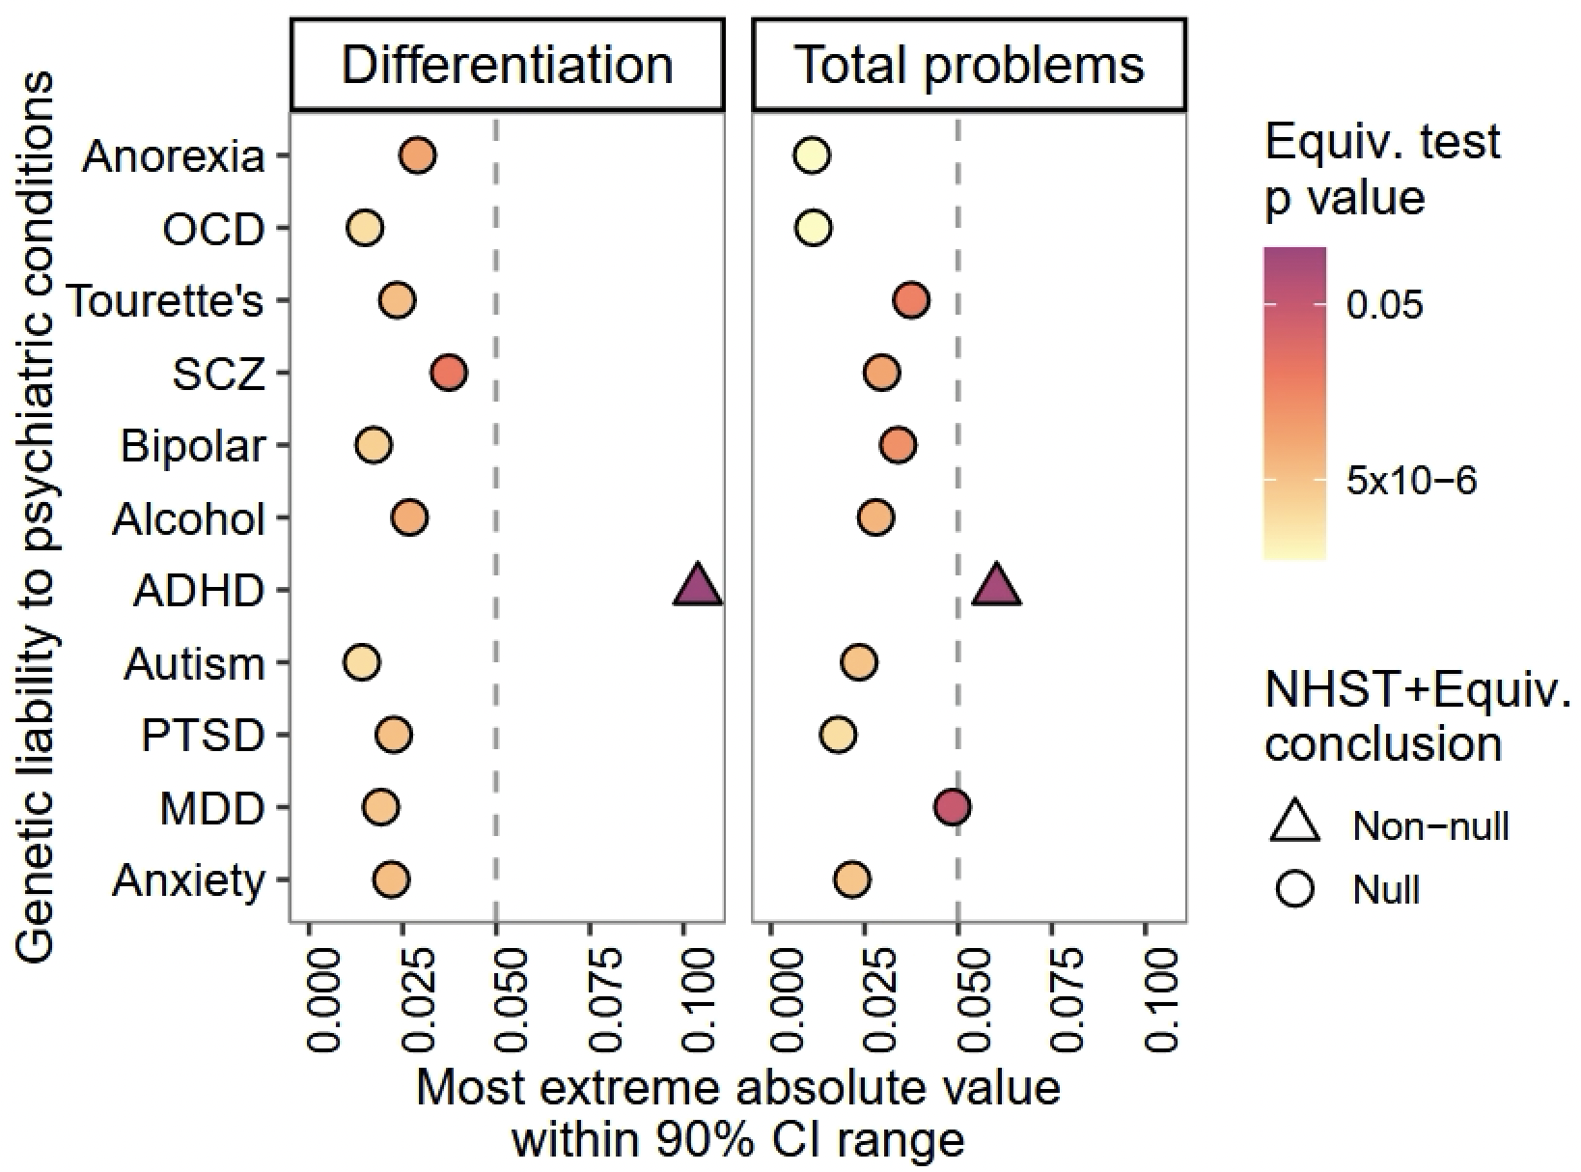
Figure S9. Equivalence testing of child-only sample PGS associations.
NHST, null hypothesis significance test; OCD, obsessive- compulsive disorder; SCZ,
schizophrenia; ADHD, attention-deficit hyperactivity disorder; PTSD, post-traumatic
stress disorder; MDD, major depression.

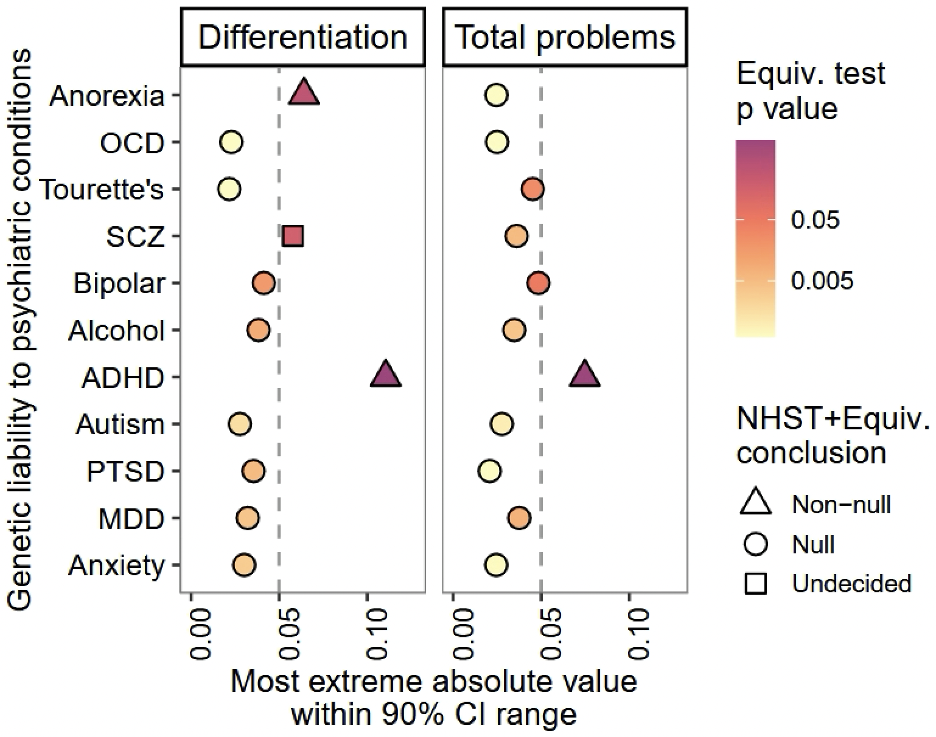
Figure S10. Equivalence testing of direct genetic effects from the trios.
NHST, null hypothesis significance test; OCD, obsessive- compulsive disorder; SCZ,
schizophrenia; ADHD, attention-deficit hyperactivity disorder; PTSD, post-traumatic
stress disorder; MDD, major depression.

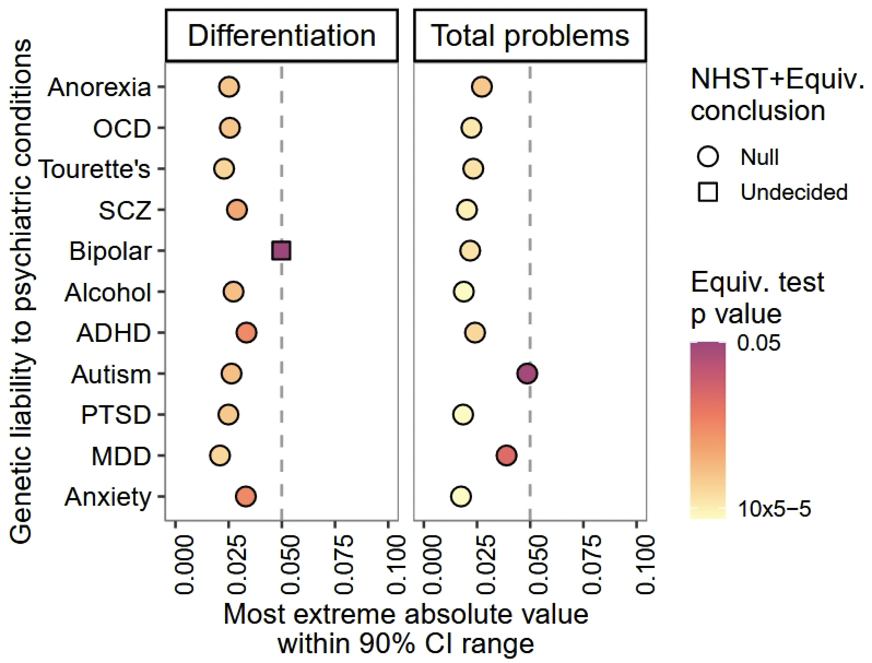
Figure S11. Equivalence testing of maternal indirect genetic effects in trios.
NHST, null hypothesis significance test; OCD, obsessive- compulsive disorder; SCZ,
schizophrenia; ADHD, attention-deficit hyperactivity disorder; PTSD, post-traumatic
stress disorder; MDD, major depression.

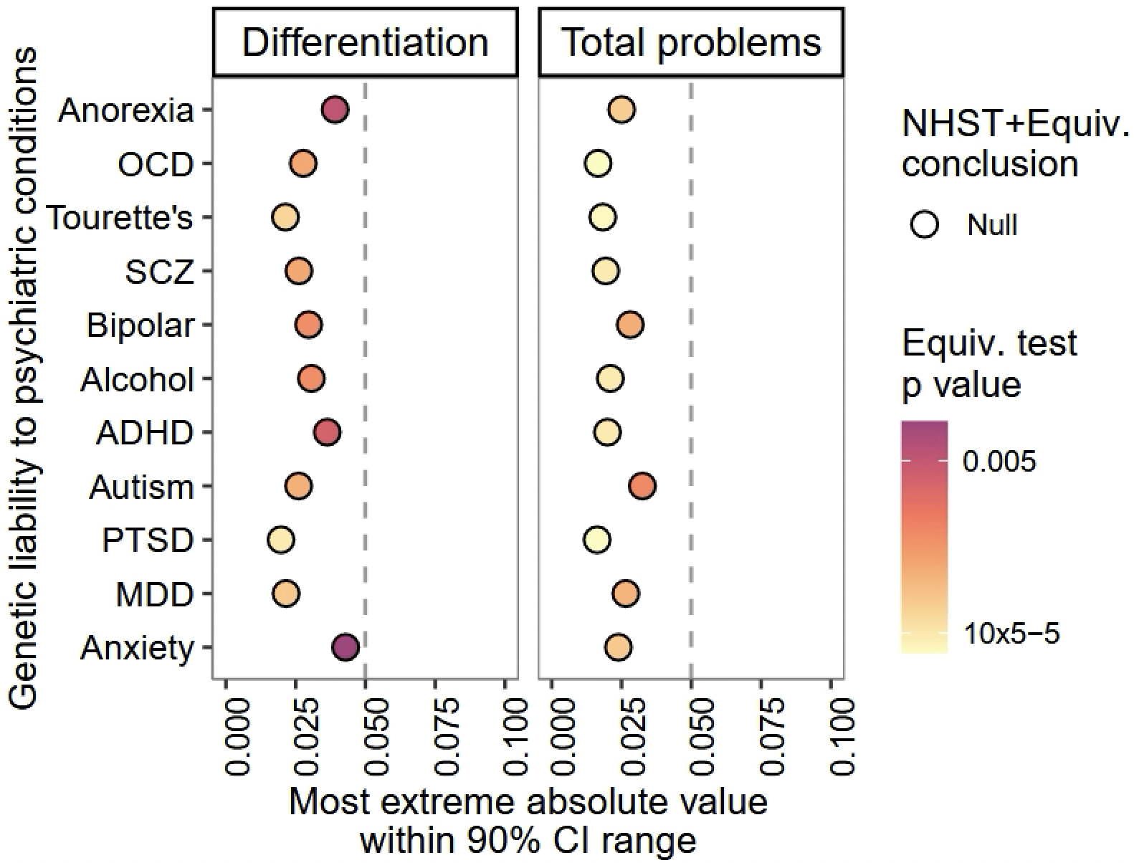
Figure S12. Equivalence testing of paternal indirect genetic effects in trios.
NHST, null hypothesis significance test; OCD, obsessive- compulsive disorder; SCZ,
schizophrenia; ADHD, attention-deficit hyperactivity disorder; PTSD, post-traumatic
stress disorder; MDD, major depression.

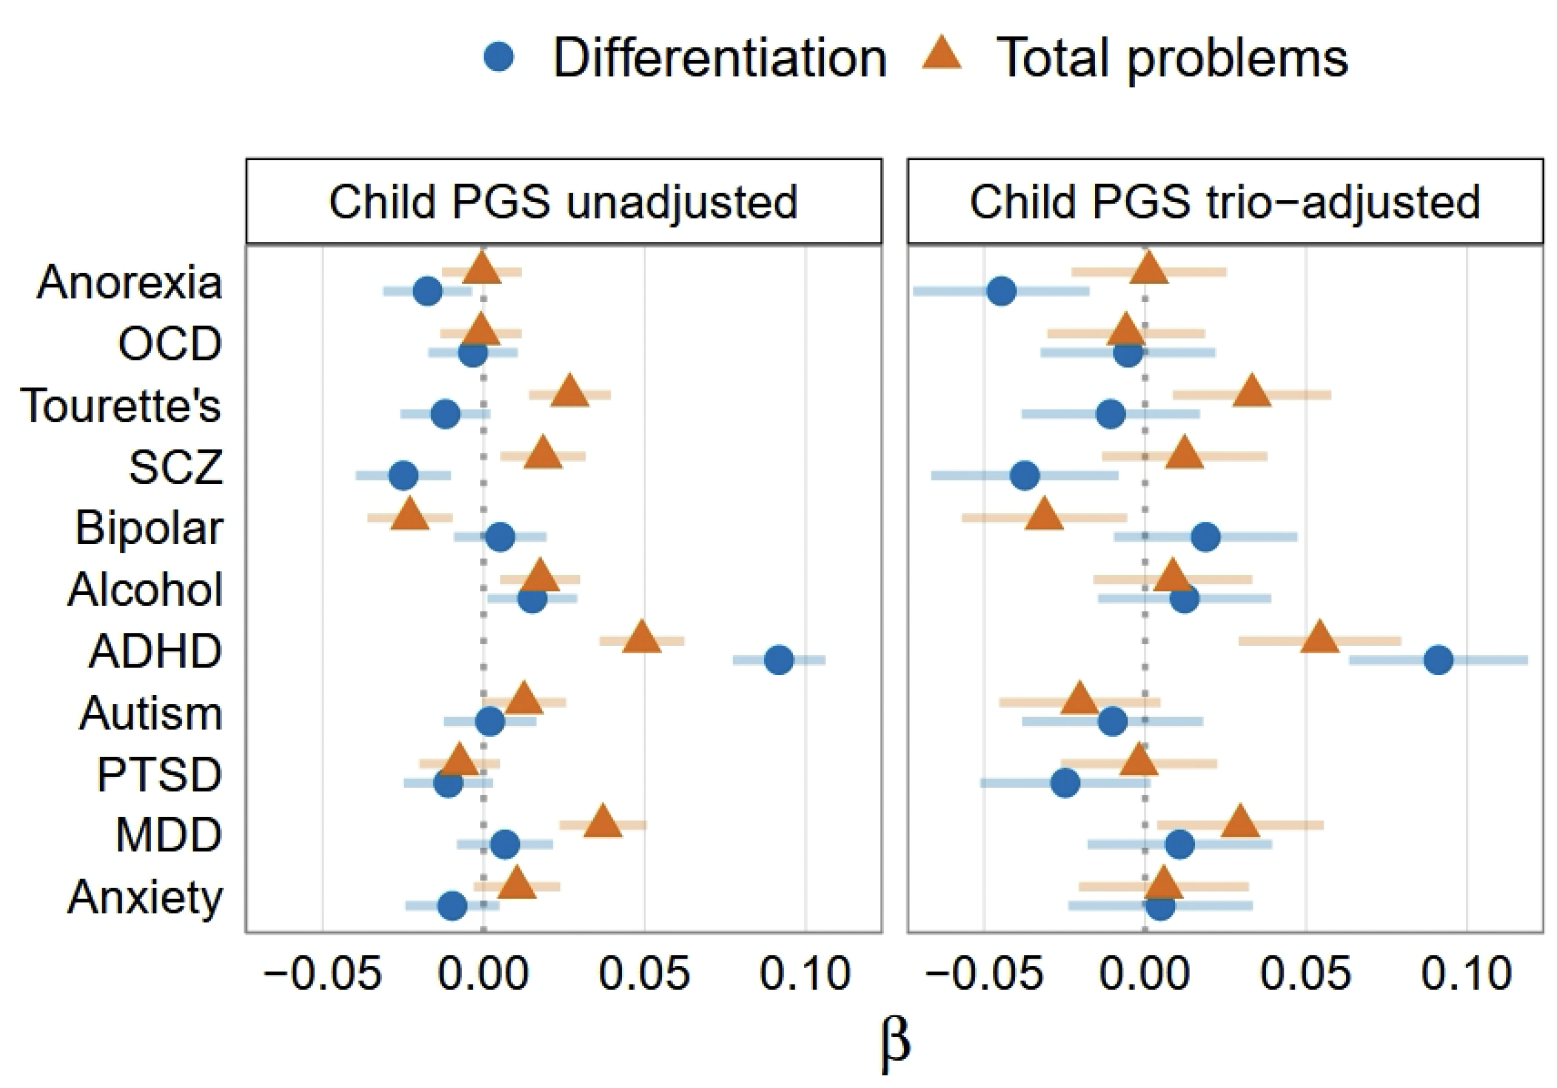
Figure S13. Unrelated trio results with child-only and trio-adjusted PGS effects.
OCD, obsessive- compulsive disorder; SCZ, schizophrenia; ADHD, attention-deficit hyperactivity disorder; PTSD, post-traumatic stress disorder; MDD, major depression.

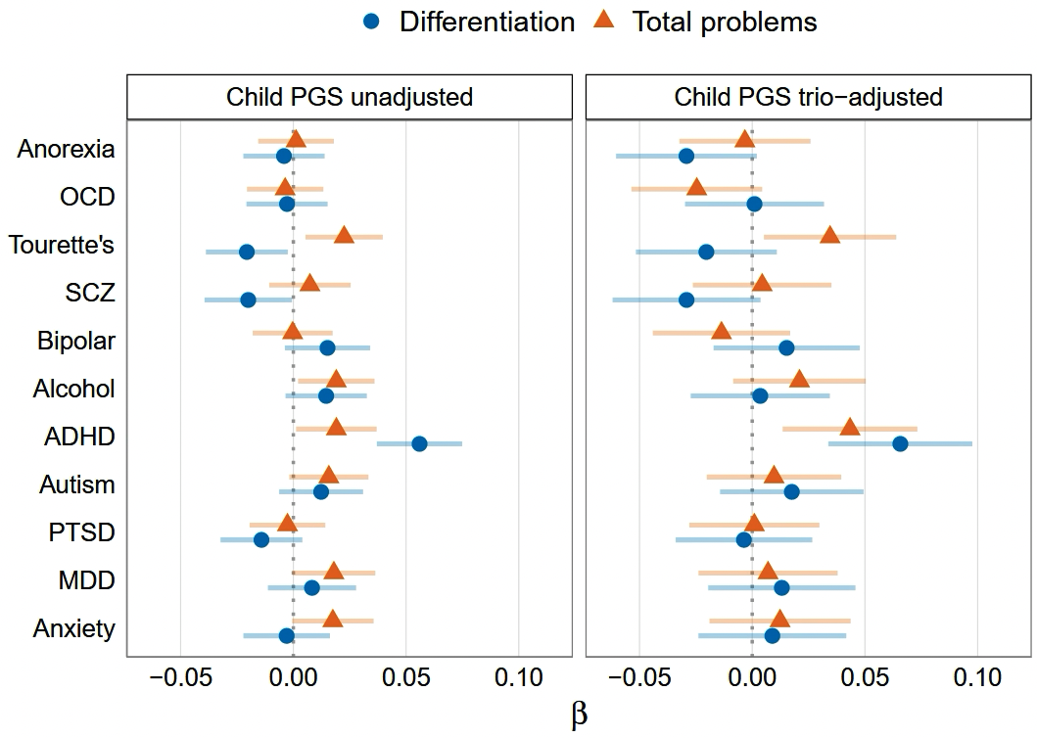
Figure S14. Child-only and trio-adjusted PGS associations with the slope factor.
OCD, obsessive- compulsive disorder; SCZ, schizophrenia; ADHD, attention-deficit hyperactivity disorder; PTSD, post-traumatic stress disorder; MDD, major depression.

