Table 1. Question categories and their meanings
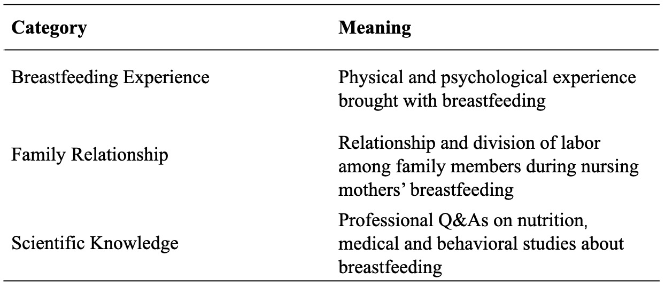

Table 2. The number of answers posted by professionals and laypeople under the three question categories regarding breastfeeding (N = 4447).

Question category Answer, n (%)
Breastfeeding experience
Professional 31 (2.29)
Laypeople 1,320 (97.71)
Family relationship
Professional 35 (3.44)
Laypeople 981 (96.56)
Scientific knowledge
Professional 115 (5.53)
Laypeople 1,965 (94.47)

Table 3. Answer length of professionals and laypeople under three question categories regarding breastfeeding (N = 4447).
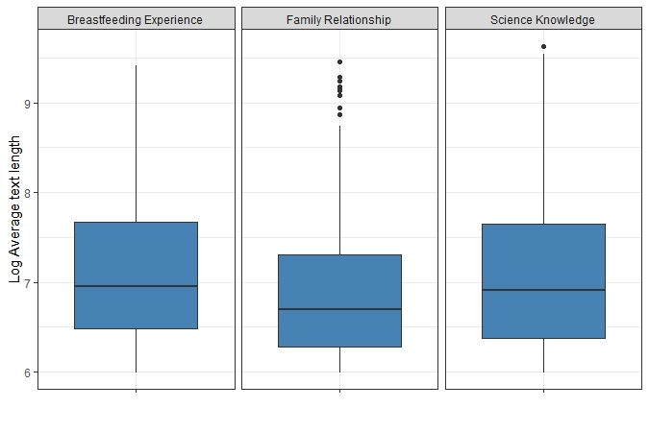

Table 4. Attitude distribution of professionals and laypeople under three question categories regarding breastfeeding (N = 4447).
