Supplementary Materials

Superconductivity in a breathing kagome metals ROs₂ (R = Sc, Y, Lu)
Karolina Górnicka^{1,2,3}, Michał J. Winiarski^{1,2}, Dorota I. Walicka³ and Tomasz Klimczuk^{1,2}
¹ Faculty of Applied Physics and Mathematics, Gdansk University of Technology,
ul. Narutowicza 11/12, 80-233 Gdańsk, Poland,
²Advanced Materials Centre, Gdansk University of Technology,
ul. Narutowicza 11/12, 80-233 Gdańsk, Poland,
³ Department of Quantum Matter Physics, University of Geneva,
24 Quai Ernest-Ansermet, 1211 Geneva 4, Switzerland.

Powder x-ray diffraction

Figure S1 presents the powder x-ray diffraction pattern for ScOs₂, YOs₂ and LuOs₂ together with the LeBail refinement. All compounds crystallize in hexagonal centrosymmetric MgZn₂ – type structure (P6₃/mmc, No. 194).
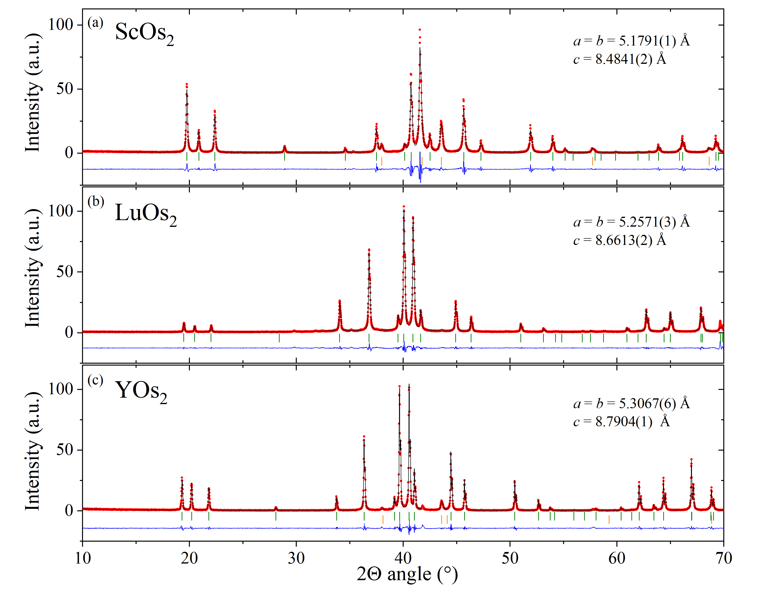
Figure S1. Powder x-ray diffraction pattern (pXRD) (red points) together with the LeBail refinement profile (black solid line) for ROs₂ (R=Sc, Lu and Y) compounds.
Figure S2 presents a schematic view of the hexagonal structure of ROs₂. The 4f (1/3, 2/3, z) site is occupied by RE atoms and the 2a (0,0,0) and 6h (x, 2x, 1/4) sites are occupied by Os atoms.
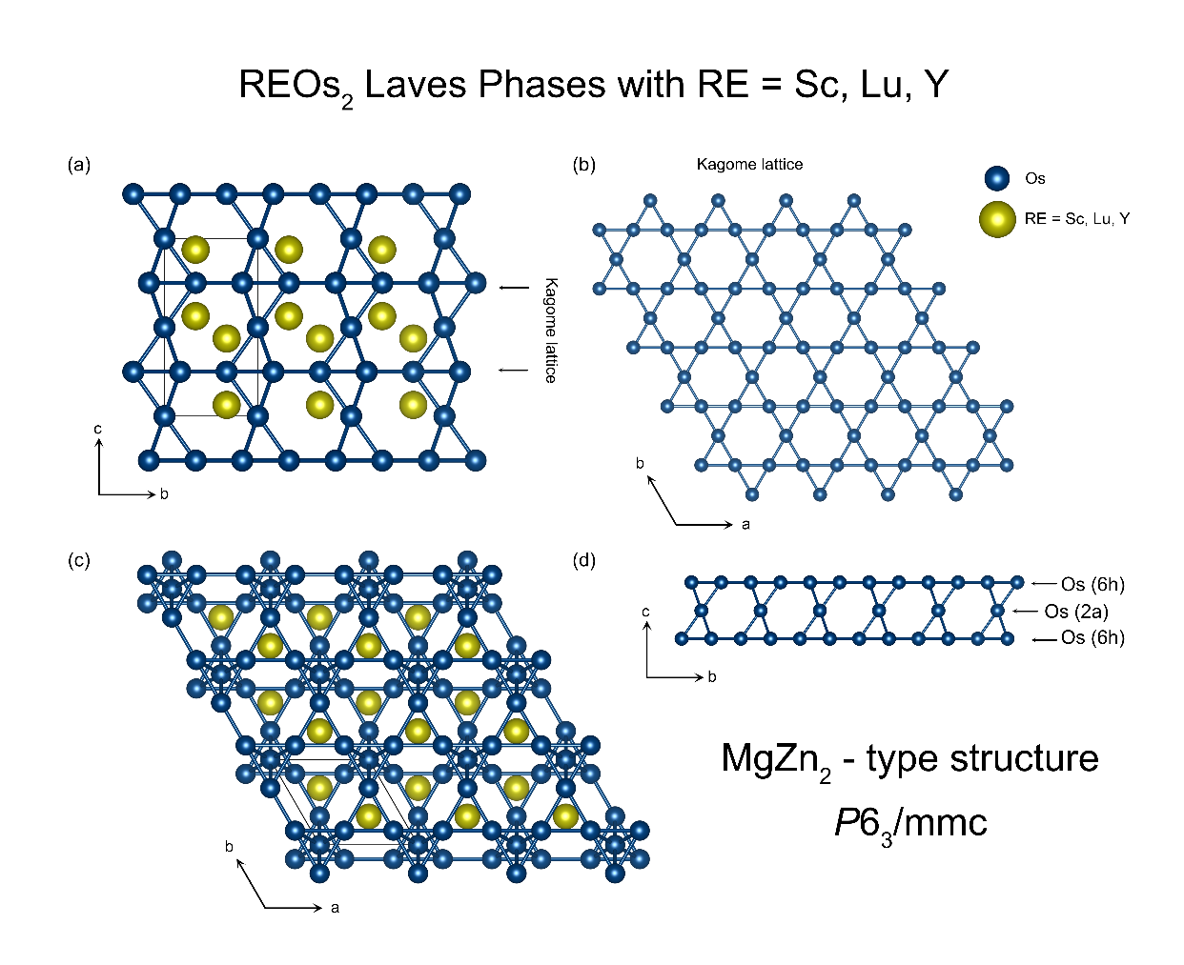
Figure S2. Crystal structure of ROs₂ viewed along different orientations with R and
Os atoms represented by yellow and blue balls, respectively.

Magnetic property measurements

Figure S3 depicts the magnetization as a function of magnetic field at several, selected temperatures below the superconducting transition temperature T_{c} for all studied compounds. For each temperature, the experimental data obtained in small magnetic fields were fitted using the proportionality M_{fit} = −aH, appropriate for a full Meissner state. Comparing the value of prefactor a derived from the isotherm taken at T = 1.7 K with the ideal diamagnetism quantified as −1/4π, the demagnetization factor (N = 0.33-0.73) for all Laves compounds was found.

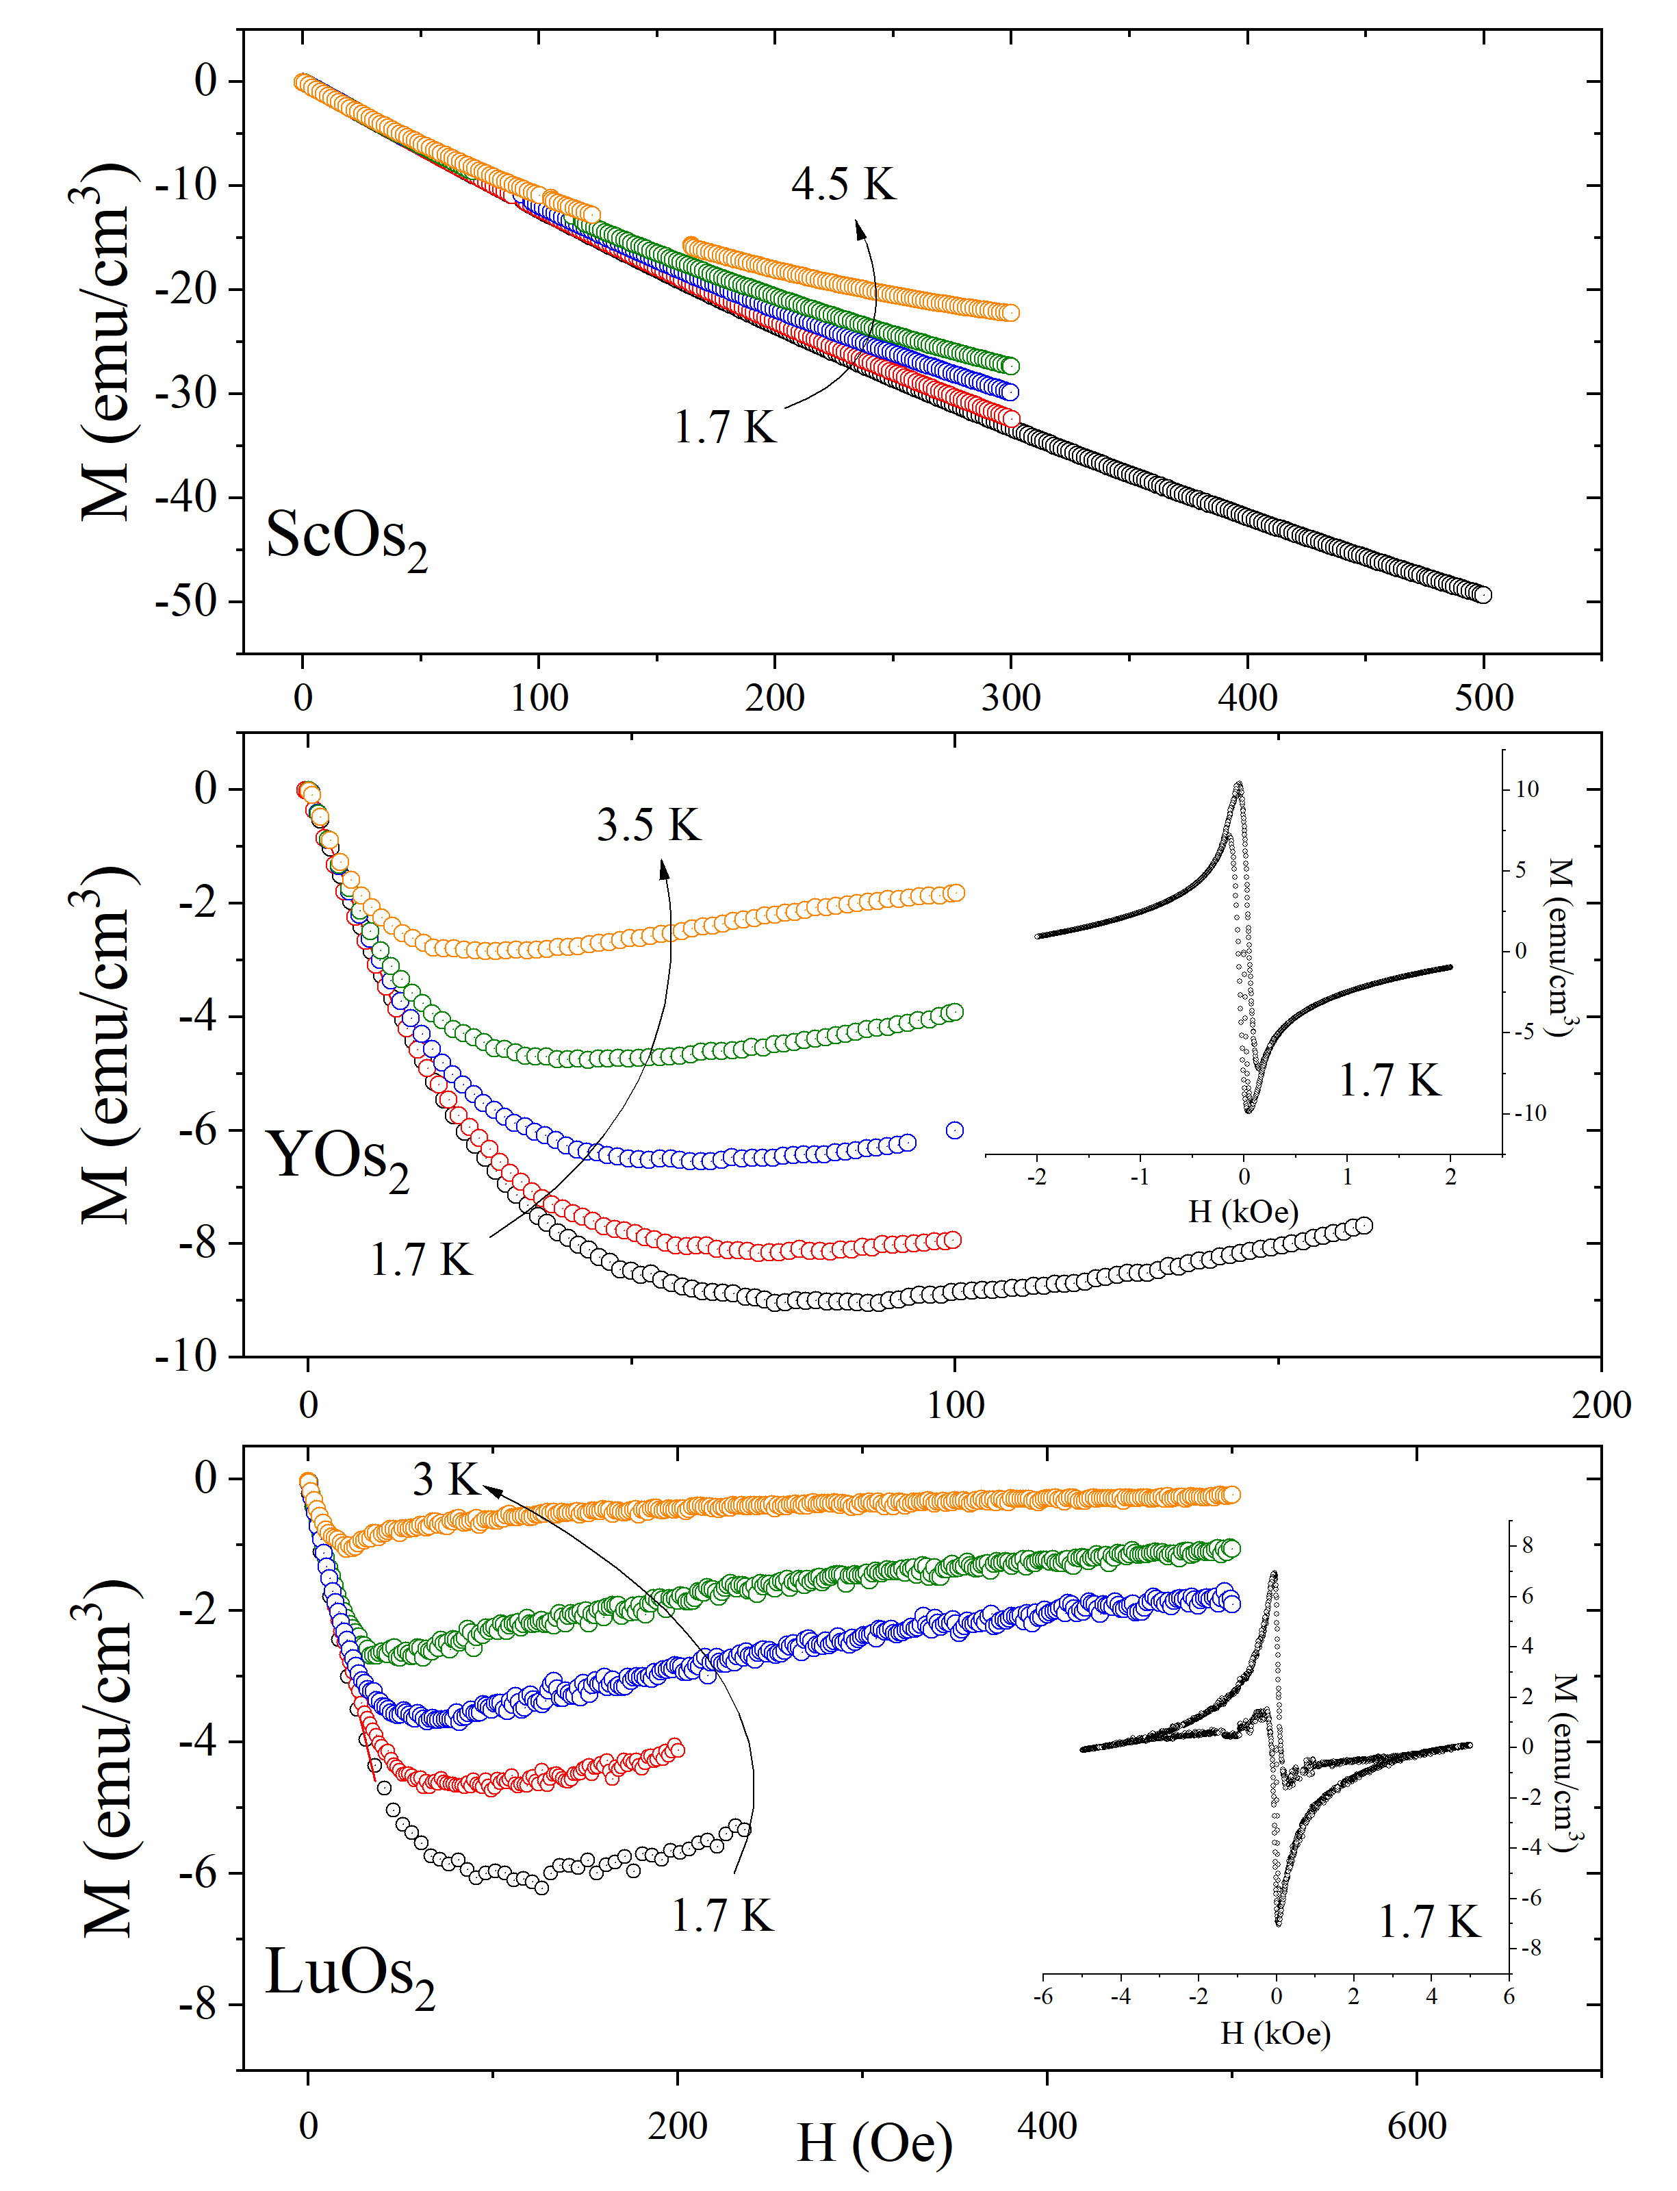
Figure S3. The field-dependent magnetization curves M(H) for ScOs₂, YOs₂, and LuOs₂ taken at different temperatures.

Electrical resistivity measurements

For a single-band type-II BCS superconductor, the orbital upper critical field at 0 K can be estimated from the Werthamer–Helfand–Hohenberg expression^{1,2}:
 | $$μ_{0}H_{c2}\left(0\right)=-AT_{c}{\left.\frac{dμ_{0}H_{c2}}{dT}\right| }_{T=T_{c}}$$ | (1)
where A is the purity factor given by 0.693 for the dirty limit. Table S1 presents the µ₀H_{c2}(0) value obtained from WHH and GL models for all investigated compounds.

Table S1. The upper critical field µ₀H_{c2}(0) estimated from WHH and GL models.
μ₀Hc₂(0) | Unit | ScOs₂ | YOs₂ | LuOs₂
GL | T | 2.58(1) | 2.23(2) | 1.64(5)
WHH | T | 1.90 | 1.62 | 1.37
µ₀$H_{c2}^{p}\left(0\right)$ | T | 9.90 | 8.40 | 6.4

References
1. Helfand, E. & Werthamer, N. R. Temperature and Purity Dependence of the Superconducting Critical Field, H c 2 . II. Phys. Rev. 147, 288–294 (1966).
2. Werthamer, N. R., Helfand, E. & Hohenberg, P. C. Temperature and Purity Dependence of the Superconducting Critical Field, H c 2 . III. Electron Spin and Spin-Orbit Effects. Phys. Rev. 147, 295–302 (1966).

