Morphological variation of the Baka pygmies’ deciduous second molars

Petra G. Šimková¹, Gerhard W. Weber^{1,2}, Fernando Ramirez-Rozzi^{3,4}, Lotfi Slimani⁵, Jérémy Sadoine⁵, Cinzia Fornai^{1,6}

¹Department of Evolutionary Anthropology, University of Vienna, Austria. ²Core Facility for Micro-Computed Tomography, University of Vienna, Austria. ³UMR7206 Ecoanthropologie, MNHN, CNRS, UP, Musée de l’Homme, Paris, France. ⁴EA 2496 Pathologies, Imagerie et biothérapies oro-faciales, Université Paris Descartes, Montrouge, France. ⁵UR2496 - Plateforme Imageries du Vivant, Université de Paris, Montrouge, France. ⁶Institute of Evolutionary Medicine, University of Zurich, Switzerland.

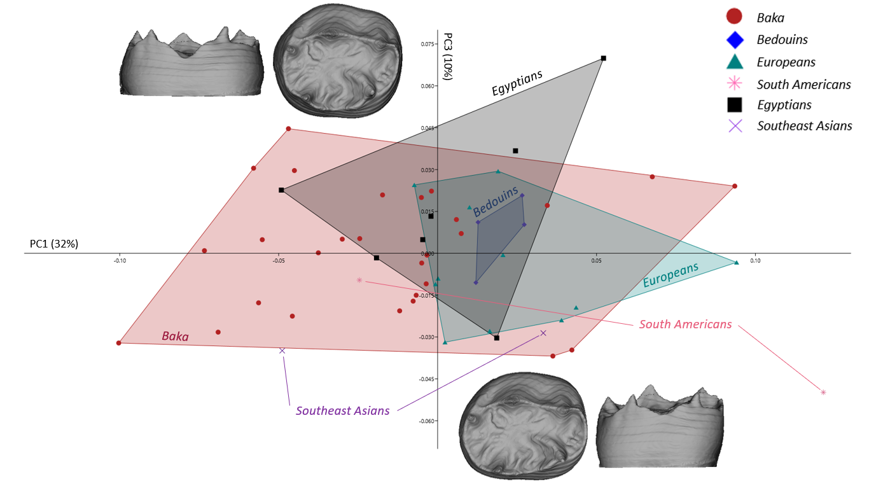
Supplementary Figure S1 PC1 – PC3 plot for the lower deciduous second molars in shape space for the combined EDJ and cervical outline. Along PC3 (explaining 10% of the total variance), the human groups overlap extensively. Shape changes are driven by the relative size of the tooth base in relation to the occlusal aspect, as well as changes in the crown height that increases with decreased relative size of the base (warpings at value ± 0.07). For the description of the results along PC1, see Fig. 1a in the main text.

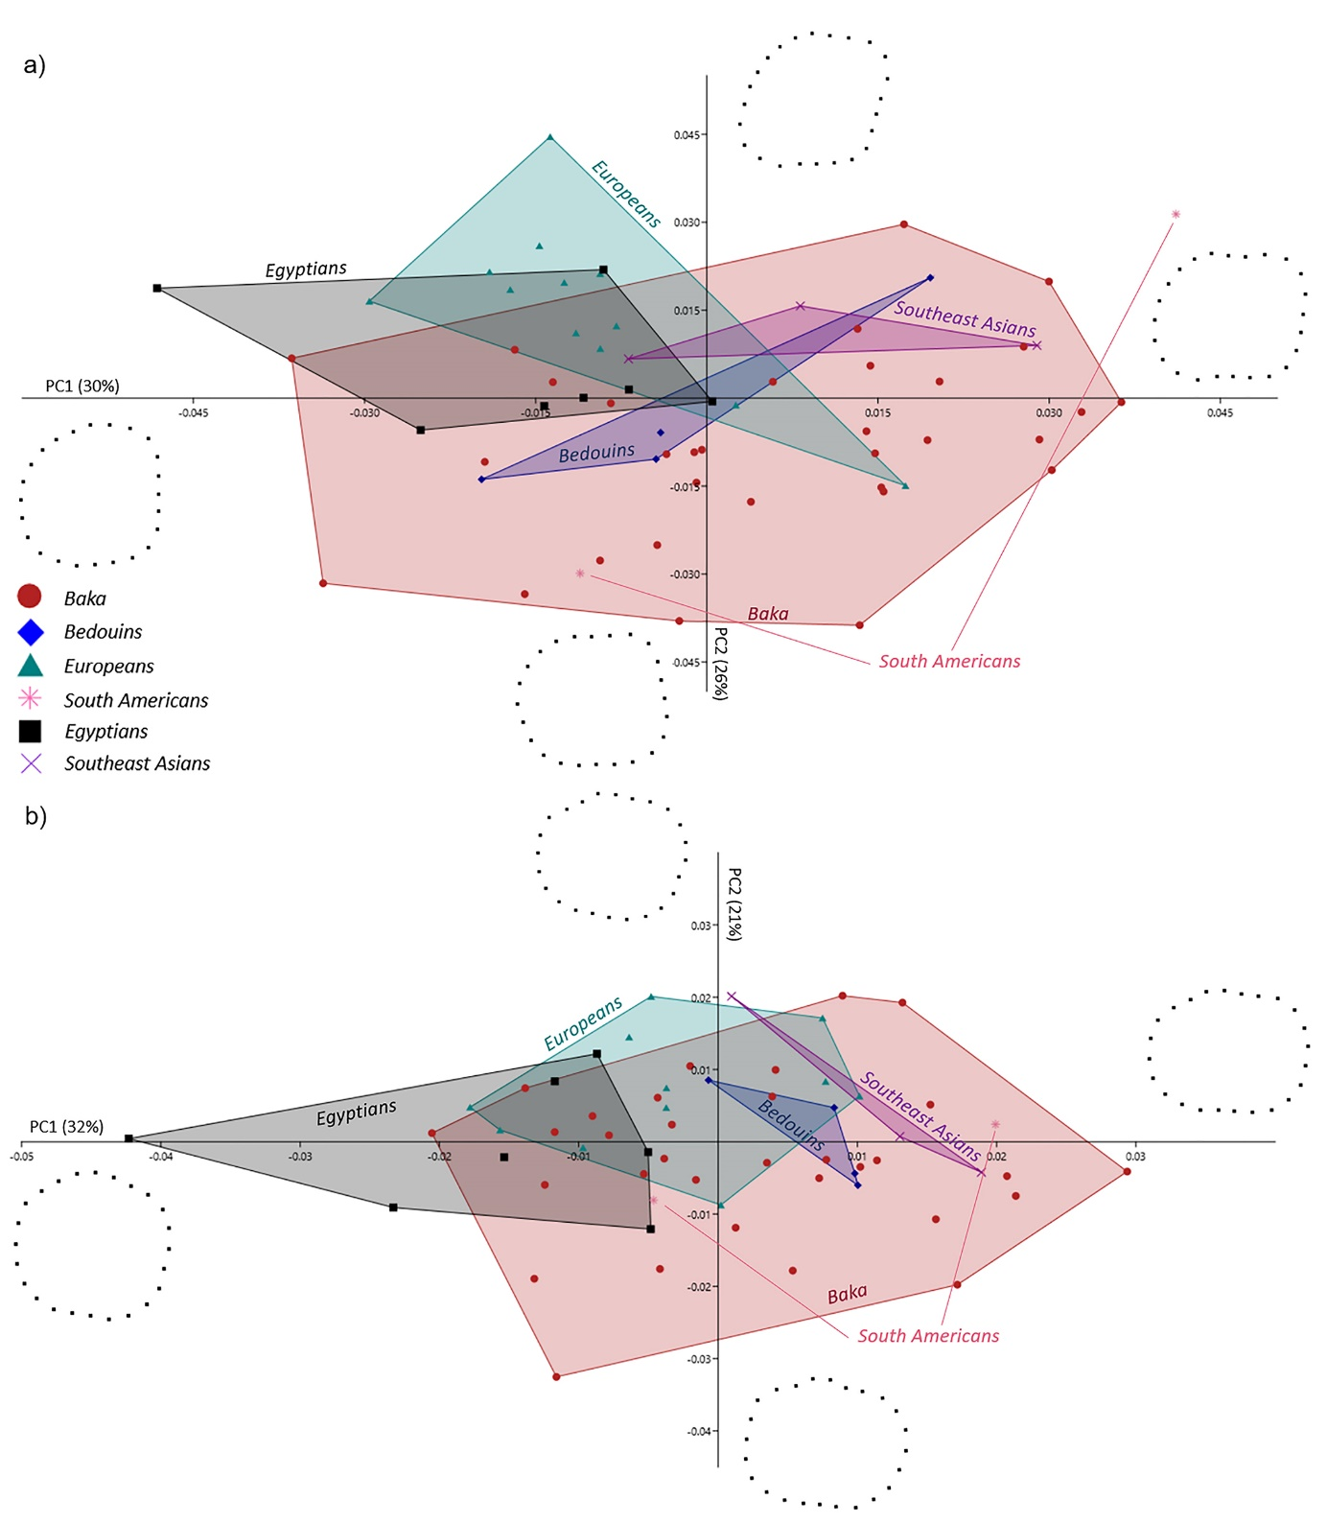

Supplementary Figure S2 PCA plots for the lower deciduous second molars’ dental outlines. a) PC1 - PC2 plot in shape space for the cervical outline (warpings at value ± 0.05). The Baka exceed the range of variation of the rest of the sample, for the particularly pronounced hourglass-like shaped cervical outlines; b) PC1 - PC2 in shape space for the crown outline (warpings at value ± 0.05). The Baka show an extreme variation expression in elongated and bucco-lingually constricted crown outlines.

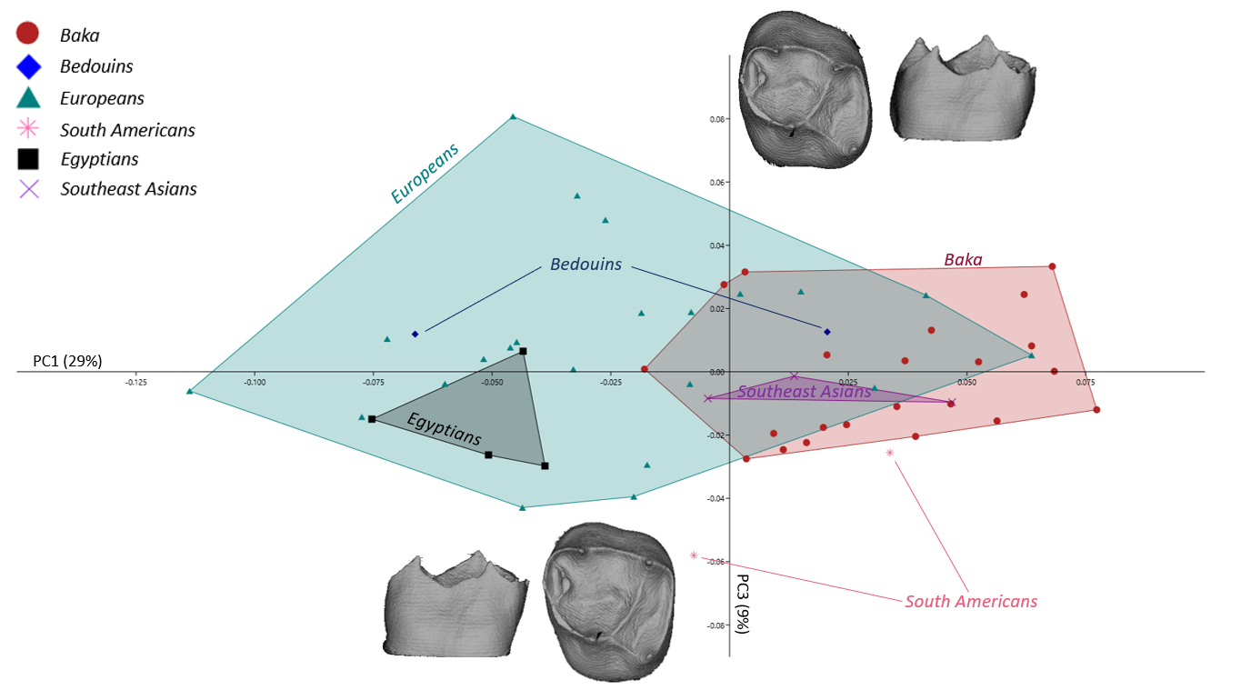
Supplementary Figure S3 PC1 – PC3 plot for the upper deciduous second molars in shape space for the combined EDJ and cervical outline. Along PC3 (explaining 9% of total variance), the variation is driven mainly by the relative expansion of the trigon with respect to the talon. The reduction of the trigon is associated with observed metacone reduction. The Europeans exceed the range of variation of the rest of the sample in both directions, while the Baka are much less variable and centered around the mean values (warpings at value ± 0.085). The two South American specimens possess particularly reduced talon. For the description of the results for PC1 see Fig. 1b in the main text.

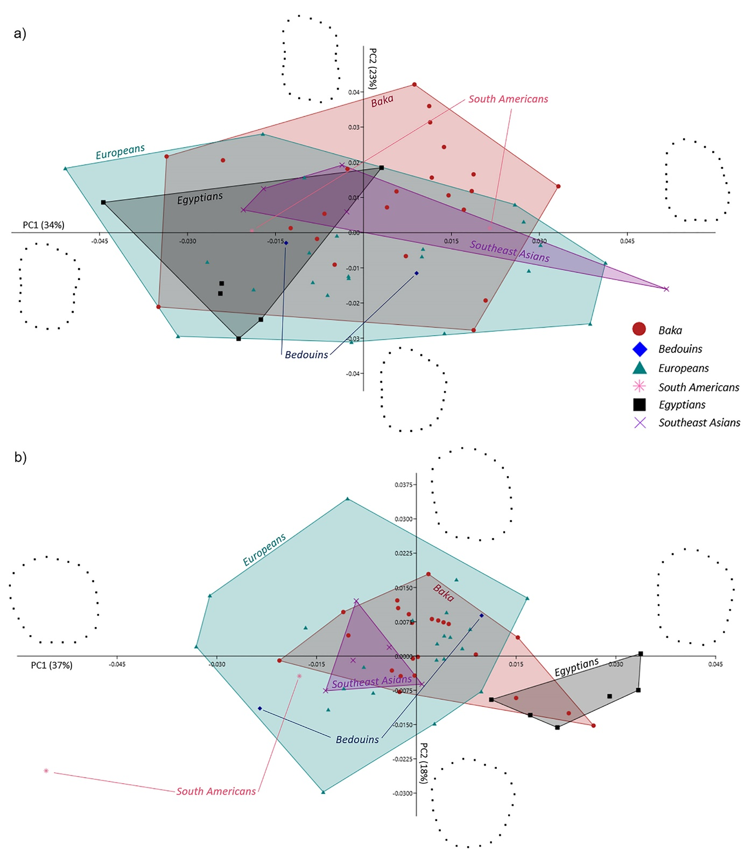

Supplementary Figure S4 PCA plots for the upper deciduous second molars’ dental outlines a) PC1 - PC2 plot in shape space for the cervical outline (warpings at value ± 0.05). The human groups overlap extensively; b) PC1 - PC2 plot in shape space for the crown outline (warpings at value ± 0.04). The Europeans are more variable than the Baka, and exceed the range of variance of the sample along PC2.

Supplementary Table 1. Variance on Procrustes shape coordinates for the Baka’s and Europeans’ dentinal crowns (combined EDJ and cervical outline) (ldm2s = lower deciduous second molars; udm2s = upper deciduous second molars).
 | The Baka | Europeans
ldm2 | 0.006 | 0.005
udm2 | 0.005 | 0.007

