Table 1. MR estimates from each method of assessing the causal effect of glaucoma on the risk of RVO
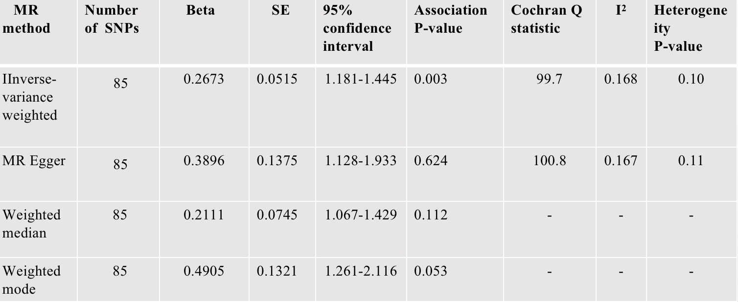
SNP, single nucleotide polymorphism; MR, Mendelian randomization; Beta, beta coefficient;SE, standard error;.
ªI² = (Q − df)/Q.²⁴

