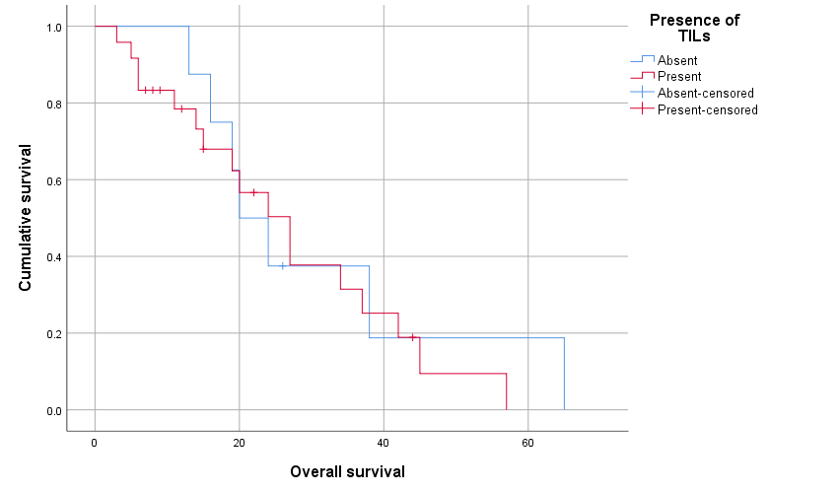
Fig. S1 Kaplan–Meier survival curves comparing the survival of patients with primary nodular melanoma with or without TILs (p = 0.662)

