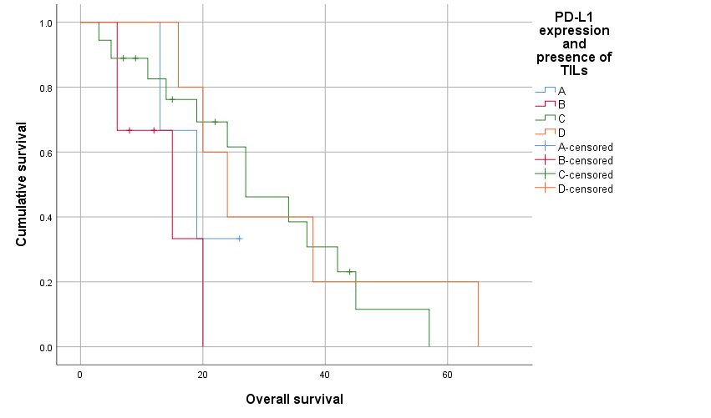 Fig. S2 Kaplan–Meier survival curves comparing the survival of patients with primary nodular melanoma based on PD-L1 expression and the presence of TILs (p = 0.090)
(A: upregulated PD-L1 without TILs, B: upregulated PD-L1 with TILs,
C: normoregulated PD-L1 with TILs, D: normoregulated PD-L1 without TILs)

