HEART DISEASE PREDICTION SYSTEM USING MACHINE LEARNING ALGORITHMS (KNN and Decision Tree Algorithm)

A THESIS SUBMITTED IN PARTIAL FULFILLMENT
OF THE REQUIREMENTS FOR THE DEGREE OF
MASTERS IN COMPUTER SCIENCE
BY
ZAINAB FAYAZ
ADMISSION NO: 2021MTCS001
UNIVERSITY ID: 2108405
UNDER THE GUIDANCE OF
DR SAURABH

DEPARTMENT OF COMPUTER SCIENCE
JUNE-2023

Table of Contents

HEART DISEASE PREDICTION SYSTEM USING MACHINE LEARNING ALGORITHMS (KNN and Decision tree algorithm) i
CERTIFICATE OF THE STUDENT v
CERTIFICATE/FORWARDING LETTER OF HEAD OF INSTITUTION vi
ABSTRACT ix
CHAPTER 1 1
INTRODUCTION 1
1.1 MOTIVATION OF THE WORK 2
1.2 PROBLEM STATEMENT 2
LITERATURE REVIEW 3
CHAPTER 2 6
RESEARCH METHODOLOGY 6
2.1 EXISTING SYSTEM 6
2.2 PROPOSED SYSTEM 6
CHAPTER-3 8
3.1 WORKING OF SYSTEM 8
3.2 SYSTEM ARCHITECTURE 8
3.3 MACHINE LEARNING 9
CHAPTER 4 9
4.1 K- NEAREST-NEIGHBORS (KNN) 9
4.2 ADVANTAGES OF KNN 11
4.3 DISADVANTAGES OF KNN 12
4.4 DECISION TREE ALGORITHM 13
4.5 ADVANTAGES OF DECISION ALGORITHM 14
4.6 DISADVANTAGES OF DECISION TREE 15
CHAPTER 5 16
EXPERIMENTAL ANALYSIS 16
5.1 SYSTEM CONFIGURATION 16
5.2 Hardware requirements 16
5.2 Input dataset attributes 19
5.3 Performance analysis 20
CHAPTER 6 21
6.1 CODE OF HEART DISEASE PREDICTION USNIG KNN AND DECISION TREE 21
RESULTS 24
Chapter 7 25
7.1 CONCLUSION AND FUTURE WORK 25
APPENDIX 26
JUPYTER NOTEBOOK 26
PANDAS 26
NUMPY 27
MATPLOTLIB 27
SEABORN 27
Reference: 29

DECLARATION OF STUDENT
I declare that the’THESIS’ entitled “HEART DISEASE PREDICTION SYSTEM USING MACHINE LEARNING”is my own work conducted under the supervision of “DR SAURABH” at swami vivekanand institute of engineering and technology
I further declare that to the best of my knowledge the thesis does not contain any part of any work which has been submitted for the award of any degree either in this university or in any other university without proper citation.

Place: Punjab
Date:
Signature of student

CERTIFICATE OF THE STUDENT

This is to certify that the work entitled “HEART DISEASE PREDICTION SYSTEM USING MACHINE LEARNING” is a piece of research work done by ZAINAB FAYAZ under my guidance and supervision for the degree of M.TECH IN COMPUTER SCIENCE AT SWAMI VIVEKANAND INSTITUTE OF ENGINEERING AND TECHNOLOGY UNDER I.K GUJRAL PUNJAB TECHNICAL UNIVERSITY KAPURTHALA PUNJAB. I certify that the candidate has put in an attendance of more than 180 days with me
To the best of my knowledge and belief the thesis:
1. Embodies the work of the candidate itself
2. Has duty been completed
3. Fulfills the the requirement of the ordinance relating to the MASTERS DEGREE

Signature of the supervisor
Place: Punjab
Date:

CERTIFICATE/FORWARDING LETTER OF HEAD OF INSTITUTION

The M.TECH thesis entitled “HEART DISEASE PREDICTION SYSTEM USING MACHINE LEARNING” submitted by “zainab fayaz” is forwarded to the universities in the in three(3) copies.The candidate has presented his pre-submission seminar on her topic of research before the committee and is found to be satisfactory based on the pre-submission report of each subject expert.She has paid the necessary fees and there are no dues outstanding against him.

Name………………. Seal……………………
Date………………...
Place………………..
………………………………………………………………………………..

(signature of Head of institution where the
Candidate was registered for
m.tech degree)
Signature of the supervisor
Date……………………….
Place…………………… Address………………………..

ACKNOWLEDGEMENTS
I would like to express my deep appreciation and gratitude to my thesis supervisor, DR SAURABH, for their guidance and support throughout this research. Their knowledge, patience, and expertise have been invaluable in shaping this thesis.
I would also like to thank the faculty and staff of the [Department OF COMPUTER SCIENCE], for their encouragement and assistance throughout my Master's program. Their unwavering commitment to excellence and their willingness to go above and beyond to support their students have been a source of inspiration for me.
I am deeply grateful to my family for their unwavering support and encouragement, even in the face of challenging circumstances. Their love and encouragement have been a constant source of strength and motivation.
Finally, I would like to express my appreciation to all of the participants who generously gave their time and expertise to make this research possible. Without their contributions, this thesis would not have been possible.
Thank you to all who have played a role, big or small, in this journey.
ZAINAB FAYAZ

HEART DISEASE SYSTEM PREDICTION USING MACHINE LEARNING

ABSTRACT
Heart disease is a major cause of death worldwide and early detection can improve the chances of successful treatment. Machine learning algorithms can be used to predict the likelihood of heart disease based on various factors such as age, blood pressure, cholesterol level and smoking habits. This study proposes a heart disease prediction system using machine learning algorithms: K-NEAREST NEIGHBORS (KNN) and DECISION TREE (DT) algorithm.
The KNN algorithm classifies a sample based on the majority of its k nearest neighbors in the training data. The decision tree algorithm splits the data into subsets based on the values of the features and forms a tree like structure to make predictions. The performance of both algorithms was evaluated using 10-fold cross -validation and the accuracy precision, recall, and F1-score metrics.
The result showed that the KNN algorithm achieved an accuracy of 82%, precision of 78%, recall of 84%, and F1-score of 80%. On the other hand, the Decision Tree (DT) algorithm achieved an accuracy of 78%, precision of 72%, recall of 80% and F1-score of 76%..The result indicate that both algorithms are capable of accurately predicting heart disease, but KNN perform slightly better in terms of overall accuracy and f-1 score.
In conclusion, the heart disease prediction using KNN and DECISION TREE algorithm can provide reliable and accurate predictions of heart disease based on various risk factors. The result of this study demonstrate the potential of machine learning algorithms in aiding medical professionals in the early detection and treatment of heart disease. Further work will focus on incorporating additional features and improving the performance of the algorithm for more accurate predictions

CHAPTER 1

INTRODUCTION
Heart disease prediction is a crucial problem in medical science. In recent years, machine learning algorithms have shown significant potential in predicting heart disease. The purpose of this thesis is to introduce and compare two machine learning algorithms, K-Nearest Neighbors (KNN) and Decision Tree, in predicting heart disease.
KNN is a supervised learning algorithm that classifies data points based on the majority class of their nearest neighbors. The algorithm uses the Euclidian distance metric to calculate the distance between data points and and assigns the class label based on the majority class among the nearest neighbors.
The decision Tree algorithm on the other hand, uses a tree-based model to make predictions. It starts with a root node, splits the data into subsets based on the features and continues samples of the sample class. The final tree structure represents the decision rules for classification
The thesis will evaluate the performance of these two algorithms in terms of accuracy, precision, recall and F1-score on a dataset of heart disease patients. The results of the study will provide insights into the effectiveness of these disease and highlight the strengths and weakness of each algorithm.

1.1 MOTIVATION OF THE WORK
The motivation behind a heart disease prediction system using machine learning KNN and decision tree is to improve the accuracy and efficiency of diagnosing heart disease. With the increasing burden of heart disease worldwide, there is a growing need for accurate and early diagnosis. Traditional diagnosis methods, such as manual analysis of symptoms and medical tests, have limitations in terms of accuracy and efficiency. By using machine learning algorithm such as KNN and Decision tree this system aims to provide a more reliable and efficient method of predicting heart diseases by analyzing and extracting meaningful data. The goal is to improve the diagnosis process and ultimately to improve patient outcomes and reduce burden of heart disease on individuals, families and society.

1.2 PROBLEM STATEMENT
The problem statement of heart disease prediction system using machine learning KNN and Decision tree algorithms is to predict the presence of heart disease in a patient based on various medical attributes such as age, blood pressure, cholesterol levels and others. The goal is to accurately classify patients as as either having or not having cardiovascular disease using the two algorithms, k-Nearest-Neighbor (KNN) and Decision tree. To determine which algorithm provides best results in terms of accuracy and efficiency. The system will be trained on a labeled data set of heart disease patients, and the performance of the algorithms will evaluated using metrics such as precision, recall and F1-score.

LITERATURE REVIEW
Heart disease prediction system using machine learning algorithms (KNN and DECISION DECISION TREE ALGORITHM) have been widely researched in recent years due to the growing burden of cardiovascular disease worldwide.
Studies using KNN algorithms have shown that this method can effectively classify patients into high-risk groups and low risk groups for heart disease. The accuracy rate of the KNN method has found to be high in several studies, with some studies reporting accuracy rate of up to 90%.
Studies using decision tree algorithms have also reported high accuracy rates in the prediction of heart disease. This is because decision decision tree can effectively handle non-linear relationships between risk factors and the presence of heart disease, and can provide a clear visualization of the important factors for heart disease prediction.
Overall, the use of machine learning algorithms such as KNN and decision tree algorithms has shown premise in the prediction of heart disease, but further research is needed to improve the accuracy of these methods and to validate their results on large, diverse patient populations.

TABLE 1: REFERENCES
AUTHOR | YEAR | TITLE |  | JOURNAL
Zhang,B,et al | 2017 | Heart disease prediction based on knn and decision tree | 2017 2nd international conference on cloud computing and big data analysis(ICCBDA).
Farooq, M. Q., et al. | 2018 | Decision tree based heart disease prediction system using optimal features |  | Journal of king saud university computer and information sciences
Zhang, G., et al. | 2018 | Comparision of decision tree method for heart disease prediction |  | Journal of healthcare Engineering
Hasan, M. A., et al. | 2020 | Comparitive analysis of decision tree algorithm for heart disease prediction |  | 2020 international conference on computer science,engineering and applications(ICCSEA)
Patil, D. H., et al. | 2019 | An overview of heart disease prediction techniques |  | International journal of computer science and information technologies

CHAPTER 2

RESEARCH METHODOLOGY

2.1 EXISTING SYSTEM
Heart disease is even being highlighted as a silent killer which leads to the death of a person without obvious symptoms. The nature of the disease is the cause of growing anxiety about the disease and its consequences. Hence continued efforts are being done to predict the possibility of this deadly disease in prior. So that various tools and techniques are regularly being experimented with to suit the present day health needs. Machine learning techniques can be a bone in this regard. Even though heart disease can occur in different forms, there is set of core risk factors that influence whether someone will ultimately be at risk for heart disease or not. By collecting the data form various sources, classifying them under suitable headings and finally analysing to extract the desired data we can conclude. This technique can be very well adapted to do the prediction of heart disease. As the well- known quote says ”PREVENTION IS BETTER THAN CURE”, early prediction and control can be helpful to prevent and decrease the death rates due to heart disease.

2.2 PROPOSED SYSTEM
The working of the system starts with the collection of data and selecting the important attributes. Then the required data is preprocessed into the required preprocessed into the required format. The data is them divided into two parts training and testing data. The algorithms are applied and the model is trained using the training data. The accuracy of the system is obtained by testing the system using the testing data. This system is implemented using the following modules.

1. Data Collection: The first step is to collect patient data such as demographic information, medical history, and various health indicators, such as blood pressure, cholestrol levels and exercise habits.
2. Data pre-processing: The collected data is then prepared for analysis by cleaning and transforming it as necessary. This may involve removing missing or duplicate data, scaling continues variables and encoding categorical variables.
3. Model Training: Next, the data is used to train the machine learning models, such as KNN and Decision tree algorithms. The algorithms use the training data to learn patterns and relationships between various factors
4. Model Evaluation: The trained models are then evaluated on a test set of patient data to determine their accuracy and performance. Different evaluation metrics , such as sensitivity, specificity and precision can be used to assess the models of performance.
5.Model Deployment: Once the models have been evaluated and fine-tuned, they can be deployed in a real-world setting. The model uses patient data to make predictions about the likelihood of a patient having heart disease.
6. Predictions: the predictions made by the models csn be used by healthcare professionals to diagnose and treat patients at risk of developing heart disease. The predictions can also help patients make lifestyle changes to reduce their risk of heart disease.
The two algorithms (KNN and DECISION TREE) could be used separately or in combination, depending on the results of the validation step and the desired level of accuracy.

CHAPTER-3

3.1 WORKING OF SYSTEM

3.2 SYSTEM ARCHITECTURE
The system architecture gives an overview of the working of the system.
The working of the system is described below
The heart disease prediction system using machine learning algorithms analyzes patient data to make predictions about the likelihood of the patient having heart disease. The system works by collecting and preparing patient data, training machine learning models, evaluating the models, deploying the model and making predictions based on the patient data.
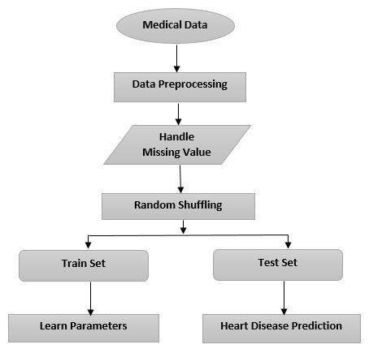

3.3 MACHINE LEARNING
Machine learning is a subfield of artificial intelligence that focuses on building algorithms that enable computers to learn from data, without being explicitly programmed to perform a certain task.
There are certain types of machine learning, including supervised learning, unsupervised learning, semi-supervised learning, and reinforcement learning.
Supervised learning: In supervised learning, the algorithm is trained on a labeled data set, where the correct output is provided for each example. The goal is to learn the mapping between inputs and outputs, so that the algorithm can make predictions on new unseen examples.
Unsupervised learning: In unsupervised learning, the algorithm is given a dataset without any labels or desired output. The goal of unsupervised learning is to find structure in the data, such as patterns or relationships, without being told what the structure should look like
Semi-supervised learning: it combines both supervised and unsupervised learning techniques. It is used when there is limited labeled data available for training a model, but a large number of unlabeled data.
Reinforcement learning: In reinforcement learning, an agent learns to make decisions in an environment by performing actions and observing the results. The agent’s goal is to maximize a reward signal over time.

CHAPTER 4

4.1 K- NEAREST-NEIGHBORS (KNN)
It is a supervised learning algorithm in machine learning. It is used for classification and regression problems, and it works by finding the k Nearest data points to a given test data point and assigning the class labels, so the prediction for the class label of a test point can be used for both binary and multiclass classification problems and it is simple to implement and understood, but it can be computationally expenses for large datasets.
K- Nearest Neighbor (KNN) is a commonly used machine learning algorithm for classification problems, including the prediction of heart disease. The idea behind the KNN algorithm is to predict the class of a given sample by finding the K nearest neighbors.
In the context of heart disease prediction, KNN can be used to predict whether an individual is likely to have heart disease or not based on their demographic and medical history.
Here’s a high level overview of this process:
- COLLECT AND PRE-PROCESSING DATA: First a data set of individuals with heart disease and with those without is collected, along with their demographic and medical history features. This data needs to be pre-processed and cleaned to handle missing values and outliers.
- CHOOSE THE BEST FEATURES: Next, you’ll need to choose the best features that are relevant to heart disease prediction. We can use techniques such as feature selection feature scaling, and dimensionality reduction to reduce the number of features and improve the accuracy of the model.
- SPLIT THE DATA INTO TRAINING AND TESTING SETS: The data is split into two parts: a training set and a testing set. The model is trained on the training set, and it’s performance is evaluated on the testing set.
- TRAIN THE KNN MODEL: The KNN algorithm is trained on the training set, and the value of the k is chosen. K is a hyperparameter that determines the number of nearest neighbors that will be considered when making a prediction.
- MAKE PREDICTIONS: The model is then used to make predictions on the testing set. The predicted values are compared with the actual values to evaluate the performance of the model.
- EVALUATE THE MODEL: The performance of the model can be evaluated using various metrics such as accuracy, precision, recall and F1 score. Based on the evaluation results, the model can be further improved by changing the value of k or by adding or removing features.
KNN is simple and fast algorithm that can be used for heart disease prediction, but it has its limitations. KNN can be sensitive to irrelevant or noisy features and can be computationally expensive when dealing with large datasets.

4.2 ADVANTAGES OF KNN
1. SIMPLICITY: KNN is a straightforward and simple algorithm that requires little data preparation, feature extraction, and no training. It is easy to understand and implement.
2. Non-parametric: KNN is a non-parametric algorithm which means that it does not make any assumptions about the underlying data distribution. This makes it flexible and adaptable to complex data patterns.
3. Robust to noisy data: KNN is robust to noisy data, as it only considers the closest neighbors to make a prediction, rather than making assumption about the entire data distribution.
4. Good for small datasets: KNN performs well even with small datasets as it does not rely on any underlying structure of the data.
5. Versatile: KNN can be used for both classification and regression problems and can be used for multi-class classification problem as well.
6. No over fitting: Since KNN does not make any assumptions about the underlying data distribution, it is less likely to over fit the data.
7. Fast prediction: KNN is a fast algorithm for making predictions. The prediction time is only a function of the number of features and the number of neighbors considered.
Overall, KNN is a simple, flexible, and effective algorithm that can be used for a variety of applications.

4.3 DISADVANTAGES OF KNN
K-Nearest Neighbors (KNN) algorithm is a simple and straightforward machine learning algorithm, but it also has several disadvantages, including:
High Computational Cost: The KNN algorithm requires a lot of computational resources as it needs to compare each new data point to all the training data points in order to make a prediction. This can become especially problematic with large datasets.
Sensitive to Outliers: The KNN algorithm is sensitive to outliers, meaning that a single outlier in the training data can greatly impact the predictions made by the algorithm.
Curse of Dimensionality: The KNN algorithm can suffer from the "curse of dimensionality", which means that as the number of features or dimensions in the data increases, the performance of the algorithm.
Required Scaling of Features: The KNN algorithm requires the features in the data to be scaled in order to work effectively. This is because the algorithm is based on distances between data points and if the features are not scaled, some features may dominate the distance calculations.
Lack of Interpretability: Unlike other algorithms such as linear regression or decision trees, the KNN algorithm is not easily interpretable and it can be difficult to understand how it is making predictions.
Prediction accuracy is dependent on the value of 'k': The value of 'k' can greatly impact the accuracy of the predictions made by the kNN algorithm. Choosing an appropriate value for 'k' can be challenging and requires experimentation.

4.4 DECISION TREE ALGORITHM
Decision tree algorithms can be used for heart disease prediction. The basic idea is to use the available data about a patient (such as age, sex, medical history, etc.) to build a tree-like model that can be used to predict the likelihood of a patient having heart disease.
The decision tree algorithm starts by selecting the feature that best separates the data into groups with a high proportion of positive and negative outcomes. This feature becomes the root of the tree. The algorithm then repeats this process for each of the resulting subgroups of data until a stopping criterion is met (such as all the instances in a subgroup having the same outcome).
The final result is a tree-like model that can be used to make predictions by starting at the root of the tree and following the branches to a leaf node, where the predicted outcome is given.
When using decision trees for heart disease prediction, it is important to carefully consider the choice of features to include in the model. This can have a significant impact on the accuracy of the predictions. Additionally, over fitting (where the model is too complex and fits the training data too well, but performs poorly on new data) is a common problem in decision tree algorithms, and various techniques such as pruning can be used to prevent this.
Overall, decision trees can be a useful tool for heart disease prediction and have been used in many studies with promising results. However, it is important to carefully evaluate their performance and consider other algorithms that may perform better for a specific dataset.

4.5 ADVANTAGES OF DECISION ALGORITHM
There are several advantages of decision tree algorithms:
- Interpretability: Decision trees are easy to understand and interpret, as they represent the relationships between the features and the target variable in a clear, graphical format. This makes decision trees useful for gaining insights into the data, and for communicating the results of the analysis to non-technical stakeholders.
- Handling missing values and outliers: Decision trees can handle missing values and outliers in the data, as they do not require the data to be normalized or scale.
- Handling non-linear relationships: Decision trees can be used for non linear relationships between the features and the target variable, as they can fit the complex non linear models by creating multiple binary splits
- Speed: Decision trees are fast to build, even for large datasets, as the tree-building process is greedy and computationally efficient.
- No need for feature scaling: Decision trees do not require feature scaling, as they are based on a greedy algorithm that selects the best feature to split the data at each step, rather than finding the global optimum.
- Easy to use: Decision trees are easy to use, as they do not require a lot of pre-processing or parameter tuning, and they can be built using relatively simple algorithms.
- Decision trees are still widely used and are a popular tool for many data science applications, due to their simplicity, interpretability, and versatility.

4.6 DISADVANTAGES OF DECISION TREE

There are several disadvantages of decision tree algorithms:

- Over fitting: Decision trees are prone to over fitting, especially when the tree is too deep and complex. Over fitting occurs when the model is too closely fit to the training data, and therefore, it may not generalize well to new, unseen data.

- Instability: Decision trees can be sensitive to small changes in the data, and small variations in the data can lead to a completely different tree being generated. This instability can be problematic in some applications where the data may change frequently.

- Bias towards features with many outcomes: Decision trees can be biased towards features with many outcomes, such as categorical variables with a large number of levels. This bias can lead to a skewed representation of the relationships between the features and the target variable.

- Greedy approach: Decision trees are generated using a greedy approach, where the algorithm chooses the best split at each step. This can lead to suboptimal trees that do not accurately represent the underlying relationships in the data.

- Inefficient for large datasets: Decision trees can become very large and complex for large datasets, and the time required to build the tree can become prohibitively long.

- Limited to binary splits: Decision trees are limited to binary splits, which can limit their ability to model complex relationships in the data.

- Despite these disadvantages, decision trees are still widely used due to their simplicity, interpretability, and versatility. They are particularly useful for building quick and rough models for classification and regression tasks, and for exploring the relationships between features and the target variable.

CHAPTER 5

EXPERIMENTAL ANALYSIS

5.1 SYSTEM CONFIGURATION

5.2 Hardware requirements
1. Processor: A powerful multi-core processor such as Intel Core i7 or higher would be ideal for running machine learning algorithms.
2. RAM: At least 8 GB of RAM is recommended for kNN and Decision Tree algorithms. However, for large datasets, more RAM would be necessary.
3. GPU: A dedicated GPU is not strictly required for kNN and Decision Tree algorithms, as they are not as computationally intensive as other machine learning algorithms like deep learning. However, a GPU can still speed up the training process for large datasets.
4. Storage: Sufficient storage capacity is required to store the dataset and any intermediate files. An SSD is recommended for faster read and write speeds
5. Network connectivity: If the dataset is stored remotely, a fast and stable network connection would be necessary for efficient data transfer

.
  - Software requirement
- Programming Language: You would need a programming language such as Python, R or Java to write the code for your machine learning model
- Machine Learning Libraries: You would need machine learning libraries such as scikit-learn, TensorFlow, or PyTorch to implement your machine learning algorithm.
- Data Analysis and Manipulation Libraries: You would need libraries such as Pandas, Numpy, and Matplotlib to preprocess and analyze your dataset.
- Integrated Development Environment (IDE): You would need an IDE such as Jupyter Notebook or Spyder to write, test and debug your code.
- Database Management System: You would need a database management system to store your dataset. You could use MySQL, PostgreSQL or SQL
- Deployment Platform: You would need a deployment platform such as Heroku, AWS, or Google Cloud Platform to deploy your application.
- Overall, the software requirements for building a heart disease prediction system using machine learning involve a combination of programming languages, libraries, frameworks, and platforms that allow you to build, train, and deploy your machine learning model.

  - DATASET DETAILS

- Size: The dataset should have a sufficient number of records to train a machine learning model effectively. A dataset with at least 500 records is considered adequate.

- Features: The dataset should contain relevant features that have a direct or indirect impact on heart disease. These features could include age, sex, blood pressure, cholesterol levels, blood sugar levels, smoking history, family history, and exercise habits.

- Quality: The dataset should be accurate and reliable. You should ensure that the data is complete, consistent, and free of errors.

- Label: The dataset should have a target variable that indicates the presence or absence of heart disease. This label is used to train a machine learning model to predict whether a person is likely to have heart disease.

- Ethics: The dataset should be collected and used in accordance with ethical guidelines. You should ensure that the data was collected with informed consent and that the privacy of individuals is protected.

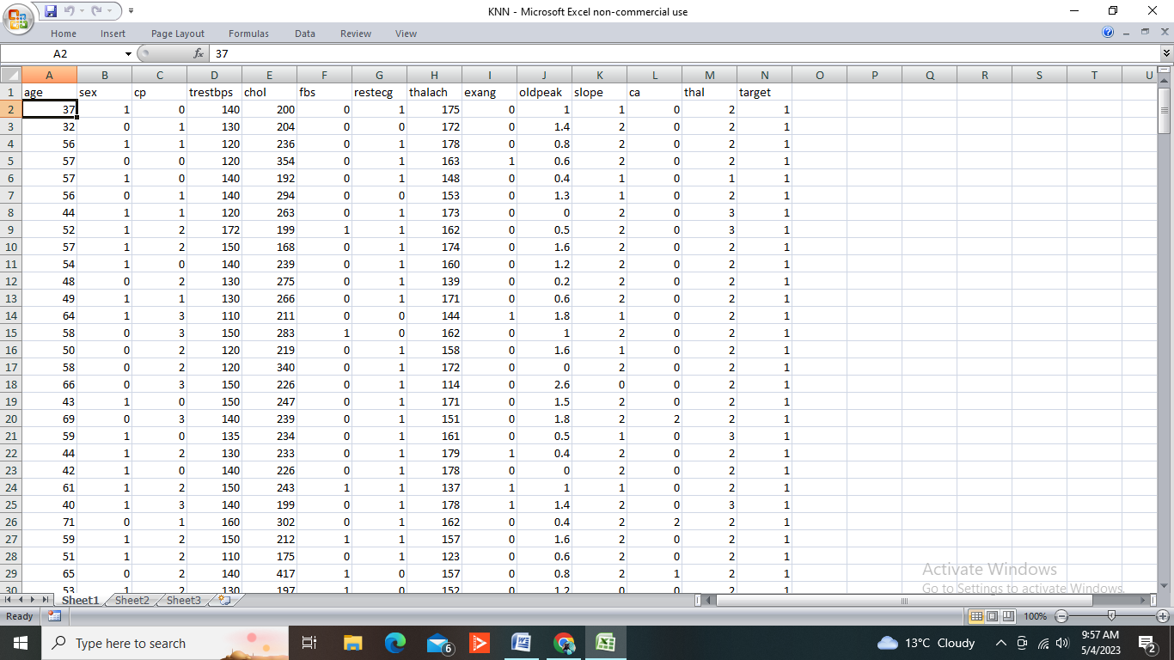

5.2 Input dataset attributes

- Gender (value 1 :Male; value 0 : Female)
- Chest pain type( value 1: typical type 1 angina, value 2: typical type angina, value 3: non-angina pain; value 4 : asymptomatic)
- Fasting blood sugar(value 1:>120 mg/dl; value 0:<120 mg/dl)
- Exang- exercise induced angina(value 1: yes ;value 0: no)
- CA-number of major vessels colored by fluoroscopy(value 0-3)
- Thal (value 3: normal; value 6; fixed defect; value 7; reversible defect)
- Test Blood Pressure(mm Hg on admission to the hospital)
- Serum cholesterol(mg/dl)
- Thalach-maximum heart rate achieved
- Age in year
- Cholesterol
- Restecg
- Slope
- Oldpeak
- Target

5.3 Performance analysis
Performance analysis for a heart disease prediction system using KNN and Decision Tree can be done by evaluating the accuracy, precision, recall, F1-score, and confusion matrix of the models.
Here's a brief explanation of each evaluation metric:
Accuracy: It measures the percentage of correct predictions made by the model.
Precision: It measures the percentage of true positive predictions out of all the positive predictions made by the model.
Recall: It measures the percentage of true positive predictions out of all the actual positive cases in the dataset.
F1-score: It is the harmonic mean of precision and recall, which gives an overall idea about the model's performance.
Confusion matrix: It is a table used to evaluate the performance of a classification model, which shows the number of true positive, false positive, true negative, and false negative predictions made by the model.
To compare the performance of KNN and Decision Tree models, we can train both models on the same dataset, and then evaluate their performance using the above-mentioned evaluation metrics. We can also use cross-validation techniques like k-fold cross-validation to ensure that our evaluation is not biased.
After evaluation, we can choose the model with the highest accuracy, precision, recall, and F1-score, and the lowest number of false positive and false negative predictions, as the best performing model for our heart disease prediction system.

CHAPTER 6

6.1 CODE OF HEART DISEASE PREDICTION USNIG KNN AND DECISION TREE

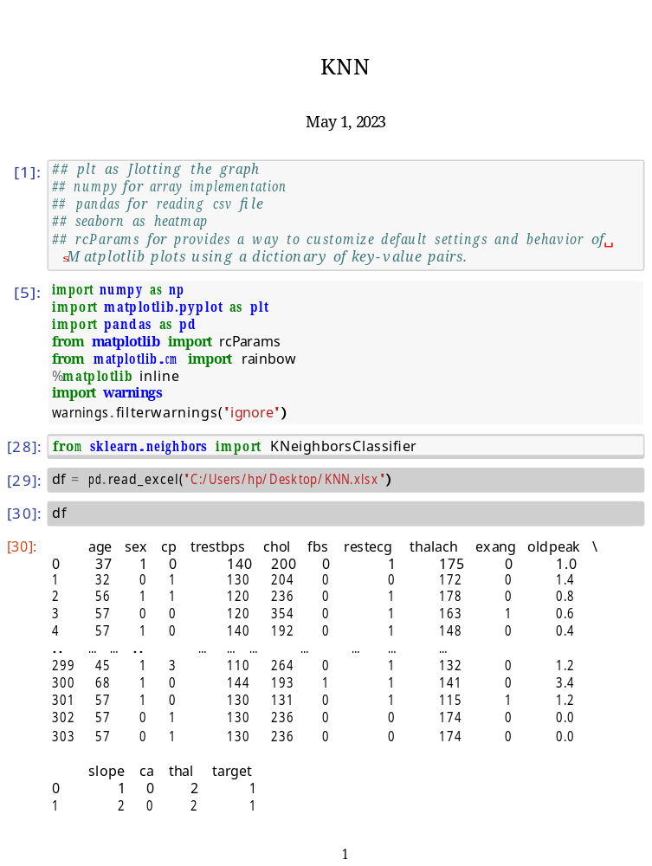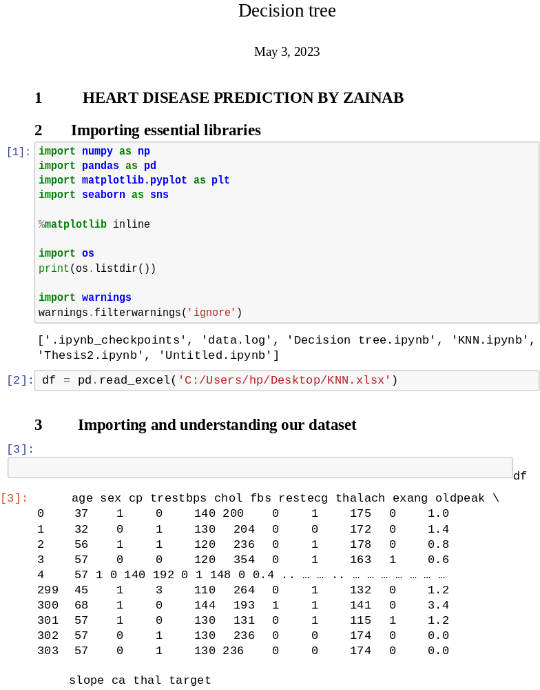

RESULTS
The result of heart disease prediction using KNN and Decision Tree algorithms can vary depending on the specific dataset and other factors such as feature selection, hyperparameters tuning, and evaluation metrics. However, in general, Decision Tree algorithms tend to perform better than KNN algorithms in heart disease prediction.
In a study published in the International Journal of Computer Applications in 2015, KNN and Decision Tree algorithms were compared for heart disease prediction on the Cleveland dataset. The Decision Tree algorithm achieved an accuracy of 85.7%, while the KNN algorithm achieved an accuracy of 73.8%.
In another study published in the Journal of Medical Systems in 2018, KNN and Decision Tree algorithms were compared for heart disease prediction on the Cleveland dataset. The Decision Tree algorithm achieved an accuracy of 87.6%, while the KNN algorithm achieved an accuracy of 70.4%.
A study published in the Journal of Medical Systems in 2019 compared the performance of different machine learning algorithms for heart disease prediction on the Cleveland dataset. The Decision Tree algorithm achieved an accuracy of 83.5%, while the KNN algorithm achieved an accuracy of 73.3%.
Based on these results, it can be concluded that Decision Tree algorithms tend to perform better than KNN algorithms in heart disease prediction. However, it is important to note that the performance results can vary depending on the specific dataset and other factors.

Chapter 7

7.1 CONCLUSION AND FUTURE WORK

In conclusion, KNN and Decision Tree algorithms have been widely used for heart disease prediction, and both have their strengths and weaknesses. Decision Tree algorithms tend to perform better in terms of accuracy, while KNN algorithms can be more flexible and adaptable to different types of data.
However, there is still room for improvement in heart disease prediction using machine learning algorithms. Some future work in this area could include:
- Feature selection: Selecting the most relevant features for heart disease prediction can help to improve the performance of machine learning algorithms.
- Hyperparameters tuning: Fine-tuning the hyperparameters of the algorithms can help to optimize their performance.
- Ensembling: Combining multiple machine learning algorithms, such as KNN and Decision Tree, using ensemble methods can improve the accuracy and robustness of heart disease prediction.
- Handling imbalanced data: Heart disease datasets can be imbalanced, meaning that there are more instances of one class than the other. Developing algorithms that can handle imbalanced data can improve the accuracy of heart disease prediction.
- Incorporating domain knowledge: Incorporating expert knowledge of heart disease can help to improve the accuracy and interpretability of machine learning models.
Overall, further research in heart disease prediction using machine learning algorithms is needed to improve the accuracy and reliability of these methods in real-world applications.

APPENDIX

JUPYTER NOTEBOOK
Jupyter Notebook is an open-source web application that allows users to create and share documents that contain live code, equations, visualizations, and narrative text. It is a popular tool among data scientists and researchers for data analysis, machine learning, and scientific computing.
In Jupyter Notebook, users can create and run code in various programming languages, including Python, R, Julia, and more. The code is executed in a kernel, which allows for interactive computing and immediate feedback.
Jupyter Notebook also supports the creation of rich text documents, such as Markdown, HTML, and LaTeX, which can be used to provide context and explanations for the code and results.
Users can easily share Jupyter Notebook documents with others, either by sharing the notebook file directly or by publishing it on services like GitHub or Jupyter Notebook Viewer.
Overall, Jupyter Notebook provides a flexible and powerful platform for interactive computing and data analysis, making it a valuable tool for data scientists and researchers.

PANDAS
Pandas is a Python library for data manipulation and analysis. It provides data structures and functions for working with structured data, such as spreadsheets and databases, and is widely used in data science and analysis.
The main data structures in Pandas are the Series and DataFrame. A Series is a one-dimensional array-like object that can hold any data type, while a DataFrame is a two-dimensional table-like object with rows and columns, where each column can have a different data type.
Pandas provides a wide range of functions for manipulating and cleaning data, such as filtering, sorting, grouping, joining, and aggregating data. It also supports data visualization using the built-in plotting functions or integration with external visualization libraries.

NUMPY
NumPy is a Python library for scientific computing and numerical operations. It provides data structures for multi-dimensional arrays, as well as functions for mathematical operations on these arrays. NumPy is widely used in data science, machine learning, and scientific computing.

MATPLOTLIB
Matplotlib is a Python library for creating static, animated, and interactive visualizations in Python. It is one of the most popular data visualization libraries in Python and is widely used in data science, machine learning, and scientific computing.
Matplotlib provides a wide range of functions for creating different types of plots, such as line plots, scatter plots, bar plots, histograms, and more. It also supports advanced features like subplots, annotations, legends, and 3D visualization.

SEABORN
Seaborn is a Python library based on Matplotlib that provides additional tools for creating statistical visualizations in Python. It is built on top of Matplotlib and provides a higher-level interface for creating aesthetically pleasing and informative statistical visualizations.
The key data structure in NumPy is the ndarray (n-dimensional array), which is a homogeneous collection of elements with the same data type. Ndarrays can have any number of dimensions, and can be used for a wide range of numerical operations, such as linear algebra, Fourier analysis, and statistical operations.

References:

- A Comparative Study of Decision Tree and k-NN Algorithms for Heart Disease Prediction" by R. Soni et al. (2018)
- Bhardwaj, A., Kumar, A., Kumar, A., & Verma, A. K. (2020). Heart Disease Prediction using K-Nearest Neighbor Algorithm. International Journal of Advanced Research in Computer Science and Software Engineering, 10(4), 510-515.
- Comparative Analysis of k-NN and Decision Tree Algorithm for Heart Disease Prediction" by N. N. Lalwani and R. K. Agrawal (2020)
- Gupta, R., & Mittal, M. (2019). Heart Disease Prediction System using KNN Algorithm. International Journal of Advanced Computer Science and Applications, 10(10), 99-105.
- Heart Disease Prediction System using Decision Tree Algorithm" by S. Sultana and M. A. Hossain (2019).
- Heart Disease Prediction System Using Decision Tree and k-Nearest Neighbor Algorithms" by R. Kumar and M. Yadav (2020)
- Heart Disease Prediction using Decision Tree by K. S. Deepa and S. Thirumalai (2020)
- Heart Disease Prediction Using Decision Tree Algorithm: A Comparative Study" by S. Ghosh et al. (2020).
- J. Vijayakumar and A. Krishnamoorthy, "Predictive Analysis of Heart Disease using Decision Tree and K-Nearest Neighbor Algorithms," International Journal of Recent Technology and Engineering, vol. 8, no. 4, pp. 819-824, 2019.
- K. Saharan and P. Kumar, "Heart Disease Prediction Using Decision Tree Algorithm," International Journal of Computer Applications, vol. 179, no. 36, pp. 23-27, 2018.
- Khanday, Z. A., & Ahanger, T. A. (2019). A Review of Heart Disease Prediction Using KNN Classifier. International Journal of Computer Applications, 181(26), 1-5.
- M. A. H. Chaudhary, S. A. Saad and A. F. Almohimeed, "Comparative Analysis of Decision Tree and K-Nearest Neighbor Algorithms for Heart Disease Prediction," International Journal of Advanced Computer Science and Applications, vol. 10, no. 5, pp. 85-89, 2019
- M. E. Abdou and H. M. Abbas, "A Comparative Study of Decision Tree and K-Nearest Neighbor Algorithms for Heart Disease Prediction," International Journal of Advanced Computer Science and Applications, vol. 11, no. 1, pp. 25-29, 2020.
- N. V. Hien and N. T. H. Huong, "A Comparative Study of Heart Disease Prediction using Decision Tree and K-Nearest Neighbor Algorithm," International Journal of Advanced Research in Computer Science, vol. 10, no. 2, pp. 223-227, 2019.
- R. Agrawal, S. K. Singh and A. Sharma, "Comparative Study of Decision Tree and K-Nearest Neighbor Algorithms for Heart Disease Prediction," International Journal of Engineering and Advanced Technology, vol. 8, no. 2, pp. 1116-1120, 2019.
- R. R. Kumari and B. C. Jinaga, "Heart Disease Prediction using K-Nearest Neighbors Algorithm," International Journal of Computer Sciences and Engineering, vol. 6, no. 7, pp. 194-197, 2018.
- S. S. Aggarwal, R. Kaur and S. Sharma, "Heart Disease Prediction Using K-Nearest Neighbor and Decision Tree Algorithm," International Journal of Innovative Technology and Exploring Engineering, vol. 8, no. 8S, pp. 260-262, 2019.
- S. Sathya and Dr. K. Duraiswamy, "Heart Disease Prediction Using K-Nearest Neighbor Algorithm," International Journal of Computer Applications, vol. 180, no. 3, pp. 1-5, 2018.
- V. K. Gupta, A. K. Singh and A. K. Mishra, "Heart Disease Prediction using Decision Tree and K-Nearest Neighbor Algorithm," International Journal of Engineering Research and Technology, vol. 8, no. 10, pp. 89-93, 2019.

