Supplementary Information
Title: Enhancing native seedling establishment on degraded agricultural land with topsoil pellets
Journal: Plant and Soil
Authors: Thomas P. Munro, Todd E. Erickson, Dale G. Nimmo, Frederick A. Dadzie, Miriam Muñoz- Rojas, Jodi N. Price
* Corresponding author: tmunro@csu.edu.au, Gulbali Institute, Charles Sturt University, Albury, New South Wales, Australia.

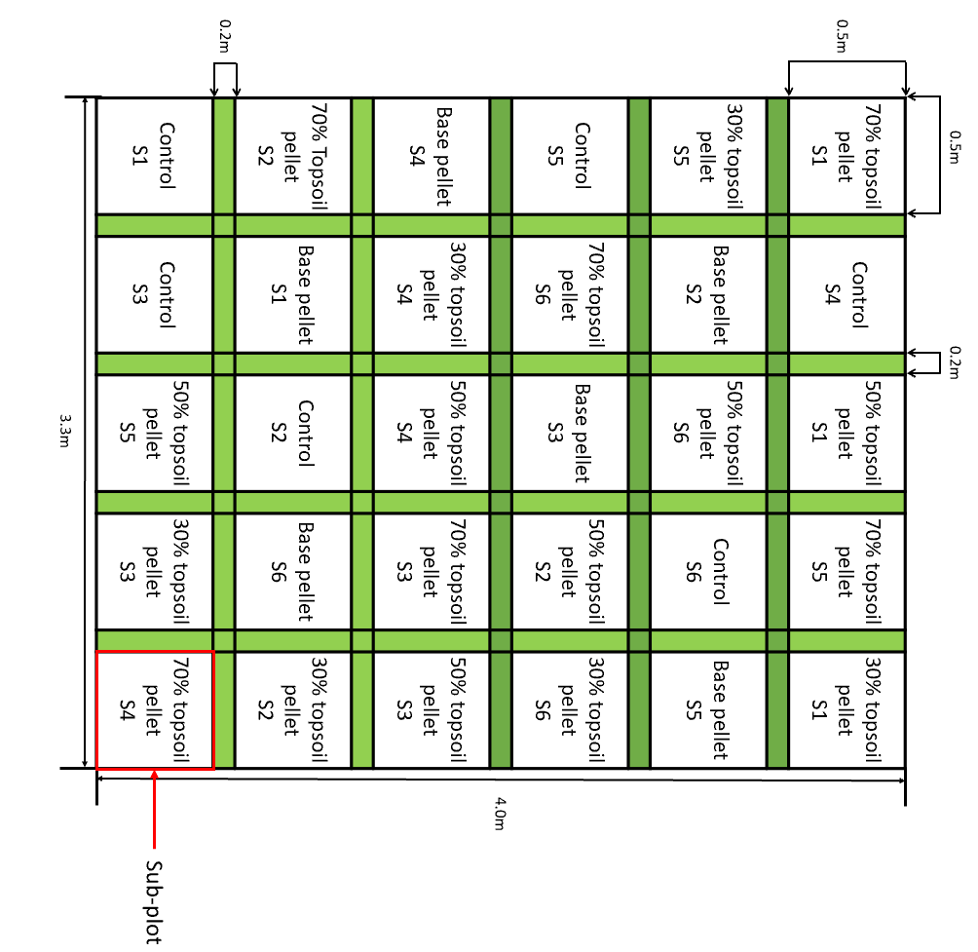

Fig. S1. Experimental design showing one replicate block with five seed enhancement treatments: control (non-enhanced seed), base pellet and three topsoil pellets and six native plant species (S1-S6) randomly arranged. The block (4 x 3.3 m) is divided into 30 nested sub-plots (five treatments x six species). The treatment sub-plots were 0.5 x 0.5 m (with a 0.2 x 0.2 m buffer between each sub-plot), within each treatment sub-plot, there were 20 units (pellets or non-enhanced seed clustered to mimic the pellet seed density). The blocks were replicated 8 times, giving a total of 240 units/species/treatment
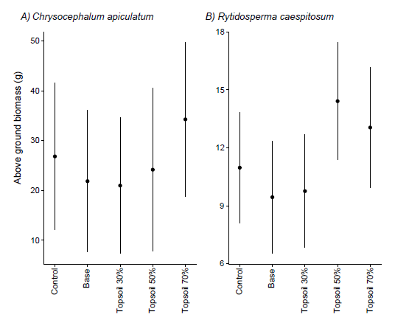

Fig. S2. Above ground biomass (g) for R. caespitosum and C. apiculatum from all SET treatments and control (non-enhanced seed) showing medians with upper and lower quartiles (± SE) for all four species. Significant results indicated with *, p-value < 0.05 = (*), p-value <0.01 = (**), p-value <0.001 = (***)
Species | Predictors | Odds Ratio | Confidence intervals | p-value
Chrysocephalum apiculatum | (Intercept) | 26.83 | 12.04 – 41.62 | 0.001**
 | Base pellet | -4.98 | -25.22 – 15.27 | 0.623
 | 30% Topsoil pellet | -5.86 | -25.62 – 13.91 | 0.554
 | 50% Topsoil pellet | -2.67 | -24.23 – 18.89 | 0.804
 | 70% Topsoil pellet | 7.43 | -13.70 – 28.57 | 0.483
Rytidosperma caespitosum | (Intercept) | 10.97 | 8.11 – 13.83 | <0.001***
 | Base pellet | -1.53 | -5.41 – 2.35 | 0.437
 | 30% Topsoil pellet | -1.21 | -5.09 – 2.67 | 0.537
 | 50% Topsoil pellet | 3.44 | -0.53 – 7.42 | 0.089
 | 70% Topsoil pellet | 2.08 | -1.96 – 6.11 | 0.310
Table S1 Summary table of LMM analysis for aboveground biomass for R. caespitosum and C. apiculatum in all SET treatments and control (non-enhanced seed). Significant results indicated with *, p-value < 0.05 = (*), p-value <0.01 = (**), p-value <0.001 = (***)

Appendix S1
Pilot study
A pilot study was conducted to determine the best recipes for the field trial. We used four different recipes varying the proportions of ingredients (outlined in Table 1) to determine an optimal ingredient combination that maintained the pellet’s structural integrity during transport and deployment while rapidly dissolving to integrate into the soil profile (Madsen et al. 2016). Topsoil samples were collected from a reference site containing remnant native vegetation located approximately 500 m from the study site. The topsoil was sieved through a 2 mm sieve to remove larger seeds and coarse organic material. Pellets were produced by combining ingredients (detailed in Table 1) with water into a slurry/paste, poured into moulds (each unit 35 x 35mm), and seeds were then pushed into the moulds to position them in the centre of the pellet. Finally, pellets were left to air dry.
Table 1 Pellet recipes containing commercially available ingredient (Calcium bentonite, diatomaceous earth, and sand) and locally sourced topsoil used during the pilot study conducted under field conditions at Wirraminna Environmental Education Centre, New South Wales
Ingredients | Base Pellet | Topsoil Pellet
Ca Bentonite (%) | 10 | 10 | 10 | 15
Diatomaceous earth (%) | 20 | 20 | 5 | 5
Sand (%) | 70 | 0 | 25 | 30
Activated carbon (%) | 0 | 0 | 0 | 0
Topsoil (%) | 0 | 70 | 60 | 50

Reference list
Madsen M, Hulet A, Phillips K, Staley J, Davies K, Svejcar T (2016) Extruded seed pellets: a novel approach for enhancing sagebrush seedling emergence. Native Plants Journal 17: 230-243. doi: 10.3368/npj.17.3.230.

