Supplementary Material 7：Sensitivity analysis figures of highly heterogeneous outcomes
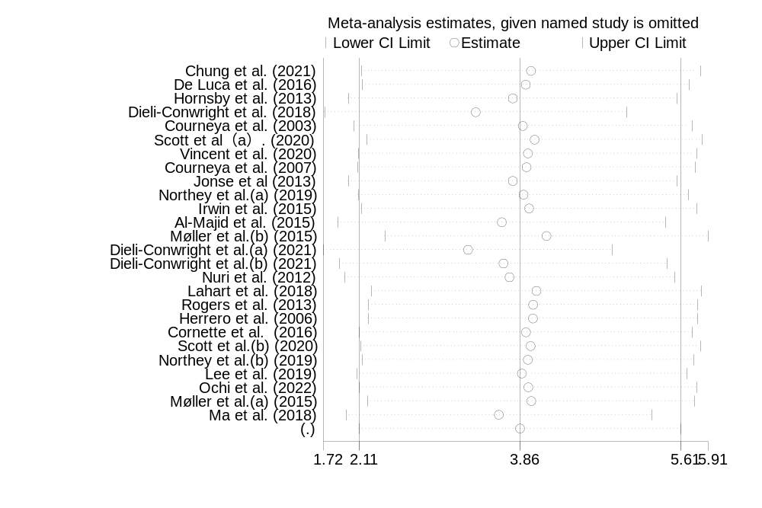7.1 Sensitivity analysis figure of VO₂max
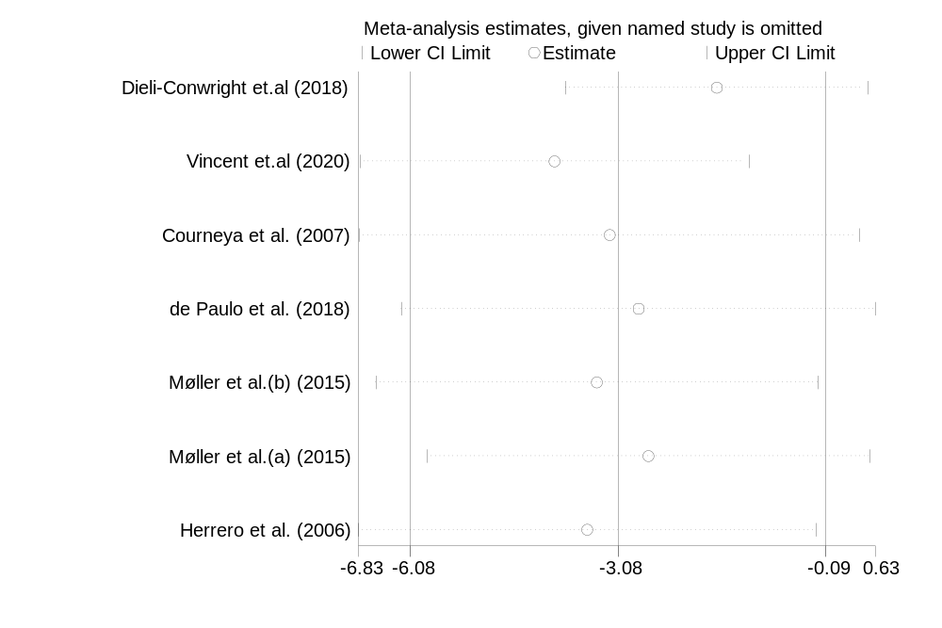7.2 Sensitivity analysis figure of fat mass
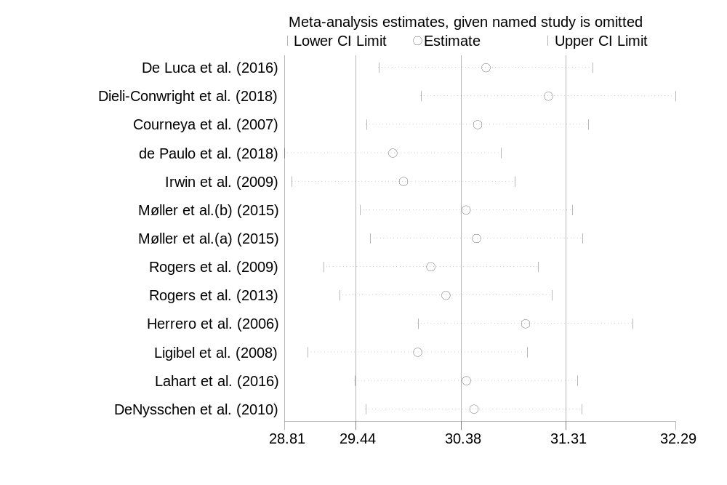7.3 Sensitivity analysis figure of BF%
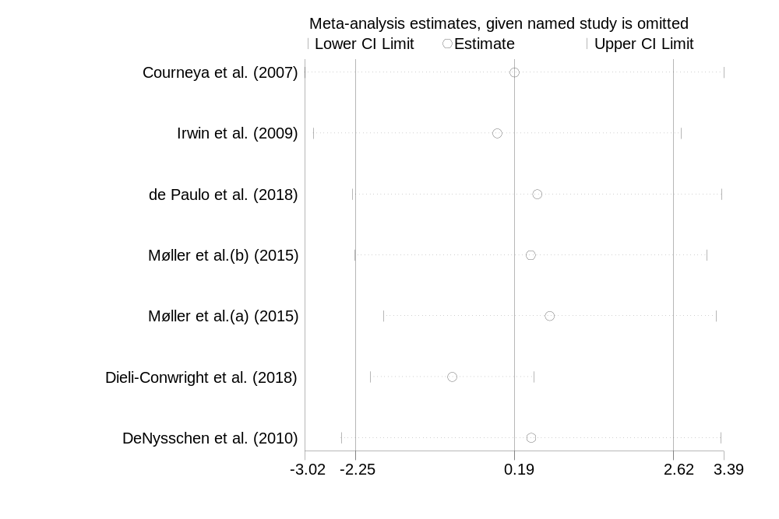
7.4 Sensitivity analysis figure of lean mass
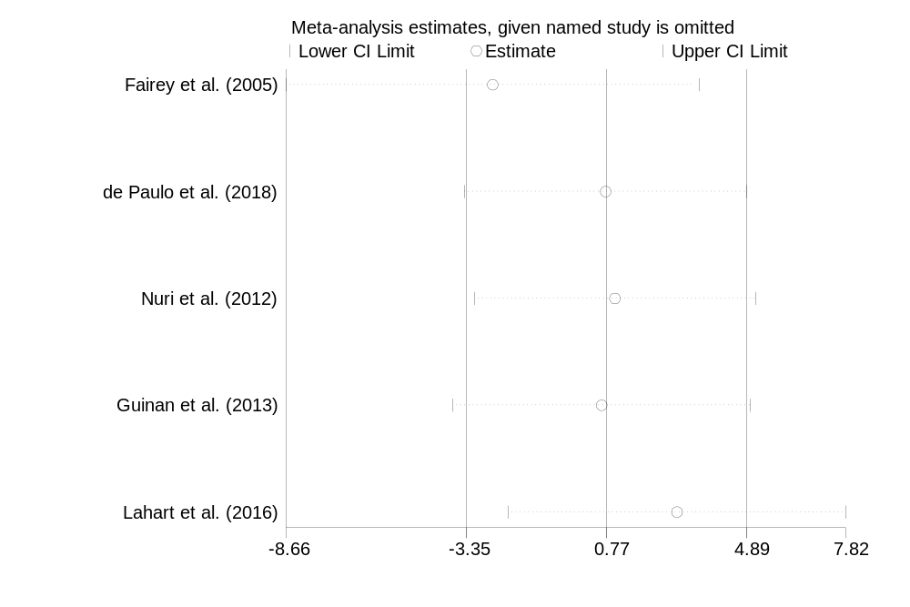7.5 Sensitivity analysis figure of total cholesterol (TG)
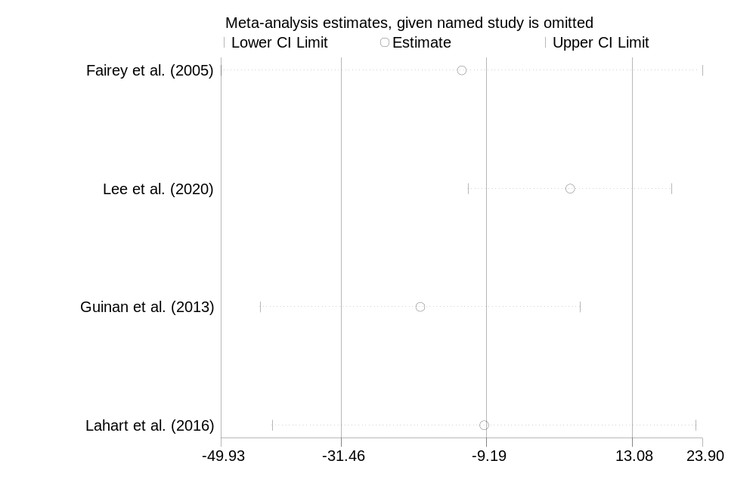7.6 Sensitivity analysis figure of triglycerid (TC)
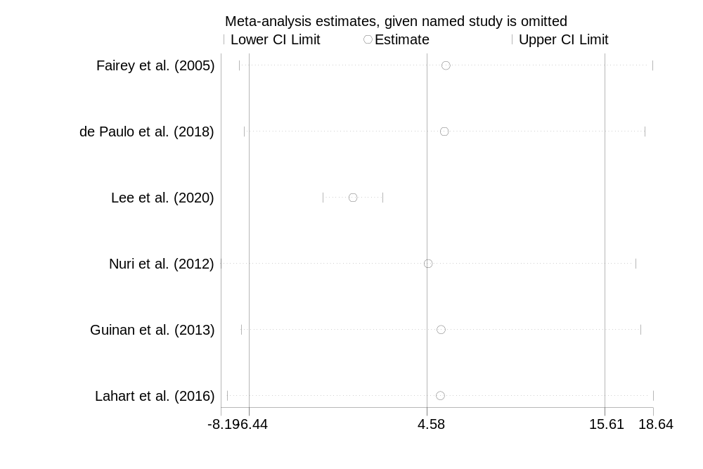7.7 Sensitivity analysis figure of HDL-C
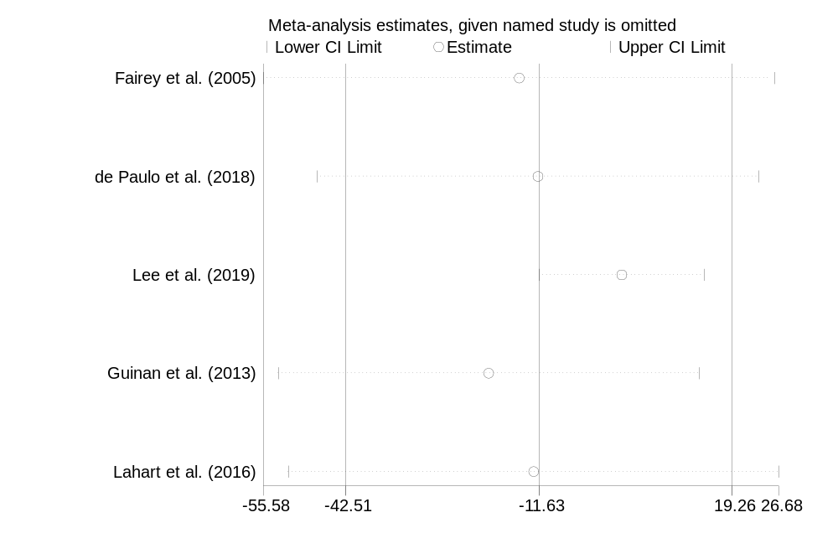7.8 Sensitivity analysis figure of LDL-C
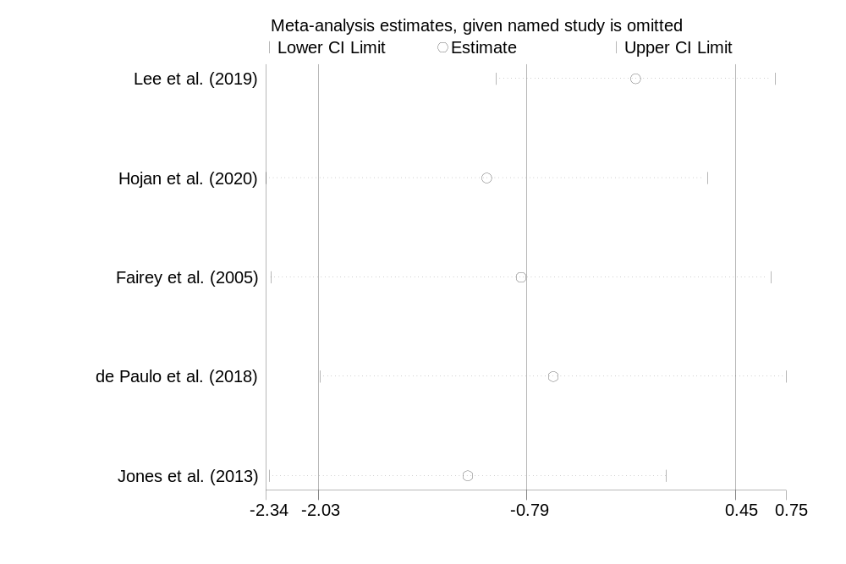7.9 Sensitivity analysis figure of CRP
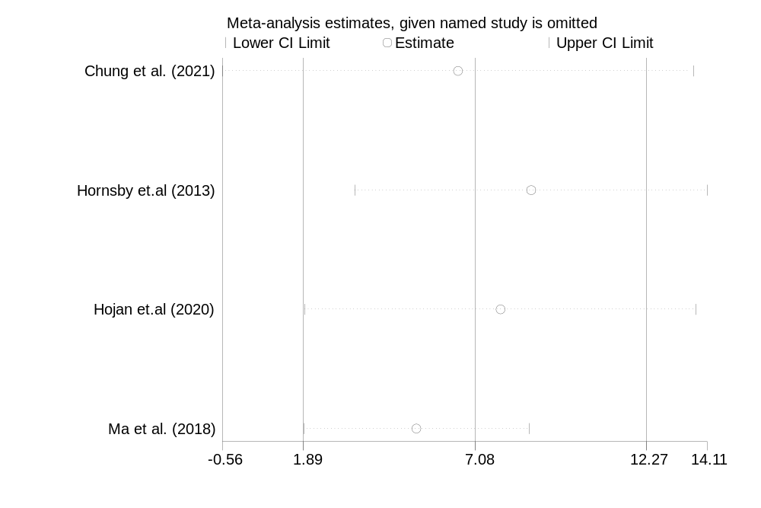7.10 Sensitivity analysis figure of LVEF

