Supplementary Material 6: Funnel plots and Trim and fill method plots
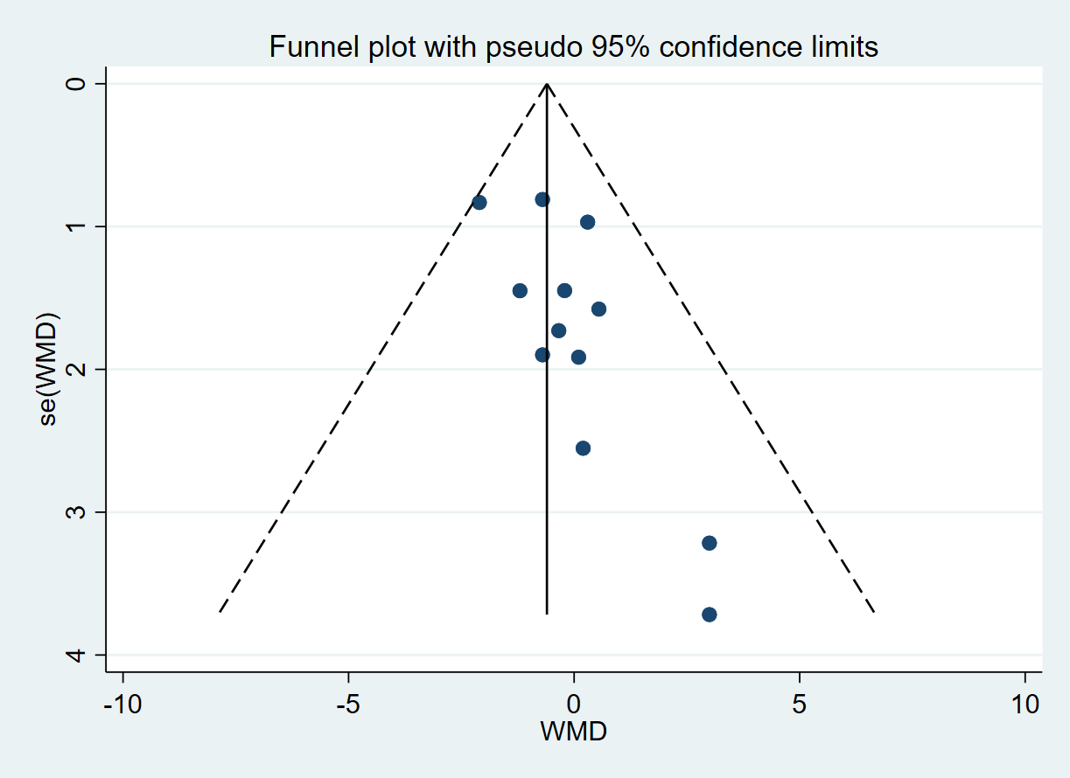
Figure 1: Funnel plot of body mass index (BMI) in RCTs.
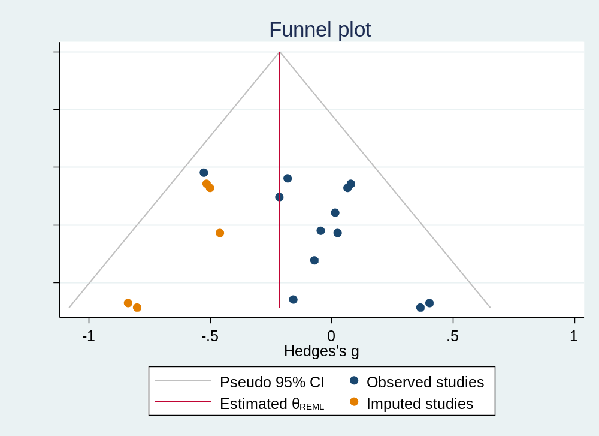
Figure 2: Trim and fill method plot of body mass index (BMI) in RCTs.
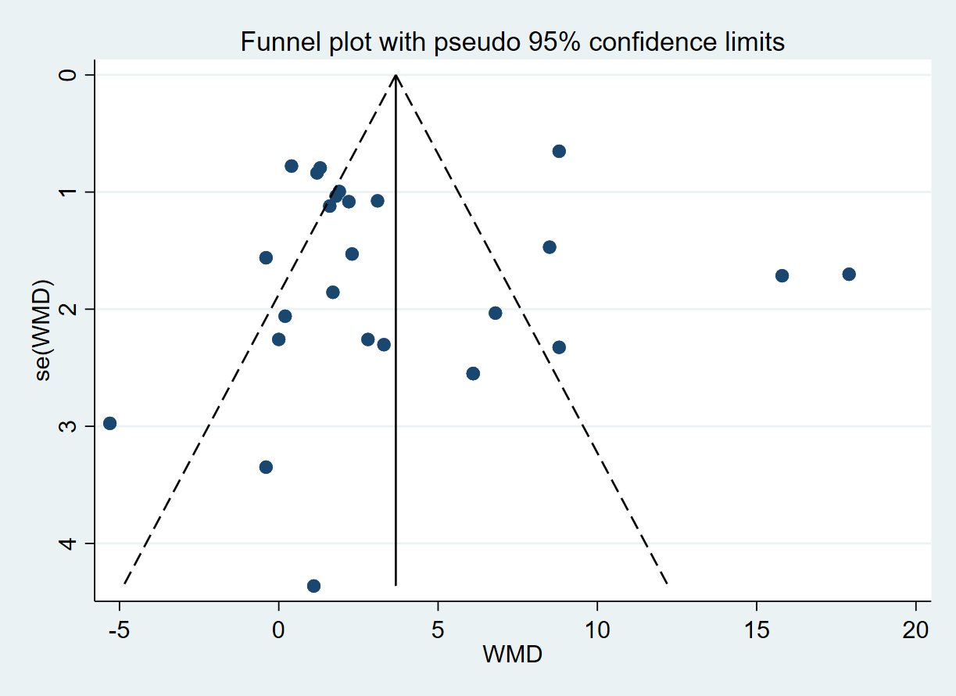
Figure 3: Funnel plot of maximum oxygen uptake (VO₂max) in RCTs.
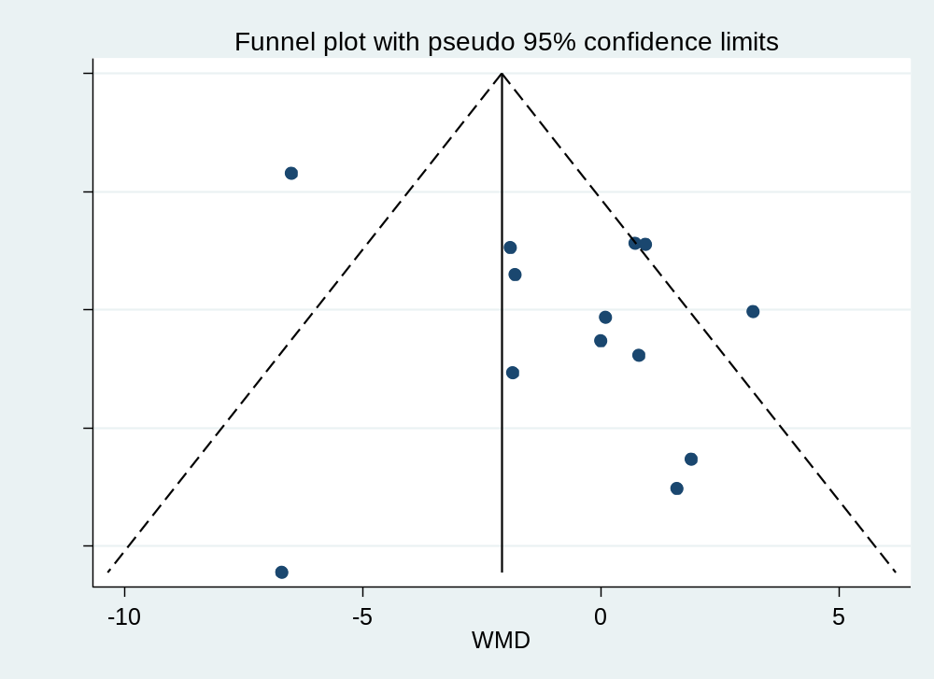
Figure 4: Funnel plot of BF% in RCTs.
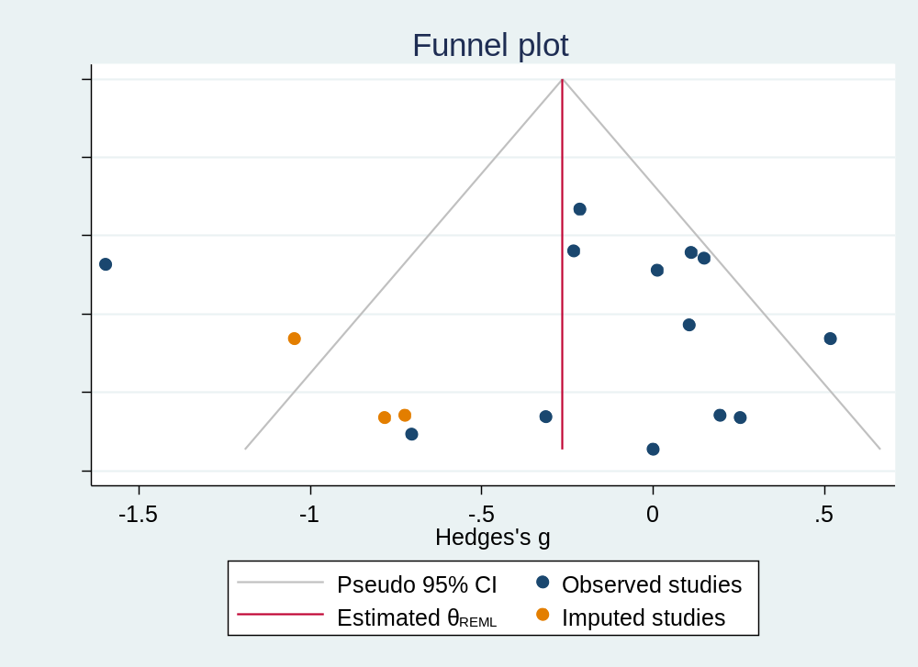
Figure 5: Trim and fill method plot of BF%.
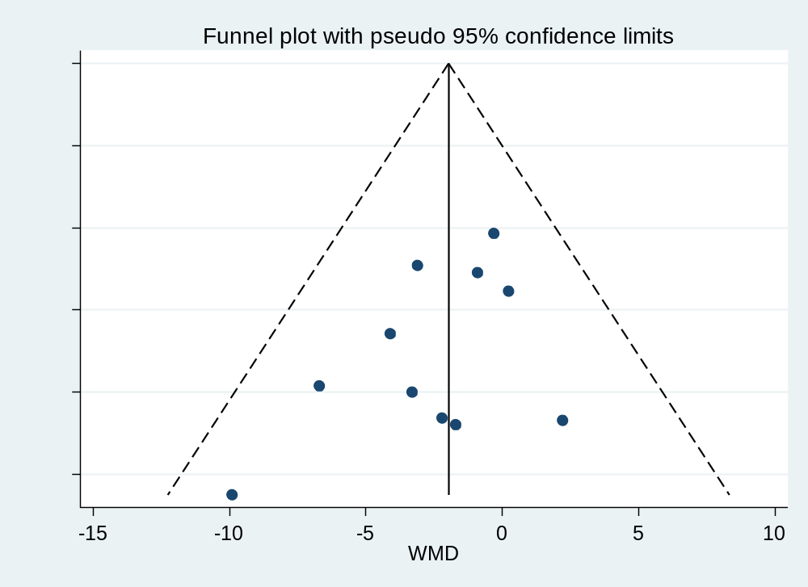
Figure 6: Funnel plot of weight.

