Systematic Review
Knowledge and Attitude towards Monkeypox: Systematic review and meta-analysis
Darwin A. León-Figueroa ¹, Joshuan J. Barboza ^{2,} *, Abdelmonem Siddiq ³, Ranjit Sah ^{4,5,6}, Mario J. Valladares-Garrido ^{7,8}, and Alfonso J. Rodriguez-Morales ^{9,10}
¹ Facultad de Medicina Humana, Universidad de San Martín de Porres, Chiclayo 15011, Peru; darwin_leon@usmp.pe (DALF)
² Facultad de Ciencias de la Salud, Escuela de Medicina, Universidad César Vallejo, Trujillo 13007, Peru; jbarbozameca@gmail.com
³ Faculty of Pharmacy, Mansoura University, Mansoura 35516, Egypt; Abdelmonemalsaid555@std.mans.edu.eg
⁴ Department of Microbiology, Tribhuvan University Teaching Hospital, Institute of Medicine, Kathmandu 44600, Nepal; ranjitsah@iom.edu.np
⁵ Department of Microbiology, Dr. D. Y. Patil Medical College, Hospital and Research Centre, Dr. D. Y. Patil Vidyapeeth, Pune 411018, Maharashtra, India
⁶ Department of Public Health Dentistry, Dr. D.Y. Patil Dental College and Hospital, Dr. D.Y. Patil Vidyapeeth, Pune 411018, Maharashtra, India.
⁷ Universidad Continental, Lima 15046, Peru; mvalladares@continental.edu.pe
⁸ Oficina de Epidemiología, Hospital Regional Lambayeque, Chiclayo 14012, Peru
⁹ Master of Clinical Epidemiology and Biostatistics, Universidad Cientifica del Sur, Lima 15067, Peru; arodriguezmo@cientifica.edu.pe
¹⁰ Gilbert and Rose-Marie Chagoury School of Medicine, Lebanese American University, Beirut 1102, Lebanon; alphonso.morales@lau.edu.lb

* Correspondence: E-mail: jbarbozameca@gmail.com . Address: Juan del Corral 937. El Bosque, Trujillo, Peru. Tel.+51 992108520

Supplementary material
- S1 PRISMA Checklist (PRISMA 2020 Main Checklist and PRIMSA Abstract Checklist)
- S2 Table. The adjusted search terms as per searched electronic databases.
- S3 Table. Quality of the included studies
- S1 Figure. Forest plot showing prevalence of intention to vaccinate against monkeypox among study participants.
- S2 Figure. Subgroup analysis by country on good knowledge of monkeypox.
- S3 Figure. Subgroup analysis by country on positive attitude toward monkeypox.
- S4 Figure. Subgroup analysis by study subjects on good knowledge of monkeypox.
- S5 Figure. Subgroup analysis by study subjects on positive attitude toward monkeypox.
- S6 Figure. Subgroup analysis by study year on good knowledge of monkeypox.
- S7 Figure. Subgroup analysis by study year on positive attitude toward monkeypox.
- References

S1 PRISMA Checklist (PRISMA 2020 Main Checklist and PRIMSA Abstract Checklist)

PRISMA 2020 Main Checklist
Topic | No. | Item | Location where item is reported
TITLE
Title | 1 | Identify the report as a systematic review. | 1
ABSTRACT
Abstract | 2 | See the PRISMA 2020 for Abstracts checklist
INTRODUCTION
Rationale | 3 | Describe the rationale for the review in the context of existing knowledge. | 2-3
Objectives | 4 | Provide an explicit statement of the objective(s) or question(s) the review addresses. | 2-3
METHODS
Eligibility criteria | 5 | Specify the inclusion and exclusion criteria for the review and how studies were grouped for the syntheses. | 3
Information sources | 6 | Specify all databases, registers, websites, organisations, reference lists and other sources searched or consulted to identify studies. Specify the date when each source was last searched or consulted. | 3
Search strategy | 7 | Present the full search strategies for all databases, registers and websites, including any filters and limits used. | 3-4
Selection process | 8 | Specify the methods used to decide whether a study met the inclusion criteria of the review, including how many reviewers screened each record and each report retrieved, whether they worked independently, and if applicable, details of automation tools used in the process. | 3-4
Data collection process | 9 | Specify the methods used to collect data from reports, including how many reviewers collected data from each report, whether they worked independently, any processes for obtaining or confirming data from study investigators, and if applicable, details of automation tools used in the process. | 4
Data items | 10a | List and define all outcomes for which data were sought. Specify whether all results that were compatible with each outcome domain in each study were sought (e.g. for all measures, time points, analyses), and if not, the methods used to decide which results to collect. | 4
 | 10b | List and define all other variables for which data were sought (e.g. participant and intervention characteristics, funding sources). Describe any assumptions made about any missing or unclear information. | 4
Study risk of bias assessment | 11 | Specify the methods used to assess risk of bias in the included studies, including details of the tool(s) used, how many reviewers assessed each study and whether they worked independently, and if applicable, details of automation tools used in the process. | 4
Effect measures | 12 | Specify for each outcome the effect measure(s) (e.g. risk ratio, mean difference) used in the synthesis or presentation of results. | 4
Synthesis methods | 13a | Describe the processes used to decide which studies were eligible for each synthesis (e.g. tabulating the study intervention characteristics and comparing against the planned groups for each synthesis (item 5)). | 4
 | 13b | Describe any methods required to prepare the data for presentation or synthesis, such as handling of missing summary statistics, or data conversions. | 4
 | 13c | Describe any methods used to tabulate or visually display results of individual studies and syntheses. | 4
 | 13d | Describe any methods used to synthesize results and provide a rationale for the choice(s). If meta-analysis was performed, describe the model(s), method(s) to identify the presence and extent of statistical heterogeneity, and software package(s) used. | 4
 | 13e | Describe any methods used to explore possible causes of heterogeneity among study results (e.g. subgroup analysis, meta-regression). | 4
 | 13f | Describe any sensitivity analyses conducted to assess robustness of the synthesized results. | 4
Reporting bias assessment | 14 | Describe any methods used to assess risk of bias due to missing results in a synthesis (arising from reporting biases). | 4
Certainty assessment | 15 | Describe any methods used to assess certainty (or confidence) in the body of evidence for an outcome. | 4
RESULTS
Study selection | 16a | Describe the results of the search and selection process, from the number of records identified in the search to the number of studies included in the review, ideally using a flow diagram. | 5
 | 16b | Cite studies that might appear to meet the inclusion criteria, but which were excluded, and explain why they were excluded. | 5
Study characteristics | 17 | Cite each included study and present its characteristics. | 5-6
Risk of bias in studies | 18 | Present assessments of risk of bias for each included study. | 5-6
Results of individual studies | 19 | For all outcomes, present, for each study: (a) summary statistics for each group (where appropriate) and (b) an effect estimate and its precision (e.g. confidence/credible interval), ideally using structured tables or plots. | 5-6
Results of syntheses | 20a | For each synthesis, briefly summarise the characteristics and risk of bias among contributing studies. | 5-6
 | 20b | Present results of all statistical syntheses conducted. If meta-analysis was done, present for each the summary estimate and its precision (e.g. confidence/credible interval) and measures of statistical heterogeneity. If comparing groups, describe the direction of the effect. | 5-6
 | 20c | Present results of all investigations of possible causes of heterogeneity among study results. | 5-6
 | 20d | Present results of all sensitivity analyses conducted to assess the robustness of the synthesized results. | 5-6
Reporting biases | 21 | Present assessments of risk of bias due to missing results (arising from reporting biases) for each synthesis assessed. | 5-6
Certainty of evidence | 22 | Present assessments of certainty (or confidence) in the body of evidence for each outcome assessed. | 5-6
DISCUSSION
Discussion | 23a | Provide a general interpretation of the results in the context of other evidence. | 6-7
 | 23b | Discuss any limitations of the evidence included in the review. | 6-7
 | 23c | Discuss any limitations of the review processes used. | 7-8
 | 23d | Discuss implications of the results for practice, policy, and future research. | 7-8
OTHER INFORMATION
Registration and protocol | 24a | Provide registration information for the review, including register name and registration number, or state that the review was not registered. | 3
 | 24b | Indicate where the review protocol can be accessed, or state that a protocol was not prepared. | 3
 | 24c | Describe and explain any amendments to information provided at registration or in the protocol. | 3
Support | 25 | Describe sources of financial or non-financial support for the review, and the role of the funders or sponsors in the review. | 8
Competing interests | 26 | Declare any competing interests of review authors. | 8
Availability of data, code and other materials | 27 | Report which of the following are publicly available and where they can be found: template data collection forms; data extracted from included studies; data used for all analyses; analytic code; any other materials used in the review. | 8

PRIMSA Abstract Checklist
Topic | No. | Item | Reported?
TITLE
Title | 1 | Identify the report as a systematic review. | Yes
BACKGROUND
Objectives | 2 | Provide an explicit statement of the main objective(s) or question(s) the review addresses. | Yes
METHODS
Eligibility criteria | 3 | Specify the inclusion and exclusion criteria for the review. | Yes
Information sources | 4 | Specify the information sources (e.g. databases, registers) used to identify studies and the date when each was last searched. | Yes
Risk of bias | 5 | Specify the methods used to assess risk of bias in the included studies. | Yes
Synthesis of results | 6 | Specify the methods used to present and synthesize results. | Yes
RESULTS
Included studies | 7 | Give the total number of included studies and participants and summarise relevant characteristics of studies. | Yes
Synthesis of results | 8 | Present results for main outcomes, preferably indicating the number of included studies and participants for each. If meta-analysis was done, report the summary estimate and confidence/credible interval. If comparing groups, indicate the direction of the effect (i.e. which group is favoured). | Yes
DISCUSSION
Limitations of evidence | 9 | Provide a brief summary of the limitations of the evidence included in the review (e.g. study risk of bias, inconsistency and imprecision). | Yes
Interpretation | 10 | Provide a general interpretation of the results and important implications. | Yes
OTHER
Funding | 11 | Specify the primary source of funding for the review. | Yes
Registration | 12 | Provide the register name and registration number. | Yes

From: Page MJ, McKenzie JE, Bossuyt PM, Boutron I, Hoffmann TC, Mulrow CD, et al. The PRISMA 2020 statement: an updated guideline for reporting systematic reviews. MetaArXiv. 2020, September 14. DOI: 10.31222/osf.io/v7gm2. For more information, visit: www.prisma-statement.org

S2 Table. The adjusted search terms as per searched electronic databases.

PubMed
 | #1 | (Monkeypox OR “Monkey Pox”) | 3,412
 | #2 | (“Knowledge”) | 1,005,183
 | #3 | (“ Attitude” OR “ Attitudes” OR “Sentiment” OR “Sentiments” OR “Opinions” OR “Opinion”) | 608,550
 | #4 | #1 AND #2 AND #3 | 48
Scopus
 | #1 | TITLE-ABS-KEY ( monkeypox OR "Monkey Pox" ) | 3,965
 | #2 | TITLE-ABS-KEY ( "Knowledge" ) | 2,690,119
 | #3 | TITLE-ABS-KEY ( " Attitude" OR " Attitudes" OR "Sentiment" OR "Sentiments" OR "Opinions" OR "Opinion" ) | 1,411,155
 | #4 | #1 AND #2 AND #3 | 53
Embase
 | #1 | 'monkeypox'/exp OR 'monkeypox' | 4,147
 | #2 | 'knowledge' | 1,219,506
 | #3 | 'attitude' | 541,342
 | #4 | #1 AND #2 AND #3 | 40
Web of Science
 | #1 | ALL=(Monkeypox OR “Monkey Pox”) | 3,450
 | #2 | ALL= (“Knowledge”) | 2,001,028
 | #3 | ALL= (“ Attitude” OR “ Attitudes” OR “Sentiment” OR “Sentiments” OR “Opinions” OR “Opinion”) | 707,095
 | #4 | #1 AND #2 AND #3 | 54
ScienceDirect
 | #1 | (Monkeypox OR “Monkey Pox”) | 1,016
 | #2 | (“Knowledge”) | 421,556
 | #3 | (“ Attitude” ) | 78,759
 | #4 | #1 AND #2 AND #3 | 104

S3 Table. Quality of the included studies

 | Authors | Year | Eligibility criteria | Study subjects and the setting | Exposure measured in a valid and reliable way 'gold standard' | A specified diagnosis or definition | Confounding factors | Dealing with confounding factors | Outcomes measured in a valid and reliable way | Appropriate statistical analysis | Scores (8) | Quality (high, moderate, low)
Hasan M, et al. [1] |  | 2023 | Yes | Yes | Yes | Yes | No | NA | Yes | Yes | 7 | High
Swed S, et al. [2] |  | 2023 | Yes | Yes | Yes | Yes | No | NA | Yes | Yes | 7 | High
Dong C, et al. [3] |  | 2023 | Yes | Yes | Yes | Yes | No | NA | Yes | Yes | 7 | High
Swed S, et al. [4] |  | 2023 | Yes | Yes | Yes | Yes | No | NA | Yes | Yes | 7 | High
Peng X, et al. [5] |  | 2023 | Yes | Yes | Yes | Yes | No | NA | Yes | Yes | 7 | High
Berdida DJE, et al. [6] |  | 2023 | Yes | Yes | Yes | Yes | No | NA | Yes | Yes | 7 | High
Elkhwesky Z, et al. [7] |  | 2023 | Yes | Yes | Yes | Yes | No | NA | Yes | Yes | 7 | High
Youssef D, et al. [8] |  | 2023 | Yes | Yes | Yes | Yes | No | NA | Yes | Yes | 7 | High
Malaeb D, et al. [9] |  | 2023 | Yes | Yes | Yes | Yes | No | NA | Yes | Yes | 7 | High
Chen Y, et al. [10] |  | 2023 | Yes | Yes | Yes | Yes | No | NA | Yes | Yes | 7 | High
Lounis M, et al. [11] |  | 2023 | Yes | Yes | Yes | Yes | No | NA | Yes | Yes | 7 | High
Ahmed SK, et al. [12] |  | 2023 | Yes | Yes | Yes | Yes | No | NA | Yes | Yes | 7 | High
Das SK, et al. [13] |  | 2023 | Yes | Yes | Yes | Yes | No | NA | Yes | Yes | 7 | High
Al-Mustapha AI, et al. [14] |  | 2023 | Yes | Yes | Yes | Yes | No | NA | Yes | Yes | 7 | High
Ren F, et al. [15] |  | 2023 | Yes | Yes | Yes | Yes | No | NA | Yes | Yes | 7 | High
Alrasheedy AA, et al. [16] |  | 2023 | Yes | Yes | Yes | Yes | No | NA | Yes | Yes | 7 | High
Sahin TK, et al. [17] |  | 2022 | Yes | Yes | Yes | Yes | No | NA | Yes | Yes | 7 | High
Alshahrani NZ, et al. [18] |  | 2022 | Yes | Yes | Yes | Yes | No | NA | Yes | Yes | 7 | High
Jairoun AA, et al. [19] |  | 2022 | Yes | Yes | Yes | Yes | No | NA | Yes | Yes | 7 | High
Kaur A, et al. [20] |  | 2022 | Yes | Yes | Yes | Yes | No | NA | Yes | Yes | 7 | High
Alshahrani NZ, et al. [21] |  | 2022 | Yes | Yes | Yes | Yes | No | NA | Yes | Yes | 7 | High
Kumar N, et al. [22] |  | 2022 | Yes | Yes | Yes | Yes | No | NA | Yes | Yes | 7 | High
Ajman F, et al. [23] |  | 2022 | Yes | Yes | Yes | Yes | No | NA | Yes | Yes | 7 | High
Alshahrani NZ, et al. [24] |  | 2022 | Yes | Yes | Yes | Yes | No | NA | Yes | Yes | 7 | High
Harapan H, et al. [25] |  | 2020 | Yes | Yes | Yes | Yes | No | NA | Yes | Yes | 7 | High
Harapan H, et al. [26] |  | 2020 | Yes | Yes | Yes | Yes | No | NA | Yes | Yes | 7 | High
Harapan H, et al. [27] |  | 2020 | Yes | Yes | Yes | Yes | No | NA | Yes | Yes | 7 | High
NA: Not assessed

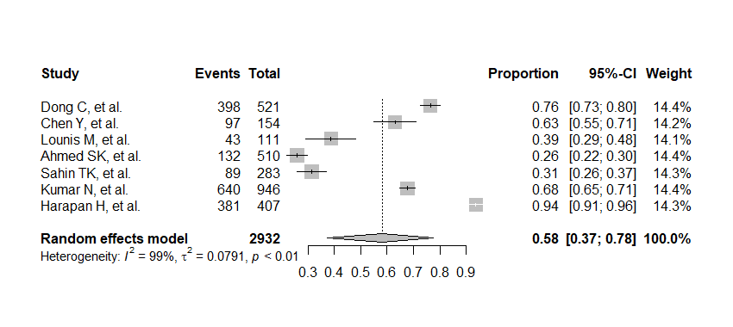
S1 Figure. Forest plot showing prevalence of intention to vaccinate against monkeypox among study participants.

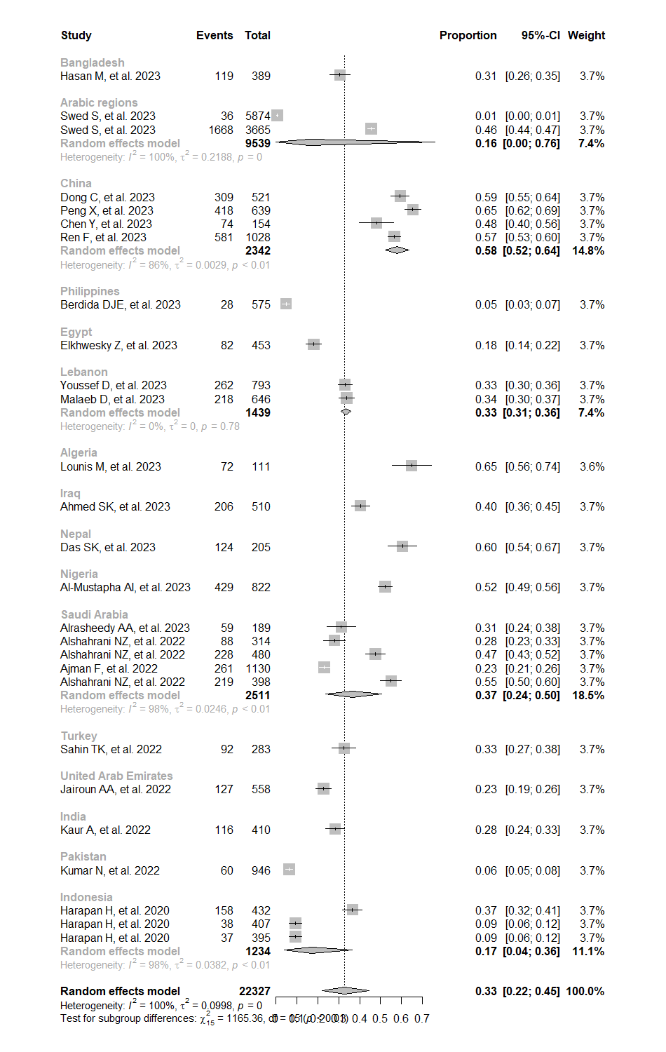
S2 Figure. Subgroup analysis by country on good knowledge of monkeypox.

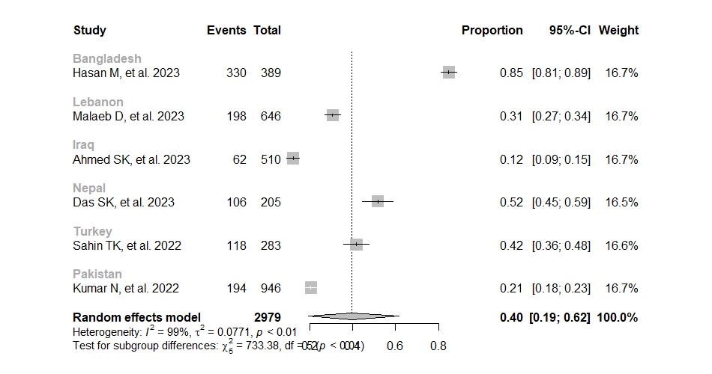

S3 Figure. Subgroup analysis by country on positive attitude toward monkeypox.

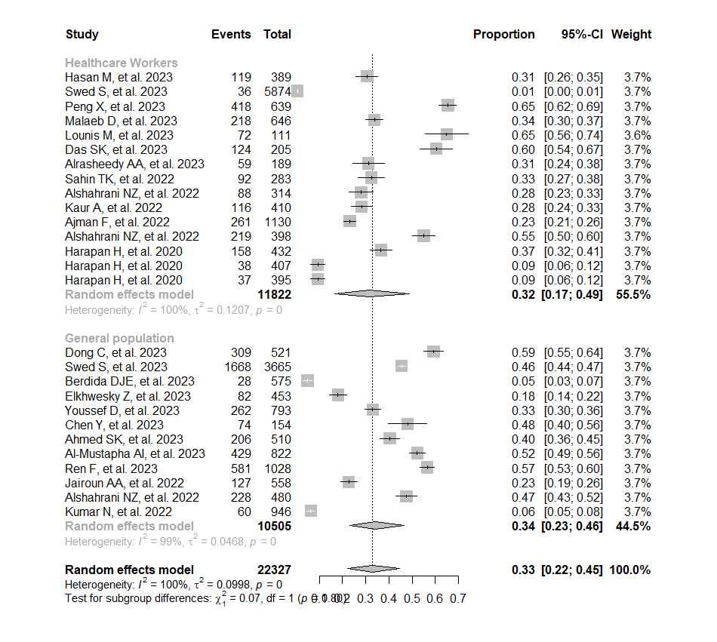
S4 Figure. Subgroup analysis by study subjects on good knowledge of monkeypox.

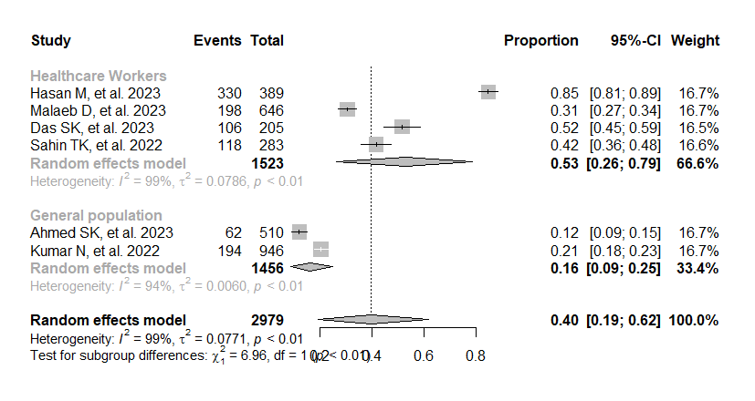
S5 Figure. Subgroup analysis by study subjects on positive attitude toward monkeypox.

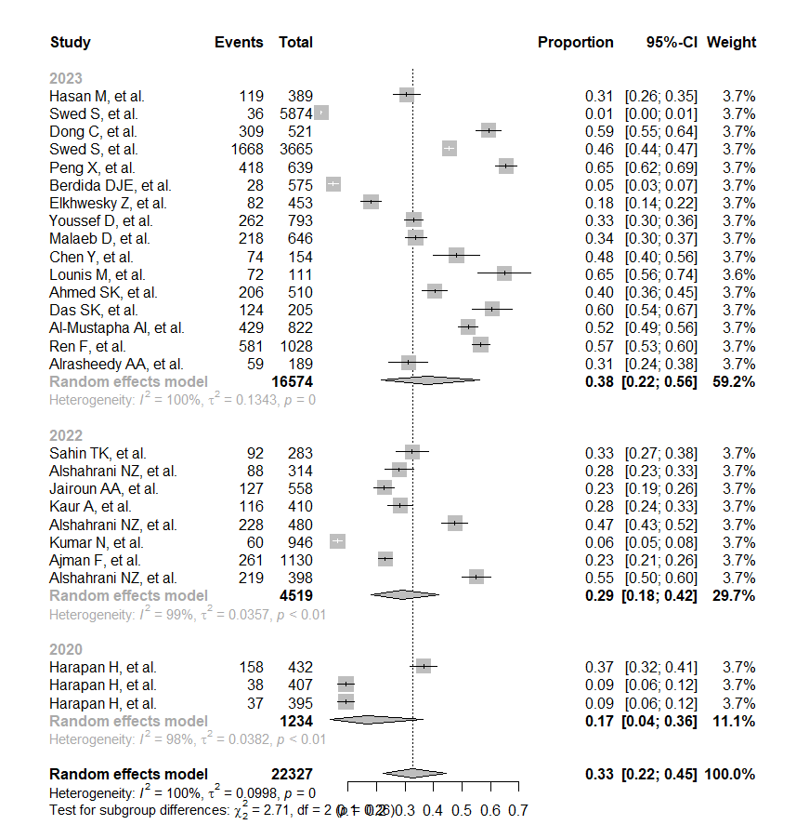
S6 Figure. Subgroup analysis by study year on good knowledge of monkeypox.

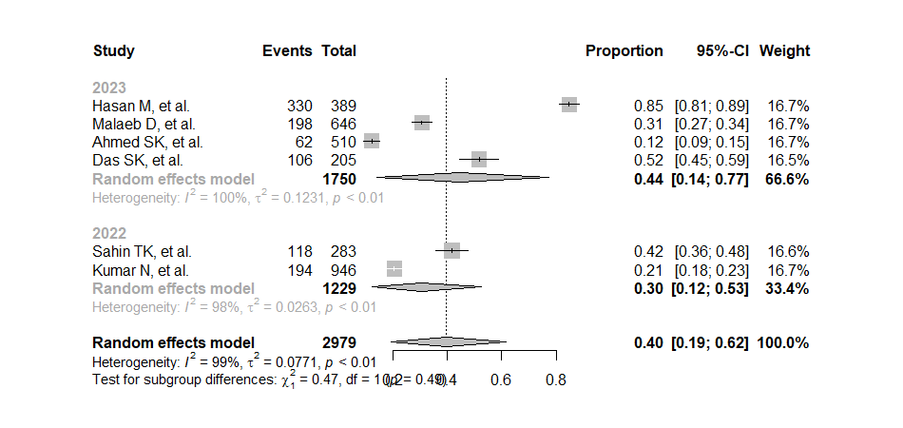
S7 Figure. Subgroup analysis by study year on positive attitude toward monkeypox.

References
1. Hasan, M.; Hossain, M.A.; Chowdhury, S.; Das, P.; Jahan, I.; Rahman, M.F.; Haque, M.M.A.; Rashid, M.U.; Khan, M.A.S.; Hossian, M.; et al. Human Monkeypox and Preparedness of Bangladesh: A Knowledge and Attitude Assessment Study among Medical Doctors. J. Infect. Public Health 2023, 16, 90–95, doi:10.1016/j.jiph.2022.11.032.
2. Swed, S.; Bohsas, H.; Patwary, M.M.; Alibrahim, H.; Rakab, A.; Nashwan, A.J.; Hafez, W.; Hassan, N.A.I.; Shoib, S.; Elsayed, M.; et al. Knowledge of Mpox and Its Determinants among the Healthcare Personnel in Arabic Regions: A Multi-Country Cross-Sectional Study. New Microbes New Infect. 2023, 54, 101146, doi:10.1016/j.nmni.2023.101146.
3. Dong, C.; Yu, Z.; Zhao, Y.; Ma, X. Knowledge and Vaccination Intention of Monkeypox in China’s General Population: A Cross-Sectional Online Survey. Travel Med. Infect. Dis. 2023, 52, 102533, doi:10.1016/j.tmaid.2022.102533.
4. Swed, S.; Bohsas, H.; Alibrahim, H.; Rakab, A.; Hafez, W.; Sawaf, B.; Amir, R.M.; Motawei, A.S.; Aljabali, A.; Shoib, S.; et al. Monkeypox Post-COVID-19: Knowledge, Worrying, and Vaccine Adoption in the Arabic General Population. Vaccines 2023, 11, 759, doi:10.3390/vaccines11040759.
5. Peng, X.; Wang, B.; Li, Y.; Chen, Y.; Wu, X.; Fu, L.; Sun, Y.; Liu, Q.; Lin, Y.-F.; Liang, B.; et al. Perceptions and Worries about Monkeypox, and Attitudes towards Monkeypox Vaccination among Medical Workers in China: A Cross-Sectional Survey. J. Infect. Public Health 2023, 16, 346–353, doi:10.1016/j.jiph.2023.01.010.
6. Berdida, D.J.E. Population-Based Survey of Human Monkeypox Disease Knowledge in the Philippines: An Online Cross-Sectional Study. J. Adv. Nurs. 2023, 79, 2684–2694, doi:10.1111/jan.15635.
7. Elkhwesky, Z.; Derhab, N.; Elkhwesky, F.F.Y.; Abuelhassan, A.E.; Hassan, H. Hotel Employees’ Knowledge of Monkeypox’s Source, Symptoms, Transmission, Prevention, and Treatment in Egypt. Travel Med. Infect. Dis. 2023, 53, 102574, doi:10.1016/j.tmaid.2023.102574.
8. Youssef, D.; Abboud, E.; Kawtharani, M.; Zheim, Z.; Abou Arrage, N.; Youssef, J. When a Neglected Tropical Zoonotic Disease Emerges in Non-Endemic Countries: Need to Proactively Fill the Unveiled Knowledge Gaps towards Human Monkeypox among the Lebanese Population. J. Pharm. Policy Pract. 2023, 16, 39, doi:10.1186/s40545-023-00544-1.
9. Malaeb, D.; Sallam, M.; Salim, N.A.; Dabbous, M.; Younes, S.; Nasrallah, Y.; Iskandar, K.; Matta, M.; Obeid, S.; Hallit, S.; et al. Knowledge, Attitude and Conspiracy Beliefs of Healthcare Workers in Lebanon towards Monkeypox. Trop. Med. Infect. Dis. 2023, 8, 81, doi:10.3390/tropicalmed8020081.
10. Chen, Y.; Li, Y.; Fu, L.; Zhou, X.; Wu, X.; Wang, B.; Peng, X.; Sun, Y.; Liu, Q.; Lin, Y.-F.; et al. Knowledge of Human Mpox (Monkeypox) and Attitude towards Mpox Vaccination among Male Sex Workers in China: A Cross-Sectional Study. Vaccines 2023, 11, 285, doi:10.3390/vaccines11020285.
11. Lounis, M.; Bencherit, D.; Abdelhadi, S. Knowledge and Awareness of Algerian Healthcare Workers about Human Monkeypox and Their Attitude toward Its Vaccination: An Online Cross-Sectional Survey. Vacunas 2023, 24, 122–127, doi:10.1016/j.vacun.2022.11.003.
12. Ahmed, S.K.; Abdulqadir, S.O.; Omar, R.M.; Abdullah, A.J.; Rahman, H.A.; Hussein, S.H.; Mohammed Amin, H.I.; Chandran, D.; Sharma, A.K.; Dhama, K.; et al. Knowledge, Attitude and Worry in the Kurdistan Region of Iraq during the Mpox (Monkeypox) Outbreak in 2022: An Online Cross-Sectional Study. Vaccines 2023, 11, 610, doi:10.3390/vaccines11030610.
13. Das, S.K.; Bhattarai, A.; Kc, S.; Shah, S.; Paudel, K.; Timsina, S.; Tharu, S.; Rawal, L.; Leon-Figueroa, D.A.; Rodriguez-Morales, A.J.; et al. Socio-Demographic Determinants of the Knowledge and Attitude of Nepalese Healthcare Workers toward Human Monkeypox: A Cross-Sectional Study. Front. Public Health 2023, 11, 1161234, doi:10.3389/fpubh.2023.1161234.
14. Al-Mustapha, A.I.; Ogundijo, O.A.; Sikiru, N.A.; Kolawole, B.; Oyewo, M.; El-Nadi, H.; Mustapha, A.M.; Adebudo, L.I.; Odukoya, A.; Asiegbu, E.C.; et al. A Cross-Sectional Survey of Public Knowledge of the Monkeypox Disease in Nigeria. BMC Public Health 2023, 23, 591, doi:10.1186/s12889-023-15398-0.
15. Ren, F.; Liu, J.; Miao, J.; Xu, Y.; Zhang, R.; Fan, J.; Lin, W. Public Awareness, Specific Knowledge, and Worry about Mpox (Monkeypox): A Preliminary Community-Based Study in Shenzhen, China. Front. Public Health 2023, 11, 1077564, doi:10.3389/fpubh.2023.1077564.
16. Alrasheedy, A.A.; Aldawsari, A.H.; Alqasir, M.I.; Alsawyan, O.A.; Alalwan, O.A.; Alwaker, S.A.; Almutairi, M.S.; Godman, B. Knowledge of Community Pharmacists in Saudi Arabia Regarding Human Monkeypox, Its Management, Prevention, and Vaccination: Findings and Implications. Vaccines 2023, 11, 878, doi:10.3390/vaccines11040878.
17. Sahin, T.K.; Erul, E.; Aksun, M.S.; Sonmezer, M.C.; Unal, S.; Akova, M. Knowledge and Attitudes of Turkish Physicians towards Human Monkeypox Disease and Related Vaccination: A Cross-Sectional Study. Vaccines 2022, 11, 19, doi:10.3390/vaccines11010019.
18. Alshahrani, N.Z.; Mitra, S.; Alkuwaiti, A.A.; Alhumam, M.N.; Altmimi, S.M.B.; Alamri, M.H.M.; Albalawi, Z.A.S.; Almorgi, M.W.; Alharbi, H.K.D.; Alshahrani, S.M. Medical Students’ Perception Regarding the Re-Emerging Monkeypox Virus: An Institution-Based Cross-Sectional Study From Saudi Arabia. Cureus 2022, 14, e28060, doi:10.7759/cureus.28060.
19. Jairoun, A.A.; Al-Hemyari, S.S.; Abdulla, N.M.; El-Dahiyat, F.; Shahwan, M.; Hassan, N.; Jairoun, O.; Alyousef, N.G.; Sharif, S.; Jaber, A.A.S. Awareness and Preparedness of Human Monkeypox Outbreak among University Student: Time to Worry or One to Ignore? J. Infect. Public Health 2022, 15, 1065–1071, doi:10.1016/j.jiph.2022.08.015.
20. Kaur, A.; Goel, R.; Singh, R.; Bhardwaj, A.; Kumari, R.; Gambhir, R.S. Identifying Monkeypox: Do Dental Professionals Have Adequate Knowledge and Awareness? Rocz. Panstw. Zakl. Hig. 2022, 73, 365–371, doi:10.32394/rpzh.2022.0226.
21. Alshahrani, N.Z.; Alzahrani, F.; Alarifi, A.M.; Algethami, M.R.; Alhumam, M.N.; Ayied, H.A.M.; Awan, A.Z.; Almutairi, A.F.; Bamakhrama, S.A.; Almushari, B.S.; et al. Assessment of Knowledge of Monkeypox Viral Infection among the General Population in Saudi Arabia. Pathog. Basel Switz. 2022, 11, 904, doi:10.3390/pathogens11080904.
22. Kumar, N.; Ahmed, F.; Raza, M.S.; Rajpoot, P.L.; Rehman, W.; Khatri, S.A.; Mohammed, M.; Muhammad, S.; Ahmad, R. Monkeypox Cross-Sectional Survey of Knowledge, Attitudes, Practices, and Willingness to Vaccinate among University Students in Pakistan. Vaccines 2022, 11, 97, doi:10.3390/vaccines11010097.
23. Ajman, F.; Alenezi, S.; Alhasan, K.; Saddik, B.; Alhaboob, A.; Altawil, E.S.; Alshahrani, F.; Alrabiaah, A.; Alaraj, A.; Alkriadees, K.; et al. Healthcare Workers’ Worries and Monkeypox Vaccine Advocacy during the First Month of the WHO Monkeypox Alert: Cross-Sectional Survey in Saudi Arabia. Vaccines 2022, 10, 1408, doi:10.3390/vaccines10091408.
24. Alshahrani, N.Z.; Algethami, M.R.; Alarifi, A.M.; Alzahrani, F.; Alshehri, E.A.; Alshehri, A.M.; Sheerah, H.A.; Abdelaal, A.; Sah, R.; Rodriguez-Morales, A.J. Knowledge and Attitude Regarding Monkeypox Virus among Physicians in Saudi Arabia: A Cross-Sectional Study. Vaccines 2022, 10, 2099, doi:10.3390/vaccines10122099.
25. Harapan, H.; Setiawan, A.M.; Yufika, A.; Anwar, S.; Wahyuni, S.; Asrizal, F.W.; Sufri, M.R.; Putra, R.P.; Wijayanti, N.P.; Salwiyadi, S.; et al. Knowledge of Human Monkeypox Viral Infection among General Practitioners: A Cross-Sectional Study in Indonesia. Pathog. Glob. Health 2020, 114, 68–75, doi:10.1080/20477724.2020.1743037.
26. Harapan, H.; Setiawan, A.M.; Yufika, A.; Anwar, S.; Wahyuni, S.; Asrizal, F.W.; Sufri, M.R.; Putra, R.P.; Wijayanti, N.P.; Salwiyadi, S.; et al. Physicians’ Willingness to Be Vaccinated with a Smallpox Vaccine to Prevent Monkeypox Viral Infection: A Cross-Sectional Study in Indonesia. Clin. Epidemiol. Glob. Health 2020, 8, 1259–1263, doi:10.1016/j.cegh.2020.04.024.
27. Harapan, H.; Setiawan, A.M.; Yufika, A.; Anwar, S.; Wahyuni, S.; Asrizal, F.W.; Sufri, M.R.; Putra, R.P.; Wijayanti, N.P.; Salwiyadi, S.; et al. Confidence in Managing Human Monkeypox Cases in Asia: A Cross-Sectional Survey among General Practitioners in Indonesia. Acta Trop. 2020, 206, 105450, doi:10.1016/j.actatropica.2020.105450.

