Ecological Niche Modeling for the Prediction of Suitable Habitat for Chrysodeixis chalcites (Noctuidae) in the Continguous United States

Nicholas A. Galle, Kayla R. Hankins, Sibyl Bucheli, Justin K. Williams, and Christopher P. Randle*

Department of Biological Sciences, Sam Houston State University, Huntsville, TX 77340

*corresponding author: randle@shsu.edu

Supplement

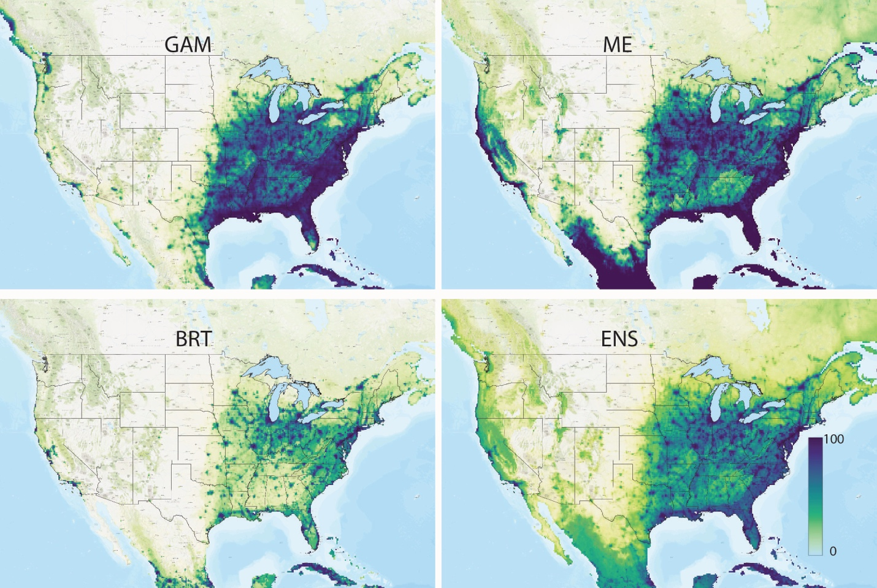

Supplementary Figure 1. Projections for models trained using HI. Upper left: Generalized Additive Model. Upper right: Maximum Entropy. Lower left: Boosted Regression Trees. Bottom right: Ensemble projection.

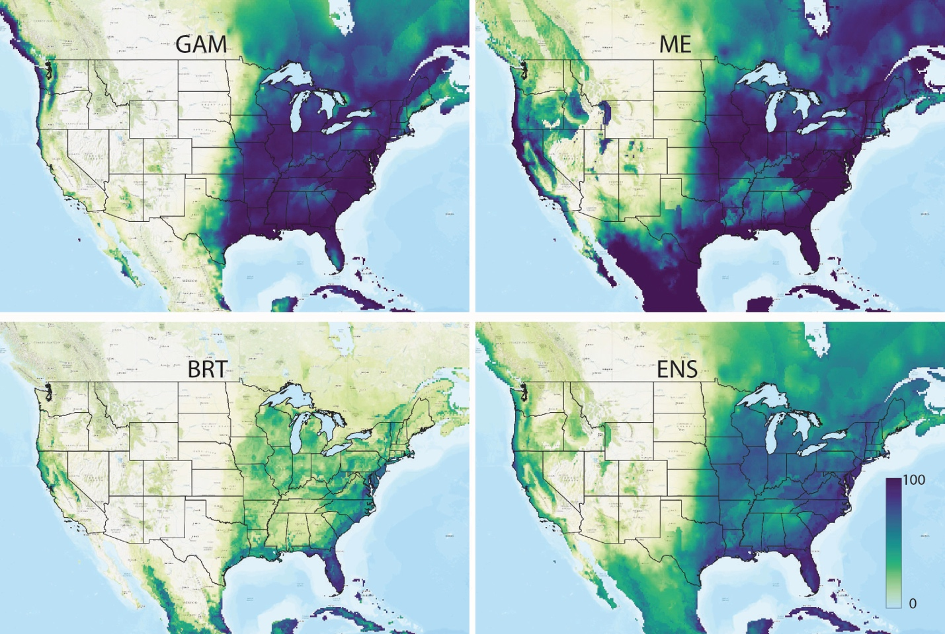
Supplementary Figure 2. Projections for models trained without HI. Upper left: Generalized Additive Model. Upper right: Maximum Entropy. Lower left: Boosted Regression Trees. Bottom right: Ensemble projection.

