Supplementary Materials

Supplementary Table 1: Tumor and normal tissue FLTs from in situ widefield TD fluorescence imaging of HCC tumors across four mice. FLTs are presented as Mean ± SD.

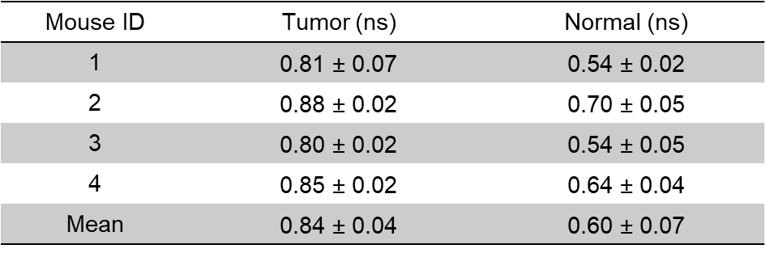

Supplementary Figure 1
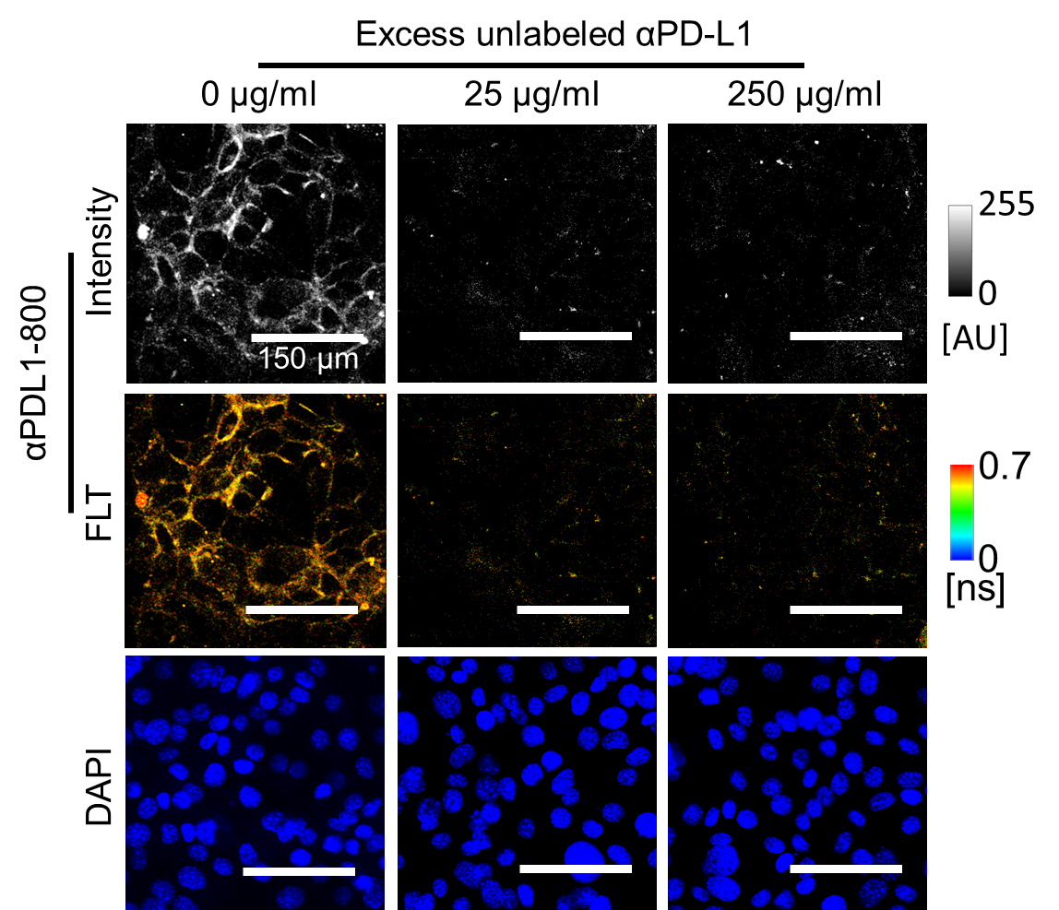
Supplementary Figure 1. PD-L1 specificity of αPDL1-800 FLTs in RIL-175 cells. A competition assay of αPDL1-800 uptake in RIL-175 cells with excess unlabeled αPDL1 (anti-PD-L1 antibody) showing PD-L1 dependent intracellular accumulation of αPDL1-800. Confocal fluorescence intensity (top row) and FLIM (middle row) images of RIL-175 cells after 1 h incubation of αPDL1-800 (100 µg) and increasing doses of unlabeled αPD-L1 antibody are shown. The bottom row shows nuclear stain with DAPI. Excess unlabeled anti-PD-L1 antibody reduced the intracellular αPDL1-800 fluorescence in a dose-dependent manner indicating that the uptake of αPDL1-800 is PD-L1 specific. Scale bar: 150 µm.

Supplementary Figure 2
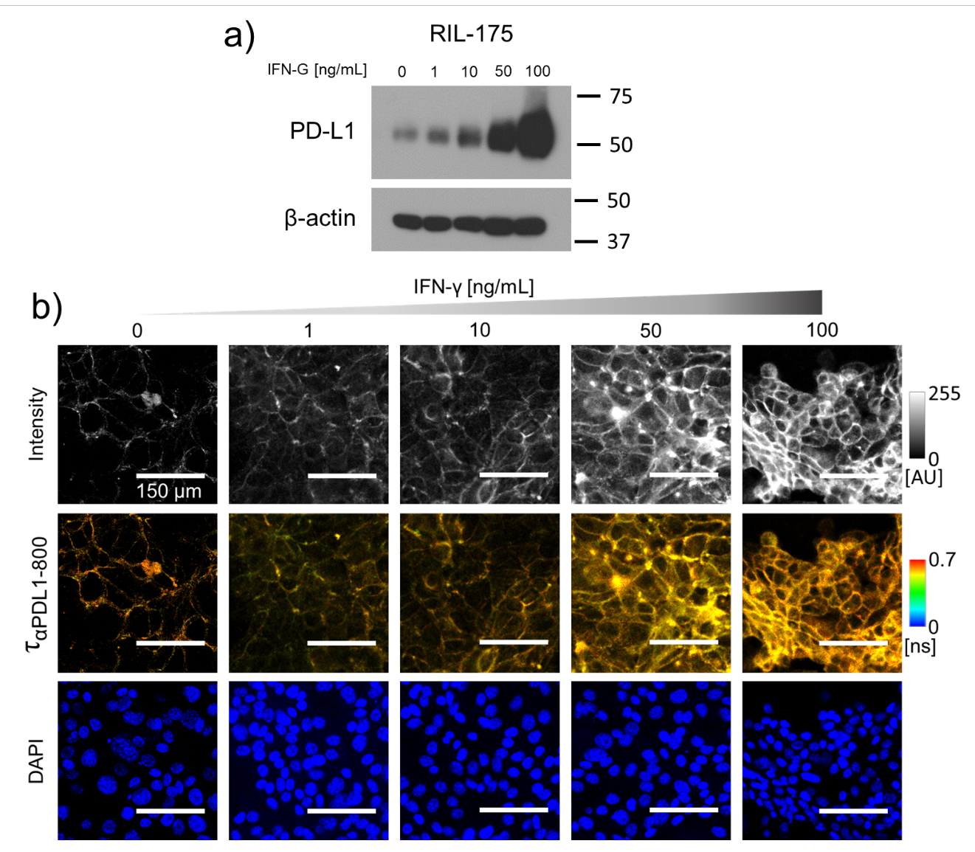
Supplementary Figure 2. IFN-γ induced PD-L1 expression in RIL-175 HCC cell line increases intracellular αPDL1-800 uptake. a, PD-L1 expression measured via western blot from RIL-175 cells harvested after IFN-γ treatment (48 hours at 37⁰C). β-Actin is used as a loading control. b, Confocal fluorescence intensity (top row) and FLIM (middle row) images of RIL-175 cells treated with increasing concentration of IFN-γ (48 hours at 37⁰C) followed by 1 h incubation with αPDL1-800 (100 µg) are shown. The bottom row shows nuclear stain with DAPI. The intracellular αPDL1-800 uptake increased with increasing doses of IFN-γ (top row) indicating higher PD-L1 expression with IFN-g treatment. The mean intracellular FLT was unaffected (middle row) with increasing IFN-γ doses and remained at 0.67 ± 0.06 ns.

Supplementary Figure 3

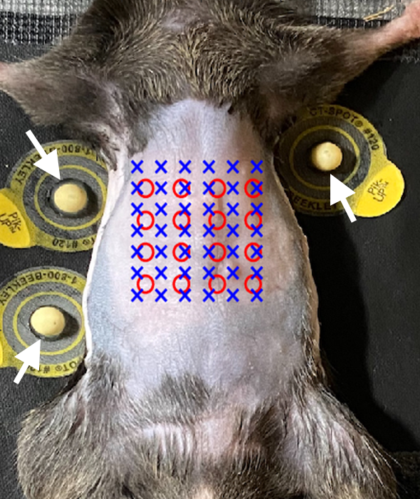
Supplementary Figure 3. Photograph representing the source and detector locations. Top-down view of the ventral surface of a representative mouse with orthotopic RIL-175 tumor in the liver. Arrows indicate the fiducial points used for co-registration of the tomographic data with CT. The sources (o) determined from the impulse response function and detectors (x) assigned on the camera are shown. The sources were separated by 5 mm from each other, while the detector locations were separated by 3.3 mm.

Supplementary Figure 4
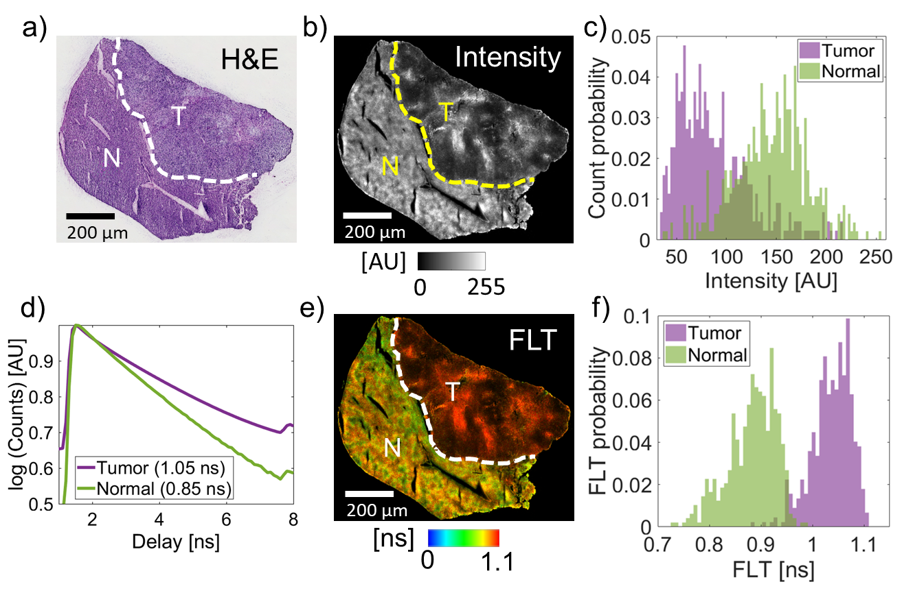
Supplementary Figure 4. Ex vivo validation of the αPDL1-800 FLT enhancement in a representative HCC tumor. The tumor was harvested from a mouse with an orthotopic RIL-175 tumor in the liver, 48 h after systemic administration of αPDL1-800. a, A histology image of an OCT frozen tissue section (10 µm). The tumor (T) and normal liver boundary is indicated by a white dashed line. b, Confocal microscopy of the same tissue section is shown. c, Intensity histograms show a considerable overlap between the HCC tumor (purple) and normal liver (green) with a mean tumor intensity of 87.6±37.2 AU and a mean normal liver intensity of 144.2±36.2 AU. d, Representative TD fluorescence decay curves of αPDL1-800 obtained from confocal FLIM. The decay curve from the tumor (purple) showed a longer FLT (1.05 ns) compared to that in the normal liver (green; 0.85 ns). The corresponding confocal FLIM image (e) of the same tissue section and the FLT histograms (f) of tumor (purple) and normal liver (green) are shown. The tumor FLT was longer ($τ_{T}$ = 1.04±0.04 ns) than the normal liver FLT ($τ_{NS}$ = 0.88±0.05 ns) with minimal overlap.

