SUPPLEMENT MATERIAL

Neutralizing antibody responses assessment after Vaccination in People Living with HIV in the Republic of the Congo

Supplemental Table 1. Characteristics of investigated vaccines.
Vaccine name | Manufacturer | Active component at first dose | Active component at second dose | Type
Janssen/Ad26.COV2.S | Johnson & Johnson, New Jersey, USA | 5×10¹⁰ viral particles | NA | Adenovirus- vectored
Sputnik/Gam-COVID-Vac | Gamaleya National Research Centre for Epidemiology and Microbiology, Moscow, Russia | (1.0±0.5) x 1011 viral particles | (1.0±0.5) x 1011 viral particles | Adenovirus- vectored
Sinopharm/BBIP-CorV | Sinopharm, Beijing, China | 6.5 U (4 mg) of inactivated SARS-CoV-2 antigens | 6.5 U (4 mg) of inactivated SARS-CoV-2 antigens | Inactivated virus

Supplemental Table 2: Characteristics of the study population
Variables | All  N= 1016 | PLWH  N=684 | Non-PLWH  N=332
Age in years (median with IQR) | 43 (24 ; 54) | 48 (35 ; 56) | 28 (2; 41)
Age groups, n (%)  0-19 years  20-39 years  40-59 years  60-79 years  80-99 years | 160/1016 (15.7)  290/1016 (28.5)  445/1016 (43.8)  119/1016 (11.8)  2/1016 (0.2) | 101/684 (14.8)  110/684 (16.1)  373/684 (54.5)  98/684 (14.3)  2/684 (0.3) | 59/332 (17.8)  180/332 (54.2)  72/332 (21.7)  21/332 (6.3)  0/332 (0)
Sex, n (%)  Female  Male | 639/1016 (62.9)  377/1016 (37.1) | 472/684 (69)  212/684 (31) | 149/332 (44.9)  183/332 (55.1)
Vaccination status
Vaccinated, n (%)  Sinopharm/BBIP-CorV  Sputnik/Gam-COVID-Vac  Janssen/Ad26.COV2.S | 394/1016 (38.7)  104/394 (26.3)  93/394 (23.7)  197/394 (50) | 143/684 (20.9)  27/143 (18.8)  49/143 (34.3)  67/143 (46.8) | 251/332 (75.6)  55/251 (21.9)  66/251 (26.3)  130/251 (51.8)
Unvaccinated individuals, n (%) | 622/1016 (61.3) | 541/684 (79.1) | 81/332 (24.4)

N: number of participants in the group; n: number of participants in the subgroup; IQR: interquartile range

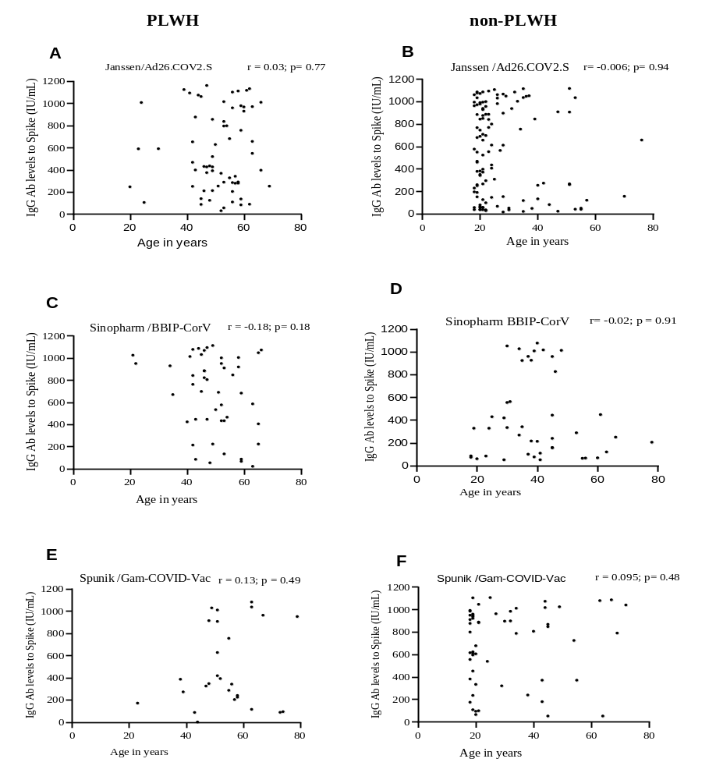
Supplemental Figure 1. Assessment of IgG levels against SARS-COV2 spike protein according to the age of PLWH and non-PLWH participants. Graphs represent the correlation between age and IgG levels after vaccination with Janssen/Ad26.COV2.S (A-B), Sinopharm/BBIP-CorV (C-D), and Sputnik/Gam-COVID-Vac vaccinees (E-F). Dots represent individual donors. Spearman’s ranking test was used to calculate r values .

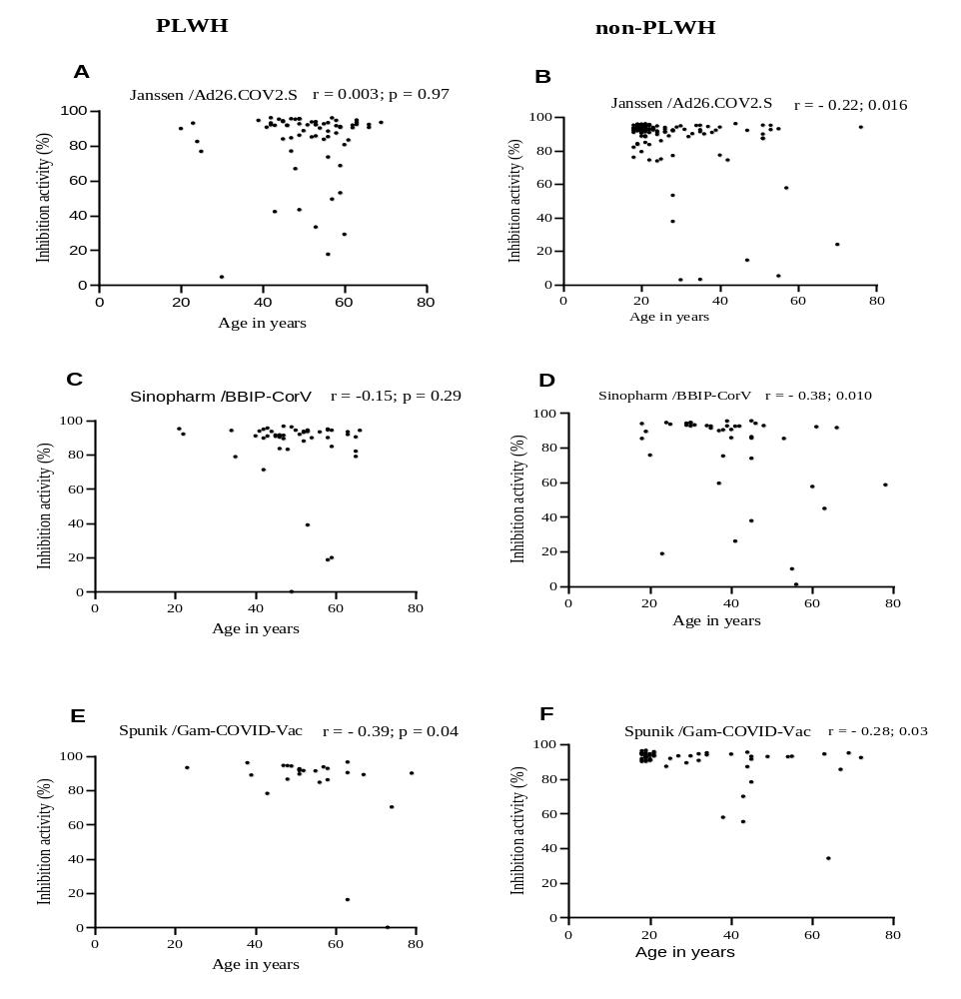
Supplemental Figure 2. Assessment of inhibition activity of neutralizing antibodies in serum samples from vaccibated PLWH and non-PLWH participants. Graphs represent the correlation between age and inhibition activity after vaccination with Janssen/Ad26.COV2.S (A-B), Sinopharm/BBIP-CorV (C-D), and Sputnik/Gam-COVID-Vac vaccinees (E-F). Dots represent individual donors. Spearman’s ranking test was used to calculate r values.
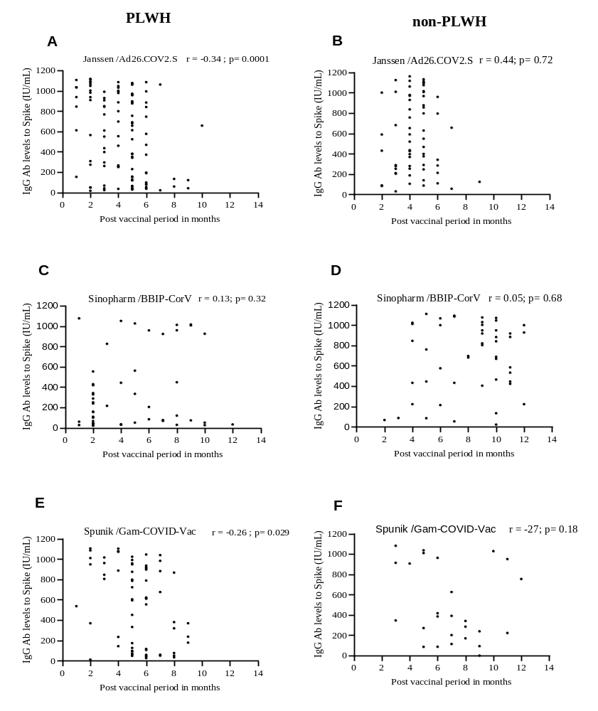
Supplemental Figure 3. Evaluation of post COVID-19 vaccination IgG levels over a period of 12 moinths. Graphs represent the correlation between the post-vaccinal period and IgG levels after vaccination with Janssen/Ad26.COV2.S (A-B), Sinopharm/BBIP-CorV (C-D), and Sputnik/Gam-COVID-Vac vaccinees (E-F). Dots represent individual donors. Spearman’s ranking test was used to calculate r values.

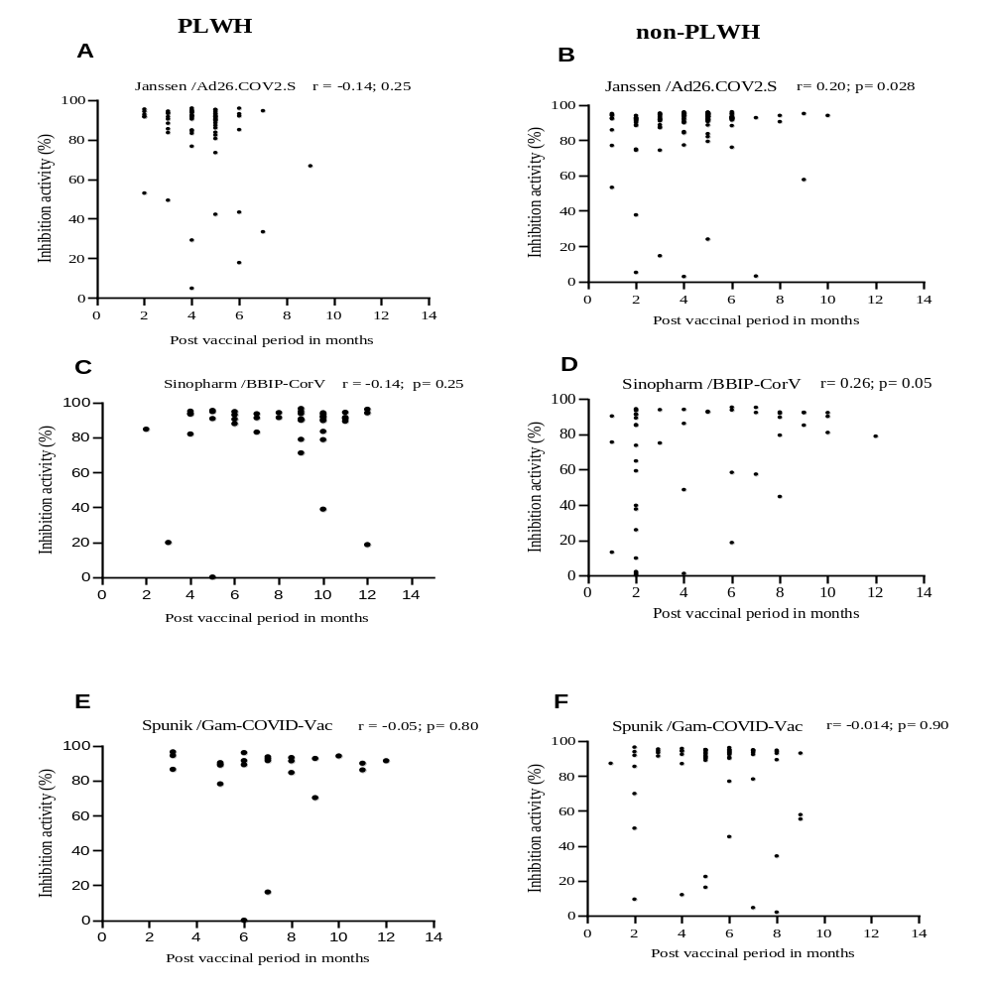

Supplemental Figure 4. Assessment of post-vaccination inhibition capacity of neutralizing antibodies over 12 months period. Graphs represent the correlation between the post-vaccinal period and inhibition activity after vaccination in Janssen/Ad26.COV2.S (A-B), Sinopharm/BBIP-CorV (C-D), and Sputnik/Gam-COVID-Vac (E-F). Dots represent individual donors. Spearman’s ranking test was used to calculate r values.

